COPMGRR Number | 037 | COPMGRR Title | Market Notification for Ad Hoc Invoices and COPMG Cleanup
Timeline | Normal | Action |  | Tabled
Date of Decision |  | May 14, 2014
Proposed Effective Date |  | To be determined.
Priority and Rank Assigned |  | To be determined.
Commercial Operations Market Guide Sections Requiring Revision |  | 8.1, Invoice Process  8.1.2, Types of Ad Hoc Invoices  8.1.3, Method of Communication  8.1.4, Timing of Communication  8.1.5, Content of Communication  8.2, Settlement Statements and Invoices  8.2.1.1, CRR Auction Award Invoices  8.2.3, Real-Time Market Statements and Invoices  8.2.3.2, Settlement Invoice
Other Binding Documents Requiring Revision or Related Revision Requests |  | NPRR618, Market Notices for Resettlement Statements and True-up Settlement Timeline Changes
Revision Description |  | This Commercial Operations Market Guide Revision Request (COPMGRR) updates the Commercial Operations Market Guide (COPMG) to reflect current market practices and proposes changes to market communication for ad hoc Invoices, aligning the COPMG with revisions proposed in NPRR618.
Reason for Revision |  | Addresses current operational issues.  Meets Strategic goals (tied to the ERCOT Strategic Plan or directed by the ERCOT Board).  Market efficiencies or enhancements  Administrative  Regulatory requirements  Other: (explain)  (please select all that apply)
Procedural History |  | - On 4/29/14, COPMGRR037 and an Impact Analysis were posted.  - On 5/14/14, the Communications and Settlements Working Group (CSWG) considered COPMGRR037.
CSWG Decision |  | On 5/14/14, the CSWG was in consensus to table COPMGRR037.
Summary of CSWG Discussion |  | On 5/14/14, participants requested additional time to review COPMGRR037.

Business Case
Qualitative Benefits | - Aligns with the Protocols  - Updates COPMG.
Quantitative Benefits
Impact to Market Segments
Other

Sponsor
Name | Matt Tozer / Ted Hailu
E-mail Address | mtozer@ercot.com / thailu@ercot.com
Company | ERCOT
Phone Number | 512-248-6332 / 512-248-3873
Cell Number
Market Segment | Not applicable.

Market Rules Staff Contact
Name | Sandra Tindall
E-Mail Address | stindall@ercot.com
Phone Number | 512-248-3867

Comments Received
Comment Author | Comment Summary
None

Proposed Guide Language Revision

8.1 Invoice Process
The process for receiving the ERCOT daily Invoice based on Settlement Statements are documented in Protocol Section 9.6, Settlement Invoices for the Day-Ahead and Real-Time Market. This Section explains the process for Invoices that are not settled according to the Protocol timeline.

8.1.2 Types of Ad Hoc Invoices
The following are types of Settlements that will be invoiced on an ad hoc basis:

(a) Recurring ad hoc charges -
These are recurring ad hoc charges that are not included in other ERCOT market Settlement Invoices including the following:
(i) Wide Area Network (WAN) fee; and
(ii) Electric Reliability Organization (ERO) fee.

(b) Other ad hoc Settlements -
These are Settlements that are issued infrequently and are not included in ERCOT market Settlement Invoices including litigation and other undefined scenarios such as the following:
(i) Uplift of short pays; and
(ii) Litigation; and
(iii) Other undefined scenarios.

8.1.3 Method of Communication
(1) ERCOT will communicate with Market Participants regarding the posting of ad hoc Invoices by sending Market Notices to registered contacts of Market Participants and public e-mail distribution lists applicable to the Invoices.
(2) Market Notices regarding ad hoc invoices will be sent to the following contact types:
(a) Primary Authorized Representative;
(b) Backup Authorized Representative;
(c) Accounts payable; and
(d) Accounts payable backup.
8.1.4 Timing of Communication
ERCOT will send Market Notices regarding ad hoc invoices as many days in advance of the posting of the Invoice as possible, but no later than the next Business Day after the ad hoc Invoice is posted.
8.1.5 Content of Communication
The Market Notice from ERCOT will contain as much detail as possible including the following:
(a) A subject line indicating the appropriate urgency and action required.
(b) A description of the type of Market Participants to which ad hoc Invoices have been issued.
(c) Contact information for ERCOT personnel to be contacted for inquiries regarding ad hoc Invoices.
(d) When and where the Invoice will be posted. Ad hoc Invoices are normally posted on the Market Information System (MIS) Certified Area.
8.2 Settlement Statements and Invoices
(1) The Real-Time Market (RTM), the Day-Ahead Market (DAM), and the Congestion Revenue Right (CRR) Auction are settled separately. Each type of Settlement has a unique set of statements and/or Invoices and settles according to a different timeline. Settlement Statements and Invoices can apply to a registered CRR Account Holder (CRRAH), a registered Qualified Scheduling Entity (QSE), or both. The table below provides details regarding the various statements and Invoices.
Type | Invoice or Statement | Recipient | Frequency | Post Timing | Payment Due
CRR | CRR Auction Invoice | - CRRAHs | Monthly | 1st Business Day after completion of a CRR Auction (Monthly and Annual CRR Auctions will be invoiced separately) | 3rd Bank Business Day after Invoice posts (or next day that is both Business Day and Bank Business Day)
CRR | CRR Auction Revenue Distribution Invoice | - QSEs (with Load) | Monthly | 1st Business Day after RTM Initial Statement posts for the last day of the relevant month  and  1st Business Day after RTM Final Statement posts for the last day of the relevant month | 5th Bank Business Day after Invoice posts (or next day that is both Business Day and Bank Business Day)
CRR | CRR Balancing Account Invoice | - CRRAH (due a shortfall refund)  - QSEs (with load) | Monthly | 1st Business Day after RTM Initial Statement posts for the last day of the relevant month | 1st Bank Business Day after the due date of the Settlement Invoice that includes the RTM Initial Settlement statement for the last day of the month (or next day that is both Business Day and Bank Business Day)  *Note: Payout to market only
DAM | DAM Statement | - QSEs  - CRRAHs | Daily | 2nd Business after the Operating Day | n/a
DAM | DAM Resettlement Statement | - QSEs  - CRRAHs | Ad hoc | Ad hoc (on Business Day) | n/a
RTM | RTM Initial Settlement Statement | - QSEs  - CRRAHs | Daily | Operating Day + 6 (or next Business Day) | n/a
RTM | RTM Final Settlement Statement | - QSEs  - CRRAHs | Daily | Operating Day + 57 (or next Business Day) | n/a
RTM | RTM True-Up Settlement Statement | - QSEs  CRRAHs | Daily | Operating Day + 180 (or next Business Day) | n/a
RTM | RTM Resettlement Settlement Statement | - QSEs  CRRAHs | Ad hoc | Ad hoc (on Business Day) | n/a
STL | Settlement Invoice | - QSE  - CRRAHs | Daily | Every Business Day – Rolls up all statements posted that day | 2nd Bank Business Day after the Invoice posts, (or next day that is both Business Day and Bank Business Day)
STL | Default Uplift Invoice | - QSEs  - CRRAHs | Ad hoc | Ad hoc (on Business Day)  *Market Notice required | 5th Bank Business Day after the Invoice posts, (or next day that is both Business Day and Bank Business Day)
STL | Late Fee Invoice | - QSE  - CRRAHs | Monthly | 10th calendar day after the end of the relevant month (or next Business Day) | 4th Business Day after Invoice posts (or next day that is both Business Day and Bank Business Day)
MISC | Miscellaneous Invoice | - QSEs  - CRRAHs | Ad hoc | Ad hoc (on Business Day)  *Market Notice required | Specified in the Market Notice

[COPMGRR036: Replace paragraph (1) above with the following on 5/1/14 unless the ERCOT Board affirmatively votes to delay implementation of NPRR570:]
(1) The Real-Time Market (RTM), the Day-Ahead Market (DAM), and the Congestion Revenue Right (CRR) Auction are settled separately. Each type of Settlement has a unique set of statements and/or Invoices and settles according to a different timeline. Settlement Statements and Invoices can apply to a registered CRR Account Holder (CRRAH), a registered Qualified Scheduling Entity (QSE), or both. The table below provides details regarding the various statements and Invoices.
Type | Invoice or Statement | Recipient | Frequency | Post Timing | Payment Due
CRR | CRR Auction Invoice | - CRRAHs | Monthly | 1st Business Day after completion of a CRR Auction (Monthly and Annual CRR Auctions will be invoiced separately) | 3rd Bank Business Day after Invoice posts (or next day that is both Business Day and Bank Business Day)
CRR | CRR Auction Revenue Distribution Invoice | - QSEs (with Load) | Monthly | 1st Business Day after RTM Initial Statement posts for the last day of the relevant month  and  1st Business Day after RTM Final Statement posts for the last day of the relevant month | 5th Bank Business Day after Invoice posts (or next day that is both Business Day and Bank Business Day)
CRR | CRR Balancing Account Invoice | - CRRAH (due a shortfall refund)  - QSEs (with load) | Monthly | 1st Business Day after RTM Initial Statement posts for the last day of the relevant month | 1st Bank Business Day after the due date of the Settlement Invoice that includes the RTM Initial Settlement statement for the last day of the month (or next day that is both Business Day and Bank Business Day)  *Note: Payout to market only
DAM | DAM Statement | - QSEs  - CRRAHs | Daily | 2nd Business after the Operating Day | n/a
DAM | DAM Resettlement Statement | - QSEs  - CRRAHs | Ad hoc | Ad hoc (on Business Day) | n/a
RTM | RTM Initial Settlement Statement | - QSEs  - CRRAHs | Daily | Operating Day + 5 (or next Business Day) | n/a
RTM | RTM Final Settlement Statement | - QSEs  - CRRAHs | Daily | Operating Day + 55 (or next Business Day) | n/a
RTM | RTM True-Up Settlement Statement | - QSEs  CRRAHs | Daily | Operating Day + 180 (or next Business Day) | n/a
RTM | RTM Resettlement Settlement Statement | - QSEs  CRRAHs | Ad hoc | Ad hoc (on Business Day) | n/a
STL | Settlement Invoice | - QSE  - CRRAHs | Daily | Every Business Day – Rolls up all statements posted that day | 2nd Bank Business Day after the Invoice posts, (or next day that is both Business Day and Bank Business Day)
STL | Default Uplift Invoice | - QSEs  - CRRAHs | Ad hoc | Ad hoc (on Business Day)  *Market Notice required | 5th Bank Business Day after the Invoice posts, (or next day that is both Business Day and Bank Business Day)
STL | Late Fee Invoice | - QSE  - CRRAHs | Monthly | 10th calendar day after the end of the relevant month (or next Business Day) | 4th Business Day after Invoice posts (or next day that is both Business Day and Bank Business Day)
MISC | Miscellaneous Invoice | - QSEs  - CRRAHs | Ad hoc | Ad hoc (on Business Day)  *Market Notice required | Specified in the Market Notice

(2) Upon approval and posting of Settlement Statements and Invoices, the associated data is sent to the Credit Monitoring & Management (CMM) system for use in credit calculations. Similarly, when payment is made to or from the QSE/CRRAH, the payment data is subsequently sent to the CMM system.
(3) The QSE Settlement Statements and Invoices and the CRRAH Statements and Invoices are available on the MIS Certified Area. Statements and Invoices are ‘MIS Certified’ meaning they are Market Participant specific and have data proprietary to individual Entities. Therefore, these files are only available to those Entities owning the data and having a matching Data Universal Numbering System (DUNS) Number.
(4) Market Participants must have access to the ERCOT MIS and a Digital Certificate with appropriate roles in order to retrieve data via the MIS and/or Application Programmatic Interface (API). This Digital Certificate must be obtained from your Entity’s User Security Administrator (USA) and must contain the role of QSE Extracts (for QSEs) or CRR Extracts (for CRRs) in order to view and download statements, Invoices and/or related Settlement extracts.
(5) Invoices, statements and extracts are also available via the API. To download the information from the API, utilize the report type IDs as listed in the ERCOT Market Information List (EMIL), along with the GetReport functionality on the API. For details regarding this option, refer to the External Web Services information posted to the ERCOT website.
(6) In addition to statements and Invoices, the Settlements Calendar which provides statement, Invoice and dispute posting information details, is provided as an extract and can be found on both the MIS Public Area and on the ERCOT website. Supporting information for the Settlements Calendar can be found in the Settlements Calendar User Guide and in the Data Definition Language (DDL) and Extensible Markup Language (XML) Schema Definition (XSD).
(7) Settlement details, including the supporting input, intermediate, and output Settlement billing determinants and other data associated with Settlement Statements and Invoices are found in the appropriate Settlements extracts and reports. When viewing QSE/CRRAH Settlement Statements, a negative amount represents a payment due to the QSE/CRRAH and a positive amount represents a payment due to ERCOT. More information about the available extracts and reports, as well as example statements and Invoices, are available on the MIS Public Area and on the ERCOT website. Descriptions and definitions for the billing determinants can be found on the ERCOT website in the Settlement Charge Matrix and in the relevant Protocol sections. (Also see Section 10, Extracts and Reports).
(8) Information about the Settlements Calendar, statements, and Invoices may be found in Protocol Section 9, Settlement and Billing.
8.2.1.1 CRR Auction Award Invoices
Refer to Protocol Sections 9.8, CRR Auction Award Invoices, and 9.9, Payment Process for CRR Auction Invoices, for details regarding CRR Auction invoicing. Monthly and Annual CRR Auctions are invoiced separately. Additionally, each auction of the CRR Long-Term Auction Sequence auctions will be invoiced separately.
CRR Auction Invoice Timeline
*Must be a Business Day or move to next Business Day.
Payment
Due to
ERCOT
CRR
Auction
Results
Posted
CRR
Auction
Day +1*
Invoice
Issued
Payment
Due to
MPs
CRR
Auction
Day +4*
CRR
Auction
Day +3*
Payment
Due to
ERCOT
CRR
Auction
Results
Posted
CRR
Auction
Results
Day +1*
Invoice
Issued
Payment
Due to
MPs
CRR
Auction Invoice Date

Day +4*
CRR
Auction Invoice Date

Day +3*
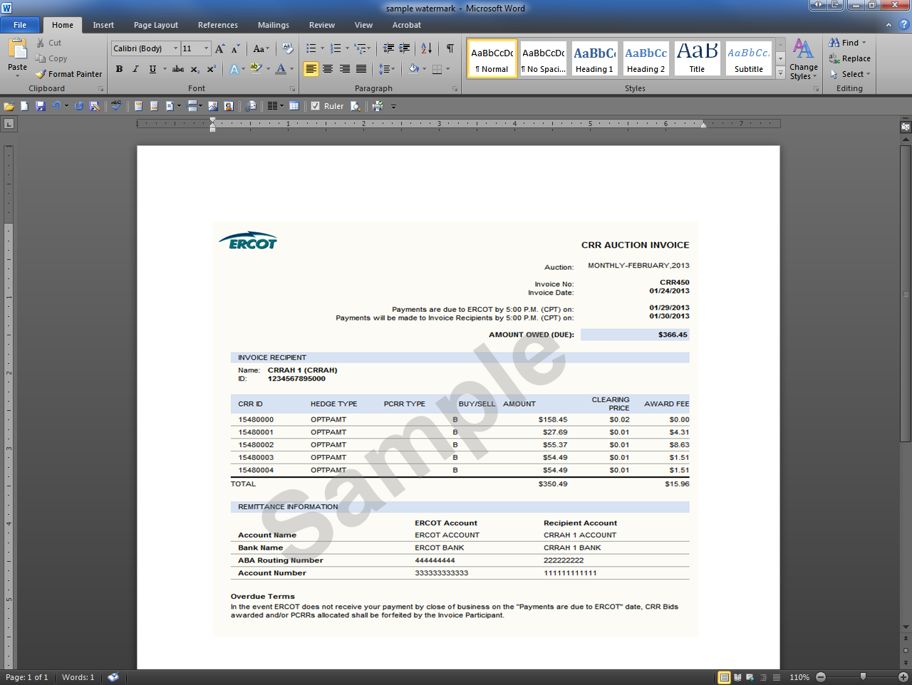

8.2.3 Real-Time Market Statements
8.2.3.2 Settlement Invoice
Refer to Protocol Section 9.6, Settlement Invoices for Day-Ahead Market and the Real-Time Market, for details regarding the invoicing process. The daily Settlement invoicing process finds and includes the DAM, RTM Initial, Final, True-Up and/or Resettlement Statements that are posting on the same day.
*Must be a Business Day or move to next Business Day.

Invoice Day
ERCOT Issues Settlement Invoice
Payment Due to ERCOT
Payment Due to MPs

Invoice Day + 2*

Invoice Day + 3*
