NPRR Number | 562 | NPRR Title | Subsynchronous Resonance
Date |  | May 14, 2014
Submitter’s Information
Name |  | Isabel Flores
E-mail Address |  | iflores@ercot.com
Company |  | ERCOT
Phone Number |  | 512-248-6531
Cell Number |  | 512-565-9117
Market Segment |  | Not applicable

Comments

On April 23, 2014, Electric Reliability Council of Texas, Inc. (ERCOT) hosted a fourth workshop for stakeholders on Nodal Protocol Revision Request (NPRR) 562, Subsynchronous Oscillation. The purpose of the workshop was to respond to questions raised during the review of NPRR562 at the April 10, 2014 Protocol Revision Subcommittee (PRS) meeting. As a result, ERCOT submits these comments to: (1) remove paragraph (6), Cost Allocation, of Section 3.21.3; (2) address minor language corrections; and (3) respond to Calpine Corporation’s (Calpine) comments dated May 6, 2014, and Luminant Energy Company LLC’s (Luminant) comments dated May 9, 2014.

In response to Calpine’s statement on the use of a “limited data sampling,” ERCOT submits that 23 years of Oncor Electric Delivery Company LLC (Oncor) Outage data and 13 years of AEP Texas Central Company (AEP) Outage data is not a “limited data sampling.” Analysis of these data sets indicates that Outage patterns for two of the largest Transmission Service Providers (TSPs) in the ERCOT Region are similar which leads us to believe that the data used to develop the proposed revised technical criteria is reasonable and appropriate. ERCOT will work with the TSPs who provided the Outage data for this analysis to make it available to Market Participants.

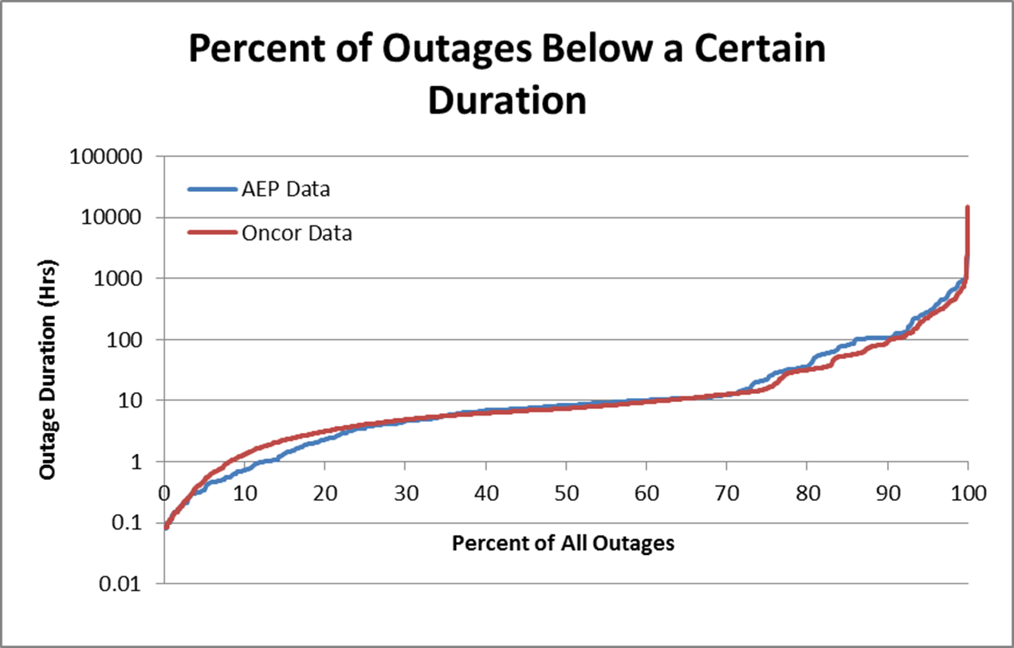

ERCOT respectfully disagrees with Calpine’s comment in reference to our April 3, 2014 recommendation that the “change in criteria is in [sic] obvious contradiction of the Planning Criteria found in ERCOT’s Planning Guide at 4.1.1.1” because the proposed revised technical criteria still recommends mitigation for an N-1 condition at two simultaneous Outages. The proposed revised technical criteria addresses required action by either a TSP or Resource Entity for the rare possibility of a Subsynchronous Oscillation (SSO) event and does not prevent any Entity from implementing additional protection on its equipment. It is appropriate to have different criteria from that used during Real-Time Operations which evaluates the impact to a single Transmission Element at a specific point in time. The Credible Single Contingency framework has not been relaxed with the proposed revised technical criteria. In fact, the criteria expands beyond the N-1 condition to better reflect the low probability, yet high risk impact of a potential SSO event on the ERCOT System.

The table below captures the scenarios that are more likely to occur which formed the basis for the proposed revised technical criteria. It shows the probability of a particular Outage combination occurring at least once in 50 years for any of the Generation Resources that are close enough to a series capacitor with the potential of a SSO event.

ERCOT respectfully disagrees with Luminant’s proposal to implement automatic by-pass of the series capacitors as a mitigation solution because ERCOT/TSP coordination and reliability studies are likely needed in order to ensure that this action does not lead to reliability problem on the ERCOT System. As such, ERCOT does not support the automatic control recommendation without further analysis.

Finally, to address Luminant’s comment that a “torsional relay” may not be reliably retrofitted on all machines, ERCOT submits that either a TSP or a Resource Entity would be able to submit documentation during the review process to demonstrate technical infeasibility of a proposed solution. ERCOT would evaluate any analysis provided by either Entity to determine what solution can be implemented to resolve the potential SSO event. Thus far, ERCOT is not aware of any Entity providing such documentation to ERCOT which substantiates that its equipment cannot be retrofitted for protection.

Revised Cover Page Language

NPRR Number | 562 | NPRR Title | Subsynchronous Oscillation

Revised Proposed Protocol Language

2.1 DEFINITIONS
Subsynchronous Oscillation (SSO)
Coincident oscillation occurring between two or more Transmission Elements or Generation Resources at a natural harmonic frequency lower than the normal operating frequency of the ERCOT System (60 Hz), including, but not limited to, the following types of interactions:
- Subsynchronous resonance – the torsional interaction between series capacitors and turbine-generators.
- Subsynchronous torsional interaction – the interaction between active Transmission Elements (e.g. high-voltage direct current or Static Var Compensator) and turbine-generators.
- Induction generator effects – interactions involving the electrical network only between series capacitors and Generation Resources.
- Subsynchronous control interaction – the amplification of subsynchronous currents due to positive feedback between series capacitors and the control systems of certain Generation Resources.

2.2 ACRONYMS AND ABBREVIATIONS
SSO Subsynchronous Oscillation
FIS Full Interconnection Study

3.21 Subsynchronous Oscillation
3.21.1 Initial Identification and Evaluation of Subsynchronous Oscillation Risk
(1) Subsynchronous Oscillation (SSO) screening studies, including frequency scans, shall be performed by ERCOT in consultation with the interconnecting Transmission Service Provider (TSP) to evaluate a Generation Resource’s risk of becoming radial or near radial to a Transmission Element or Facilities capable of causing SSO.
(2) In the case of a new Generation Resource, ERCOT’s initial evaluation and screening studies shall occur through the ERCOT Generator Interconnection Screening study process provided in the ERCOT Planning Guide.
(3) In the case of a change to the topology of the ERCOT Transmission Grid, ERCOT’s initial evaluation and screening studies shall occur through ERCOT’s review of transmission project proposals submitted through the ERCOT Regional Planning process pursuant to Section 3.11, Transmission Planning, and ERCOT’s review of transmission project updates.
(4) If the screening study shows an SSO risk in the case of six or fewer concurrent Transmission Element Outages in the converged power flow case, then a detailed SSO risk study shall be performed by a designated TSP for a Generation Resource.
(5) If ERCOT’s review of transmission project proposals submitted through the ERCOT Regional Planning process or ERCOT’s review of transmission project updates shows an SSO risk in the case of six or fewer concurrent Transmission Element Outages in a converged power flow case, then a detailed SSO risk study shall be performed by a designated TSP for the changes to the topology of the ERCOT Transmission Grid.
(6) If ERCOT deems a detailed SSO risk study necessary, the provision for such study shall be as follows:
(a) The designated TSP shall be the TSP owning the series capacitor or active Transmission Element involved in the SSO risk, unless another TSP is selected to perform the study by mutual agreement of the TSPs.
(b) If more than one TSP owns series capacitors or Transmission Elements involved in the SSO risk, the TSPs shall mutually agree on the designated TSP to perform the detailed SSO risk study.
(c) If the TSPs do not mutually agree on a designated TSP to perform the detailed SSO risk study, then ERCOT shall select one of the TSPs owning Transmission Facilities involved in the SSO risk to perform the detailed study.
3.21.2 Detailed Subsynchronous Oscillation Studies
(1) The designated TSP shall develop a comprehensive scope, including contingencies, for the detailed SSO risk study and distribute it to ERCOT and the other affected Resource Entities and TSPs for comment. ERCOT shall issue its comments within ten Business Days from receipt of the study scope.
(2) The detailed SSO risk study report shall include a survey of and recommendation for possible mitigation and protection measures if needed, as defined below in Section 3.21.3. The designated TSP may engage a third-party consultant for this assessment or other purposes.
(3) Generation Resource Data – The specificity of the study and any associated recommendations are directly related to the accuracy of the data provided regarding the Generation Resource that may be at risk of SSO.
    - Upon request from ERCOT or the designated TSP, any affected Resource Entity shall provide the data necessary to model the Generation Resource for the purpose of analyzing SSO risk.
    - If the requested data is proprietary and/or confidential, beyond the reasonable control of the affected Resource Entity and can only be obtained from a manufacturer or from another third party, a non-disclosure agreement may be necessary between the manufacturer or third party and the designated TSP, its consultant, if any, and ERCOT. Detailed modelled data obtained pursuant to a non-disclosure agreement associated with a detailed SSO risk study shall not be used for any other purpose and shall not be disclosed to outside parties.
    - If data is not available from the affected Resource Entity and cannot be obtained from a manufacturer or third party, then the designated TSP or its consultant, if any, may make reasonable assumptions in the study
(4) Transmission Equipment Data – The specificity of the study and any associated recommendations are directly related to the accuracy of the data provided regarding the Transmission Elements that may affect the risk of SSO.
    - Upon request from ERCOT or the designated TSP, any affected TSP shall provide the data necessary to model the Transmission Element for the purpose of analyzing SSO risk.
    - If the requested data is proprietary and/or confidential, beyond the reasonable control of the affected TSP and can only be obtained from a manufacturer or from another third party, a non-disclosure agreement may be necessary between the manufacturer or third party and the designated TSP, its consultant, if any, and ERCOT. Detailed modelled data obtained pursuant to a non-disclosure agreement associated with a detailed SSO risk study shall not be used for any other purpose and shall not be disclosed to outside parties.
    - If data is not available from the affected TSP and cannot be obtained from a manufacturer or third party, then the designated TSP or its consultant, if any, may make reasonable assumptions in the detailed SSO risk study.
(5) The detailed SSO risk study shall be reviewed as follows:
(a) The designated TSP shall present the draft detailed SSO risk study report to ERCOT, affected Resource Entities, and the affected TSPs for comment. Where multiple Generation Resources are affected, confidential data shall be redacted in the study report provided to Resource Entities.
(b) Any questions, comments, proposed revisions, or clarifications by any affected Entity shall be made in writing to the designated TSP within 30 days after receipt of the draft detailed SSO risk study. ERCOT may extend this review period by an additional 20 Business Days by notifying the designated TSP that it needs additional time to review the draft study report. ERCOT Staff may request additional data from the affected TSPs and Resource Entities. ERCOT or the affected Entities may further request that the designated TSP conduct additional analysis.
- ERCOT Staff in consultation with the affected Entities shall deem the study complete after reviewing the information received from affected Resource Entities, and affected TSPs. The designated TSP shall issue the final detailed SSO risk study report to ERCOT, affected Resource Entities, and affected TSPs. Where multiple Generation Resources are affected, confidential data shall be redacted in the study report provided to Resource Entities.
- ERCOT may deem a detailed SSO risk study not necessary if an Interconnecting Entity and/or Resource Entity synchronizing the new Generation Resource, or TSP provide documentation stating that its equipment is protected against SSO risk. ERCOT shall review any documentation provided with other affected Resource Entities and TSPs to determine whether further analysis is needed.
3.21.3 Subsynchronous Oscillation Protection and Mitigation Measures
(1) Protection and/or Mitigation measures described in this Section may be necessary as a result of a detailed SSO risk study conducted pursuant to Section 3.21.2. For purposes of this Section, the terms “Protection” and “Mitigation” shall have the following meaning:
(a) “Protection” shall refer to an automatic switching action that removes the affected Generation Resource and/or Transmission Element from service.
(b) “Mitigation” shall refer to the installation and use of any equipment or the implementation of any procedure that may be used to mitigate or eliminate SSO risk.
(i) “Structural Mitigation” shall refer to installation and use of equipment that does not require operator action. As applied to Transmission Facilities, this may include Special Protection Systems (SPSs), active or passive filters, thyristor-controlled series capacitors, and series capacitor segmentation, construction of new Transmission Facilities, etc. As applied to the Generation Resource, this may include Special Protection Systems (SPSs), passive filters, mechanical redesign, damping controllers, etc.
(ii) “Procedural Mitigation” shall refer to implementation of any procedure involving operator action that may be used to mitigate or eliminate SSO risk, such as Outage Coordination, monitoring tools, series capacitor bypass and series capacitor segmentation. ERCOT and the TSP requesting an Outage, clearance, or switching action shall review such actions for possible SSO risk.
(2) The use of Protection and Mitigation measures shall be determined by assessing the nature of the SSO risk. The number of concurrent Transmission Element Outages shall be considered an indicator of the risk.
 | Potential Risk | Action | Responsible Entity
(a) | 3 or fewer concurrent Transmission Outages | Protection and Structural Mitigation | All affected
(b) | 4 or fewer concurrent Transmission Outages | Protection | All affected
(c) | 4, 5, 6 concurrent Transmission Outages | Procedural Mitigation | All affected and ERCOT

(3) All affected Entities shall participate in the coordination and selection of the implemented solution.
(4) The Protection and Mitigation measures required in this Section are minimum requirements and do not preclude an affected Entity from implementing additional measures.
(5) Approval and Reporting of Protection and/or Mitigation Measures.
(a) ERCOT shall review the final detailed SSO risk study and approve, reject or recommend modification of Protection and/or Mitigation measures with 30 days of receipt of the study.
(b) ERCOT shall incorporate conclusions regarding SSO risk, including level of study and approved Protection and/or Mitigation measures, in its future studies or reviews for transmission planning projects.

(6) Modification of Mitigation Measures. Any proposed change to an ERCOT-approved Mitigation measure associated with SSO risk shall be submitted to all affected Entities and approved by ERCOT in writing before taking effect. ERCOT shall approve or reject the proposed change within 90 days of notification.

