LMP Contour Map
RTM LMP view – Standard and High Gradient Views
- Add a disclaimer to the RTM LMP view below the Hover over points to view details: “LMP values do not include Real-Time price adders.”

- Add static values and the label Real-Time Price Adders to the top of the RTM-LMP map (under Download KML (see wireframe): Contours and Points / Points Only / Texas Counties row) for

Real-Time Price Adders
- RTORPA - $xxx.xx (which is the Online Price Adder - <value> updated every five minutes)
- RTOFFPA - $xxx.xx (which is Offline Price Adder - <value> updated every five minutes)

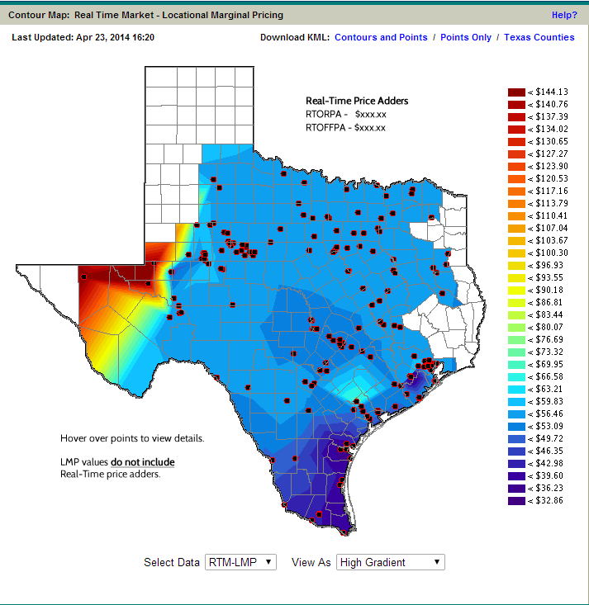
LMP Contour
RTM SPP view – Standard and High Gradient Views

- Add a disclaimer to the RTM SPP view below the Hover over points to view details: “SPP values include the 15 minute Online Reserve Price.”

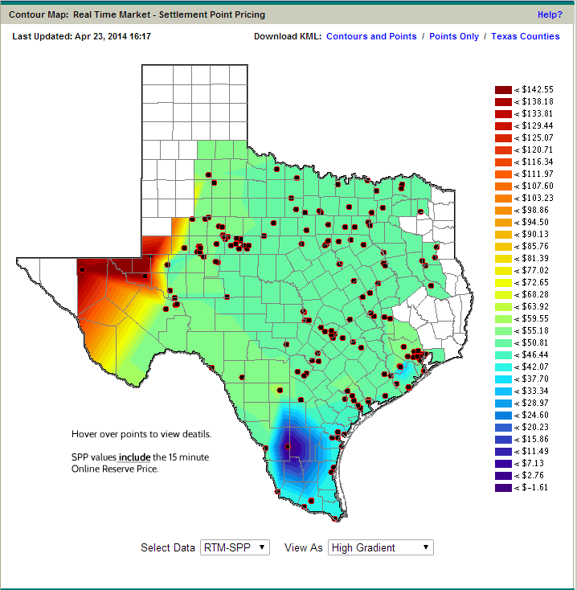

Real-Time LMPs for Load Zones and Trading Hubs Display

- Add a disclaimer to the page: “LMP values do not include the Real-Time price adders.”
- Add a box at the top of the page displaying static values
Price Adders RTORPA - $xxx.xx RTOFFPA - $xxx.xx
RTORPA/Online Price Adder - <value> (updated every 5 minutes)
RTOFFPA/Offline Price Adder - <value> (updated every 5 minutes)
- Add two new columns to the table:
RTORPA/RT Online Price Adder + LMP Price
RTORPA/RT Online Price Adder + LMP Price delta for 5 Minute Change
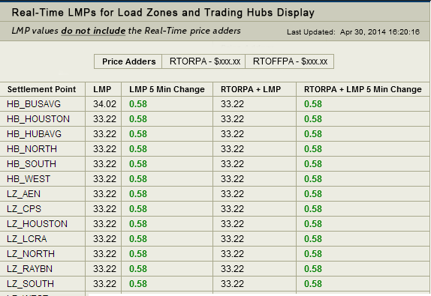

Real-Time LMPs for latest SCED Run
- Add a disclaimer to the page: “LMP values do not include the Real-Time price adders”
- Add a box at the top of the page displaying static values
Price Adders RTORPA - $xxx.xx RTOFFPA - $xxx.xx
RTORPA/Online Price Adder - <value> (updated every 5 minutes)
RTOFFPA/Offline Price Adder - <value> (updated every 5 minutes)
- Add two new columns to the table:
RTORPA/RT Online Price Adder + LMP Price
RTORPA/RT Online Price Adder + LMP Price delta for 5 Minute Change
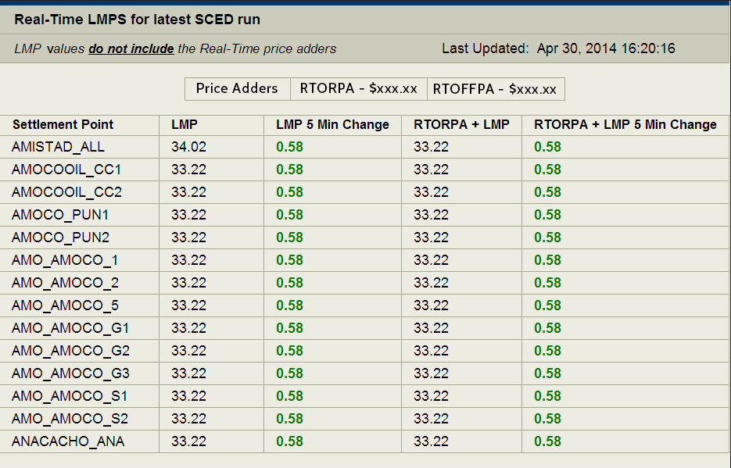

Mobile
- Add a disclaimer to the Settlement Point Prices (i) page: “SPP values include the 15 minute Online Reserve Price.”
    - Will be provided to the user on the (i) page
No Change to the Mobile display pricing display page on the (i) page provide the disclaimer

Real-Time SPP Report
- Add a disclaimer to the page: “SPP values include the 15 minute Online Reserve Price”
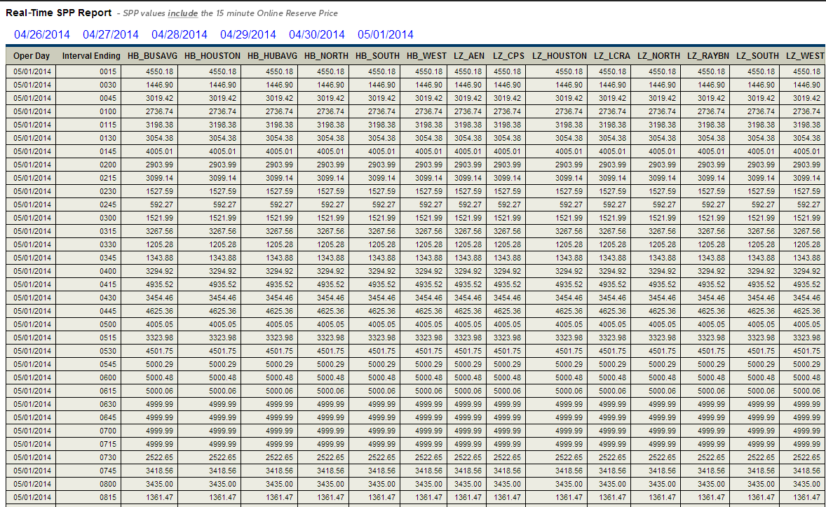

Report ID | Product | Frequency | Format | MIS Display | First Posting
13221 | SCED Total Available Reserves and Price Adders Based on ORDC (Public) | Every SCED run | XML and CSV (zip files) and web service | 1 month | 6/1/2014
13220 | Real-Time Reserve Prices Based on ORDC for 15 Minute Settlement Interval (Public) | 15-min Settlement Interval | XML and CSV (zip files) and web service | 1 month | 6/1/2014
13222 | RTD Indicative Total Available Reserves and Price Adders Based on ORDC (Public) | Every 5 minutes | XML and CSV (zip files) and web service | 1 month | 6/1/2014
13231 | Historical Real-Time Reserve ORDC Price Adder (Public) | 5 minute data, accumulates and updates weekly | XLSX | 3 years -  File overwrites with most current file weekly. | 6/8/2014
13233 | LOLP Distribution by Season and TOD Block (Public) | Seasonal posting with forecast and backcast view | XLSX | 3 years | 6/20/2014
None | Methodology for Implementing ORDC Real-Time Reserve Price Adder | Ad-Hoc - Posted with Other Binding Documents | Document | Most Current Posted
MIS Report Impacts for ORDC

Product | Current Product Being Replaced (If avail) | New ORDC Product Report columns
SCED Total Available Reserves and Price Adders Based on ORDC (Public) | Real-Time Reserve Price Adder Based on ORDC – Interim  Available on ERCOT.com and MIS  RPT ID 13115 | Batch ID, SCED Timestamp, Repeated Hour Flag Repeated Hour, Flag, System Lambda, PRC, RTORPA, RTOFFPA, RTOLCAP, RTOFFCAP, RTOLHSL, RTBP, RTCLRCAP, RTCLRREG, RTCLRBP, RTCLRLSL, RTCLRNS, RTNCLRRRS, RTOLNSRS, RTCST30HSL, RTOFFNSHSL, RTOFF10, RTOFF30
Real-Time Reserve Prices Based on ORDC for 15 Minute Settlement Interval (Public) |  | Batch ID, Delivery Date, Delivery Hour, Delivery Interval, Delivery Time, RTRSVPOR, RTRSVPOFF, DST_FLAG
RTD Indicative Total Available Reserves and Price Adders Based on ORDC (Public) |  | Batch ID, RTD Timestamp, Repeated Hour Flag, Interval ID, Interval Ending, IE Repeated Hour Flag, System Lambda, RTORPA, RTOFFPA, RTOLCAP, RTOFFCAP
Historical Real-Time Reserve ORDC Price Adder (Public) | Real-Time Reserve Price Adder Based on ORDC - Interim Historical Reports  Available on ERCOT.com and MIS  RPT ID 13166 | Batch ID, SCED Timestamp, Repeated Hour Flag Repeated Hour, Flag, System Lambda, PRC, RTOLCAP, RTOFFCAP, RTORPA, RTOFFPA, RTOLHSL, RTBP, RTOLNSRS, RTCLRCAP, RTCLRBP, RTCLRLSL, RTCLRNS, RTCLRREG, RTNCLRRRS, RTCST30HSL, RTOFFNSHSL, RTOFF10, RTOFF30
LOLP Distribution by Season and TOD Block (Public) |  | Season, Start Date, End Date, Start Hour, End Hour, Average, Standard Deviation
Methodology for Implementing ORDC Real-Time Reserve Price Adder | Methodology for Implementing Operating Reserve Demand Curve (ORDC) to Calculate Real-Time Reserve Price Adder  Available on ERCOT.com

