
April 2014 ERCOT Monthly Operations Report

Reliability and Operations Subcommittee Meeting
May 8, 2014
Table of Contents
1. Report Highlights 1
2. Frequency Control 2
2.1. Frequency Events 2
2.2. Responsive Reserve Events 3
2.3. Load Resource Events 3
3. Reliability Unit Commitment 3
4. Wind Generation as a Percent of Load 4
5. Congestion Analysis 4
5.1. Notable Constraints for March 4
5.2. Generic Transmission Limit Congestion 6
5.3. Congestion Costs for Calendar Year 2014 6
6. System Events 7
6.1. ERCOT Peak Load 7
6.2. Load Shed Events 7
6.3. Stability Events 7
6.4. Notable PMU Events 7
6.5. TRE/DOE Reportable Events 7
6.6. New/Updated RAPs and PCAPs 7
6.7. New/Modified/Removed SPS 8
6.8. New Procedures/Forms/Operating Bulletins 8
7. Emergency Conditions 8
7.1. OCNs 8
7.2. Advisories 8
7.3. Watches 8
7.4. Emergency Notices 8
8. Application Performance 8
8.1. TSAT/VSAT Performance Issues 8
8.2. Communication Issues 8
9. Net-Forecast Bias Applied to NSRS Procurement for May 2014 9
10. Appendix A: Real-Time Constraints 10

Report Highlights
There was less activity on the ERCOT Interconnection in April due to the continued mild weather. Operations continued to note fewer frequency events and RRS deployments than what had been observed during the colder months. The amount of SCED congestion held steady in April, and was attributed primarily to ongoing outages. There was one reportable system event in April and no issues with ERCOT applications.

Highlights of this report:
- The unofficial ERCOT peak for April was 48,464 MW.
- There were three frequency events in April, two of which were significant enough for PMU data to be captured. The ERCOT system transitioned well in each case.
- There were four instances where Responsive Reserves were deployed. Three of these were the result of frequency events and the final was related to a generation deviation. There were no Load Resource deployments in April.
- There were fewer RUC Commitments in April than in previous months.
- The level of SCED congestion remained steady in April and was mainly due to ongoing outages.
- There was one reportable system event in April.
- ERCOT Applications performed well. There were no issues in April.

Frequency Control

Frequency Events
The ERCOT Interconnection experienced three frequency events in April, all of which resulted from Resource trips. The average event duration was approximately 47 seconds, which was consistent with the system performance observed in previous months.

When analyzing frequency events, ERCOT evaluates PMU data according to industry standards. Events with an oscillating frequency of less than 1 Hz are considered to be inter-area, while higher frequencies indicate local events. Industry standards specify that damping ratio for inter-area oscillations should be 3.0% or greater. All events listed below indicate the ERCOT system met these standards and transitioned well after each disturbance. Further details on the Resource trip events can be seen in the Performance Disturbance Compliance Working Group report. A summary of the frequency events is provided below:

Date and Time | Max/Min Frequency  (Hz) | Duration of Event  (seconds) | PMU Data |  | Comments
Date and Time | Max/Min Frequency  (Hz) | Duration of Event  (seconds) | Oscillation Mode | Damping Ratio | Comments
4/2/2014 0:33 | 59.870 | 6 | No significant oscillation modes captured. |  | Unit trip with approximately 472 MW
4/6/2014 7:35 | 59.774 | 114 | 0.689 Hz  1.080 Hz | 8.74%  14.4% | Unit trip with approximately 927 MW
4/29/2014 8:57 | 59.859 | 22 | 0.729 Hz | 5.82% | Unit trip with approximately 465 MW

(Note: the duration of the frequency events is defined to be the time at which the frequency was outside the range of 60±0.1 Hz)

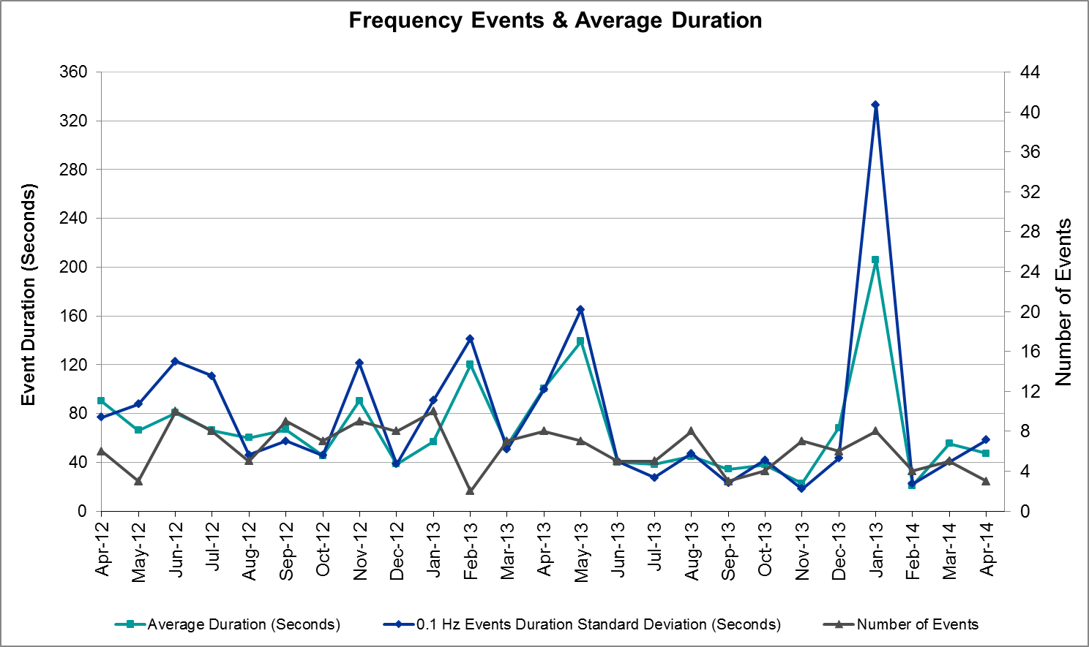

Responsive Reserve Events
There were four events where Responsive Reserve MWs were released to SCED in April. The events highlighted in blue were related to frequency events reported in section 2.1 above.

Date and Time  Released to SCED | Date and Time  Recalled | Duration of Event | Maximum MWs Released | Comments
4/2/14 0:33:34 | 4/2/14 0:36:22 | 0:02:48 | 323.75
4/6/14 7:35:22 | 4/6/14 7:40:34 | 0:05:12 | 1002.7
4/7/14 8:46:46 | 4/7/14 8:52:38 | 0:05:52 | 237.89 | Generation deviation of approximately -962 MW over 9 minutes.
4/29/14 8:58:08 | 4/29/14 9:01:44 | 0:03:36 | 222.6

Load Resource Events
There were no load resource deployment events in April.

Reliability Unit Commitment
ERCOT reports on Reliability Unit Commitments (RUC) on a monthly basis. Commitments are reported grouped by operating day and weather zone. The total number of hours committed is the sum of the hours for all the units in the specified region. Additional information on RUC commitments can be found on the MIS secure site at Grid → Generation → Reliability Unit Commitment.

There were no DRUC commitments in April.

HRUC Commitments
Resource Location | # of Resources | Operating Day | # Hours Committed | Total MWhs | Reason for commitment
Southern | 1 | 4/8/2014 | 10 | 2,363 | Valley Import
Southern | 1 | 4/10/2014 | 23 | 5,430 | Valley Import
Southern | 2 | 4/11/2014 | 17 | 4,678 | Valley Import

Wind Generation as a Percent of Load
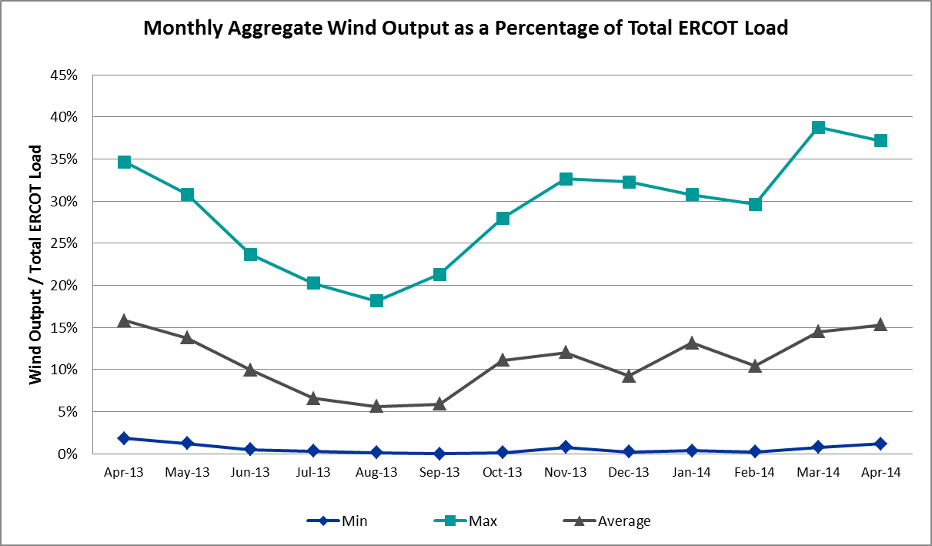

Congestion Analysis
The number of congestion events experienced by the ERCOT system remained steady again in April. Since the weather again mild during the month, most of the reportable congestion events were related to ongoing outages. There were also nine days of activity on the SOP110 Generic Transmission Limit (GTL) resulting from planned outages in the area and one day of activity on the West to North GTL due to high wind output.

Notable Constraints for March
Nodal protocol section 3.20 specifies that ERCOT shall identify transmission constraints that are active or binding three or more times within a calendar month. As part of this process, ERCOT reports congestion that meets this criterion to ROS. In addition ERCOT also highlights notable constraints that have an estimated congestion rent exceeding $1,000,000 for a calendar month. These constraints are detailed in the table below. Rows highlighted in blue indicate the congestion was affected by one or more outages. For a list of all constraints activated in SCED for the month of March, please see Appendix A at the end of this report.

Contingency | Overload | # of Days Constraint Active | Estimated Congestion Rent | Transmission Project
Midland East Axfmr 1 (3) 345/138 kV | Odessa North Sd3 138 kV | 7 | $13,143,124 | 2012-R3, 2012-R4
DCKT Jewett - Singleton 345 kV | Twin Oak Switch - Gibbons Creek 345 kV | 1 | $10,808,204
Moss Switch Axfmr 1 345/138 kV | Odessa North Sd3 138 kV | 18 | $10,418,868 | 2012-R3, 2012-R4
DCKT Wa Parish - Jeanetta 345 kV | Smithers - Bellaire 345 kV | 3 | $7,105,728
DCKT Flewellen - Obrien and Maso Road 138 kV | Hockley - Betka 138 kV | 1 | $6,266,840
Apache Tnp - Caddo Sw Sta Tnp 138 kV | Heights Tnp HEIGHAT1 138/69 kV | 1 | $2,627,829
Koch Up River - Gila 138 kV | Gila - Hiway 9 138 kV (GILA_HIWAY_2) | 18 | $2,538,262
Midland Downtown - Spraberry Switch 138 kV | Midland East - Windwood 138 kV | 1 | $2,125,054
Midland Downtown - Spraberry Switch 138 kV | SOP110 | 9 | $1,530,411
Alice - Kingsville 138 kV | Lon Hill - Calallen Sub 69 kV | 3 | $1,374,399 | 2012-R13, 12TPIT0181
Midland East - Moss Switch - Odessa Ehv Switch 345 kV | Odessa Ehv Switch - Big Three Odessa Tap 345 kV | 1 | $1,302,767
Nelson Sharpe - Ajo 345 kV | Rio Hondo - Burns Sub 138 kV | 11 | $1,160,827
Wolf Hollow 345 Switch - Comanche Peak Ses 345 kV | Primrose Fort Worth - Wedgwood Switch 138 kV (6122) | 5 | $1,046,387
DCKT Wa Parish - Jeanetta 345 kV | Wa Parish - Bellaire 345 kV | 12 | $1,007,710
Mathis - Stevens and Lon Hill 69 kV | Orange Grove 69 Sub - Casa Blanca 69 kV | 3 | $931,848 | 16TPIT0037
Nelson Sharpe - Ajo 345 kV | Las Pulgas - Raymondville 2 138 kV | 4 | $913,661 | 12TPIT0103
Victoria - Coleto Creek 138 kV (COLETO_VICTOR1) | Victoria - Coleto Creek 138 kV (COLETO_VICTOR2) | 8 | $730,000 | 16TPIT0034
Fayetteville - Salem LCRA 138 kV | Zorn - Pooley Road 138 kV | 3 | $695,113
Laquinta - Lobo 138 kV | Bruni 138_69_1 138/69 kV | 13 | $352,809 | 13TPIT0159
Bluff Creek T1 (3) 345/138 kV | Cedar Hill Aep 138_69_1 138/69 kV | 3 | $298,805
Bosque Switch - Whitney 138 kV | Bosque Switch - Lake Whitney Tnp 138 kV | 8 | $294,029
Ajo - Rio Hondo 345 kV | Las Pulgas - Rio Hondo 138 kV | 3 | $22,734 | 14TPIT0050
Nelson Sharpe - Lon Hill 345 kV | Celanese Bishop - Kleberg Aep 138 kV | 3 | $16,262
Aspermont Aep - Spur 138 kV | Wolfgang - Rotan 69 kV | 5 | $15,507
Scurry Switch - Sun Switch 138 kV | Wolfgang - Rotan 69 kV | 9 | $13,943
Basecase | Ena Snyder Wind - Wkn_Bkr 69 kV | 3 | $2,079

Generic Transmission Limit Congestion
There were nine days of GTL activity on the SOP110 stability limit resulting from ongoing outages in the area. In addition, there was one day of activity on the West – North stability limit as a result of high wind output. There was no GTL activity on the North – Houston or Valley Import GTLs.

Congestion Costs for Calendar Year 2014
The following table represents the top twenty active constraints for the calendar year to date based on the estimated congestion rent attributed to the congestion. ERCOT updates this list on a monthly basis.

Contingency | Binding Element | # of 5-min SCED Intervals | Estimated Congestion Rent | Transmission Project
Lytton Springs LY_AT2 345/138 kV | Lytton Springs LY_AT1 345/138 kV | 1,989 | $55,956,002
Midland East Axfmr 1 (3) 345/138 kV, Moss Switch Axfmr 1 345/138 kV, and Midland East - Moss Switch - Odessa Ehv Switch 345 kV | Odessa North Sd3 138 kV | 5,310 | $23,944,433 | 2012-R3, 2012-R4
Basecase | Valley Import | 495 | $11,577,259
DCKT Jewett - Singleton 345 kV | Twin Oak Switch - Gibbons Creek 345 kV | 273 | $10,912,808
DCKT Gabriel - Glasscock LCRA and Rivery 138 kV, Glasscock LCRA - Gabriel 138 kV, and DCKT Gabriel - Bell County - Hutto Switch 138 kV | Marshall Ford - Lago Vista 138 kV | 209 | $9,871,526 | 15TPIT0061
DCKT Paris Switch - Valley Ses and Valley South 345 kV | Paris Switch AXFMR1 (3) 345/138 kV | 1,442 | $9,291,357 | 14TPIT0093
Alice - Kingsville 138 kV, Kingsville - Lon Hill 138 kV, Nelson Sharpe - Lon Hill 345 kV | Lon Hill - Calallen Sub 69 kV | 912 | $7,699,219 | 12TPIT0181, 2012-R13
DCKT Wa Parish - Jeanetta 345 kV | Smithers - Bellaire 345 kV | 448 | $7,122,994
DCKT Flewellen - Obrien and Maso Road 138 kV, DCKT Singleton - Zenith 345 kV | Hockley - Betka 138 kV | 226 | $6,440,946
Sun Switch - Morgan Creek Ses 138 kV and Bluff Creek Switch - Ennis Creek Switch 138 kV | Snyder - Sacroc 138 kV | 217 | $6,270,391 | 09TPIT0120
Stadium Aep - Alice 69 kV, Pawnee Switching Station - Lon Hill 345 kV, and Alice - Kingsville 138 kV | Lon Hill - Robstown Tap 69 kV | 904 | $6,091,279 | 12TPIT0180
Coleto Creek - Pawnee Switching Station 345 kV, Pawnee Switching Station - Calaveras 345 kV | Coleto Creek - Kenedy Switch 138 kV | 405 | $4,490,198 | 16TPIT0034
Orange Grove Switching Station - Lon Hill 138 kV and Lon Hill 345_138_2 (3) 345/138 kV | Lon Hill - Smith 69 kV | 1,806 | $4,443,063 | 16TPIT0026, 2012-R18
DCKT Tonkawa Switch - Scurry County South Switch 345 kV | Bluff Creek Switch - Exxon Sharon Ridge 138 kV | 2,291 | $4,077,342
DCKT Burleson - Carson Creek 138 kV and Pedernales - Advanced Micro Devices AEN 138 kV | Kingsberry - Mueller 138 kV | 75 | $4,036,986 | 11TPIT0008
Paris Switch AXFMR1 (3) 345/138 kV, Elkton - Tyler Kelly Tire 138 kV | Forest Grove Switch - Eustace Southeast 138 KV | 192 | $3,934,733 | 17TPIT0020
DCKT Watermill Switch - Desoto Switch and Cedar Hill Switch 345 kV | Sargent Road AXFMR1H (3) 345/138 kV | 186 | $3,794,589 | 11TPIT0034
Pawnee Switching Station - Lon Hill 345 kV, Nelson Sharpe - Lon Hill 345 kV, North Edinburg 345_1382 345/138 kV | Nelson Sharpe - Celanese Bishop 138 kV | 1,053 | $3,594,305 | 15TPIT0024
DCKT Limestone - Navarro 345 kV | Jewett - Big Brown Ses 345 kV (Line 40) | 34 | $3,428,764
Koch Up River - Gila 138 kV | Gila - Hiway 9 138 kV (GILA_HIWAY_2) | 7,205 | $3,368,979

System Events

ERCOT Peak Load
The unofficial ERCOT peak load for the month of April was 48,464 MW and occurred on April 28 during the hour ending 18:00.

Load Shed Events
None

Stability Events
None

Notable PMU Events
ERCOT analyzes PMU data for any significant system disturbances that do not fall into the Frequency Events category reported in section 2.1. The results are summarized in this section once the analysis has been completed.

There are no events to report for April.

TRE/DOE Reportable Events
ERCOT experienced one reportable event in April. On April 29, there was an unexpected loss, contrary to design, of three or more elements of the BES caused by a common disturbance. ERCOT did not request any firm load to be shed and filed an EOP-004 form following this event.

New/Updated RAPs and PCAPs
None

New/Modified/Removed SPS
None

New Procedures/Forms/Operating Bulletins
Date | Document | Description
4/4/2014 | Power Operations Bulletin 666 | DC Tie Desk V1 Rev27
4/4/2014 | Power Operations Bulletin 667 | Real Time Desk V1 Rev29
4/4/2014 | Power Operations Bulletin 668 | Reliability Unit Commitment Desk V1 Rev24
4/4/2014 | Power Operations Bulletin 669 | Resource Desk V1 Rev27
4/4/2014 | Power Operations Bulletin 670 | Shift Supervisor Desk V1 Rev26
4/4/2014 | Power Operations Bulletin 671 | Transmission and Security Desk V1 Rev31

Emergency Conditions
The ERCOT Interconnection did not experience any Emergency conditions in April. This was due to milder weather in the ERCOT region compared to previous months.

OCNs
None

Advisories
None

Watches
None

Emergency Notices
None

Application Performance
ERCOT system applications performed well in April. There no issues with Operations applications.

TSAT/VSAT Performance Issues
None

Communication Issues
None

Net-Forecast Bias Applied to NSRS Procurement for May 2014
Each month, ERCOT calculates a net Forecast Bias pursuant to the ERCOT Ancillary Services Methodology for procurement of Non-Spinning Reserve Service (NSRS). The table below indicates the amount of net Forecast Bias that was applied to the NSRS procurement for specified blocks of time for the month of May, 2014.

Blocks | Negative Net Load Forecast Average Error - ERCOT | Sum of the Individual Zones | Negative Net Load Forecast Average Error - By Weather Zone for the 5 Largest Zones
Blocks | Negative Net Load Forecast Average Error - ERCOT | Sum of the Individual Zones | Coast | East | North Central | South Central | Southern
1-2 | 0 | 0 | 0 | 0 | 0 | 0 | 0
3-6 | 0 | 0 | 0 | 0 | 0 | 0 | 0
7-10 | 0 | 0 | 0 | 0 | 0 | 0 | 0
11-14 | 0 | 0 | 0 | 0 | 0 | 0 | 0
15-18 | 0 | 0 | 0 | 0 | 0 | 0 | 0
19-22 | 0 | 0 | 0 | 0 | 0 | 0 | 0
23-24 | 0 | 0 | 0 | 0 | 0 | 0 | 0

Appendix A: Real-Time Constraints
The following is a complete list of constraints activated in SCED for the month of April. Full contingency descriptions can be found in the Standard Contingencies List located on the MIS secure site at Grid → Generation → Reliability Unit Commitment.

Contingency | Constrained Element | From Station | To Station | # of Days Constraint Active
MXMOS58 | ODNTH_SD3_1 | ODNTH | ODNTH | 18
SKOCNU28 | GILA_HIWAY_2_1 | GILA | HIWAY_9 | 18
SLAQLOB8 | BRUNI_69_1 | BRUNI | BRUNI | 13
DWAP_JN5 | BI_WAP50_A | WAP | BI | 12
SN_SAJO5 | S104A_1 | RIOHONDO | MV_BURNS | 11
BASE CASE | SOP110 |  |  | 9
SSCUSUN8 | ROTN_WOLFGA1_1 | WOLFGANG | ROTN | 9
SBOSWHT8 | OLKW_BOS_1 | BOSQUESW | LKWHITNY | 8
SVICCO28 | COLETO_VICTOR2_1 | COLETO | VICTORIA | 8
XMDL58 | ODNTH_SD3_1 | ODNTH | ODNTH | 7
SSPUASP8 | ROTN_WOLFGA1_1 | WOLFGANG | ROTN | 5
SWOFCPS5 | 6122__A | PRFTW | WDGSW | 5
SN_SAJO5 | LASPUL_RAYMND1_1 | LASPULGA | RAYMND2 | 4
BASE CASE | SNYDER_WKN_BK1_1 | ENAS | WKN_BKR | 3
DFAYSAL8 | 101T158_1 | ZORN | POOLRO | 3
DWAP_JN5 | BI_SMR98_A | SMITHERS | BI | 3
SAJORI25 | LASPUL_RIOHON1_1 | LASPULGA | RIOHONDO | 3
SALIKIN8 | CALALS_LON_HI1_1 | LON_HILL | CALALS | 3
SN_SLON5 | CELANE_KLEBER1_1 | CELANEBI | KLEBERG | 3
SSTELO29 | CSA_ORN_1 | ORNGRVS | CASA_BLA | 3
XBLU58 | CEDH_69_1 | CEDH | CEDH | 3
DJEWSNG5 | 256_A_1 | TOKSW | GIBCRK | 2
SAPACAD8 | HEIGHTTN_HAT1 | HEIGHTTN | HEIGHTTN | 2
SBRAUVA8 | HAMILT_MAVERI1_1 | HAMILTON | MAVERICK | 2
SGRMGRS8 | GRMSW_FMR1 | GRMSW | GRMSW | 2
SILLFTL8 | FDR_OZN_1 | FRIEND_R | OZNA | 2
SMDLODE5 | 6345__B | GNTSW | SPRTP | 2
SMDLODE5 | 6500__B | ODEHV | BTHOT | 2
SMDLODE5 | ODNTH_SD3_1 | ODNTH | ODNTH | 2
SN_SLON5 | CELANE_N_SHAR1_1 | N_SHARPE | CELANEBI | 2
SN_SLON5 | KINGSV_KLEBER1_1 | KLEBERG | KINGSVIL | 2
SN_SLON5 | LOYOLA_69_1 | LOYOLA | LOYOLA | 2
SV_DVI28 | VICTOR_V_DUPS2_1 | VICTORIA | V_DUPSW | 2
XBLU58 | BALG_FTCHAD1_1 | FTCHADBT | BALG | 2
XBLU58 | NICOLE_OAKC1_1 | NICOLE | OAKC | 2
XRI2O58 | STEWAR_WESLAU1_1 | STEWART | WESLAU | 2
BASE CASE | S104A_1 | RIOHONDO | MV_BURNS | 1
BASE CASE | W_TO_N |  |  | 1
DBRAALA8 | E1_M1_1 | M1 | E1 | 1
DCALHOT8 | N4_X3_1 | CALAVERS | X3 | 1
DCPSWOF5 | 6122__B | RKCRK | PRFTW | 1
DFL_MAR8 | BETHK_66_A | HK | BET | 1
DGIBSNG5 | 260_A_1 | JEWET | SNG | 1
DI_DWHI8 | RINCON_WHITE_2_1 | RINCON | WHITE_PT | 1
DJEWSNG5 | JK_TOKSW_1 | TOKSW | JK_CK | 1
DLONWAR5 | AIRCO4_RINCON1_1 | RINCON | AIRCO4 | 1
DLONWAR5 | MAT_MAT_1 | MATHIS | MATHI_ST | 1
DLONWAR5 | SINTON_SKIDMO1_1 | SINTON | SKIDMORE | 1
DNAVLEG5 | 10__A | BBSES | NAVARRO | 1
DNAVLEG5 | 50__A | JEWET | BBSES | 1
DPRSVLY5 | PRSSW_MR1H | PRSSW | PRSSW | 1
DRIOHAR5 | HAINE__LA_PAL1_1 | LA_PALMA | HAINE_DR | 1
DRIOHAR5 | WES_MV_W_1 | WESLACO | MV_WESL4 | 1
DSCOTKW5 | 6216__A | BCKSW | SHRNE | 1
DSNGZEN5 | BETHK_66_A | HK | BET | 1
DWH_STP5 | SINTON_SKIDMO1_1 | SINTON | SKIDMORE | 1
DWLV89N8 | 3410__A | ELVSW | REGST | 1
MXMOS58 | 6475__F | ODESA | ODNTH | 1
SBELFTS9 | BARL_FTSW1_1 | FTSW | BARL | 1
SCOLPAW5 | COLETO_KENEDS1_1 | COLETO | KENEDSW | 1
SECRBRA8 | 6240__A | SACRC | SNYDR | 1
SGARLYT5 | GARFIELD_AT1 | GARFIELD | GARFIELD | 1
SHIWCIT8 | MORRIS_NUECES1_1 | NUECES_B | MORRIS | 1
SJK_TOK5 | RBS_HRN_1 | RBS | HRN | 1
SKINKLE8 | CALALS_LON_HI1_1 | LON_HILL | CALALS | 1
SKINLON8 | CALALS_LON_HI1_1 | LON_HILL | CALALS | 1
SKLELOY8 | LOYOLA_69_1 | LOYOLA | LOYOLA | 1
SKMCKWA5 | KMCHI_KWASS2_1 | KMCHI | KWASS | 1
SLCDYN8 | FL_PT_25_A | PT | FL | 1
SLCDYN8 | SE_WA_65_A | WA | SE | 1
SLOBSAN5 | FREER_SAN_DI1_1 | SAN_DIEG | FREER | 1
SMDDMDL8 | 6511__A | MDLNE | WNDWD | 1
SMUESPR8 | BOW_FMR1 | BOW | BOW | 1
SMVHS_M8 | L_MILP_S_MCAL1_1 | S_MCALLN | L_MILPAS | 1
SN_SLON5 | N_SHARPE_PS1 | N_SHARPE | N_SHARPE | 1
SN_SLON5 | S104A_1 | RIOHONDO | MV_BURNS | 1
SPAWCAL5 | PAWNEE_XF1 | PAWNEE | PAWNEE | 1
SSPUMW18 | ROTN_WOLFGA1_1 | WOLFGANG | ROTN | 1
SWCOW2C8 | G138_18_1 | WCOLMAIN | WCOLLOCL | 1
XLOB58 | DILLEY_JARDIN1_1 | DILLEYSW | JARDIN | 1
XLOB58 | LAQUIN_LOBO1_1 | LAQUINTA | LOBO | 1
XLON289 | HEARN__KOCH_U1_1 | KOCH_UP | HEARN_RD | 1
XLON58 | S104A_1 | RIOHONDO | MV_BURNS | 1
XPH2R58 | PHR_AT3 | PHR | PHR | 1
XSTA89 | 6144__A | STASW | BSPRW | 1
XWH2T58 | WHTNY_HT1L | WHTNY | WHTNY | 1

