NPRR Number | 562 | NPRR Title | Subsynchronous Resonance
Date |  | May 6, 2014
Submitter’s Information
Name |  | Randy Jones
E-mail Address |  | rajones@calpine.com
Company |  | Calpine
Phone Number |  | 713-830-8846
Cell Number |  | 832-385-3322
Market Segment |  | Independent Generator Market Segment

Comments

Calpine appreciates the opportunity to submit these comments following up on the discussions that were held in the Subsynchronous Oscillation (SSO) Workshop on April 3rd 2014. At that workshop, the third in a series, ERCOT proposed significant changes in the criteria for the different steps of response to the probabilities of SSO impacting identified generating resources.

The material ERCOT presented at the workshop proposes changing the NPRR’s criteria for how a generating resource is protected from SSO, or if it is even identified as needing protection. On Slide #4 of ERCOT’s presentation from the workshop, summary data gathered from two Transmission Owners is provided. ERCOT’s conclusion from this limited data sampling is that the probability of the outaging double circuit lines is lower than once thought and that instead of counting both lines as one in ERCOT’s N-1,etc. calculation we should instead count both lines individually. In essence, the proposal would reduce the criteria for protecting generating resources and operating personnel from the potentially catastrophic results of SSO by a factor of 50%.

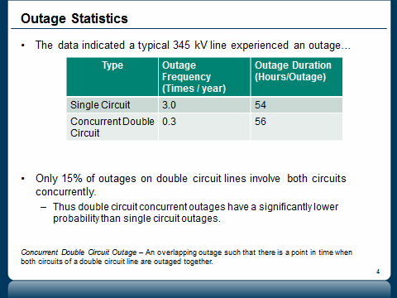

ERCOT’s Slide #8 shows the proposed shift in criteria for protecting generators:

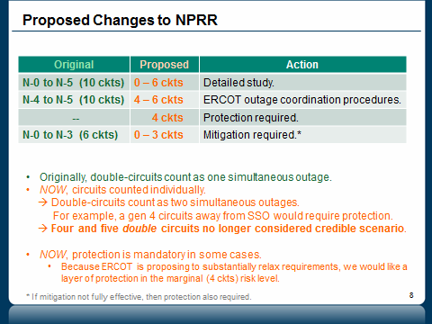

This change in criteria is in obvious contradiction of the Planning Criteria found in ERCOT’s Planning Guide at 4.1.1.1:

4.1.1 Reliability Criteria
4.1.1.1 Planning Assumptions
(1) A contingency loss of an element includes the loss of an element with or without a single line-to-ground or three-phase fault.
(2) A common tower outage is the contingency loss of a double-circuit transmission line consisting of two circuits sharing a tower for 0.5 miles or greater.

This passage makes it clear that in planning we should consider the loss of a double-circuit transmission line as one element and not two. ERCOT’s new criteria would treat this loss as two lines.

Changing the criteria as ERCOT proposes will effectively and significantly reduce the number of units that will require some form of mitigation or protection. While this may make the threat of SSO appear to go away, it raises serious questions for any units that may move out of the “protected” group to a now much larger unprotected group. This change in criteria seems to make managing the SSO threat more manageable for ERCOT as they would have fewer units to protect with Outage Coordination and Protection methods, but this change may also lead to a false sense of security for resources previously identified as subject to one of the three steps of protection. As the Reliability Coordinator for the region we look to ERCOT to manage the network to ensure the safety of our personnel and equipment and simply changing the criteria for protection based on a limited data set is a concern at this point.
We believe that changing the criteria for which units are protected with Outage Coordination, Mitigation and Protection steps is not particularly helpful at this time and only clouds the picture of SSO and how we should mitigate it system-wide. Many issues are left unresolved, including Cost Allocation, what to do in the case of generators who cannot be retrofitted with torsional relaying and a more equitable approach for owners who have already specified and paid monies on turbines that ERCOT can now deem ineligible for interconnection under the proposed language. Calpine continues to assert that ERCOT has an obligation to protect all generators against the potential of SSO and that until all the relevant aspects of SSO are satisfactorily addressed the series capacitors that are the proximate cause of SSO should remain bypassed.

Revised Cover Page Language

None proposed at this time.

Revised Proposed Protocol Language
None proposed at this time.

