 |  |  |  | System Planning
Monthly Status Report
April 2014

 |  | Report Highlights
 | - ERCOT is currently tracking 234 active generation interconnection requests totaling over 60,400 MW. This includes over 26,900 MW of wind generation.
- ERCOT is currently reviewing proposed transmission improvements with a total cost of $226 Million.
- Transmission Projects endorsed in 2014 total $620 Million.
- All projects (in engineering, routing, licensing and construction) total approximately $4.4 Billion.
- Transmission Projects energized in 2014 total about $123.3 Million.

Table of Contents

1. Generation Interconnection 1
1.1 Signed Generation Interconnection Agreements 1
1.2 New Generation Approved for Synchronization 1
1.3 New Generation Approved for Commercial Operations 1
1.4 Summary of Generation Interconnection Requests 1
1.5 Projects with Interconnection Agreements 5
1.6 Projects Undergoing Full Interconnection Studies with Confidentiality Waived 6
1.7 Generation Projects Undergoing Full Interconnection Studies 7
1.8 Wind Generation Capacity Installed by Year 11
2. Regional Planning Group Project Reviews 11
3. Asynchronous Tie Interconnection 12
4. Planning Model Activities 13
5. Other Notable Activities 13

1. Generation Interconnection
Additional information regarding detailed generation interconnection and impact studies is contained in the “Generation Project Interconnection Information” folder in the “Operations and System Planning” area on the ERCOT website: http://planning.ercot.com/login/login.

Signed Generation Interconnection Agreements

14INR0066 – Lamar Power Projects Upgrade – 130 MW in Lamar County

New Generation Approved for Synchronization

None reported for April 2014.

New Generation Approved for Commercial Operations

None reported for April 2014.

The total installed wind capacity is now reported as 11,059 MW by the resource owners through the registration process. Capacity by North, South and West is 605 MW, 2,024 MW, and 8,431 MW respectively. Eight-hundred fifty MW is able to switch between the West and South zones and is currently shown in the West Zone.

Summary of Generation Interconnection Requests

Summary of Generation Interconnection Requests
Currently tracking 234 generation interconnection or change requests
April 2014 | Total
Security Screening Study (SSS) Underway | 12
SSS Completed | 40
Full Interconnect Study (FIS) Underway | 110
FIS Completed | 8
Interconnection Agreement Executed, FIS Pending | 22
Interconnection Agreement Executed | 42
Total Interconnection Requests | 234
Cancelled Studies (since last month) | 3
Total Capacity Under Study, MW | 60,407
Total Wind Capacity, MW | 26,984
Interconnection Agreement Executed, MW | 18,720
Cancelled Capacity, MW (since last month) | 454

Fuel Type | Screening Study (MW)* | Screening Study w/ Public Letter (MW)** | Full Study (MW)* | Full Study w/ Public Letter (MW)** | IA Executed (MW)** | IA Executed FIS Pending (MW)** | Grand Total (MW)
Gas-AllOther |  |  | 0 | 0 | 1,140 | 753
Gas-CCGT |  |  | 12,679 | 0 | 4,337 | 3,421
Total Gas | 6,772 | 0 | 12,679 | 0 | 5,477 | 4,174 | 29,102
Nuclear | 0 | 0 | 0 | 0 | 0 | 0 | 0
Coal | 0 | 0 | 30 | 0 | 0 | 240 | 270
Wind | 5,809 | 0 | 12,544 | 0 | 4,896 | 3,734 | 26,983
Solar | 1,333 | 0 | 1,926 | 0 | 198 | 0 | 3,457
Biomass | 0 | 0 | 0 | 0 | 0 | 0 | 0
Storage | 0 | 0 | 594 | 0 | 0 | 0 | 594
Petroleum Coke | 0 | 0 | 0 | 0 | 0 | 0 | 0
Total | 13,914 | 0 | 27,773 | 0 | 10,571 | 8,148 | 60,406
* Confidential Project Interconnection Requests
** Public Project Interconnection Requests; i.e., waiver of confidential information received by ERCOT (“Public Letter”), or Interconnection Agreement executed

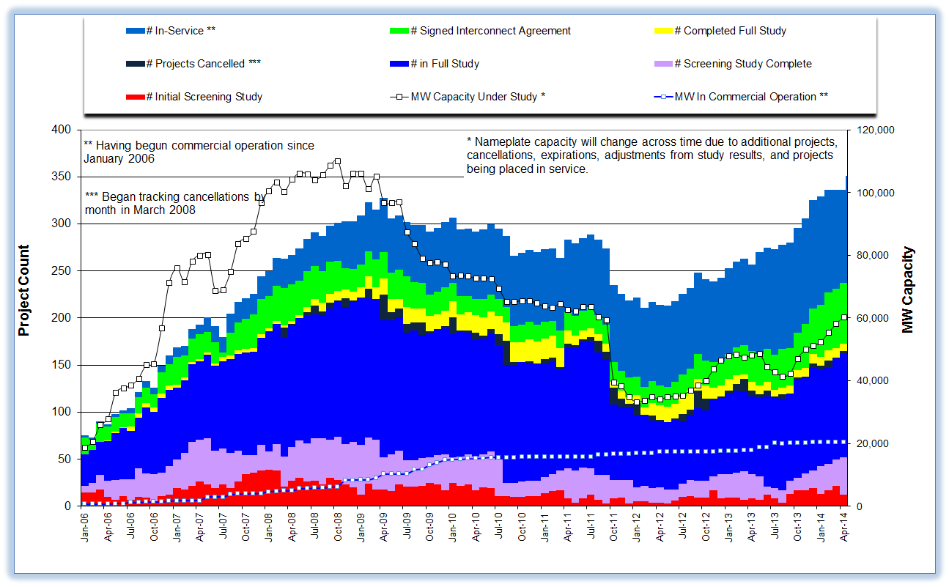

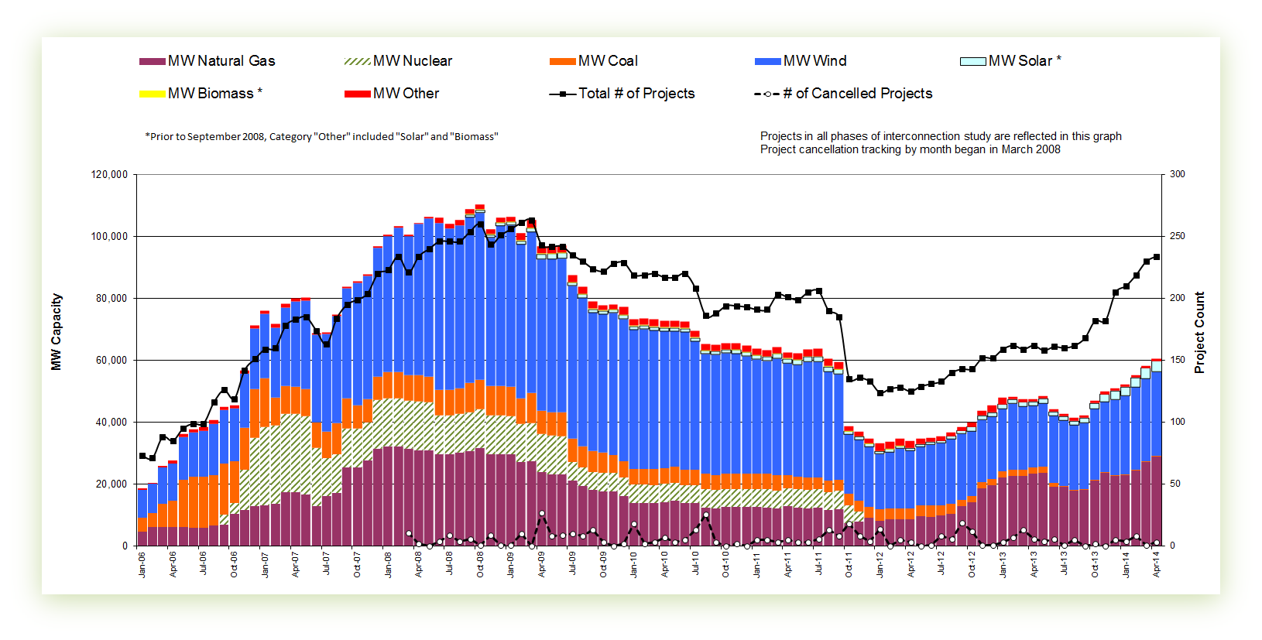

Interconnection Requests by Zone (MW)
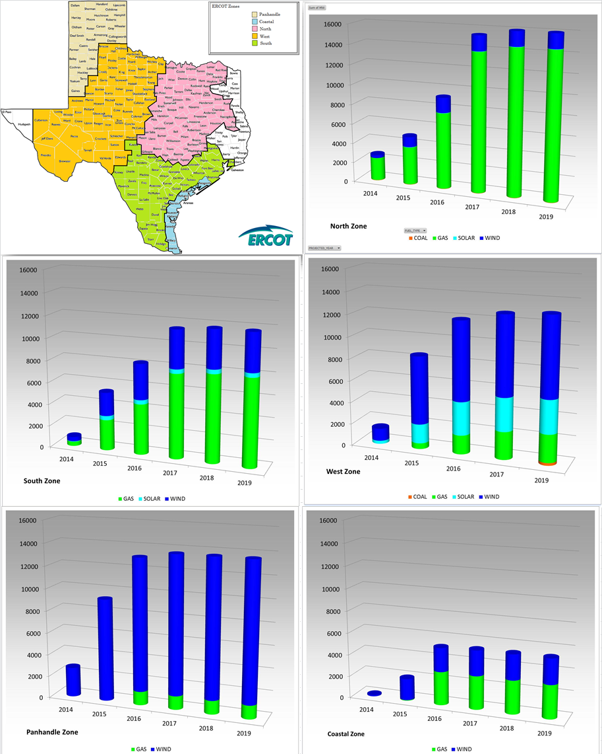

Projects with Interconnection Agreements
Generation Interconnection Agreements as of April 2014

GINR Number | Project Name | County | Projected COD | Fuel | MW For Grid | Changes From Last Report | Sufficient Financial Security
11INR0013 | Goldthwaite Wind Energy | Mills | 5/2014 | WIND | 149 | Projected COD | Yes
13INR0048 | Spinning Spur Wind Two | Oldham | 6/2014 | WIND | 161 |  | Yes
13INR0021 | Ferguson Replacement Project | Llano | 7/2014 | GAS | 570 |  | Yes
14INR0012a | Miami Wind 1 Project | Gray | 7/2014 | WIND | 289 |  | Yes
14INR0015 | Deer Park Energy Center | Harris | 7/2014 | GAS | 190 |  | Yes
14INR0030a_2 | Panhandle Wind 1 | Carson | 7/2014 | WIND | 218 | Project Name | Yes
10INR0020a | Panda Temple 1 | Bell | 8/2014 | GAS | 717 | Project Name | Yes
10INR0021 | Panda Sherman Power | Grayson | 8/2014 | GAS | 720 |  | Yes
13INR0040 | Rentech Project | Harris | 8/2014 | GAS | 15 |  | Yes
14INR0024 | OCI Alamo 4 | Kinney | 8/2014 | SOLAR | 38 |  | Yes
14INR0059 | Forney Upgrade | Kaufman | 8/2014 | GAS | 34 | Project Name | No
11INR0094 | White Camp Solar | Kent | 10/2014 | SOLAR | 100 |  | No
12INR0034a | Stephens Ranch Wind Energy Phase 1 | Borden | 10/2014 | WIND | 201 |  | Yes
13INR0010a | Mariah Wind | Parmer | 10/2014 | WIND | 232 |  | No
12INR0059 | Barilla Solar | Pecos | 11/2014 | SOLAR | 30 |  | Yes
14INR0030b | Panhandle Wind 2 | Carson | 11/2014 | WIND | 182 | Project Name | Yes
14INR0066 | Lamar Power Projects Upgrade | Lamar | 11/2014 | GAS | 130 | NEW | No
13INR0005 | Grandview 1to3 (Conway Windfarm) | Carson | 12/2014 | WIND | 600 | Project Name | Yes
13INR0052 | Los Vientos III | Starr | 12/2014 | WIND | 200 |  | Yes
13INR0057 | Windthorst 2 | Archer | 12/2014 | WIND | 65 | SFS | Yes
13INR0059a | Hereford Wind | Castro | 12/2014 | WIND | 200 | Projected COD | Yes
14INR0023 | Longhorn Energy Center | Briscoe | 12/2014 | WIND | 361 |  | Yes
14INR0032a | Route66 Wind | Randall | 12/2014 | WIND | 150 |  | Yes
14INR0049_2 | Keechi Wind 138 kV Joplin | Jack | 12/2014 | WIND | 102 |  | Yes
09INR0051 | Mesquite Creek | Borden | 1/2015 | WIND | 249 |  | Yes
12INR0068 | Sendero Wind Energy Project | Jim Hogg | 2/2015 | WIND | 78 |  | Yes
12INR0070 | Green Pastures | Knox | 2/2015 | WIND | 300 |  | Yes
12INR0034b | Stephens Ranch Wind Energy Phase b | Borden | 4/2015 | WIND | 177 | SFS | Yes
13INR0059b | Jumbo Road Wind | Castro | 4/2015 | WIND | 300 | SFS | Yes
14INR0038 | PHR Peakers | Galveston | 4/2015 | GAS | 390 |  | No
14INR0047 | Wake Wind | Floyd | 4/2015 | WIND | 299 | Project Name | Yes
13INR0020a | CPV Rattlesnake Den Ph 1 | Glasscock | 5/2015 | WIND | 211 | MW For Grid | Yes
13INR0050 | Logans Gap Wind I | Comanche | 5/2015 | WIND | 200 |  | No
11INR0050 | Moore Wind 1 | Crosby | 6/2015 | WIND | 149 | Projected COD | No
11INR0057 | Cameron County Wind | Cameron | 6/2015 | WIND | 165 |  | Yes
11INR0079a | South Clay Windfarm | Clay | 6/2015 | WIND | 200 | Projected COD | No
14INR0039 | Goldsmith Peaking Facility | Ector | 6/2015 | GAS | 408 |  | No
14INR0053 | Spinning Spur Wind Three | Oldham | 6/2015 | WIND | 194 | Projected COD | Yes
14INR0025a | South Plains Wind I | Floyd | 7/2015 | WIND | 200 |  | No
08INR0018 | Gunsight Mountain | Howard | 8/2015 | WIND | 120 |  | No
10INR0020b | Panda Temple Power II | Bell | 8/2015 | GAS | 717 |  | Yes
11INR0062 | Patriot (Petronilla) Wind | Nueces | 8/2015 | WIND | 178 |  | Yes
14INR0012b | Miami Wind 1 Project | Gray | 8/2015 | WIND | 111 |  | No
13INR0049 | Friendswood Energy | Harris | 9/2015 | GAS | 316 | Project Name | No
11INR0054 | Midway Farms Wind | San Patricio | 10/2015 | WIND | 161 |  | Yes
06INR0022c | Baffin (Penascal Wind Farm 3) | Kenedy | 12/2015 | WIND | 202 |  | Yes
13INR0010b | Mariah Wind | Parmer | 12/2015 | WIND | 200 |  | No
13INR0031 | Mustang Solar Project | Travis | 12/2015 | SOLAR | 30 |  | No
14INR0025b | South Plains II | Floyd | 12/2015 | WIND | 300 |  | No
14INR0072 | Briscoe Wind Farm | Briscoe | 12/2015 | WIND | 201 | MW For Grid | Yes
13INR0020b | CPV Rattlesnake Den Ph 2 | Glasscock | 5/2016 | WIND | 158 | MW For Grid | No
13INR0028 | Antelope Station | Hale | 6/2016 | GAS | 359 |  | Yes
15INR0032 | Antelope Station CT1 | Hale | 7/2016 | GAS | 197 |  | No
15INR0033 | Antelope Station CT2 | Hale | 7/2016 | GAS | 197 |  | No
16INR0010 | FGE Texas 1 | Mitchell | 7/2016 | GAS | 799 | Projected COD | No
06INR0006 | Cobisa-Greenville | Hunt | 12/2016 | GAS | 1792 |  | No
12INR0029 | Comanche Run Wind | Swisher | 12/2016 | WIND | 500 |  | No
13INR0010c | Mariah Wind | Parmer | 12/2016 | WIND | 168 |  | No
12INR0018 | Pampa Wind | Gray | 3/2017 | WIND | 500 | Project Name | No
16INR0003 | Freeport LNG PreTreatment Facility | Brazoria | 6/2017 | GAS | 11 |  | No
10INR0022 | Pondera King Power Project | Harris | 7/2017 | GAS | 1629 | Projected COD | No
13INR0023 | Texas Clean Energy Project | Ector | 3/2019 | COAL | 240 | Projected COD | No

Projects Undergoing Full Interconnection Studies with Confidentiality Waived
INR | Site Name | County | COD | Fuel | MW for Grid | Change from Last Report

Generation Projects Undergoing Full Interconnection Studies
Full Interconnection Study Table
GINR Number | County | Fuel | Capacity to Grid (MW) | Projected COD (specified by developer) | Public Letter
14INR0076 | Galveston | Gas | 5 | 6/2014
13INR0048 | Oldham | Wind | 161 | 6/2014
14INR0077 | Smith | Gas | 10 | 8/2014
14INR0069 | Milam | Coal | 30 | 8/2014
14INR0013 | Cameron | Wind | 103 | 10/2014
13INR0010a | Parmer | Wind | 232 | 10/2014
13INR0036 | Hidalgo | Wind | 200 | 10/2014
14INR0043 | Sterling | Solar | 40 | 12/2014
14INR0009 | Kent | Wind | 248 | 12/2014
10INR0085 | Ector | Solar | 57 | 12/2014
14INR0032a | Randall | Wind | 150 | 12/2014
14INR0023 | Briscoe | Wind | 361 | 12/2014
15INR0074 | Deaf Smith | Wind | 156 | 12/2014
14INR0057b | Erath | Wind | 48 | 12/2014
14INR0057a | Erath | Wind | 48 | 12/2014
14INR0056 | Mills | Wind | 101 | 12/2014
14INR0048_1 | Wilbarger | Wind | 114 | 12/2014
13INR0010d | Parmer | Wind | 200 | 12/2014
14INR0049_2 | Jack | Wind | 102 | 12/2014
13INR0059a | Castro | Wind | 200 | 12/2014
12INR0070 | Knox | Wind | 300 | 2/2015
15INR0070_2 | Pecos | Solar | 110 | 3/2015
15INR0070_1 | Pecos | Solar | 110 | 3/2015
15INR0036 | Uvalde | Solar | 105 | 3/2015
14INR0020 | Floyd | Wind | 150 | 3/2015
10INR0009 | Castro | Wind | 300 | 3/2015
13INR0059b | Castro | Wind | 300 | 4/2015
15INR0055 | Austin | Gas | 142 | 5/2015
15INR0054 | Reeves | Gas | 123 | 5/2015
13INR0056 | Scurry | Wind | 366 | 5/2015
15INR0021 | Starr | Wind | 200 | 5/2015
15INR0069 | Pecos | Solar | 110 | 6/2015
15INR0028 | Freestone | Gas | 160 | 6/2015
14INR0074 | Williamson | Gas | 92 | 6/2015
14INR0050 | Uvalde | Solar | 40 | 6/2015
14INR0041a | Willacy | Wind | 115 | 6/2015
13INR0026 | Oldham | Wind | 201 | 6/2015
14INR0053 | Oldham | Wind | 194 | 6/2015
11INR0057 | Cameron | Wind | 165 | 6/2015
14INR0040 | Hidalgo | Gas | 225 | 6/2015
15INR0023 | Wharton | Gas | 700 | 6/2015
12INR0055 | Baylor | Wind | 40 | 7/2015
13INR0054 | Bee | Gas | 25 | 7/2015
14INR0025a | Floyd | Wind | 200 | 7/2015
11INR0082a | Val Verde | Wind | 50 | 8/2015
14INR0026 | Presidio | Solar | 30 | 9/2015
13INR0025 | Randall | Wind | 150 | 9/2015
15INR0050 | Deaf Smith | Wind | 203 | 9/2015
14INR0062 | Gray | Wind | 200 | 9/2015
15INR0068 | Sterling | Solar | 20 | 10/2015
13INR0055 | Zapata | Wind | 250 | 10/2015
14INR0048_2 | Wilbarger | Wind | 250 | 10/2015
14INR0030c | Carson | Wind | 248 | 11/2015
11INR0082b | Val Verde | Wind | 150 | 11/2015
15INR0042 | Hood | Gas | 460 | 12/2015
15INR0035 | Kenedy | Wind | 200 | 12/2015
15INR0034 | San Patricio | Wind | 201 | 12/2015
14INR0044 | Reeves | Solar | 100 | 12/2015
14INR0041b | Willacy | Wind | 115 | 12/2015
14INR0014 | Val Verde | Solar | 100 | 12/2015
08INR0019a | Gray | Wind | 250 | 12/2015
12INR0060 | Schleicher | Wind | 58 | 12/2015
11INR0065 | Nueces | Wind | 350 | 12/2015
14INR0025b | Floyd | Wind | 300 | 12/2015
15INR0051 | Castro | Wind | 200 | 12/2015
12INR0045 | Kleberg | Wind | 135 | 12/2015
14INR0060 | Haskell | Wind | 400 | 12/2015
15INR0073 | Armstrong | Wind | 201 | 12/2015
15INR0059 | Pecos | Solar | 102 | 12/2015
15INR0049 | Zapata | Wind | 250 | 12/2015
15INR0044 | Webb | Solar | 200 | 12/2015
15INR0037 | Starr | Wind | 200 | 12/2015
14INR0045b | Webb | Wind | 251 | 12/2015
14INR0045a | Webb | Wind | 502 | 12/2015
14INR0033 | Armstrong | Wind | 500 | 12/2015
13INR0045 | Castro | Wind | 288 | 12/2015
13INR0038 | Swisher | Wind | 300 | 12/2015
13INR0032 | Andrews | Solar | 30 | 12/2015
13INR0010e | Parmer | Wind | 200 | 12/2015
12INR0002a | Briscoe | Wind | 200 | 12/2015
11INR0093 | San Patricio | Wind | 41 | 12/2015
14INR0018 | Nolan | Solar | 20 | 12/2015
14INR0072 | Briscoe | Wind | 201 | 12/2015
13INR0010b | Parmer | Wind | 200 | 12/2015
15INR0053 | Winkler | Gas | 123 | 3/2016
16INR0036 | Nolan | Gas | 280 | 4/2016
14INR0028 | Live Oak | Wind | 300 | 4/2016
16INR0009 | Calhoun | Gas | 510 | 4/2016
16INR0023 | Dawson | Solar | 100 | 5/2016
17INR0004 | Hale | Gas | 202 | 6/2016
16INR0038 | McLennan | Gas | 471 | 6/2016
16INR0007 | Hidalgo | Gas | 95 | 6/2016
16INR0006 | Angelina | Gas | 785 | 6/2016
16INR0005 | Cameron | Gas | 871 | 6/2016
15INR0057 | Wharton | Gas | 142 | 6/2016
15INR0027 | Hidalgo | Gas | 79 | 6/2016
14INR0027 | Guadalupe | Gas | 471 | 6/2016
13INR0028 | Hale | Gas | 359 | 6/2016
16INR0048 | Pecos | Solar | 150 | 6/2016
16INR0041 | Pecos | Solar | 100 | 6/2016
16INR0040 | Reeves | Solar | 50 | 6/2016
16INR0039 | Reeves | Solar | 100 | 6/2016
16INR0013 | Nacogdoches | Gas | 215 | 7/2016
14INR0011 | Swisher | Storage | 270 | 7/2016
08INR0019b | Gray | Wind | 250 | 7/2016
15INR0033 | Hale | Gas | 197 | 7/2016
15INR0032 | Hale | Gas | 197 | 7/2016
16INR0037 | Floyd | Wind | 400 | 10/2016
16INR0024 | Hidalgo | Wind | 200 | 10/2016
15INR0046 | Reeves | Solar | 42 | 10/2016
16INR0004 | Cameron | Gas | 730 | 11/2016
16INR0019 | Coke | Solar | 100 | 12/2016
16INR0018 | Upton | Solar | 40 | 12/2016
16INR0017 | Culberson | Solar | 70 | 12/2016
13INR0006 | Gray | Wind | 750 | 12/2016
08INR0019c | Gray | Wind | 250 | 12/2016
06INR0006 | Hunt | Gas | 1792 | 12/2016 | 5/2005
16INR0031 | Starr | Wind | 100 | 12/2016
16INR0030 | Young | Wind | 211 | 12/2016
16INR0029 | Hill | Wind | 100 | 12/2016
16INR0028 | Jack | Wind | 100 | 12/2016
16INR0027 | Grayson | Wind | 100 | 12/2016
16INR0026 | Erath | Wind | 100 | 12/2016
16INR0011a | Cameron | Wind | 18 | 12/2016
13INR0010f | Parmer | Wind | 200 | 12/2016
12INR0002b | Briscoe | Wind | 200 | 12/2016
13INR0010c | Parmer | Wind | 168 | 12/2016
16INR0008 | Grimes | Gas | 687 | 1/2017
12INR0018 | Gray | Wind | 500 | 3/2017
15INR0013 | Anderson | Storage | 324 | 5/2017
17INR0010 | Mitchell | Gas | 799 | 6/2017
17INR0002 | Henderson | Gas | 489 | 6/2017
17INR0003 | Jackson | Gas | 965 | 6/2017
17INR0005 | Starr | Wind | 200 | 6/2017
10INR0022 | Harris | Gas | 1629 | 7/2017
17INR0009 | Hood | Gas | 1042 | 7/2017
17INR0007 | Wharton | Gas | 1141 | 7/2017
16INR0011b | Cameron | Wind | 132 | 12/2017
11INR0040 | Freestone | Gas | 640 | 3/2018
13INR0023 | Ector | Coal | 240 | 3/2019

Wind Generation Capacity Installed by Year

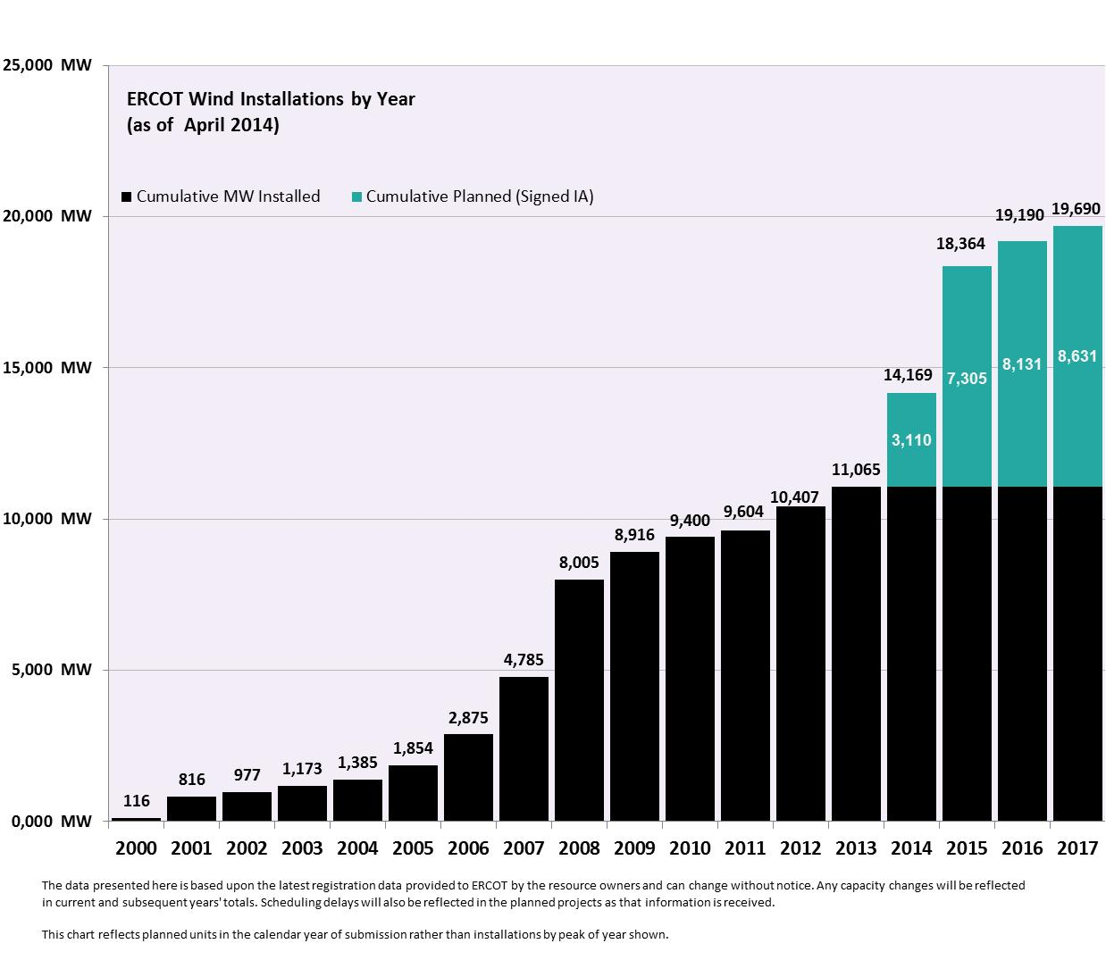

Regional Planning Group Project Reviews
- ERCOT has completed the independent review of the Houston Import Capacity project. This is a Tier 1 project that is estimated to cost $590 million. This project was endorsed by the Board of Directors on April 8, 2014.

- Oncor has submitted the West Texas Area project. This is a Tier 2 project that is estimated to cost $45 million. This project is currently under ERCOT independent review.

- CenterPoint has submitted the Katy Area project. This is a Tier 2 project that is estimated to cost $20.4 million. This project is currently under ERCOT independent review.

- LCRA TSC has submitted the Leander – Round Rock 138 kV project. This is a Tier 1 project that is estimated to cost $50.9 million. This project is currently under ERCOT independent review.

- Sharyland has submitted the Brady Area project. This is a Tier 2 project that is estimated to cost $18 million. This project has received several RPG comments and it is under study mode.

- Sharyland has submitted the West Texas projects for Stanton Area. This is a Tier 3 project that is estimated to cost $40.4 million. This project has received several RPG comments and it is under study mode.

- AEPSC has submitted the Brady Area Improvements project. This is a Tier 2 project that is estimated to cost $26.5 million. This project has received several RPG comments and it is under study mode.

- TNMP has submitted the Wink-Pecos Line 69E Rebuild project. This is a Tier 3 project that is estimated to cost $15 million. This project has completed the RPG review and EROT will send the RPG acceptance letter.

- CenterPoint has submitted the Dow-Velasco 345/138 kV autotransformer project. This is a Tier 3 project that is estimated to cost $15 million. This project has completed the RPG review and EROT will send the RPG acceptance letter.

- Denton Municipal Electric (DME), Oncor, TMPA, Brazos Electric Cooperative (BEC) and GP&L have jointly submitted the Denton Area West 345/138 kV source project. This is a Tier 2 project that is estimated to cost $44.8 million. This project is currently under ERCOT independent review.

- DUKE-American Transmission Company has submitted the Phoenix project. This is a Tier 2 project that is estimated to cost $39 million. This project has been submitted for RPG comments.

Asynchronous Tie Interconnection
Project | Notification to ERCOT | Reliability Study | RPG Review | Interconnection Agreement | In-service Year
Railroad DC tie expansion (150 MW - CFE) |  |  |  |  | 2014
Southern Cross HVDC (3000 MW - SERC)
Tres Amigas (1500 MW - SPP)

Color Legend
In progress
Complete

Planning Model Activities
- The short term calendar of major planning model events follows:
  - Apr 1, 2014 Started 15DSA case build process
  - Jun 20, 2014 Projected completion of 15DSA and MODTPIT
  - Jul 11, 2014 Projected posting of Contingency Definitions

Other Notable Activities

- The System Protection Working Group 2014 Future Year (FY) base case creation is in progress with a projected completion date of July 3, 2014.
- ERCOT has entered into an agreement with Powertech Labs to perform a small signal stability study.
- ERCOT has begun the 2014 Regional Transmission Plan (RTP). The initial cases and list of overloads were posted for stakeholder review on April 29th 2014.
- ERCOT has begun the preparation for the 2014 Long Term System Assessment (LTSA). ERCOT is currently working on developing the generation expansion plan for the current trends scenario using UPLAN.

