ERCOT Synchronous Inertial Response Service
Working Document – Work Session (4-11-2014):

Need for SIR Service
Synchronous Inertial Response has significant implications on the rate of change of frequency (RoCoF) following a disturbance. With increasing non-synchronous generation SIR is reduced and RoCoF increases, leaving insufficient time for PFR to deploy and arrest system frequency, i.e. time between point A and C, Figure 1. High RoCoF can cause frequency to reach the nadir quickly and trigger under-frequency load shedding of firm loads. There is therefore a need to assure the provision of a sufficient amount of inertial response on the ERCOT system. SIR service is intended to meet this need.
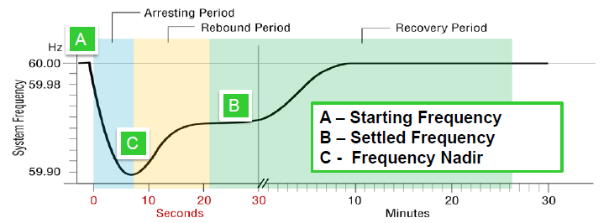

Figure 1 Typical frequency response following a generator trip.

Synchronous Inertial Response (SIR) is an instantaneous response that is continuously self-deployed from synchronous machines following disturbances and is a key determinant of the strength and stability of the power system.
Synchronous Inertial Response is defined as stored kinetic energy (at nominal frequency) that is extracted from the rotating mass of a synchronous machine to compensate an imbalance in a power system. Stored kinetic energy is based on the commissioned design capability of the plant. It can be determined through appropriate validation procedures based on the following relationship:
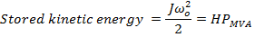

- Where; the stored kinetic energy is in MVA-seconds;
- J is the combined moment of inertia of a synchronous machine and turbine prime mover in kg·m², based on its size and weight;
- ω_{o} is the nominal rotor speed in rad/s, and
- P_{MVA} is the machines rated capacity in Mega Volt – Amperes.
- H is the figure of merit used to analyze the synchronous machine’s inertial response and is referred to as the machine’s inertia constant in seconds.
From the above expression H is defined as
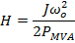

The inertial response that a synchronous machine can provide is independent of the machine’s power output and can be evaluated based on machine parameters (H and rated MVA provided in RARF) and machine status (online/offline).
Total inertial contribution from all synchronous machines, committed for energy and AS, must achieve the required system inertial response. PFR and FFR requirements are always based on certain system inertia level: the lower system inertia is the higher FFR and PRF requirements. Minimal inertial response requirement should be such that after two largest units trip (2750 MW) SIR, PFR and FFR can ensure f_{nadir} ≥ 59.4 Hz, that is 0.1 Hz above the prevailing initial threshold of Firm Load UFLS (59.3 Hz).
For example, if the target for the inertia requirement is to have the system frequency no less than 59.4 Hz after 0.5 seconds (RoCoF = 1.2 Hz/second) following two largest unit trip (2750 MW), the calculated minimum SIR requirement is estimated about 78 GW-second (at 24857 MW load and 2.44% per Hz load damping). It should be noted that such minimum SIR will require high amounts of FFR and PFR.
Based on current operations data the RoCoF during high wind low load condition was less than 0.2 Hz/second and the average time to reach frequency nadir during frequency events is within 4 to 6 seconds. Therefore, the system inertia available in the real time operations under current conditions is still sufficient.
Studies based on 2013-2014 system conditions (presented at FAST Workshop on 3/28/2014) indicated RoCoF as high as 0.45 Hz/s for two largest unit trip (2750 MW as per recently approved NERC BAL-003 standard).
Table below shows presented at FAST Workshop on 3/28/2014 and two recent penetration record cases showing system inertia.
Case | Date/Time | Load  (MW) | Wind Output  (MW) | PRC  (MW) | Wind Penetration | Net Load  (MW) | 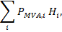  System Inertia  GW-seconds
1 | 08072013 17:00 | 67,148 | 2,398 | 4,105 | 3.57% | 64,750 | 372,123
2 | 02132014 19:00 | 36,460 | 1,188 | 5,062 | 3.26% | 35,272 | 236,382
3 | 01132014 03:00 | 24,857 | 7,196 | 5,812 | 28.95% | 17,661 | 174,428
4 | 03272014 3:19 | 25,677 | 9,868 | 5,826 | 38.43% | 15,809 | 148,037
5 | 03312014 02:12 | 24618 | 9,699 | 5,152 | 39.4% | 14,919 | 135,540

From these data it follows that there is no immediate need for SIR service but inertia keeps decreasing with increasing amounts of non-synchronous generation.

Key point and Discussion items:
- SIR is decreasing leading to higher ROCOF.
- Start tracking real time inertia, MVA*H
- Based on projections for future non-synchronous generation, develop methodology to forecast synchronous inertia trends for low load high wind situations with 2-3 years look-ahead
- ERCOT will continue to investigate the possible impact from high RoCoF on conventional generators:
- Draft a survey to understand the generator’s characteristics with regards to RoCoF in ERCOT. For example, experience from 02/26/2008 event in Florida shows that combustion turbines may disconnect due to high RoCoF.
Different references suggest RoCoF tolerance for generators between 0.5 Hz/s – 2Hz/s. RoCoF tolerance limits may put additional constraint on minimum system inertia requirement.
- If a synchronous machine is online/synchronously connected to the grid it provides all of its SIR. The amount of SIR provided is ONLY a function of its online status and is NOT a MW capacity reservation that can be co-optimized with energy and other AS.
- The SIR procurement is a commitment process. This introduces challenges on a market price MCPC for SIR. In addition commitment for SIR impacts all other prices LMP, other AS MCPCs.
- Explore possibility of existing Resources capable of providing SIR to de-clutch between turbine and synchronous generator so as to operate in synchronous condenser mode and provide SIR without LSL.
- The determination of requirements for SIR, FFR and PFR are interrelated. How much of one type is required depends on how much of the other is available. Develop methodology for SIR, PFR and FFR requirements.

On 02/26/2008 in Florida delayed clearing of 3-phase fault, 1.7s, resulted in frequency swing of +/-0.6 Hz. As one of the consequences six large frame combustion turbines tripped during the disturbance when the system frequency went high (maximum 60.64 Hz as measured in the southeast area of the State and 60.23 Hz as measured in the Northeast area of the State). Preliminary analysis indicated that the trips were due to “lean blowout” of one or more combustors. In cases involving NOx control, the combustors normally run very lean. High compressor speeds combined with governor-commanded reduced fuel flow during the high frequency transient resulted in these “blowouts”. It is important to note that the frequency rate of change (df/dt) experienced during the Event was critical in turbine-generator response. Currently, existing guidelines for generator coordination address magnitude and duration of frequency excursions, but they do not address rate of change. The remaining combustion turbine (1) tripped because the turbine control’s logic rate-of-change limiter for machine speed and output exceeded the set point in response to system frequency. [Ref: Florida Reliability Coordinating Council, FRCC System Disturbance and Under Frequency Load Shedding Event, Nov. 2008. https://www.frcc.com.]

