 |  |  |  | System Planning
Monthly Status Report
March 2014

 |  | Report Highlights
 | - ERCOT is currently tracking 230 active generation interconnection requests totaling over 58,100 MW. This includes over 26,700 MW of wind generation.
- ERCOT is currently reviewing proposed transmission improvements with a total cost of $962.5 Million.
- Transmission Projects endorsed in 2013 total $349.8 Million. No transmission projects endorsed in 2014 (Jan. through March, 2014).
- All projects (in engineering, routing, licensing and construction) total approximately $4.4 Billion.
- Transmission Projects energized in 2014 total about $123.3 Million.

Table of Contents

1. Generation Interconnection 1
1.1 Signed Generation Interconnection Agreements 1
1.2 New Generation Approved for Synchronization 1
1.3 New Generation Approved for Commercial Operations 1
1.4 Summary of Generation Interconnection Requests 1
1.5 Projects with Interconnection Agreements 5
1.6 Projects Undergoing Full Interconnection Studies with Confidentiality Waived 6
1.7 Generation Projects Undergoing Full Interconnection Studies 6
1.8 Wind Generation Capacity Installed by Year 10
2. Regional Planning Group Project Reviews 10
3. Asynchronous Tie Interconnection 11
4. Planning Model Activities 12
5. Other Notable Activities 12

1. Generation Interconnection
Additional information regarding detailed generation interconnection and impact studies is contained in the “Generation Project Interconnection Information” folder in the “Operations and System Planning” area on the ERCOT website: http://planning.ercot.com/login/login.

Signed Generation Interconnection Agreements

14INR0047 – Wake Wind Energy – 299 MW in Floyd and Crosby Counties

New Generation Approved for Synchronization

13INR0021 – Ferguson Replacement CT1 – 186 MW in Llano County

13INR0021 – Ferguson Replacement CT2 – 186 MW in Llano County

New Generation Approved for Commercial Operations

No projects have been approved for commercial operations during March 2014.

The total installed wind capacity is now reported as 11,065 MW by the resource owners through the registration process. Capacity by North, South and West is 833 MW, 2,775 MW, and 7,456 MW respectively. Eight-hundred fifty MW is able to switch between the West and South zones and is currently shown in the South zone.

Summary of Generation Interconnection Requests
GENERATION INTERCONNECTION REQUESTS CURRENTLY UNDER REVIEW
Currently tracking 230 generation interconnection or change requests
As of March 31, 2014 | Total
Security Screening Study | 22
SSS Completed | 28
Full Interconnect Study | 107
FIS Completed | 10
Suspended Studies | 0
Capacity of Suspended Study Projects | 0
Cancelled Projects | 1
Interconnect Agreement Completed | 63
Capacity under Interconnection Agreements | 18,671
Capacity for Grid, MW | 58,148
Wind Capacity, MW | 26,726
Capacity of Cancelled Projects | 280

Fuel Type | Confidential Projects (MW) | Projects Under Full Study (MW) | Public Projects (MW) | Suspended Studies (MW) | Grand Total (MW)
Gas-AllOther |  |  | 1,893 | - | 8,395
Gas-CombinedCycle |  |  | 7,628 | - | 18,826
Total Gas | 5,690 | 12,010 | 9,521 | - | 27,221
Nuclear | - | - | - | - | -
Coal | - | 30 | 240 | - | 270
Wind | 5,538 | 12,476 | 8,712 | - | 26,726
Solar | 1,375 | 1,764 | 198 | - | 3,337
Biomass | - | - | - | - | -
Storage | - | 594 | - | - | 594
Petroleum Coke | - | - | - | - | -
Grand Total | 12,603 | 26,874 | 18,671 | - | 58,148

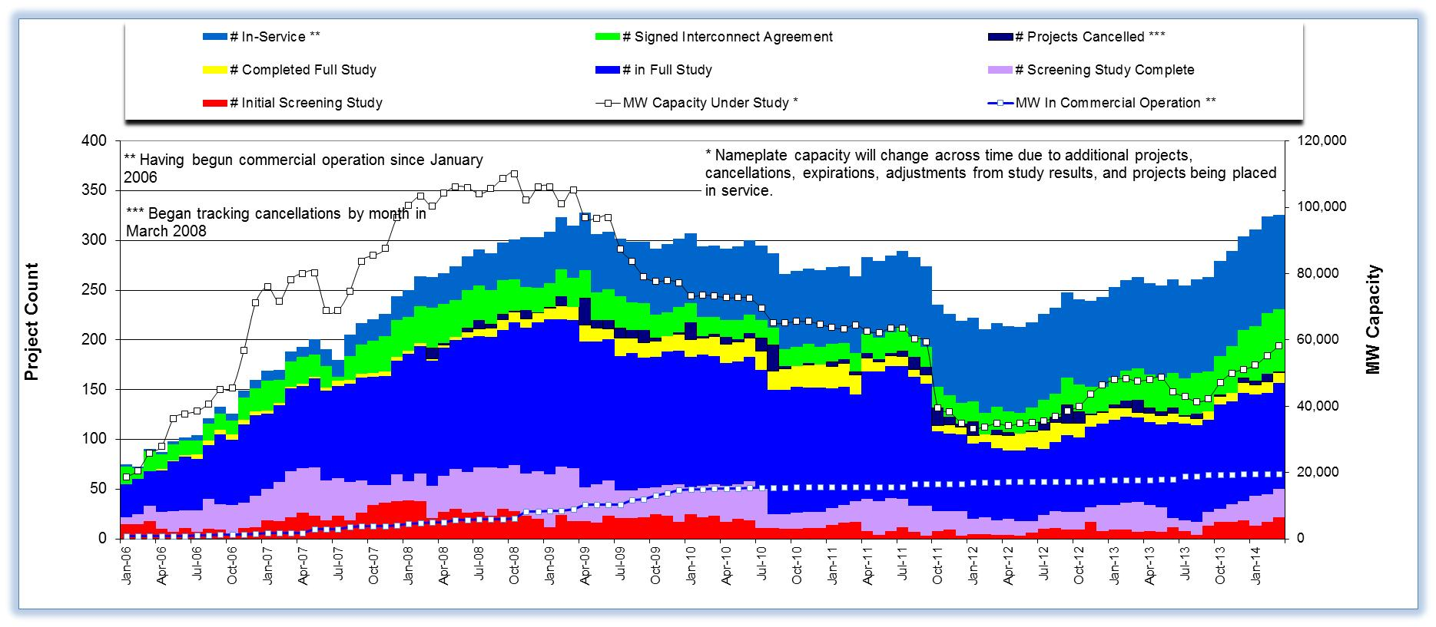

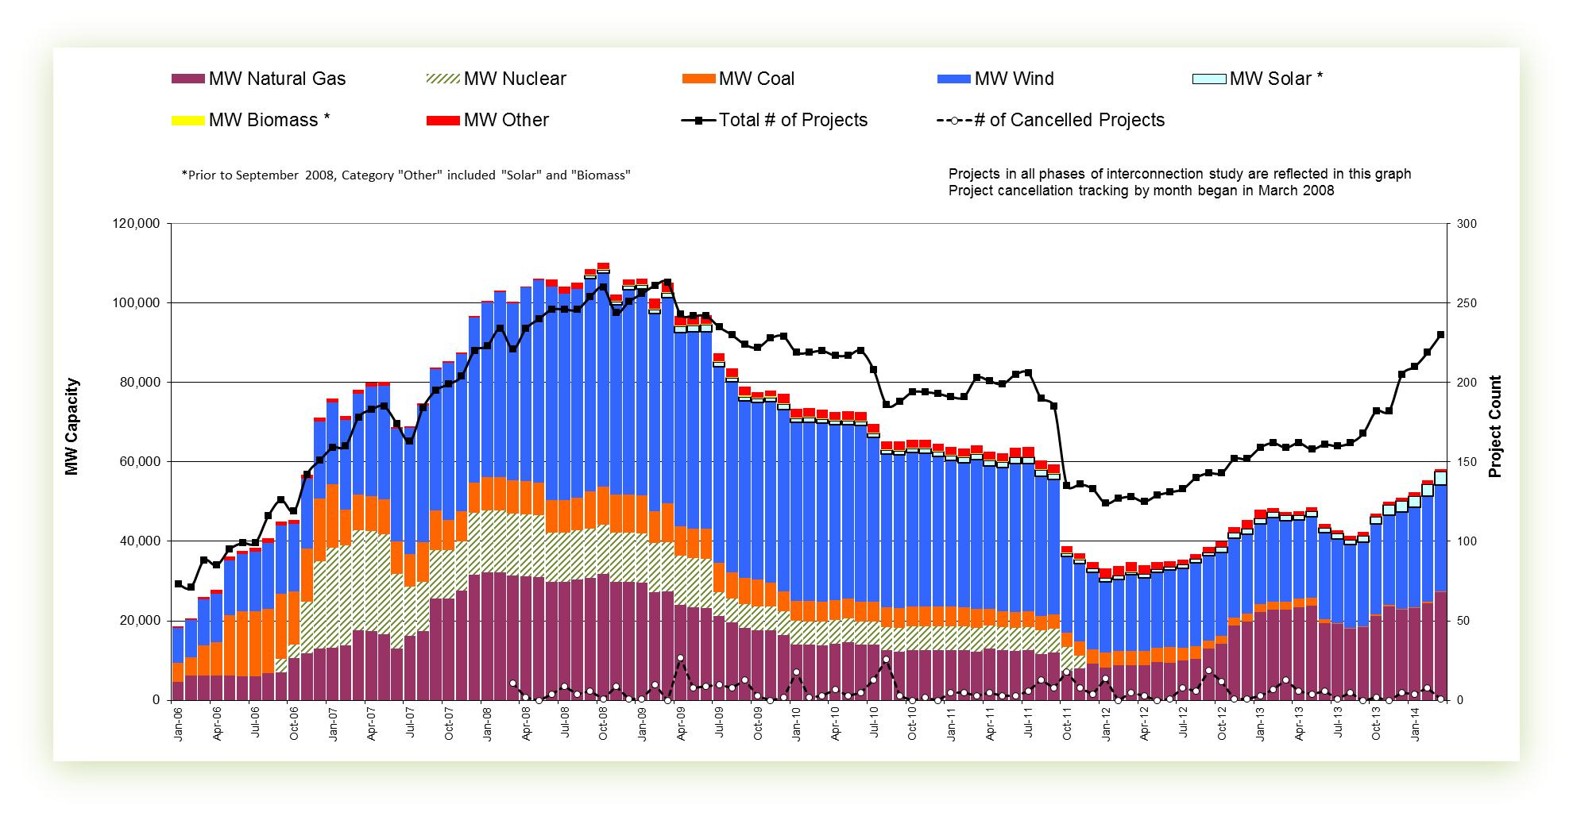

Cumulative Installed MW Capacity of Interconnection Requests by Zone

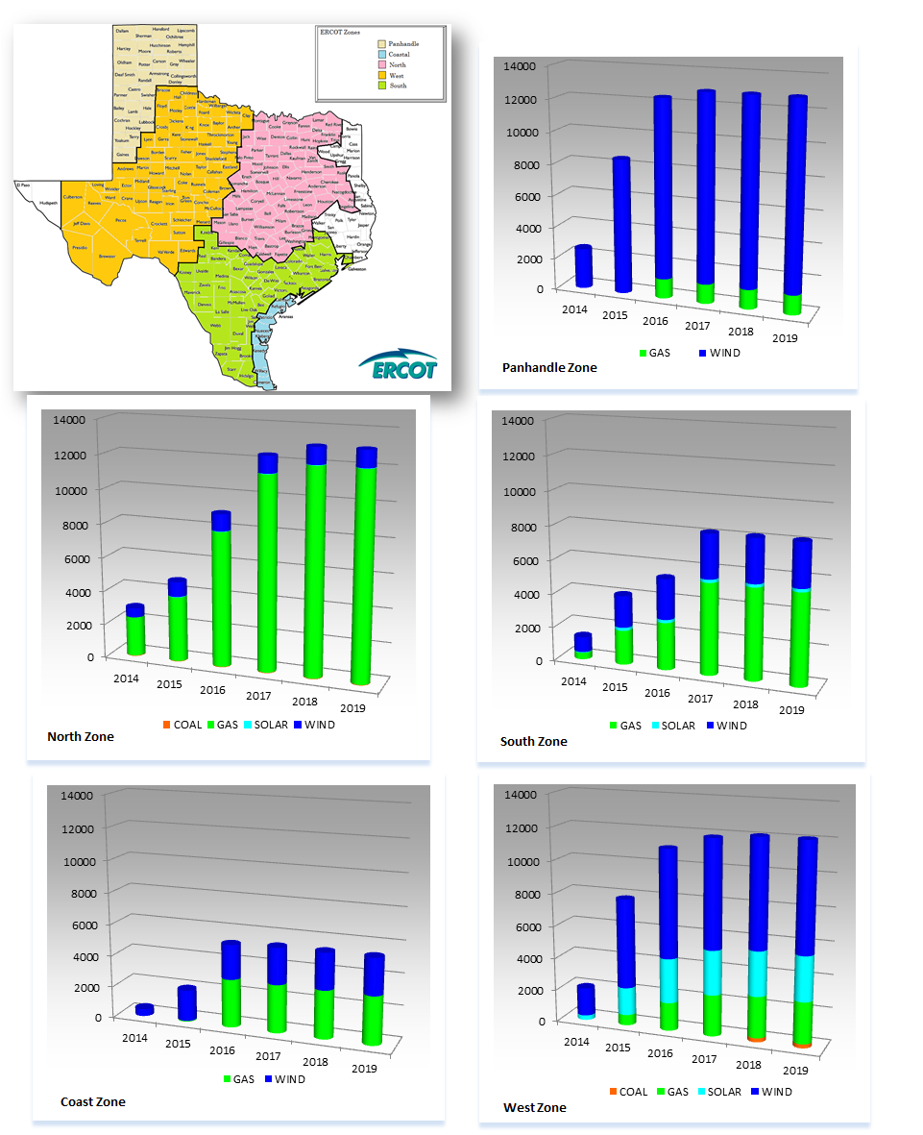

Projects with Interconnection Agreements

Generation Interconnection Agreements as of March 31, 2014

INR | Site Name | County | COD | Fuel | MW For Grid | Change from Last Report | Sufficient Financial Security Received by TSP
11INR0013 | Goldthwaite Wind Energy | Mills | 4/2014 | WIND | 149 |  | Yes
13INR0048 | Spinning Spur Wind Two | Oldham | 6/2014 | WIND | 161 |  | Yes
13INR0021 | Ferguson Replacement Project | Llano | 7/2014 | GAS | 570 |  | Yes
14INR0012a | Miami Wind 1 Project | Gray | 7/2014 | WIND | 289 |  | Yes
14INR0015 | Deer Park Energy Center | Harris | 7/2014 | GAS | 190 |  | Yes
14INR0030a_2 | Panhandle Wind | Carson | 7/2014 | WIND | 218 |  | Yes
10INR0020a | Panda Temple Power | Bell | 8/2014 | GAS | 717 |  | Yes
10INR0021 | Panda Sherman Power | Grayson | 8/2014 | GAS | 720 |  | Yes
11INR0050 | Moore Wind 1 | Crosby | 8/2014 | WIND | 149 |  | No
13INR0040 | Rentech Project | Harris | 8/2014 | GAS | 15 |  | Yes
14INR0024 | OCI Alamo 4 | Kinney | 8/2014 | SOLAR | 38 |  | Yes
14INR0059 | Forney Power Plant Upgrade | Kaufman | 8/2014 | GAS | 34 |  | No
13INR0059a | Hereford Wind | Castro | 9/2014 | WIND | 200 |  | Yes
11INR0094 | White Camp Solar | Kent | 10/2014 | SOLAR | 100 | PRJ COD | No
12INR0034a | Stephens Ranch Wind Energy Phase 1 | Borden | 10/2014 | WIND | 201 |  | Yes
13INR0010a | Mariah Wind | Parmer | 10/2014 | WIND | 232 |  | No
12INR0059 | Barilla Solar | Pecos | 11/2014 | SOLAR | 30 |  | Yes
06INR0022c | Baffin (Penascal Wind Farm 3) | Kenedy | 12/2014 | WIND | 202 |  | Yes
11INR0079a | South Clay Windfarm | Clay | 12/2014 | WIND | 200 |  | No
13INR0005 | Conway Windfarm | Carson | 12/2014 | WIND | 600 |  | Yes
13INR0052 | Los Vientos III | Starr | 12/2014 | WIND | 200 |  | Yes
13INR0057 | Windthorst 2 | Archer | 12/2014 | WIND | 65 |  | No
14INR0023 | Longhorn Energy Center | Briscoe | 12/2014 | WIND | 361 |  | Yes
14INR0032a | Route66 Wind | Randall | 12/2014 | WIND | 150 |  | Yes
14INR0049_2 | Keechi Wind 138 kV Joplin | Jack | 12/2014 | WIND | 102 |  | Yes
14INR0053 | Spinning Spur Wind Three | Oldham | 12/2014 | WIND | 194 |  | Yes
09INR0051 | Mesquite Creek | Borden | 1/2015 | WIND | 249 |  | Yes
12INR0068 | Sendero Wind Energy Project | Jim Hogg | 2/2015 | WIND | 78 |  | Yes
12INR0070 | Green Pastures | Knox | 2/2015 | WIND | 300 |  | Yes
12INR0034b | Stephens Ranch Wind Energy Phase b | Borden | 4/2015 | WIND | 177 |  | No
13INR0059b | Jumbo Road Wind | Castro | 4/2015 | WIND | 300 | SFS | No
14INR0038 | PHR Peakers | Galveston | 4/2015 | GAS | 390 |  | No
14INR0047 | Wake Wind Energy | Floyd and Crosby | 4/2015 | WIND | 299 | New | Yes
13INR0020a | CPV Rattlesnake Den Ph 1 | Glasscock | 5/2015 | WIND | 201 |  | Yes
13INR0050 | Logans Gap Wind I | Comanche | 5/2015 | WIND | 200 |  | No
11INR0057 | Cameron County Wind | Cameron | 6/2015 | WIND | 165 |  | Yes
14INR0039 | Goldsmith Peaking Facility | Ector | 6/2015 | GAS | 408 |  | No
14INR0025a | South Plains Wind I | Floyd | 7/2015 | WIND | 200 |  | No
08INR0018 | Gunsight Mountain | Howard | 8/2015 | WIND | 120 |  | No
10INR0020b | Panda Temple Power II | Bell | 8/2015 | GAS | 717 | Project Name | Yes
11INR0062 | Patriot (Petronilla) Wind | Nueces | 8/2015 | WIND | 178 |  | Yes
14INR0012b | Miami Wind 1 Project | Gray | 8/2015 | WIND | 111 |  | No
13INR0049 | Friendswood Energy Generation | Harris | 9/2015 | GAS | 316 |  | No
11INR0054 | Midway Farms Wind | San Patricio | 10/2015 | WIND | 161 |  | Yes
14INR0030b | Panhandle Wind 2 (Phase 2) | Carson | 11/2015 | WIND | 182 |  | Yes
13INR0010b | Mariah Wind | Parmer | 12/2015 | WIND | 200 |  | No
13INR0031 | Mustang Solar Project | Travis | 12/2015 | SOLAR | 30 |  | No
14INR0025b | South Plains II | Floyd | 12/2015 | WIND | 300 |  | No
14INR0072 | Briscoe Wind Farm | Briscoe | 12/2015 | WIND | 300 |  | Yes
13INR0020b | CPV Rattlesnake Den Ph 2 | Glasscock | 5/2016 | WIND | 150 |  | No
13INR0028 | Antelope Station | Hale | 6/2016 | GAS | 359 | SFS | Yes
16INR0010 | FGE Texas 1 | Mitchell | 6/2016 | GAS | 799 |  | No
15INR0032 | Antelope Station CT1 | Hale | 7/2016 | GAS | 197 |  | No
15INR0033 | Antelope Station CT2 | Hale | 7/2016 | GAS | 197 |  | No
06INR0006 | Cobisa-Greenville | Hunt | 12/2016 | GAS | 1792 |  | No
12INR0029 | Comanche Run Wind | Swisher | 12/2016 | WIND | 500 |  | No
13INR0010c | Mariah Wind | Parmer | 12/2016 | WIND | 168 |  | No
12INR0018 | Pampa Wind Project | Gray | 3/2017 | WIND | 500 |  | No
10INR0022 | Pondera King Power Project | Harris | 6/2017 | GAS | 1629 |  | No
16INR0003 | Freeport LNG PreTreatment Facility | Brazoria | 6/2017 | GAS | 11 |  | No
13INR0023 | Texas Clean Energy Project | Ector | 6/2018 | COAL | 240 |  | No

Projects Undergoing Full Interconnection Studies with Confidentiality Waived
INR | Site Name | County | COD | Fuel | MW for Grid | Change from Last Report

Generation Projects Undergoing Full Interconnection Studies
Interconnection Database Reference Number |  | County |  | Fuel |  | Capacity to Grid (MW) |  | Commercial Operation Date (as specified by the resource developer)
14INR0076 |  | Galveston |  | Gas |  | 5 |  | 6/2014
14INR0069 |  | Milam |  | Coal |  | 30 |  | 8/2014
14INR0077 |  | Smith |  | Gas |  | 10 |  | 8/2014
14INR0013 |  | Cameron |  | Wind |  | 103 |  | 10/2014
13INR0036 |  | Hidalgo |  | Wind |  | 200 |  | 10/2014
14INR0066 |  | Lamar |  | Gas |  | 130 |  | 11/2014
10INR0085 |  | Ector |  | Solar |  | 57 |  | 12/2014
14INR0009 |  | Kent |  | Wind |  | 248 |  | 12/2014
14INR0043 |  | Sterling |  | Solar |  | 40 |  | 12/2014
Interconnection Database Reference Number |  | County |  | Fuel |  | Capacity to Grid (MW) |  | Commercial Operation Date (as specified by the resource developer)
15INR0074 |  | Deaf Smith/Randall/Castro |  | Wind |  | 156 |  | 12/2014
14INR0057b |  | Erath |  | Wind |  | 48 |  | 12/2014
13INR0010d |  | Parmer |  | Wind |  | 200 |  | 12/2014
14INR0048_2 |  | Wilbarger |  | Wind |  | 250 |  | 12/2014
14INR0045a |  | Webb |  | Wind |  | 502 |  | 12/2014
14INR0057a |  | Erath |  | Wind |  | 48 |  | 12/2014
14INR0048_1 |  | Wilbarger |  | Wind |  | 114 |  | 12/2014
14INR0056 |  | Mills |  | Wind |  | 101 |  | 12/2014
12INR0045 |  | Kleberg |  | Wind |  | 135 |  | 12/2014
14INR0049_1 |  | Jack |  | Wind |  | 102 |  | 12/2014
14INR0014 |  | Val Verde |  | Solar |  | 100 |  | 1/2015
15INR0069 |  | Pecos |  | Solar |  | 110 |  | 3/2015
15INR0070_1 |  | Pecos |  | Solar |  | 110 |  | 3/2015
14INR0050 |  | Uvalde |  | Solar |  | 40 |  | 3/2015
15INR0070_2 |  | Pecos |  | Solar |  | 110 |  | 3/2015
15INR0036 |  | Uvalde |  | Solar |  | 105 |  | 3/2015
14INR0020 |  | Floyd & Motley |  | Wind |  | 150 |  | 3/2015
10INR0009 |  | Castro |  | Wind |  | 300 |  | 3/2015
15INR0055 |  | Austin |  | Gas |  | 142 |  | 5/2015
15INR0054 |  | Reeves |  | Gas |  | 123 |  | 5/2015
15INR0053 |  | Winkler |  | Gas |  | 123 |  | 5/2015
15INR0021 |  | Starr |  | Wind |  | 200 |  | 5/2015
14INR0041a |  | Willacy |  | Wind |  | 115 |  | 6/2015
14INR0074 |  | Williamson |  | Gas |  | 92 |  | 6/2015
13INR0026 |  | Oldham |  | Wind |  | 201 |  | 6/2015
15INR0027 |  | Hidalgo |  | Gas |  | 79 |  | 6/2015
15INR0028 |  | Freestone |  | Gas |  | 160 |  | 6/2015
14INR0040 |  | Hidalgo |  | Gas |  | 225 |  | 6/2015
15INR0023 |  | Wharton |  | Gas |  | 700 |  | 6/2015
13INR0054 |  | Bee |  | Gas |  | 25 |  | 7/2015
12INR0055 |  | Baylor |  | Wind |  | 40 |  | 7/2015
11INR0082a |  | Val Verde |  | Wind |  | 50 |  | 8/2015
14INR0026 |  | Presidio |  | Solar |  | 30 |  | 9/2015
13INR0025 |  | Randall |  | Wind |  | 150 |  | 9/2015
14INR0062 |  | Gray |  | Wind |  | 200 |  | 9/2015
15INR0068 |  | Sterling |  | Solar |  | 20 |  | 10/2015
13INR0055 |  | Zapata |  | Wind |  | 250 |  | 10/2015
11INR0082b |  | Val Verde |  | Wind |  | 150 |  | 11/2015
14INR0030a_1 |  | Carson |  | Wind |  | 322 |  | 11/2015
15INR0034 |  | San Patricio |  | Wind |  | 201 |  | 12/2015
Interconnection Database Reference Number | County |  | Fuel |  | Capacity to Grid (MW) |  | Commercial Operation Date (as specified by the resource developer)
15INR0035 | Kenedy |  | Wind |  | 200 |  | 12/2015
14INR0041b | Willacy |  | Wind |  | 115 |  | 12/2015
11INR0065 | Nueces |  | Wind |  | 350 |  | 12/2015
08INR0019a | Gray |  | Wind |  | 250 |  | 12/2015
12INR0060 | Schleicher |  | Wind |  | 58 |  | 12/2015
14INR0044 | Reeves |  | Solar |  | 100 |  | 12/2015
15INR0042 | Hood |  | Gas |  | 460 |  | 12/2015
15INR0051 | Castro |  | Wind |  | 200 |  | 12/2015
14INR0060 | Haskell |  | Wind |  | 400 |  | 12/2015
15INR0073 | Armstrong/Carson |  | Wind |  | 170 |  | 12/2015
13INR0032 | Andrews |  | Solar |  | 30 |  | 12/2015
12INR0002a | Briscoe |  | Wind |  | 200 |  | 12/2015
13INR0010e | Parmer |  | Wind |  | 200 |  | 12/2015
13INR0038 | Swisher |  | Wind |  | 300 |  | 12/2015
15INR0049 | Zapata / Webb |  | Wind |  | 250 |  | 12/2015
14INR0045b | Webb |  | Wind |  | 251 |  | 12/2015
11INR0093 | San Patricio |  | Wind |  | 41 |  | 12/2015
14INR0033 | Armstrong |  | Wind |  | 500 |  | 12/2015
14INR0018 | Nolan |  | Solar |  | 20 |  | 12/2015
15INR0044 | Webb and Duval |  | Solar |  | 200 |  | 12/2015
13INR0045 | Castro |  | Wind |  | 288 |  | 12/2015
15INR0059 | Pecos / Crane |  | Solar |  | 102 |  | 12/2015
15INR0037 | Starr |  | Wind |  | 200 |  | 12/2015
14INR0028 | Live Oak |  | Wind |  | 300 |  | 4/2016
16INR0036 | Nolan |  | Gas |  | 280 |  | 4/2016
16INR0009 | Calhoun |  | Gas |  | 510 |  | 4/2016
13INR0056 | Scurry |  | Wind |  | 366 |  | 5/2016
16INR0008 | Grimes |  | Gas |  | 687 |  | 5/2016
16INR0023 | Dawson |  | Solar |  | 100 |  | 5/2016
15INR0057 | Wharton |  | Gas |  | 142 |  | 6/2016
16INR0004 | Cameron |  | Gas |  | 730 |  | 6/2016
16INR0007 | Hidalgo |  | Gas |  | 95 |  | 6/2016
16INR0006 | Angelina |  | Gas |  | 785 |  | 6/2016
16INR0005 | Cameron |  | Gas |  | 871 |  | 6/2016
14INR0027 | Guadalupe |  | Gas |  | 471 |  | 6/2016
16INR0038 | McLennan |  | Gas |  | 471 |  | 6/2016
17INR0004 | Hale |  | Gas |  | 202 |  | 6/2016
16INR0041 | Pecos |  | Solar |  | 100.00 |  | 6/2016
16INR0040 | Reeves |  | Solar |  | 50.00 |  | 6/2016

Interconnection Database Reference Number | County | Fuel | Capacity to Grid (MW) | Commercial Operation Date (as specified by the resource developer)
16INR0039 | Reeves | Solar | 100.00 | 6/2016
14INR0011 | Swisher | Storage | 270.00 | 7/2016
08INR0019b | Gray | Wind | 250.00 | 7/2016
16INR0013 | Nacogdoches | Gas | 215.00 | 7/2016
16INR0024 | Hidalgo | Wind | 200.00 | 10/2016
16INR0037 | Floyd | Wind | 400.00 | 10/2016
16INR0019 | Coke/Sterling | Solar | 100.00 | 12/2016
16INR0018 | Upton | Solar | 40.00 | 12/2016
16INR0017 | Culberson | Solar | 70.00 | 12/2016
08INR0019c | Gray | Wind | 250.00 | 12/2016
13INR0006 | Gray | Wind | 750.00 | 12/2016
16INR0029 | Hill & Limestone | Wind | 100.00 | 12/2016
16INR0030 | Young & Jack | Wind | 201.00 | 12/2016
16INR0028 | Jack | Wind | 100.00 | 12/2016
16INR0027 | Grayson & Fannin | Wind | 100.00 | 12/2016
16INR0026 | Erath, Somervell & Bosque | Wind | 100.00 | 12/2016
16INR0025 | Sterling | Solar | 30.00 | 12/2016
13INR0010f | Parmer | Wind | 200.00 | 12/2016
12INR0002b | Briscoe | Wind | 200.00 | 12/2016
16INR0011a | Cameron | Wind | 18.00 | 12/2016
16INR0031 | Zapata & Starr | Wind | 100.00 | 12/2016
15INR0013 | Anderson | Storage | 324.00 | 5/2017
17INR0003 | Jackson | Gas | 965.00 | 6/2017
17INR0002 | Henderson | Gas | 489.00 | 6/2017
17INR0005 | Starr | Wind | 200.00 | 6/2017
17INR0009 | Hood | Gas | 1042.00 | 7/2017
17INR0007 | Wharton | Gas | 1141.00 | 7/2017
16INR0011b | Cameron | Wind | 132.00 | 12/2017
11INR0040 | Freestone | Gas | 640.00 | 3/2018

Wind Generation Capacity Installed by Year

Regional Planning Group Project Reviews
- CenterPoint Energy submitted the Houston Region Import Capacity project. This is a Tier 1 project that is estimated to cost between $297 to $532 million. ERCOT has issued the independent review report on Feb. 20th. ERCOT will present the project at the Board of Directors in April 2014 for their endorsement.

- Garland Power & Light (GP&L) and Cross Texas Transmission (CTT) have jointly submitted a Houston Import project. This is a Tier 1 project that is estimated to cost between $195 to $317 million. ERCOT has issued the independent review report on Feb. 20th. ERCOT will present the project at the Board of Directors in April 2014 for their endorsement.

- Lone Star Transmission has submitted a Houston Import project. This is a Tier 1 project that is estimated to cost between $417 to $675 million. ERCOT will present the project at the Board of Directors in April 2014 for their endorsement.

- Oncor has submitted the West Texas Area project. This is a Tier 2 project that is estimated to cost $45 million. This project is currently under ERCOT independent review.

- CenterPoint has submitted the Katy Area project. This is a Tier 2 project that is estimated to cost $20.4 million. This project is currently under ERCOT independent review.

- LCRA TSC has submitted the Leander – Round Rock 138 kV project. This is a Tier 1 project that is estimated to cost $50.9 million. This project is currently under ERCOT independent review.

- Sharyland has submitted the Brady Area project. This is a Tier 2 project that is estimated to cost $18 million. This project has received several RPG comments and it is under study mode.

- Sharyland has submitted the West Texas projects for Stanton Area. This is a Tier 3 project that is estimated to cost $40.4 million. This project has received several RPG comments and it is under study mode.

- AEPSC has submitted the Brady Area Improvements project. This is a Tier 2 project that is estimated to cost $26.5 million. This project has received several RPG comments and it is under study mode.

- TNMP has submitted the Wink-Pecos Line 69E Rebuild project. This is a Tier 3 project that is estimated to cost $15 million. This project has received several RPG comments and it is under study mode.

- Denton Municipal Electric (DME), Oncor, TMPA, Brazos Electric Cooperative (BEC) and GP&L have jointly the Denton Area West 345/138 kV source project. This is a Tier 2 project that is estimated to cost $ 44.8 million. This project has been submitted for RPG comments.

Asynchronous Tie Interconnection
Project | Notification to ERCOT | Reliability Study | RPG Review | Interconnection Agreement | In-service Year
Railroad DC tie expansion (150 MW - CFE) |  |  |  |  | 2014
Southern Cross HVDC (3000 MW - SERC)
Tres Amigas (1500 MW - SPP)

Color Legend
In progress
Complete

Planning Model Activities
- The short term calendar of major planning model events follows:
  - Mar 4, 2014 Posted 14DSA and 14DSB updated cases
  - Mar 5, 2014 Posted MODTPIT
  - Mar 18, 2014 Posted Updated Contingency Definitions
  - Apr 1, 2014 Start 15DSA case build process
  - Jun 20, 2014 Projected completion of 15DSA and MODTPIT
  - Jul 11, 2014 Projected posting of Contingency Definitions

Other Notable Activities

- The System Protection Working Group 2014 Current Year (CY) base creation process has been completed. The Future Year (FY) base case creation will begin with ERCOT distributing pass 0 on April 11, 2014.
- ERCOT has entered into an agreement with Powertech Labs to perform a small signal stability study.
- ERCOT has begun the 2014 Regional Transmission Plan (RTP).
- Work has begun on the 2014 Long-Term System Assessment (LTSA). Through a series of three workshops stakeholders developed ten scenarios for 2024 to 2029. At the March 25 RPG meeting ERCOT presented the input assumptions for the “Current Trends” scenario along with assumptions for several of the other scenarios. ERCOT is continuing to develop the input assumptions and will seek feedback at upcoming RPG meetings to ensure they appropriately correspond to the stakeholder developed scenario descriptions.

