
March 2014 ERCOT Monthly Operations Report

Reliability and Operations Subcommittee Meeting
May 8, 2014
Table of Contents
1. Report Highlights 1
2. Frequency Control 2
2.1. Frequency Events 2
2.2. Responsive Reserve Events 3
2.3. Load Resource Events 3
2.4. PMU Events 3
3. Reliability Unit Commitment 3
4. Wind Generation as a Percent of Load 5
5. Congestion Analysis 5
5.1. Notable Constraints for March 5
5.2. Generic Transmission Limit Congestion 7
5.3. Congestion Costs for Calendar Year 2014 7
6. System Events 8
6.1. ERCOT Peak Load 8
6.2. Load Shed Events 8
6.3. Stability Events 8
6.4. TRE/DOE Reportable Events 8
6.5. New/Updated RAPs and PCAPs 8
6.6. New/Modified/Removed SPS 8
6.7. New Procedures/Forms/Operating Bulletins 9
7. Emergency Conditions 9
7.1. OCNs 9
7.2. Advisories 9
7.3. Watches 9
7.4. Emergency Notices 9
8. Application Performance 9
8.1. TSAT/VSAT Performance Issues 9
8.2. Communication Issues 9
9. Net-Forecast Bias Applied to NSRS Procurement for April 2014 10
10. Appendix A: Real-Time Constraints 11

Report Highlights
The freezing temperatures of January and February gave way to milder weather in March after a final cold snap at the beginning of the month. As a result, there was less activity on the ERCOT Interconnection than in recent months. Operations continued to note fewer frequency events and RRS deployments than what had been observed during the winter. The amount of SCED congestion did increase slightly in March. However, this was primarily due to ongoing outages. ERCOT also reached a new wind generation record of 10,296 MW on March 26. This accounted for 29 percent of the load at the time and surpassed the previous record by over 600 MW. In addition, a separate wind penetration record of 38.43% was reached on March 27.

Highlights of this report:
- The unofficial ERCOT peak for March was 54,549 MW.
- The ERCOT region reached a new wind generation record of 10,296 MW on March 26.
- ERCOT also reached a new wind penetration record on March 27, where 9,868 MW served 38.43% of the load.
- There were five frequency events in March, two of which were significant enough for PMU data to be captured. The ERCOT system transitioned well in each case.
- There were five instances where Responsive Reserves were deployed. All of these were the result of frequency events. There were no Load Resource deployments in March.
- RUC Commitments continued in March, primarily due to voltage stability in the Rio Grande Valley during ongoing outages in the area.
- There was a slight increase in the amount of SCED congestion in March, mainly due to ongoing outages.
- ERCOT did not experience any significant system events in March.
- ERCOT Applications performed well. There were no issues in March.

Frequency Control

Frequency Events
The ERCOT Interconnection experienced five frequency events in March, all of which resulted from Resource trips. The average event duration was approximately 55 seconds, which was consistent with the system performance observed in previous months. Further details on the Resource trip events can be seen in the Performance Disturbance Compliance Working Group report. A summary of the frequency events is provided below:

Date and Time | Max/Min Frequency  (Hz) | Duration of Event  (seconds) | Comments
3/2/2014 7:37 | 59.857 | 22 | Unit trip with approximately 543 MW
3/3/2014 7:31 | 59.895 | 5 | Unit trip with approximately 538 MW
3/10/2014 8:57 | 59.877 | 96 | Two unit trips and generation deviation with approximately 957 MW lost.
3/10/2014 18:29 | 59.777 | 65 | Unit trip with approximately 800 MW
3/19/2014 8:41 | 59.796 | 89 | Unit trip with approximately 784 MW

(Note: the duration of the frequency events is defined to be the time at which the frequency was outside the range of 60±0.1 Hz)

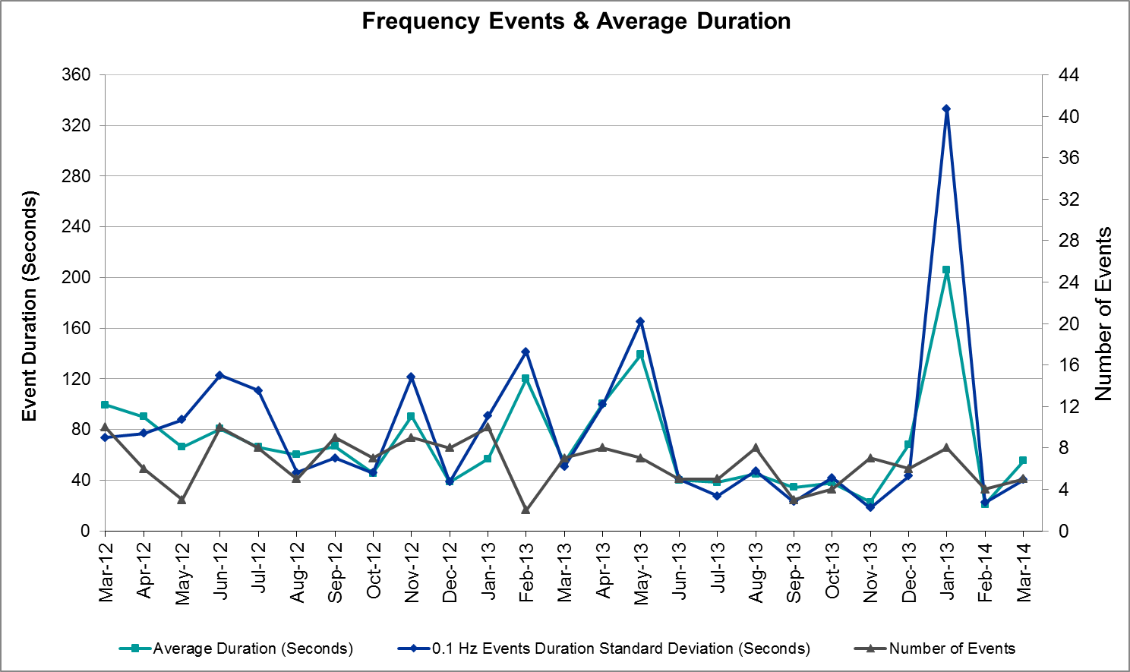

Responsive Reserve Events
There were five events where Responsive Reserve MWs were released to SCED in March. The events highlighted in blue were related to frequency events reported in section 2.1 above.

Date and Time  Released to SCED | Date and Time  Recalled | Duration of Event | Maximum MWs Released | Comments
3/2/14 7:37:54 | 3/2/14 7:40:26 | 0:02:32 | 443.37
3/3/14 7:32:02 | 3/3/14 7:40:22 | 0:08:20 | 395.18
3/10/14 8:57:45 | 3/10/14 9:02:28 | 0:04:43 | 329.42
3/10/14 18:29:40 | 3/10/14 18:32:32 | 0:02:52 | 886.22
3/19/14 8:41:18 | 3/19/14 8:46:50 | 0:05:32 | 811.54

Load Resource Events
There were no load resource deployment events in March.

PMU Events
There were two synchrophasor events captured in March. Both were the result of frequency events detailed in section 2.1 above. When analyzing system disturbances, ERCOT evaluates PMU data according to industry standards. Events with an oscillating frequency of less than 1 Hz are considered to be inter-area, while higher frequencies indicate local events. Industry standards specify that damping ratio for inter-area oscillations should be 3.0% or greater. All events listed below indicate the ERCOT system met these standards and transitioned well after each disturbance.

Date and Time | Event Type | Duration of Event | Comments
3/10/2014 18:29:21 | Unit Trip | Approx. 159 sec | The event was caused by the loss of one unit generating 798 MW net. Following the trip, frequency dropped to 59.775 Hz. The oscillating frequency of 0.683 Hz with 9.55% damping ratio was observed.
3/19/2014 08:41:02 | Unit Trip | Approx. 360 sec | The event was caused by the loss of one unit generating 770 MW net. Following the trip, frequency dropped to 59.795 Hz. The oscillating frequency of 0.752 Hz with 12.78% damping ratio was observed.

Reliability Unit Commitment
ERCOT reports on Reliability Unit Commitments (RUC) on a monthly basis. Commitments are reported grouped by operating day and weather zone. The total number of hours committed is the sum of the hours for all the units in the specified region. Additional information on RUC commitments can be found on the MIS secure site at Grid → Generation → Reliability Unit Commitment.

DRUC Commitments
Resource Location | # of Resources | Operating Day | # Hours Committed | Total MWhs | Reason for commitment
Coast | 1 | 3/3/2014 | 20 | 15,000 | Capacity

HRUC Commitments
Resource Location | # of Resources | Operating Day | # Hours Committed | Total MWhs | Reason for commitment
Southern | 1 | 3/1/2014 | 24 | 7,771 | Valley Import
Southern | 1 | 3/2/2014 | 15 | 4,831 | Valley Import
Far West | 1 | 3/2/2014 | 5 | 1,201 | Capacity
N. Central | 1 | 3/2/2014 | 7 | 1,050 | Capacity
Coast | 14 | 3/3/2014 | 118 | 6,386 | Capacity
Coast | 1 | 3/4/2014 | 12 | 708 | Capacity
Southern | 1 | 3/8/2014 | 8 | 2,685 | Valley Import
Southern | 1 | 3/9/2014 | 2 | 86 | Valley Import and Local Congestion
Southern | 1 | 3/10/2014 | 4 | 172 | Valley Import
Southern | 2 | 3/11/2014 | 2 | 464 | Valley Import
Southern | 3 | 3/12/2014 | 24 | 6,448 | Valley Import
Southern | 1 | 3/14/2014 | 8 | 1,881 | Valley Import and Local Congestion
Southern | 1 | 3/15/2014 | 9 | 2,129 | Valley Import
Southern | 2 | 3/16/2014 | 30 | 6,898 | Valley Import
Southern | 2 | 3/17/2014 | 9 | 1,374 | Valley Import
Southern | 2 | 3/18/2014 | 29 | 8,635 | Valley Import and Local Congestion
Southern | 2 | 3/19/2014 | 12 | 2,798 | Valley Import
Southern | 1 | 3/20/2014 | 3 | 1,186 | Valley Import
Southern | 1 | 3/21/2014 | 25 | 9,119 | Valley Import
Southern | 3 | 3/22/2014 | 27 | 8,023 | Valley Import
Southern | 2 | 3/23/2014 | 20 | 5,256 | Valley Import
Southern | 2 | 3/24/2014 | 15 | 3,461 | Valley Import
Southern | 1 | 3/25/2014 | 6 | 2,923 | Valley Import

Wind Generation as a Percent of Load
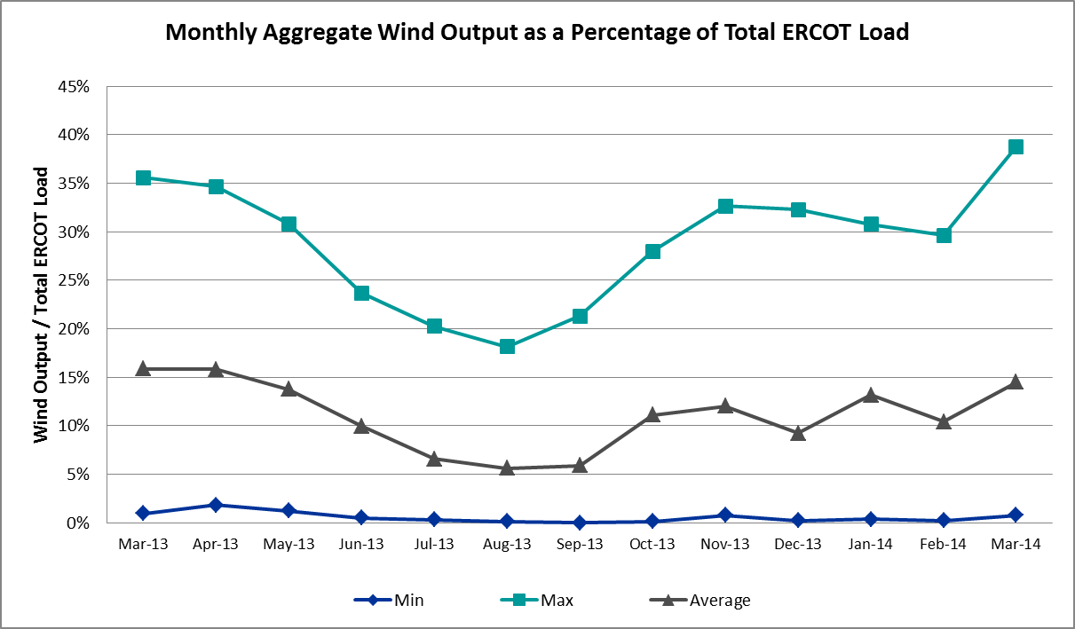

Congestion Analysis
The number of congestion events experienced by the ERCOT system remained steady again in March. Since the weather was generally milder in March, a greater fraction of the congestion events was related to outages than to cold weather, as was the case in January and February. There were also four days of activity on the Valley Import Generic Transmission Limit (GTL) resulting from planned outages in the area and five days of activity on the West to North GTL due to high wind output.

Notable Constraints for March
Nodal protocol section 3.20 specifies that ERCOT shall identify transmission constraints that are active or binding three or more times within a calendar month. As part of this process, ERCOT reports congestion that meets this criterion to ROS. In addition ERCOT also highlights notable constraints that have an estimated congestion rent exceeding $1,000,000 for a calendar month. These constraints are detailed in the table below. Rows highlighted in blue indicate the congestion was affected by one or more outages. For a list of all constraints activated in SCED for the month of March, please see Appendix A at the end of this report.

Contingency | Overload | # of Days Constraint Active | Estimated Congestion Rent | Transmission Project
Basecase | Valley Import | 4 | $11,547,002
DCKT Paris Switch - Valley Ses and Valley South 345 kV | Paris Switch AXFMR1 (3) 345/138 kV | 3 | $9,506,905 | 14TPIT0093
Sun Switch - Morgan Creek Ses 138 kV | Snyder - Sacroc 138 kV | 1 | $6,242,688 | 09TPIT0120
Lytton Springs LY_AT2 345/138 kV | Lytton Springs LY_AT1 345/138 kV | 1 | $6,207,687
Alice - Kingsville 138 kV | Lon Hill - Calallen Sub 69 kV | 1 | $3,918,991 | 2012-R13, 12TPIT0181
DCKT Watermill Switch - Desoto Switch and Cedar Hill Switch 345 kV | Sargent Road AXFMR1H (3) 345/138 kV | 1 | $3,794,589 | 11TPIT0034
Paris Switch AXFMR1 (3) 345/138 kV | Forest Grove Switch - Eustace Southeast 138 KV | 1 | $3,371,396 | 17TPIT0020
Nelson Sharpe - Lon Hill 345 kV | Lon Hill - Kingsville 138 kV | 3 | $3,362,732 | 16TPIT0026, 2012-R18
Shamburger Switch - Martin Lake Ses 345 kV | Elkton - Tyler West 138 kV | 1 | $2,982,251 | 12TPIT0118
Sacroc - Sun Switch 138 kV | Morgan Creek Ses - Sun Switch 138 kV | 1 | $2,490,202 | 15TPIT0087, 09TPIT0120
North Edinburg - Lon Hill 345 kV | Rio Hondo 345_138_1 (3) 345/138 kV | 1 | $2,179,903 | 14TPIT0050, 15TPIT0024
DCKT Marion - Zorn and Clear Springs 345 kV | Marion AT2 345/138 kV | 1 | $2,095,413
DCKT Scurry County South Switch - Faraday and Long Draw 345 kV | China Grove Switch - Bluff Creek Switch 138 kV | 1 | $1,547,915
Gaf Tnp - Greenbelt Tnp 138 kV | Greenbelt Tnp - Tejas Tnp 138 kV | 1 | $1,251,854
Nelson Sharpe - Lon Hill 345 kV | Nelson Sharpe 138_PS | 1 | $1,232,229 | 15TPIT0024
DCKT Wa Parish - Bellaire and Smithers 345 kV | Sharpstown - Bellaire 138 kV | 3 | $1,011,664 | 12TPIT0169, 14TPIT0030
DCKT Scurry County South Switch - Tonkawa Switch 345 kV | Bluff Creek Switch - Exxon Sharon Ridge 138 kV | 10 | $820,973
Laquinta - Lobo 138 kV | Bruni 138_69_1 138/69 kV | 9 | $756,819 | 11TPIT0160
Nelson Sharpe - Lon Hill 345 kV | Kleberg Aep - Kingsville 138 kV | 7 | $573,109 | 13TPIT0108, 15TPIT0069
Lon Hill 345_138_2 (3) 345/138 kV | Lon Hill - Smith 69 kV | 5 | $374,493 | 16TPIT0026, 2012-R18
DCKT Rio Hondo - North Edinburg 345 kV and Rio - Hondo Harlingen Switch 138 kV | La Palma - Haine Drive 138 kV | 3 | $328,113 | 09TPIT0101, 14TPIT0070
Victoria - Coleto Creek 138 kV (COLETO_VICTOR1) | Victoria - Coleto Creek 138 kV (COLETO_VICTOR2) | 8 | $290,036
Ajo - Rio Hondo 345 kV | Las Pulgas - Rio Hondo 138 kV | 7 | $243,109 | 14TPIT0050
Vernon 138_69T1 138/69 kV | Lake Pauline 138_69_1 138/69 kV | 3 | $147,578
Basecase | West to North | 5 | $127,535
Nelson Sharpe - Lon Hill 345 kV | Las Pulgas - Raymondville 2 138 kV | 3 | $71,915 | 12TPIT0103
Scurry Switch - Sun Switch 138 kV | Wolfgang - Rotan 69 kV | 15 | $58,439
Aspermont Aep - Spur 138 kV | Wolfgang - Rotan 69 kV | 8 | $35,493
Spur - Scurry Switch 138 kV | Wolfgang - Rotan 69 kV | 4 | $7,384
Basecase | Ena Snyder Wind - Wkn_Bkr 69 kV | 4 | $2,324

Generic Transmission Limit Congestion
There were five days of GTL activity on the West – North stability limit resulting from high West wind output in March. In addition, there were four days of activity on the Valley Import stability limit as a result of planned outages in the area. There was no GTL activity on the North – Houston or SOP110 GTLs.

Congestion Costs for Calendar Year 2014
The following table represents the top twenty active constraints for the calendar year to date based on the estimated congestion rent attributed to the congestion. ERCOT updates this list on a monthly basis.

Contingency | Binding Element | # of 5-min SCED Intervals | Estimated Congestion Rent | Transmission Project
Lytton Springs LY_AT2 345/138 kV | Lytton Springs LY_AT1 345/138 kV | 1,989 | $55,956,002
Basecase | Valley Import | 495 | $11,577,259
DCKT Gabriel - Glasscock LCRA and Rivery 138 kV, Glasscock LCRA - Gabriel 138 kV, and DCKT Gabriel - Bell County - Hutto Switch 138 kV | Marshall Ford - Lago Vista 138 kV | 209 | $9,871,526 | 15TPIT0061
DCKT Paris Switch - Valley Ses and Valley South 345 kV | Paris Switch AXFMR1 (3) 345/138 kV | 1,420 | $9,291,357 | 14TPIT0093
Sun Switch - Morgan Creek Ses 138 kV and Bluff Creek Switch - Ennis Creek Switch 138 kV | Snyder - Sacroc 138 kV | 153 | $6,260,965 | 09TPIT0120
Alice - Kingsville 138 kV, Kingsville - Lon Hill 138 kV, Nelson Sharpe - Lon Hill 345 kV | Lon Hill - Calallen Sub 69 kV | 669 | $6,229,569 | 12TPIT0181, 2012-R13
Stadium Aep - Alice 69 kV, Pawnee Switching Station - Lon Hill 345 kV, and Alice - Kingsville 138 kV | Lon Hill - Robstown Tap 69 kV | 904 | $6,091,279 | 12TPIT0180
Orange Grove Switching Station - Lon Hill 138 kV and Lon Hill 345_138_2 (3) 345/138 kV | Lon Hill - Smith 69 kV | 1,762 | $4,443,063 | 16TPIT0026, 2012-R18
Coleto Creek - Pawnee Switching Station 345 kV, Pawnee Switching Station - Calaveras 345 kV | Coleto Creek - Kenedy Switch 138 kV | 337 | $4,339,755 | 16TPIT0034
DCKT Burleson - Carson Creek 138 kV and Pedernales - Advanced Micro Devices AEN 138 kV | Kingsberry - Mueller 138 kV | 75 | $4,036,986 | 11TPIT0008
DCKT Tonkawa Switch - Scurry County South Switch 345 kV | Bluff Creek Switch - Exxon Sharon Ridge 138 kV | 2,135 | $4,004,523
Paris Switch AXFMR1 (3) 345/138 kV, Elkton - Tyler Kelly Tire 138 kV | Forest Grove Switch - Eustace Southeast 138 KV | 192 | $3,934,733 | 17TPIT0020
DCKT Watermill Switch - Desoto Switch and Cedar Hill Switch 345 kV | Sargent Road AXFMR1H (3) 345/138 kV | 186 | $3,794,589 | 11TPIT0034
Pawnee Switching Station - Lon Hill 345 kV, Nelson Sharpe - Lon Hill 345 kV, North Edinburg 345_1382 345/138 kV | Nelson Sharpe - Celanese Bishop 138 kV | 1,032 | $3,562,159 | 15TPIT0024
DCKT Limestone - Navarro 345 kV | Jewett - Big Brown Ses 345 kV (Line 40) | 34 | $3,428,764
Nelson Sharpe - Lon Hill 345 kV | Lon Hill - Kingsville 138 kV | 143 | $3,362,732 | 16TPIT0026, 2012-R18
Shamburger Switch - Martin Lake Ses 345 kV | Elkton - Tyler West 138 kV | 40 | $2,982,251 | 12TPIT0118
Pawnee Switching Station - Lon Hill 345 kV, Nelson Sharpe - Lon Hill 345 kV, North Edinburg 345_1382 345/138 kV | Celanese Bishop - Kleberg Aep 138 kV | 1,579 | $2,871,103 | 13TPIT0108, 15TPIT0069
Laquinta - Lobo 138 kV | Bruni 138_69_1 138/69 kV | 3,197 | $2,583,125 | 13TPIT0158, 13TPIT0159
Sacroc - Sun Switch 138 kV | Morgan Creek Ses - Sun Switch 138 kV | 99 | $2,507,736 | 15TPIT0087, 09TPIT0120

System Events

ERCOT Peak Load
The unofficial ERCOT peak load for the month of March was 54,549 MW and occurred on March 3 during the hour ending 08:00.

Load Shed Events
None

Stability Events
None

TRE/DOE Reportable Events
None

New/Updated RAPs and PCAPs
There was one new RAP in March: Paris Switch – Valley Ses and Paris Switch – Valley South 345 kV Double Circuit Line was implemented on 3/3/2014.

New/Modified/Removed SPS
None

New Procedures/Forms/Operating Bulletins
Date | Document | Description
3/1/2014 | Power Operations Bulletin 663 | Inadvertent Energy Procedure V1 Ver6
3/1/2014 | Power Operations Bulletin 664 | DC Tie Desk V1 Rev26
3/4/2014 | Power Operations Bulletin 665 | ERCOT DC Tie Operations Document V3 Rev8

Emergency Conditions
The ERCOT Interconnection experienced fewer Emergency Conditions in March than in previous two months due to the warmer weather. In all cases, the relevant notices were posted to the ERCOT website and are summarized in the following tables.

OCNs
None

Advisories
Date and Time | Description
3/11/2014 13:24 | ERCOT issued an Advisory due to postponement of the DAM Solution for OD 3/12/14 due to long solution time.
3/22/2014 13:31 | ERCOT issued an Advisory due to postponing the deadline for the posting of the DAM De-Energized Settlement Points in Base Case report.

Watches
Date and Time | Description
3/2/2014 09:00 | ERCOT issued a Watch due to a strong artic front passing through the ERCOT region.
3/14/2014 14:33 | ERCOT issued a Watch due to the failure of the SCED process.
3/14/2014 18:05 | ERCOT issued a Watch due to the failure of the SCED process.

Emergency Notices
None

Application Performance
ERCOT system applications performed well in March. There no issues with Operations applications.

TSAT/VSAT Performance Issues
None

Communication Issues
None

Net-Forecast Bias Applied to NSRS Procurement for April 2014
Each month, ERCOT calculates a net Forecast Bias pursuant to the ERCOT Ancillary Services Methodology for procurement of Non-Spinning Reserve Service (NSRS). The table below indicates the amount of net Forecast Bias that was applied to the NSRS procurement for specified blocks of time for the month of April, 2014.

Blocks | Negative Net Load Forecast Average Error - ERCOT | Sum of the Individual Zones | Negative Net Load Forecast Average Error - By Weather Zone for the 5 Largest Zones
Blocks | Negative Net Load Forecast Average Error - ERCOT | Sum of the Individual Zones | Coast | East | North Central | South Central | Southern
1-2 | 0 | 0 | 0 | 0 | 0 | 0 | 0
3-6 | 0 | 0 | 0 | 0 | 0 | 0 | 0
7-10 | 0 | 0 | 0 | 0 | 0 | 0 | 0
11-14 | 0 | 0 | 0 | 0 | 0 | 0 | 0
15-18 | 0 | 0 | 0 | 0 | 0 | 0 | 0
19-22 | 0 | 0 | 0 | 0 | 0 | 0 | 0
23-24 | 0 | 0 | 0 | 0 | 0 | 0 | 0

Appendix A: Real-Time Constraints
The following is a complete list of constraints activated in SCED for the month of March. Full contingency descriptions can be found in the Standard Contingencies List located on the MIS secure site at Grid → Generation → Reliability Unit Commitment.

Contingency | Constrained Element | From Station | To Station | # of Days Constraint Active
SSCUSUN8 | ROTN_WOLFGA1_1 | WOLFGANG | ROTN | 15
DSCOTKW5 | 6216__A | BCKSW | SHRNE | 10
SLAQLOB8 | BRUNI_69_1 | BRUNI | BRUNI | 9
SSPUASP8 | ROTN_WOLFGA1_1 | WOLFGANG | ROTN | 8
SVICCO28 | COLETO_VICTOR2_1 | COLETO | VICTORIA | 8
SAJORI25 | LASPUL_RIOHON1_1 | LASPULGA | RIOHONDO | 7
SN_SLON5 | KINGSV_KLEBER1_1 | KLEBERG | KINGSVIL | 7
BASE CASE | W_TO_N |  |  | 5
XLO2N58 | LON_HI_SMITH1_1 | LON_HILL | SMITH | 5
BASE CASE | SNYDER_WKN_BK1_1 | ENAS | WKN_BKR | 4
BASE CASE | VALIMP |  |  | 4
SSPUMW18 | ROTN_WOLFGA1_1 | WOLFGANG | ROTN | 4
DPRSVLY5 | PRSSW_MR1H | PRSSW | PRSSW | 3
DRIOHAR5 | HAINE__LA_PAL1_1 | LA_PALMA | HAINE_DR | 3
DWAP_BI5 | BI_ST_05_A | ST | BI | 3
SN_SAJO5 | LASPUL_RAYMND1_1 | LASPULGA | RAYMND2 | 3
SN_SLON5 | KINGSV_LON_HI1_1 | LON_HILL | KINGSVIL | 3
XVE2R89 | PAUL_69-1 | PAUL | PAUL | 3
BASE CASE | SOP110 |  |  | 2
DMARZOR5 | MARION_4AT2 | MARION | MARION | 2
DODEQAL5 | 6620__A | STASW | MRCAP | 2
DWAP_OB5 | GT_MID90_A | GT | MID | 2
SALIKIN8 | CALALS_LON_HI1_1 | LON_HILL | CALALS | 2
SBOSELM5 | 1030__B | BOSQUESW | RGH | 2
SMDLODE5 | 6500__B | ODEHV | BTHOT | 2
SN_SLON5 | CELANE_KLEBER1_1 | CELANEBI | KLEBERG | 2
SN_SLON5 | CELANE_N_SHAR1_1 | N_SHARPE | CELANEBI | 2
SN_SLON5 | LOYOLA_69_1 | LOYOLA | LOYOLA | 2
SSCUSUN8 | SPUR_69_1 | SPUR | SPUR | 2
SSPUMW18 | SPUR_69_1 | SPUR | SPUR | 2
STRIDEC8 | CKT_1027_1 | DUNLAP | DECKER | 2
SWHILON5 | KINGSV_KLEBER1_1 | KLEBERG | KINGSVIL | 2
XHLT89 | 6915__A | ODNTH | ODBSW | 2
XPRS58 | 975__E | FGRSW | EUSSE | 2
DAUSGAR5 | CKT_1027_1 | DUNLAP | DECKER | 1
DAUSLOS5 | 336T405_1 | FPPYD1 | FPPYD2 | 1
DCAGBRA5 | N5_P4_1 | CALAVERS | SKYLINE | 1
DDUNLOS5 | 336T405_1 | FPPYD1 | FPPYD2 | 1
DPRSVLY5 | PRSSW_MR1L | PRSSW | PRSSW | 1
DSCOFAR5 | 6215__A | CGRSW | BCKSW | 1
DSTPWHI5 | BLESSI_PALACI1_1 | BLESSING | PALACIOS | 1
DTRVPIR8 | FDLGBY21_A | GBY | FDL | 1
DWAP_JN5 | BI_SMR98_A | SMITHERS | BI | 1
DWAP_JN5 | BI_WAP50_A | WAP | BI | 1
DWH_STP5 | AIRCO4_RINCON1_1 | RINCON | AIRCO4 | 1
DWTRDES5 | SARRD_MR1L | SARRD | SARRD | 1
SAIRHIW9 | LON_HILL_69A2 | LON_HILL | LON_HILL | 1
SAJORI25 | CELANE_N_SHAR1_1 | N_SHARPE | CELANEBI | 1
SAJORI25 | MV_YUT_RAYMND1_1 | MV_YUTT | RAYMND2 | 1
SBGLFRI8 | SONR_69-1 | SONR | SONR | 1
SBOSWHT5 | 1030__A | ELMOT | RGH | 1
SBOSWHT8 | OLKW_BOS_1 | BOSQUESW | LKWHITNY | 1
SBRAUVA8 | HAMILT_MAVERI1_1 | HAMILTON | MAVERICK | 1
SCALLON9 | ALICE_69A1 | ALICE | ALICE | 1
SCALLON9 | LOYOLA_69_1 | LOYOLA | LOYOLA | 1
SCELKLE8 | CALALS_LON_HI1_1 | LON_HILL | CALALS | 1
SCNSCN38 | DEN_IND_1 | DENTON | INDUSTRL | 1
SCOLBAL8 | DRSY_SANA_T1_1 | SANA_TAP | DRSY | 1
SCOLPAW5 | COLETO_KENEDS1_1 | COLETO | KENEDSW | 1
SCTHHA38 | SONR_69-1 | SONR | SONR | 1
SECRBRA8 | 6240__A | SACRC | SNYDR | 1
SECRBRA8 | ROTN_WOLFGA1_1 | WOLFGANG | ROTN | 1
SELTVAN9 | RAYBURN_69_2 | RAYBURN | RAYBURN | 1
SGAFGRN8 | G138_1BB_1 | GRNBELT | TEJAS | 1
SGOLBRN8 | GOLDTH_9AT2 | GOLDTH | GOLDTH | 1
SILLFTL8 | FDR_OZN_1 | FRIEND_R | OZNA | 1
SKEYWLV8 | 6610__D | BSPSW | BSCTP | 1
SKLELOY8 | LOYOLA_69_1 | LOYOLA | LOYOLA | 1
SKOCNU28 | GILA_HIWAY_2_1 | GILA | HIWAY_9 | 1
SLAQLOB8 | FRE_BRUN_1 | BRUNI | FREERS | 1
SLORCLC9 | ABNW_ELYT1_1 | ABNW | ELYT | 1
SLOSLOS5 | 336T405_1 | FPPYD1 | FPPYD2 | 1
SMCFWAR9 | CALALS_LON_HI1_1 | LON_HILL | CALALS | 1
SMDLODE5 | 6500__C | BTHOT | ODESW | 1
SMUESPR8 | BOW_FMR1 | BOW | BOW | 1
SN_SLON5 | ALICE_69A1 | ALICE | ALICE | 1
SN_SLON5 | CALALS_LON_HI1_1 | LON_HILL | CALALS | 1
SN_SLON5 | KINGSV_KLEBER1_1 | KINGSVIL | KLEBERG | 1
SN_SLON5 | N_SHARPE_PS1 | N_SHARPE | N_SHARPE | 1
SNEDLON5 | RIOHONDO_AT1L | RIOHONDO | RIOHONDO | 1
SOXYIN28 | I_DUPP_I_DUPS1_1 | I_DUPP1 | I_DUPSW | 1
SRODB_D8 | AIRLIN_CABANI1_1 | AIRLINE | CABANISS | 1
SSACSUN8 | 6474__A | MGSES | SUNSW | 1
SSACSUN8 | 6474__A | SUNSW | MGSES | 1
SSCUSUN8 | GIRA_T_SPUR1_1 | SPUR | GIRA_TAP | 1
SSCUSUN8 | ROBY_ROTN1_1 | ROBY | ROTN | 1
SSCUSUN8 | ROBY_ROTN1_1 | ROTN | ROBY | 1
SSHBMLS5 | 1000__A | ELKTN | TYWST | 1
SSUNMGS8 | 6240__A | SNYDR | SACRC | 1
STNSPRS8 | 1560__D | PREST | LMRTP | 1
STYLEL18 | 975__C | EUSSE | EUSTC | 1
STYLEL18 | 975__E | FGRSW | EUSSE | 1
SWCOW2C8 | G138_18_1 | WCOLMAIN | WCOLLOCL | 1
XAND89 | HLTSW_FMR1 | HLTSW | HLTSW | 1
XKEN358 | 68T221_1 | VERDCR | TURTCR | 1
XLY2T58 | LYTTON_S_AT1H | LYTTON_S | LYTTON_S | 1
XMOS58 | 6500__B | ODEHV | BTHOT | 1
XNE2D58 | HAINE__LA_PAL1_1 | LA_PALMA | HAINE_DR | 1
XPRS58 | 975__D | EUSTC | MABNK | 1
XSC89 | PRTTLR84_A | PRT | TLR | 1

