MarkeTrak Task Force Meeting Notes
March 25, 2014

Attendees:
Carolyn Reed Carolyn.reed@centerpointenergy.com CenterPoint Energy
Sheri Wiegand sheri.wiegand@txu.com TXUE
Gricelda Calzada gcalzada@aep.com AEP
Cheryl Franklin cnfranklin@aep.com AEP
Barrett Morrow barrett.morrow@centerpointenergy.com CenterPoint Energy
Debbie McKeever Deborah.mckeever@oncor.com Oncor
Greg Huckaby Gregory.huckaby@oncor.com Oncor
Michael Taylor mtaylor@ercot.com ERCOT
Mike Dameron mdameron@ercot.com ERCOT
Monica Jones via WebEx Reliant
Jim Lee via WebEx Direct Energy
Diana Rehfeldt via WebEx TNMP
Tammy Stewart via WebEx ERCOT
Stephen Wilson via WebEx Sharyland Utilities
Kathryn Thurman via WebEx ERCOT
Sandra Tindall via WebEx ERCOT
ERCOT Update - PR010_03 MarkeTrak Phase 3, Part B - Business requirements
  - ERCOT provided Detail Design document (Attached)
  - ITesting is underway, but ERCOT had to break internal testing into 3 buckets due to resource constraints for multiple systems. Example: Some of the enhancements will involve the MarkeTrak CERT environment as well as Siebel which crosses multiple systems.
    - Note: ERCOT indicated post MTTF meeting that API user’s should receive preliminary WSDL (85%) around mid-April but no later than MarkeTrak April meeting.
    - ERCOT (T.Anderson) presented to March PRS, that SCR756 (PartB) which is PR010_03, had been moved to (Release Window 4 – RW4) which has calendar dates of July 28th – August 1st.
      - Debbie pointed out that RW4 is actually after the ERCOT Scheduled SLA release dates of July 26-27, 2014 which is Go-Live implementation weekend. Debbie will reach out to Troy for exact date confirmations and will bring back to the MTTF meeting in April.
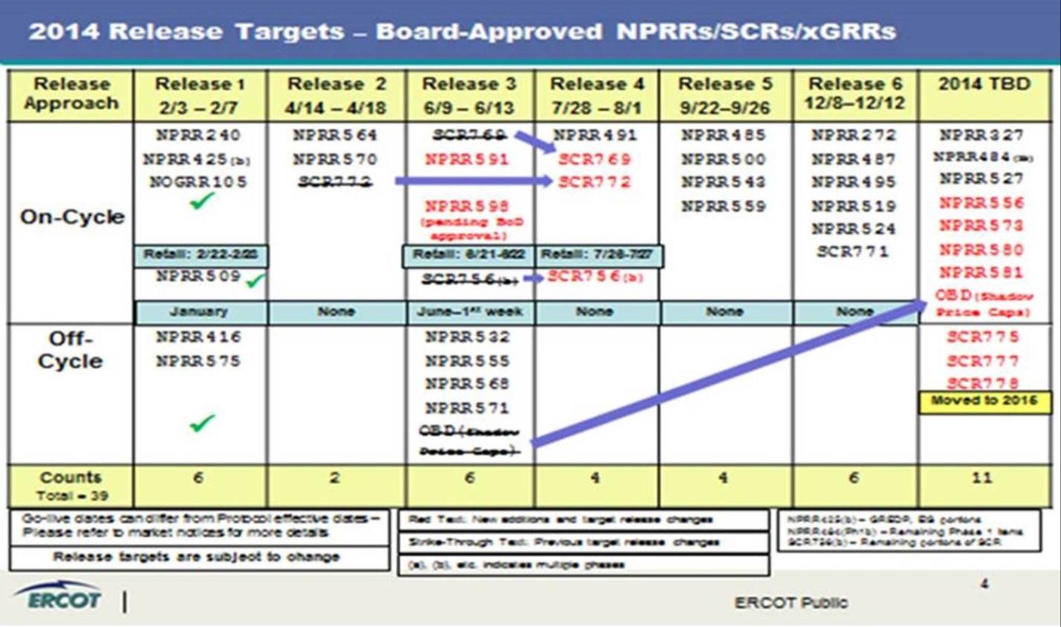

  - Detailed Design Use Case #37 was updated to reflect an escalation email to be sent at three calendar days in lieu of two days if MT remained untouched.
  - Market PR010_03 Trainings are being discussed. ONCOR and CNP still waiting on confirmation from ERCOT for Dallas and Houston training before we send notices to the market:
  - (D.McKeever indicated that ONCOR could accommodate June 17th training in Dallas)
  - CNP will host Houston training June 5th
  - Austin training scheduled for June 24th at ERCOT
  - TF still drafting test scripts (V2 Attached) - completed drafts for Use Cases #23 & 30 , #24, #25, and #27
  - ERCOT confirmed validations and automation will be turned on via CERT environment when we begin testing PR010_03 scripts.

Retail Market Guide Revision Request (RMGRR) 121 – Clarification of Inadvertent Gain Process

  - Jim Lee (Direct Energy) was asked by RMS leadership in March to reach out to CRs again and head discussion on concerns brought up at RMS. This discussion took place and the results were all CRs are NOW on board with RMGRR121 and all comments presented to RMS March 4th. MTTF agreed to endorse RMGRR121 and move forward for vote at RMS April 1st meeting. Jim will give update at RMS since he was given task by RMS leadership.
  - TF updated the User’s Guide (IAG Section(s)) to reflect RMGRR121 changes by referencing RMG sections. (See UG IAG Attachment – changes appear to be in blue for some reason)

Reversal of Fee SubType (ROF):
- User’s Guide updated to reflect RMGRR121 language (See UG IAG Attachment – changes appear to be in blue for some reason)

Additional Business Items
  - None

NEXT MEETING – April 22, 2014

Preliminary Agenda –
- ERCOT Update PR010_03
- Writing of Test Scripts for Business Requirements– PR010_03

