Final Report
ERCOT 30-Minute Emergency Response Service Pilot Project
March 2014 Update

ERCOT provides this final assessment of the 30-Minute Emergency Response Service (ERS) pilot project in accordance with the Governing Document for the 30-Minute Emergency Response Service Pilot Project (“Governing Document”), which was approved by the ERCOT Board of Directors on June 19, 2012 and amended by the ERCOT Board of Directors on December 11, 2012 and July 16, 2013. This report summarizes ERCOT’s analysis of data concerning the procurement, deployment, performance, and availability of participating Pilot Resources.

Executive Summary

During the last amendments to the PUCT rules pertaining to ERS, the Commission emphasized that ERCOT should establish classes of ERS with differing response times for the purpose of increasing participation in the service. The 30-Minute ERS pilot project has demonstrated that there is additional ERS capacity willing to be available to ERCOT for dispatch during emergency conditions. The total capacity offered into the pilot project increased over the five Standard Contract Terms of the pilot project. The various test deployments conducted during the pilot have shown that the 30-Minute ERS resources generally exceeded the fleet level obligation. The pilot project also helped highlight the varying seasonal needs for ERS which led to the development of a new procurement methodology to be used for all ERS types under a clearing price approach. This methodology requires ERCOT to assess the potential risk of an emergency condition for each Time Period in the ERS calendar year. From this assessment risk factors will be assigned to each Time Period which will provide the appropriate price signals to the DR providers prior to each ERS procurement. This methodology also assigns the same clearing price to both 30-Minute ERS and 10-Minute ERS, since both services are procured for the same reliability purpose and because 30-Minute ERS can be deployed as early as EEA Level 1, and potentially more often, whereas 10-minute ERS is deployed no earlier than EEA Level 2. Adding dispatchable capacity to the ERS program furthers the stated policy of the Commission that a robust demand response program is an essential tool for ERCOT in fulfilling its responsibilities to ensure reliable operation of the grid.

Summary of the 30-Minute ERS Pilot Project

As the Governing Document recognizes, the purpose of the pilot project is to:

1. Assess the operational benefits and challenges of deploying an ERS product with a thirty-minute ramp period;
2. Study the optimal means of deploying 30-Minute ERS in an EEA;
3. Gather data to analyze the execution and benefits of a clearing price mechanism;
4. Gather data to assist ERCOT in determining the appropriate price to pay for 30-Minute ERS;
5. Gather data to compare costs and benefits relative to 10-Minute ERS; and
6. Determine overall market interest in 30-Minute ERS before making appropriate ERCOT rule changes.
To evaluate these measures, the amended Governing Document authorizes ERCOT to procure 30- Minute ERS for the following Contract Periods:

Contract Period | Start Date  tart Date | End Date
July – September 2012 | July 15, 2012 | September 30, 2012
October 2012 – January 2013 | October 1, 2012 | January 31, 2013
February – May 2013 | February 1, 2013 | May 31, 2013
June – September 2013 | June 1, 2013 | September 30, 2013
October 2013 – January 2014 | October 1, 2013 | January 31, 2014

The Governing Document required ERCOT to deploy Pilot Resources a minimum of one time and a maximum of four times in each Contract Period. The deployments could occur during an Energy Emergency Alert (EEA) or through fleet-wide tests. ERCOT experienced one EEA event requiring the deployment of Pilot Resources and conducted nine test deployments of these Resources over the course of the five Contract Periods.

Purpose 1: Assess the operational benefits and challenges of deploying an ERS product with a thirty- minute ramp period

Data from the nine fleet-wide tests indicates that an ERS product with a 30-Minute ramp period can provide additional valuable demand response upon dispatch. Table 1, below, summarizes the results of each deployment test conducted. With the exception of the first and sixth tests, the fleet provided Load reduction in excess of its aggregate obligation. Resource-level deployment information for each test can be found in the appendix. The results of each test, including explanations for the underperformance in the first and sixth tests, are described below.

 | Test Date | Contract Period | Time Period | Fleet Obligation (MW) | Fleet Load  Reduction (MW)
Test 1 | September 5, 2012 | JulSep12 | BH1 | 18.01 | 9.09
Test 2 | September 13, 2012 | JulSep12 | BH1 | 19.40 | 24.13
Test 3 | September 26, 2012 | JulSep12 | BH2 | 16.25 | 22.44
Test 4 | October 30, 2012 | OctJan13 | BH2 | 82.33 | 93.95
Test 5 | November 20, 2012 | OctJan13 | BH1 | 80.28 | 89.32
Test 6 | February 28, 2013 | FebMay13 | BH1 | 47.57 | 32.16
Test 7 | May 23, 2013 | FebMay13 | BH1 | 72.96 | 77.08
Test 8 | September 19, 2013 | JunSep13 | BH2 | 87.65 | 101.27
Test 9 | January 30, 2014 | Oct13Jan14 | BH2 | 136.35 | 169.04

Table 1: Summary of Test Deployments
Test 1 Results

The Dispatch Instruction for this first test deployment was issued during the Non-Business Hours (NBH) Time Period slightly more than 30 minutes before the beginning of the Business Hours 1 (BH1) Time Period. Only those Pilot Resources that had an obligation in both the NBH and BH1 Time Periods were required to remain deployed during BH1. For the first full interval of the deployment in BH1 the fleet’s aggregate obligation was 18.0 MW. The actual Load reduction measured during the full interval, however, was only 9.09 MW. Review of the Resource-level performance showed that five of the eight Pilot Resources met their required Load reduction. The fleet-level performance was significantly impacted by the fact that a single Resource accounted for about 48% (8.60 MW) of the total fleet obligation and was among the three Pilot Resources that did not provide the required amount of Load reduction.

ERCOT concluded that the Time Period overlap in the middle of this deployment created some confusion among some Qualified Scheduling Entities (QSEs) and/or their Pilot Resources, and the failure of the 30-Minute ERS fleet to meet its aggregate deployment requirement was largely attributable to this confusion. ERCOT subsequently emphasized to QSEs that their ERS Resources must not only remain deployed when a test or event crosses into a new Time Period but must also meet the obligation associated with that new Time Period. During the Demand Side Working Group meeting held on February 8, 2013, ERCOT reviewed training slides created to emphasize the deployment across Time Periods and also distributed them by email to all QSEs in the 30-Minute ERS Pilot.

Test 2 and 3 Results

The second and third test deployments more clearly demonstrated the demand response capability of the 30-Minute ERS fleet. The September 13, 2012 test deployment occurred entirely in the BH1 Time Period. The overall fleet obligation for the first full interval was 19.4 MW and the overall Load reduction observed was 24.13 MW (a 24% over-provision). Results for the September 26, 2012 test deployment were similar. The test deployment occurred in the BH2 Time Period, with an overall fleet obligation for the first full interval of 16.25 MW. ERCOT observed an overall Load reduction of 22.44 MW or an over-provision of 38%.

Test 4 and 5 Results

During the second 30-minute ERS Contract Period, ERCOT conducted two additional test deployments on October 30, 2012 and November 20, 2012. For this Contract Period, both the overall capacity (as high as 95.58 MW in BH2) and the number of Pilot Resources participating (30 in BH1 and BH2) was significantly greater than in the first Contract Period.

The fourth test deployment on October 30, 2012 occurred entirely within the BH2 Time Period. During this Time Period, the total obligation for the first full interval was 82.33 MW, and the overall Load reduction was 93.95 MW representing an over-provision of about 14%.

The fifth test deployment on November 20, 2012 occurred entirely within the BH1 Time Period. During this Time Period, the total obligation for the first full interval was 80.28 MW, and the overall Load reduction was 89.32 MW representing an over-provision of about 11%.

Test 6

This sixth test was targeted to replicate the time parameters of Test 1. The Dispatch Instruction was issued during the NBH Time Period, but just over 30 minutes before the beginning of the BH1 Time Period. Only those Pilot Resources that had an obligation in both the NBH and BH1 Time Periods were required to remain deployed during BH1. For the first full interval of the deployment in BH1 the fleet’s obligation was 47.6 MW. The actual Load reduction measured during the full interval, however, was only 32.16 MW. The fleet-level performance was significantly impacted by a single ERS Resource that accounted for approximately 38% (18.0 MW) of the total fleet obligation. Ten other Resources also failed to meet their required Load reductions, but the fleet nonetheless would have met its aggregate obligation had the one large Resource curtailed as required. Since the fleet failure of this retest was not attributed to the confusion with obligations crossing time periods ERCOT felt it was not necessary to retest again under the same parameters for a third time.

Test 7

The test deployment on May 23, 2013, occurred entirely within the BH1 Time Period. During this Time Period, the total obligation for the first full interval was 72.96 MW, and the overall Load reduction was 77.08 MW representing an over-provision of about 6%.

Test 8

The test deployment on September 19, 2013, occurred within the BH2 Time Period. During this Time Period, the total obligation for the first full interval was 87.65 MW, and the overall Load reduction was 101.27 MW representing an over-provision of about 15.5%.

Test 9

The test deployment on January 30, 2014, occurred within the BH2 time period. During this Time Period, the total obligation for the first full interval was 136.35 MW, and the overall Load reduction was 169.04 MW representing an over-provision of about 24%.

Overall Test Findings

Except for the first and sixth tests, the deployments of 30-Minute ERS were successful, with the fleet over-providing during each test. The aggregate performance characteristics of these Pilot Resources are similar to the aggregate characteristics observed for conventional 10-minute ERS Resources during the February 2, 2011, and August 4, 2011, ERS deployments.

January 6, 2014 ERS Deployment Event

During a cold weather event on the morning of January 6, 2014, ERCOT deployed 30-Minute ERS Pilot Resources obligated during the Business Hours 1 time period. During this event there were 111.671 MW obligated to provide 30-minute ERS. Following the 30-Minute ramp period, these resources were deployed for a duration (sustained response period) of just under 20 minutes, and therefore the deployment spanned only two partial intervals. The fleet level event performance was determined by analyzing the first partial interval only which was approximately 11 ½ minutes long and therefore the time weighted obligation for that partial interval was 86.111 MWs. The fleet response during the event was 94.831 MW, which exceeded the fleet’s combined obligation by 10%. As per the ERCOT protocols, the last partial interval is not used to evaluate performance. Approximately four minutes following the deployment of the 30-Minute ERS Resources, an instruction was issued to all QSEs to deploy all 10-Minute ramp ERS Resources. This event concluded without entering into Level 3 of an Energy Emergency Alert (EEA).

Impact of Over-Provision of 30-Minute ERS Resources

During the December 2012 Board meeting, a concern was raised about potential unintended consequences related to over-performance by the ERS fleet during a deployment. Graph 1, below, plots the system frequency during the October 30, 2012 test deployment of the 30-Minute ERS fleet. During the time period for this test deployment, the 30-minute ERS fleet carried an obligation of just over 82 MWs of demand response. The fleet actually delivered approximately 94 MWs or 114% of its obligation. As can be observed from the graph, there is no discernible impact to the frequency during the deployment. This can be largely attributed to the fact that the Pilot Resources tend to provide their obligated Load reduction gradually over the thirty-minute period following the instruction rather than all at once. It should also be noted that the ERCOT frequency bias is typically in the 400-500 MW range, so there is little reason to expect that over-provision of the ERS fleet during deployments will be an issue, especially at the currently anticipated participation levels.

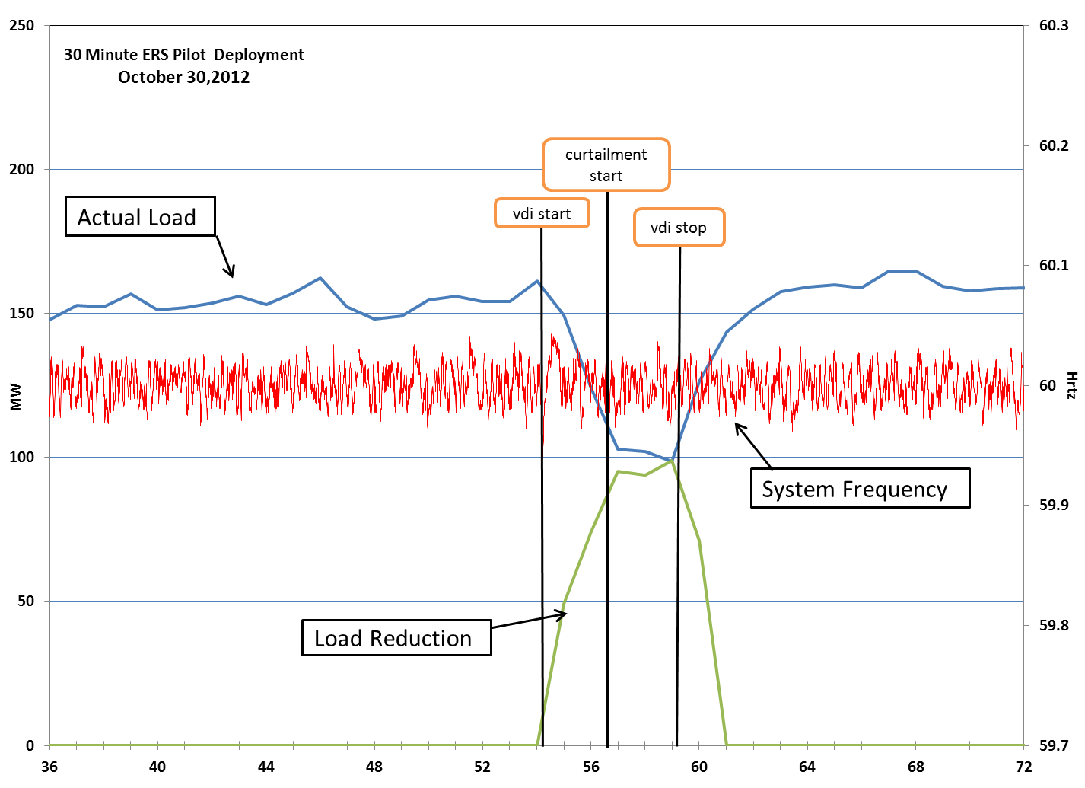
Graph 1: 30 Minute ERS Pilot Deployment for October 30, 2012
Availability Results

30-Minute ERS Resources are evaluated (and paid) based on both event performance and availability during their committed hours. Availability for each Resource is first calculated for each Time Period within a Contract Period; the individual availability factors for each Time Period are subsequently combined across Time Periods on a time- and capacity-weighted basis to provide a single availability factor for the Contract Period.

For an ERS Load on a default baseline, the availability factor is equal to the percent of hours for which the metered Load is greater than or equal to 95% of its contracted ERS MW capacity. For an ERS Load on the alternate baseline, availability is equal to the average Load (less the maximum base Load) for the Time Period, divided by its contracted ERS MW capacity. If the result of these calculations is greater than or equal to 95%, the ERS Load is deemed to have been available for that Contract Period.

Table 2 below shows the QSE-level availability for the five Contract Periods. Only three QSEs had an availability factor less than 95%.

July - September 2012 Availability |  |  | June - September 2013 Availability
QSE1 | 108.00 |  | QSE 1 | 99.49
QSE2 | 100.00 |  | QSE 2 | 101.67
QSE3 | 100.00 |  | QSE 3 | 104.52
QSE4 | 99.00 |  | QSE 4 | 123.59
QSE5 | 143.00 |  | QSE 5 | 111.62
October 2012 - January 2013 Availability |  |  | QSE 6 | 196.54
QSE 1 | 106.00 |  | QSE 7 | 100.00
QSE 2 | 100.00 |  | QSE 8 | 117.74
QSE 3 | 84.00 |  | QSE 9 | 127.00
QSE 4 | 132.00 |  | QSE 10 | 105.65
QSE 5 | 103.00 |  | QSE 11 | 102.24
QSE 6 | 104.00 |  | QSE 12 | 97.90
QSE 7 | 98.00 |  | QSE 13 | 100.00
QSE 8 | 123.00 |  | QSE 14 | 100.00
QSE 9 | 98.00 |  | QSE 15 | 43.55
QSE 10 | 100.00 |  | October 2013 - January 2014 Availability
February - May 2013 Availability |  |  | QSE 1 | 100.73
QSE 1 | 111.44 |  | QSE 2 | 137.48
QSE 2 | 99.61 |  | QSE 3 | 99.96
QSE 3 | 126.28 |  | QSE 4 | 304.89
QSE 4 | 107.00 |  | QSE 5 | 171.35
QSE 5 | 128.23 |  | QSE 6 | 105.99
QSE 6 | 104.11 |  | QSE 7 | 141.89
QSE 7 | 115.63 |  | QSE 8 | 104.62
QSE 8 | 109.50 |  | QSE 9 | 113.41
QSE 9 | 100.00 |  | QSE 10 | 108.02
 |  |  | QSE 11 | 119.03
 |  |  | QSE 12 | 99.97
 |  |  | QSE 13 | 85.67
 |  |  | QSE 14 | 99.78
 |  |  | QSE 15 | 100.00
 |  |  | QSE 16 | 131.57

Table 2: Availability Results for the five Contract Periods.

Purpose 2: Study the optimal means of deploying 30-Minute ERS in an EEA

Based on the demonstrated capability of pilot Resources to deploy within the required ramp period, ERCOT believes that the operational benefit of 30-Minute ERS can be maximized by allowing it to be deployed in EEA level 1, which could decrease the likelihood and/or duration of an EEA level 2 event and also minimize the risk of firm Load shed in EEA level 3. Because 10-Minute ERS can be deployed more quickly, ERCOT supports limiting the deployment of that service to EEA level 2.

Purpose 3: Gather data to analyze the execution and benefits of a clearing price mechanism

During the time frame of the 30-Minute ERS Pilot Project, ERCOT procured 10-Minute ERS on a “pay-as-offer” basis using the criteria defined in the Process for Determining Cost Limits & Reasonableness of Offers, located on the ERCOT website. As part of the procurement process, a cross-departmental ERCOT procurement committee convened to analyze the offer stacks for each ERS Time Period. In evaluating competing offers, the committee considered a number of factors, including historical Ancillary Services prices, historical and projected natural gas prices, projected demand during the upcoming Standard Contract Term, and spreads in the offers versus capacity. Once the committee determines the appropriate quantity and corresponding price based on the above-mentioned factors, all ERS Resources offering at or below this price are cleared and are awarded their respective offer prices—not the price offered by the marginal Resource.

During the 30-Minute ERS Pilot Project, ERCOT used basically the same procurement process as used for 10-Minute ERS with the exception that the offer with the highest cleared price established the price paid to all lower priced offers. This allowed ERCOT to gather information from the ERS providers on how the offer behavior might change based on a clearing price.

The change in offer behavior can be observed in Graphs 1-4 provided below. The graphs reveal that 10-Minute ERS offers, under the “pay-as-offer” approach, have a tendency to cluster at higher prices, indicating that the ERS providers are attempting to “guess” the highest price ERCOT is likely to accept. Offers for 30-Minute ERS, on the other hand, do not show this same tendency; instead they are spread out over a much wider range along the entire offer curve. This is the pattern of offers that would be expected for Resources basing their offers at prices relative to their specific cost of providing the service. This offer behavior should ultimately result in the most economically efficient procurement for the service.

Graph 2: Offer Distribution for BH1 (June 2012-September 2013)
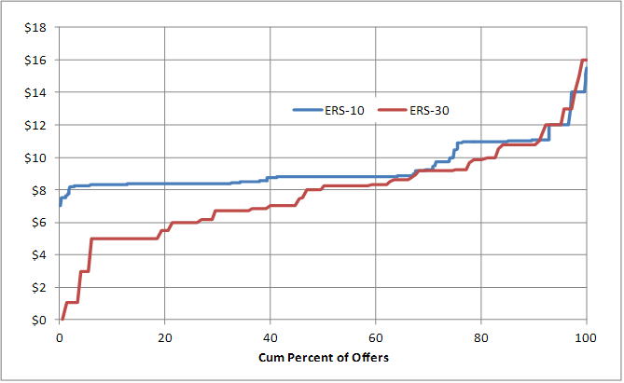
Graph 3: Offer Distribution for BH2 (June 2012 – September 2013)

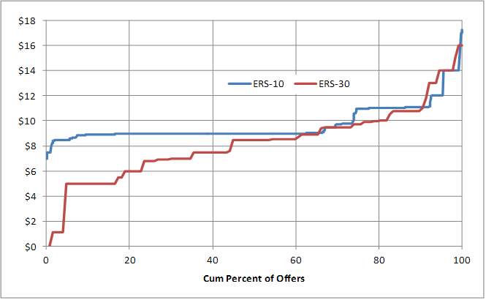
Graph 4: Offer Distribution for BH3 (June 2012 – September 2013)
Graph 5: Offer Distribution for NBH (June 2012 – September 2013)
During the latter part of this pilot project ERCOT introduced an alternative procurement methodology that would remove much of the subjectivity from the process and that would more closely align the price for the service with the need for the service.

Purpose 4 and 5: Gather data to assist ERCOT in determining the appropriate price to pay for 30 - Minute ERS and to costs and benefits relative to 10-Minute ERS

ERCOT has compared the clearing prices for 30-Minute ERS to the prices offered and paid for 10- Minute ERS in each of the Contract Periods. Table 3 below shows the highest price cleared and the average price paid for 10-Minute ERS and the clearing price for 30-Minute ERS for each Time Period of the two Contract Periods. Based on these comparisons, it appears that ERS providers value the two services roughly equally. Prices offered for 30-Minute ERS during the pilot are likely to be skewed somewhat higher due to the 100% probability of being deployed through tests.

The Governing Document allows ERCOT to test Pilot Resources up to 4 times per Contract Period, whereas 10-Minute ERS Resources are subject to testing only once per year. The prices for 30-Minute ERS in the first Contract Period were higher than they otherwise would have been because the number of participating Pilot Resources and the amounts offered were small and the ERCOT procurement committee decided to procure all 30-Minute ERS capacity offered. For subsequent Contract Periods, the number of offering Resources increased significantly, giving the committee greater flexibility to reject higher offers.

There were a few instances where QSEs offered the same ERS Resources into both 10- and 30-Minute ERS in the same Time Periods. In the second Contract Period, each ERS Resource was offered in to both services at the same price. For the third Contract Period, however, a few ERS Resources were offered into both services, with significantly higher prices for the 30-Minute service, possibly reflecting costs associated with the certainty of deployment during the pilot.

Contract Period |  | BH1  HE 0900-1300  M-F except holidays | BH2  HE 1400-1600  M-F except holidays | BH3  HE 1700-2000  M-F except holidays | NBH  All Other Hours
10 -Minute ERS Jun-Sep12 | Highest Offer Accepted | $16.00 | $16.00 | $16.00 | $12.75
10 -Minute ERS Jun-Sep12 | Average Price | $8.70 | $9.67 | $9.97 | $8.83
30 -Minute ERS Pilot Jul 15-Sep12 | Clearing Price | $11.00 | $16.00 | $16.00 | $11.00
10 -Minute ERS Oct12-Jan13 | Highest Offer Accepted | $8.75 | $9.75 | $9.75 | $8.75
10 -Minute ERS Oct12-Jan13 | Average Price | $8.22 | $8.77 | $9.06 | $8.15
30 -Minute ERS Pilot Oct12-Jan13 | Clearing Price | $8.10 | $9.20 | $9.50 | $8.20
10 -Minute ERS Feb-May13 | Highest Offer Accepted | $8.75 | $9.75 | $9.75 | $8.75
10 -Minute ERS Feb-May13 | Average Price | $8.10 | $8.71 | $8.82 | $8.04
30 -Minute ERS Pilot Feb-May13 | Clearing Price | $7.81 | $8.60 | $8.90 | $7.80
10 -Minute ERS Jun-Sep 13 | Highest Offer Accepted | $12.15 | $15.12 | $12.60 | $12.15
10 -Minute ERS Jun-Sep 13 | Average Price | $10.21 | $12.07 | $12.60 | $10.13
30 -Minute ERS Pilot Jun-Sep 13 | Clearing Price | $11.00 | $12.00 | $14.00 | $11.00
10 -Minute ERS Oct13-Jan14 | Highest Offer Accepted | $9.21 | $9.25 | $9.35 | $9.13
10 -Minute ERS Oct13-Jan14 | Average Price | $8.01 | $8.37 | $8.44 | $7.98
30 -Minute ERS Pilot Oct13-Jan14 | Clearing Price | $8.00 | $8.50 | $8.80 | $8.00
Table 3: Price Comparison Table, all prices are $/MW/Hr

To perform a more in-depth cost/benefit analysis, ERCOT compared the cost of 30-Minute ERS to both the average historical cost of Non-Spinning Reserve Service as well as the incentive payments provided to participants in the TDSP Standard Offer Load Management Programs.

Comparing Cost to Non-Spinning Reserve Service

Like 30-Minute ERS, Non-Spinning Reserve Service (NSRS) is also a 30-Minute ramp service. Table 4 below shows the comparison of the clearing price for 30-Minute ERS versus the average cost of NSRS for the Time Periods defined for ERS.

The prices paid for 30-Minute ERS were less than NSRS prices during the higher risk BH2 and BH3 time periods during the initial June-September Contract Period. Otherwise, NSRS prices were lower than 30-Minute ERS. It should be kept in mind, however that Ancillary Services are procured in the Day- Ahead Market for each Operating Day, whereas 30-Minute ERS is procured three times a year and requires a four-month commitment. NSRS providers have the opportunity to adjust their offers on a daily and hourly basis to reflect anticipated operating conditions for the next day. ERS providers, on the other hand, are required to make their offers to ERCOT about two weeks before the beginning of each Contract Period and therefore have only historical information and planning reports such as the CDR or SARA to base their offers on.

Table 4: ERS-30 Prices vs Average Price paid in Day-Ahead for Non-Spinning Reserve Service.

Comparing Cost to Incentives Paid to Load Management Programs

As part of meeting their Energy Efficiency Goals, TDSPs in the competitive choice areas in ERCOT administer Load Management Programs during roughly the same Time Period defined as BH2 and BH3 of the June-September ERS Contract Period. Even though the incentives for the TDSP programs are capped by the avoided cost, currently $80/KW/yr, the utilities typically have paid Load Management Program participants at one-half the avoided cost, or $40/KW/yr. Based on the commitment hours for the Load Management Programs (summer month weekdays from 1:00 pm to 7:00 pm), the $40/KW/yr is equivalent to $79.36/MW/hr and is substantially higher than the prices paid for 30-minute ERS for the comparable time periods.

Costs/Benefits Summary

Based on the comparisons provided above, 30-Minute ERS can be a cost-effective tool to prevent or reduce the length of firm Load shed events, especially during certain time periods. Much criticism toward ERS in general has been based on the concern that the price paid for the service during certain Time Periods does not align with the need for the service. This concern was addressed through the ERS Procurement Methodology approved by the ERCOT Board on 11/19/2013.

Purpose 6: Determine overall market interest in 30-Minute ERS before making appropriate ERCOT rule changes.

One of the primary reasons for proposing a new ERS product with a 30-Minute ramp period is that numerous ERS providers have communicated to both ERCOT and the PUCT that a product with a longer ramp could bring additional Demand Response into ERS. As Table 5, below, shows, the MW capacity offered has grown to a high of 126.97 MW in the current Contract Period. It should also be noted that the relatively low amount of capacity offered into the initial contract term was likely attributable to the very limited time providers had to market the product and subscribe participants.

 | BH1  HE 0900-1300  M-F except holidays | BH2  HE 1400-1600  M-F except holidays | BH3  HE 1700-2000  M-F except holidays | NBH  All Other Hours
July 15, 2012-September 2012 | 19.4 MW | 16.25 MW | 15.80 MW | 9.5 MW
October 2012-January 2013 | 93.68 MW | 95.58 MW | 89.01 MW | 75.15 MW
February-May 2013 | 106.26 MW | 106.30 MW | 95.28 MW | 82.61 MW
June-September 2013 | 126.97 MW | 87.65 MW | 76.19 MW | 100.94 MW
October 2013-January 2014 | 134.252 MW | 136.348 MW | 122.565 MW | 111.671 MW

Table 5: Capacity Offered in each Time Period for 30-Minute ERS

Follow-Up to July 16, 2013 ERCOT Board Meeting

During the July 16th Board meeting it was requested that ERCOT perform an analysis of the reliability value of the pilot programs”; in this case 30-Minute ERS Pilot. In response ERCOT feels that the reliability value is the additional resources a 30-Minute ERS product can attract. The capacity offered into the pilot project has grown from 19 MWs in the first Standard Contract Term to just under 138 MW in the October 2013 through January 2014 Standard Contract Term. It’s important to note that the loads that offer into ERS are not able to follow a 5-minute dispatch and therefore would not be able to participate in the new design of Loads in SCED. Therefore 30-Minute ERS is attracting new capacity that otherwise would not be able to participate under an ERCOT instruction. In addition ERS has proven to be a valuable operational tool to help minimize the effects of a firm load shed as can be observed during the February 2, 2011 event. During that event 384.2 MWs of ERS were deployed which based on the load profiles for that particular day had the equivalent impact of reducing the firm load shed to approximately 250,000 residential homes.

Also during the July Board meeting ERCOT was asked if a seasonality study for the different time periods had been undertaken. In response ERCOT acknowledges that the risk of an ERS deployment varies throughout the ERS budget year and that the prices paid for ERS in some time periods (higher risk) is more competitive compared to other services than in other time periods. To better align the price for ERS with the risk of deployment ERCOT as proposed a new ERS procurement methodology will allow ERCOT to assign potential risk levels to each of the time periods which will help push prices down during lower risk periods. The development of this new procurement methodology also helped highlight issues with the existing Standard Contract Terms and time periods. As an example the highest risk period for a winter peak are generally in the early morning hours (6 to 8 a.m.) during December, January and February. Therefore only about 5.8% of the hours in the ERS budget year should be assigned a higher risk value to cover the winter peak but under the currently defined Standard Contract Terms and time periods 53% of the annual hours would need to be assigned the higher values. Modifying the existing Standard Contract Terms and time periods will help optimize the reliability value of ERS.

It is ERCOT's opinion that the added new dispatchable capacity that the 30-Minute ERS pilot has attracted proves the reliability value of this program. It is also ERCOT's opinion that the new procurement methodology proposed by ERCOT will help increase the value of this service by better aligning the price paid for the service with the assigned risk levels for each time period. And finally it is ERCOT's recommendation that making changes to the ERS Standard Contract Terms and time periods will help improve the value of ERS across all ERS time periods.

Pilot Conclusions

One of the primary objectives of the 30-Minute ERS pilot was to test the feasibility and usefulness of an ERS type with differing response times, as encouraged by the commission in its rulemaking to amend Substantive Rule §25.507. In its final order approving the rule amendments, the commission stated:

The suggestion that ERCOT establish classes of ERS participants with differing response times appears to have merit, and could encourage participation in the program by more load resources than currently participate. The commission encourages ERCOT to expeditiously explore the feasibility and usefulness of implementing this feature. If ERCOT determines that the program should include classes of ERS participants with differing response times, the commission encourages ERCOT to implement this feature as soon as possible but not later than the summer of 2013.

* * *

The commission made it clear in the previous rulemakings pertaining to this service that it regards a robust demand response program as an essential tool for ERCOT in fulfilling its responsibilities to ensure reliable operation of the grid. The commission has acted in the past to expand and increase participation in the program. The commission restates here that this continues to be the policy of the commission. EILS has, in the EEA event of February 2011 and in the peak demand periods of the summer of 2011, demonstrated its value in forestalling the need for firm load shedding.

Final Order, Project 39948, Rulemaking to Amend Substantive Rule § 25.507, Relating to Electric Reliability Council of Texas (ERCOT) Emergency Interruptible Load Service (EILS), at 17, 19 (March 23, 2012). It is ERCOT's opinion that the new dispatchable capacity that the 30-Minute ERS pilot has attracted proves the reliability value of this program. It is also ERCOT's opinion that the new procurement methodology proposed by ERCOT will help increase the value of this service by better aligning the price paid for the service with the assigned risk levels for each time period. And finally it is ERCOT's recommendation that making changes to the ERS Standard Contract Terms and time periods will help improve the value of ERS across all ERS time periods.

Appendix A: Test Results

Resource Level Summary & Fleet Performance for
September 5, 2012 Test

Resource | Event Performance Factor | Obligation (MW) | Load Reduction (MW)
Resource 1 | 1.000 | 0.30 | 0.31
Resource 2 | 0.050 | 8.60 | 0.17
Resource 3 | 1.000 | 0.40 | 0.50
Resource 4 | 1.000 | 6.00 | 6.38
Resource 6 | 0.476 | 0.10 | 0.06
Resource 9 | 0.067 | 2.00 | 0.25
Resource 11 | 1.000 | 0.30 | 1.06
Resource 12 | 1.000 | 0.30 | 0.37
Fleet | 0.830 | 18.00 | 9.09

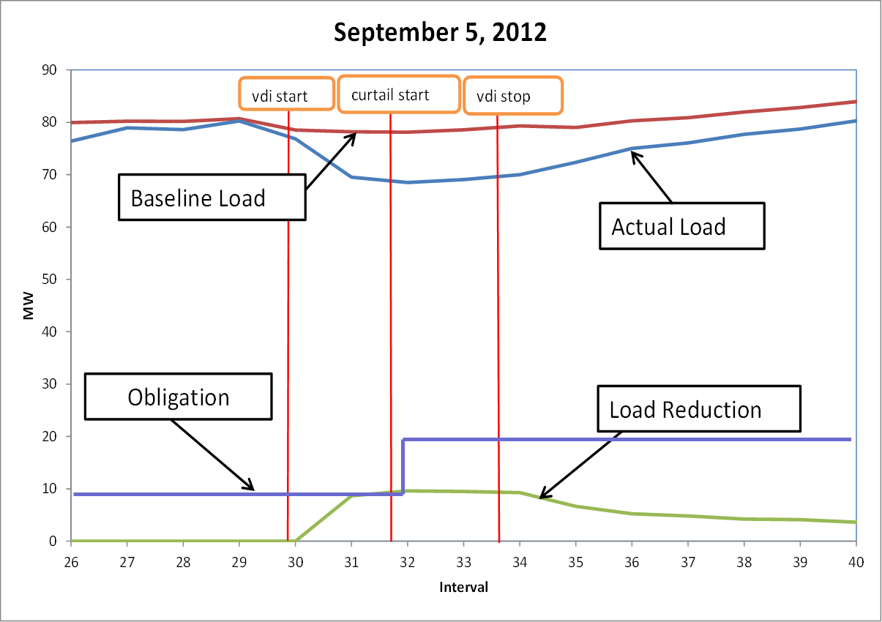

Resource Level Summary & Fleet Performance for
September 13, 2012 Test

Resource | Event Performance Factor | Obligation (MW) | Load Reduction (MW)
Resource 1 | 1.000 | 0.30 | 0.37
Resource 2 | 1.000 | 8.60 | 12.43
Resource 3 | 1.000 | 0.40 | 0.50
Resource 4 | 1.000 | 6.00 | 6.77
Resource 5 | 1.000 | 0.20 | 0.30
Resource 6 | 0.545 | 0.10 | 0.18
Resource 8 | 0.624 | 0.20 | 0.11
Resource 9 | 0.482 | 2.00 | 0.83
Resource 10 | 1.000 | 1.00 | 1.80
Resource 11 | 1.000 | 0.30 | 0.48
Resource 12 | 1.000 | 0.30 | 0.35
Fleet | 1.235 | 19.40 | 24.13

Resource Level Summary & Fleet Performance for
September 26, 2012 Test

Resource | Event Performance Factor | Obligation (MW) | Load Reduction (MW)
Resource 2 | 1.000 | 8.60 | 14.63
Resource 3 | 1.000 | 0.50 | 0.60
Resource 4 | 1.000 | 6.00 | 7.25
Resource 5 | 0.000 | 0.20 | -0.03
Resource 6 | 1.000 | 0.10 | 0.27
Resource 7 | 0.400 | 0.35 | 0.12
Resource 8 | 0.798 | 0.20 | 0.13
Resource 11 | 0.389 | 0.30 | -0.53
Fleet | 1.638 | 16.25 | 22.44

Resource Level Summary & Fleet Performance for
October 30, 2012 Test
Resource | Event Performance Factor | Obligation (MW) | Load Reduction (MW)
Resource 1 | 0.877 | 4.50 | 2.22
Resource 2 | 1.000 | 0.80 | 1.03
Resource 3 | 1.000 | 0.80 | 1.27
Resource 4 | 1.000 | 0.20 | 0.21
Resource 5 | 1.000 | 0.10 | 0.16
Resource 6 | 0.470 | 0.15 | 0.11
Resource 7 | 0.178 | 0.18 | 0.00
Resource 8 | 1.000 | 0.55 | 0.42
Resource 9 | 0.456 | 0.85 | 0.27
Resource 10 | 1.000 | 2.20 | 3.46
Resource 11 | 0.694 | 1.70 | 1.01
Resource 12 | 0.115 | 2.00 | 0.00
Resource 13 | 0.714 | 1.00 | 0.14
Resource 14 | 0.728 | 0.60 | 0.43
Resource 15 | 1.000 | 4.73 | 5.46
Resource 16 | 1.000 | 1.60 | 1.44
Resource 17 | 0.992 | 0.20 | 0.22
Resource 18 | 0.082 | 0.20 | 0.01
Resource 19 | 1.000 | 0.20 | 0.26
Resource 20 | 1.000 | 0.30 | 0.31
Resource 21 | 1.000 | 0.80 | 1.10
Resource 22 | 1.000 | 0.20 | 0.29
Resource 23 | 1.000 | 0.30 | 0.38
Resource 24 | 0.955 | 18.00 | 16.62
Resource 25 | 1.000 | 2.60 | 3.37
Resource 26 | 1.000 | 0.43 | 0.37
Resource 27 | 1.000 | 0.55 | 0.44
Resource 28 | 1.000 | 34.00 | 50.61
Resource 29 | 0.081 | 0.10 | 0.00
Resource 30 | 0.963 | 2.50 | 2.34
Fleet | 1.342 | 82.33 | 93.95

Resource Level Summary & Fleet Performance for
November 20, 2012 Test
Resource | Event Performance Factor | Obligation (MW) | Load Reduction (MW)
Resource 1 | 1.000 | 4.50 | 5.06
Resource 2 | 0.000 | 0.80 | 0.00
Resource 3 | 0.080 | 0.80 | 0.07
Resource 4 | 1.000 | 0.20 | 0.20
Resource 5 | 0.000 | 0.10 | 0.00
Resource 6 | 0.000 | 0.15 | 0.00
Resource 7 | 0.261 | 0.18 | 0.00
Resource 8 | 1.000 | 0.60 | 0.40
Resource 9 | 0.067 | 0.75 | 0.01
Resource 10 | 1.000 | 2.20 | 3.55
Resource 11 | 0.486 | 1.00 | 0.00
Resource 12 | 1.000 | 1.60 | 1.21
Resource 13 | 0.774 | 1.70 | 1.14
Resource 14 | 0.957 | 0.60 | 0.55
Resource 15 | 0.370 | 2.00 | 1.46
Resource 16 | 1.000 | 4.73 | 5.23
Resource 17 | 1.000 | 0.20 | 0.20
Resource 18 | 1.000 | 0.30 | 0.36
Resource 19 | 0.957 | 2.60 | 3.63
Resource 20 | 0.672 | 18.00 | 10.52
Resource 21 | 1.000 | 0.20 | 0.23
Resource 22 | 1.000 | 0.20 | 0.33
Resource 23 | 1.000 | 0.80 | 1.00
Resource 24 | 0.115 | 0.20 | 0.03
Resource 25 | 1.000 | 0.30 | 0.42
Resource 26 | 1.000 | 0.43 | 0.41
Resource 27 | 1.000 | 0.55 | 0.56
Resource 28 | 1.000 | 32.00 | 49.25
Resource 29 | 1.000 | 0.10 | 0.19
Resource 30 | 1.000 | 2.50 | 3.29
Fleet | 1.231 | 82.33 | 93.95

Resource Level Summary & Fleet Performance for
February 28, 2013 Test
Resource | Event Performance Factor | Obligation (MW) | Load Reduction (MW)
Resource 1 | 1.000 | 0.25 | 0.76
Resource 2 | 1.000 | 0.40 | 0.51
Resource 3 | 0.503 | 0.15 | 0.07
Resource 4 | 0.017 | 0.80 | 0.01
Resource 5 | 1.000 | 1.30 | 1.57
Resource 6 | 1.000 | 1.00 | 1.63
Resource 7 | 0.576 | 0.10 | 0.00
Resource 8 | 1.000 | 0.39 | 0.12
Resource 9 | 1.000 | 0.22 | 0.33
Resource 10 | 0.893 | 0.35 | 0.28
Resource 11 | 1.000 | 2.30 | 2.53
Resource 12 | 0.889 | 0.95 | 0.91
Resource 13 | 0.532 | 0.25 | 0.05
Resource 14 | 1.000 | 0.50 | 0.82
Resource 15 | 1.000 | 0.50 | 0.51
Resource 16 | 1.000 | 5.00 | 7.85
Resource 17 | 1.000 | 1.60 | 2.16
Resource 18 | 1.000 | 0.30 | 0.44
Resource 19 | 1.000 | 0.23 | 0.26
Resource 20 | 1.000 | 0.18 | 0.50
Resource 21 | 1.000 | 0.10 | 0.54
Resource 22 | 1.000 | 0.20 | 0.22
Resource 23 | 0.491 | 0.20 | 0.17
Resource 24 | 1.000 | 0.20 | 0.21
Resource 25 | 1.000 | 0.30 | 1.41
Resource 26 | 0.018 | 18.00 | 0.00
Resource 27 | 0.811 | 1.40 | 1.15
Resource 28 | 1.000 | 0.60 | 0.78
Resource 29 | 0.201 | 0.30 | 0.00
Resource 30 | 1.000 | 0.30 | 0.40
Resource 31 | 0.943 | 5.00 | 4.50
Resource 32 | 0.040 | 1.20 | 0.03
Resource 33 | 0.410 | 3.00 | 1.44
Fleet | 0.826 | 47.56 | 32.16

February 28, 2013

Resource Level Summary & Fleet Performance for
May 23, 2013 Test

Resource | Event Performance Factor | Obligations (MW) | Load Reduction (MW)
Resource 1 | 1.000 | 0.25 | 0.36
Resource 2 | 1.000 | 0.40 |  | 0.89
Resource 3 | 1.000 | 0.40 |  | 0.66
Resource 4 | 1.000 | 0.15 |  | 0.35
Resource 5 | 1.000 | 0.80 |  | 1.04
Resource 6 | 1.000 | 1.30 |  | 1.62
Resource 7 | 1.000 | 0.20 |  | 0.24
Resource 8 | 1.000 | 0.30 |  | 0.00
Resource 9 | 0.000 | 1.00 |  | 1.33
Resource 10 | 0.034 | 0.10 |  | 0.00
Resource 11 | 0.568 | 0.39 |  | 0.08
Resource 12 | 0.480 | 0.22 |  | 0.10
Resource 13 | 1.000 | 0.35 |  | 0.62
Resource 14 | 1.000 | 2.30 |  | 4.56
Resource 15 | 1.000 | 1.20 |  | 1.41
Resource 16 | 0.607 | 0.95 |  | 0.56
Resource 17 | 0.034 | 0.28 |  | 0.00
Resource 18 | 0.000 | 0.25 |  | 0.00
Resource 19 | 1.000 | 0.50 |  | 0.85
Resource 20 | 1.000 | 0.50 |  | 0.56
Resource 21 | 1.000 | 5.00 |  | 6.79
Resource 22 | 1.000 | 1.60 |  | 1.77
Resource 23 | 1.000 | 0.20 |  | 0.29
Resource 24 | 0.966 | 0.13 |  | 0.19
Resource 25 | 0.000 | 0.80 |  | 0.00
Resource 26 | 0.000 | 1.00 |  | 0.00
Resource 27 | 1.000 | 0.20 |  | 0.29
Resource 28 | 1.000 | 1.90 |  | 3.21
Resource 29 | 0.000 | 0.18 |  | 0.00
Resource 30 | 0.966 | 0.10 |  | 0.15
Resource 31 | 0.953 | 0.18 |  | 0.17
Resource 32 | 0.487 | 0.13 |  | 0.06
Resource 33 | 0.951 | 0.13 |  | 0.21
Resource 34 | 1.000 | 0.23 |  | 0.44
Resource 35 | 0.683 | 0.35 |  | 0.25
Resource 36 | 0.000 | 0.75 |  | 0.00
Resource 37 | 0.986 | 0.50 |  | 0.66
Resource 38 | 0.115 | 0.30 |  | 0.03
Resource 39 | 0.497 | 0.18 |  | 0.09
Resource 40 | 1.000 | 0.10 |  | 0.39
Resource 41 | 0.000 | 1.20 |  | 0.00
Resource 42 | 1.000 | 0.20 |  | 0.35
Resource 43 | 1.000 | 0.20 |  | 0.25
Resource 44 | 0.000 | 0.20 |  | 0.00
Resource 45 | 1.000 | 0.30 |  | 0.65
Resource 46 | 1.000 | 18.00 |  | 19.82
Resource 47 | 1.000 | 2.60 |  | 3.28
Resource 48 | 1.000 | 1.40 |  | 1.66
Resource 49 | 1.000 | 1.30 |  | 1.56
Resource 50 | 0.492 | 0.60 |  | 0.79
Resource 51 | 1.000 | 0.30 |  | 0.44
Resource 52 | 1.000 | 0.30 |  | 0.32
Resource 53 | 0.755 | 10.80 |  | 8.06
Resource 54 | 0.797 | 5.00 |  | 3.95
Resource 55 | 1.000 | 0.10 |  | 0.54
Resource 56 | 0.000 | 0.50 |  | 0.00
Resource 57 | 0.739 | 1.20 |  | 0.88
Resource 58 | 1.000 | 3.00 |  | 4.98
Fleet | 1.764 | 72.96 |  | 77.75
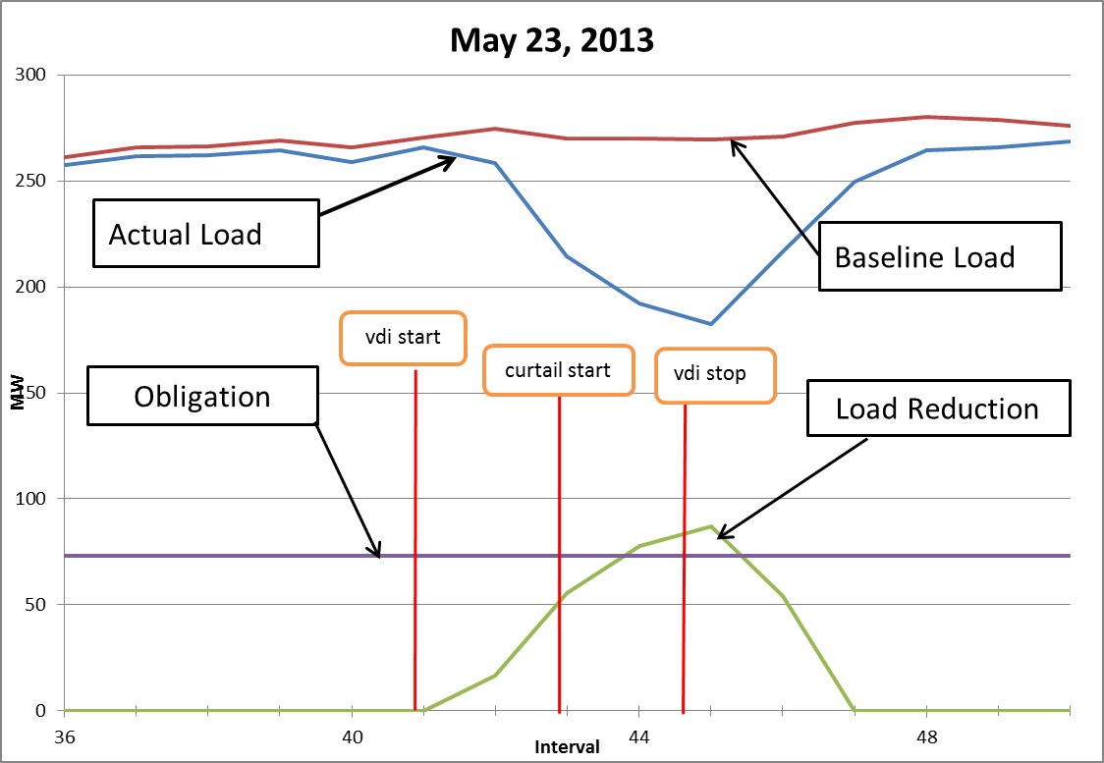

Resource Level Summary & Fleet Performance for
September 19, 2013 Test

Resource | Event Performance Factor | Obligations (MW) | Load Reduction (MW)
Resource 1 | 1.00 | 0.30 | 0.71
Resource 2 | 0.00 | 0.15 | 0.00
Resource 3 | 1.00 | 0.25 | 1.04
Resource 4 | 1.00 | 0.23 | 0.66
Resource 5 | 0.18 | 0.10 | 0.02
Resource 6 | 0.91 | 0.50 | 0.44
Resource 7 | 0.00 | 1.00 | 0.00
Resource 8 | 0.07 | 0.30 | 0.00
Resource 9 | 0.92 | 0.65 | 0.58
Resource 10 | 0.59 | 0.10 | 0.07
Resource 11 | 1.00 | 1.28 | 1.76
Resource 12 | 1.00 | 0.15 | 0.18
Resource 13 | 0.93 | 0.25 | 0.21
Resource 14 | 0.21 | 0.35 | 0.09
Resource 15 | 0.49 | 0.15 | 0.00
Resource 16 | 0.99 | 1.45 | 1.60
Resource 17 | 0.95 | 0.20 | 0.18
Resource 18 | 0.00 | 0.13 | 0.00
Resource 19 | 1.00 | 0.20 | 0.45
Resource 20 | 0.00 | 0.10 | 0.00
Resource 21 | 1.00 | 0.30 | 1.37
Resource 22 | 0.00 | 1.50 | 0.00
Resource 23 | 0.61 | 20.00 | 11.32
Resource 24 | 1.00 | 4.00 | 6.82
Resource 25 | 1.00 | 2.40 | 3.62
Resource 26 | 1.00 | 10.80 | 16.36
Resource 27 | 1.00 | 0.55 | 0.61
Resource 28 | 1.00 | 36.30 | 47.42
Resource 29 | 1.00 | 0.90 | 1.34
Resource 30 | 1.00 | 1.25 | 2.31
Resource 31 | 0.99 | 0.55 | 0.76
Resource 32 | 0.62 | 0.48 | 0.31
Resource 33 | 0.97 | 0.80 | 1.04
Fleet | 1.190 | 87.65 | 101.27

September 19, 2013 Test

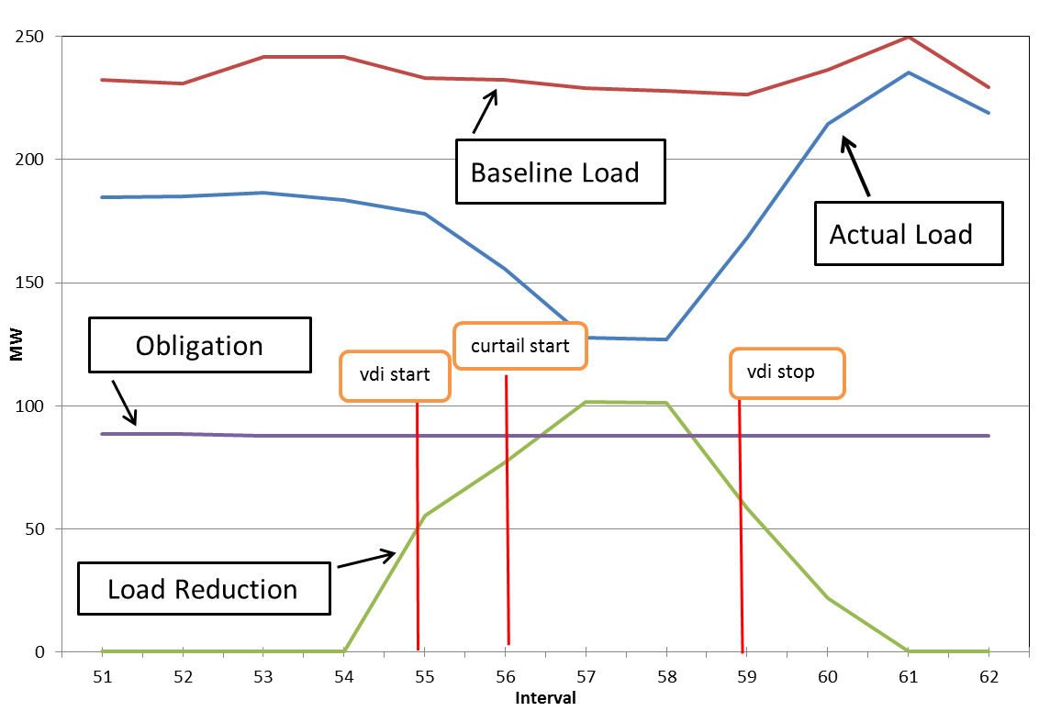

Fleet Performance & Resource Level Summary for
January 30, 2014 Test

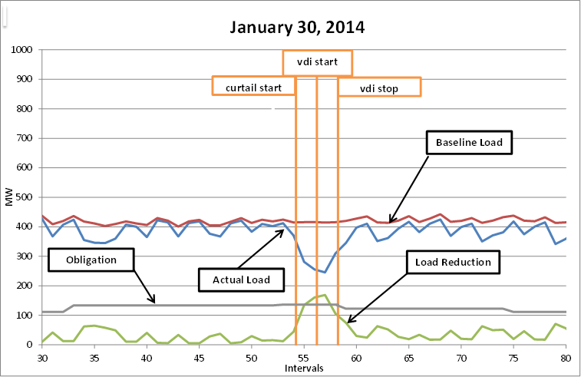

Appendix B: January 6, 2014 Event Results

Fleet Performance and Resource Level Summary
for January 6, 2014 Event

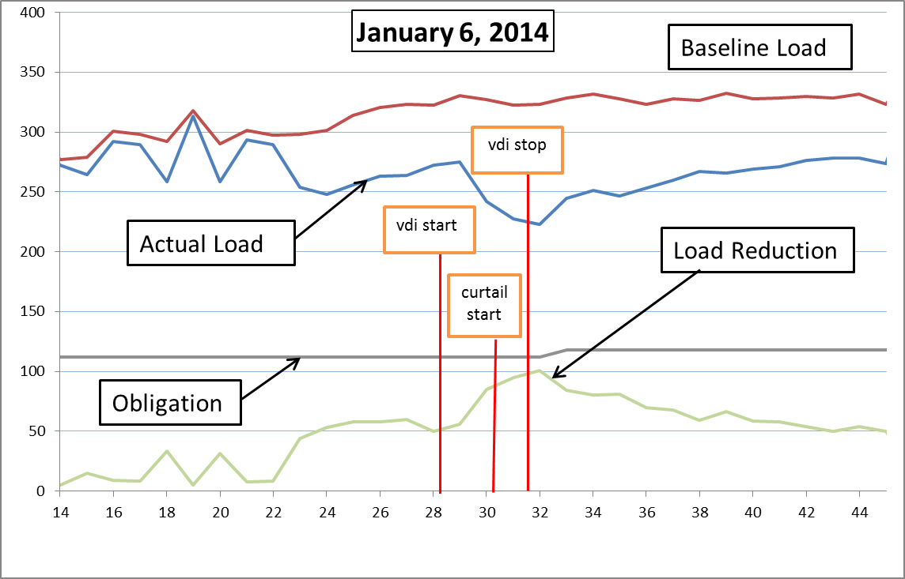

Resource | Event Performance Factor | Obligation (MW) | Load Reduction (MW)
Resource1 | 1.000 | 0.250 | 0.777
Resource2 | 1.000 | 0.150 | 0.345
Resource3 | 1.000 | 0.400 | 0.863
Resource4 | 1.000 | 0.380 | 0.693
Resource5 | 1.000 | 0.900 | 0.795
Resource6 | 1.000 | 0.350 | 0.486
Resource7 | 1.000 | 0.120 | 0.195
Resource8 | 0.783 | 1.000 | 0.000
Resource9 | 1.000 | 0.900 | 1.089
Resource10 | 0.052 | 0.620 | 0.025
Resource11 | 0.051 | 5.700 | 0.224
Resource12 | 0.346 | 0.600 | 0.160
Resource13 | 1.000 | 4.000 | 3.481
Resource14 | 1.000 | 5.700 | 5.153
Resource15 | 1.000 | 0.500 | 0.494
Resource16 | 1.000 | 0.245 | 0.327
Resource17 | 0.981 | 0.100 | 0.076
Resource18 | 1.000 | 0.790 | 0.776
Resource19 | 0.017 | 0.160 | 0.002
Resource20 | 0.815 | 0.681 | 0.428
Resource21 | 1.000 | 2.800 | 2.576
Resource22 | 0.000 | 0.100 | 0.000
Resource23 | 1.000 | 0.450 | 0.368
Resource24 | 0.494 | 0.600 | 0.229
Resource25 | 1.000 | 4.400 | 9.670
Resource26 | 1.000 | 1.000 | 1.753
Resource27 | 1.000 | 1.100 | 2.415
Resource28 | 1.000 | 0.150 | 0.248
Resource29 | 1.000 | 0.125 | 0.492
Resource30 | 0.697 | 0.100 | 0.054
Resource31 | 0.307 | 0.100 | 0.024
Resource32 | 1.000 | 0.250 | 0.384
Resource33 | 1.000 | 0.200 | 0.207
Resource34 | 0.000 | 1.000 | 0.000
Resource35 | 0.000 | 0.200 | 0.000
Resource36 | 0.000 | 0.500 | 0.000
Resource37 | 0.000 | 0.150 | 0.000
Resource38 | 1.000 | 0.200 | 0.210
Resource39 | 1.000 | 0.150 | 0.000
Resource40 | 0.000 | 1.000 | 0.000
Resource41 | 1.000 | 0.500 | 0.540
Resource42 | 1.000 | 0.300 | 0.327
Resource43 | 0.118 | 21.000 | 1.908
Resource44 | 1.000 | 0.300 | 0.287
Resource45 | 1.000 | 1.400 | 1.197
Resource46 | 1.000 | 1.300 | 1.018
Resource47 | 1.000 | 2.500 | 2.015
Resource48 | 1.000 | 0.600 | 0.750
Resource49 | 1.000 | 38.000 | 45.464
Resource50 | 1.000 | 3.000 | 3.539
Resource51 | 0.582 | 1.000 | 0.449
Resource52 | 1.000 | 0.100 | 0.384
Resource53 | 0.007 | 3.200 | 0.016
Resource54 | 1.000 | 0.350 | 1.921
Fleet | 1.101 | 111.671 | 94.831

The Governing Document is available at http://www.ercot.com/mktrules/pilots/.
Except where defined by the ERCOT Protocols, capitalized terms in this report are those defined in the Governing Document.
Available at: http://www.ercot.com/content/services/programs/load/eils/ERS_k/Process_for_Determining_Cost_Limits_&_Reasonablen ess_of_Offe.pdf

