
February 2014 ERCOT Monthly Operations Report

Reliability and Operations Subcommittee Meeting
March 6, 2014
Table of Contents
1. Report Highlights 1
2. Frequency Control 2
2.1. Frequency Events 2
2.2. Responsive Reserve Events 3
2.3. Load Resource Events 3
2.4. PMU Events 3
3. Reliability Unit Commitment 3
4. Wind Generation as a Percent of Load 5
5. Congestion Analysis 5
5.1. Notable Constraints for February 5
5.2. Generic Transmission Limit Congestion 6
5.3. Congestion Costs for Calendar Year 2014 7
6. System Events 8
6.1. ERCOT Peak Load 8
6.2. Load Shed Events 8
6.3. Stability Events 8
6.4. TRE/DOE Reportable Events 8
6.5. New/Updated RAPs and PCAPs 8
6.6. New/Modified/Removed SPS 8
6.7. New Procedures/Forms/Operating Bulletins 9
7. Emergency Conditions 9
7.1. OCNs 9
7.2. Advisories 9
7.3. Watches 9
7.4. Emergency Notices 9
8. Application Performance 10
8.1. TSAT/VSAT Performance Issues 10
8.2. Communication Issues 10
9. Net-Forecast Bias Applied to NSRS Procurement for March 2014 10
10. Appendix A: Real-Time Constraints 11

Report Highlights
There continued to be a high level of activity on the ERCOT Interconnection as cold weather continued through the first half of February. The system responded well to the freezing temperatures and there were no Energy Emergency Alerts issued during the month. Since the weather became milder in the second half of the month, Operations noted fewer frequency events and RRS deployments than what had been observed in January. In addition, the amount of SCED congestion remained consistent with pervious months, though a greater fraction was related to ongoing outages.

Highlights of this report:
- The unofficial ERCOT peak for February was 57,056 MW.
- There were four frequency events in February. None of the disturbances were severe enough for PMU data to be captured and the ERCOT system recovered quickly in each case.
- There were four instances where Responsive Reserves were deployed. All of these were the result of frequency events. There were no Load Resource deployments in February.
- There was an increase in the number of RUC Commitments in February. The majority of these were to ensure voltage stability in the Rio Grande Valley during ongoing outages.
- The number of SCED congestion events was on par with previous months.
- ERCOT did not experience any significant system events in February despite the colder weather.
- ERCOT Applications performed well. There were no issues in February.

Frequency Control

Frequency Events
The ERCOT Interconnection experienced four frequency events in February, three of which were as a result of Resource trips. The average event duration was approximately 21 seconds, which was more consistent with the system performance observed in previous months. Further details on the Resource trip events can be seen in the Performance Disturbance Compliance Working Group report. A summary of the frequency events is provided below:

Date and Time | Max/Min Frequency  (Hz) | Duration of Event  (seconds) | Comments
2/1/2014 23:47 | 59.878 | 1 | Unit trip with approximately 292 MW
2/4/2014 0:00 | 59.896 | 49 | Gen deviation of -1070 MW
2/20/2014 21:06 | 59.864 | 28 | Unit trip with approximately 449 MW
2/28/2014 13:25 | 59.876 | 5 | Unit trip with approximately 503 MW

(Note: the duration of the frequency events is defined to be the time at which the frequency was outside the range of 60±0.1 Hz)

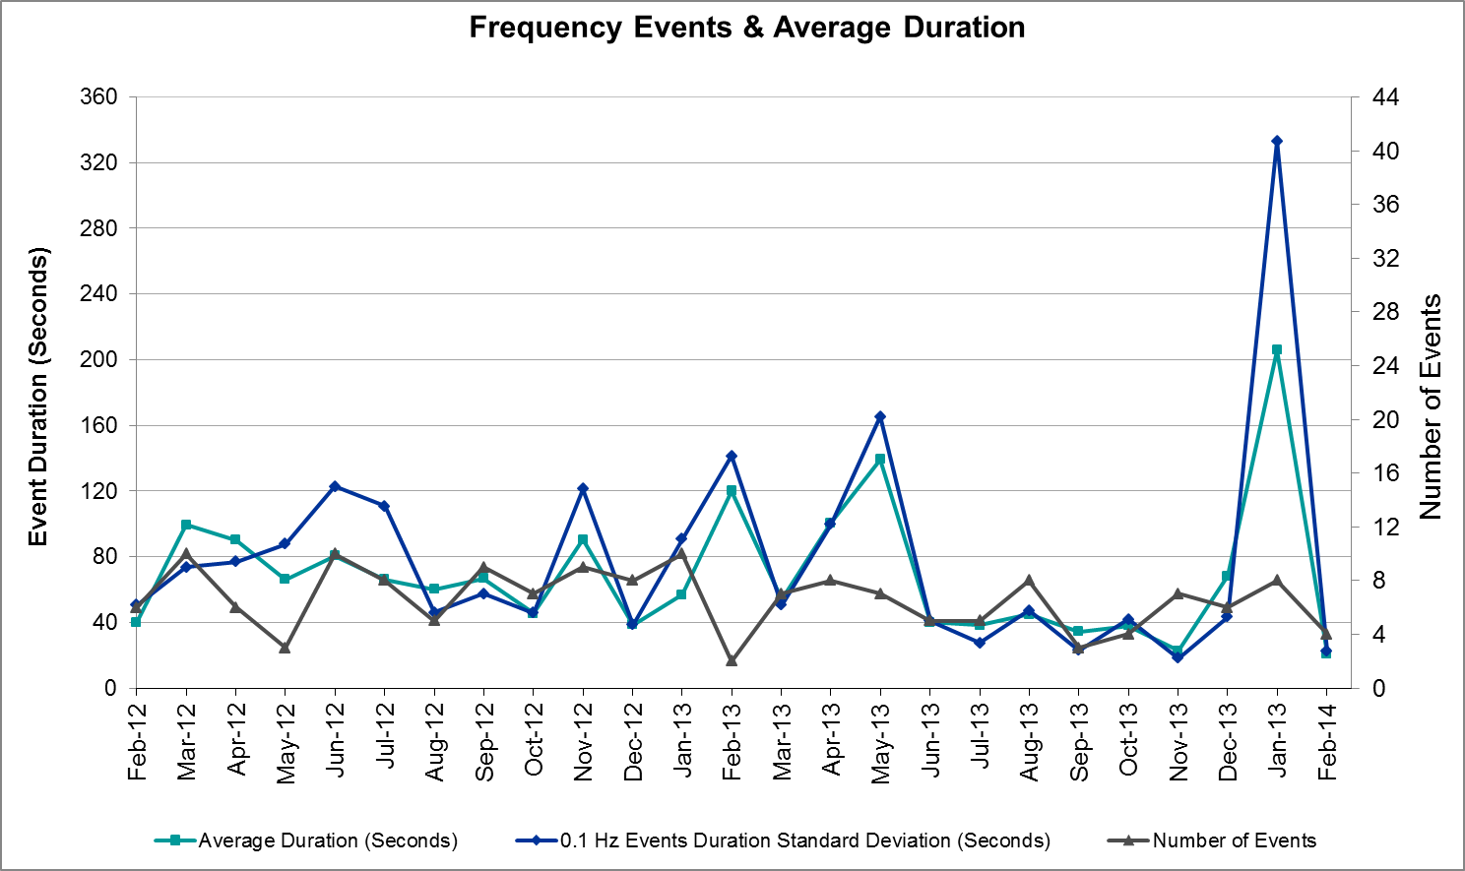

Responsive Reserve Events
There were four events where Responsive Reserve MWs were released to SCED in February. The events highlighted in blue were related to frequency events reported in section 2.1 above.

Date and Time  Released to SCED | Date and Time  Recalled | Duration of Event | Maximum MWs Released | Comments
2/1/14 23:47:32 | 2/1/14 23:49:16 | 0:01:44 | 138.11
2/4/14 0:00:32 | 2/4/14 0:04:24 | 0:03:52 | 491.37
2/20/14 21:06:59 | 2/20/14 21:09:48 | 0:02:49 | 376.97
2/28/14 13:26:10 | 2/28/14 13:29:54 | 0:03:44 | 462.59

Load Resource Events
There were no load resource deployment events in February.

PMU Events
There were no synchrophasor events captured in February that were the result of frequency events identified in section 2.1 above. The small duration and intensity of the events did not create a large enough system disturbance to be captured. When analyzing system disturbances, ERCOT evaluates PMU data according to industry standards. Events with an oscillating frequency of less than 1 Hz are considered to be inter-area, while higher frequencies indicate local events. Industry standards specify that damping ratio for inter-area oscillations should be 3.0% or greater.

Reliability Unit Commitment
ERCOT reports on Reliability Unit Commitments (RUC) on a monthly basis. Commitments are reported grouped by operating day and weather zone. The total number of hours committed is the sum of the hours for all the units in the specified region. Additional information on RUC commitments can be found on the MIS secure site at Grid → Generation → Reliability Unit Commitment.

DRUC Commitments
Resource Location | # of Resources | Operating Day | # Hours Committed | Total MWhs | Reason for commitment
N. Central | 1 | 2/3/2014 | 18 | 9,450 | Capacity
East | 1 | 2/19/2014 | 14 | 7,028 | Area Voltage Support

HRUC Commitments
Resource Location | # of Resources | Operating Day | # Hours Committed | Total MWhs | Reason for commitment
Southern | 1 | 2/1/2014 | 24 | 7,779 | Local Congestion
Southern | 1 | 2/2/2014 | 17 | 5,733 | Local Congestion
Coast | 2 | 2/2/2014 | 10 | 3,830 | Capacity
N. Central | 3 | 2/2/2014 | 17 | 5,726 | Capacity
S. Central | 2 | 2/2/2014 | 16 | 3,745 | Capacity
Northern | 1 | 2/2/2014 | 5 | 610 | Capacity
Southern | 1 | 2/3/2014 | 12 | 2,886 | Local Congestion
N. Central | 1 | 2/5/2014 | 3 | 300 | Capacity
Southern | 1 | 2/6/2014 | 24 | 1,451 | Local Congestion
N. Central | 1 | 2/6/2014 | 22 | 5,742 | Capacity
Coast | 1 | 2/6/2014 | 2 | 812 | Capacity
Coast | 1 | 2/7/2014 | 11 | 4,466 | Capacity
N. Central | 1 | 2/7/2014 | 10 | 2,610 | Capacity
Southern | 1 | 2/7/2014 | 6 | 366 | Voltage Stability
Southern | 4 | 2/8/2014 | 46 | 10,442 | Voltage Stability and Local Congestion
East | 1 | 2/10/2014 | 2 | 1,004 | Local Congestion
East | 1 | 2/11/2014 | 3 | 1,506 | Local Congestion
Coast | 1 | 2/11/2014 | 4 | 1,492 | Capacity
Southern | 3 | 2/13/2014 | 24 | 10,991 | Local Congestion
Southern | 2 | 2/14/2014 | 20 | 4,871 | Voltage Stability
Southern | 1 | 2/15/2014 | 24 | 8,195 | Voltage Stability
Southern | 1 | 2/16/2014 | 24 | 7,962 | Voltage Stability
Southern | 1 | 2/17/2014 | 24 | 8,000 | Voltage Stability
Southern | 1 | 2/18/2014 | 14 | 4,649 | Voltage Stability
Southern | 1 | 2/19/2014 | 24 | 7,964 | Voltage Stability
Southern | 4 | 2/20/2014 | 39 | 6,347 | Voltage Stability and Local Congestion
Southern | 1 | 2/21/2014 | 24 | 8,162 | Voltage Stability
Southern | 1 | 2/22/2014 | 24 | 8,106 | Voltage Stability
Southern | 1 | 2/23/2014 | 24 | 7,787 | Voltage Stability
Southern | 1 | 2/24/2014 | 6 | 1,954 | Voltage Stability
Southern | 1 | 2/25/2014 | 24 | 7,796 | Voltage Stability
Southern | 1 | 2/26/2014 | 5 | 1,613 | Voltage Stability
Southern | 1 | 2/27/2014 | 4 | 1,373 | Voltage Stability
Southern | 1 | 2/28/2014 | 4 | 7,369 | Voltage Stability

Wind Generation as a Percent of Load
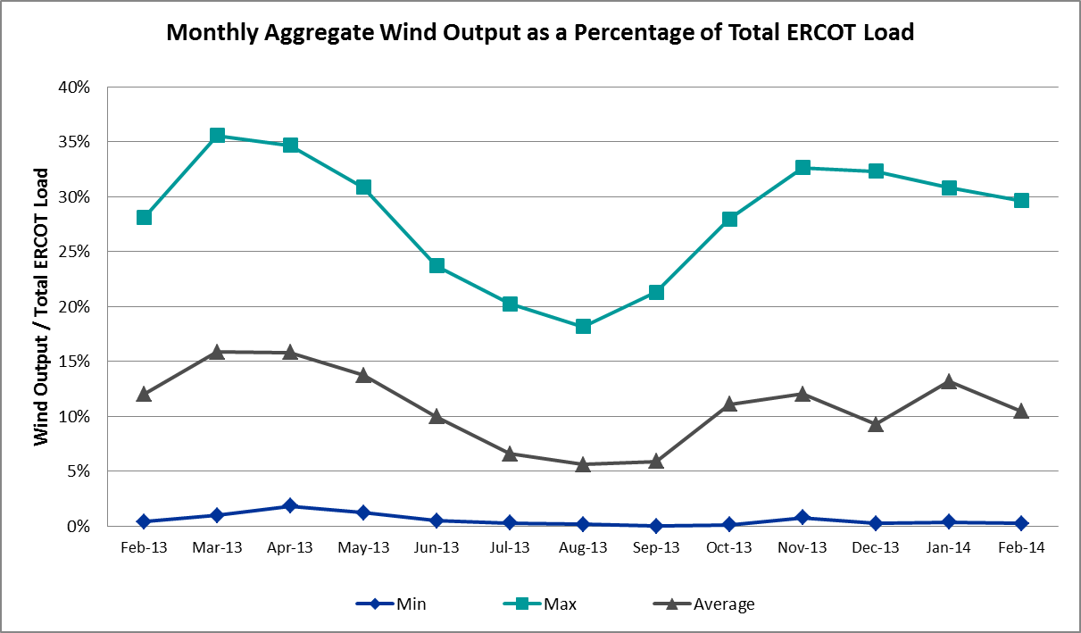

Congestion Analysis
The number of congestion events experienced by the ERCOT system remained steady again in February. Since the weather turned milder after the first half of the month, there were more congestion events related to outages than in January. There were also two days of activity on the Valley Import Generic Transmission Limit (GTL) resulting from planned outages in the area.

Notable Constraints for February
Nodal protocol section 3.20 specifies that ERCOT shall identify transmission constraints that are active or binding three or more times within a calendar month. As part of this process, ERCOT reports congestion that meets this criterion to ROS. In addition ERCOT also highlights notable constraints that have an estimated congestion rent exceeding $1,000,000 for a calendar month. These constraints are detailed in the table below. Rows highlighted in blue indicate the congestion was affected by one or more outages. For a list of all constraints activated in SCED for the month of February, please see Appendix A at the end of this report.

Contingency | Overload | # of Days Constraint Active | Estimated Congestion Rent | Transmission Project
Lytton Springs LY_AT2 345/138 kV | Lytton Springs LY_AT1 345/138 kV | 6 | $26,888,980
DCKT Gabriel - Bell County - Hutto Switch 138 kV | Marshall Ford - Lago Vista 138 kV | 2 | $4,766,492 | 15TPIT0061
DCKT Burleson - Carson Creek 138 kV and Pedernales - Advanced Micro Devices AEN 138 kV | Kingsberry - Mueller 138 kV | 1 | $4,036,986 | 11TPIT0008
Glasscock LCRA - Gabriel 138 kV | Marshall Ford - Lago Vista 138 kV | 1 | $3,825,703 | 15TPIT0061
DCKT Watermill Switch - Desoto Switch and Cedar Hill Switch 345 kV | Sargent Road AXFMR1H (3) 345/138 kV | 1 | $2,016,599 | 11TPIT0034
Alice - Kingsville 138 kV | Lon Hill - Robstown Tap 69 kV | 3 | $1,987,792 | 12TPIT0180
Pawnee Switching Station - Lon Hill 345 kV | Nelson Sharpe - Celanese Bishop 138 kV | 1 | $1,979,521 | 15TPIT0024
Orange Grove Switching Station - Lon Hill 138 kV | Lon Hill - Smith 69 kV | 4 | $1,971,898 | 16TPIT0026,  2012-R18
Nelson Sharpe - Lon Hill 345 kV | Celanese Bishop - Kleberg Aep 138 kV | 6 | $1,918,001 | 13TPIT0108,  15TPIT0069
DCKT Tonkawa Switch - Scurry County South Switch 345 kV | Bluff Creek Switch - Exxon Sharon Ridge 138 kV | 11 | $1,896,391
DCKT Gabriel - Glasscock LCRA and Rivery 138 kV | Marshall Ford - Lago Vista 138 kV | 1 | $1,279,331 | 15TPIT0061
Pawnee Switching Station - Lon Hill 345 kV | Lon Hill - Robstown Tap 69 kV | 1 | $1,001,932 | 12TPIT0180
DCKT Tri Corner - Tyler Grande and Martin Lake Ses - Elkton 345 kV | Elkton SD2 138 kV | 3 | $849,503
Nelson Sharpe - Lon Hill 345 kV | Nelson Sharpe - Celanese Bishop 138 kV | 3 | $825,862 | 15TPIT0069
Laquinta - Lobo 138 kV | Bruni 138_69_1 138/69 kV | 8 | $706,382 | 11TPIT0002
Pawnee Switching Station - Lon Hill 345 kV | Las Pulgas - Rio Hondo 138 kV | 5 | $532,746 | 14TPIT0050
DCKT Sam Switch - Tradinghouse Ses 345 kV | Whitney AXFMR2 (3) 345/138 kV | 3 | $492,096 | 12TPIT0090
DCKT Singleton - Zenith 345 kV | Singleton - Tomball 345 kV | 4 | $295,512
Koch Up River - Gila 138 kV | Gila - Hiway 9 138 kV (GILA_HIWAY_2) | 4 | $177,149
Bosque Switch - Whitney 138 kV | Bosque Switch - Lake Whitney Tnp 138 kV | 6 | $128,652
North Edinburg - Lon Hill 345 kV | Las Pulgas - Raymondville 2 138 kV | 5 | $79,448 | 10TPIT0148
Scurry Switch - Sun Switch 138 kV | Wolfgang - Rotan 69 kV | 8 | $19,563
Aspermont Aep - Spur 138 kV | Wolfgang - Rotan 69 kV | 5 | $2,119

Generic Transmission Limit Congestion
There were two days of GTL activity on the Valley Import Stability limit as a result of planned outages in the area. There was no GTL activity on the North – Houston, West – North, or SOP110 GTLs.

Congestion Costs for Calendar Year 2014
The following table represents the top twenty active constraints for the calendar year to date based on the estimated congestion rent attributed to the congestion. ERCOT updates this list on a monthly basis.

Contingency | Binding Element | # of 5-min SCED Intervals | Estimated Congestion Rent | Transmission Project
Lytton Springs LY_AT2 345/138 kV | Lytton Springs LY_AT1 345/138 kV | 1,943 | $49,748,316
DCKT Gabriel - Glasscock LCRA and Rivery 138 kV, Glasscock LCRA - Gabriel 138 kV, and DCKT Gabriel - Bell County - Hutto Switch 138 kV | Marshall Ford - Lago Vista 138 kV | 209 | $9,871,526 | 15TPIT0061
Stadium Aep - Alice 69 kV, Pawnee Switching Station - Lon Hill 345 kV, and Alice - Kingsville 138 kV | Lon Hill - Robstown Tap 69 kV | 904 | $6,091,279 | 12TPIT0180
Orange Grove Switching Station - Lon Hill 138 kV | Lon Hill - Smith 69 kV | 1,461 | $4,068,570 | 16TPIT0026, 2012-R18
DCKT Burleson - Carson Creek 138 kV and Pedernales - Advanced Micro Devices AEN 138 kV | Kingsberry - Mueller 138 kV | 75 | $4,036,986 | 11TPIT0008
Pawnee Switching Station - Lon Hill 345 kV, Nelson Sharpe - Lon Hill 345 kV, North Edinburg 345_1382 345/138 kV | Nelson Sharpe - Celanese Bishop 138 kV | 906 | $3,519,941 | 15TPIT0024
Coleto Creek - Pawnee Switching Station 345 kV, Pawnee Switching Station - Calaveras 345 kV | Coleto Creek - Kenedy Switch 138 kV | 267 | $3,451,890 | 16TPIT0034
DCKT Limestone - Navarro 345 kV | Jewett - Big Brown Ses 345 kV (Line 40) | 34 | $3,428,764
DCKT Tonkawa Switch - Scurry County South Switch 345 kV | Bluff Creek Switch - Exxon Sharon Ridge 138 kV | 1,373 | $3,183,550
Pawnee Switching Station - Lon Hill 345 kV, Nelson Sharpe - Lon Hill 345 kV, North Edinburg 345_1382 345/138 kV | Celanese Bishop - Kleberg Aep 138 kV | 1,532 | $2,860,092 | 13TPIT0108, 15TPIT0069
DCKT Watermill Switch - Desoto Switch and Cedar Hill Switch 345 kV | Sargent Road AXFMR1H (3) 345/138 kV | 106 | $2,016,599 | 11TPIT0034
Laquinta - Lobo 138 kV | Bruni 138_69_1 138/69 kV | 2,527 | $1,826,305 | 13TPIT0158, 13TPIT0159
DCKT Henne - Zorn - McCarty Lane 138 kV | Comal - Henne 138 kV (88T234) | 26 | $1,734,600 | 13TPIT0012
DCKT West Levee Switch - 800/900 Network 138 kV | East Levee Switch - Reagan Street 138 kV (3410) | 60 | $1,628,842 | 16TPIT0061
Trinidad Ses - Watermill Switch 345 kV and DCKT Trinidad Ses - Watermill Switch and Tricorner 345 kV | Trinidad Ses AXFMR6 (3) 345/138 kV | 38 | $1,567,670 | 13TPIT0186
DCKT Henne - Zorn - McCarty Lane 138 kV | Zorn - McCarty Lane 138 kV (98T202) | 69 | $1,509,786 | 13TPIT0012
Salt Flat Road - Skywest 138 kV | Midland East - Buffalo 138 kV | 83 | $1,163,940
Midland East - Moss Switch 345 kV | Odessa Ehv Switch - Big Three Odessa Tap 138 kV | 334 | $1,157,684 | 15TPIT0090, 15TPIT0092,  15TPIT0048,  14TPIT0054
Kingsville - Lon Hill 138 kV | Lon Hill - Calallen Sub 69 kV | 304 | $1,008,129 | 12TPIT0181, 2012-R13
DCKT Paris Switch - Valley Ses and Valley South | Paris Switch AXFMR1H (3) 345/138 kV | 168 | $888,867

System Events
The ERCOT interconnection continued to experience cold weather conditions in the first half of February. The system did not enter into EEA this month. However, there were two TRE/DOE reportable events resulting from ERCOT media appeals. These are discussed in section 6.4 below and detailed further in section 7 of this report. There were no other System Events in February.

ERCOT Peak Load
The unofficial ERCOT peak load for the month of February was 57,056 MW and occurred on February 6 during the hour ending 08:00.

Load Shed Events
None

Stability Events
None

TRE/DOE Reportable Events
ERCOT experienced two reportable events this month, both related to cold weather. On February 6, ERCOT issued a media appeal for conservation due to the cold weather impacting the entire region. ERCOT issued an additional appeal for the Rio Grande Valley region on February 7. ERCOT has filed OE-417 reports for both events. Please refer to these for additional information.

New/Updated RAPs and PCAPs
None

New/Modified/Removed SPS
Permian Basin SPS #50 was placed into service on 2/27/2014. Further details can be found on the MIS secure site at Grid → Long-Term Planning → Approved Special Protection Systems (SPS).

New Procedures/Forms/Operating Bulletins
Date | Document | Description
2/25/2014 | Power Operations Bulletin 659 | DC Tie Desk V1 Rev25
2/25/2014 | Power Operations Bulletin 660 | Transmission and Security Desk V1 Rev30
2/25/2014 | Power Operations Bulletin 661 | ERCOT Inadvertent Energy Procedure for DC Tie V1 Rev5
2/25/2014 | Power Operations Bulletin 662 | ERCOT DC Tie Operations Document V3 Rev7

Emergency Conditions
The ERCOT Interconnection experienced fewer Emergency Conditions in February than in January. This was mainly the result of warmer weather after the first half of the month. There was also an issue with the posting of the DAM solutions that occurred on February 25. In all cases, the relevant notices were posted to the ERCOT website and are summarized in the following tables.

OCNs
Date and Time | Description
2/4/2014 11:48 | ERCOT issued an OCN for a severe cold front expected to impact the region later in the week.
2/9/2014 20:30 | ERCOT issued an OCN due to a cold front impacting the region early in the week. ERCOT expected freezing temperatures and the possibility of frozen precipitation for a large portion of the ERCOT region.

Advisories
Date and Time | Description
2/5/2014 08:53 | ERCOT issued an Advisory due to severe cold weather beginning to impact the ERCOT region. ERCOT expected high system loading, low wind chill values, and the possibility of freezing precipitation starting on 2/6/2014.
2/10/2014 09:00 | ERCOT issued an Advisory due to the severe cold front impacting the region through the morning of Wednesday, 2/12/14.
2/10/2014 10:25 | ERCOT issued an Advisory for Physical Responsive Capability less than 3000 MW.
2/25/2014 13:09 | ERCOT issued an Advisory for the delayed deadline for the posting of the DAM solutions for OD 2/26/2014 due to long solution time.

Watches
Date and Time | Description
2/2/2014 11:28 | ERCOT issued a Watch due to freezing rain and sleet with ice accumulation in the West, North, and North Central Regions.
2/6/2014 15:38 | ERCOT issued a Watch for the severe cold front impacting the ERCOT region and made a media appeal for energy conservation.
2/25/2014 18:23 | ERCOT issued a Watch due to DRUC time deviation.

Emergency Notices
None

Application Performance
ERCOT system applications performed well in February. There no issues with Operations applications.

TSAT/VSAT Performance Issues
None

Communication Issues
None

Net-Forecast Bias Applied to NSRS Procurement for March 2014
Each month, ERCOT calculates a net Forecast Bias pursuant to the ERCOT Ancillary Services Methodology for procurement of Non-Spinning Reserve Service (NSRS). The table below indicates the amount of net Forecast Bias that was applied to the NSRS procurement for specified blocks of time for the month of March, 2014.

Blocks | Negative Net Load Forecast Average Error - ERCOT | Sum of the Individual Zones | Negative Net Load Forecast Average Error - By Weather Zone for the 5 Largest Zones
Blocks | Negative Net Load Forecast Average Error - ERCOT | Sum of the Individual Zones | Coast | East | North Central | South Central | Southern
1-2 | 0 | 0 | 0 | 0 | 0 | 0 | 0
3-6 | 0 | 0 | 0 | 0 | 0 | 0 | 0
7-10 | 0 | 0 | 0 | 0 | 0 | 0 | 0
11-14 | 0 | 0 | 0 | 0 | 0 | 0 | 0
15-18 | 0 | 0 | 0 | 0 | 0 | 0 | 0
19-22 | 0 | 0 | 0 | 0 | 0 | 0 | 0
23-24 | 0 | 0 | 0 | 0 | 0 | 0 | 0

Appendix A: Real-Time Constraints
The following is a complete list of constraints activated in SCED for the month of February.

Contingency | Constrained Element | From Station | To Station | # of Days Constraint Active
DSCOTKW5 | 6216__A | SHRNE | BCKSW | 8
SLAQLOB8 | BRUNI_69_1 | BRUNI | BRUNI | 8
SSCUSUN8 | ROTN_WOLFGA1_1 | WOLFGANG | ROTN | 8
SBOSWHT8 | OLKW_BOS_1 | BOSQUESW | LKWHITNY | 6
SN_SLON5 | CELANE_KLEBER1_1 | CELANEBI | KLEBERG | 6
XLY2T58 | LYTTON_S_AT1H | LYTTON_S | LYTTON_S | 6
SNEDLON5 | LASPUL_RAYMND1_1 | LASPULGA | RAYMND2 | 5
SPAWLON5 | LASPUL_RIOHON1_1 | LASPULGA | RIOHONDO | 5
SSPUASP8 | ROTN_WOLFGA1_1 | WOLFGANG | ROTN | 5
DSNGZEN5 | SNGTB_74_A | SNG | TB | 4
SKOCNU28 | GILA_HIWAY_2_1 | GILA | HIWAY_9 | 4
SORNLON8 | LON_HI_SMITH1_1 | LON_HILL | SMITH | 4
DSAMTHS5 | WHTNY_FMR2 | WHTNY | WHTNY | 3
DSCOTKW5 | 6216__A | BCKSW | SHRNE | 3
DTRCTYG5 | ELKTN_SD2_1 | ELKTN | ELKTN | 3
SALIKIN8 | LON_HI_ROB_CP1_1 | LON_HILL | ROB_CPL | 3
SN_SLON5 | CELANE_N_SHAR1_1 | N_SHARPE | CELANEBI | 3
BASE CASE | ANA_LINE_1 | ANACACHO | ODLASW | 2
BASE CASE | VALIMP |  |  | 2
DGABBEL8 | 227T256_1 | MARSFO | LAGOVI | 2
DPRSVLY5 | PRSSW_MR1H | PRSSW | PRSSW | 2
SASPPAI8 | MUNDAY_MUNDAY1_1 | MUNDAYST | MUNDAYR2 | 2
SMDLODE5 | 6500__B | ODEHV | BTHOT | 2
SPAWLON5 | CELANE_KLEBER1_1 | CELANEBI | KLEBERG | 2
SPAWLON5 | CELANE_N_SHAR1_1 | N_SHARPE | CELANEBI | 2
SPAWLON5 | LON_HI_ROB_CP1_1 | LON_HILL | ROB_CPL | 2
SRIONED5 | WES_MV_W_1 | WESLACO | MV_WESL4 | 2
SVICCO28 | COLETO_VICTOR2_1 | COLETO | VICTORIA | 2
XNE2D58 | CELANE_KLEBER1_1 | CELANEBI | KLEBERG | 2
XNE2D58 | CELANE_N_SHAR1_1 | N_SHARPE | CELANEBI | 2
XNE2D58 | LASPUL_RIOHON1_1 | LASPULGA | RIOHONDO | 2
XWAR89 | RAYBURN_69_2 | RAYBURN | RAYBURN | 2
BASE CASE | MDOPHR99_A | MDO | PHR | 1
DBURAMD8 | CKT_937_1 | WHELESS | CAMERON | 1
DBURAMD8 | CKT_938_1 | KINGSBER | MUELLER | 1
DFMRMNS5 | 390__A | MNSES | PRSSW | 1
DGALRIV8 | 227T256_1 | MARSFO | LAGOVI | 1
DGARBRA8 | JN_WW_25_A | JN | WW | 1
DGARLYT5 | GARFIELD_AT1 | GARFIELD | GARFIELD | 1
DMETCAR8 | CKT_979_1 | MAGPLANT | NORTHLAN | 1
DNORCDH5 | 1140__C | DFWD1 | DFWCE | 1
DRIOHAR5 | HAINE__LA_PAL1_1 | LA_PALMA | HAINE_DR | 1
DRIOHAR5 | HARLNS_OLEAND1_1 | HARLNSW | OLEANDER | 1
DSNGZEN5 | LU_TB_81_A | TB | LU | 1
DSNGZEN5 | TB_AT1L | TB | TB | 1
DSNGZEN5 | TB_AT2L | TB | TB | 1
DTRSTRC5 | TRSES_MR6L | TRSES | TRSES | 1
DTYGFOR5 | ELKTN_SD1_1 | ELKTN | ELKTN | 1
DWAP_JN5 | BI_WAP50_A | WAP | BI | 1
DWH_STP5 | BONIVI_RINCON1_1 | RINCON | BONIVIEW | 1
DWTRDES5 | SARRD_MR1H | SARRD | SARRD | 1
SAIRHIW9 | LON_HILL_69A2 | LON_HILL | LON_HILL | 1
SBRAUVA8 | HAMILT_MAVERI1_1 | HAMILTON | MAVERICK | 1
SBRBI8 | JN_WW_25_A | JN | WW | 1
SCOLPAW5 | COLETO_KENEDS1_1 | COLETO | KENEDSW | 1
SFTLMES8 | RIOP_SCROSS1_1 | RIOP | SCROSSTP | 1
SGLAGA28 | 227T256_1 | MARSFO | LAGOVI | 1
SGOLBRN8 | GOLDTH_9AT2 | GOLDTH | GOLDTH | 1
SHIWCIT8 | MORRIS_NUECES1_1 | NUECES_B | MORRIS | 1
SKINKLE8 | LON_HILL_69A2 | LON_HILL | LON_HILL | 1
SKLELOY8 | LOYOLA_69_1 | LOYOLA | LOYOLA | 1
SMCEABS8 | ABNW_ELYT1_1 | ABNW | ELYT | 1
STRIDEC8 | CKT_1027_1 | DUNLAP | DECKER | 1
XALI89 | LOYOLA_69_1 | LOYOLA | LOYOLA | 1
XNE2D58 | KLEBER_LOYOLA1_1 | KLEBERG | LOYOLA | 1
XNE2D58 | LASPUL_RAYMND1_1 | LASPULGA | RAYMND2 | 1
XRA3Y89 | WARBURTN_69_1 | WARBURTN | WARBURTN | 1
XVIC89 | MAGRUD_VICTOR2_1 | VICTORIA | MAGRUDER | 1

