 |  |  |  | System Planning
Monthly Status Report
February 2014

 |  | Report Highlights
 | - ERCOT is currently tracking 219 active generation interconnection requests totaling over 55,300 MW. This includes over 26,700 MW of wind generation.
- ERCOT is currently reviewing proposed transmission improvements with a total cost of $917.7 Million
- Transmission Projects endorsed in 2014 total $349.8 Million
- All projects (in engineering, routing, licensing and construction) total approximately $4.4 Billion.
- Transmission Projects energized in 2014 total about $123.3 Million.

Table of Contents

1. Generation Interconnection 1
1.1 Signed Generation Interconnection Agreements 1
1.2 New Generation Approved for Commercial Operations 1
1.3 Summary of Generation Interconnection Requests 1
1.4 Projects with Interconnection Agreements 5
1.5 Projects Undergoing Full Interconnection Studies with Confidentiality Waived 6
1.6 Generation Projects Undergoing Full Interconnection Studies 6
1.7 Wind Generation Capacity Installed by Year 9
2. Regional Planning Group Project Reviews 10
3. Asynchronous Tie Interconnection 10
4. Planning Model Activities 11
5. Other Notable Activities 11

1. Generation Interconnection
Additional information regarding detailed generation interconnection and impact studies is contained in the “Generation Project Interconnection Information” folder in the “Operations and System Planning” area on the ERCOT website: http://planning.ercot.com/login/login.

Signed Generation Interconnection Agreements

14INR0059 – Forney Plant Upgrade – 34 MW in Kaufman County
14INR0072 – Briscoe Wind Farm – 300 MW located in Briscoe County
16INR0010 – FGE Texas 1 – 799 MW located in Mitchell County
15INR0032 – Antelope Station CT1 – 197 MW located in Hale County
15INR0033 – Antelope Station CT2 – 197 MW located in Hale County
16INR0003 – Freeport LNG Pretreatment Facility – 11 MW located in Brazoria County

New Generation Approved for Commercial Operations

No projects have been approved for commercial operations during February 2014.

The total installed wind capacity is now reported as 11,065 MW by the resource owners through the registration process. Capacity by North, South and West is 833 MW, 2,775 MW, and 7,456 MW respectively. Eight-hundred fifty MW is able to switch between the West and South zones and is currently shown in the South zone.

Summary of Generation Interconnection Requests
GENERATION INTERCONNECTION REQUESTS CURRENTLY UNDER REVIEW
Currently tracking 219 generation interconnection or change requests
As of February 28, 2014 | Total
Security Screening Study | 17
SSS Completed | 28
Full Interconnect Study | 101
FIS Completed | 11
Suspended Studies | 0
Capacity of Suspended Study Projects | 0
Cancelled Projects | 8
Interconnect Agreement Completed | 62
Capacity under Interconnection Agreements | 18,372
Capacity for Grid, MW | 55,321
Wind Capacity, MW | 26,728
Capacity of Cancelled Projects | 2,010

Fuel Type | Confidential Projects (MW) | Projects Under Full Study (MW) | Public Projects (MW) | Suspended Studies (MW) | Grand Total (MW)
Gas-AllOther |  |  | 1,893 | - | 5,882
Gas-CombinedCycle |  |  | 8,215 | - | 18,620
Total Gas | 3,544 | 11,437 | 9,521 | - | 24,502
Nuclear | - | - | - | - | -
Coal | - | 30 | 240 | - | 270
Wind | 5,538 | 12,777 | 8,413 | - | 26,728
Solar | 1,335 | 1,414 | 198 | - | 2,947
Biomass | - | - | - | - | -
Storage | - | 874 | - | - | 874
Petroleum Coke | - | - | - | - | -
Grand Total | 10,417 | 26,532 | 18,372 | - | 55,321

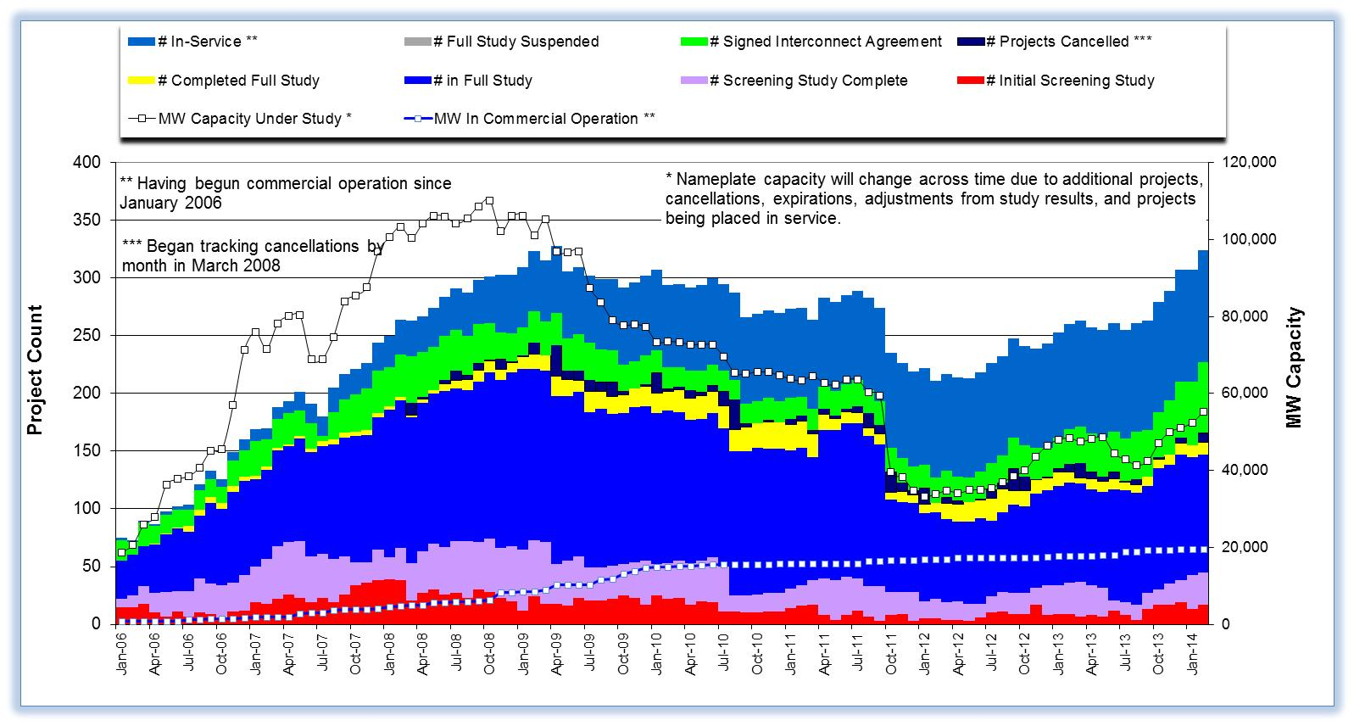

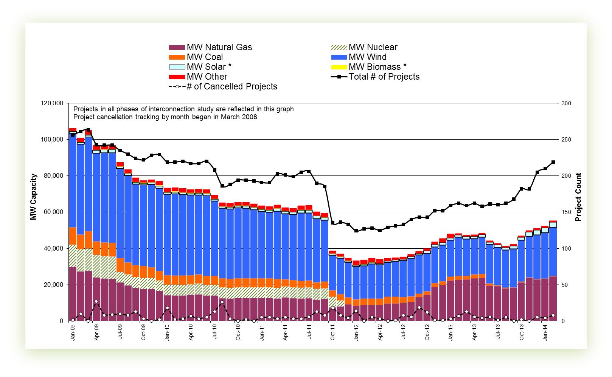

Cumulative Installed MW Capacity of Interconnection Requests by Zone

Projects with Interconnection Agreements

Generation Interconnection Agreements as of February 28, 2014

INR | Site Name | County | COD | Fuel | MW For Grid | Change from Last Report | Sufficient Financial Security Received by TSP
11INR0013 | Goldthwaite Wind Energy | Mills | Apr-14 | WIND | 149 |  | No
13INR0048 | Spinning Spur Wind Two | Oldham | Jun-14 | WIND | 161 |  | Yes
11INR0094 | White Camp Solar | Kent | Jun-14 | SOLAR | 100 | Date Change | No
14INR0015 | Deer Park Energy Center | Harris | Jul-14 | GAS | 190 |  | Yes
14INR0030a_2 | Panhandle Wind | Carson | Jul-14 | WIND | 218 | Date Change | Yes
14INR0012a | Miami Wind 1 Project | Gray | Jul-14 | WIND | 289 |  | Yes
13INR0021 | Ferguson Replacement Project | Llano | Jul-14 | GAS | 570 |  | Yes
10INR0020a | Panda Temple Power | Bell | Aug-14 | GAS | 717 |  | Yes
13INR0040 | Rentech Project | Harris | Aug-14 | GAS | 15 |  | Yes
10INR0021 | Panda Sherman Power | Grayson | Aug-14 | GAS | 720 |  | Yes
14INR0059 | Forney Power Plant Upgrade | Kaufman | Aug-14 | GAS | 34 | New | No
11INR0050 | Moore Wind 1 | Crosby | Aug-14 | WIND | 149 |  | No
14INR0024 | OCI Alamo 4 | Kinney | Aug-14 | SOLAR | 38 | Date Change | Yes
13INR0059a | Hereford Wind | Castro | Sep-14 | WIND | 200 |  | Yes
12INR0034a | Stephens Ranch Wind Energy Phase 1 | Borden | Oct-14 | WIND | 201 | New | Yes
13INR0010a | Mariah Wind | Parmer | Oct-14 | WIND | 232 |  | No
12INR0059 | Barilla Solar | Pecos | Nov-14 | SOLAR | 30 |  | Yes
14INR0032a | Route66 Wind | Randall | Dec-14 | WIND | 150 |  | Yes
14INR0023 | Longhorn Energy Center | Briscoe | Dec-14 | WIND | 361 |  | Yes
13INR0005 | Conway Windfarm | Carson | Dec-14 | WIND | 600 |  | Yes
13INR0052 | Los Vientos III | Starr | Dec-14 | WIND | 200 |  | Yes
06INR0022c | Baffin (Penascal Wind Farm 3) | Kenedy | Dec-14 | WIND | 202 |  | Yes
14INR0053 | Spinning Spur Wind Three | Oldham | Dec-14 | WIND | 194 |  | Yes
14INR0049_2 | Keechi Wind 138 kV Joplin | Jack | Dec-14 | WIND | 102 |  | Yes
13INR0057 | Windthorst 2 | Archer | Dec-14 | WIND | 65 |  | No
11INR0079a | South Clay Windfarm | Clay | Dec-14 | WIND | 200 |  | No
09INR0051 | Mesquite Creek | Borden | Jan-15 | WIND | 249 |  | Yes
12INR0070 | Green Pastures | Knox | Feb-15 | WIND | 300 |  | Yes
12INR0068 | Sendero Wind Energy Project | Jim Hogg | Feb-15 | WIND | 78 |  | Yes
12INR0034b | Stephens Ranch Wind Energy Phase b | Borden | Apr-15 | WIND | 177 | New | No
13INR0059b | Jumbo Road Wind | Castro | Apr-15 | WIND | 300 |  | Yes
14INR0038 | PHR Peakers | Galveston | Apr-15 | GAS | 390 |  | No
13INR0020a | CPV Rattlesnake Den Ph 1 | Glasscock | May-15 | WIND | 201 |  | Yes
13INR0050 | Logans Gap Wind I | Comanche | May-15 | WIND | 200 |  | No
14INR0039 | Goldsmith Peaking Facility | Ector | Jun-15 | GAS | 408 |  | No
11INR0057 | Cameron County Wind | Cameron | Jun-15 | WIND | 165 |  | Yes
14INR0025a | South Plains Wind I | Floyd | Jul-15 | WIND | 200 | Date Change | No
08INR0018 | Gunsight Mountain | Howard | Aug-15 | WIND | 120 |  | No
10INR0020b | Panda Temple Power | Bell | Aug-15 | GAS | 717 |  | No
14INR0012b | Miami Wind 1 Project | Gray | Aug-15 | WIND | 111 |  | No
11INR0062 | Patriot (Petronilla) Wind | Nueces | Aug-15 | WIND | 178 |  | Yes
13INR0049 | Friendswood Energy Generation | Harris | Sep-15 | GAS | 316 |  | No
11INR0054 | Midway Farms Wind | San Patricio | Oct-15 | WIND | 161 |  | Yes
14INR0030b | Panhandle Wind 2 (Phase 2) | Carson | Nov-15 | WIND | 182 | Date/MW change | Yes
14INR0025b | South Plains II | Floyd | Dec-15 | WIND | 300 |  | No
14INR0072 | Briscoe Wind Farm | Briscoe | Dec-15 | WIND | 300 | New | Yes
13INR0010b | Mariah Wind | Parmer | Dec-15 | WIND | 200 |  | No
13INR0031 | Mustang Solar Project | Travis | Dec-15 | SOLAR | 30 |  | No
13INR0020b | CPV Rattlesnake Den Ph 2 | Glasscock | May-16 | WIND | 150 |  | No
16INR0010 | FGE Texas 1 | Mitchell | Jun-16 | GAS | 799 | New | No
13INR0028 | Antelope Station | Hale | Jun-16 | GAS | 359 |  | No
15INR0033 | Antelope Station CT2 | Hale | Jul-16 | GAS | 197 | New | No
15INR0032 | Antelope Station CT1 | Hale | Jul-16 | GAS | 197 | New | No
06INR0006 | Cobisa-Greenville | Hunt | Dec-16 | GAS | 1792 |  | No
13INR0010c | Mariah Wind | Parmer | Dec-16 | WIND | 168 |  | No
12INR0029 | Comanche Run Wind | Swisher | Dec-16 | WIND | 500 |  | No
12INR0018 | Pampa Wind Project | Gray | Mar-17 | WIND | 500 |  | No
10INR0022 | Pondera King Power Project | Harris | Jun-17 | GAS | 1629 | Date Change | No
16INR0003 | Freeport LNG PreTreatment Facility | Brazoria | Jun-17 | GAS | 11 | New | No
13INR0023 | Texas Clean Energy Project | Ector | Jun-18 | COAL | 240 |  | No

Projects Undergoing Full Interconnection Studies with Confidentiality Waived
INR | Site Name | County | COD | Fuel | MW for Grid | Change from Last Report

Generation Projects Undergoing Full Interconnection Studies
Interconnection Database Reference Number | County | Fuel | Capacity to Grid (MW) | Commercial Operation Date (as specified by the resource developer)
14INR0076 | Galveston | GAS | 5 | Jun-14
14INR0069 | Milam | COAL | 30 | Aug-14
13INR0055 | Zapata | WIND | 250 | Sep-14
14INR0013 | Cameron | WIND | 103 | Oct-14
13INR0036 | Hidalgo | WIND | 200 | Oct-14
13INR0056 | Scurry | WIND | 366 | Nov-14
14INR0066 | Lamar | GAS | 130 | Nov-14
14INR0009 | Kent | WIND | 248 | Dec-14
14INR0028 | Live Oak | WIND | 300 | Dec-14
10INR0085 | Ector | SOLAR | 57 | Dec-14
14INR0043 | Sterling | SOLAR | 40 | Dec-14
15INR0074 | Deaf Smith/Randall/Castro | WIND | 156 | Dec-14
14INR0056 | Mills | WIND | 101 | Dec-14
14INR0057b | Erath | WIND | 48 | Dec-14
13INR0010d | Parmer | WIND | 200 | Dec-14
14INR0048_2 | Wilbarger | WIND | 250 | Dec-14
12INR0045 | Kleberg | WIND | 135 | Dec-14
12INR0055 | Baylor | WIND | 40 | Dec-14
14INR0048_1 | Wilbarger | WIND | 114 | Dec-14
14INR0057a | Erath | WIND | 48 | Dec-14
14INR0049_1 | Jack | WIND | 102 | Dec-14
14INR0045a | Webb | WIND | 502 | Dec-14
14INR0014 | Val Verde | SOLAR | 100 | Jan-15
14INR0047 | Floyd and Crosby | WIND | 301 | Feb-15
14INR0050 | Uvalde | SOLAR | 40 | Mar-15
15INR0036 | Uvalde | SOLAR | 105 | Mar-15
15INR0069 | Pecos | SOLAR | 110 | Mar-15
14INR0020 | Floyd & Motley | WIND | 150 | Mar-15
15INR0070_2 | Pecos | SOLAR | 110 | Mar-15
15INR0070_1 | Pecos | SOLAR | 110 | Mar-15
10INR0009 | Castro | WIND | 300 | Mar-15
15INR0054 | Reeves | GAS | 123 | May-15
15INR0055 | Austin | GAS | 142 | May-15
15INR0053 | Winkler | GAS | 123 | May-15
15INR0021 | Starr | WIND | 200 | May-15
14INR0041a | Willacy | Wind | 115 | Jun-15
15INR0027 | Hidalgo | Gas | 79 | Jun-15

Interconnection Database Reference Number | County | Fuel | Capacity to Grid (MW) | Commercial Operation Date (as specified by the resource developer)
15INR0028 | Freestone | Gas | 160 | Jun-15
13INR0026 | Oldham | Wind | 201 | Jun-15
14INR0040 | Hidalgo | Gas | 225 | Jun-15
15INR0023 | Wharton | Gas | 700 | Jun-15
11INR0082a | Val Verde | Wind | 50 | Jul-15
13INR0054 | Bee | Gas | 25 | Jul-15
13INR0025 | Randall | Wind | 150 | Sep-15
14INR0026 | Presidio | Solar | 30 | Sep-15
14INR0062 | Gray | Wind | 200 | Sep-15
15INR0068 | Sterling | Solar | 20 | Oct-15
14INR0030a_1 | Carson | Wind | 322 | Nov-15
12INR0060 | Schleicher | Wind | 58 | Dec-15
15INR0042 | Hood | Gas | 460 | Dec-15
15INR0034 | San Patricio | Wind | 201 | Dec-15
14INR0044 | Reeves | Solar | 100 | Dec-15
15INR0035 | Kenedy | Wind | 200 | Dec-15
08INR0019a | Gray | Wind | 250 | Dec-15
11INR0065 | Nueces | Wind | 350 | Dec-15
14INR0041b | Willacy | Wind | 115 | Dec-15
11INR0082b | Val Verde | Wind | 150 | Dec-15
15INR0051 | Castro | Wind | 200 | Dec-15
14INR0060 | Haskell | Wind | 400 | Dec-15
15INR0073 | Armstrong/Carson | Wind | 170 | Dec-15
15INR0037 | Starr | Wind | 200 | Dec-15
15INR0059 | Pecos / Crane | Solar | 102 | Dec-15
13INR0045 | Castro | Wind | 288 | Dec-15
13INR0032 | Andrews | Solar | 30 | Dec-15
13INR0038 | Swisher | Wind | 300 | Dec-15
14INR0018 | Nolan | Solar | 20 | Dec-15
12INR0002a | Briscoe | Wind | 200 | Dec-15
15INR0044 | Webb and Duval | Solar | 200 | Dec-15
11INR0093 | San Patricio | Wind | 41 | Dec-15
15INR0049 | Zapata / Webb | Wind | 250 | Dec-15
14INR0033 | Armstrong | Wind | 500 | Dec-15
13INR0010e | Parmer | Wind | 200.00 | Dec-15
14INR0045b | Webb | Wind | 251.00 | Dec-15
16INR0036 | Nolan | Gas | 280.00 | Apr-16

Interconnection Database Reference Number | County | Fuel | Capacity to Grid (MW) | Commercial Operation Date (as specified by the resource developer)
16INR0009 | Calhoun | Gas | 510.00 | Apr-16
16INR0008 | Grimes | Gas | 687.00 | May-16
17INR0004 | Hale | Gas | 202.00 | Jun-16
14INR0027 | Guadalupe | Gas | 471.00 | Jun-16
16INR0006 | Angelina | Gas | 785.00 | Jun-16
16INR0005 | Cameron | Gas | 871.00 | Jun-16
15INR0057 | Wharton | Gas | 142.00 | Jun-16
16INR0007 | Hidalgo | Gas | 95.00 | Jun-16
16INR0004 | Cameron | Gas | 730.00 | Jun-16
16INR0013 | Nacogdoches | Gas | 215.00 | Jul-16
08INR0019b | Gray | Wind | 250.00 | Jul-16
14INR0011 | Swisher | Storage | 270.00 | Jul-16
16INR0037 | Floyd | Wind | 400.00 | Oct-16
16INR0024 | Hidalgo | Wind | 200.00 | Oct-16
08INR0019c | Gray | Wind | 250.00 | Dec-16
16INR0017 | Culberson | Solar | 70.00 | Dec-16
16INR0018 | Upton | Solar | 40.00 | Dec-16
13INR0006 | Gray | Wind | 750.00 | Dec-16
16INR0019 | Coke/Sterling | Solar | 100.00 | Dec-16
12INR0002b | Briscoe | Wind | 200.00 | Dec-16
16INR0030 | Young & Jack | Wind | 201.00 | Dec-16
16INR0029 | Hill & Limestone | Wind | 100.00 | Dec-16
16INR0028 | Jack | Wind | 100.00 | Dec-16
16INR0027 | Grayson & Fannin | Wind | 100.00 | Dec-16
16INR0026 | Erath, Somervell, Bosque | Wind | 100.00 | Dec-16
16INR0025 | Sterling | Solar | 30.00 | Dec-16
16INR0031 | Zapata & Starr | Wind | 100.00 | Dec-16
16INR0011a | Cameron | Wind | 18.00 | Dec-16
13INR0010f | Parmer | Wind | 200.00 | Dec-16
15INR0013 | Anderson | Storage | 324.00 | May-17
17INR0003 | Jackson | Gas | 965.00 | Jun-17
17INR0002 | Henderson | Gas | 489.00 | Jun-17
17INR0005 | Starr | Wind | 200.00 | Jun-17
17INR0009 | Hood | Gas | 1042.00 | Jul-17
17INR0007 | Wharton | Gas | 1141.00 | Jul-17
16INR0011b | Cameron | Wind | 132.00 | Dec-17
11INR0040 | Freestone | Gas | 640.00 | Mar-18
15INR0014 | Matagorda | Storage | 280.00 | May-18

Wind Generation Capacity Installed by Year

Regional Planning Group Project Reviews
- CenterPoint Energy submitted the Houston Region Import Capacity project. This is a Tier 1 project that is estimated to cost between $297 to $532 million. ERCOT has issued the independent review report on Feb. 20th. ERCOT will present the project to TAC on March 27, 2014 and at the Board of Directors in April 2014 for their endorsement.

- Garland Power & Light (GP&L) and Cross Texas Transmission (CTT) have jointly submitted a Houston Import project. This is a Tier 1 project that is estimated to cost between $195 to $317 million. ERCOT has issued the independent review report on Feb. 20th. ERCOT will present the project to TAC on March 27, 2014 and at the Board of Directors in April 2014 for their endorsement.

- Lone Star Transmission has submitted a Houston Import project. This is a Tier 1 project that is estimated to cost between $417 to $675 million. ERCOT has issued the independent review report on Feb. 20th. ERCOT will present the project to TAC on March 27, 2014 and at the Board of Directors in April 2014 for their endorsement.

- Oncor has submitted the West Texas Area project. This is a Tier 2 project that is estimated to cost $45 million. This project is currently under ERCOT independent review.

- CenterPoint has submitted the Katy Area project. This is a Tier 2 project that is estimated to cost $20.4 million. This project is currently under ERCOT independent review.

- LCRA TSC has submitted the Leander – Round Rock 138 kV project. This is a Tier 1 project that is estimated to cost $50.9 million. This project is currently under ERCOT independent review.

- Sharyland has submitted the Brady Area project. This is a Tier 2 project that is estimated to cost $18 million. This project has received several RPG comments and it is under study mode.

- Sharyland has submitted the West Texas projects for Stanton Area. This is a Tier 3 project that is estimated to cost $40.4 million. This project has received several RPG comments and it is under study mode.

- AEPSC has submitted the Brady Area Improvements project. This is a Tier 2 project that is estimated to cost $26.5 million. This project has received several RPG comments and it is under study mode.

- TNMP has submitted the Wink-Pecos Line 69E Rebuild project. This is a Tier 3 project that is estimated to cost $15 million. This project has been submitted for RPG comments.

Asynchronous Tie Interconnection
Project | Notification to ERCOT | Reliability Study | RPG Review | Interconnection Agreement | In-service Year
Railroad DC tie expansion (150 MW - CFE) |  |  |  |  | 2014
Southern Cross HVDC (3000 MW - SERC)
Tres Amigas (1500 MW - SPP)

Color Legend
In progress
Complete

Planning Model Activities
- The short term calendar of major planning model events follows:
  - Mar 4, 2014 Posted 14DSA and 14DSB updated cases
  - Mar 7, 2014 Post MODTPIT
  - Mar 14, 2014 Post Updated Contingency Definitions
  - Apr 1, 2014 Start 15DSA case build process

Other Notable Activities

- The System Protection Working Group 2014 Current Year (CY) base creation process has started. The process will include 4 passes and conclude March 21, 2014.
- ERCOT has posted the final report on the results of the Long-term study and the improvements to the long-term study process as a result of the grant received from the Department of Energy.
- ERCOT has completed and posted the 2013 Constraints and Needs Report.
- ERCOT has entered into an agreement with Powertech Labs to perform a small signal stability study.

