 |  |  |  | System Planning
Monthly Status Report
January 2014

 |  | Report Highlights
 | - ERCOT is currently tracking 210 active generation interconnection requests totaling over 52,300 MW. This includes over 25,200 MW of wind generation.
- ERCOT is currently reviewing proposed transmission improvements with a total cost of $876.2 Million
- Transmission Projects endorsed in 2013 total $349.8 Million
- All projects (in engineering, routing, licensing and construction) total approximately $6.23 Billion.
- Transmission Projects energized in 2013 total about $3.17 Billion.

Table of Contents

1. Generation Interconnection 1
1.1 Signed Generation Interconnection Agreements 1
1.2 New Generation Approved for Commercial Operations 1
1.3 Summary of Generation Interconnection Requests 1
1.4 Projects with Interconnection Agreements 5
1.5 Projects Undergoing Full Interconnection Studies with Confidentiality Waived 6
1.6 Generation Projects Undergoing Full Interconnection Studies 6
1.7 Wind Generation Capacity Installed by Year 9
2. Regional Planning Group Project Reviews 10
3. Asynchronous Tie Interconnection 10
4. Planning Model Activities 11
5. Other Notable Activities 11

1. Generation Interconnection
Additional information regarding detailed generation interconnection and impact studies is contained in the “Generation Project Interconnection Information” folder in the “Operations and System Planning” area on the ERCOT website: http://planning.ercot.com/login/login.

Signed Generation Interconnection Agreements

14INR0024 – OCI Alamo 4 – 42 MW in Kinney County
14INR0025a – South Plains Wind 1 – 200 MW located in Floyd County
12INR0059 – Barilla Solar – 30 MW located in Pecos County
14INR0038 – PHR Peakers – 390 MW located in Galveston County
14INR0039 – Goldsmith Peaking Facility – 408 MW located in Ector County
14INR0025b – South Plains II – 300 MW located in Floyd County

New Generation Approved for Commercial Operations

The total installed wind capacity is now reported as 11,213 MW by the resource owners through the registration process. Capacity by North, South and West is 982 MW, 2,775 MW, and 7,456 MW respectively. Eight-hundred fifty MW is able to switch between the West and South zones and is currently shown in the South zone.

Summary of Generation Interconnection Requests
GENERATION INTERCONNECTION REQUESTS CURRENTLY UNDER REVIEW
Currently tracking 210 generation interconnection or change requests
As of January 31, 2013 | Total
Security Screening Study | 13
SSS Completed | 30
Full Interconnect Study | 102
FIS Completed | 10
Suspended Studies | 0
Capacity of Suspended Study Projects | 0
Cancelled Projects | 4
Interconnect Agreement Completed | 55
Capacity under Interconnection Agreements | 16,715
Capacity for Grid, MW | 52,367
Wind Capacity, MW | 25,240
Capacity of Cancelled Projects | 918

Fuel Type | Confidential Projects (MW) | Projects Under Full Study (MW) | Public Projects (MW) | Suspended Studies (MW) | Grand Total (MW)
Gas-AllOther |  |  | 1,499 | - | 7,442
Gas-CombinedCycle |  |  | 7,032 | - | 15,684
Total Gas | 3,382 | 11,213 | 8,531 | - | 23,126
Nuclear | - | - | - | - | -
Coal | - | 30 | 240 | - | 270
Wind | 4,582 | 12,678 | 7,979 | - | 25,240
Solar | 1,326 | 1,329 | 202 | - | 2,857
Biomass | - | - | - | - | -
Storage | - | 874 | - | - | 874
Petroleum Coke | - | - | - | - | -
Grand Total | 9,290 | 26,124 | 16,952 | - | 52,367

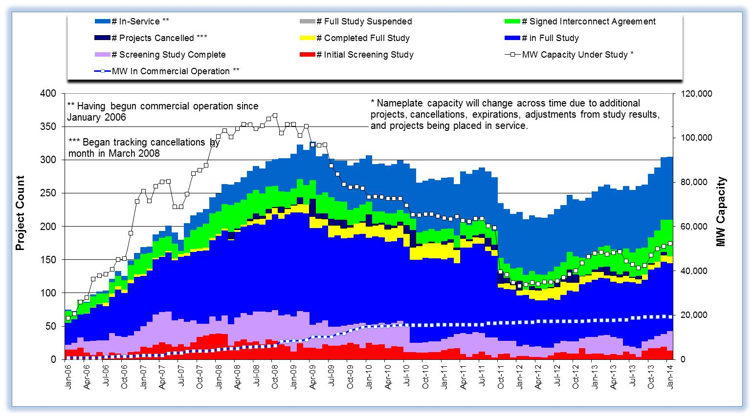

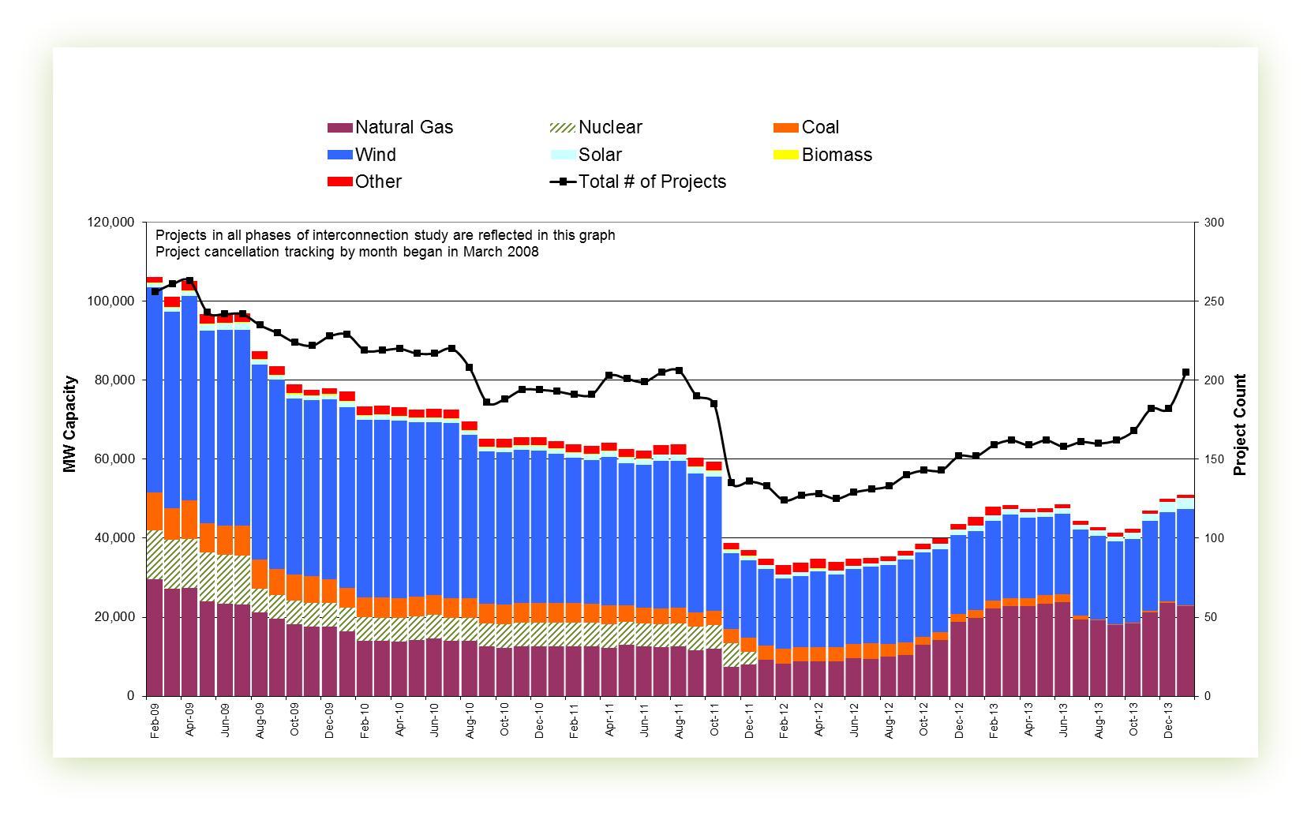

Cumulative Installed MW Capacity of Interconnection Requests by Zone

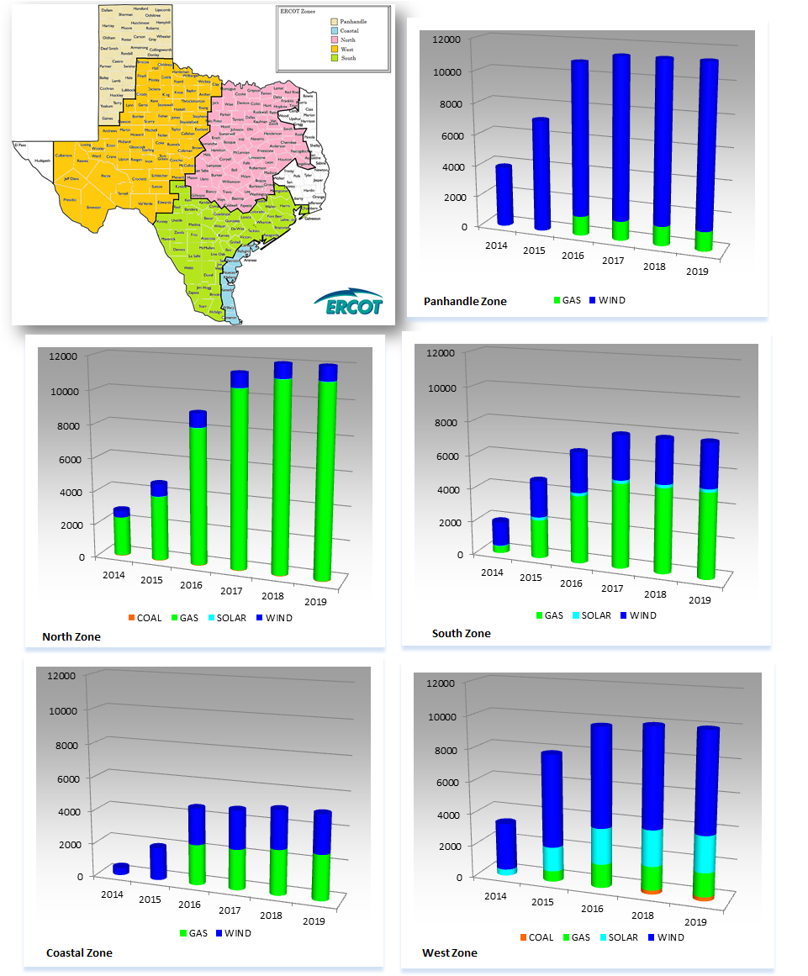

Projects with Interconnection Agreements

Generation Interconnection Agreements as of January 31, 2014

INR | Site Name | County | COD | Fuel | MW For Grid | Change from Last Report | Sufficient  Financial  Security  Received by TSP
11INR0094 | White Camp Solar | Kent | 4/2014 | SOLAR | 100 |  | No
13INR0048 | Spinning Spur Wind Two | Oldham | 6/2014 | WIND | 161 |  | Yes
14INR0024 | OCI Alamo 4 | Kinney | 6/2014 | SOLAR | 42 | New | No
14INR0016 | Channel Energy Center 138/345kV CT | Harris | 6/2014 | GAS | 190 |  | Yes
14INR0015 | Deer Park Energy Center | Harris | 7/2014 | GAS | 190 |  | Yes
13INR0021 | Ferguson Replacement Project | Llano | 7/2014 | GAS | 570 |  | Yes
14INR0012a | Miami Wind 1 Project | Gray | 7/2014 | WIND | 289 |  | Yes
14INR0030a_2 | Panhandle Wind | Carson | 8/2014 | WIND | 218 |  | Yes
13INR0040 | Rentech Project | Harris | 8/2014 | GAS | 15 |  | Yes
10INR0020a | Panda Temple Power | Bell | 8/2014 | GAS | 717 |  | Yes
10INR0021 | Panda Sherman Power | Grayson | 8/2014 | GAS | 720 |  | Yes
11INR0050 | Moore Wind 1 | Crosby | 8/2014 | WIND | 149 |  | No
14INR0030b | Panhandle Wind 2 (Phase 2) | Carson | 9/2014 | WIND | 198 |  | Yes
13INR0059a | Hereford Wind | Castro | 9/2014 | WIND | 200 |  | Yes
13INR0010a | Mariah Wind | Parmer | 10/2014 | WIND | 232 | MW Change | No
12INR0034 | Stephens Ranch Wind Energy | Borden | 10/2014 | WIND | 378 |  | Yes
13INR0005 | Conway Windfarm | Carson | 12/2014 | WIND | 600 |  | Yes
14INR0023 | Longhorn Energy Center | Briscoe | 12/2014 | WIND | 361 |  | Yes
14INR0025a | South Plains Wind I | Floyd | 12/2014 | WIND | 200 | New | No
14INR0032a | Route66 Wind | Randall | 12/2014 | WIND | 150 |  | No
12INR0059 | Barilla Solar | Pecos | 12/2014 | SOLAR | 30 | New | Yes
14INR0053 | Spinning Spur Wind Three | Oldham | 12/2014 | WIND | 194 | MW Change | Yes
11INR0079a | South Clay Windfarm | Clay | 12/2014 | WIND | 200 |  | No
13INR0057 | Windthorst 2 | Archer | 12/2014 | WIND | 65 |  | No
13INR0052 | Los Vientos III | Starr | 12/2014 | WIND | 200 |  | Yes
14INR0049_2 | Keechi Wind 138 kV Joplin | Jack | 12/2014 | WIND | 102 |  | Yes
06INR0022c | Baffin (Penascal Wind Farm 3) | Kenedy | 12/2014 | WIND | 202 |  | Yes
09INR0051 | Mesquite Creek | Borden | 1/2015 | WIND | 249 |  | Yes
12INR0070 | Green Pastures | Knox | 2/2015 | WIND | 300 |  | Yes
12INR0068 | Sendero Wind Energy Project | Jim Hogg | 2/2015 | WIND | 78 |  | Yes
13INR0059b | Hereford Wind | Castro | 4/2015 | WIND | 300 |  | Yes
14INR0038 | PHR Peakers | Galveston | 4/2015 | GAS | 390 | New | No
13INR0020a | CPV Rattlesnake Den Ph 1 | Glasscock | 5/2015 | WIND | 201 | Date change | Yes
13INR0050 | Logans Gap Wind I | Comanche | 5/2015 | WIND | 200 |  | No
14INR0039 | Goldsmith Peaking Facility | Ector | 6/2015 | GAS | 408 | New | No
11INR0057 | Cameron County Wind | Cameron | 6/2015 | WIND | 165 | Date change | Yes
08INR0018 | Gunsight Mountain | Howard | 8/2015 | WIND | 120 |  | No
10INR0020b | Panda Temple Power | Bell | 8/2015 | GAS | 717 |  | No
14INR0012b | Miami Wind 1 Project | Gray | 8/2015 | WIND | 111 |  | No
11INR0062 | Patriot (Petronilla) Wind | Nueces | 8/2015 | WIND | 178 |  | Yes
13INR0049 | Friendswood Energy Generation | Harris | 9/2015 | GAS | 316 |  | No
11INR0054 | Midway Farms Wind | San Patricio | 10/2015 | WIND | 161 |  | Yes
14INR0025b | South Plains II | Floyd | 12/2015 | WIND | 300 | New | No
13INR0031 | Mustang Solar Project | Travis | 12/2015 | SOLAR | 30 |  | No
13INR0010b | Mariah Wind | Parmer | 12/2015 | WIND | 200 |  | No
13INR0020b | CPV Rattlesnake Den Ph 2 | Glasscock | 5/2016 | WIND | 150 | Date change | No
13INR0028 | Antelope Station | Hale | 6/2016 | GAS | 359 |  | No
06INR0006 | Cobisa-Greenville | Hunt | 12/2016 | GAS | 1,792 |  | No
10INR0022 | Pondera King Power Project | Harris | 12/2016 | GAS | 1,629 |  | No
12INR0029 | Comanche Run Wind | Swisher | 12/2016 | WIND | 500 |  | No
13INR0010c | Mariah Wind | Parmer | 12/2016 | WIND | 168 | MW Change | No
12INR0018 | Pampa Wind Project | Gray | 3/2017 | WIND | 500 |  | No
13INR0023 | Texas Clean Energy Project | Ector | 6/2018 | Coal | 240 | Date change | No

Projects Undergoing Full Interconnection Studies with Confidentiality Waived
INR | Site Name | County | COD | Fuel | MW for Grid | Change from Last Report

Generation Projects Undergoing Full Interconnection Studies
Interconnection Database Reference Number | County | Fuel | Capacity to Grid (MW) | Commercial Operation Date (as specified by the resource developer)
14INR0069 | Milam | COAL | 30 | 3/31/2014
14INR0048_1 | Wilbarger | WIND | 114 | 6/1/2014
13INR0026 | Oldham | WIND | 201 | 6/1/2014
14INR0014 | Val Verde | SOLAR | 100 | 7/1/2014
11INR0093 | San Patricio | WIND | 41 | 7/1/2014
14INR0059 | Kaufman | GAS | 52 | 8/1/2014
13INR0055 | Zapata | WIND | 250 | 9/1/2014
13INR0038 | Swisher | WIND | 300 | 9/15/2014
14INR0062 | Hall/Motley | WIND | 200 | 9/30/2014
14INR0047 | Floyd and Crosby | WIND | 301 | 10/1/2014
14INR0013 | Cameron | WIND | 103 | 10/15/2014
14INR0048_2 | Wilbarger | WIND | 250 | 10/15/2014
13INR0036 | Hidalgo | WIND | 200 | 10/31/2014
13INR0056 | Scurry | WIND | 366 | 11/21/2014
14INR0066 | Lamar | GAS | 130 | 11/30/2014
14INR0043 | Sterling | SOLAR | 40 | 12/1/2014
11INR0082a | Val Verde | WIND | 50 | 12/1/2014
14INR0028 | Live Oak | WIND | 300 | 12/1/2014
13INR0054 | Bee | GAS | 25 | 12/1/2014
10INR0085 | Ector | SOLAR | 57 | 12/1/2014
14INR0033 | Armstrong | WIND | 500 | 12/1/2014
11INR0082b | Val Verde | WIND | 150 | 12/1/2014
14INR0009 | Kent | WIND | 248 | 12/1/2014
14INR0060 | Haskell | WIND | 400 | 12/19/2014
15INR0073 | Armstrong/Carson | WIND | 170 | 12/30/2014
15INR0074 | Deaf Smith/Randall/Castro | WIND | 156 | 12/30/2014
13INR0045 | Castro | WIND | 288 | 12/30/2014
12INR0055 | Baylor | WIND | 40 | 12/31/2014
14INR0049_1 | Jack | WIND | 102 | 12/31/2014
14INR0045a | Webb | WIND | 502 | 12/31/2014
13INR0010d | Parmer | WIND | 200 | 12/31/2014
14INR0057b | Erath | WIND | 48 | 12/31/2014
12INR0045 | Kleberg | WIND | 135 | 12/31/2014
14INR0057a | Erath | WIND | 48 | 12/31/2014
14INR0056 | Mills | WIND | 101 | 12/31/2014
14INR0020 | Floyd & Motley | WIND | 150 | 3/1/2015
15INR0070 | Pecos | SOLAR | 110 | 3/1/2015

Interconnection Database Reference Number | County | Fuel | Capacity to Grid (MW) | Commercial Operation Date (as specified by the resource developer)
14INR0050 | Uvalde | SOLAR | 40 | 3/1/2015
15INR0036 | Uvalde | SOLAR | 105 | 3/1/2015
15INR0069 | Pecos | SOLAR | 110 | 3/1/2015
10INR0009 | Castro | WIND | 300 | 3/31/2015
15INR0054 | REEVES | GAS | 123 | 5/1/2015
15INR0053 | WINKLER | GAS | 123 | 5/1/2015
15INR0055 | Austin | GAS | 142 | 5/1/2015
15INR0021 | Starr | WIND | 200 | 5/15/2015
15INR0028 | Freestone | GAS | 160 | 6/1/2015
15INR0042 | Hood | GAS | 460 | 6/1/2015
14INR0041a | Willacy | WIND | 115 | 6/1/2015
15INR0027 | Hidalgo | GAS | 79 | 6/1/2015
14INR0027 | Guadalupe | GAS | 471 | 6/1/2015
14INR0040 | Hidalgo | GAS | 225 | 6/7/2015
15INR0023 | Wharton | GAS | 700 | 6/15/2015
14INR0026 | Presidio | SOLAR | 30 | 9/1/2015
13INR0025 | Randall | WIND | 150 | 9/1/2015
15INR0068 | Sterling | SOLAR | 20 | 10/1/2015
11INR0065 | Nueces | WIND | 350 | 10/31/2015
14INR0030a_1 | Carson | WIND | 322 | 11/1/2015
12INR0060 | Schleicher | WIND | 58 | 12/1/2015
15INR0034 | San Patricio | WIND | 201 | 12/1/2015
14INR0044 | Reeves | SOLAR | 100 | 12/1/2015
15INR0035 | Kenedy | WIND | 200 | 12/1/2015
14INR0041b | Willacy | WIND | 115 | 12/1/2015
08INR0019a | Gray | WIND | 250 | 12/1/2015
13INR0010e | Parmer | WIND | 200 | 12/31/2015
14INR0045b | Webb | WIND | 251 | 12/31/2015
15INR0037 | Starr | WIND | 200 | 12/31/2015
13INR0032 | Andrews | SOLAR | 30 | 12/31/2015
15INR0059 | Pecos / Crane | SOLAR | 102 | 12/31/2015
15INR0060 | Pecos / Crane | SOLAR | 25 | 12/31/2015
15INR0044 | Webb and Duval | SOLAR | 200 | 12/31/2015
14INR0072 | Briscoe | WIND | 300 | 12/31/2015
14INR0018 | Nolan | SOLAR | 20 | 12/31/2015
12INR0002a | Briscoe | WIND | 200 | 12/31/2015
15INR0049 | Zapata / Webb | WIND | 250 | 12/31/2015

Interconnection Database Reference Number | County | Fuel | Capacity to Grid (MW) | Commercial Operation Date (as specified by the resource developer)
16INR0010 | Mitchell | GAS | 799 | 2/1/2016
16INR0009 | Calhoun | GAS | 510 | 4/14/2016
16INR0008 | Grimes | GAS | 687 | 5/1/2016
16INR0004 | Cameron | GAS | 730 | 6/1/2016
17INR0004 | Hale | GAS | 202 | 6/1/2016
16INR0005 | Cameron | GAS | 871 | 6/1/2016
16INR0007 | Hidalgo | GAS | 95 | 6/1/2016
16INR0006 | Angelina | GAS | 785 | 6/1/2016
08INR0019b | Gray | WIND | 250 | 7/1/2016
16INR0013 | Nacogdoches | GAS | 215 | 7/1/2016
15INR0033 | Hale | GAS | 197 | 7/1/2016
15INR0032 | Hale | GAS | 197 | 7/1/2016
14INR0011 | Swisher | Storage | 270 | 7/1/2016
16INR0024 | Hidalgo | WIND | 200 | 10/1/2016
08INR0019c | Gray | WIND | 250 | 12/1/2016
13INR0006 | Gray | WIND | 750 | 12/1/2016
16INR0017 | Culberson | SOLAR | 70 | 12/1/2016
16INR0018 | Upton | SOLAR | 40 | 12/1/2016
16INR0019 | Coke/Sterling | SOLAR | 100 | 12/1/2016
16INR0027 | Grayson & Fannin | WIND | 100 | 12/31/2016
16INR0026 | Erath, Somervell & Bosque | WIND | 100 | 12/31/2016
16INR0029 | HILL & LIMESTONE | WIND | 100 | 12/31/2016
16INR0032 | JIM HOGG | WIND | 201 | 12/31/2016
16INR0028 | Jack | WIND | 100 | 12/31/2016
13INR0010f | Parmer | WIND | 200 | 12/31/2016
16INR0030 | YOUNG & JACK | WIND | 201 | 12/31/2016
12INR0002b | Briscoe | WIND | 200 | 12/31/2016
16INR0025 | Sterling | SOLAR | 30 | 12/31/2016
16INR0011a | Cameron | WIND | 18 | 12/31/2016
16INR0031 | ZAPATA & STARR | WIND | 100 | 12/31/2016
15INR0013 | Anderson | Storage | 324 | 5/1/2017
17INR0002 | Henderson | GAS | 489 | 6/1/2017
17INR0003 | Jackson | GAS | 965 | 6/1/2017
17INR0005 | Starr | WIND | 200 | 6/30/2017
17INR0007 | Wharton | GAS | 1,141 | 7/31/2017
16INR0011b | Cameron | WIND | 132 | 12/30/2017
11INR0040 | Freestone | GAS | 640 | 3/1/2018
15INR0014 | Matagorda | Storage | 280 | 5/1/2018

Wind Generation Capacity Installed by Year
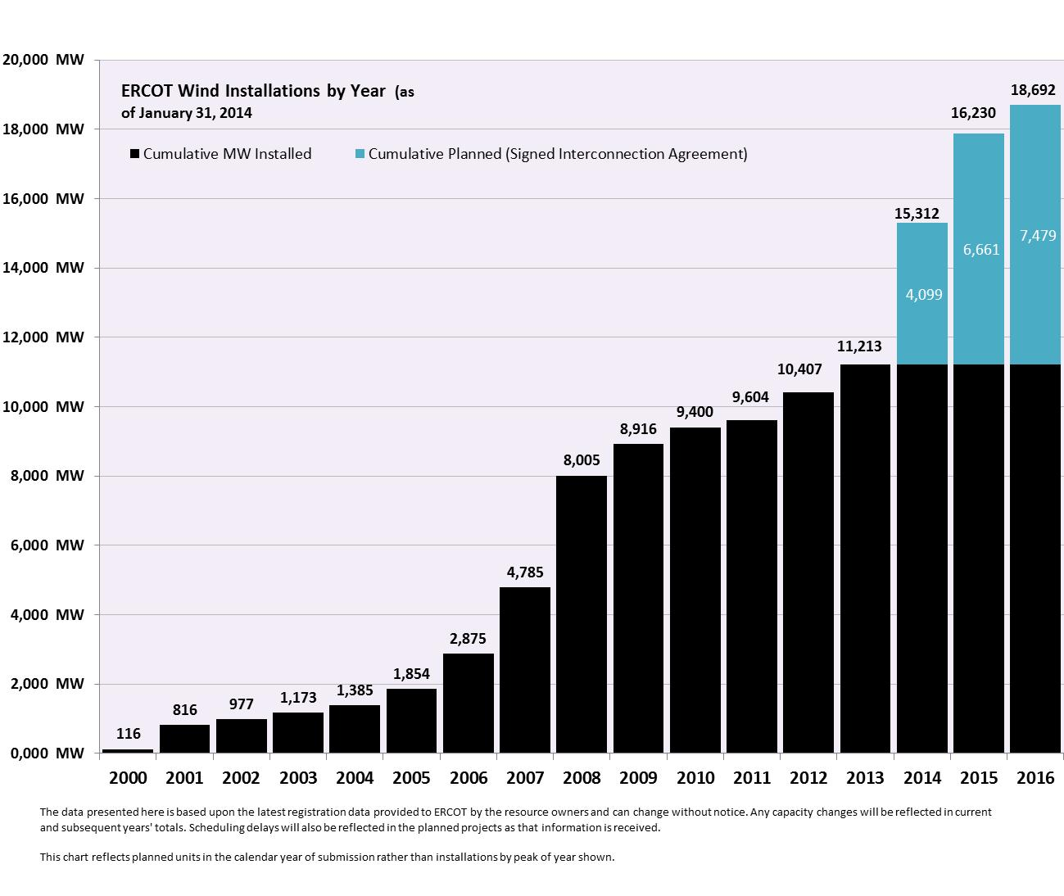

Regional Planning Group Project Reviews
- CenterPoint Energy submitted the Houston Region Import Capacity project. This is a Tier 1 project that is estimated to cost between $297 to $532 million. This project is currently under ERCOT independent review.

- Garland Power & Light (GP&L) and Cross Texas Transmission (CTT) have jointly submitted a Houston Import project. This is a Tier 1 project that is estimated to cost between $195 to $317 million. This project is currently under ERCOT independent review.

- Lone Star Transmission has submitted a Houston Import project. This is a Tier 1 project that is estimated to cost between $417 to $675 million. This project is currently under ERCOT independent review.

- Oncor has submitted the West Texas Area project. This is a Tier 2 project that is estimated to cost $45 million. This project is currently under ERCOT independent review.

- CenterPoint has submitted the Katy Area project. This is a Tier 2 project that is estimated to cost $20.4 million. This project is currently under ERCOT independent review.

- LCRA TSC has submitted the Leander – Round Rock 138 kV project. This is a Tier 1 project that is estimated to cost $50.9 million. This project has received several RPG comments and it is under study mode.

- Sharyland has submitted the Brady Area project. This is a Tier 2 project that is estimated to cost $18 million. This project has received several RPG comments and it is under study mode.

- Sharyland has submitted the West Texas projects for Stanton Area. This is a Tier 3 project that is estimated to cost $40.4 million. This project has received several RPG comments and it is under study mode.

- AEPSC has submitted the Brady Area Improvements project. This is a Tier 2 project that is estimated to cost $26.5 million. This project has been submitted for RPG comments.

Asynchronous Tie Interconnection
Project | Notification to ERCOT | Reliability Study | Interconnection Agreement | In-service Year
Railroad DC tie expansion (150 MW - CFE) |  |  |  | 2014
Southern Cross HVDC (3000 MW - SERC)
Tres Amigas (1500 MW - SPP)

Color Legend
In progress
Complete

Planning Model Activities
- The short term calendar of major planning model events follows:
  - Mar 1, 2014 Post 14DSA and 14DSB updated cases
  - Mar 15, 2014 Post MODTPIT
  - Apr 1, 2014 Start 15DSA case build process

Other Notable Activities

- The System Protection Working Group 2014 Current Year (CY) base creation process has started. The process will include 4 passes and conclude March 21, 2014.
- ERCOT has entered into an agreement with Powertech Labs to perform a small signal stability study.
- ERCOT held two stakeholder workshops on scenario development for the 2014 Long-Term System Assessment in January. The third and final scenario development workshop will be held on February 14 at the ERCOT Austin office.

