ERCOT Contingency Reserve Service
Working Document – Work Session (2-28-2014):

Needs of CR Service
Contingency Reserve is to ensure that ERCOT is able to restore frequency within defined limits following a DCS event within 15 minutes and restore its Fast Frequency, Primary Frequency and Regulating Reserves. The Contingency Reserve may also be used to cover for large net load forecast error.

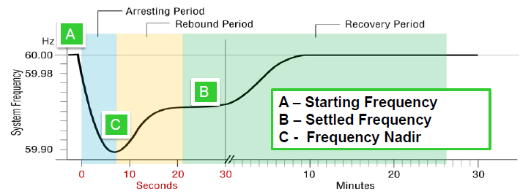
Figure 1 Typical frequency response following a generator trip.

Discussion
- Capacity of a Resource with CR responsibility will automatically be released to SCED once system frequency meets or drops below 59.91 Hz or manual deployment.
- Once CR capacity is released to SCED, SCED will dispatch Resources with CR Responsibility as any other Resource in SCED, based on economics, system needs and constraints.
- CR resource should be capable of ramping to its full CR responsibility within 10 minutes. SCED base point instructions will determine CR resource dispatch in real time.
- CR Resource should be capable of sustaining its full response for as long as it has responsibility to provide this service. SCED base point instructions will determine CR resource dispatch in real time.
- CR capacity can be recalled once frequency and PRC has reached stable threshold.
- Once CR capacity is recalled, CR resources will update their schedules, SCED will dispatch CR resources to their HASL through base point instructions based on CR Resource ramp rates.
- Resources should be recalled within certain criteria for it to be qualified as CR (LR, Gen or any other technology).
- Load resources potentially providing CR should be capable of following SCED dispatch. Prerequisite for this will be changes to SCED that allow dispatch of “blocky” resources.
- Generating Resources providing CR should be qualified up to the MW value they are able to ramp to within 10 minutes from the time of deployment.
Load Resources should be qualified for CR up to the MW value by which they are able to decrease their power consumption within 10-minutes from the time of deployment.
- Resources providing CR will be subject to disqualification in addition to SCED base point deviation charges for failure to follow SCED base points.

