NPRR Number | 533 | NPRR Title | Clarification of PCRR Eligibility Requirements
Date |  | February 25, 2014
Submitter’s Information
Name |  | Chris Foster, CGFO
E-mail Address |  | Chris.foster@georgetown.org
Company |  | City of Georgetown
Phone Number |  | 512-930-2584
Cell Number
Market Segment |  | Municipal

Comments

The City of Georgetown supports NPRR 533 as approved by PRS at the February PRS Meeting.

We do not support the January 15, or February 5, 2014 ERCOT comments. Georgetown is a former LCRA customer who now resides in the South Load Zone. We purchase CRR’s at full price to hedge our load position and we receive CRR Auction Revenues to offset our hedging costs. According to ERCOT’s latest conservative analysis, Georgetown’s customers, would be subsidizing the customers of other NOIEs in the LCRA Load Zone tens of thousands dollars per long-term auction sequence. Moreover each subsequent auction sequence will increase the amount of this subsidization. Under the language ERCOT proposed prior to the PRS meeting, these other NOIEs would receive the benefits of PCRRs previously owned by Georgetown. And Georgetown’s customers will face higher congestion hedging costs as a result. These higher hedging costs could have a negative impact on Georgetown’s economic development activities.

Georgetown competes for economic development opportunities against both competitive areas to north and east and Non-Opt in areas to the west and south of Georgetown. To compete against other NOIEs who have been allocated Georgetown’s historic PCRR’s is simply unacceptable.

Some Market Participants have argued that the same “load” is being served by the same “pre 1999 resources” and therefore, the PCRR’s should remain the same. We agree. Loads being served by the same generation should continue to receive their historic allocation, and that is exactly what the PRS approved language does. ERCOTs language would have allocated additional PCRR’s to such loads, which had never previously been entitled to them. We submit the following graphic that clearly shows which loads being served are the same and which are different.

Pre 2012 NOIES Eligible for PCRRs
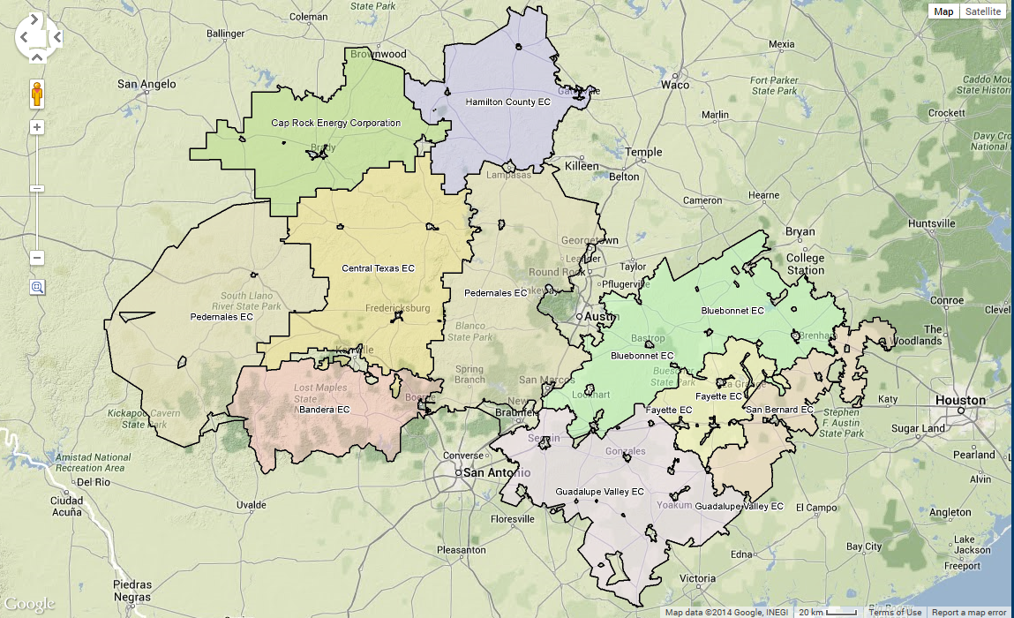

Post 2016 NOIEs Eligible for PCRRs
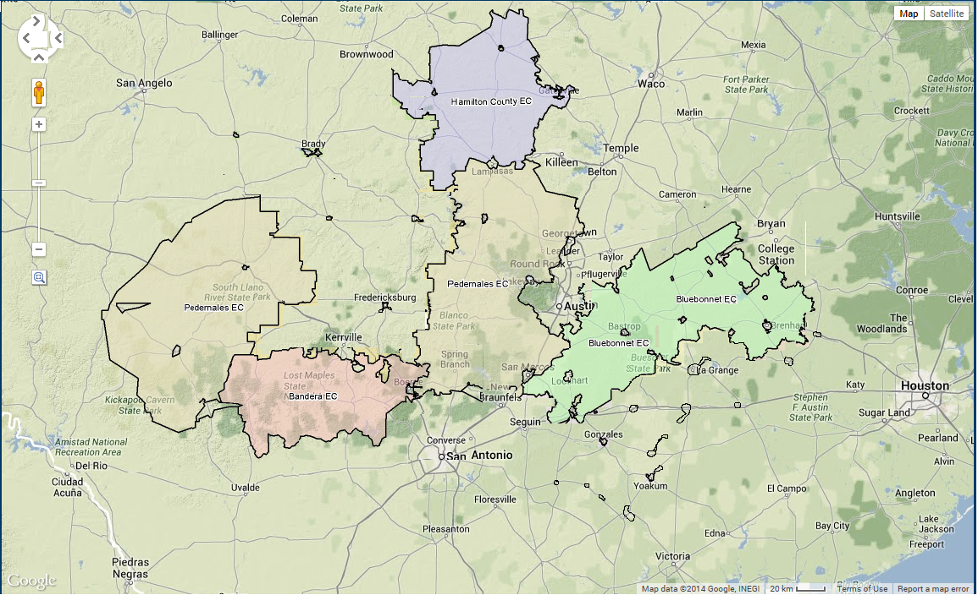

It has been suggested that the PRS approved version of NPRR 533, somehow reduces the PCRR’s that NOIEs served by LCRA have traditionally held. That is not the case. The PRS approved language allocates PCRRs for customers to exactly what they traditionally held, no more, no less. This can be seen in the Table by comparing the 2003 PCRRs column and number of MWs for each individual NOIE and the column labeled “PRS Approved Allocation” for each member. The PRS approved language releases PCRRs associated with NOIEs who have opted into competition or who have terminated their long-term contracts and returns them to the market, as we believe the Market Participants always intended.

Total pre 1999 PPA PCRR's | Gideon | Fayette | Hydro | Wind | Total
ERCOT 533 Spreadsheet | 620 | 1068 | 288 | 25 | 2001
NOIE | 2003 4 CP Load | 4 CP & 2003 PCRR % | 2003 PCRRS | Post 2016 eligibility | PRS Approved Allocation | Allocation As Filed by ERCOT
Bandera Electric Coop | 98.0 | 3.76% | 75.2 | Y | 75.2 | 115.4
Bluebonnet Electric Coop | 313.0 | 12.00% | 240.2 | Y | 240.2 | 368.7
Sharyland Utilities | 18.4 | 0.71% | 14.1 | N
Central Texas Electric Coop | 88.6 | 3.40% | 68.0 | N
City of Bastrop | 12.5 | 0.48% | 9.6 | Y | 9.6 | 14.7
City of Bellville | 12.7 | 0.49% | 9.7 | Y | 9.7 | 15.0
City of Brady | 15.0 | 0.58% | 11.5 | N
City of Boerne | 22.3 | 0.85% | 17.1 | N
City of Brenham | 59.3 | 2.28% | 45.5 | Y | 45.5 | 69.9
City of Burnet | 15.2 | 0.58% | 11.6 | Y | 11.6 | 17.9
City of Cuero | 24.8 | 0.95% | 19.0 | Y | 19.0 | 29.2
City of Flatonia | 4.5 | 0.17% | 3.5 | Y | 3.5 | 5.3
City of Fredericksburg | 28.3 | 1.09% | 21.7 | Y | 21.7 | 33.4
City of Giddings | 12.7 | 0.49% | 9.8 | Y | 9.8 | 15.0
City of Goldthwaite | 5.1 | 0.19% | 3.9 | Y | 3.9 | 6.0
City of Gonzales | 16.6 | 0.63% | 12.7 | Y | 12.7 | 19.5
City of Hallettsville | 8.5 | 0.33% | 6.5 | Y | 6.5 | 10.0
City of Hempstead | 12.3 | 0.47% | 9.4 | Y | 9.4 | 14.5
City of La Grange | 14.8 | 0.57% | 11.3 | Y | 11.3 | 17.4
City of Lampasas | 20.8 | 0.80% | 16.0 | Y | 16.0 | 24.5
City of Lexington | 2.7 | 0.10% | 2.1 | Y | 2.1 | 3.2
City of Llano | 9.7 | 0.37% | 7.4 | Y | 7.4 | 11.4
City of Lockhart | 22.7 | 0.87% | 17.4 | Y | 17.4 | 26.7
City of Luling | 11.5 | 0.44% | 8.8 | Y | 8.8 | 13.5
City of Mason | 4.9 | 0.19% | 3.7 | Y | 3.7 | 5.7
City of Moulton | 2.2 | 0.08% | 1.7 | Y | 1.7 | 2.6
City of San Marcos | 96.6 | 3.70% | 74.1 | Y | 74.1 | 113.8
City of San Saba | 8.1 | 0.31% | 6.2 | Y | 6.2 | 9.6
City of Schulenburg | 11.8 | 0.45% | 9.1 | Y | 9.1 | 13.9
City of Seguin | 55.4 | 2.12% | 42.5 | N
City of Shiner | 8.8 | 0.34% | 6.7 | Y | 6.7 | 10.3
City of Smithville | 9.5 | 0.37% | 7.3 | Y | 7.3 | 11.2
City of Waelder | 3.3 | 0.13% | 2.5 | Y | 2.5 | 3.8
City of Weimar | 7.3 | 0.28% | 5.6 | Y | 5.6 | 8.6
City of Yoakum | 16.8 | 0.64% | 12.9 | Y | 12.9 | 19.8
Fayette Electric Cooperative | 39.8 | 1.53% | 30.6 | N
Georgetown Utility Systems | 84.7 | 3.25% | 65.0 | N
Guadalupe Valley Electric Coop | 220.3 | 8.45% | 169.0 | N
Hamilton County Electric Coop | 14.6 | 0.56% | 11.2 | Y | 11.2 | 17.2
Kerrville Public Utility Board | 98.4 | 3.77% | 75.5 | N
New Braunfels Utilities | 172.4 | 6.61% | 132.3 | N
Pedernales Electric Coop | 809.2 | 31.03% | 620.9 | Y | 620.9 | 953.2
San Bernard Electric Coop | 93.9 | 3.60% | 72.0 | N
 | 2,607.9 | 100.00% | 2001.0 |  | 1303.4 | 2001.0
Total PPA PCRR's | Gideon | Fayette | Hydro | Wind | Total
PRS Approved Methodology | 403.8 | 695.7 | 187.6 | 16.3 | 1303.4

4CP Source Doc http://www.ercot.com/content/mktinfo/data_agg/4cp/2003/20034CP2.xls

We believe the concept approved by PRS, which releases Transmission Capacity to the market when a NOIE terminates its long-term contract or opts into competition is consistent with the intent and understanding of Market Participants at the time PCRRs were negotiated.

ERCOT has filed comments and we have verified, that reliable and verifiable 4CP data did not exist on a per NOIE level until after 2001. Furthermore, ERCOT stated in its August 20, 2010 letter to Kerrville that PCRRs would be allocated to NOIEs served by LCRA based on their 2003 peak load. In an effort to find common ground as such we have no objection to using the 2003 load data.

Georgetown appreciates the efforts of Kerville and the market in recognizing many aspects of this important issue and in moving in a market oriented direction. We recommend TAC approve NPRR 533 as approved by PRS with the exception of the date change from 1999 to 2003, consistent with the August, 20, 2010, letter from ERCOT.

Revised Cover Page Language

None.

Revised Proposed Protocol Language

None.

