ERCOT Primary Frequency Response
Working Document – Work Session (1-31-2014):

Definition of PFR Service
PFR Service is an Ancillary Service that acts without operator action to provide an arresting and/or counter response to frequency deviations and, in this manner, acts to maintain the steady state frequency in the ERCOT Interconnection within defined limits. A PFR response to frequency disturbances in the ERCOT Interconnection can be provided by online synchronous Generation Resources through the operation of their speed governor or by other types of Resources capable of providing a similar automatic control action in response to frequency deviations. Resources that provide PFR Service must be able to assist in arresting and stabilizing over or under frequency excursions. Error: Reference source not found illustrates a PFR Service provider’s frequency response to the loss of generation event. A PFR Service provider’s Governor is expected to initiate frequency response action shortly following the departure of system frequency outside the Governor Dead-band which then assist in establishing the Frequency Nadir (point “C”) and in restoring system frequency to a stable condition referred to as the Settled Frequency (point “B”). PFR operates within the first few seconds following the initiating event and is fully delivered within 12 to 14 seconds and thus has significant implications on the rate of change of frequency (RoCoF) during sudden power imbalance.

Needs of PFR Service
ERCOT is a single Balancing Authority Interconnection and is not synchronously connected with any other interconnections, therefore, ERCOT is solely responsible for maintaining interconnection frequency to ensure reliability and meet NERC standard requirements. With an increasing amount of non‐synchronous generation (e.g. wind generators) there is a significant possibility this response will be reduced as the result of the economic displacement of generation resources capable of providing the PFR service with the consequence that RoCoF becomes higher, leaving insufficient time for other reserves to deploy and arrest the decline in system frequency before it drops to an unacceptable level. The ability of the ERCOT Grid to stabilize after a sudden loss of generation is dependent on the sufficiency of the system’s primary frequency response. Resources providing primary frequency response must be able to provide continuous full proportional response against the frequency deviation and contribute to ERCOT’s meeting it’s FRO as established by the NERC. On January 16, 2014 FERC approved the BAL-003 NERC Frequency Response Standard pending few clarifications from NERC. The BAL-003 standard sets a Frequency Response Obligation (FRO) for each BA and based on this standard the requirement for ERCOT is 413 MW/0.1 Hz. The necessity of a separate PFR Down service will require further discussions.
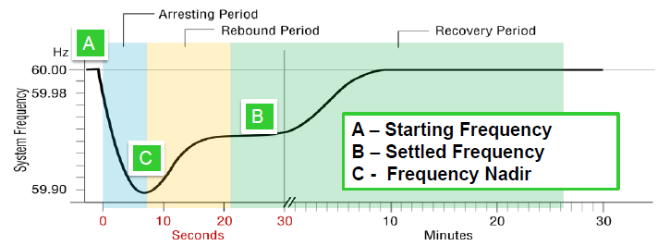
Figure 1

Protocol Definition for Primary Frequency Response (PFR) Service –Concept Level – Consensus acceptance requested prior to Protocol Language development:

Primary Frequency Response (PFR): The immediate proportional increase or decrease in real power output provided by a Resource and the natural real power dampening response provided by Load in response to system frequency deviations. This response is in the direction that stabilizes frequency.

In the ERCOT Interconnection the minimum amount of guaranteed cumulative PFR Service that must be self-provided by QSEs or procured by ERCOT for every Operating Hour is determined based on minimum FFR and PFR needed to avoid under-frequency firm load shedding for simultaneous loss of two largest units totaling 2750 MW.

Governor Setting Requirement for Generation Resources
To assure system frequency stability and compliance with NERC performance criteria, all Resources with speed governors shall have their governor in-service whenever the Resource is providing energy to the ERCOT Transmission Grid and set to operate with a droop setting not to exceed 5% and a frequency response dead band of no more than +/- 0.036 Hz.
ERCOT acknowledges that governor like actions on certain generating machines (such as synchronous Generating Resources) are inherent to the design of the machine and will occur in response to frequency deviations that exceed the machines governor dead-band setting (limited by NERC Guidelines to no more than +/- 0.036 Hz). These actions are consistent with maintaining the frequency stability of the ERCOT Interconnection and consequently, it may be appropriate to compensate these machines in some manner for their governor like control actions. Such compensation could be awarded on the basis of the continuous nature of the governor response or limited to those governor actions occurring as the result of the occurrence of the operating event that determines the minimum guaranteed cumulative amount of PFR that must be provided in the ERCOT Interconnection. The concept of allowing such compensation and determining the price and energy quantity are not directly related to ERCOT’s Real Time reliability and NERC compliance needs. However, ERCOT is interested in promoting the development of Resources capable of providing PFR and is consequently interested in exploring this concept with Market Participants as an incentive to such development.

Protocol Concept – Consensus acceptance requested prior to Protocol Language development:
Governor
The electronic, digital, or mechanical device that implements Primary Frequency Response of a Resource.

Governor Dead-Band
The range of deviations of system frequency (+/-) that produces no Primary Frequency Response.
ERCOT will require that Resources connected to the ERCOT Transmission System and capable of providing PFR governor actions as part of their inherent design to have their governor control systems in operation at all times when they are online. ERCOT may only require specific PFR performance criteria from those Resources that are providing PFR Service as the result of QSE self-arrangement or a DAM or RT Market award.

Possible Protocol Concepts – Selection of a concept based on a consensus choice:
Market Participants may wish to propose and consider the need to include protocol provisions that would allow compensation to Resources that are not included in the self-arranged or PFR award categories but that respond by design to frequency deviations and thereby contribute to maintain the steady state frequency in the ERCOT Interconnection within defined limits. To help initiate this discussion ERCOT offers the following suggestions received from various Market Participants for consideration. ERCOT at this time does not endorse any one of these particular suggestions nor suggest that these are the only possible set of possibilities available for consideration.
- Option of paying for Governor Response only during certain qualified events
- A hybrid approach that continuously measures Governor Response delivered using the concept of Control Performance Standard 1 (CPS1) and event based measurement using the concept of BAL-TRE-001 Regional Standard.
- Resources that are not supplying the service are NOT required to reserve capacity for governor response. They have the flexibility to offer energy in the RT Market that would otherwise be withheld to meet a PFR Responsibility. If Resources believe there is additional cost due to governor movements then those cost can be reflected in the Energy Offers.
This was extensively discussed at the work sessions and the general consensus was that:
- All Resources that are required to have a Governor (as specified in current protocol) must have their Governor in service and must be fully frequency responsive whenever there is capacity available to either increase output or decrease output.
- Resources that were awarded PFR service will receive the payment for capacity reservation.
- It was also recommended that Resources that are without any PFR responsibility can widen their Governor Dead-band up to 0.036 HZ. There will not be any compensation for providing governor response.

There will not be any compensation outside the payment for capacity reservation for PFR.

Performance Measurement

Protocol Concept – Consensus acceptance requested prior to Protocol Language development:

The event based performance of Resources will be measured using the concept similar to as presented in BAL-TRE-001 Standard which has been approved by FERC on January 16, 2014. ERCOT proposes to use event driven PFR measurement using the BAL-TRE-001 Standard, Requirement R9 & R10. (http://www.texasre.org/CPDL/01-BAL-001-TRE-1_12.7.12.pdf ).
ERCOT had conducted a field trial from June of 2011 until May 2012 for the period of 12 months to see the performance of selected Resources against the Requirement R9 and R10. The table below summarizes the performance of Combined Cycle, Coal/Lignite and Gas Steam Resources.
Generation Type | Maximum HSL Limit | Minimum HSL Limit
Combined Cycle | 24.48% | 7.34%
Coal/Lignite | 19.48% | 4.71%
Gas Steam | 20.76% | 8.29%

Any Resources that fails the BAL-TRE-001 R9 and R10 or other similar metric will be disqualified. Once disqualified resources can request for qualification pending Governor Tests and documentation.
A Resource with PFR service responsibility that does not meet the minimum performance requirement will be subject to financial penalty (details to be discussed later).

Qualification and Limit on Resources Providing PFR

Qualification

Protocol Concept – Consensus acceptance requested prior to Protocol Language development:

In qualifying and establishing limits on Resources for providing PFR, ERCOT will consider the performance abilities and limitations of the technology of each Resource seeking to qualify as a PFR provider, subject to the requirement that the cumulative action by PFR qualified Resources must meet or exceed the system response characteristic illustrated in Figure 1. Because qualification requirements for different technologies may reflect their technical capabilities and limitations, ERCOT may impose other administrative limitations (such as the total amount of capacity reservation that can be awarded to each type of Resource technology) to assure the required system response as illustrated in Figure 1 is achievable. The technology qualification and performance requirements will be described in the ERCOT Nodal Protocols as they are developed. In the interim ERCOT will continue to qualify those Generation Resource technologies currently acknowledged as capable of providing PFR Service in the current Nodal Protocols and Operating Guides.
Resources seeking to qualify as a PFR AS provider must demonstrate their ability to meet the following criteria:
- Automatic Proportional response must be delivered by 16 seconds (B point) from A point (see Figure 2), droop response will be calculated at 16 seconds; and
- Automatic Proportional response must be sustained for an additional 30 seconds after B point, and droop response will be calculated at 46 seconds.

Limit of on Resources Providing PFR
This methodology would provide incentives for resources to improve their droop performance to carry more PFR capacity. Another advantage with a performance based approach is, as Resources start performing poorly, they will be limited on how much PFR they can carry hence more resources will be carrying PFR reserves, which would further improve Grid Reliability. The performance based PFR capacity limit will work as closed loop feedback to improve PFR performance. Besides the PFR capacity limit proposed above ERCOT will limit Resources from providing a large amount of PFR on a single Resource to ensure proper distribution of PFR services. Private Use Network (PUN) with registered Resources may use the Gross HSL for qualification and establishing a limit on amount of PFR capacity that the PUN Resources can provide. ERCOT also proposes that the limits established on the Resources be based on their capability to provide PFR.
Calculated droop = $\frac{P∗Δ\text{Hz}}{\text{60}∗Δ\text{MW}}$
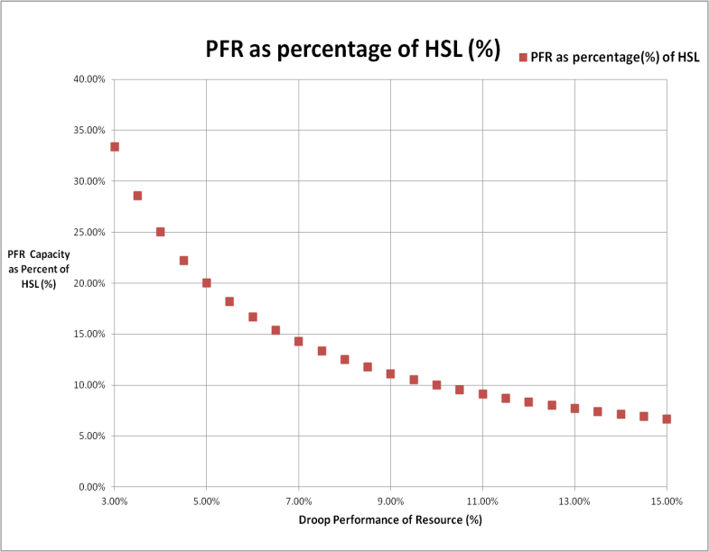
P - Will be equal to the HSL of the unit and will not include any Power Augmentation.

Figure 2: Resource’s Ability to Carry PFR Capacity as Percent of HSL Based on Droop Performance
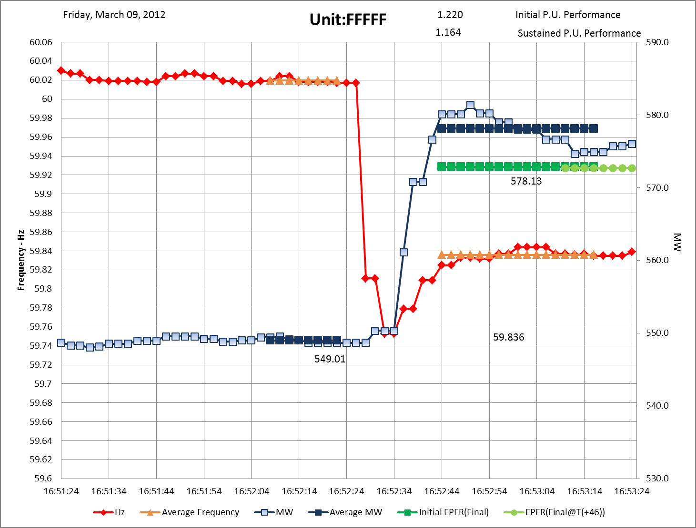
Figure 3 Showing PFR performance measurements for BAL-TRE-001 Standard
(P or HSL = 605 MW)
Table 1
Table 1 shows and example calculated droop performance based on the equation below. The 5.10 % droop performance means unit will be able to provide 118.5 MW or 19.5 9% of HSL, whichever is minimum.

Protocol Concept – Consensus acceptance requested prior to Protocol Language development:

Once the PFR market is established, ERCOT will limit the PFR capacity reservation award to individual Resources based on the Median of their actual performance during past 6 events. ERCOT will calculate the MW/0.1 Hz response during these events and calculate Resource’s capability for 1% or 0.6 Hz change in frequency. If a new or previously disqualified Resource with appropriate droop setting seeks PFR qualification, ERCOT will limit the PFR capacity reservation to no more than 20% of the Resource’s Frequency Responsive HSL. Private Use Network (PUN) with registered Resources may use the Gross HSL for qualification and establishing a limit on amount of PFR capacity that the PUN Resources can provide. This is the amount of MW that can respond during a frequency event. ERCOT also proposes that the limits established on the Resources be based on their capability to provide PFR.

- Methodology to Determine Requirement for PFR service
ERCOT as the system Reliability Coordinator will determine the amount of governor capability that must be available in each hour of the Operating Day to assure a system response characteristic as illustrated in Figure 1. ERCOT will conduct series of dynamic studies to quantify the amount of PFR needed under various system conditions. The results of these studies together with applicable safety margins and amount of FFR procured will determine how much PFR is needed for each hour of the Operating Day. ERCOT will procure at a minimum, full amount of combined PFR and FFR needed to avoid firm load shedding for simultaneous loss of two largest units totaling 2750 MW.

ERCOT had performed dynamic simulation studies in 2011 to study the minimum quantities of Load Response (set at 59.70 Hz triggered by UFR) and Governor Response needed to protect under-frequency load shed at 59.30 Hz for a loss of two largest units totaling 2750 MW. The results indicate the need of 2,800 MW (up to 50% can be provided by LRs) is required for the studied high wind low load system condition. Total load in the case was 28,400 MW including 5000 MW of PUN and 7,400 MW of wind generation.

- AS Plan Topics
This subsection explains:

The amount of capability is expressed as a MW of PFR capacity reservation for each Resource and will be published to the market in ERCOT’s daily Ancillary Service Plan. ERCOT’s intent is to procure the required PFR capacity reservation (AS Plan requirement less QSE self-arranged PFR capacity amounts) specified for each operating hour in the Operating Day in the Day-Ahead Market.

- Day-ahead and Real Time ERCOT posting requirements.

  - ERCOT will post the quantities of FFR and PFR (for example, a particular hour may have an AS Plan requirement of X MW of FFR and Y MW of PFR)
  - ERCOT will set QSE PFR Service Obligations consistent with the methodology in current usage for assigning QSE AS Obligations – Load Ratio Share
    - Open to discuss alternative options on assigning AS obligations
  - QSE with AS obligations can self-arrange AS up to a maximum of their AS obligation amount subject to protocol requirement of FFR to PFR ratio or other such criteria.
  - If Operating Reserve Demand Curve (ORDC) is implemented for Day Ahead Market (DAM), then the disaggregated ORDC for each AS is also posted

    - If, due to economics (maximizing the area between the AS demand curve and AS supply curve), more AS is procured than the requirement, then LSE QSE charged on a pro-rated basis. This pro-ratio will be based on the difference between the original LSE QSE obligation of the AS plan (ideal/preferred) and the amount self-arranged.
  - If DAM cannot procure sufficient AS, then will follow current process of dealing with DAM AS insufficiency.
    - If sufficient FFR capacity is not available, then more PFR will need to be procured (the amount of additional PFR required to compensate for deficiency in FFR will depend on the ratio of PFR to FFR from prior operations studies)
    - LSE QSE will be charged on a pro-rated basis for procuring the deficiency. Proration will be based on difference between the original LSE QSE obligation of the AS plan (ideal/preferred) and the amount self-arranged.
- Resources providing PFR capacity will have their HASL= HSL-PFR capacity-other AS capacity (excluding SIR).

Day-Ahead Self-Arrangement and Offers
This subsection explains:
- DA self-arrangement notification requirements;
- Applicability of negative self-arrangement;
- The service offer criteria; and,
- Pre-DAM and continuous validations rules for this service.

AS Trades
This subsection explains:
- AS trade criteria for this service;
- The day ahead and continuous trade validation rules applicable for this service; and
- The provisions applicable to QSE to QSE AS trades of this service including AS trade criteria, AS trade validation rules, and the QSE’s AS supply responsibility for this service.

The DAM Clearing Process
This subsection explains:
- DAM co-optimization constraint set applicable to this service;

- The marginal clearing prices determined by DAM.

Where possible, the ERCOT DAM implementation will co-optimize the procurement of PFR Service capacity reservation and energy for all qualified technologies, subject to the maximization of the total PFR Capacity Reservation offered in the DAM not to exceed the AS Plan requirements (or ORDC) as adjusted by QSE PFR Service self-arrangements. ERCOT expects to utilize for PFR Service offers the existing AS offer methodologies described in ERCOT’s Business Practice Manual “Ancillary Services Market Transactions in the Day-Ahead Market and Real Time Adjustment Period.” QSE’s may self-arrange this service or procure it through the ERCOT Markets in the Day-Ahead or Adjustment Period.

AS Substitution:
- Concept is to allow offers for higher quality AS to be used to satisfy (substitute) lower quality AS if required
  - Ensures the clearing price (MCPC) for higher quality AS is higher than lower quality AS
  - Example of the constraint set where Regulation Up offers can substitute for Contingency Reserves are:
Sum(RegUp_Award) >= RegUp_Req
Sum (RegUp_Award) + Sum (CR_Award) >= RegUp_Req + CR_Req
- In the context of PFR service, constraints could be setup where PFR offers can be used to substitute for CR and SR. Furthermore, submission rules for ERCOT’s linked AS offers can be modified to ensure that the clearing price hierarchy is maintained (MCPC for higher quality AS is higher than MCPC for lower quality AS).

Overview of PFR Constraints in energy and AS co-optimization:

- Option 1: Combined clearing (Single clearing price, MCPC) for FFR+PFR
  - This option may be beneficial when there is lack of liquidity in a given service
  - Constraints are set up as :
Sum (FFR_Award) + Sum ( PFR_Award) >= FFR_Req + PFR_Req
Sum (FFR_Award) <= 50% of ( FFR_Req + PFR_Req)
  - Co-optimization of energy and AS is maintained

- Option 2: Separate clearing (separate clearing price, MCPC) for FFR and PFR
  - This option is more appropriate if there is sufficient liquidity
  - Constraints are setup as :
Sum (FFR_Award) >= FFR_Req
Sum (PFR_Award) >= PFR_Req
  - Co-optimization of energy and AS is maintained

- Resource capacity constraint is setup as:
LSL<= Energy_Award+PFR_Award+Other_AS_Award <= HSL

DAM Settlement
This subsection explains the settlement process that ERCOT intends to use for this service. At this time is not necessary that settlement equations be provided; however, the text description should fully describe the methodology that will be utilized in the settlement process including the application of the clearing prices in settling the supplier’s payments and the allocation of charges to the QSE to cover these payments.

COP Requirements
This subsection describes the COP reporting requirements for this service.

RUC Processes applicable to this Service
This section explains ERCOT’s intentions when using the RUC processes to cure an insufficiency for this service that is not corrected by market mechanisms in the day-ahead or the adjustment period and real time.

Adjustment Period and Real Time
Further discussion required to consider Real-Time energy and AS co-optimization that allows QSEs to adjust their AS portfolio in Real-Time and also allow ERCOT to procure additional AS in Real-Time, if required.
This subsection explains:
- The provisions that apply for this service during the adjustment period to AS trades or request for changes in AS Resource responsibilities;
- The processes that apply when ERCOT determines that additional service capacity is required or replacement capacity is needed because of a failure to provide or transmission constraints affect the current supplier’s ability to deliver the service when deployed;
- The conduct of the SASM, if required, and the RT co-optimization of this service with energy;
- The application of Resource limits for SCED;
- A description of the reporting requirements for this service in the AS Capacity Monitor; and
- Provisions applicable to operational deployments and any unique requirements that apply in the event of Emergency or short supply Operations.

Real Time Settlement
This subsection explains the settlement process that ERCOT intends to use for this service. At this time is not necessary that settlement equations be provided; however, the text description should fully describe the methodology that will be utilized in the settlement process including the application of the clearing prices in settling the supplier’s payments and the allocation of charges to the QSE to cover these payments. Additionally, this description must include, if appropriate, any pay-for performance settlement.

The design for pay-for performance needs to consider whether the payment includes an uplift component or redistribution of the total AS capacity reservation revenue among the resources based on performance (or a combination of both).
- The majority of the feedback at the work session was to avoid pay-for performance as far as PFR is concerned.

“Use of Frequency Response Metrics to Assess the Planning and Operating Requirements for Reliable Integration of Variable Renewable Generation” by Joseph H. Eto, Principal Investigator Lawrence Berkeley National Laboratory
Refer to ERCOT’s Discussion Paper “Future Ancillary Service in ERCOT” for further descriptions of the need for this service
http://www.ercot.com/content/meetings/ros/keydocs/2012/0614/08._LRs_Assessment_2012_ROS.ppt

