
January 2014 ERCOT Monthly Operations Report

Reliability and Operations Subcommittee Meeting
February 6 2014
Table of Contents
1. Report Highlights 1
2. Frequency Control 2
2.1. Frequency Events 2
2.2. Responsive Reserve Events 3
2.3. PMU Events 3
2.4. Load Resource Events 4
3. Reliability Unit Commitment 4
4. Wind Generation as a Percent of Load 5
5. Congestion Analysis 5
5.1. Notable Constraints for January 5
5.2. Generic Transmission Limit Congestion 6
5.3. Congestion Costs for Calendar Year 2014 7
6. System Events 8
6.1. ERCOT Peak Load 8
6.2. Load Shed Events 8
6.3. Stability Events 8
6.4. TRE/DOE Reportable Events 8
6.5. New/Updated RAPs and PCAPs 8
6.6. New/Modified/Removed SPS 8
6.7. New Procedures/Forms/Operating Bulletins 8
7. Emergency Conditions 8
7.1. OCNs 9
7.2. Advisories 9
7.3. Watches 9
7.4. Emergency Notices 9
8. Application Performance 10
8.1. TSAT/VSAT Performance Issues 10
8.2. Communication Issues 10
9. Net-Forecast Bias Applied to NSRS Procurement for February 2014 10
10. Appendix A: Real-Time Constraints 11

Report Highlights
The ERCOT Interconnection experienced a busy start to 2014 as a result of numerous cold fronts that swept across Texas in January. Though the system generally responded well to the freezing temperatures, Operations noted an above-average number of frequency events, RUC commitments, and SCED congestion not related to outages. In addition, the ERCOT system entered into Energy Emergency Alert (EEA) twice during the month of January. Both of these incidents are discussed briefly in this document, and are detailed fully in separate reports prepared by ERCOT.
Highlights of this report:
- The unofficial ERCOT peak for January was 57,277 MW.
- There were eight frequency events in January. PMU data indicates the ERCOT system exhibited sufficient dampening and transitioned well after each disturbance.
- There were eight instances where Responsive Reserves were deployed and three instances were Load Resources were deployed.
- The number of RUC Commitments remained consistent with previous months, and was due to a combination of inclement weather and local congestion.
- The number of SCED congestion events was on par with previous months. However, more were related to higher loads caused by cold weather.
- ERCOT entered into EEA twice during the month of January. There was no firm load shed in either case.
- ERCOT Applications performed well. There was one VSAT issue following a server failover.

Frequency Control

Frequency Events
The ERCOT Interconnection experienced eight frequency events in January, all of which were as a result of Resource trips. The average duration of these events was just over 3 minutes. This represents an increase over previous months, largely the result of the long duration of the events that occurred during the EEA event on January 6. Further details on the Resource trip events can be seen in the Performance Disturbance Compliance Working Group report. A summary of the frequency events is provided below:

Date and Time | Max/Min Frequency  (Hz) | Duration of Event  (seconds) | Comments
1/6/2014 0:30 | 59.899 | 3 | Unit trip with approximately 470 MW net
1/6/2014 6:39 | 59.831 | 960 | Multiple unit trips during EEA event
1/6/2014 7:00 | 59.860 | 250 | Unit trip with approximately 310 MW net during EEA event
1/6/2014 8:10 | 59.851 | 360 | Unit trip with approximately 900 MW net during EEA event
1/13/2014 4:19 | 59.785 | 9 | Unit trip with approximately 824 MW net
1/18/2014 8:40 | 59.716 | 9 | Unit trip with approximately 1237 MW net
1/25/2014 0:07 | 59.817 | 50 | Unit trip with approximately 720 MW net
1/30/2014 17:28 | 59.889 | 6 | Unit trip with approximately 428 MW net

(Note: the duration of the frequency events is defined to be the time at which the frequency was outside the range of 60±0.1 Hz)

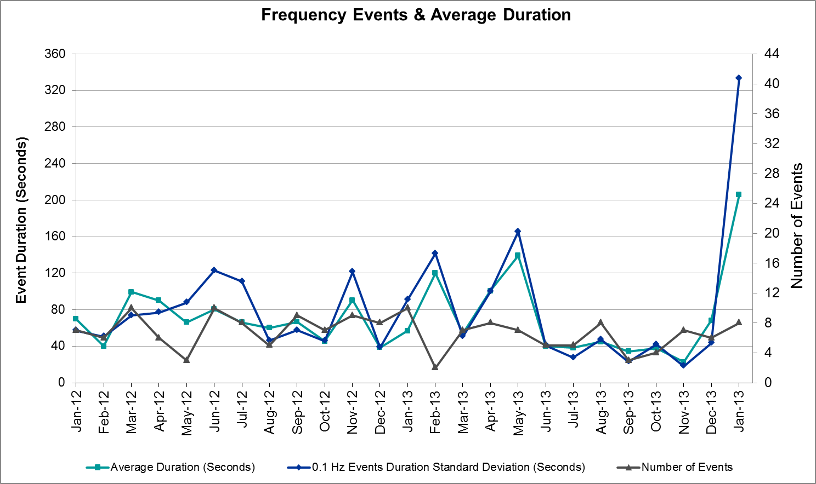

Responsive Reserve Events
There were eight events where Responsive Reserve MWs were released to SCED in January. The events highlighted in blue were related to frequency events reported in section 2.1 above.

Date and Time  Released to SCED | Date and Time  Recalled | Duration of Event | Maximum MWs Released | Comments
1/6/14 0:30:44 | 1/6/14 0:34:36 | 0:03:52 | 210.69
1/6/14 6:05:50 | 1/6/14 6:08:56 | 0:03:06 | 239.01 | One Unit derated by 500 MW
1/6/14 6:37:56 | 1/6/14 8:02:32 | 1:24:36 | 1773.9
1/6/14 8:10:56 | 1/6/14 8:17:55 | 0:06:59 | 415.68
1/13/14 4:19:56 | 1/13/14 4:26:56 | 0:07:00 | 1070
1/18/14 8:41:10 | 1/18/14 8:41:34 | 0:00:24 | 833.7
1/25/14 12:07:10 | 1/25/14 12:10:26 | 0:03:16 | 641.28
1/30/14 17:28:32 | 1/30/14 17:30:40 | 0:02:08 | 139.68

PMU Events
Three synchrophaser events were captured in January, and all were a result of frequency events identified in section 2.1 above. ERCOT evaluates PMU data according to industry standards. Events with an oscillating frequency of less than 1 Hz are considered to be inter- area, while higher frequencies indicate local events. Industry standards specify that damping ratio for inter-area oscillations should be 3.0% or greater. All events listed below indicate the ERCOT system met these standards and transitioned well after each disturbance.

Date and Time | Event Type | Duration of Event | Comments
1/6/2014 08:10:41 | Unit Trip | Approx. 480 sec | The event was caused by the loss of one unit generating 902 MW net. Following the trip, frequency dropped to 59.851 Hz. The oscillating frequency of 0.606 Hz with 8% damping ratio was observed.
1/18/2014 08:40:53 | Unit Trip | Approx. 15 sec | The event was caused by the loss of one unit generating 1230 MW net. Following the trip, frequency dropped to 59.7 Hz. Two oscillating frequencies of 0.7 Hz with a 13.8% damping ratio and 0.79 Hz with a 10.13% damping ratio were observed.
1/25/2014 12:06:57 | Unit Trip | Approx. 191 sec | The event was caused by the loss of one unit generating 657 MW net. Following the trip, frequency dropped to 59.817 Hz. The oscillating frequency of 0.7 Hz with 9.68% damping ratio was observed.

Load Resource Events
There were three load resource deployment events in January. All were related to EEA events experienced by the ERCOT system in January.

Date and Time  Started | Date and Time  Recalled | Duration of Event | Maximum MWs Deployed | Comments
1/6/14 6:53:39 | 1/6/14 7:53:16 | 0:59:37 | 546.4 | First Load Resource group deployed to maintain system frequency
1/6/14 7:03:26 | 1/6/14 7:53:16 | 0:49:50 | 536.2 | Second Load Resource group deployed to maintain system frequency
1/18/14 8:41:10 | 1/18/14 9:40:00 | 0:38:50 | 875 | Load Resources tripped offline on under-frequency relay action

Reliability Unit Commitment
The ERCOT Interconnection committed six resources for the month of January.

DRUC Commitments
Resource Location | # of Resources | Operating Day | # Hours Committed | Total MWhs | Reason for commitment
Coast | 3 | 1/24/2014 | 14 | 4,611 | Capacity

HRUC Commitments
Resource Location | # of Resources | Operating Day | # Hours Committed | Total MWhs | Reason for commitment
S. Central | 1 | 1/6/2014 | 17 | 5,355 | Local Congestion
Coast | 2 | 1/28/2014 | 22 | 11,222 | Capacity
S. Central | 1 | 1/28/2014 | 9 | 2,070 | Capacity
Southern | 1 | 1/30/2014 | 3 | 1,490 | Local Congestion
Southern | 1 | 1/31/2014 | 12 | 8,605 | Local Congestion

Wind Generation as a Percent of Load
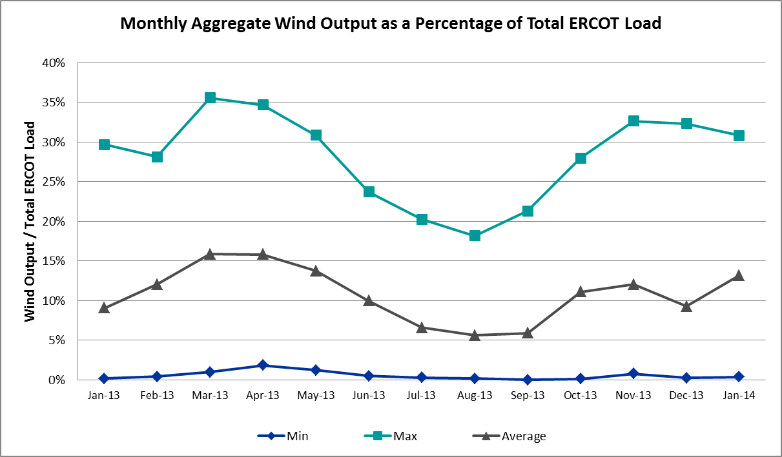

Congestion Analysis
The number of congestion events experienced by the ERCOT system did not vary significantly from December 2013. The majority of the congestion observed was due to the colder weather rather than ongoing outages as was the case in previous months. There were three days of activity on the W-N Generic Transmission Limit due to very high wind output in the West. Note that Operations has slightly revised the criteria for identifying reportable congestion events. These criteria are described in section 5.1.

Notable Constraints for January
Nodal protocol section 3.20 specifies that ERCOT shall identify transmission constraints that are active or binding three or more times within a calendar month. As part of this process, ERCOT reports congestion that meets this criterion to ROS. In addition ERCOT also highlights notable constraints that have an estimated congestion rent exceeding $1,000,000 for a calendar month. These constraints are detailed in the table below. Rows highlighted in blue indicate the congestion was affected by one or more outages. For a list of all constraints activated in SCED for the month of January, please see Appendix A at the end of this report.

Contingency | Overload | # of Days Constraint Active | Estimated Congestion Rent | Transmission Project
Lytton Springs LY_AT2 345/138 kV | Lytton Springs LY_AT1 345/138 kV | 6 | $22,859,336
DCKT Limestone - Navarro 345 kV | Jewett - Big Brown Ses 345 kV (Line 40) | 1 | $3,428,764
Coleto Creek - Pawnee Switching Station 345 kV | Coleto Creek - Kenedy Switch 138 kV | 1 | $2,953,422 | 16TPIT0034
Orange Grove Switching Station - Lon Hill 138 kV | Lon Hill - Smith 69 kV | 7 | $2,096,672 | 16TPIT0026, 2012-R18
DCKT Henne - Zorn - McCarty Lane 138 kV | Comal - Henne 138 kV (88T234) | 1 | $1,734,600
DCKT West Levee Switch - 800/900 Network 138 kV | East Levee Switch - Reagan Street 138 kV (3410) | 1 | $1,628,842 | 16TPIT0061
Alice - Kingsville 138 kV | Falfurrias 138_69A1 138/69 kV | 1 | $1,588,327 | 12TPIT0180
DCKT Henne - Zorn - McCarty Lane 138 kV | Zorn - McCarty Lane 138 kV (98T202) | 1 | $1,509,786
Stadium Aep - Alice 69 kV | Lon Hill - Robstown Tap 69 kV | 2 | $1,319,726 | 12TPIT0180
DCKT Tonkawa Switch - Scurry County South Switch 345 kV | Bluff Creek Switch - Exxon Sharon Ridge 138 kV | 8 | $1,287,159
Salt Flat Road - Skywest 138 kV | Midland East – Pecan Grove 138 kV | 1 | $1,163,940 | 14TPIT0052
Trinidad Ses - Watermill Switch 345 kV | Trinidad Ses AXFMR6 (3) 345/138 kV | 1 | $1,132,158 | 13TPIT0186
Laquinta - Lobo 138 kV | Bruni 138_69_1 138/69 kV | 19 | $1,119,924 | 11TPIT0002
Kingsville - Lon Hill 138 kV | Lon Hill - Calallen Sub 69 kV | 2 | $1,008,129 | 12TPIT0181, 2012-R13
Nelson Sharpe - Lon Hill 345 kV | Celanese Bishop - Kleberg Aep 138 kV | 8 | $615,951 | 15TPIT0069
Koch Up River - Gila 138 kV | Gila - Hiway 9 138 kV (GILA_HIWAY_2) | 7 | $523,453
Warburton Road Switching Station 138_69_1 138/69 kV | Sam Rayburn Switching Station 138_69_2 138/69 kV | 4 | $291,369
Victoria - Coleto Creek 138 kV (Coleto_Victor1) | Victoria - Coleto Creek 138 kV (Coleto_Victor2) | 3 | $168,302 | 16TPIT0034
Vernon 138_69T1 138/69 kV | Lake Pauline 138_69_1 138/69 kV | 3 | $125,698
Aspermont Aep - Spur 138 kV | Wolfgang - Rotan 69 kV | 9 | $64,417
Sherriffs Posse - Marion 138 kV | Marion - Cibolo 138 kV | 3 | $54,102 | 17TPIT0008
Bosque Switch - Whitney 138 kV | Bosque Switch - Lake Whitney Tnp 138 kV | 8 | $49,576 | 2013-R42
Basecase | Whirlwind Energy Center - Matador 69 KV | 4 | $31,135
Scurry Switch - Sun Switch 138 kV | Wolfgang - Rotan 69 kV | 5 | $24,142
Loyola Sub - Kleberg Aep 138 kV | Loyola Sub 138_69_1 138/69kV | 4 | $14,454
Basecase | Langford Wind Power LLC - Santiago 138 kV | 3 | $4,652

Generic Transmission Limit Congestion
There were three days of GTL activity on the West – North Stability limit as a result of high output from West Texas wind generation. There was no GTL activity on the North – Houston, Valley Import, or SOP110 GTLs.

Congestion Costs for Calendar Year 2014
The following table represents the top twenty active constraints for the calendar year to date based on the estimated congestion rent attributed to the congestion. ERCOT updates this list on a monthly basis.

Contingency | Binding Element | # of 5-min SCED Intervals | Estimated Congestion Rent | Transmission Project
Lytton Springs LY_AT2 345/138kV | Lytton Springs LY_AT1 345/138kV | 852 | $22,859,336.00
Coleto Creek - Pawnee Switching Station 345kV and Pawnee Switching station - Calaveras 345kV | Coleto Creek - Kenedy Switch 138kV | 125 | $3,445,446.00 | 16TPIT0034
DCKT Limestone - Navarro 345kV | Big Brown SES - Jewett 345kV | 34 | $3,428,764.00
Kingsville to Lon Hill 138kV and Alice to Stadium AEP 69kV and Alice to Kingsville 138kV | Lon_hill - Robstown Tap 69kV | 448 | $2,948,350.00 | 12TPIT0180
Orange Grove Switching Station - Lon_hill 138kV | Lon_hill - Smith 69kV | 843 | $2,096,672.00 | 16TPIT0026, 2012-R18
DCKT McCarty Lane - Zorn 138kV | Comal - Henne 138kV | 26 | $1,734,600.00
DCKT West Levee Switch - 89NWK 138kV | East Levee Switch - Reagan Street 138kV | 60 | $1,628,842.00 | 16TPIT0061
DCKT Zorn - Henne & McCarty Lane 138kV | McCarty Lane - Zorn 138kV | 69 | $1,509,786.00
DCKT Tonkawa Switch - Scurry County South Switch 345kV | Bluff Creek Switch - Exxon Sharon Ridge 138kV | 806 | $1,287,159.00
Trinidad SES - Watermill Switch 345kV | Trinidad SES AXFMR6 345/138kV | 30 | $1,228,117.00 | 13TPIT0186
Salt Flat Road (SU_1956) - Skywest 138kV | Pecan Grove -Midland East 138kV | 83 | $1,163,940.00 | 14TPIT0052
Laquinta - Lobo 138kV | Bruni Sub 138_69_1 138/69kV | 1679 | $1,119,924.00 | 11TPIT0002
Kingsville to Lon Hill 138kV | Calallen Sub - Lon_Hill 69kV | 304 | $1,008,129.00 | 12TPIT0181, 2012-R13
Drilco - North Belt 138kV and DCKT Northbelt-King & Cedar Bayou Plant 345kV | Humble - Treaschwig 138kV | 87 | $776,984.00 | 14TPIT0099
Nelson Sharpe - Lon_Hill 345kV | Celanese Bishop - Kleberg AEP 138kV | 615 | $615,951.00 | 15TPIT0069
Koch Up River - Gila 138kV | Gila - Hiway_9 138kV | 1670 | $523,453.00
Sherriffs Posse - marion 138kV | Cibolo - Marion 138kV | 238 | $409,090.00 | 17TPIT0008
Lon_Hill 138_69A1 138/69kV | Lon_Hill 138_69A2 138/69kV | 201 | $378,330.00
DCKT Garfield AEN - Hicross AEN & Onio Creek - Pilot Knob 138kV | Pedernales - Advanced Micro Device AEN 138kV | 22 | $310,041.00 | 11TPIT0008
Warburton Road Switching Station 138_69_1 138/69kV | Sam Rayburn Switching Station 138_69_2 138/69kV | 374 | $291,369.00

System Events
The ERCOT interconnection experienced several cold weather events in January. The system entered EEA on two separate occasions during the month, resulting in two TRE/DOE reportable events. These are discussed in section 6.4 below and detailed further in section 7 of this report. There were no other System Events in January.

ERCOT Peak Load
The unofficial ERCOT peak load for the month of January was 57,277 MW and occurred on January 7 during the hour ending 08:00.

Load Shed Events
None

Stability Events
None

TRE/DOE Reportable Events
ERCOT experienced two reportable events in January, both related to the EEA events during the month. ERCOT has filed an OE-417 report for the media appeal made on January 6 and an EOP-004 form for the loss of generation exceeding 1000 MW on January 18. ERCOT will provide full reports on both EEA events. Please refer to these for additional information.

New/Updated RAPs and PCAPs
None

New/Modified/Removed SPS
None

New Procedures/Forms/Operating Bulletins
Date | Document | Description
1/1/2014 | Power Operations Bulletin 654 | Real Time Desk V1 Rev28
1/1/2014 | Power Operations Bulletin 655 | Reliability Unit Commitment Desk V1 Rev23
1/1/2014 | Power Operations Bulletin 656 | Transmission and Security Desk V1 Rev29
1/29/2014 | Power Operations Bulletin 657 | DC Tie Desk V1 Rev24
1/29/2014 | Power Operations Bulletin 658 | Shift Supervisor V1 Rev25

Emergency Conditions
The ERCOT Interconnection experienced Emergency Conditions on numerous occasions in January. These were almost entirely due to cold weather events experienced throughout the month. The relevant notices were posted to the ERCOT website and are summarized in the following tables. The ERCOT system also entered into EEA on two occasions in January. One of these instances was related to freezing temperatures while the other was caused by a large unit trip. Please refer to the detailed reports prepared by ERCOT for additional information beyond what is covered in the tables below.

OCNs
Date and Time | Description
1/22/2014 10:19 | ERCOT issued an OCN for freezing temperatures expected on Thursday (1/23/2014) night and Friday (1/24/2014) morning.
1/24/2014 13:13 | ERCOT issued an OCN for a severe cold front expected to hit the region on Tuesday (1/28/14) night and Wednesday (1/29/14) morning. Loads were projected to be near the winter peak during this period.

Advisories
Date and Time | Description
1/5/2014 10:10 | ERCOT issued an Advisory due to forecasted hard freeze across the entire state for the night of 1/5/2014 and the morning of 1/6/2014.
1/5/2014 13:33 | ERCOT issued an Advisory for the timeline deviation of the Day Ahead Market. Start of DRUC was delayed.
1/6/2014 13:28 | ERCOT issued an Advisory due to postponing the deadline for posting of the DAM solution for OD 1/7/2014.
1/9/2014 17:22 | ERCOT issued an Advisory due to the Voltage Security Assessment (VSAT) tool being currently unavailable.
1/18/2014 11:29 | ERCOT issued an Advisory for Physical Responsive Capability less than 3000 MW.
1/22/2014 10:01 | ERCOT issued an Advisory for freezing temperatures with freezing rain and sleet expected across most of the state on Thursday (1/23/2014) night and Friday (1/24/2014) morning.
1/26/2014 12:59 | ERCOT issued an Advisory for a severe cold front expected to hit the region between Monday (1/27/2014) night to Wednesday (1/29/2014) morning. Loads were projected to be near the winter peak during this period.

Watches
Date and Time | Description
1/5/2014 13:31 | ERCOT issued a Watch due to the postponement of the posting of the DAM Solution for OD 1/6/2014 due to long processing time.
1/5/2014 13:31 | ERCOT issued an Advisory for the timeline deviation of the Day Ahead Market. Start of DRUC was delayed.
1/6/2014 06:30 | ERCOT issued a Watch for Physical Responsive Capability less than 2500 MW.
1/18/2014 09:47 | ERCOT issued a Watch for Physical Responsive Capability less than 2500 MW.
1/23/2014 09:51 | ERCOT issued a Watch for freezing temperatures expected in most of the state on Thusday (1/23/14) night and Friday (1/24/14) morning with freezing rain and sleet for the Central, Southern, and Coastal areas.
1/27/2014 10:58 | ERCOT issued a Watch for the severe cold front impacting the region through the morning of Wednesday, 1/29.

Emergency Notices
Date and Time | Description
1/6/2014 06:56 | ERCOT issued an Emergency Notice after declaring EEA 1 – Reserves below 2300 MW.
1/6/2014 07:08 | ERCOT issued an Emergency Notice after declaring EEA 2 at 07:05 – Reserves below 1750 MW.
1/6/2014 07:53 | ERCOT issued an Emergency Notice after moving from EEA 2 to EEA 1 due to improving system conditions.
1/6/2014 09:18 | ERCOT issued an Emergency Notice after moving from EEA 1 to Normal condition.
1/18/2014 09:00 | ERCOT issued an Emergency Notice after declaring EEA 1 – Reserves below 2300 MW.
1/18/2014 09:48 | ERCOT issued an Emergency Notice after moving from EEA 1 to Normal condition.

Application Performance
ERCOT system applications performed well overall in January. There was a single issue with the VSAT tool not solved for 30 minutes. No other application issues occurred.

TSAT/VSAT Performance Issues
There was one issue in January related to VSAT due to a server issue during a site failover.

Date and Time | Description
1/9/2014 17:22 | ERCOT issued an Advisory due to the Voltage Security Assessment (VSAT) tool being currently unavailable.

Communication Issues
None.

Net-Forecast Bias Applied to NSRS Procurement for February 2014
Each month, ERCOT calculates a net Forecast Bias pursuant to the ERCOT Ancillary Services Methodology for procurement of Non-Spinning Reserve Service (NSRS). The table below indicates the amount of net Forecast Bias that was applied to the NSRS procurement for specified blocks of time for the month of February, 2014.

Blocks | Negative Net Load Forecast Average Error - ERCOT | Sum of the Individual Zones | Negative Net Load Forecast Average Error - By Weather Zone for the 5 Largest Zones
Blocks | Negative Net Load Forecast Average Error - ERCOT | Sum of the Individual Zones | Coast | East | North Central | South Central | Southern
1-2 | 0 | 0 | 0 | 0 | 0 | 0 | 0
3-6 | 0 | 0 | 0 | 0 | 0 | 0 | 0
7-10 | 0 | 0 | 0 | 0 | 0 | 0 | 0
11-14 | 0 | 0 | 0 | 0 | 0 | 0 | 0
15-18 | 0 | 0 | 0 | 0 | 0 | 0 | 0
19-22 | 0 | 0 | 0 | 0 | 0 | 0 | 0
23-24 | 0 | 0 | 0 | 0 | 0 | 0 | 0

Appendix A: Real-Time Constraints
The following is a complete list of constraints activated in SCED for the month of January.

Contingency | Constrained Element | From Station | To Station | # of Days Constraint Active
SLAQLOB8 | BRUNI_69_1 | BRUNI | BRUNI | 19
SSPUASP8 | ROTN_WOLFGA1_1 | WOLFGANG | ROTN | 9
DSCOTKW5 | 6216__A | BCKSW | SHRNE | 8
SBOSWHT8 | OLKW_BOS_1 | BOSQUESW | LKWHITNY | 8
SN_SLON5 | CELANE_KLEBER1_1 | CELANEBI | KLEBERG | 8
SKOCNU28 | GILA_HIWAY_2_1 | GILA | HIWAY_9 | 7
SORNLON8 | LON_HI_SMITH1_1 | LON_HILL | SMITH | 7
XLY2T58 | LYTTON_S_AT1H | LYTTON_S | LYTTON_S | 6
SSCUSUN8 | ROTN_WOLFGA1_1 | WOLFGANG | ROTN | 5
BASE CASE | MATA_WEC1_1 | WEC | MATA | 4
SKLELOY8 | LOYOLA_69_1 | LOYOLA | LOYOLA | 4
XWAR89 | RAYBURN_69_2 | RAYBURN | RAYBURN | 4
BASE CASE | LGD_SANTIA1_1 | LGD | SANTIAGO | 3
BASE CASE | W_TO_N |  |  | 3
SSHEMAR8 | 95T302_1 | MARION | CIBOLO | 3
SVICCO28 | COLETO_VICTOR2_1 | COLETO | VICTORIA | 3
XVE2R89 | PAUL_69-1 | PAUL | PAUL | 3
DCALHOT8 | N4_X3_1 | CALAVERS | X3 | 2
DSCOTKW5 | 6216__A | SHRNE | BCKSW | 2
SALIKIN8 | LON_HI_ROB_CP1_1 | LON_HILL | ROB_CPL | 2
SBRAUVA8 | HAMILT_MAVERI1_1 | HAMILTON | MAVERICK | 2
SKINLON8 | CALALS_LON_HI1_1 | LON_HILL | CALALS | 2
SLAQLOB8 | FALFUR_69A1 | FALFUR | FALFUR | 2
SSTAALI9 | LON_HI_ROB_CP1_1 | LON_HILL | ROB_CPL | 2
XLON89 | LON_HILL_69A2 | LON_HILL | LON_HILL | 2
D_NBCBY5 | HB_TWG66_A | HB | TWG | 1
DHENMCC8 | 98T202_1 | ZORN | MCCALA | 1
DI_DWHI8 | RINCON_WHITE_2_1 | RINCON | WHITE_PT | 1
DLULZOR8 | F1_O9_1 | F1 | SUTHRLND | 1
DMARSKY5 | 95T302_1 | MARION | CIBOLO | 1
DNAVLEG5 | 40__A | JEWET | BBSES | 1
DONIPIL8 | CKT_1017_1 | ADVANCE | PEDERNAL | 1
DSAMTHS5 | WHTNY_FMR2 | WHTNY | WHTNY | 1
DSKYCAL5 | N5_U3_1 | CALAVERS | BRAUNIG | 1
DTRSTRC5 | TRSES_MR6L | TRSES | TRSES | 1
DWH_STP5 | AIRCO4_RINCON1_1 | RINCON | AIRCO4 | 1
DWH_STP5 | BONIVI_RINCON1_1 | RINCON | BONIVIEW | 1
DWLV89N8 | 3410__A | ELVSW | REGST | 1
DZORMCC8 | 88T234_1 | COMAL | HENNE | 1
DZORSEG8 | F1_O9_1 | F1 | SUTHRLND | 1
SALIKIN8 | FALFUR_69A1 | FALFUR | FALFUR | 1
SCAGKEN5 | 67T280_1 | VERDCR | BANDER | 1
SCOLPAW5 | COLETO_KENEDS1_1 | COLETO | KENEDSW | 1
SCOLPAW5 | COLETO_VICTOR1_1 | COLETO | VICTORIA | 1
SCOLPAW5 | KENEDS_LYSSY0_1 | KENEDSW | LYSSY | 1
SDANBLE8 | BLESSI_MARKHA1_1 | BLESSING | MARKHAM | 1
SDQNB8 | HB_TWG66_A | HB | TWG | 1
SECRBRA8 | 6240__A | SACRC | SNYDR | 1
SFREGIL8 | FREDER_AT2 | FREDER | FREDER | 1
SHIWCIT8 | MORRIS_NUECES1_1 | NUECES_B | MORRIS | 1
SI_DI_38 | I_DUPP_I_DUPS1_1 | I_DUPP1 | I_DUPSW | 1
SKINLON8 | LON_HI_ROB_CP1_1 | LON_HILL | ROB_CPL | 1
SNEDLON5 | LASPUL_RAYMND1_1 | LASPULGA | RAYMND2 | 1
SNEDLON5 | LASPUL_RIOHON1_1 | LASPULGA | RIOHONDO | 1
SOXYIN28 | I_DUPP_I_DUPS1_1 | I_DUPP1 | I_DUPSW | 1
SPAWCAL5 | COLETO_KENEDS1_1 | COLETO | KENEDSW | 1
SSALSK28 | 6146__A | MDLNE | EMDLD | 1
SSHBMLS5 | ELKTN_SD1_1 | ELKTN | ELKTN | 1
STRSWTR5 | TRSES_MR6L | TRSES | TRSES | 1
SWINPBS8 | PBSES_FMR2 | PBSES | PBSES | 1
XRA3Y89 | WARBURTN_69_1 | WARBURTN | WARBURTN | 1

