PGRR Number | 031 | PGRR Title | Implement 95% Facility Rating Limit in the Planning Criteria

Date | February 4, 2014

Submitter’s Information
Name | Paul Hassink
E-mail Address | jphassink@ercot.com
Company | American Electric Power Service Corporation
Phone Number | 918-599-2653
Cell Number | 918-346-3569
Market Segment | Investor-Owned Utility (IOU)

Comments

American Electric Power Service Corporation (AEPSC) recommends that the Board rely on the guidance provided by the Transmission Operators (TOs), the Operations and Transmission Synchronization Task Force (OPSTF) and the Reliability and Operations Subcommittee (ROS), which is reflected in PGRRO31. AEPSC urges the Board to approve PGRR031 as recommended by the Technical Advisory Committee (TAC). The TOs are in agreement that implementing a 95% facility rating limit in the planning criteria is in the best interest of safely and reliably operating the grid.

In their comments filed on February 3, 2014, Calpine refers to the following slide presented by ERCOT at the January 28, 2014 TAC Meeting:

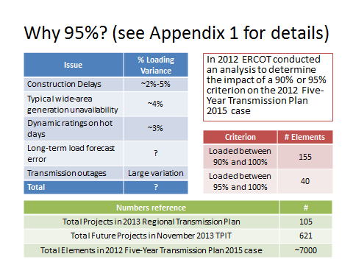

Calpine specifically calls into question the “Issues” shown on the left-hand side of the slide, which are the unforeseeable, unpredictable operational events that can and do happen in real time and impact the facility rating limits. Calpine questions the validity of the recommendation of moving the threshold to 95% when, if you add up the percentage impact of each of the issues, the impact is closer to 10%. There are two important facts for the Board to consider here. First, the slide, which is attempting to illustrate the fundamental principle that there are at least five operational conditions that our existing planning criteria do not capture. The occurrence of any one of these five conditions may individually impact the system in a manner that is equivalent to a 5% reduction in ratings. Second, AEP sees moving to the 95% rating as a first step with hopes that it would resolve the operational concerns without having to move to the 90%.

Further Calpine expresses a concern that the TOs are using a conservative emergency rating because it is the same as the continuous rating for a large percentage of the line (i.e. 81% of the 345 kV lines). For AEP, in those cases where the continuous and the emergency ratings are equal, the rating as modeled represents the ultimate (i.e. emergency) capacity of the conductor, and allows AEP to rate the conductor at its ultimate capability continuously due to the type of the conductor.

Finally, AEP feels it is important to provide operators with a level of margin that will allow them to safely operate the transmission system. If you were driving down the highway behind an eighteen-wheeled vehicle, and you knew that it would take you exactly 65 feet to be able to stop, would you drive exactly 65 feet behind the truck? Or would you add in some margin to prevent the unforeseeable. As presented by ERCOT to the OPSTF, ROS and TAC, there are simply some conditions that cannot be captured in our studies mathematically. The proposed PGRR is a reasonable attempt to provide operators with a margin to safely operate the transmission system.

Revised Cover Page Language
None at this time.

Revised Proposed Guide Language
None at this time.

