PGRR Number | 031 | PGRR Title | Implement 95% Facility Rating Limit in the Planning Criteria

Date | February 3, 2014

Submitter’s Information
Name | Randy Jones
E-mail Address | rajones@calpine.com
Company | Calpine
Phone Number | 713.830.8846
Cell Number | 832.385.3322
Market Segment | Independent Generator

Comments

Calpine recommends the Board of Directors insist on a more compelling case be offered prior to the adoption of PGRR031. This PGRR would establish a criteria of 95% of a facility’s rating for transmission project planning. This 5% deduct would be applied after all other conservative measures are used to plan a project six years out rather than looking for more accurate ways to account for planning uncertainty.

At the January 28th 2014 Technical Advisory Committee (TAC) meeting, ERCOT Staff presented an overview of the Operations and Planning Synchronization Task Force (OPSTF) work and thought processes that went into PGRR031’s development by OPSTF members. Of particular interest was slide #3 provided below of the presentation “Response to TAC Questions on PGRR031:”
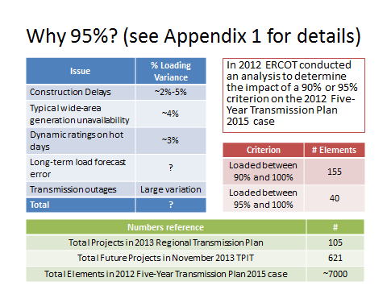
TAC members were told that due to the “Issues” in the left column the OPSTF membership were mostly in favor of making the criteria 95% of the facility’s rating but many members favored a 90% criteria. Although there may be some overlap of these factors for any given project or set of projects, stakeholders are expected to see the case for a 5% deduction as compelling despite the fact that these issues could add up to more than a 10% deduction for some projects. ERCOT informed TAC that 95% was chosen, but OPSTF members were split over 90% or 95%.

To the casual observer the choice made by the OPSTF, ratified by ROS and barely passed by TAC was an extremely arbitrary choice that is stacked on top of a number of planning measures already in place to ensure that the transmission customer’s investment is used and useful.

One additional point we would like stakeholders to consider is the very conservative approach already being used by Transmission Operators (TOs) in their selection of line ratings in the Steady State Working Group (SSWG) Base Cases.

In transmission congestion analysis, Rating A (Normal Rating) is used for base case violations, and Rating B (Emergency or 2-hour Rating) is used for N-1 violations. Most planning transmission constraints are bound by an N-1 violation, which is by Rating B.

For some time we have noticed ERCOT planning cases using the same Rating A (Normal Rating) and Rating B (Emergency or 2-hour Rating). Logically, normal ratings should always be lower or equal to the Emergency ratings.

We checked the ERCOT SSWG planning power flow case (13DSA_2014_WIN1_TPIT_Final_10152013.raw) as a test and found the following:

Line Voltage (kV) | 69 | 138 | 345
# of lines whose Rating A ≠ Rating B | 362 | 1044 | 108
# of lines whose Rating A = Rating B | 1485 | 3181 | 466
Total Number of lines | 1847 | 4225 | 574
% of lines with same Rating A & B | 80.4% | 75.3% | 81.2%
For lines where Rating A ≠ Rating B, average % of Rating B higher than Rating A | 34.8% | 20.3% | 18.4%

This data indicates that there is already significant substitution occurring in the studies where the A Rating is being used instead of the B Rating, for whatever reason, resulting in a very conservative outcome in the studies. To layer on top of this factor another 5% reduction in the line ratings for planning purposes begs the question where these conservative biases should stop.

Revised Cover Page Language
None proposed at this time.

Revised Proposed Guide Language
None proposed at this time.

