ERCOT Fast Frequency Response
Working Document – Work Session D (1-31-14):

Definition of FFR Service
Protocol Definition for Fast Frequency Response (FFR) Service –Concept Level – Consensus acceptance requested prior to Protocol Language development:

Fast Frequency Response (FFR): A response from a resource that is self-deployed and provides a full response within 30 cycles after frequency meets or drops below a preset threshold, and is sustained until recalled by ERCOT instruction.

In the ERCOT Interconnection, the minimum amount of guaranteed cumulative FFR Service that must be self-provided by QSEs or procured by ERCOT for every Operating Hour is determined based on minimum FFR and PFR needed to avoid under-frequency firm load shedding for simultaneous loss of two largest units totaling 2750 MW.

Needs of FFR Service
Primary Frequency Response is achieved through Governor or Governor-like action that is immediate and proportional to the frequency deviation; this response is generally delivered completely within 12 seconds to 14 seconds. Fast Frequency Response (FFR) provides a full MW response within 30 cycles, slowing the frequency decay and allowing sufficient time for PFR-capable resources to respond. The benefits and needs of FFR are:

Increasing the time from point A (pre-disturbance, normal system frequency) to point C (frequency nadir/peak after a sudden power imbalance), shown in Figure 1, allowing PFR resources to respond and assist in arresting frequency decay.

Raising the level of the frequency nadir to reduce the risk of frequency reaching or dropping below the first tier of under frequency load shedding, which is the backstop for the simultaneous loss of the system’s two largest units, totaling 2750 MW.

During periods with low inertia, in the absence of this service, much higher PFR capacity reservation would be needed to ensure that sufficient response capability is available to arrest sudden frequency decay in the event of generation losses.

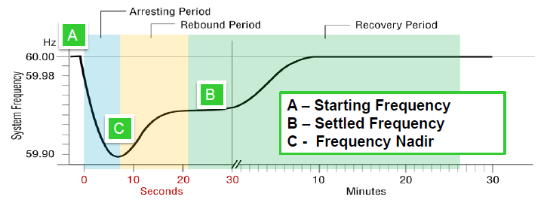
Figure 1 Typical frequency response following a generator trip.

Discussions
- Should ERCOT consider FFR-DOWN?
- Should ERCOT consider multiple frequency thresholds for FFR deployment?
- What is an appropriate sustained response period for FFR?
- What is an appropriate restoration period after receiving ERCOT’s recall signal?
- What issues are associated with varying hourly FFR requirements?
- Should a resource participating in FFR be required to provide ERCOT with high resolution measurement data for both qualification and performance evaluation?

“Use of Frequency Response Metrics to Assess the Planning and Operating Requirements for Reliable Integration of Variable Renewable Generation” by Joseph H. Eto, Principal Investigator Lawrence Berkeley National Laboratory

