SCR Number | 775 | SCR Title | Posting Results of Real-Time Data in a Display Format
Timeline | Normal | Action |  | Recommended Approval
Date of Decision |  | January 28, 2014
Proposed Effective Date |  | Upon system implementation.
Priority and Rank Assigned |  | Priority – 2014; Rank – 1100
Supporting Protocol Section |  | 6.3.2, Activities for Real-Time Operations
Other Document Reference/Source |  | None.
System Change Description |  | This System Change Request (SCR) adds two new displays to the Day-Ahead and Real-Time data displays section under the Market Information tab on the ERCOT Market Information System (MIS):  - RTD Load Zone Forecasted Prices  - RTD Hub Forecasted Prices  Each pricing display would automatically update with new revised prices on each execution of Real-Time data and delete the oldest data as shown in the examples.
Reason for System Change |  | - Many large industrial loads purchase at least a portion of their power based on the Real-Time Locational Marginal Price (LMP) for a Load Zone or have arrangements with their Load Serving Entity (LSE) to interrupt when prices reach a certain threshold established by contract.  - Real-Time data provides a source for forecasted prices, but currently is only in a Comma Separated Value (CSV) or Hypertext Markup Language (HTML) format. These files contain all the LMPs from Real-Time data for all Resource Nodes, Hubs, and Load Zones when a particular load is only interested in the prices at a specific Load Zone or Hub.  - Real-Time data output files show LMPs for all Resource Nodes, Hubs, and Load Zones in a time sequential order, making it difficult to sort out the changes in price projections for an individual Load Zone.  - To understand potential price excursions, a history of forecasted prices for an individual location is needed:  - Low prices can be as important as high prices.  - Loads need to be able to access MIS directly from ERCOT using simple off-the shelf products:  - Windows IE, Firefox, etc.
Procedural History |  | - On 10/03/13, SCR775 was posted.  - On 11/14/13, WMS comments were posted.  - On 11/21/13, PRS considered SCR775.  - On 12/18/13, an Impact Analysis was posted.  - On 12/18/13, ERCOT comments were posted.  - On 12/19/13, PRS considered the 11/21/13 PRS Report and Impact Analysis for SCR775.  - On 1/15/14, a second set of ERCOT comments were posted.  - On 1/16/14, PRS considered the 12/19/13 PRS Report and Impact Analysis for SCR775.  - On 1/28/14, TAC considered SCR775.
PRS Decision |  | On 11/21/13, PRS voted to recommend approval of SCR775 as submitted. There were two opposing votes from the Investor Owned Utility (IOU) and Municipal Market Segments and two abstentions from the Independent Power Marketer (IPM) and Municipal Market Segments. All Market Segments were present for the vote.  On 12/19/13, PRS voted to table SCR775. There was one opposing vote from the Independent Generator Market Segment and three abstentions from the IPM Market Segment. All Market Segments were present for the vote.  On 1/16/14, PRS voted via roll call vote to endorse and forward the 12/19/13 PRS Report as revised by PRS and the Impact Analysis for SCR775 to TAC with a recommended priority of 2014 and rank of 1100. There were four opposing votes from the Independent Generator, IPM and IOU (2) Market Segments and seven abstentions from the Consumer, Cooperative (3), IPM, IOU and Municipal Market Segments. All Market Segments were present for the vote.
Summary of PRS Discussion |  | On 11/21/13, there was no discussion.  On 12/19/13, ERCOT Staff reviewed the Impact Analysis and the alternative solution for implementation as identified in the 12/18/13 ERCOT comments. There was discussion regarding the budgetary impact of SCR775 and whether the value of the data displayed warranted the additional expenditure since the data is already available to Market Participants in a different format. It was requested that ERCOT reassess the impacts to determine if efficiencies could be achieved by eliminating the interactive portion from the scope of SCR775.  On 1/16/14, participants again discussed the budgetary impact of SCR775 and the value of the data to be displayed; and whether it should be the responsibility of individual participants to manipulate data into a useful format. It was noted that the 1/15/14 ERCOT comments reported that even with the removal of the Optional Price Threshold from the scope of SCR775, the range of the budgetary impact as indicated in the Impact Analysis, would remain the same.
TAC Decision |  | On 1/28/14, TAC voted to recommend approval of SCR775 as recommended by PRS in the 1/16/14 PRS Report. There was one opposing vote from the IOU Market Segment and five abstentions from the Independent Generator, IPM, and IOU (3) Market Segments. All Market Segments were present for the vote.
Summary of TAC Discussion |  | On 1/28/14, there was no discussion.
ERCOT Opinion |  | ERCOT supports approval of SCR775 as recommended by the market. The SCR775 User Interfaces will provide greater visual representation of data and additional transparency for Market Participants by providing new displays of Real-Time Indicative Pricing alongside the current LMP data for the ERCOT Hubs and Load Zones.

Business Case
Business Case | 1 | Qualitative benefits:  - Providing the capability for large energy consumers to directly access ERCOT price forecasts supports the objectives of the Public Utility Commission of Texas (PUCT) and ERCOT to increase volunteer Load response to high prices thereby providing another Resource adequacy tool to manage reliability.
Business Case | 2 | Quantifiable benefits:  - This change is expected to be used by as many as 100 LSEs who follow current and projected prices in ERCOT.
Business Case | 3 | Impacts to Market Segments:  - Assists the Consumer Market Segment, Retail Electric Providers (REPs) and other LSEs in serving Load in ERCOT and reducing entry costs to participate in voluntary Load response.
Business Case | 4 | The display content and operation of the Real-Time data displays contemplated by this SCR have been presented to the Demand Side Working Group (DSWG) for comment as well as reviewed by several large industrial consumers.

Sponsor
Name | Mark Smith
E-mail Address | mws@austin.rr.com
Company | ERCOT Steel Companies
Phone Number | (512) 241-0431
Cell Number | (512) 635-7930
Market Segment | Consumer

Market Rules Staff Contact
Name | Sandra Tindall
E-Mail Address | stindall@ercot.com
Phone Number | 512-248-3867

Comments Received
Comment Author | Comment Summary
WMS 111413 | Endorsed as submitted.
ERCOT 121813 | Provided clarification of the alternative solution identified in the 12/18/13 Impact Analysis for SCR775.
ERCOT 011514 | Responded to request from the 12/19/13 PRS meeting to reassess the impacts associated with SCR775.

Comments

As discussed at the 1/16/14 PRS meeting, the screen shots will not be displayed in different colors. Comments have been inserted below to capture the intent of the discussion.

Business Case for Proposed System Change
Issue:
Currently the forecasted prices per Load Zone and ERCOT Hubs are only available in CSV or HTML format. The Real-Time data output files are in sequential order and include all prices for every Resource Node as well as those for Load Zone and Hub prices. That format is not conducive to understanding potential Real-Time pricing excursions projected by Real-Time data. The SCR provides greater access to information already produced by Real-Time data in a more usable format. In addition, Loads need to have access to this information using simple off-the-shelf products.
Resolution:
Develop new display screens for forecasted Load Zone and Hub prices as shown by the following examples.
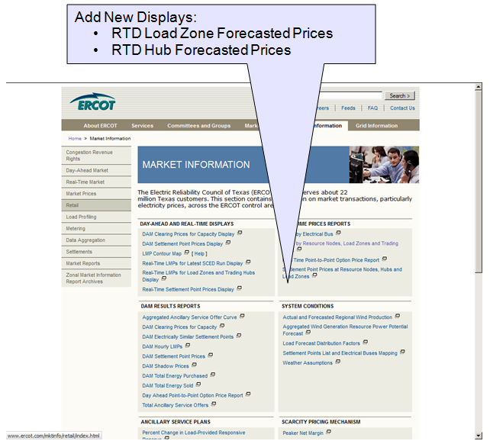
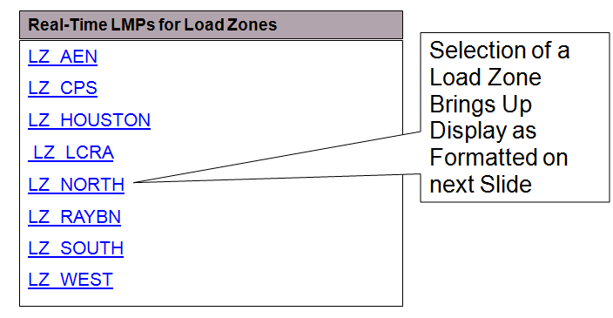
Example of the RTD Forecasted LMPs for North Load Zone
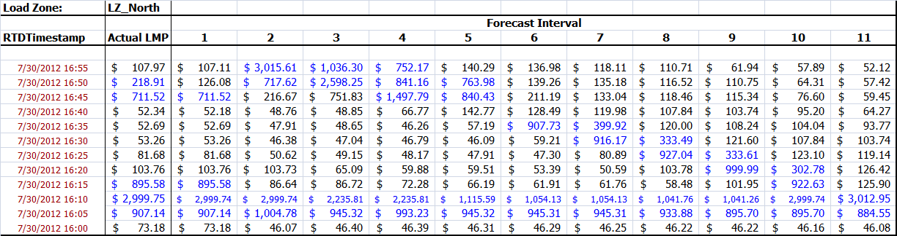
A similar screen will be created for forecasted prices for each ERCOT Hub
Updated Example of the RTD Forecasted LMPs for North Load Zone showing new prices after RTD execution and deletion of the oldest prices from the bottom row.
