SCR Number | 775 | SCR Title | Posting Results of Real-Time Data in a Display Format

Date | January 15, 2014

Submitter’s Information
Name | Jamie Lavas
E-mail Address | jlavas@ercot.com
Company | ERCOT
Phone Number | 512-248-6788
Cell Number | 512-560-2421
Market Segment | Not applicable.

Comments
ERCOT submits these comments in response to a request made at the 12/19/13 PRS meeting, that ERCOT reassess the impacts in SCR775 to determine if efficiencies could be achieved by eliminating the interactive portion from the scope of SCR775. After additional assessment, ERCOT has determined that the range of the budgetary impacts, as captured in the 12/18/13 Impact Analysis, remain the same.
The cost of the non-user entered functionality captured in the Impact Analysis is due to the multi-query functionality to display the detailed information out by individual Load Zone or Hub, as well as the system changes to integrate the current Locational Marginal Price (LMP) and Forecasted RTD data elements per Security-Constrained Economic Dispatch (SCED) interval on each screen. The Impact Analysis accounts for two dashboards, RTDs by Load Zone and RTD by Hub. Each of these links will include a pick list for selecting the specific Load Zone or Hub to view. Once selected, there would be individual screens based on the singular selection.
The cost for non-user entered functionality as requested at the 12/19/13 PRS meeting would look similar to the original screen shots requested, with the pick list and multi-screens, including the rolling one hour snapshot of data, but would not provide the option for a user to enter a threshold. There would not be a color differentiation between any of the prices seen as depicted in the original screenshots provided in SCR775.
The user entered functionality as originally requested would be at the high end of the cost range, but would include a user selected threshold from a defined value set in line with the LMP Contour Map color chart breakdown. To support an actual user set threshold, this display may need to be made available only through the Market Information System (MIS) to registered Market Participants in order to support a set number of users for known Digital Certificate load.
Basic functionality from the alternative solution proposed in the 12/18/13 ERCOT Comments would look similar to the RTM SPP screen as depicted below. This Hypertext Markup Language (HTML) screen would provide the current run of the next 11 forecasted RTD prices at each of the Load Zones and Hubs.
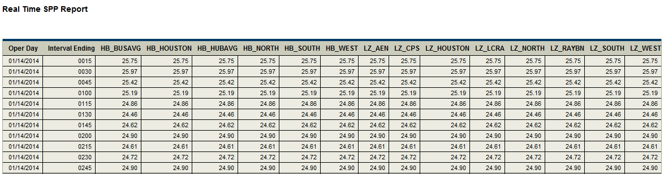

Revised Business Case for Proposed System Change
None at this time.

