An Introduction to BES Frequency Management after a Generator Trips Off-line
The following is a description of the sequence of events after a Bulk Electric System [BES] generator forced outage occurs. The four phases of frequency management are also identified.
- Assume a unit trip [the generator breaker opens and 600 MW Net input to the BES is lost] at t=0 seconds. The response of the on-line generators will be exactly the same as if a 600 MW load was connected to the bus that the tripped unit was connected to.
- Instantaneously other Synchronous Generators [SG] increase their Net MW outputs and replace the 600 MW of generation. Observe that the total generation on the BPS is always equal to total load plus losses [assuming no AC tie lines]. There is never connected load that is not being served. Any document that says that generation MW can be less than load plus losses MW is describing a phenomenon that violates what we like to call the Laws of Physics.
- The new MW output of each SG can be estimated by performing a load flow calculation that models all transmission elements, loads at each node, SG step-up transformer elements, SG transient reactance, SG internal constant voltage source [at t=0-] and other non-SG generator inputs at each node.
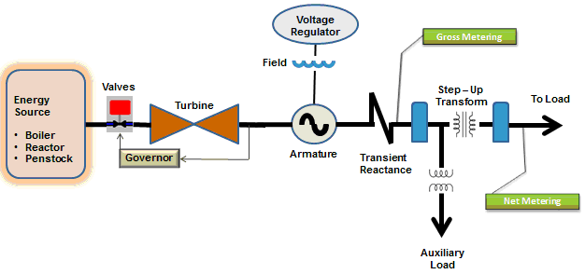
- Since the new Electric Power [MW] of SG that are electrically close to the loss of generation will be more than the original [t=0-] Mechanical Power input to the turbine, the difference [ΔP] is supplied by the rotational Kinetic Energy [KE] of the rotating turbine generator assembly. The stored KE is proportional to the speed [rpm] and inertia. The inertia is proportional to the sizing and mass of the rotating assembly.
- The Mechanical Power input to the turbine section of the rotating assembly is provided by steam under pressure from a fossil fired boiler or nuclear reaction, water from a hydro dam penstock or fuel for the jet engine of a combustion turbine, etc. Note that any detailed description of power system frequency must make a clear distinction between SG Electric Power output and SG Mechanical Power input.
- Since the energy being extracted by the electric generator is greater than the energy being supplied by the mechanical turbine, the rotating assembly starts to slow down [rpm] which causes the Electric Power frequency [Hz] to decrease. The synchronizing torque provided by the SG magnetic fields tries to keep all SG synchronized [at the same frequency] but there are localized instantaneous variations that can be seen by the high speed Phase Monitoring Units [PMUs]. For the first few seconds, all of the energy for the new 600 MW SG output is provided by what some are calling Synchronous Inertial Response [SIR].
- SG resources that have speed governors turned on and available reserve MW capacity immediately see the speed start to decline and begin to open valves between the mechanical energy supply and the turbine. As more and more energy enters the turbine, the ΔP difference between the Electric Power output and the Mechanical Power input gets smaller. This reduces the rate that energy is extracted from the Kinetic [Inertial] Energy and the Rate of Change of Frequency [RoCoF] decreases.
- When the total SG Mechanical Power input to the BES is equal to the total SG Electric Power output, the speed [frequency] stops declining. This is called the Nadir or C point of the frequency vs. time graph. At this point, SIR is not needed. Only new Mechanical Power input is now driving the recovery. This is commonly called Primary Frequency Response [PFR].
- At t=0+, the 600 MW was divided among the on-line SG based primarily by the equivalent impedances between each SG field/exciter and the node with the loss of generation. At t=C point, the wild transient is over and each SG increase in Electric Power output is being supplied in proportion to the increase in Mechanical Power contributed by each SG.
- Since the speed/frequency of the system is less that the desired/scheduled frequency [normally 60 Hz}, the governor will continue to add more Mechanical Power input to the turbines. This increases speed/frequency and starts restoring Kinetic Energy to the SG rotating assemblies. It should be noted that any SG without an in-service governor [such as a nuclear resource] will not participate in this KE restoration. Resources with governors will pull the speed of non-governor resources up to the prevailing frequency through the synchronizing torque coupling of parallel synchronous generators.
- The increase in frequency and restoration of stored KE controlled by the localized governors continues until a steady state condition is reached. This frequency is called the B point. At this balanced state, the Mechanical Power input from generators to the BES is equal to Electric Power Output to the BES loads and most of the Kinetic Energy has been restored.
- As stated earlier, the management of frequency by the governors up to this steady-state condition is called Primary Frequency Control. At t=B point, each SG Electric Power of output is determined by the intersection of system frequency with that SG’s steady state speed characteristic [droop curve]. The curve is usually drawn as straight line with a slope consistent with the speed droop percentage and X-intercept at the governor set-point. No real-time deployment from a central location has been needed.
- At this point in time [about 30 seconds after the generator trip], Supplemental Control [AGC] normally starts sending control signals from the QSE to each SG plant site. The goal of these signals is to restore the steady state frequency to the scheduled value [usually 60 Hz] by increasing selected SG governor set-points [MW] until the sum of the governor set-points equals the total Electric Power output of all on-line SG resources. When 60 Hz has been reached, all turbine-generator KE has been restored. This Automatic Generation Control [AGC] to restore frequency to the scheduled value is commonly called Secondary Frequency Control [SFC].
- Following the concept of Frequency Management, as compared to Frequency Response, the fourth phase of the recovery from the forced outage of a generator is often called System Restoration. The primary goals of this phase are the restoration of spinning reserves, as needed, and restoration of optimal resource dispatch.
RKG 01/07/2014

