 |  |  |  | System Planning
Monthly Status Report
December 2013

 |  | Report Highlights
 | - ERCOT is currently tracking active generation interconnection requests totaling over 51,100 MW. This includes over 24,200 MW of wind generation.
- ERCOT is currently reviewing proposed transmission improvements with a total cost of $849.7 Million
- Transmission Projects endorsed in 2013 total $349.8 Million
- All projects (in engineering, routing, licensing and construction) total approximately $6.23 Billion.
- Transmission Projects energized in 2013 total about $3.17 Billion.

Table of Contents

1. Generation Interconnection 1
1.1 Signed Generation Interconnection Agreements 1
1.2 New Generation Approved for Commercial Operations 1
1.3 Summary of Generation Interconnection Requests 1
1.4 Projects with Interconnection Agreements 5
1.5 Projects Undergoing Full Interconnection Studies with Confidentiality Waived 6
1.6 Generation Projects Undergoing Full Interconnection Studies 6
1.7 Wind Generation Capacity Installed by Year 9
2. Regional Planning Group Project Reviews 10
3. Asynchronous Tie Interconnection 10
4. Planning Model Activities 11
5. Other Notable Activities 11

1. Generation Interconnection
Additional information regarding detailed generation interconnection and impact studies is contained in the “Generation Project Interconnection Information” folder in the “Operations and System Planning” area on the ERCOT website: http://planning.ercot.com/login/login.

Signed Generation Interconnection Agreements

14INR0053 – Spinning Spur Wind III – 161 MW in Oldham County
12INR0070 – Green Pastures – 300 MW located in Knox County
13INR0050 – Logans Gap Wind 1 – 200 MW located in Comanche County

New Generation Approved for Commercial Operations

The total installed wind capacity is now reported as 11,255 MW by the resource owners through the registration process. Capacity by North, South and West is 982 MW, 2,775 MW, and 7,498 MW respectively. Eight-hundred fifty MW is able to switch between the West and South zones and is currently shown in the South zone.

Summary of Generation Interconnection Requests
GENERATION INTERCONNECTION REQUESTS CURRENTLY UNDER REVIEW
Currently tracking 205 generation interconnection or change requests
As of December 31, 2013 | Total
Security Screening Study | 19
SSS Completed | 19
Full Interconnect Study | 109
FIS Completed | 10
Suspended Studies | 0
Capacity of Suspended Study Projects | 0
Cancelled Projects | 5
Interconnect Agreement Completed | 48
Capacity under Interconnection Agreements | 15,465
Capacity for Grid, MW | 51,113
Wind Capacity, MW | 24,266
Capacity of Cancelled Projects | 453

Fuel Type | Confidential Projects (MW) | Projects Under Full Study (MW) | Public Projects (MW) | Suspended Studies (MW) | Grand Total (MW)
Gas-AllOther |  |  | 690 | - | 7,352
Gas-CombinedCycle |  |  | 6,794 | - | 15,492
Total Gas | 3,260 | 12,110 | 7,484 | - | 22,854
Nuclear | - | - | - | - | -
Coal | - | 30 | 240 | - | 270
Wind | 4,083 | 12,736 | 7,447 | - | 24,266
Solar | 966 | 1,753 | 130 | - | 2,849
Biomass | - | - | - | - | -
Storage | - | 874 | - | - | 874
Petroleum Coke | - | - | - | - | -
Grand Total | 8,309 | 27,503 | 15,301 | - | 51,113

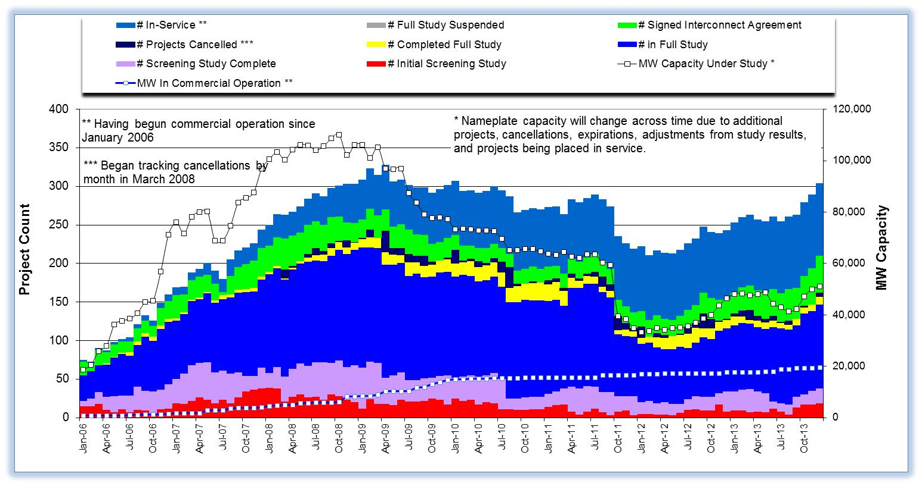

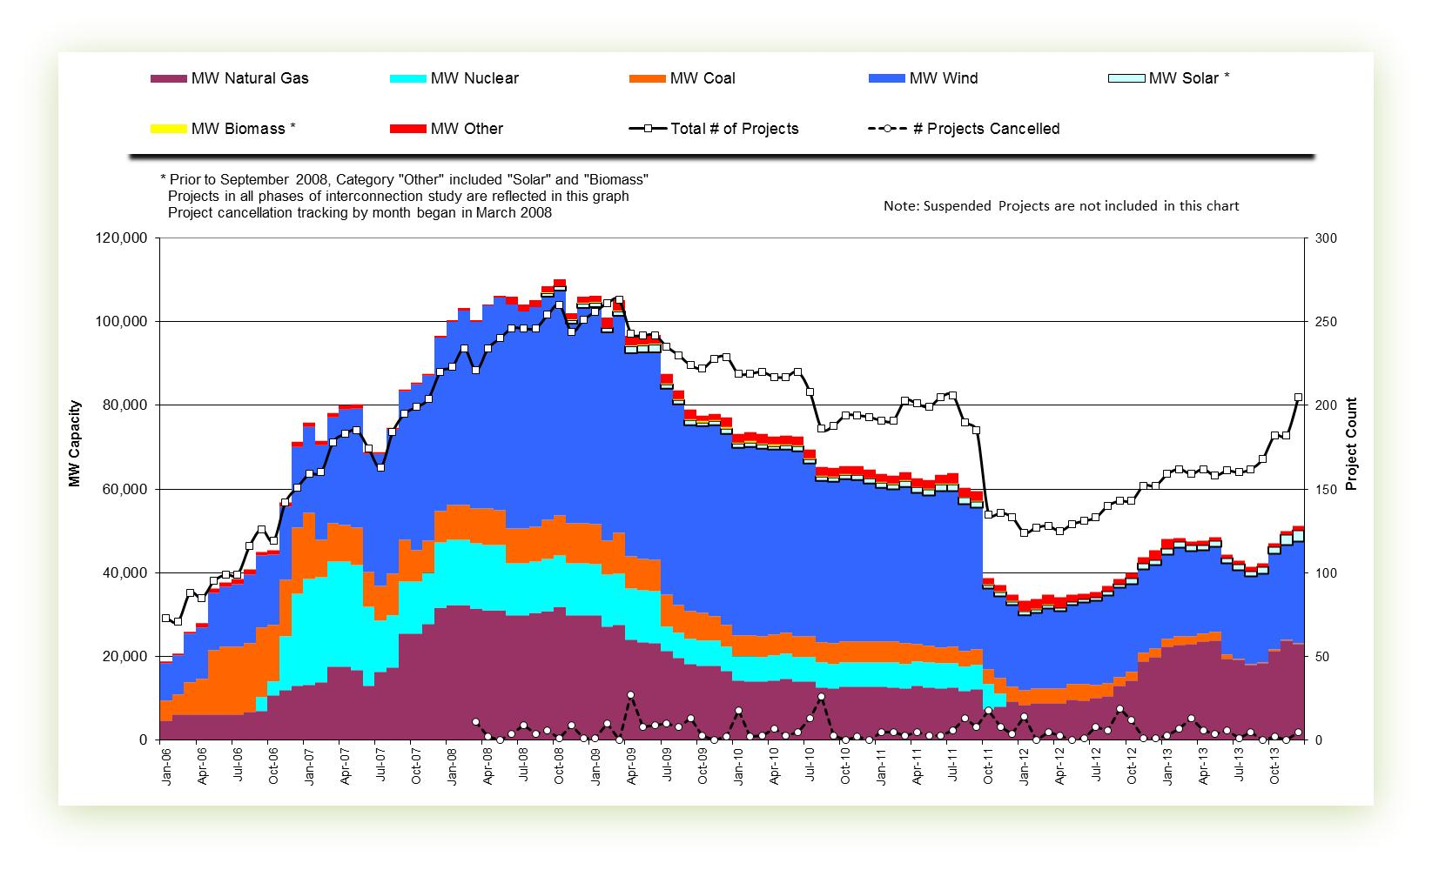

Cumulative Installed MW Capacity of Interconnection Requests by Zone

Projects with Interconnection Agreements

Generation Interconnection Agreements as of December 31, 2013

INR | Site Name | County | COD | Fuel | MW For Grid | Change from Last Report
12INR0068 | Sendero Wind Energy Project | Jim Hogg | Feb-14 | Wind | 78 | Projected COD
11INR0094 | White Camp Solar | Kent | Apr-14 | Solar | 100 | Projected COD
14INR0016 | Channel Energy Center 138/345kV CT | Harris | Jun-14 | Gas | 190
13INR0048 | Spinning Spur Wind Two | Oldham | Jun-14 | Wind | 161
14INR0015 | Deer Park Energy Center | Harris | Jul-14 | Gas | 190 | MW for Grid
13INR0021 | Ferguson Replacement Project | Llano | Jul-14 | Gas | 570
14INR0012a | Miami Wind 1 Project | Gray | Jul-14 | Wind | 289 | MW for Grid
13INR0040 | Rentech Project | Harris | Aug-14 | Gas | 15
14INR0030a_2 | Panhandle Wind | Carson | Aug-14 | Wind | 218
10INR0021 | Panda Sherman Power | Grayson | Aug-14 | Gas | 720
10INR0020a | Panda Temple Power | Bell | Aug-14 | Gas | 717
11INR0050 | Moore Wind 1 | Crosby | Aug-14 | Wind | 149
14INR0030b | Panhandle Wind 2 (Phase 2) | Carson | Sep-14 | Wind | 198 | Projected COD
13INR0059a | Hereford Wind | Castro | Sep-14 | Wind | 200
13INR0020a | CPV Rattlesnake Den Ph 1 | Glasscock | Oct-14 | Wind | 200
12INR0034 | Stephens Ranch Wind Energy | Borden | Oct-14 | Wind | 378
13INR0010a | Mariah Wind | Parmer | Oct-14 | Wind | 200
13INR0020b | CPV Rattlesnake Den Ph 2 | Glasscock | Oct-14 | Wind | 150
11INR0054 | Midway Farms Wind | San Patricio | Oct-14 | Wind | 161
14INR0032a | Route66 Wind | Randall | Dec-14 | Wind | 150
13INR0005 | Conway Windfarm | Carson | Dec-14 | Wind | 600
14INR0023 | Longhorn Energy Center | Briscoe | Dec-14 | Wind | 361
11INR0057 | Cameron County Wind | Cameron | Dec-14 | Wind | 165
14INR0053 | Spinning Spur Wind Three | Oldham | Dec-14 | Wind | 161 | New
06INR0022c | Penascal Wind Farm 3 | Kenedy | Dec-14 | Wind | 202
14INR0049_2 | Keechi Wind 138 kV Joplin | Jack | Dec-14 | Wind | 102
13INR0052 | Los Vientos III | Starr | Dec-14 | Wind | 200
13INR0057 | Windthorst 2 | Archer | Dec-14 | Wind | 65
11INR0079a | South Clay Windfarm | Clay | Dec-14 | Wind | 200
09INR0051 | Mesquite Creek | Borden | Jan-15 | Wind | 249
12INR0070 | Green Pastures | Knox | Feb-15 | Wind | 300 | New
13INR0059b | Hereford Wind | Castro | Apr-15 | Wind | 300
13INR0050 | Logans Gap Wind I | Comanche | May-15 | Wind | 200 | New
08INR0018 | Gunsight Mountain | Howard | Aug-15 | Wind | 120
10INR0020b | Panda Temple Power | Bell | Aug-15 | Gas | 717
11INR0062 | Patriot (Petronilla) Wind | Nueces | Aug-15 | Wind | 178
14INR0012b | Miami Wind 1 Project | Gray | Aug-15 | Wind | 112 | MW for Grid
13INR0049 | Friendswood Energy Generation | Harris | Sep-15 | Gas | 316
13INR0031 | Mustang Solar Project | Travis | Dec-15 | Solar | 30
13INR0010b | Mariah Wind | Parmer | Dec-15 | Wind | 200
13INR0023 | Texas Clean Energy Project | Ector | Jan-16 | Coal | 240
13INR0028 | Antelope Station | Hale | Jun-16 | Gas | 359
06INR0006 | Cobisa-Greenville | Hunt | Dec-16 | Gas | 1792 | Projected COD
10INR0022 | Pondera King Power Project | Harris | Dec-16 | Gas | 1629 | MW for Grid,Proj. COD
12INR0029 | Comanche Run Wind | Swisher | Dec-16 | Wind | 500
13INR0010c | Mariah Wind | Parmer | Dec-16 | Wind | 200
12INR0018 | Pampa Wind Project | Gray | Mar-17 | Wind | 500

Projects Undergoing Full Interconnection Studies with Confidentiality Waived
INR | Site Name | County | COD | Fuel | MW for Grid | Change from Last Report

Generation Projects Undergoing Full Interconnection Studies
Interconnection Database Reference Number | County | Fuel | Capacity to Grid (MW) | Commercial Operation Data (as specified by the resource developer)
14INR0069 | Milam | Coal | 30 | Mar-14
14INR0013 | Cameron | Wind | 103 | Apr-14
14INR0048_1 | Wilbarger | Wind | 114 | Jun-14
14INR0048_2 | Wilbarger | Wind | 250 | Jun-14
14INR0040 | Hidalgo | Gas | 225 | Jun-14
12INR0059 | Pecos | Solar | 50 | Jun-14
11INR0093 | San Patricio | Wind | 41 | Jul-14
14INR0014 | Val Verde | Solar | 100 | Jul-14
14INR0059 | Kaufman | Gas | 52 | Aug-14
13INR0055 | Zapata | Wind | 250 | Sep-14
13INR0038 | Swisher | Wind | 300 | Sep-14
14INR0062 | Hall/Motley | Wind | 200 | Sep-14
12INR0045 | Kleberg | Wind | 135 | Oct-14
13INR0025 | Randall | Wind | 150 | Nov-14
14INR0060 | Haskell | Wind | 400 | Nov-14
13INR0056 | Scurry | Wind | 366 | Nov-14
14INR0066 | Lamar | Gas | 130 | Nov-14
11INR0082a | Val Verde | Wind | 50 | Dec-14
11INR0082b | Val Verde | Wind | 150 | Dec-14
14INR0009 | Kent | Wind | 248 | Dec-14
10INR0085 | Ector | Solar | 57 | Dec-14
14INR0025a | Floyd | Wind | 200 | Dec-14

Interconnection Database Reference Number | County | Fuel | Capacity to Grid (MW) | Commercial Operation Data (as specified by the resource developer)
13INR0054 | Bee | Gas | 25 | Dec-14
14INR0028 | Live Oak | Wind | 300 | Dec-14
14INR0029 | Uvalde | Solar | 42 | Dec-14
14INR0033 | Armstrong | Wind | 500 | Dec-14
14INR0041 | Willacy | Wind | 114 | Dec-14
14INR0043 | Sterling | Solar | 40 | Dec-14
14INR0044 | Reeves | Solar | 100 | Dec-14
13INR0045 | Castro | Wind | 288 | Dec-14
12INR0055 | Baylor | Wind | 40 | Dec-14
13INR0010d | Parmer | Wind | 200 | Dec-14
14INR0045a | Webb | Wind | 502 | Dec-14
14INR0049_1 | Jack | Wind | 102 | Dec-14
14INR0056 | Mills | Wind | 101 | Dec-14
14INR0057a | Erath | Wind | 48 | Dec-14
14INR0057b | Erath | Wind | 48 | Dec-14
14INR0020 | Floyd & Motley | Wind | 150 | Mar-15
14INR0039 | Ector | Gas | 450 | Mar-15
14INR0050 | Uvalde | Solar | 40 | Mar-15
15INR0036 | Uvalde | Solar | 105 | Mar-15
15INR0069 | Pecos | Solar | 110 | Mar-15
15INR0070 | Pecos | Solar | 110 | Mar-15
10INR0009 | Castro | Wind | 300 | Mar-15
14INR0038 | Galveston | Gas | 390 | Apr-15
15INR0053 | Winkler | Gas | 123 | May-15
15INR0054 | Reeves | Gas | 123 | May-15
15INR0055 | Austin | Gas | 142 | May-15
15INR0021 | Starr | Wind | 200 | May-15
15INR0027 | Hidalgo | Gas | 79 | Jun-15
15INR0028 | Freestone | Gas | 160 | Jun-15
15INR0042 | Hood | Gas | 460 | Jun-15
15INR0023 | Wharton | Gas | 700 | Jun-15
14INR0026 | Presidio | Solar | 30 | Sep-15
15INR0013 | Anderson | Storage | 324 | Oct-15
15INR0014 | Matagorda | Storage | 280 | Oct-15
14INR0030a_1 | Carson | Wind | 322 | Nov-15
08INR0019a | Gray | Wind | 250 | Dec-15
15INR0034 | San Patricio | Wind | 201 | Dec-15
15INR0035 | Kenedy | Wind | 200 | Dec-15
14INR0025b | Floyd | Wind | 300 | Dec-15
15INR0065 | Anson | Solar | 150 | Dec-15
12INR0002a | Briscoe | Wind | 200 | Dec-15
13INR0032 | Andrews | Solar | 30 | Dec-15

Interconnection Database Reference Number | County | Fuel | Capacity to Grid (MW) | Commercial Operation Data (as specified by the resource developer)
13INR0010e | Parmer | Wind | 200 | Dec-15
14INR0045b | Webb | Wind | 251 | Dec-15
15INR0037 | Starr | Wind | 200 | Dec-15
15INR0044 | Webb and Duval | Solar | 200 | Dec-15
15INR0049 | Zapata / Webb | Wind | 250 | Dec-15
14INR0072 | Briscoe | Wind | 300 | Dec-15
15INR0059 | Pecos / Crane | Solar | 102 | Dec-15
15INR0060 | Pecos / Crane | Solar | 25 | Dec-15
15INR0066 | Pecos | Solar | 80 | Dec-15
15INR0067 | Reeves | Solar | 80 | Dec-15
16INR0010 | Mitchell | Gas | 799 | Feb-16
16INR0009 | Calhoun | Gas | 510 | Apr-16
16INR0006 | Angelina | Gas | 785 | Jun-16
16INR0003 | Brazoria | Gas | 11 | Jun-16
16INR0004 | Cameron | Gas | 730 | Jun-16
16INR0005 | Cameron | Gas | 871 | Jun-16
16INR0007 | Hidalgo | Gas | 95 | Jun-16
17INR0004 | Hale | Gas | 202 | Jun-16
08INR0019b | Gray | Wind | 250 | Jul-16
14INR0011 | Swisher | Storage | 270 | Jul-16
15INR0032 | Hale | Gas | 197 | Jul-16
15INR0033 | Hale | Gas | 197 | Jul-16
16INR0013 | Nacogdoches | Gas | 215 | Jul-16
16INR0025 | Sterling | Solar | 30 | Sep-16
08INR0019c | Gray | Wind | 250 | Dec-16
13INR0006 | Gray | Wind | 750 | Dec-16
16INR0017 | Culberson County | Solar | 70 | Dec-16
16INR0018 | Upton | Solar | 40 | Dec-16
16INR0019 | Coke/Sterling | Solar | 100 | Dec-16
12INR0002b | Briscoe | Wind | 200 | Dec-16
13INR0010f | Parmer | Wind | 200 | Dec-16
16INR0011a | Cameron | Wind | 18 | Dec-16
16INR0026 | Erath, Somervell & Bosque | Wind | 100 | Dec-16
16INR0027 | Grayson & Fannin | Wind | 100 | Dec-16
16INR0028 | Jack, Wise & Parker | Wind | 100 | Dec-16
16INR0029 | Hill & Limestone | Wind | 100 | Dec-16
16INR0030 | Young & Jack | Wind | 201 | Dec-16
16INR0031 | Zapata & Starr | Wind | 100 | Dec-16
16INR0032 | Jim Hogg | Wind | 201 | Dec-16
Interconnection Database Reference Number | County | Fuel | Capacity to Grid (MW) | Commercial Operation Data (as specified by the resource developer)
17INR0002 | Henderson | Gas | 489 | Jun-17
17INR0003 | Jackson | Gas | 965 | Jun-17
17INR0005 | Starr | Wind | 200 | Jun-17
17INR0007 | Wharton | Gas | 1177 | Jul-17
16INR0011b | Cameron | Wind | 132 | Dec-17
11INR0040 | Freestone | Gas | 640 | Mar-18

Wind Generation Capacity Installed by Year
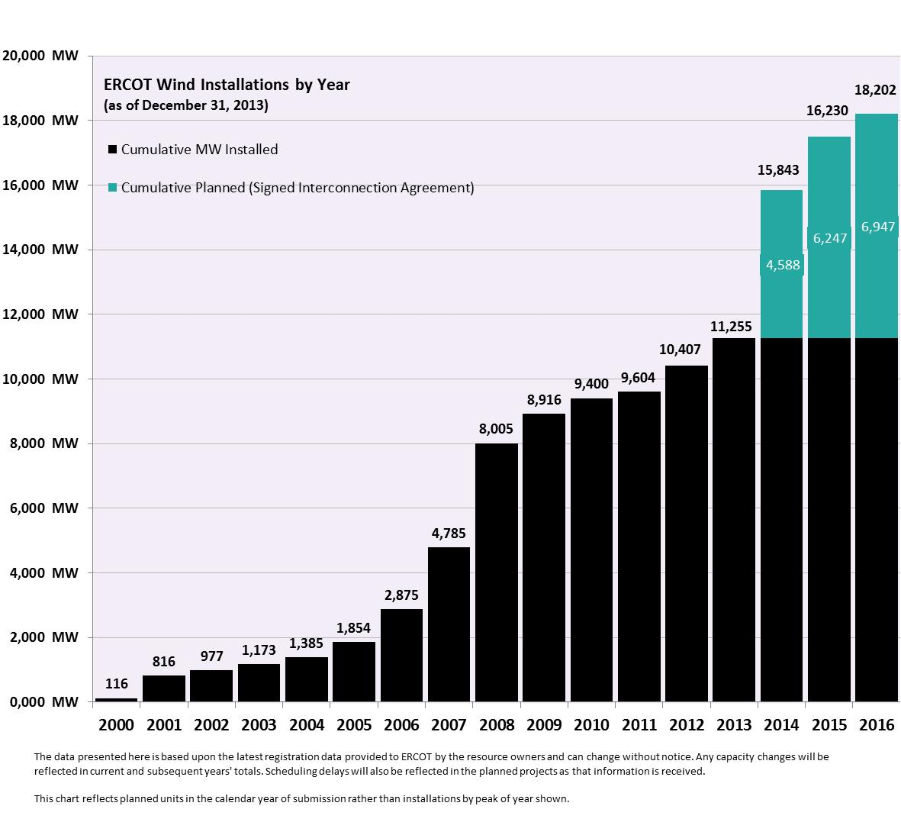

Regional Planning Group Project Reviews
- CenterPoint Energy submitted the Houston Region Import Capacity project. This is a Tier 1 project that is estimated to cost between $297 to $532 million. This project is currently under ERCOT independent review.

- Garland Power & Light (GP&L) and Cross Texas Transmission (CTT) have jointly submitted a Houston Import project. This is a Tier 1 project that is estimated to cost between $195 to $317 million. This project has received several RPG comments and it is under study mode.

- Lone Star Transmission has submitted a Houston Import project. This is a Tier 1 project that is estimated to cost between $417 to $675 million. This project has received several RPG comments and it is under study mode.

- Oncor has submitted the West Texas Area project. This is a Tier 2 project that is estimated to cost $45 million. This project has received several RPG comments and is under ERCOT independent review.

- CenterPoint has submitted the Katy Area project. This is a Tier 2 project that is estimated to cost $20.4 million. This project has been submitted for RPG comments.

- LCRA TSC has submitted the Leander – Round Rock 138 kV project. This is a Tier 1 project that is estimated to cost $50.9 million. This project has been submitted for RPG comments.

- Sharyland has submitted the Brady Area project. This is a Tier 2 project that is estimated to cost $18 million. This project has been submitted for RPG comments.

- Sharyland has submitted the West Texas projects for Stanton Area. This is a Tier 3 project that is estimated to cost $40.4 million. This project has been submitted for RPG comments.

Asynchronous Tie Interconnection
Project | Notification to ERCOT | Reliability Study | RPG Review | Interconnection Agreement | In-service Year
Railroad DC tie expansion (150 MW - CFE) |  |  |  |  | 2014
Southern Cross HVDC (3000 MW - SERC)
Tres Amigas (1500 MW - SPP)

Color Legend
In progress
Complete

Planning Model Activities
- The short term calendar of major planning model events follows:
  - Dec 27, 2013 Transmission Loss Factor calculations completed
  - Jan 6, 2014 Start 14DSA and 14DSB update
  - Jan 10, 2014 Post Planning Data Dictionary
  - Mar 1, 2014 Post 14DSA and 14DSB updated cases
  - Mar 15, 2014 Post MODTPIT
  - Apr 1, 2014 Start 15DSA case build process

Other Notable Activities

- The System Protection Working Group 2014 Current Year (CY) base creation process has started. The process will include 4 passes and conclude March 21, 2014.
- ERCOT has completed the 2013 Regional Transmission Plan (RTP) study and the 2013 RTP final report was posted at the ERCOT POI on Dec. 30, 2013.
- ERCOT has posted the final report on the results of the Long-term study and the improvements to the long-term study process as a result of the grant received from the Department of Energy.
- ERCOT has completed and posted the 2013 Constraints and Needs Report.
- ERCOT has entered into an agreement with Powertech Labs to perform a small signal stability study.

