ERCOT Operations Report
December 2013 ROS & OWG

Frequency Control
Time | Freq (Hz) | Duration (s)
12/2/2013 16:03 | 59.740 | 76 | Unit trip with approximately 840 MW net
12/8/2013 13:07 | 59.894 | 4 | Unit trip with approximately 576 MW net
12/9/2013 8:43 | 59.814 | 71 | Unit trip with approximately 933 MW net
12/13/2013 19:37 | 59.739 | 138 | Two units tripped with approximately 1348 MW net
12/17/2013 11:45 | 59.819 | 52 | Unit trip with approximately 786 MW net
12/30/2013 9:44 | 59.830 | 69 | Unit trip with approximately 785 MW net
Note: Time of frequency excursions outside the range of +/- 0.1 Hz.

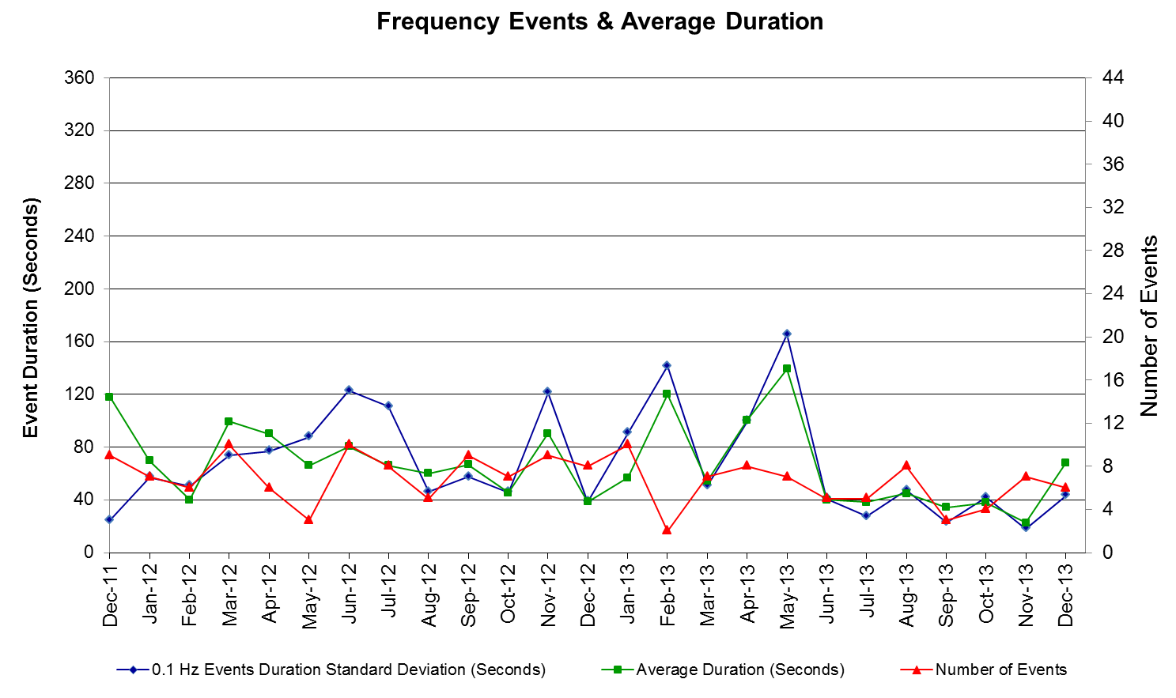

PMU Events
ERCOT evaluates PMU data according to industry standards. Events with an oscillating frequency of less
than 1 Hz are considered to be inter- area, while higher frequencies indicate local events. Industry standards
specify that damping ratio for inter-area oscillations should be 3.0% or greater. All events listed below
indicate the ERCOT system transitioned well after each disturbance.

Date | Events | Duration | Summary
12/2/2013 16:03:48 | Unit Trip | Approx. 178 sec | The event was caused by the loss of one unit. The unit was generating 840 MW net before the trip, the frequency dropped to 59.739 Hz. The oscillating frequency of 0.67 Hz with 6.49% damping ratio was observed.
12/9/2013 08:43:06 | Unit Trip | Approx. 206 sec | The event was caused by the loss of one unit. The unit was generating 933 MW net before the trip, the frequency dropped to 59.813 Hz. The oscillating frequency of 0.625 Hz with 6.5% damping ratio was observed.
12/13/2013 19:37:48 | Unit Trip | Approx. 280 sec | The event was caused by the loss of two units. The units were generating 1348 MW net before the trip, the frequency dropped to 59.737 Hz. The oscillating frequency of 0.66 Hz with 7.25% damping ratio was observed.
12/17/2013 11:45:38 | Unit Trip | Approx. 204 sec | The event was caused by the loss of one unit. The unit was generating 786 MW net before the trip, the frequency dropped to 59.816 Hz. The oscillating frequency of 0.67 Hz with 9.4% damping ratio was observed.
12/30/2014 09:44:18 | Unit Trip | Approx. 342 sec | The event was caused by the loss of one unit. The unit was generating 785 MW net before the trip, the frequency dropped to 59.828 Hz. The oscillating frequency of 0.65 Hz with 14.74% damping ratio was observed.

Deployed Responsive (Reported Above)

Time deployed | Stop Time | Duration | Max | Details
12/2/13 16:04:06 | 12/2/13 16:08:02 | 0:03:56 | 1317.7
12/8/13 13:07:40 | 12/8/13 13:11:08 | 0:03:28 | 278.64
12/9/13 8:43:24 | 12/9/13 8:47:52 | 0:04:28 | 693.28
12/13/13 19:38:06 | 12/13/13 19:43:54 | 0:05:48 | 1209.5
12/17/13 11:45:54 | 12/17/13 11:50:30 | 0:04:36 | 760.83
12/30/13 9:44:33 | 12/30/13 9:49:38 | 0:05:05 | 610.39

RUC Commitments

SCED Congestion Management Activity
Congestion affected by outages
Contingency Description | Overloaded Element | # Days Active
Techridge - Aen Dunlap 138 kV | Dunlap - Decker 138 kV | 15
Laquinta - Lobo 138 kV | Bruni 138_69_1 138/69 kV | 13
Bosque Switch - Whitney 138 kV | Bosque Switch - Lake Whitney Tnp 138 kV | 11
DCKT Austrop - Garfield Aen and Zorn 345 kV | Dunlap - Decker 138 kV | 8
Loyola Sub - Kleberg Aep 138 kV | Loyola Sub 138_69_1 138/69kV | 8
Orange Grove Switching Station - Lon Hill 138 kV | Lon Hill - Smith 69 kV | 8
DCKT Tonkawa Switch - Scurry County South Switch 345 kV | Bluff Creek Switch - Exxon Sharon Ridge 138 kV | 7
Koch Up River - Gila 138 kV | Gila - Hiway 9 138 kV (GILA_HIWAY_2) | 7
North Edinburg - Lon Hill 345 kV | Las Pulgas - Raymondville 2 138 kV | 7
Scurry Switch - Sun Switch 138 kV | Wolfgang - Rotan 69 kV | 7
DCKT Paris Switch - Valley Ses and Valley South 345 kV | Brookstone Tap - Bonham Lake Poi 138 kV | 5
DCKT Rio Hondo - North Edinburg 345 kV and Harlingen Switch 138 kV | Rio Hondo - Burns Sub 138 kV | 5
DCKT Paris Switch - Valley Ses and Valley South 345 kV | Paris Switch AXFMR1 (3) 345/138 kV | 4
Laquinta - Lobo 138 kV | Falfurrias 138_69A1 138/69 kV | 4
DCKT Odessa Ehv Switch - Quail Switch - Longshore Switch 345 kV | Stanton East - 1276_Triangle 138 kV | 3
DCKT Sam Switch - Tradinghouse Ses 345 kV | Whitney AXFMR2 (3) 345/138 kV | 3
DCKT Singleton - Zenith 345 kV | Tomball - Louetta 138 kV | 3
Oxychem Ingleside - Ingleside Cogen Switch 138 kV (Icosw_Idpsw_2B) | Dupont Pp1-Ingleside - Dupont Switch-Ingleside 138 kV (I_DUPP_I_DUPS1) | 3
Victoria - Coleto Creek 138 kV (Coleto_Victor1) | Victoria - Coleto Creek 138 kV (Coleto_Victor2) | 3
Lytton Springs LY_AT2 345/138 kV | Lytton Springs LY_AT1 345/138 kV | 3
Basecase | Langford Wind Power Llc - Santiago 138 kV | 2
Basecase | Ena Snyder Wind - Wkn_Bkr 69 kV | 2
DCKT Krum West Switch - Lewisville Switch - Roanoke Switch 345 kV | Teasley Substation - Pockrus Substation 138 kV | 2
DCKT Tomball - Singleton 345 kV | Zenith - Th Wharton 345 kV (Thwzen71) | 2
Alice - Kingsville 138 kV | Lon Hill - Robstown Tap 69 kV | 2
North Edinburg - Lon Hill 345 kV | Celanese Bishop - Kleberg Aep 138 kV | 2
Desoto Switch - Ennis Switch 138 kV | Ennis West Switch - Waxahachie 138 kV | 2
Rio Hondo - North Edinburg | Weslaco Switch - Weslaco Sub 138 kV | 2
Aspermont Aep - Spur 138KV | Wolfgang - Rotan 69 kV | 2
Stanton East AXFMRH 138/69 kV | Stanton East - Big Spring West 138 kV | 2
Basecase | SOP110 | 1
Basecase | West to North | 1
DCKT Carrolton Northwest - Lewisville Switch 345 kV | Lakepointe Tnp - Carrollton Northwest 138 kV | 1
DCKT Pilot Knob - Onion Creek and Hicross Aen - Garfield Aen 138 kV | Advanced Micro Devices Aen - Pedernales 138 kV | 1
DCKT Tonkawa Switch - Scurry County South Switch 345 kV | Bluff Creek Switch - Exxon Sharon Ridge 138 kV | 1
DCKT Singleton - Zenith 345 kV | Hockley - Betka 138 kV | 1
DCKT Singleton - Zenith 345 kV | Tomball - Rothwood 138 kV | 1
DCKT Trinidad Ses - Tri Corner and Watermill Switch 345 kV | Trinidad Ses AXFMR6 (3) 345/138 kV | 1
DCKT Whitepoint - Lon Hill & South Texas Project 345kV | Rincon - Airco Aep 138kV | 1
DCKT West Levee Switch - 800/900 Network 138 kV | East Levee Switch - Reagan Street 138 kV (3410_A) | 1
Vanderbilt Switching Station - El Toro Switching Station 69 kV | Sam Rayburn Switching Station 138_69_2 138/69 kV | 1
Falcon Seaboard - Midland East 345 kV | Stanton East - 1276_Triangle 138 kV | 1
Fort Stockton Plant - Barrilla 138 kV | Fort Stockton Switch - Barilla 69 kV | 1
Laquinta - Lobo 138 kV | Falfurrias - Premont 69 kV | 1
North Edinburg - Lon Hill 345 kV | Kleberg Aep - Loyola Sub 138 kV | 1
North Edinburg - Lon Hill 345 kV | Las Pulgas - Rio Hondo 138 kV | 1
North Edinburg - Lon Hill 345 kV | Lon Hill - Robstown Tap 69 kV | 1
Richland Chambers - Trinidad Ses 345 kV (Line 21) | Richland Chambers - Trinidad Ses 345 kV (Line 31) | 1
Stadium Aep - Alice 69 kV | Lon Hill - Robstown Tap 69 kV | 1
Tonkawa Switch - Scurry County South Switch 345 kV (34520) | Bluff Creek Switch - Exxon Sharon Ridge 138 kV | 1
West Conoco Load - Escondido and Asherton 138 kV | Brackettville - Hamilton Road 138 kV | 1
Schulenburg - Weimar - Glidden Lcra 138 kV | Victoria - Magruder 138 kV (Magrud_Victor2) | 1
Zenith - Th Wharton 345 kV (Thwzen98) | Zenith - Th Wharton 345 kV (Thwzen71) | 1
Decker Unit 2 | Dunlap - Decker 138 kV | 1
Dunlap AT1H 345/138 kV | Austrop - Dunlap 345 kV | 1
Midland East AXFMR1 (3) 345/138 kV | Stanton East - 1276_Triangle 138 kV | 1
Victoria 138_69_A2 138/69 kV | Victoria - Magruder 138 kV (Magrud_Victor2) | 1

Generic Transmission Limits (GTL’s)
GTL | Days
West – North | 1
SOP110 | 1

Congestion Cost
Binding Constraints – Year to Date
Contingency | Binding Element | Number of 5-min intervals | Shadow Price Range $/MWh | Estimated Congestion Rent $ (Shadow Price*Limit) | Transmission Project
Midland East to Odessa EHV 345 kV & Moss Switch 345/138 kV Xfmr | Odessa - Odessa North 138 kV | 9038 | 0 - 3500 | 57,143,394 | 13TPIT0136,  14TPIT0054
Midland East to Odessa EHV 345 kV & Moss Switch 345/138 kV Xfmr | Odessa EHV Switch - Big Three Odessa Tap 138kV | 4335 | 0 - 3500 | 31,785,167 | 13TPIT0153
Roanoke Switch - West Denton 345 kV & Roanoke Switch - Lewisville Switch 345 kV; or West Denton - Roanoke Switch 345 kV; or West Denton - Rdwells 138 kV | Jim Cristal - North Denton 138kV | 1407 | 0 - 3500 | 18,679,874 | 14TPIT0047
DCKT Roansprairie - Kuykendahl - King & Singleton - Tomball 345 kV | Singleton - Zenith 345 kV | 473 | 0 - 4500 | 17,737,088
Sun Switch - Golden Switch 138 kV; Sun Switch - Morgan Creek SES 138 kV | Bluff Creek Switch - China Grove Switch 138 kV | 1042 | 0 - 3500 | 17,681,085 | 12TPIT0058, 13TPIT0098
Roanoke Switch - West Denton 345 kV & Roanoke Switch - Lewisville Switch 345 kV; or West Denton - Roanoke Switch 345 kV | Fort Worth - Teasley 138 kV | 2813 | 0 - 3500 | 16,898,845 | 14TPIT0047
Amoco South Foster to Westover 138 kV | Moss Switch - Amoco North Cowden Tap 138 kV | 1204 | 0 - 3500 | 15,801,329 | 13TPIT0098, 13TPIT0093
Morgan Creek SES 345/138 kV Autotransformer 2 | Morgan Creek SES 345/138 kV Autotransformer 4 | 394 | 0 - 4500 | 13,917,840
Morgan Creek SES AXFMR2 345/138kV | Mogan Creek SES AXFMR1 345/138kV | 4841 | 0 - 1370 | 12,209,796
Austrop 345/138 kV Xfmr & Garfield LCRA 345/138 kV Xfmr | Austrop 345/138 kV Xfmr | 1965 | 0 - 4500 | 11,898,409 | 10TPIT0031
West Denton - Rdwells 138 kV | Teasley - Pockrus Substation 138 kV | 1203 | 0 - 3500 | 11,278,354 | 5YTP [2012-R46]
Cangon AXFMR3 345/138kV | Cangon AXFMR4 345/138kV | 3515 | 0 - 3500 | 10,671,747
DCKT Roansprairie - Kuykendahl - King & Singleton - Tomball 345 kV | Singleton - Zenith 345 kV | 3029 | 0 - 4500 | 9,828,893
McNeil - Gilleand Creek 138 kV | Hutto - Round Rock NE 138 kV | 1983 | 0 - 3500 | 7,822,046
Ajo - Rio Hondo 345 kV | North Edinburg - Lon Hill 345 kV | 39 | 2 - 4500 | 7,633,932 | 14TPIT0050
Calallen Sub to Lon Hill 69kV | Lon Hill - Robstown Tap 69kV | 781 | 0 - 2800 | 7,270,688 | 13TPIT0220
DCKT Salado Switch - Killeen Switch 345kV | Temple Switch - Temple Southeast 138kV | 716 | 0 - 3500 | 6,980,592 | 5YTP[2012-R45]
Garfield LCRA 345/138 kV Xfmr & Austrop - Daffin 138 kV | Austrop - Dunlap 138 kV | 836 | 0 - 3500 | 6,752,664 | 10TPIT0031
Odlaw Switchyard to Uvalde AEP 138kV | Hamilton Road - Maverick 138kV | 5716 | 0 - 2905 | 6,469,174 | 16TPIT0024
Wink 138/69 kV Autotransformer; or Wink - Wink Sub 138 kV | Wink Basin Tap - Wink Sub 69 kV | 772 | 0 - 2800 | 6,378,270 | 17TPIT0018, 5YTP[2012-R4]

Binding Constraints – December 2013
Contingency | Binding Element | Number of 5-min intervals | Shadow Price Range $/MWh | Estimated Congestion Rent $ (Shadow Price*Limit) | Transmission Project | Comments
DCKT Austrop - Garfield LCRA& Zorn 345kV and Techridge - AEN Dunlap 138kV | Decker - AEN Dunlap 138kV | 2415 | 0 - 3500 | 4,207,636 | 16TPIT0036, 10TPIT0031, 07TPIT0050 | Planned outage of McNeil - Decker 138 kV
North Edinburg - Rio Hondo 345kV | Weslaco Switch - Weslaco Sub 138kV | 193 | 0 - 3500 | 3,574,773 | 11TPIT0002  14TPIT0050  14TPIT0051 | Planned outage of Ajo - Nelson Sharpe 345 kV
Koch Up River - Gila 138kV | Gila - Hiway_9 138kV | 1338 | 0 - 3500 | 3,197,365 |  | Forced outage of Gila - Hiway 9 (GILA_HIWAY_1) 138KV
Orange Grove Switching Station - Lon_hill 138kV | Lon_hill - Smith 69kV | 766 | 0 - 2800 | 1,068,146 | 2012-R18 | High load in Corpus Christi area
Laquinta - Lobo 138kV | Bruni Sub 138_69_1 138/69kV | 1250 | 0 - 2800 | 1,000,282 |  | High area wind
North Edinburg - Lon_hill 345kV | Las Pulgas - Raymondville 2 138kV | 847 | 0 - 2135 | 965,923 | 11TPIT0002, 14TPIT0050, 14TPIT0051 | Planned outage of Ajo - Nelson Sharpe 345 kV
DCKT Odessa EHV Switch - Longshore Switch & Quail Switch 345kV and Midland East AXFMR1 345/138kV | Stanton East - 1276 Triangle 138kV | 410 | 0 - 1537 | 890,008 | 14TPIT0052 | High area wind
Lytton Springs LY_AT2 345/138kV | Lytton Springs LY_AT1 345/138kV | 269 | 0 - 4500 | 808,271 |  | Planned outage of Wyldwood - Wolf Lane 138 kV
North Edinburg - Lon_hill 345kV and Alice to Stadium AEP 69kV and Alice to Kingsville 138kV | Lon_hill - Robstown Tap 69kV | 114 | 0 - 2800 | 802,397 | 12TPIT0180 | Planned outage of Callen Sub - Lon Hill 69 kV
DCKT Paris Swith - Valley SES & Valley South 345kV | Paris Switch AXFMR1 345/138kV | 342 | 0 - 2360 | 599,206 |  | Forced outage of Monticello Ses - Allen Switch 345 kV
DCKT Riohondo - North Edinburg 345kV and Harlingen Switch 138kV | Burns Sub - Riohondo 138kV | 610 | 0 - 1507 | 528,208 | 11TPIT0002, 14TPIT0050, 14TPIT0051 | Planned outage of Ajo - Nelson Sharpe 345 kV
DCKT West Levee Switch - 800/900 Network 138kV | East Levee Switch - Reagon Street 138kV | 61 | 0 - 3500 | 511,875 |  | Planned outage of West Network - East Levee Switch 138 kV DCKT
DCKT Scurry County South Switch - Tonkawa Switch 345kV | Bluff Creek Switch - Exxon Sharon Ridge 138kV | 588 | 0 - 109 | 387,331 | 12TPIT0058 | High West-North flow due to high West wind output
DCKT Whitepoint - Lon Hill & South Texas Project 345kV | Airco AEP - Rincon 138kV | 91 | 0 - 3500 | 301,834 | 08TPIT0132  08TPIT0131 | High output from Corpus Christi area
DCKT Paris Swith - Valley SES & Valley South 345kV | Brookstone Tap - Bonhan Lake POI 138kV | 543 | 0 - 138 | 297,175 |  | Forced outage of Monticello Ses - Allen Switch 345 kV
Laquinta - Lobo 138kV | Falfur 138_69A1 138/69kV | 259 | 0 - 632 | 194,682 |  | Multiple planned area outages
North Edinburg - Lon_hill 345kV | Celanese Bishop- Kleberg AEP 138kV | 60 | 0 - 470 | 189,568 | 11TPIT0002, 14TPIT0050, 14TPIT0051 | Planned outage of Ajo - Nelson Sharpe 345 kV
Oxychem Ingleside - Ingleside Cogen Switch 138kV | Dupont PP1 Ingleside - Dupont Switch - Ingleside 138kV | 618 | 0 - 3500 | 167,174 |  | Planned outage of Ingleside Cogen Switch - Dupont Switch-Ingleside 138 kV
Coleto Creek - Victoria 138kV (COLETO_VICTOR1) | Coleto Creek - Victoria 138kV (COLETO_VICTOR2) | 431 | 0 - 260 | 161,590 |  | High area generation
DCKT Singleton - Tomball 345kV | Th Wharton - Zenith 345 kV | 229 | 0 - 47 | 119,876 |  | Planned outage of Th Wharton - Zenith 345 kV (THWZEN98A)

Wind Generation as a Percent of Load

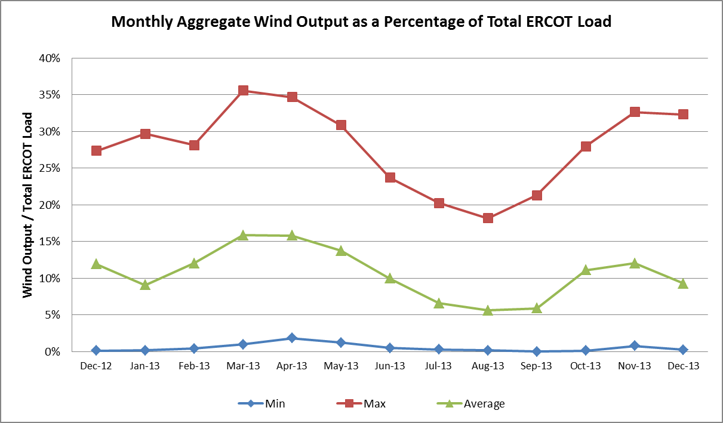

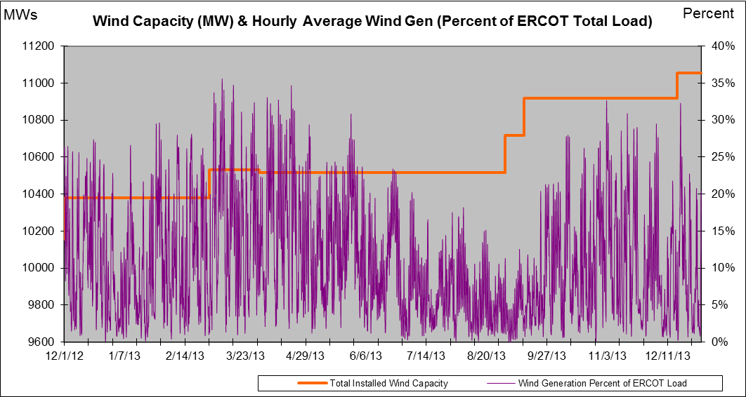

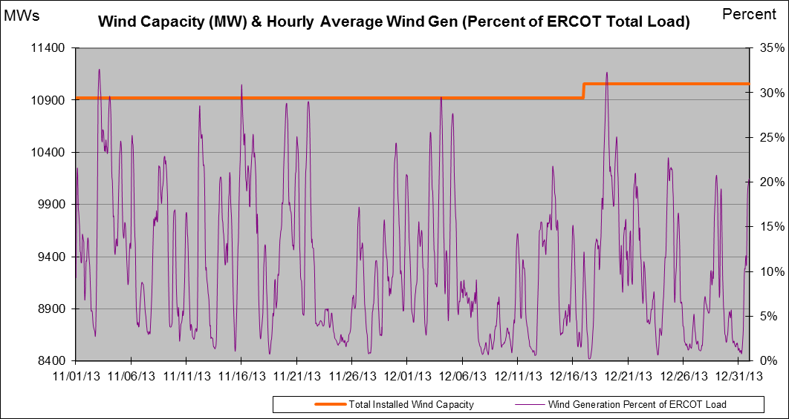

New RAP, PCAP (Date indicates last update of RAP, PCAP not implementation date.)
None

SPS (RAS) (New, Modified, Removed)
None

New Procedures/Forms/Operations Bulletins
Power Operations Bulletin 648 - DC Tie Desk V1 Rev23
Power Operations Bulletin 649 - Real Time Desk V1 Rev27
Power Operations Bulletin 650 - Reliability Unit Commitment Desk V1 Rev22
Power Operations Bulletin 651 - Resource Desk V1 Rev26
Power Operations Bulletin 652 - Shift Supervisor Desk V1 Rev24
Power Operations Bulletin 653 - Transmission and Security Desk V1 Rev28

Load Shed Incidences
None

EEA
None

System Voltage Problems
None

Application Issues
12/09 19:05 ERCOT issued an Advisory due to the Voltage Security Assessment Tool (VSAT) not solved for 30 minutes.
12/12 06:30 ERCOT issued an Advisory due to the Voltage Security Assessment Tool (VSAT) not solved for 30 minutes.

Communication Issues
None

ERCOT peak (Unofficial)
12/10 08:00 53,690 MW

Yearly MTLF Error Comparison
Yearly Mid-Term (Hourly) Load Forecast Error Comparison for the ERCOT Forecast
Month | MAPE for MTLF at 16:00 Day-Ahead
Month | 2010 | 2011 | 2012 | 2013
January | 3.78 | 2.91 | 2.94 | 3.50
February | 3.79 | 3.46 | 2.51 | 2.83
March | 2.24 | 2.02 | 3.49 | 2.68
April | 2.47 | 3.55 | 2.78 | 2.81
May | 2.63 | 3.27 | 3.09 | 3.12
June | 2.84 | 2.28 | 2.85 | 2.51
July | 2.39 | 1.63 | 2.85 | 2.70
August | 2.29 | 2.28 | 2.96 | 2.07
September | 3.14 | 2.70 | 3.43 | 2.41
October | 2.37 | 3.51 | 2.99 | 2.87
November | 3.46 | 3.38 | 2.90 | 3.48
December | 2.60 | 2.99 | 3.47 | 3.37
Annual Average | 2.83 | 2.83 | 3.02 | 2.86

OCN, Advisory, Watch & Emergency Notices
Capacity

OCN
None

Advisory
Date | Event
12/5/2013 06:00 | ERCOT issued an Advisory due to forecasted freezing rain and sleet with one half inch of ice accumulation in the West, North, and North Central Regions.
12/9/2013 19:05 | ERCOT issued an Advisory due to the Voltage Security Assessment Tool (VSAT) not solved in the last 30 minutes.
12/12/2013 06:30 | ERCOT issued an Advisory due to the Voltage Security Assessment Tool (VSAT) not solved in the last 30 minutes.

Transmission Watch
None

Watch
None

Emergency Notice
None

Texas RE Event Analysis
None

