SCR Number | 775 | SCR Title | Posting Results of Real-Time Data in a Display Format
Timeline | Normal | Action |  | Tabled
Date of Decision |  | December 19, 2013
Proposed Effective Date |  | To be determined.
Priority and Rank Assigned |  | To be determined.
Supporting Protocol Section |  | 6.3.2, Activities for Real-Time Operations
Other Document Reference/Source |  | None
System Change Description |  | This System Change Request (SCR) adds two new displays to the Day-Ahead and Real-Time data displays section under the Market Information tab on the ERCOT Market Information System (MIS):  - RTD Load Zone Forecasted Prices  - RTD Hub Forecasted Prices  Each pricing display would automatically update with new revised prices on each execution of Real-Time data and delete the oldest data as shown in the examples.  As an option, ERCOT would also provide the ability of an MIS user to specify a price threshold selected by the user that would cause the displayed prices that exceed this threshold to be highlighted in a different background color.
Reason for System Change |  | - Many large industrial loads purchase at least a portion of their power based on the Real-Time Locational Marginal Price (LMP) for a Load Zone or have arrangements with their Load Serving Entity (LSE) to interrupt when prices reach a certain threshold established by contract.  - Real-Time data provides a source for forecasted prices, but currently is only in a Comma Separated Value (CSV) or Hypertext Markup Language (HTML) format. These files contain all the LMPs from Real-Time data for all Resource Nodes, Hubs, and Load Zones when a particular load is only interested in the prices at a specific Load Zone or Hub.  - Real-Time data output files show LMPs for all Resource Nodes, Hubs, and Load Zones in a time sequential order, making it difficult to sort out the changes in price projections for an individual Load Zone.  - To understand potential price excursions, a history of forecasted prices for an individual location is needed:  - Low prices can be as important as high prices.  - Loads need to be able to access MIS directly from ERCOT using simple off-the shelf products:  - Windows IE, Firefox, etc.
Procedural History |  | - On 10/03/13, SCR775 was posted.  - On 11/14/13, WMS comments were posted.  - On 11/21/13, PRS considered SCR775.  - On 12/18/13, an Impact Analysis was posted.  - On 12/18/13, ERCOT comments were posted.  - On 12/19/13, PRS considered the 11/21/13 PRS Report and Impact Analysis for SCR775.
PRS Decision |  | On 11/21/13, PRS voted to recommend approval of SCR775 as submitted. There were two opposing votes from the Investor Owned Utility (IOU) and Municipal Market Segments and two abstentions from the Independent Power Marketer (IPM) and Municipal Market Segments. All Market Segments were present for the vote.  On 12/19/13, PRS voted to table SCR775. There was one opposing vote from the Independent Generator Market Segment and three abstentions from the IPM Market Segment. All Market Segments were present for the vote.
Summary of PRS Discussion |  | On 11/21/13, there was no discussion.  On 12/19/13, ERCOT Staff reviewed the Impact Analysis and the alternative solution for implementation as identified in the 12/18/13 ERCOT comments. There was discussion regarding the budgetary impact of SCR775 and whether the value of the data displayed warranted the additional expenditure since the data is already available to Market Participants in a different format. It was requested that ERCOT reassess the impacts to determine if efficiencies could be achieved by eliminating the interactive portion from the scope of SCR775.

Business Case
Business Case | 1 | Qualitative benefits:  - Providing the capability for large energy consumers to directly access ERCOT price forecasts supports the objectives of the Public Utility Commission of Texas (PUCT) and ERCOT to increase volunteer Load response to high prices thereby providing another Resource adequacy tool to manage reliability.
Business Case | 2 | Quantifiable benefits:  - This change is expected to be used by as many as 100 LSEs who follow current and projected prices in ERCOT.
Business Case | 3 | Impacts to Market Segments:  - Assists the Consumer Market Segment, Retail Electric Providers (REPs) and other LSEs in serving Load in ERCOT and reducing entry costs to participate in voluntary Load response.
Business Case | 4 | The display content and operation of the Real-Time data displays contemplated by this SCR have been presented to the Demand Side Working Group (DSWG) for comment as well as reviewed by several large industrial consumers.

Sponsor
Name | Mark Smith
E-mail Address | mws@austin.rr.com
Company | ERCOT Steel Companies
Phone Number | (512) 241-0431
Cell Number | (512) 635-7930
Market Segment | Consumer

Market Rules Staff Contact
Name | Sandra Tindall
E-Mail Address | stindall@ercot.com
Phone Number | 512-248-3867

Comments Received
Comment Author | Comment Summary
WMS 111413 | Endorsed as submitted.
ERCOT 121813 | Provided clarification of the alternative solution identified in the 12/18/13 Impact Analysis for SCR775.

Business Case for Proposed System Change
Issue:
Currently the forecasted prices per Load Zone and ERCOT Hubs are only available in CSV or HTML format. The Real-Time data output files are in sequential order and include all prices for every Resource Node as well as those for Load Zone and Hub prices. That format is not conducive to understanding potential Real-Time pricing excursions projected by Real-Time data. The SCR provides greater access to information already produced by Real-Time data in a more usable format. In addition, Loads need to have access to this information using simple off-the-shelf products.
Resolution:
Develop new display screens for forecasted Load Zone and Hub prices as shown by the following examples.
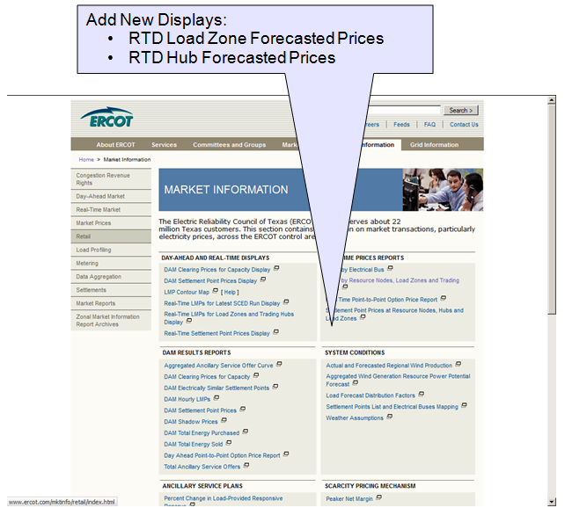
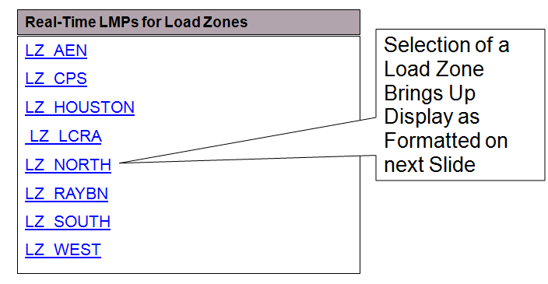
Example of the RTD Forecasted LMPs for North Load Zone
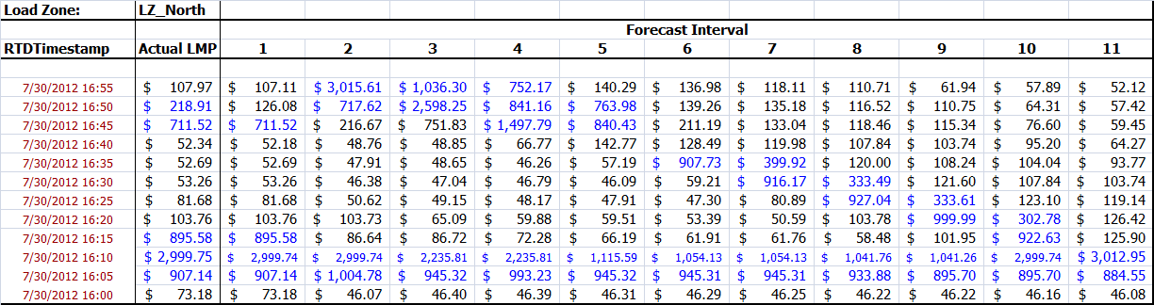
A similar screen will be created for forecasted prices for each ERCOT Hub
Updated Example of the RTD Forecasted LMPs for North Load Zone showing new prices after RTD execution and deletion of the oldest prices from the bottom row.
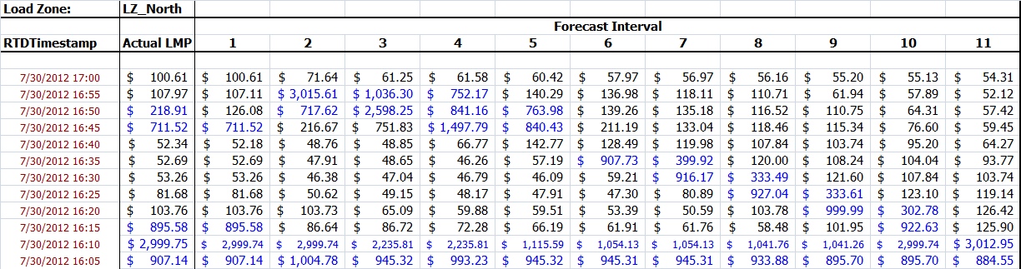
The Optional Price Threshold that causes prices exceeding the threshold to be displayed in a different color would be an user enterable field on either the sample displays shown above or on the on the Load Zone/Hub selection display. The threshold display would remain for all subsequent updates (refresh) to the display until changed by the user.

