SCR Number | 775 | SCR Title | Posting Results of Real-Time Data in a Display Format

Date | December 18, 2013

Submitter’s Information
Name | Jamie Lavas
E-mail Address | jlavas@ercot.com
Company | ERCOT
Phone Number | 512-248-6788
Cell Number | 512-642-3309
Market Segment | Not applicable.

Comments

These comments provide clarification of the alternative solution identified in the “Alternatives for a More Efficient Implementation” section in the 12/18/13 Impact Analysis for SCR775. Providing the forecasted Real-Time data on a single screen in a manner consistent with current pricing displays will lower the expected cost impact to between $20k and $40k

Revised Business Case for Proposed System Change
Issue:
Currently the forecasted prices per Load Zone and ERCOT Hubs are only available in CSV or Extensible Markup Language (XML) format. The Real-Time data output files are in sequential order and include all prices for every Resource Node as well as those for Load Zone and Hub prices. That format is not conducive to understanding potential Real-Time pricing excursions projected by Real-Time data. The SCR provides greater access to information already produced by Real-Time data in a more usable format. In addition, Loads need to have access to this information using simple off-the-shelf products.
Resolution:
Provide the forecasted prices per Load Zone and ERCOT Hubs in an HTML format on the Market Information System (MIS) Public Area. This data is in addition to the reports already produced by Real-Time data and on a corresponding five minute timeframe. The pricing display will automatically update with new revised prices on each execution of Real-Time data and delete the prior data set.

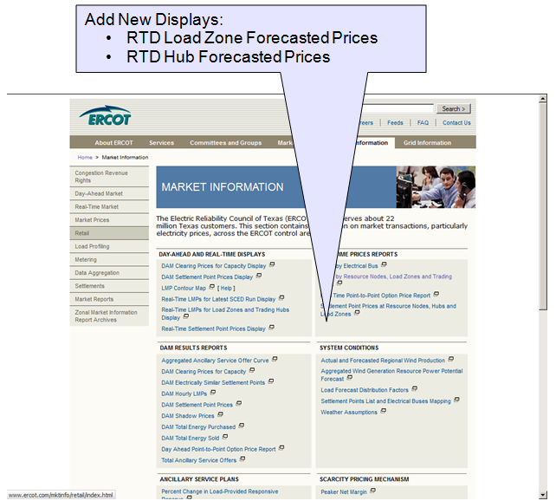
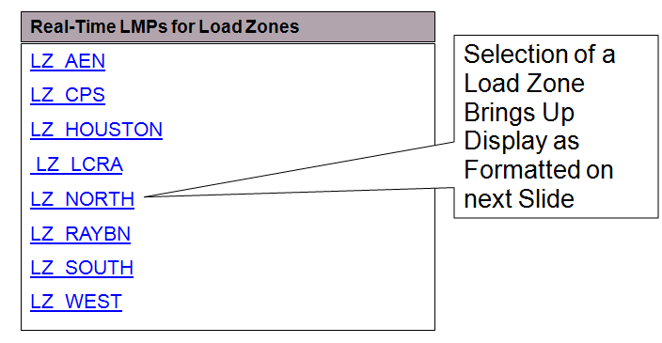
Example of the RTD Forecasted LMPs for North Load Zone
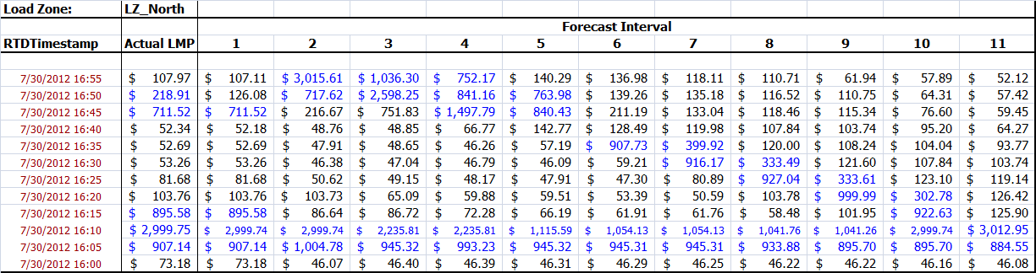
A similar screen will be created for forecasted prices for each ERCOT Hub
Updated Example of the RTD Forecasted LMPs for North Load Zone showing new prices after RTD execution and deletion of the oldest prices from the bottom row.
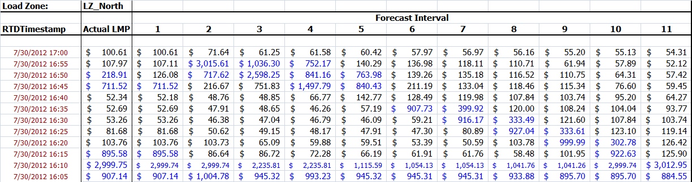
The Optional Price Threshold that causes prices exceeding the threshold to be displayed in a different color would be an user enterable field on either the sample displays shown above or on the on the Load Zone/Hub selection display. The threshold display would remain for all subsequent updates (refresh) to the display until changed by the user.

