ERCOT Operations Report
November 2013 ROS & OWG

Frequency Control
Time | Freq (Hz) | Duration (s)
11/1/2013 21:47 | 59.707 | 13 | Unit trip with approximately 1212 MW net
11/12/2013 16:34 | 59.896 | 3 | Unit trip with approximately 450 MW net
11/14/2013 2:38 | 59.796 | 39 | Unit trip with approximately 787 MW net
11/14/2013 11:01 | 59.858 | 25 | Unit trip with approximately 539 MW net
11/22/2013 16:23 | 59.880 | 24 | Two Unit trips with approximately 506 MW net
11/23/2013 15:58 | 59.897 | 3 | Unit trip with approximately 613 MW net
11/27/2013 6:16 | 59.856 | 52 | Unit trip with approximately 856 MW net
Note: Time of frequency excursions outside the range of +/- 0.1 Hz.

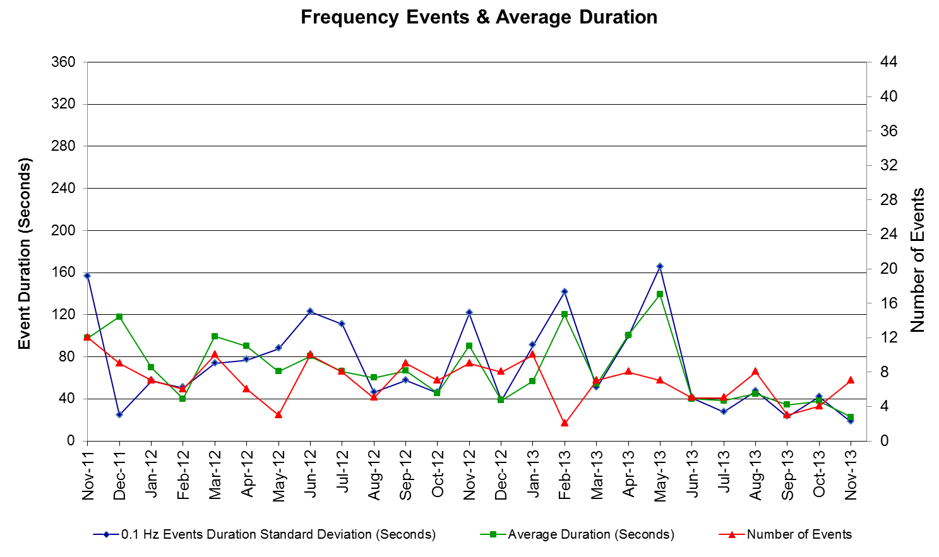

PMU Events
ERCOT evaluates PMU data according to industry standards. Events with an oscillating frequency of less
than 1 Hz are considered to be inter- area, while higher frequencies indicate local events. Industry standards
specify that damping ratio for inter-area oscillations should be 3.0% or greater. All events listed below
indicate the ERCOT system transitioned well after each disturbance.

Date | Events | Duration | Summary
11/1/2013 21:47:25 | Unit Trip | Approx. 110 sec | The event was caused by the loss of one unit. The unit was generating 1212 MW net before the trip, the frequency dropped to 59.70 Hz. The oscillating frequency of 0.64 Hz with 8.6% damping ratio was observed.
11/12/2013 16:33:59 | Unit Trip | Approx. 72 sec | The event was caused by the loss of three units. The units were generating 450 MW net before the trip, the frequency dropped to 59.89 Hz. The oscillating frequency of 0.66 Hz with 6.8% damping ratio was observed.
11/14/2013 02:38:55 | Unit Trip | Approx. 175 sec | The event was caused by the loss of one unit. The unit was generating 787 MW net before the trip, the frequency dropped to 59.79 Hz. The oscillating frequency of 0.7 Hz with 5.9% damping ratio was observed.
11/14/2013 11:01:49 | Unit Trip | Approx. 153 sec | The event was caused by the loss of one unit. The unit was generating 539 MW net before the trip, the frequency dropped to 59.86 Hz. The oscillating frequency of 0.69 Hz with 8.0% damping ratio was observed.
11/27/2013 06:16:13 | Unit Trip | Approx. 209 sec | The event was caused by the loss of one unit. The unit was generating 856 MW net before the trip, the frequency dropped to 59.85 Hz. The oscillating frequency of 0.62 Hz with 9.2% damping ratio was observed.

Deployed Responsive (Reported Above)

Time deployed | Stop Time | Duration | Max | Details
11/1/13 21:47:32 | 11/1/13 21:50:00 | 0:02:28 | 1301.9
11/12/13 16:34:10 | 11/12/13 16:41:16 | 0:07:06 | 152.29
11/14/13 2:39:01 | 11/14/13 2:43:14 | 0:04:13 | 749.2
11/14/13 11:01:58 | 11/14/13 11:05:26 | 0:03:28 | 565.44
11/22/13 16:23:50 | 11/22/13 16:28:02 | 0:04:12 | 400.11
11/23/13 15:58:50 | 11/23/13 16:01:26 | 0:02:36 | 218.87
11/26/13 14:07:14 | 11/26/13 14:08:34 | 0:01:20 | 217.89 | Unit trip with approximately 400 MW net
11/27/13 6:16:26 | 11/27/13 6:20:26 | 0:04:00 | 11.05
11/29/13 11:22:10 | 11/29/13 11:24:50 | 0:02:40 | 126.92 | Unit trip with approximately 390 MW net

RUC Commitments

SCED Congestion Management Activity
Congestion affected by outages

Contingency Description | Overloaded Element | # Days Active
DCKT Rio Hondo - North Edinburg 345 kV and Harlingen Switch 138 kV | Rio Hondo - Burns Sub 138 kV | 9
DCKT Singleton - Zenith 345 kV | Singleton - Tomball 345kV | 9
North Edinburg - Lon Hill 345 kV | Las Pulgas - Raymondville 2 138 kV | 9
Scurry Switch - Sun Switch 138 kV | Wolfgang - Rotan 69 kV | 9
Koch Up River - Gila 138 kV | Gila - Hiway 9 138 kV (GILA_HIWAY_2) | 7
Tonkawa Switch - Scurry County South Switch 345 kV (34520) | Bluff Creek Switch - Exxon Sharon Ridge 138 kV | 7
Techridge - Aep Dunlap 138 kV | Dunlap - Decker 138 kV | 7
Bosque Switch - Elm Mott 345 kV | Bosque Switch - Rogers Hill Bepc 138 kV | 5
Bosque Switch - Whitney 138 kV | Bosque Switch - Lake Whitney Tnp 138 kV | 5
Orange Grove Switching Station - Lon Hill 138 kV | Lon Hill - Smith 69 kV | 5
Aspermont Aep - Spur 138KV | Wolfgang - Rotan 69 kV | 5
Basecase | Post Oak Wind AT1 345/138 kV | 4
Basecase | Ena Snyder Wind - Wkn_Bkr 69kV | 4
Laquinta - Lobo 138 kV | Bruni 138_69_1 138/69 kV | 4
North Edinburg - Lon Hill 345 kV | Kleberg Aep - Loyola Sub 138 kV | 4
DCKT Austrop - Sandow Switch 345 kV | Hutto - Round Rock Northeast 138 kV (1661_B) | 3
DCKT Dowlap - Morgans Point and Airpro - Shell 138 kV | Deer Park - Cardiff 138 kV | 3
DCKT Marion - Zorn and Clear Springs 345 KV | Seguin - Seguin West 138 kV | 3
DCKT Salado Switch - Killeen Switch 345 kV | Temple Switch - Temple Southeast 138 kV | 3
Dupont Switch-Ingleside - Ingleside Cogen Switch 138 kV | Dupont Pp1-Ingleside - Dupont Switch-Ingleside 138 kV (I_DUPP_I_DUPS1) | 3
Basecase | Orlando - Vernon 138 kV | 2
DCKT Austrop - Garfield Aen and Zorn 345 kV | Dunlap - Decker 138 kV | 2
DCKT Austrop - Sandow Switch 345 kV | Temple Switch - Temple Southeast 138 kV | 2
DCKT Whitepoint - Lon Hill & South Texas Project 345kV | Rincon - Airco Aep 138kV | 2
DCKT Watermill Switch - Desoto Switch - Cedar Hill Switch 345 kV | Tri Corner - Seagoville Switch 345 kV | 2
Bigbay - Bayou Cogen 138 kV (Bbpbyu79) | Deer Park - Cardiff 138 kV | 2
Loyola Sub - Kleberg Aep 138 kV | Loyola Sub 138_69_1 138/69kV | 2
Midland East - Moss Switch 345kV | Glenhaven - Crmwd 8 Tap 138 kV | 2
Aspermont Aep - Spur 138KV | Girard Tap - Jayton 138 kV | 2
Aspermont Aep - Spur 138KV | Spur 138_69_1 138/69 kV | 2
Salt Creek Bepc - Spur And Scurry Switch 138kV | Wolfgang - Rotan 69 kV | 2
Basecase | Sweetwater Wind 3 XT2 345/138 kV | 1
Basecase | Valley Import | 1
DCKT Carrolton Northwest - Lewisville Switch 345 kV | Lakepointe Tnp - Carrollton Northwest 138 kV | 1
DCKT Fayette Plant 2 - Lytton Springs & Holman Aen 345 kV | Austrop - Garfield 345 kV | 1
DCKT Gibbons Creek - Singleton 345 kV | Jewett - Singleton 345 kV (240_A) | 1
DCKT Lon Hill - Coleto Creek & Medio Creek - Lon Hill & Warburton Road Switching Station 345kV | Rincon - Airco Aep 138kV | 1
DCKT Rio Hondo - North Edinburg 345 kV and Harlingen Switch 138 kV | Burns Sub - Heidelburg Sub 138 kV | 1
DCKT Tonkawa Switch - Scurry County South Switch 345 kV | Bluff Creek Switch - Exxon Sharon Ridge 138 kV | 1
DCKT South Texas Project - Dow Chemical 345 kV | South Texas Project - Hillje 345 kV (Ckt_3124) | 1
Aspermont Aep - Paint Creek 138 kV | Munday Aep - Bkem Munday 69 kV | 1
Ackerly Vealmoor Switch - Big Spring Switch and China Grove Switch 138 kV | Big Spring Switch - Big Spring Crmwd Tap 69 kV | 1
Asphalt Mines - Uvalde Aep & Odlaw Switchyard 138kV | Hamilton Road - Maverick 138kV | 1
Big Three Odessa - Odessa Ehv Switch and Moss Switch 138 kV | Odessa - Odessa North 138 kV | 1
Cosden - Morgan Creek Ses 138 kV | Morgan Creek Ses AXFMR3 (3) 138/69 kV | 1
Dowlap - Morgans Point 138 kV | Deer Park - Cardiff 138 kV | 1
Ennis Creek Switch - Knapp 138 kV | Sacroc - Snyder 138kV | 1
Garfield Aen - Austrop 345 kV | Dunlap - Decker 138 kV | 1
Nacdches - Skyline 138 kV | Weiderstein - Randolph 138 kV | 1
McDonald Road - Big Spring Switch 138 kV | McDonald Road - Morgan Creek Ses 138 kV | 1
Midland East - Moss Switch 345kV | Odessa - Odessa North 138 kV | 1
Midland East - Moss Switch 345kV | Odessa Ehv Switch - Big Three Odessa Tap 138 kV | 1
Nelson Sharpe - Lon Hill 345kV | Airline Aep - Cabaniss 138 kV | 1
North Edinburg - Lon Hill 345 kV | North Edinburg - Rachal 138 kV | 1
Sherry Switch - Century 345 kV | Cedar Hill Switch - Fish Creek Switch 138 kV (3180) | 1
Sun Switch - Morgan Creek Ses 138kV | Bluff Creek Switch - Exxon Sharon Ridge 138 kV | 1
Forcfb Unit FORMOSG12 | Victoria- Victoria Dupont Switch 138 kV | 1
Alice 138_69A1 138/69 kV | Lon Hill - Robstown Tap 69 kV | 1
Willow Valley Switch MR1H (3) 345/138 kV | Morgan Creek Ses AXFMR3 (3) 138/69 kV | 1
Generic Transmission Limits (GTL’s)

GTL | Days
West – North | 0
Valley Import | 1

Congestion Cost
Binding Constraints – Year to Date
Contingency | Binding Element | Number of 5-min intervals | Shadow Price Range $/MWh | Estimated Congestion Rent $ (Shadow Price*Limit) | Transmission Project
Midland East to Odessa EHV 345 kV & Moss Switch 345/138 kV Xfmr | Odessa - Odessa North 138 kV | 9038 | 0 - 3500 | 57,143,394 | 13TPIT0136,  14TPIT0054
Midland East to Odessa EHV 345 kV & Moss Switch 345/138 kV Xfmr | Odessa EHV Switch - Big Three Odessa Tap 138kV | 4335 | 0 - 3500 | 31,785,167 | 13TPIT0153
Roanoke Switch - West Denton 345 kV & Roanoke Switch - Lewisville Switch 345 kV; or West Denton - Roanoke Switch 345 kV; or West Denton - Rdwells 138 kV | Jim Cristal - North Denton 138kV | 1407 | 0 - 3500 | 18,679,874 | 14TPIT0047
DCKT Roansprairie - Kuykendahl - King & Singleton - Tomball 345 kV | Singleton - Zenith 345 kV | 473 | 0 - 4500 | 17,737,088
Sun Switch - Golden Switch 138 kV; Sun Switch - Morgan Creek SES 138 kV | Bluff Creek Switch - China Grove Switch 138 kV | 1042 | 0 - 3500 | 17,681,085 | 12TPIT0058, 13TPIT0098
Roanoke Switch - West Denton 345 kV & Roanoke Switch - Lewisville Switch 345 kV; or West Denton - Roanoke Switch 345 kV | Fort Worth - Teasley 138 kV | 2813 | 0 - 3500 | 16,898,845 | 14TPIT0047
Amoco South Foster to Westover 138 kV | Moss Switch - Amoco North Cowden Tap 138 kV | 1204 | 0 - 3500 | 15,801,329 | 13TPIT0098, 13TPIT0093
Morgan Creek SES 345/138 kV Autotransformer 2 | Morgan Creek SES 345/138 kV Autotransformer 4 | 394 | 0 - 4500 | 13,917,840
Morgan Creek SES AXFMR2 345/138kV | Mogan Creek SES AXFMR1 345/138kV | 4841 | 0 - 1370 | 12,209,796
Austrop 345/138 kV Xfmr & Garfield LCRA 345/138 kV Xfmr | Austrop 345/138 kV Xfmr | 1965 | 0 - 4500 | 11,898,409 | 10TPIT0031
West Denton - Rdwells 138 kV | Teasley - Pockrus Substation 138 kV | 1093 | 0 - 3500 | 11,227,954 | 5YTP [2012-R46]
Cangon AXFMR3 345/138kV | Cangon AXFMR4 345/138kV | 3515 | 0 - 3500 | 10,671,747
DCKT Roansprairie - Kuykendahl - King & Singleton - Tomball 345 kV | Singleton - Zenith 345 kV | 3029 | 0 - 4500 | 9,828,893
McNeil - Gilleand Creek 138 kV | Hutto - Round Rock NE 138 kV | 1983 | 0 - 3500 | 7,822,046
Ajo - Rio Hondo 345 kV | North Edinburg - Lon Hill 345 kV | 39 | 2 - 4500 | 7,633,932 | 14TPIT0050
DCKT Salado Switch - Killeen Switch 345kV | Temple Switch - Temple Southeast 138kV | 716 | 0 - 3500 | 6,980,592 | 5YTP[2012-R45]
Garfield LCRA 345/138 kV Xfmr & Austrop - Daffin 138 kV | Austrop - Dunlap 138 kV | 740 | 0 - 3500 | 6,752,182 | 10TPIT0031
Odlaw Switchyard to Uvalde AEP 138kV | Hamilton Road - Maverick 138kV | 5716 | 0 - 2905 | 6,469,174 | 16TPIT0024
Calallen Sub to Lon Hill 69kV | Lon Hill - Robstown Tap 69kV | 667 | 0 - 2800 | 6,468,291 | 13TPIT0220
Wink 138/69 kV Autotransformer; or Wink - Wink Sub 138 kV | Wink Basin Tap - Wink Sub 69 kV | 772 | 0 - 2800 | 6,378,270 | 17TPIT0018, 5YTP[2012-R4]

Binding Constraints – November 2013
Contingency | Binding Element | Number of 5-min intervals | Shadow Price Range $/MWh | Estimated Congestion Rent $ (Shadow Price*Limit) | Transmission Project | Comments
DCKT Salado Switch - Killeen Switch 345kV | Temple Switch - Temple Southeast 138kV | 612 | 0 - 3500 | 5,844,297 | 5YTP[2012-R45] | Planned outage of Temple North - Temple Northwest 138 kV double circuit
DCKT South Texas Project - Dow Chemical 345kV | Hillje - South Texas Project 345kV | 177 | 0 - 4271 | 3,172,155 |  | Planned outage of South Texas Project - Hillje 345 kV
Basecase | Valley interface | 29 | 0 - 2000 | 1,188,500 |  | Planned outage of Ajo - Nelson Sharpe 345 kV and drop in valley wind
DCKT Scurry County South Switch - Tonkawa Switch 345kV | Bluff Creek Switch - Exxon Sharon Ridge 138kV | 744 | 0 - 241 | 1,161,165 | 12TPIT0058 | Planned outages of Tonkawa Switch - Graham Ses and Scurry County South Switch (34530) 345 kV
North Edinburg -Lon_hill 345kV | Kleberg AEP - Loyola Sub 138kV | 93 | 0 - 3500 | 1,159,335 | 11TPIT0002, 14TPIT0050, 14TPIT0051 | Planned outage of Ajo - Nelson Sharpe 345 kV
North Edinburg -Lon_hill 345kV | Las Pulgas - Raymondville 2 138kV | 1044 | 0 - 3500 | 815,247 | 11TPIT0002, 14TPIT0050, 14TPIT0051 | Planned outage of Ajo - Nelson Sharpe 345 kV
Bigbay - Bayou Cogen 138kV | Cardiff - Deer Park 138kV | 771 | 0 - 3500 | 762,311 |  | Planned outages of Bayou Cogen - Ph Robinson and Bigbay - Bayou Cogen (Bppbyu79) 138 kV
DCKT Singleton - Zenith 345kV | Singleton - Tomball 345kV | 656 | 0 - 65 | 598,651 |  | Planned maintenance outages in the area
DCKT Austrop - Garfiled & Zorn 345kV and Techiridge - AEN Dunlap 138kV and Garfiled AEN GF_AT1 345/138kV | Decker - AEN Dunlap 138kV | 1495 | 0 - 1461 | 509,281 | 16TPIT0036, 10TPIT0031, 07TPIT0050 | Planned outage of McNeil - Decker 138 kV
DCKT Sandow Switch - Austrop 345kV | Hutto Switch - Round Rock Northeast 138 kV | 217 | 0 - 3500 | 483,996 |  | Planned outages of McNeil - Decker and Decker - Sprinkle 138 kV
DCKT Riohondo - North Edinburg 345kV and Harlingen Switch 138kV | Burns Sub - Riohondo 138kV | 577 | 0 - 2433 | 412,617 |  | Planned outage of Ajo - Nelson Sharpe 345 kV
Bosque Switch - Whitney 138kV | Lake Whitney TNP -Bosque Switch 138kV | 571 | 0 - 3500 | 343,467 | 5YTP [2012-R47], 12TPIT0090 | High area wind
Alice 138_69A1 138/69KV | Lon_hill - Robstown Tap 69kV | 108 | 0 - 2800 | 328,448 | 12TPIT0180 | Planned outage of Ajo - Nelson Sharpe 345 kV
Laquinta - Lobo 138kV | Bruni Sub 138_69_1 138/69kV | 453 | 0 - 2800 | 310,427 |  | High area wind
Koch Up River - Gila 138kV | Gila - Hiway_9 138kV | 1335 | 0 - 3500 | 304,453 |  | High output at Nueces Bay and forced outage of Gila - Hiway 9 (GILA_HIWAY_1) 138KV
DCKT Whitepoint - Lon Hill & South Texas Project 345kV | Airco AEP - Rincon 138kV | 331 | 0 - 301 | 294,352 | 08TPIT0132  08TPIT0131 | Planned outage of George West Switching Station - George West 138 kV
Big Spring Switch - Ackerly Vealmoor Switch and China Grove Switch 138kV | Big Spring Switch - Big Spring West 138kV | 56 | 0 - 2800 | 234,240 | 15TPIT0080 | High area wind
Aspermont AEP - Paint Creek 138kV | Munday AEP - Munday East 69kV | 41 | 0 - 2800 | 215,437 | 14TPIT0063 | Planned outage of Munday Aep - Weinert 69 kV
Basecase/Oklaunion - Abilen Muberry Creek 345kV/DCKT Demott Switch - Scurry County South Switch 345kV | Orlando - Vernon 138kV | 332 | 0 - 5000 | 201,236 | 14TPIT0106 | High west wind and outages around Graham Ses
Cosden - Morgan Creek Ses 138kV | Morgen Creek Ses AXFMR3 138/69kV | 13 | 0 - 3500 | 172,346 |  | Forced outages in area due to icy weather
Wind Generation as a Percent of Load

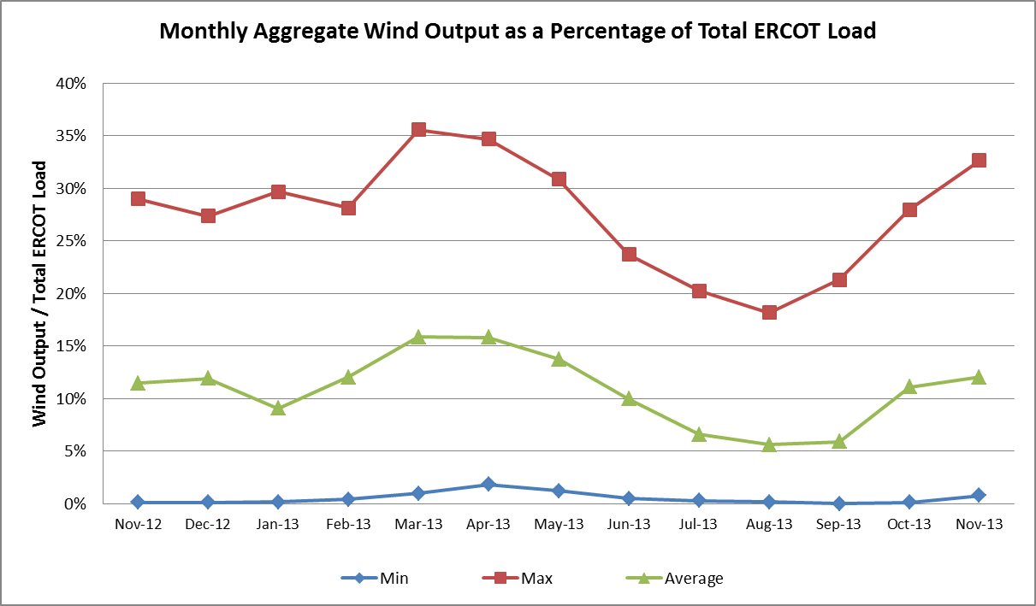

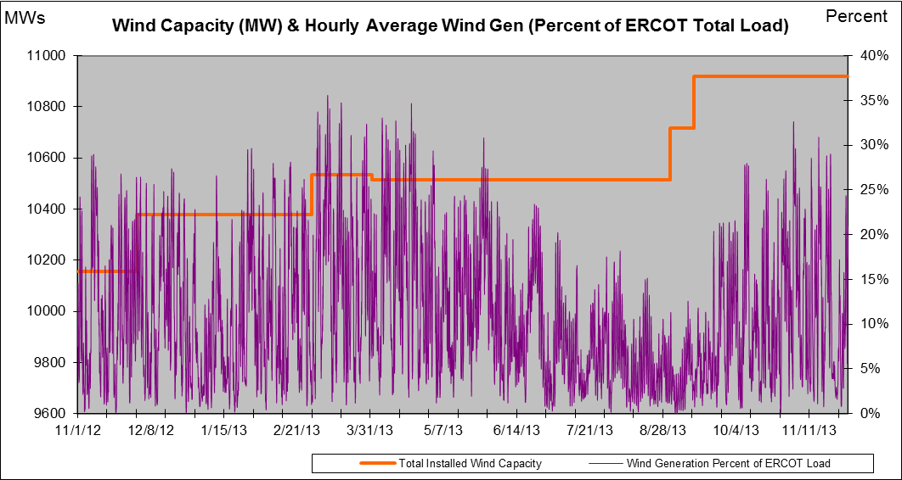

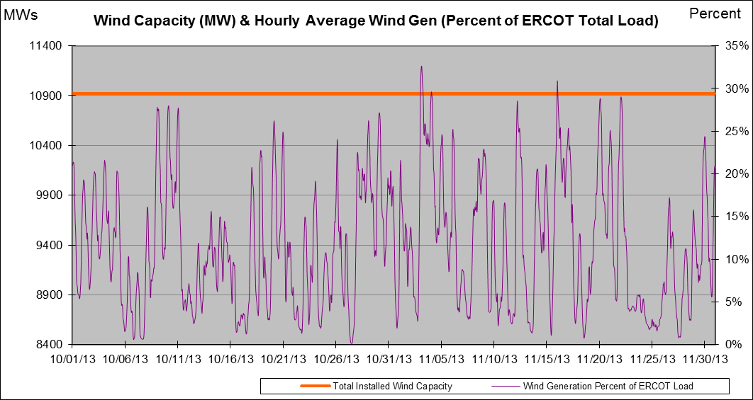

New RAP, PCAP (Date indicates last update of RAP, PCAP not implementation date.)
None

SPS (RAS) (New, Modified, Removed)
Willow Valley SPS #32 was removed

New Procedures/Forms/Operations Bulletins
None

Load Shed Incidences
None

EEA
None

System Voltage Problems
None

Application Issues
None

Communication Issues
None

ERCOT peak (Unofficial)
11/25 17:00 46,931 MW

Yearly MTLF Error Comparison
Yearly Mid-Term (Hourly) Load Forecast Error Comparison for the ERCOT Forecast
Month | MAPE for MTLF at 16:00 Day-Ahead
Month | 2010 | 2011 | 2012 | 2013
January | 3.78 | 2.91 | 2.94 | 3.50
February | 3.79 | 3.46 | 2.51 | 2.83
March | 2.24 | 2.02 | 3.49 | 2.68
April | 2.47 | 3.55 | 2.78 | 2.81
May | 2.63 | 3.27 | 3.09 | 3.12
June | 2.84 | 2.28 | 2.85 | 2.51
July | 2.39 | 1.63 | 2.85 | 2.70
August | 2.29 | 2.28 | 2.96 | 2.07
September | 3.14 | 2.70 | 3.43 | 2.41
October | 2.37 | 3.51 | 2.99 | 2.87
November | 3.46 | 3.38 | 2.90 | 3.48
December | 2.60 | 2.99 | 3.47
Annual Average | 2.83 | 2.83 | 3.02 | 2.75

OCN, Advisory, Watch & Emergency Notices
Capacity

OCN
Date | Event
11/24/2013 05:00 | ERCOT issued an OCN due to unplanned outages in far West Texas

Advisory
Date | Event
11/5/2013 08:30 | ERCOT issued an Advisory due to Physical Responsive Capability (PRC)
11/6/2013 11:00 | ERCOT issued an Advisory due to Physical Responsive Capability (PRC)
11/22/2013 17:45 | ERCOT issued an Advisory due to Physical Responsive Capability (PRC)

Transmission Watch
None

Watch
None

Emergency Notice
None

Texas RE Event Analysis
None

