NPRR Number | 574 | NPRR Title | Removal of Offer Curve Flexibility for DAM-Committed Resources
Date |  | November 20, 2013
Submitter’s Information
Name |  | Amanda Frazier
E-mail Address |  | amanda.frazier@luminant.com
Company |  | Luminant Energy Company LLC
Phone Number |  | 512-349-6442
Cell Number |  | 512-364-3275
Market Segment |  | Investor Owned Utility (IOU)

Comments

Luminant Energy Company LLC (Luminant) appreciates the opportunity to submit these comments in response to the submission of NPRR 574: Removal of Offer Curve Flexibility for DAM-Committed Resources.

In the revision description for this NPRR, the sponsor stated that this NPRR is needed because: “[t]he allowance of Energy Offer Curve modification intra-day has produced results that are inconsistent with a properly functioning competitive wholesale market and may not be reflective of actual Resource availability.” Luminant is unaware of any quantitative analysis that has been provided to Market Participants to support this claim or to bolster the case for unwinding the market efficiency improvements that were facilitated by NPRR321, which allows all Generation Resources to be able to respond to changes in physical facility capabilities and market conditions as they play out in Real-Time. Luminant submits that market analysis demonstrates that ERCOT is a very competitive and price efficient wholesale market.

First, considering the average Real Time minus Day Ahead prices for 2011, 2012, and 2013, as well as the standard deviation of this measure to determine whether or not an increase in this spread had occurred after NPRR321 was implemented in December 2011, the analysis shows that, especially for the 5x16 and 2x16 products, there has been general trend toward both lower average RT – DAM spreads and improving standard deviations. This is true in spite of the fact that the System Wide Offer Cap has increased by 67% across this time period. Therefore, this metric shows that the reforms introduced by NPRR321 have not decreased market efficiency.

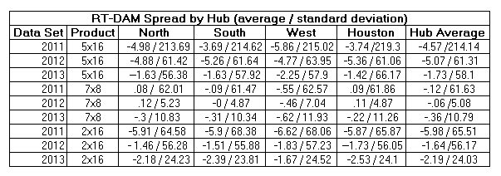

Second, the Peaker Net Margin metric published by the IMM and ERCOT also indicates that market efficiency has not decreased since the implementation of NPRR321.
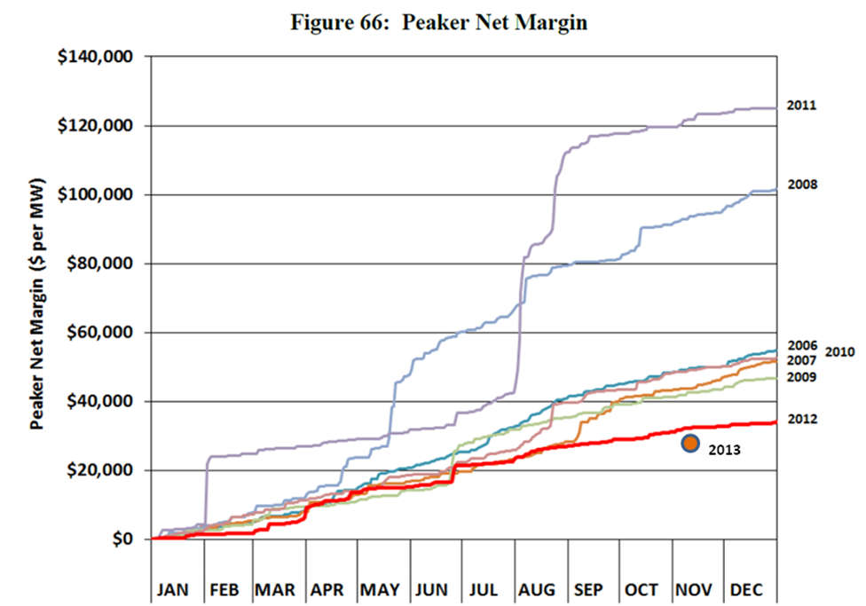
Source: 2012 State of the Market Repor for the ERCOT Wholesale Electricity Markets, Potomac Economics, Ltd. and ERCOT’s current 2013 published values.

This analysis shows that 2012 and 2013 are the two years with the lowest accumulation of Peaker Net Margin in the past 7 years. Thus, the implementation of NPRR321 has not had the effect of raising wholesale prices, at least relative to the 5 years that preceded it.

Most important, the ability for Generation Resource owners to have flexibility in their offers between the Day Ahead Market and Real Time is fundamental in an energy-only market with significant Real Time price volatility. Stakeholders have already debated and decided this issue in the context of NPRR 321, which allows all Generation Resources to be able to respond to changes in physical facility capabilities and market conditions as they play out in Real-Time. This improves price efficiency as Resource Owners or their representatives can optimize prices based on market or physical conditions affecting their portfolio (e.g. ambient temperature, Ancillary Service Resource Responsibilities and associated availabilities, etc.) The Flexibility to update EOCs results in less risk premium priced into Day-Ahead offers, since the QSE faces less uncertainty in otherwise binding commitment decisions.

The importance of NPRR 321 compounds with the advent of the Operating Reserve Demand Curve. Resource Managers must estimate their opportunity costs of selling into the Day-Ahead Market based on price expectations that will soon have more propensity to diverge should scarcity materialize. Moreover, when the ORDC is implemented, it will only exist in the Real Time market, and Resource owners will have to value and capture more of their opportunity costs in their Day-Ahead offers in order for those markets to achieve price convergence. Luminant reminds stakeholders that the Day-Ahead Market is intended to be financially binding, rather than physically binding – therefore, the pricing flexibility granted in the current protocol language is appropriate.

Given that the sponsor of this NPRR has not provided any supporting data to justify their claim that NPRR321 “…has produced results that are inconsistent with a properly functioning competitive wholesale market…,” and in fact, evidence suggests that the market has been very efficient since NPRR 321 was implemented, Luminant urges Market Participants to reject NPRR 574.

Revised Proposed Protocol Language

None at this time.

