 |  |  |  | System Planning
Monthly Status Report
October 2013

 |  | Report Highlights
 | - ERCOT is currently tracking 182 active generation interconnection requests totaling over 47,100 MW. This includes over 22,800 MW of wind generation.
- ERCOT is currently reviewing proposed transmission improvements with a total cost of $675 Million
- Transmission Projects endorsed in 2013 total $349.8 Million
- All projects (in engineering, routing, licensing and construction) total approximately $6.23 Billion.
- Transmission Projects energized in 2013 total about $3.17 Billion.

Table of Contents

1. Generation Interconnection 1
1.1 Signed Generation Interconnection Agreements 1
1.2 New Generation Approved for Commercial Operations 1
1.3 Summary of Generation Interconnection Requests 1
1.4 Projects with Interconnection Agreements 5
1.5 Projects Undergoing Full Interconnection Studies with Confidentiality Waived 6
1.6 Generation Projects Undergoing Full Interconnection Studies 6
1.7 Wind Generation Capacity Installed by Year 9
2. Regional Planning Group Project Reviews 11
3. Asynchronous Tie Interconnection 11
4. Planning Model Activities 12
5. Other Notable Activities 12

1. Generation Interconnection
Additional information regarding detailed generation interconnection and impact studies is contained in the “Generation Project Interconnection Information” folder in the “Operations and System Planning” area on the ERCOT website: http://planning.ercot.com/login/login.

Signed Generation Interconnection Agreements

New Generation Approved for Commercial Operations

The total installed wind capacity is now reported as 10,970 MW by the resource owners through the registration process. Capacity by North, South and West is 832 MW, 2,775 MW, and 7,363 MW respectively. Eight-hundred fifty MW is able to switch between the West and South zones and is currently shown in the South zone.

Summary of Generation Interconnection Requests
GENERATION INTERCONNECTION REQUESTS CURRENTLY UNDER REVIEW
Currently tracking 182 generation interconnection or change requests
As of October 31, 2013 | Total
Security Screening Study | 17
SSS Completed | 13
Full Interconnect Study | 105
FIS Completed | 8
Suspended Studies | 0
Capacity of Suspended Study Projects | 0
Interconnect Agreement Completed | 39
Capacity under Interconnection Agreements | 12,900
Capacity for Grid, MW | 47,104
Wind Capacity, MW | 22,881
Cancelled Projects | 2

Fuel Type | Confidential Projects (MW) | Projects Under Full Study (MW) | Public Projects (MW) | Suspended Studies (MW) | Grand Total (MW)
Gas-AllOther |  |  | 374 | - | 4,857
Gas-CombinedCycle |  |  | 6,515 | - | 16,462
Total Gas | 1,670 | 12,760 | 6,889 | - | 21,319
Nuclear | - | - | - | - | -
Coal | - | 30 | 240 | - | 270
Wind | 3,943 | 13,317 | 5,621 | - | 22,881
Solar | 458 | 1,151 | 150 | - | 1,759
Biomass | - | - | - | - | -
Storage | - | 874 | - | - | 874
Petroleum Coke | - | - | - | - | -
Grand Total | 6,071 | 28,132 | 12,900 | - | 47,103

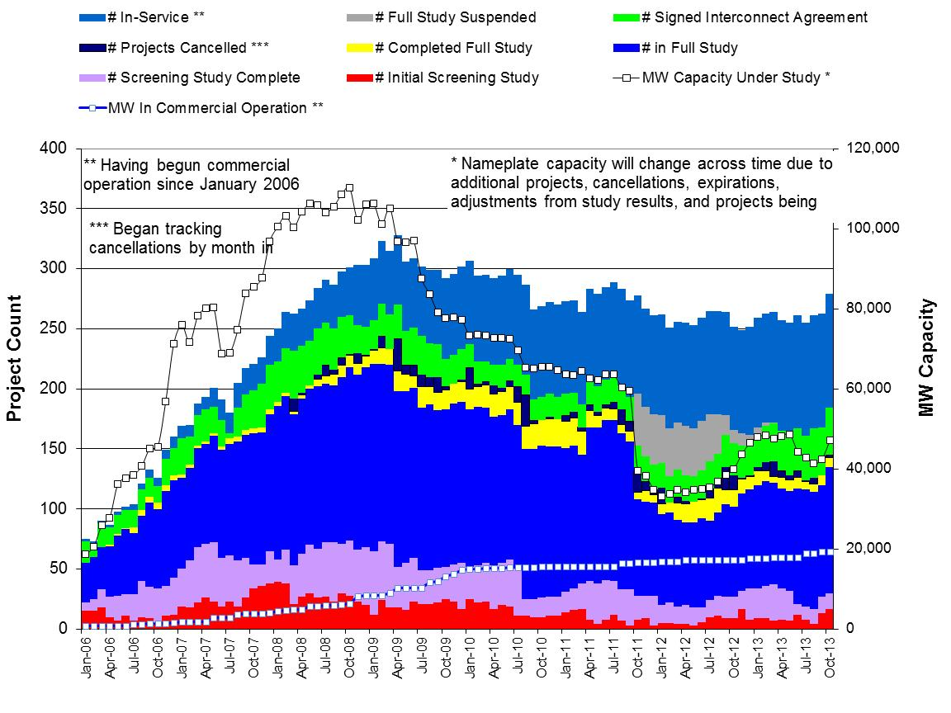

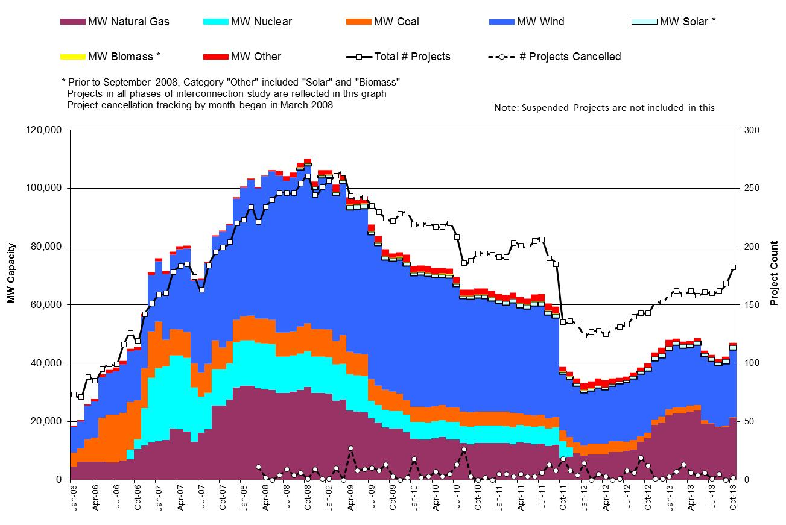

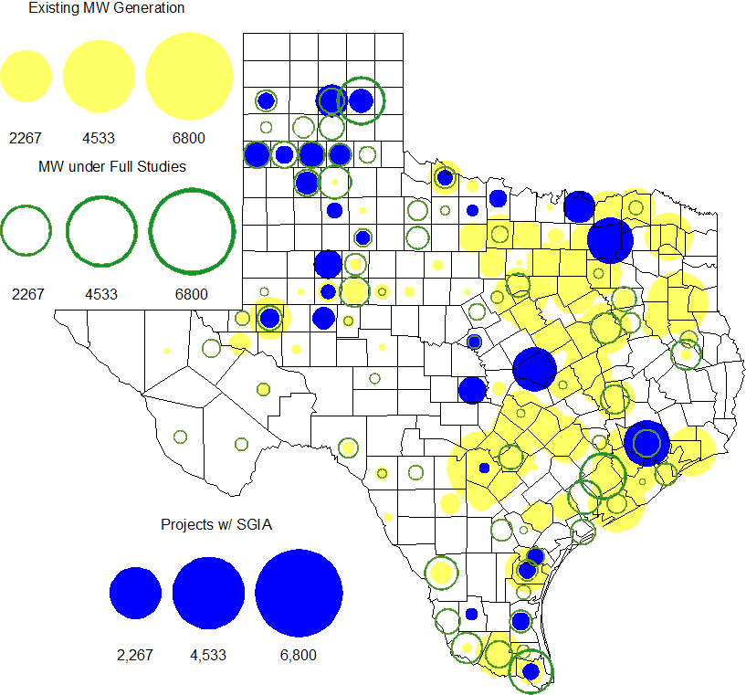

County Location of Installed Generation and Interconnection Requests (all fuels)

Projects with Interconnection Agreements

Generation Interconnection Agreements as of October 31, 2013

INR | Site Name | County | COD | Fuel | MW For Grid | Change from Last Report
12INR0075 | Blue Summit Windfarm | Wilbarger | Oct-13 | Wind | 135
13INR0058 | OCI Alamo 1 | Bexar | Oct-13 | Solar | 50
11INR0094 | White Camp Solar | Kent | Nov-13 | Solar | 100
11INR0013 | Goldthwaite Wind Energy | Mills | Dec-13 | Wind | 150
12INR0068 | Sendero Wind Energy Project | Jim Hogg | Feb-14 | Wind | 78
12INR0034 | Stephens Ranch Wind Energy | Borden | Apr-14 | Wind | 378
13INR0059a | Hereford Wind | Castro | Apr-14 | Wind | 200
13INR0057 | Windthorst 2 | Archer | Jun-14 | Wind | 65
14INR0015 | Deer Park Energy Center | Harris | Jun-14 | Gas | 192
14INR0016 | Channel Energy Center 138/345kV CT | Harris | Jun-14 | Gas | 190
13INR0048 | Spinning Spur Wind Two | Oldham | Jun-14 | Wind | 161
11INR0062 | Patriot (Petronilla) Wind | Nueces | Jun-14 | Wind | 178
14INR0012a | Miami Wind 1 Project | Gray | Jul-14 | Wind | 231
13INR0021 | Ferguson Replacement Project | Llano | Jul-14 | Gas | 570
14INR0030a_2 | Panhandle Wind | Carson | Aug-14 | Wind | 218
10INR0021 | Panda Sherman Power | Grayson | Aug-14 | Gas | 720
13INR0040 | Rentech Project | Harris | Aug-14 | Gas | 15
10INR0020a | Panda Temple Power | Bell | Aug-14 | Gas | 717
11INR0050 | Moore Wind 1 | Crosby | Aug-14 | Wind | 149
13INR0010a | Mariah Wind | Parmer | Oct-14 | Wind | 200
13INR0020a | CPV Rattlesnake Den Ph 1 | Glasscock | Oct-14 | Wind | 200
13INR0020b | CPV Rattlesnake Den Ph 2 | Glasscock | Oct-14 | Wind | 150
11INR0054 | Midway Farms Wind | San Patricio | Oct-14 | Wind | 161
14INR0023 | Longhorn Energy Center | Briscoe | Dec-14 | Wind | 361
13INR0005 | Conway Windfarm | Carson | Dec-14 | Wind | 600
11INR0057 | Cameron County Wind | Cameron | Dec-14 | Wind | 165
11INR0079a | South Clay Windfarm | Clay | Dec-14 | Wind | 200
06INR0022c | Penascal Wind Farm 3 | Kenedy | Dec-14 | Wind | 202
09INR0051 | Mesquite Creek | Borden | Jan-15 | Wind | 249
08INR0018 | Gunsight Mountain | Howard | Aug-15 | Wind | 120
14INR0012b | Miami Wind 1 Project | Gray | Aug-15 | Wind | 170
10INR0020b | Panda Temple Power | Bell | Aug-15 | Gas | 791
13INR0010b | Mariah Wind | Parmer | Dec-15 | Wind | 200
12INR0029 | Comanche Run Wind | Swisher | Dec-15 | Wind | 500
13INR0023 | Texas Clean Energy Project | Ector | Jan-16 | Coal | 240
13INR0028 | Antelope Station | Hale | Jun-16 | Gas | 359
13INR0023 | Texas Clean Energy Project | Ector | Jan-16 | Coal | 240
06INR0006 | Cobisa-Greenville | Hunt | Dec-16 | Gas | 1,792
10INR0022 | Pondera King Power Project | Harris | Jun-16 | Gas | 1,380

Projects Undergoing Full Interconnection Studies with Confidentiality Waived
INR | Site Name | County | COD | Fuel | MW for Grid | Change from Last Report

Generation Projects Undergoing Full Interconnection Studies
Interconnection Database Reference Number | County | Fuel | Capacity to Grid (MW) | Commercial Operation Data (as specified by the resource developer)
14INR0039 | Ector | Gas | 450 | 3/1/2014
14INR0069 | Milam | Coal | 30 | 3/31/2014
14INR0024 | Kinney | Solar | 42 | 4/1/2014
14INR0013 | Cameron | Wind | 103 | 4/1/2014
14INR0048_1 | Wilbarger | Wind | 114 | 6/1/2014
14INR0038 | Galveston | Gas | 390 | 6/1/2014
14INR0048_2 | Wilbarger | Wind | 250 | 6/1/2014
13INR0026 | Oldham | Wind | 201 | 6/1/2014
14INR0040 | Hidalgo | Gas | 225 | 6/7/2014
12INR0059 | Pecos | Solar | 50 | 6/30/2014
11INR0093 | San Patricio | Wind | 41 | 7/1/2014
14INR0029 | Uvalde | Solar | 42 | 7/1/2014
14INR0014 | Val Verde | Solar | 100 | 7/1/2014
14INR0059 | Kaufman | Gas | 52 | 8/1/2014
13INR0055 | Zapata | Wind | 250 | 9/1/2014
14INR0030b | Carson | Wind | 198 | 9/1/2014
13INR0038 | Swisher | Wind | 300 | 9/15/2014
14INR0062 | Hall/Motley | Wind | 200 | 9/30/2014
14INR0042 | Deaf Smith | Solar | 80 | 9/30/2014
14INR0047 | Floyd and Crosby | Wind | 301 | 10/1/2014
13INR0036 | Hidalgo | Wind | 200 | 10/31/2014
11INR0065 | Nueces | Wind | 350 | 10/31/2014
12INR0045 | Kleberg | Wind | 135 | 10/31/2014
14INR0060 | Haskell | Wind | 400 | 11/1/2014
13INR0025 | Randall | Wind | 150 | 11/1/2014
13INR0056 | Scurry | Wind | 366 | 11/21/2014
14INR0066 | Lamar | Gas | 130 | 11/30/2014
14INR0044 | Reeves | Solar | 100 | 12/1/2014
10INR0085 | Ector | Solar | 57 | 12/1/2014
14INR0041 | Willacy | Wind | 114 | 12/1/2014
13INR0050 | Comanche | Wind | 200 | 12/1/2014
14INR0043 | Sterling | Solar | 40 | 12/1/2014
14INR0028 | Live Oak | Wind | 300 | 12/1/2014

Interconnection Database Reference Number | County | Fuel | Capacity to Grid (MW) | Commercial Operation Data (as specified by the resource developer)
14INR0033 | Armstrong | Wind | 500 | 12/1/2014
13INR0054 | Bee | Gas | 25 | 12/1/2014
14INR0025a | Floyd | Wind | 200 | 12/1/2014
14INR0032a | Randall | Wind | 200 | 12/1/2014
14INR0009 | Kent | Wind | 248 | 12/1/2014
11INR0082b | Val Verde | Wind | 150 | 12/1/2014
11INR0082a | Val Verde | Wind | 50 | 12/1/2014
11INR0081 | Live Oak | Wind | 72 | 12/1/2014
14INR0058 | Brewster | Solar | 100 | 12/1/2014
13INR0045 | Castro | Wind | 288 | 12/30/2014
14INR0057a | Erath | Wind | 48 | 12/31/2014
13INR0010d | Parmer | Wind | 200 | 12/31/2014
13INR0052 | Starr | Wind | 200 | 12/31/2014
14INR0045a | Webb | Wind | 502 | 12/31/2014
14INR0049_1 | Jack | Wind | 102 | 12/31/2014
14INR0056 | Mills | Wind | 101 | 12/31/2014
14INR0049_2 | Jack | Wind | 102 | 12/31/2014
12INR0055 | Baylor | Wind | 40 | 12/31/2014
14INR0057b | Erath | Wind | 48 | 12/31/2014
14INR0053 | Oldham | Wind | 161 | 12/31/2014
12INR0070 | Knox | Wind | 300 | 1/1/2015
14INR0020 | Floyd & Motley | Wind | 150 | 3/1/2015
15INR0036 | Uvalde | Solar | 105 | 3/1/2015
10INR0009 | Castro | Wind | 300 | 3/31/2015
15INR0055 | AUSTIN | Gas | 142 | 5/1/2015
15INR0053 | WINKLER | Gas | 142 | 5/1/2015
15INR0054 | REEVES | Gas | 142 | 5/1/2015
15INR0021 | Starr | Wind | 200 | 5/15/2015
14INR0027 | Guadalupe | Gas | 471 | 6/1/2015
15INR0022 | Presidio | Solar | 75 | 6/1/2015
15INR0042 | Hood | Gas | 460 | 6/1/2015
14INR0031 | Harris | Gas | 270 | 6/1/2015
15INR0027 | Hidalgo | Gas | 79 | 6/1/2015
15INR0028 | Freestone | Gas | 160 | 6/1/2015
15INR0023 | Wharton | Gas | 700 | 6/15/2015
13INR0049 | Harris | Gas | 352 | 7/15/2015
14INR0026 | Presidio | Solar | 30 | 9/1/2015
15INR0041 | Pecos | Solar | 51 | 9/1/2015
15INR0014 | Matagorda | Storage | 280 | 10/9/2015

Interconnection Database Reference Number | County | Fuel | Capacity to Grid (MW) | Commercial Operation Data (as specified by the resource developer)
15INR0013 | Anderson | Storage | 324.00 | 10/9/2015
14INR0030a_1 | Carson | Wind | 322.00 | 11/1/2015
15INR0035 | Kenedy | Wind | 200.00 | 12/1/2015
12INR0060 | Schleicher | Wind | 58.00 | 12/1/2015
14INR0025b | Floyd | Wind | 300.00 | 12/1/2015
15INR0034 | San Patricio | Wind | 201.00 | 12/1/2015
08INR0019a | Gray | Wind | 250.00 | 12/1/2015
15INR0037 | Starr | Wind | 200.00 | 12/31/2015
13INR0031 | Travis | Solar | 30.00 | 12/31/2015
13INR0032 | Andrews | Solar | 30.00 | 12/31/2015
14INR0045b | Webb | Wind | 251.00 | 12/31/2015
14INR0018 | Nolan | Solar | 20.00 | 12/31/2015
12INR0002a | Briscoe | Wind | 200.00 | 12/31/2015
15INR0044 | Webb and Duval | Solar | 200.00 | 12/31/2015
13INR0010e | Parmer | Wind | 200.00 | 12/31/2015
15INR0049 | Zapata / Webb | Wind | 250.00 | 12/31/2015
16INR0010 | Mitchell | Gas | 799.00 | 2/1/2016
16INR0005 | Cameron | Gas | 871.00 | 4/1/2016
16INR0009 | Calhoun | Gas | 510.00 | 4/14/2016
15INR0033 | Hale | Gas | 197.00 | 5/1/2016
15INR0032 | Hale | Gas | 197.00 | 5/1/2016
16INR0008 | Grimes | Gas | 687.00 | 5/1/2016
17INR0004 | Hale | Gas | 202.00 | 6/1/2016
16INR0004 | Cameron | Gas | 730.00 | 6/1/2016
16INR0007 | Hidalgo | Gas | 95.00 | 6/1/2016
16INR0003 | Brazoria | Gas | 11.00 | 6/1/2016
16INR0006 | Angelina | Gas | 785.00 | 6/1/2016
14INR0011 | Swisher | Storage | 270.00 | 7/1/2016
08INR0019b | Gray | Wind | 250.00 | 7/1/2016
16INR0013 | Nacogdoches | Gas | 215.00 | 7/1/2016
13INR0006 | Gray | Wind | 750.00 | 12/1/2016
08INR0019c | Gray | Wind | 250.00 | 12/1/2016
12INR0079 | Kenedy | Wind | 200.00 | 12/15/2016
12INR0002b | Briscoe | Wind | 200.00 | 12/31/2016
13INR0010f | Parmer | Wind | 200.00 | 12/31/2016
12INR0018 | Gray | Wind | 500.00 | 3/31/2017
17INR0002 | Henderson | Gas | 489.00 | 6/1/2017
17INR0003 | Jackson | Gas | 965.00 | 6/1/2017
17INR0005 | Starr | Wind | 200.00 | 6/30/2017
17INR0007 | Wharton | Gas | 1177.00 | 7/31/2017
11INR0040 | Freestone | Gas | 640.00 | 3/1/2018

Wind Generation Capacity Installed by Year
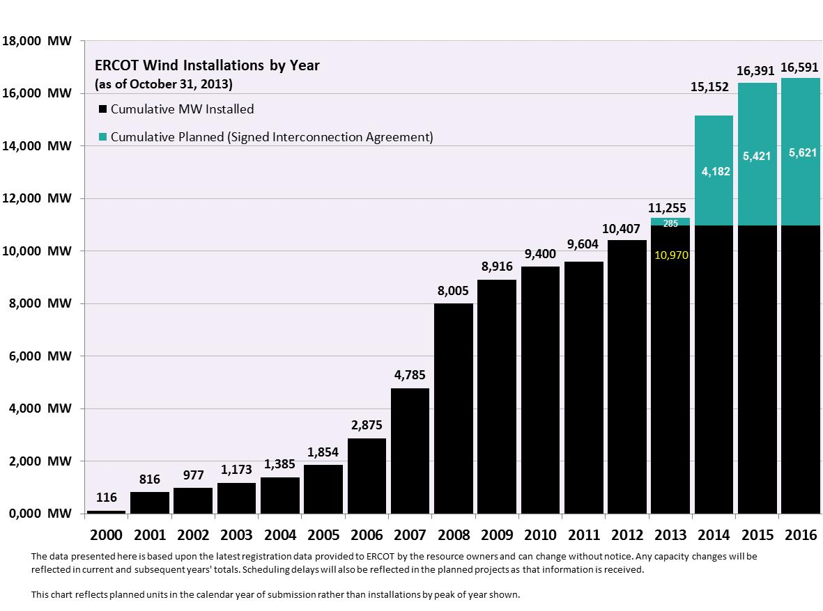

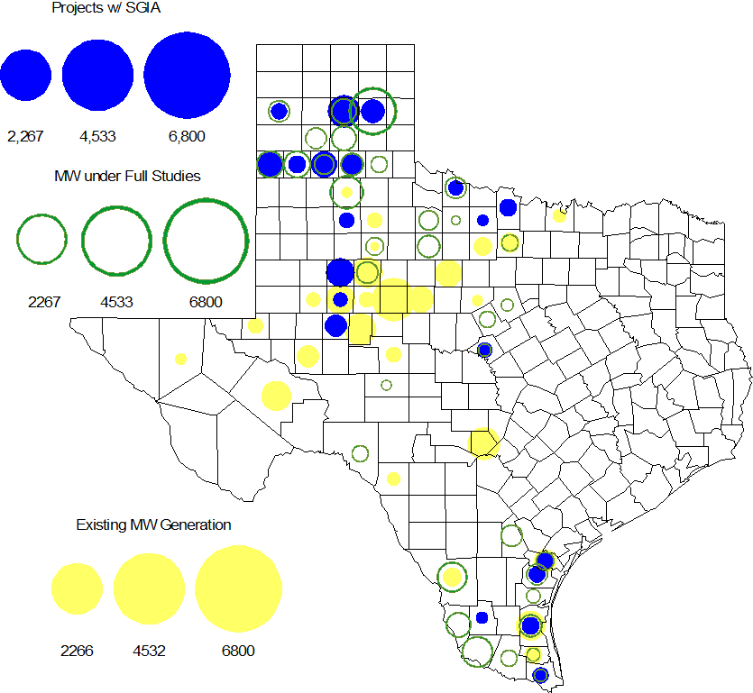

Regional Planning Group Project Reviews

- CenterPoint Energy submitted the Houston Region Import Capacity project. This is a Tier 1 project that is estimated to cost between $297 to $532 million. This project is currently under ERCOT independent review.

- Garland Power & Light (GP&L) and Cross Texas Transmission (CTT) have jointly submitted the Houston Import project. This is a Tier 1 project that is estimated to cost between $195 to $317 million. This project has received several RPG comments and it is under study mode.

- Denton Municipal Electric submitted the Spencer-Pockrus 138 kV project. The project is estimated to cost approximately $5.5 million. This project was initially classified as a Tier 3 and and the project has statisfied all the RPG comments. In accordance with Protocol Section 3.11.4.5, the Spencer-Pockrus 138 kV project has been reclassified as a “Tier 4 Neutral Project.”

- Lone Star Transmission has submitted the Houston Import project. This is a Tier 1 project that is estimated to cost between $417 to $675 million. This project has received several RPG comments and it is under study mode.

Asynchronous Tie Interconnection

Project | Notification to ERCOT | Reliability Study | RPG Review | Interconnection Agreement | In-service Year
Railroad DC tie expansion (150 MW - CFE) |  |  |  |  | 2014
Southern Cross HVDC (3000 MW - SERC)
Tres Amigas (1500 MW - SPP)

Color Legend
In progress
Complete

Planning Model Activities
- The short term calendar of major planning model events follows:
  - Oct 15, 2013 SSWG Data Set B posted on POI, MIS
  - Nov 4, 2013 TPIT spreadsheet posted on POI
  - Nov 4, 2013 Contingency files posted on POI
  - Nov 15, 2013 Post 2014 DSB HWLL case to POI

Other Notable Activities
- The project to complete the missing and questionable data for the remaining Resource Asset Registration Forms (RARF) that are still incomplete is underway. ERCOT and Siemens created a list of 3387 individual data items that are missing or suspect. Most of the estimates of missing data have been completed and the estimates are being sent to RE’s as completed. RE’s must return completed RARF’s to ERCOT by December 1, 2013 via the normal RARF submission process using the estmates provided by ERCOT or actual or test data if available.
- ERCOT is working on the 2013 Regional Transmission Plan (RTP). The N-1 secure cases including the N-1 reliability projects was posted at the ERCOT POI on Oct. 25, 2013. ERCOT is currently working on G-1+N-1 reliability analysis and economic analysis.
- ERCOT has posted the draft report on the results of the Long-term study and the improvements to the long-term study process as a result of the grant received from the Department of Energy.
- ERCOT has issued a Request For Proposal (RFP) in order to hire a consultant to perform a small signal stability study.

