ERCOT Operations Report
October 2013 ROS & OWG

Frequency Control
Time | Freq (Hz) | Duration (s)
10/9/2013 8:00 | 59.898 | 1 | Unit trip with approximately 317 MW net
10/12/2013 20:23 | 59.883 | 55 | Unit trip with approximately 802 MW net
10/18/2013 0:11 | 59.863 | 7 | Unit trip with approximately 274 MW net
10/31/2013 7:09 | 59.837 | 89 | Unit trip with approximately 641 MW net
Note: Time of frequency excursions outside the range of +/- 0.1 Hz.

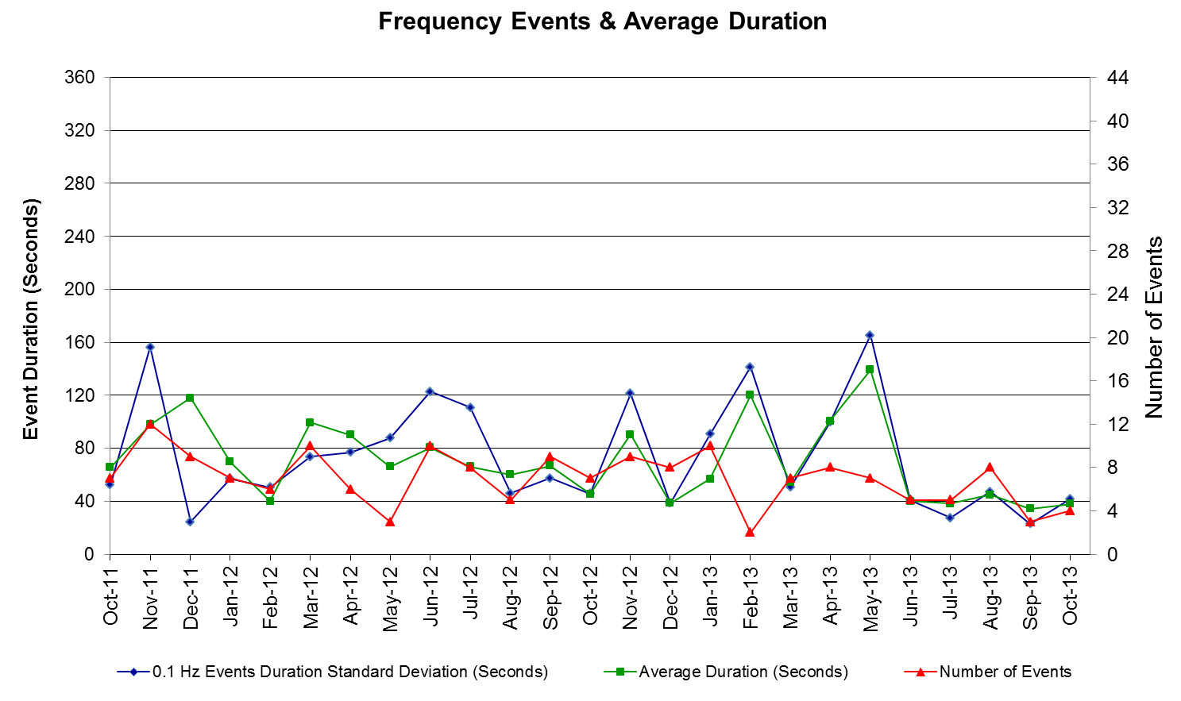

PMU Events
ERCOT evaluates PMU data according to industry standards. Events with an oscillating frequency of less
than 1 Hz are considered to be inter- area, while higher frequencies indicate local events. Industry standards
specify that damping ratio for inter-area oscillations should be 3.0% or greater. All events listed below
indicate the ERCOT system transitioned well after each disturbance.

Date | Events | Duration | Summary
10/12/2013 20:23:18 | Unit Trip | Approx. 152 sec | The event was caused by the loss of one unit. The unit was generating 802 MW net before the trip, the frequency dropped to 59.83 Hz. The oscillating frequency of 0.67 Hz with 7.7% damping ratio was observed.
10/18/2013 00:11:14 | Unit Trip | Approx. 151 sec | The event was caused by the loss of two units. The units were generating 274 MW net before the trip, the frequency dropped to 59.86 Hz. The oscillating frequency of 0.7 Hz with 12.3% damping ratio was observed.
10/31/2013 07:09:24 | Unit Trip | Approx. 168 sec | The event was caused by the loss of four units. The units were generating 641 MW net before the trip, the frequency dropped to 59.84 Hz. The oscillating frequency of 0.86 Hz with 18.9% damping ratio was observed.

Deployed Responsive (Reported Above)

Time deployed | Stop Time | Duration | Max | Details
10/9/13 08:00:40 | 10/9/13 08:02:56 | 0:02:16 | 76.802
10/12/13 08:23:26 | 10/12/13 08:27:24 | 0:03:58 | 572.59
10/18/13 0:11:22 | 10/18/13 0:16:10 | 0:04:48 | 255.56
10/30/13 7:59:38 | 10/30/13 8:01:38 | 0:02:00 | 77.089 | Unit trip of approximately 370.9 MW.
10/31/13 7:09:44 | 10/31/13 7:13:44 | 0:04:00 | 746.15
10/31/13 14:09:44 | 10/31/13 14:12:08 | 0:02:24 | 93.965 | Unit trip of approximately 230 MW.

RUC Commitments

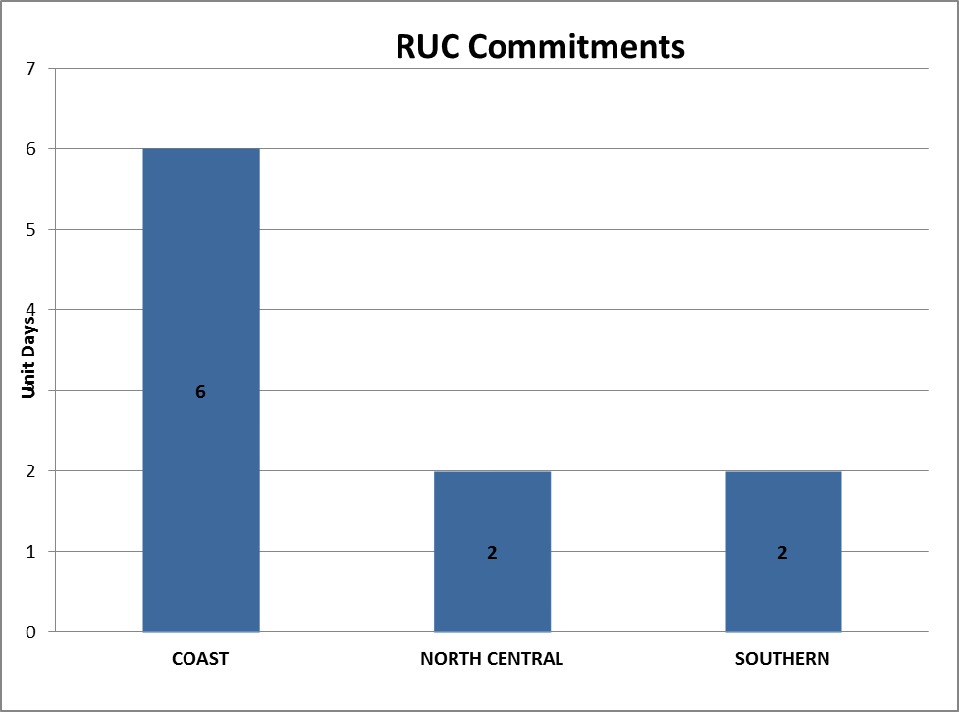

SCED Congestion Management Activity
Congestion affected by outages
Contingency Description | Overloaded Element | # Days Active
Koch Up River - Gila 138kV | Gila - Hiway 9 138 kV (GILA_HIWAY_2) | 20
DCKT Singleton - Zenith 345kV | Singleton - Tomball 345kV | 14
Midland East - Moss Switch 345kV | Odessa Ehv Switch - Big Three Odessa Tap 138 kV | 13
DCKT Skyline - Calaveras 345kV | Cagnon AXFMR4L-H 345/138kV | 9
Dupont Switch-Ingleside - Ingleside Cogen Switch 138 kV | Dupont Pp1-Ingleside - Dupont Switch-Ingleside 138 kV (I_DUPP_I_DUPS1) | 8
DCKT Jewett - Singleton 345kV | Twin Oak Switch - BTU Jack Creek Switch 345 kV | 7
DCKT Gibbons Creek - Singleton 345 kV | Jewett - Singleton 345 kV (260_A) | 6
Falcon Seaboard - Midland East 345 kV | Odessa Ehv Switch - Big Three Odessa Tap 138 kV | 6
Scurry Switch - Sun Switch 138 kV | Wolfgang - Rotan 69kV | 6
DCKT Marion - Zorn and Clear Springs 345 KV | Seguin - Seguin West 138 kV | 5
DCKT Whitepoint - Lon Hill & South Texas Project 345kV | Rincon - Airco Aep 138kV | 5
DCKT Zorn - Hays Energy 345 kV | Kendal AT4 (3) 345/138 kV | 5
Basecase | Whirlwind Energy Center - Matador 69 kV | 4
DCKT Kendal - Hays Energy 345 kV and Boerne - Fairra 138 kV | Comfort - Cico 138kV | 4
DCKT Lewisville Switch - Krum West Switch 345 kV | Teasley Substation - Pockrus Substation 138kV | 4
Barton Switch - Oran Sub 138 KV | Graham Switch Axfmr1 138/69 kV | 4
Loyola Sub - Kleberg Aep 138 kV | Loyola Sub 138_69_1 138/69kV | 4
DCKT Zorn - Hays Energy 345 kV | Kendal - Comfort 138 kV | 3
DCKT Zorn - Hays Energy 345 kV | Comfort - Cico 138kV | 3
Coleto Creek - Pawnee Switching Station 345kV | Coleto Creek - Victoria 138 kV (COLETO_VICTOR1) | 3
Fort Stockton Plant - Barrilla 138kV | Fort Stockton Switch - Barrilla 69 kV | 3
Moss Switch AXFMR1T (3) 345/138 kV | Odessa Ehv Switch - Big Three Odessa Tap 138 kV | 3
Basecase | Ena Snyder Wind - Wkn_Bkr 69kV | 2
DCKT Austrop - Sandow Switch 345 kV | Hutto - Round Rock Northeast 138 kV (1661_B) | 2
DCKT Carrolton Northwest - Lewisville Switch 345 kV | Lewisville Switch - Jones Street Tnp 138kV | 2
DCKT Wa Parish - Dewalt & H O Clarke 138 kV | Karsten At1_L 138/69kV | 2
DCKT Singleton - Zenith 345kV | Hockley - Betka 138 kV | 2
DCKT Roans Prairie - Kuykendahl - King and Singleton - Tomball 345 kV | Singleton - Zenith 345 kV (SNGZEN99) | 2
DCKT Zorn - Hays Energy 345 kV | Kendal AT4 (3) 345/138 kV | 2
Mesa View Switch - Fort Lancaster 138 kV | West Yates - Air Products Tap Aep 69kV | 2
Graham Ses - Long Creek 345 kV | Orlando - Vernon 138kV | 2
Medow - Ph Robinson 345 kV | Alvin Tnp - Freeway Park Tnp 138kV | 2
Orange Grove Switching Station - Lon Hill 138 kV | Lon Hill - Smith 69 kV | 2
Aspermont Aep - Spur 138KV | Wolfgang - Rotan 69kV | 2
Techridge - Aep Dunlap 138 kV | Dunlap - Decker 138 kV | 2
Victoria - Coleto Creek 138kV (Coleto_Victor1) | Coleto - Victoria 138 kV (Coleto_Victor2) | 2
Valley South - Paris Switch 345 kV | Paris Switch AXFMR1 (3) 345/138 kV | 2
South Texas Project STP_G1 & STP_G2 | Lolita - Blessing 138kV | 2
Bluff Creek Axfmr T2 345/138 kV | Nicole - Orient 138 kV | 2
Vernon 138_69t1 138/69 kV | Lake Pauline 138_69_1 138/69 kV | 2
Basecase | Omega - Kendal 345 kV | 1
Basecase | Post Oak Wind UXFMR_T2 345/138 kV | 1
Basecase | Anacacho - Odlaw Switchyard 138kV | 1
DCKT Allen Switch - Royse Switch and Monticello Ses 345 KV | Centerville Road Switch - Garland Road 138 kV (3250_A) | 1
DCKT Austrop - Lost Pines and Dunlap 345 kV | Fayette Plant 2 - Holman Aen 345 kV | 1
DCKT Fayette Plant 2 - Lytton Springs & Holman Aen 345 kV | Plum - Flatonia 138 kV | 1
DCKT Gibbons Creek - Singleton 345 kV | Jewett - Singleton 345 kV (240_A) | 1
DCKT Lon Hill - Coleto Creek & Medio Creek - Lon Hill & Warburton Road Switching Station 345kV | Rincon - Airco Aep 138kV | 1
DCKT Norwood Switch - Liggett Switch and Cedar Hill Switch 345 KV | Cedar Hill Switch - Mountain Creek Ses 138 kV (3210_A) | 1
DCKT Norwood Switch - Liggett Switch and Cedar Hill Switch 345 KV | Cedar Hill Switch - Mountain Creek Ses 138 kV (3200_A) | 1
DCKT Rio Hondo - North Edinburg 345 kV and Harlingen Switch 138 kV | Harlingen Switch - Oleander 138 kV | 1
DCKT Singleton - Zenith 345kV | Tomball - Louetta 138 kV | 1
DCKT Roans Prairie - Kuykendahl - King and Singleton - Tomball 345 kV | Hockley - Tomball 138 kV | 1
DCKT Wa Parish - O'Brien 345 kV | Meadow - Ph Robinson 345kV | 1
DCKT Whitepoint - Lon Hill & South Texas Project 345kV | Lolita - Blessing 138kV | 1
Airline Aep - Barney Davis 138 kV | Barney Davis - Rodd Field 138 kV | 1
Bosque Switch - Whitney 138 kV | Bosque Switch - Lake Whitney Tnp 138 kV | 1
Asphalt Mines - Uvalde Aep & Odlaw Switchyard 138kV | Hamilton Road - Maverick 138kV | 1
Barton Switch - Oran Sub 138 KV | Graham Switch - Graham 69kV | 1
Barton Switch - Oran Sub 138 KV | Ivan Sub - Breckenridge 69 kV | 1
Baytown Energy Ctr - Chambers 345 kV | Baytown Energy Ctr At-2 345/148 kV | 1
Burwick Switching Station - Jacksboro Switching 345 kV | Olney Xfmr22 138/69 kV | 1
Coleto Creek - Pawnee Switching Station 345kV | Coleto Creek - Kenedy Swtich 138kV | 1
Ennis Creek Switch - Knapp 138 kV | Sacroc - Snyder 138kV | 1
Ennis Creek Switch - Knapp 138 kV | Sun Switch - Morgan Creek SES 138 kV | 1
Gonzales - Luling 138 KV | Plum - Flatonia 138 kV | 1
Holman Aen - Hillje 345 kV | Bellville South - Peters 138kV | 1
Nelson Sharpe - Ajo 345 kV | Las Pulgas - Raymondville 2 138kV | 1
Nelson Sharpe - Lon Hill 345kV | Nelson Sharpe - Celanese Bishop 138kV | 1
Nelson Sharpe - Lon Hill 345kV | Celanese Bishop - Kleberg Aep 138kv | 1
Oklaunion - Abilene Mulberry Creek 345 kV | Orlando - Lake Pauline 138 kV | 1
Pawnee Switching Station - Lon Hill 345 kV | Stinton - Skidmore 69 kV | 1
Salt Creek Bepc - Spur And Scurry Switch 138kV | Wolfgang - Rotan 69kV | 1
Lon Hill - Mathis and Stevens 69 kV | Stinton - Skidmore 69 kV | 1
Coleto Creek 345_138H (3) 345/138 kV | Victoria - Loop 463 Sub 138kV | 1
Coleto Creek 345_138H (3) 345/138 kV | Lolita - Blessing 138kV | 1
Lon Hill 138_69A1 138/69 kV | Lon Hill 138_69A2 138/69 kV | 1
Lewisville Switch Axfmr22 345/138 KV | Euless - Grapevine Highway 360 138 kV (1065_L) | 1
Vernon 138_69t1 138/69 kV | Bomarton (Oncor) - Seymour (Oncor) 69 kV | 1

Generic Transmission Limits (GTL’s)
GTL | Days
West – North | 1

Congestion Cost
Binding Constraints – Year to Date
Contingency | Binding Element | Number of 5-min intervals | Shadow Price Range $/MWh | Estimated Congestion Rent $ (Shadow Price*Limit) | Transmission Project
Midland East to Odessa EHV 345 kV & Moss Switch 345/138 kV Xfmr | Odessa - Odessa North 138 kV | 8936 | 0 - 3500 | 56,980,309 | 13TPIT0136,  14TPIT0054
Midland East to Odessa EHV 345 kV & Moss Switch 345/138 kV Xfmr | Odessa EHV Switch - Big Three Odessa Tap 138kV | 4296 | 0 - 3500 | 31,616,390 | 13TPIT0153
Roanoke Switch - West Denton 345 kV & Roanoke Switch - Lewisville Switch 345 kV; or West Denton - Roanoke Switch 345 kV; or West Denton - Rdwells 138 kV | Jim Cristal - North Denton 138kV | 1407 | 0 - 3500 | 18,679,874 | 14TPIT0047
DCKT Roansprairie - Kuykendahl - King & Singleton - Tomball 345 kV | Singleton - Zenith 345 kV | 473 | 0 - 4500 | 17,737,088
Sun Switch - Golden Switch 138 kV; Sun Switch - Morgan Creek SES 138 kV | Bluff Creek Switch - China Grove Switch 138 kV | 1042 | 0 - 3500 | 17,681,085 | 12TPIT0058, 13TPIT0098
Roanoke Switch - West Denton 345 kV & Roanoke Switch - Lewisville Switch 345 kV; or West Denton - Roanoke Switch 345 kV | Fort Worth - Teasley 138 kV | 2813 | 0 - 3500 | 16,898,845 | 14TPIT0047
Amoco South Foster to Westover 138 kV | Moss Switch - Amoco North Cowden Tap 138 kV | 1204 | 0 - 3500 | 15,801,329 | 13TPIT0098, 13TPIT0093
Morgan Creek SES 345/138 kV Autotransformer 2 | Morgan Creek SES 345/138 kV Autotransformer 4 | 394 | 0 - 4500 | 13,917,840
Morgan Creek SES AXFMR2 345/138kV | Mogan Creek SES AXFMR1 345/138kV | 4841 | 0 - 1370 | 12,209,796
Austrop 345/138 kV Xfmr & Garfield LCRA 345/138 kV Xfmr | Austrop 345/138 kV Xfmr | 1965 | 0 - 4500 | 11,898,409 | 10TPIT0031
West Denton - Rdwells 138 kV | Teasley - Pockrus Substation 138 kV | 1093 | 0 - 3500 | 11,227,954 | 5YTP [2012-R46]
Cangon AXFMR3 345/138kV | Cangon AXFMR4 345/138kV | 3515 | 0 - 3500 | 10,671,747
DCKT Roansprairie - Kuykendahl - King & Singleton - Tomball 345 kV | Singleton - Zenith 345 kV | 3029 | 0 - 4500 | 9,828,893
Ajo - Rio Hondo 345 kV | North Edinburg - Lon Hill 345 kV | 39 | 2 - 4500 | 7,633,932 | 14TPIT0050
McNeil - Gilleand Creek 138 kV | Hutto - Round Rock NE 138 kV | 1766 | 0 - 3500 | 7,338,051
Garfield LCRA 345/138 kV Xfmr & Austrop - Daffin 138 kV | Austrop - Dunlap 138 kV | 740 | 0 - 3500 | 6,752,182 | 10TPIT0031
Odlaw Switchyard to Uvalde AEP 138kV | Hamilton Road - Maverick 138kV | 5689 | 0 - 2905 | 6,461,169 | 16TPIT0024
Wink 138/69 kV Autotransformer; or Wink - Wink Sub 138 kV | Wink Basin Tap - Wink Sub 69 kV | 772 | 0 - 2800 | 6,378,270 | 13TPIT0220
Calallen Sub to Lon Hill 69kV | Lon Hill - Robstown Tap 69kV | 559 | 0 - 2800 | 6,139,843 | 12TPIT0181
DCKT Singleton - Zenith 345kV | Singleton - Tomball 345kV | 2704 | 0 - 2167 | 5,562,728

Binding Constraints – October 2013
Contingency | Binding Element | Number of 5-min intervals | Shadow Price Range $/MWh | Estimated Congestion Rent $ (Shadow Price*Limit) | Transmission Project | Comments
Midland East to Odessa EHV 345 kV & Moss Switch 345/138 kV Xfmr | Odessa EHV Switch - Big Three Odessa Tap 138kV | 2874 | 0 - 3500 | 21,961,319 | 13TPIT0153 | Outage of Odessa - Odessa North 138 kV
Cangon AXFMR3 345/138kV | Cangon AXFMR4 345/138kV | 1121 | 0 - 3500 | 6,514,720 | 14TPIT0031 | Outage of Kendal - Cagnon 345 kV
DCKT Zorn - Hays Energy 345kV | Kendall AT4 345/138kV | 736 | 0 - 189 | 3,424,168 |  | Outage of Kendal - Cagnon 345 kV
DCKT Allen Switch - Monticello SES & Royse Switch 345kV | Centerville Road Switch - Garland Road 345kV | 88 | 0 - 3500 | 2,969,820 | 5YTP [2012-R53] | Outage of Anna Switch - Collin Switch 345 kV
Koch Up River - Gila 138kV | Gila - Hiway_9 138kV | 3017 | 0 - 3500 | 2,854,589 |  | Outage of Gila - Hiway 9 138 kV (GILA_HIWAY_1)
DCKT Singleton - Zenith 345kV | Singleton - Tomball 345kV | 1396 | 0 - 69 | 2,138,398 |  | Planned outages of King - Kuykendahl 345 kV and generation outages
DCKT Roansprairie - Kuykendahl - King & Singleton - Tomball 345 kV | Singleton - Zenith 345 kV | 231 | 0 - 2209 | 1,230,466 |  | Generation outages
Valley South - Paris Switch 345kV | Paris Switch AXFMR1 345/138kV | 143 | 0 - 4500 | 1,028,284 |  | Outage of Monticello - Paris Switch 345 kV
DCKT Gibbons Creek - Singleton 345kV | Jewet - Singleton 345kV | 533 | 0 - 142 | 639,556 |  | Planned outages of King - Kuykendahl 345 kV and generation outages
DCKT Zorn - Hays Energy 345kV | Cico - Comfort 138kV | 421 | 0 - 352 | 625,895 | 5YTP[2012-E3] | Outage of Kendal - Cagnon 345 kV
DCKT Fayette Plant 2 - Lytton Spring & Holman AEN 345kV | Flatonia - Plum 138kV | 86 | 0 - 3500 | 618,238 | 5YTP[2012-R9] | Outage of Frelsburg - Glidden Lcra 138 kV
DCKT Austrop - Garfiled & Zorn 345kV and Techiridge - AEN Dunlap 138kV and Garfiled AEN GF_AT1 345/138kV | Decker - AEN Dunlap 138kV | 85 | 0 - 3500 | 448,506 | 10TPIT0031 | Outage of Austrop - Zorn 345 kV
DCKT Zorn - Hays Energy 345kV | Comfort - Kendall 138kV | 254 | 0 - 201 | 419,469 | 5YTP[2012-E3] | Outage of Kendal - Cagnon 345 kV
DCKT Jewet - Singleton 345kV | BTU_jack_Creek - Twin Oak Switch 345kV | 504 | 0 - 405 | 406,370 |  | Planned outages of King - Kuykendahl 345 kV and generation outages
DCKT Whitepoint - Lon Hill & South Texas Project 345kV | Airco AEP - Rincon 138kV | 450 | 0 - 3500 | 402,484 | 08TPIT0132  08TPIT0131 | Outage of Victoria - Edna 138 kV
DCKT Norwood Switch - Liggett Switch & Cedar Hill Switch 345kV | Cedar Hill Switch - Mountain Creek SES 138kV | 20 | 0 - 3500 | 294,854 |  | Outage on Cedar Hill operating bus OB1
Lon Hill 138_69A1 138/69kV | Lon Hill 138_69A2 138/69kV | 63 | 0 - 2800 | 245,411 |  | Outage of Sigmor - San Miguel 345_138 kV Switchyards 138 kV
DCKT Whitepoint - Lon Hill & South Texas Project 345kV | Sinton - Skidmore 69kV | 123 | 0 - 2800 | 243,848 | 5YTP[2012-R16] | Outage of Sigmor - San Miguel 345_138 kV Switchyards 138 kV
Kleberg AEP - Loyola Sub 69kV | Loyala Sub 138_69_1 138/69kV | 932 | 0 - 2800 | 194,958 | 5YTP[2012-R22] | Outage of Rio Hondo - Las Pulgas 138 kV
Ingleside Cogen Switch - Dupont PP1 Ingleside 138kV | Dupont PP1 Ingleside - Dupont Switch - Ingleside 138kV | 838 | 0 - 3500 | 181,816 |  | High unit output

Wind Generation as a Percent of Load

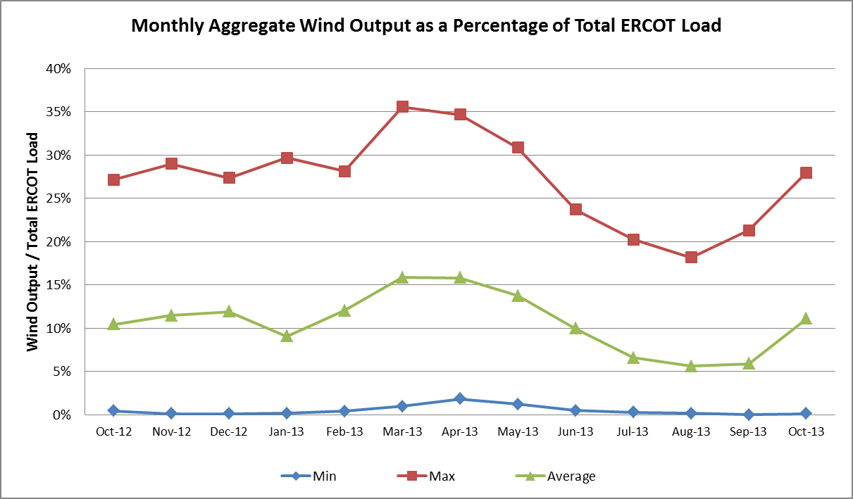

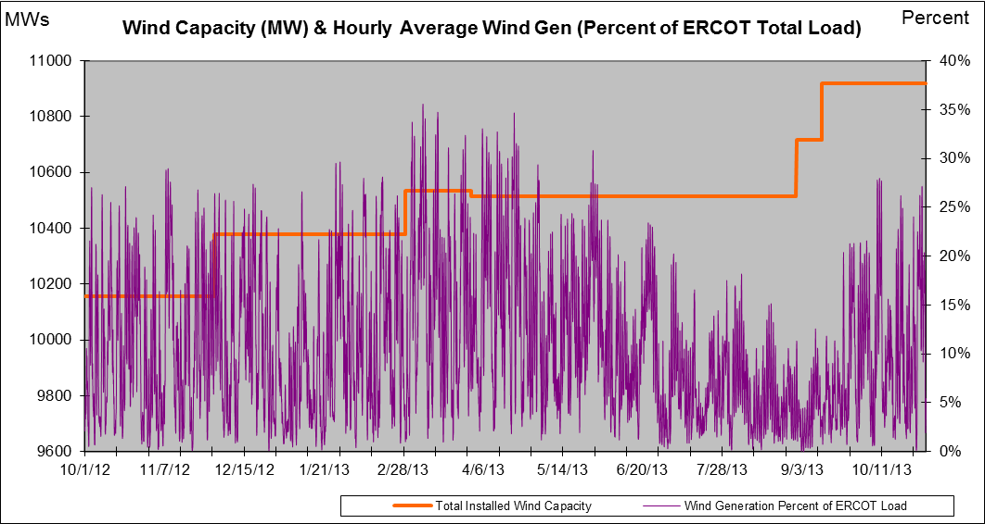

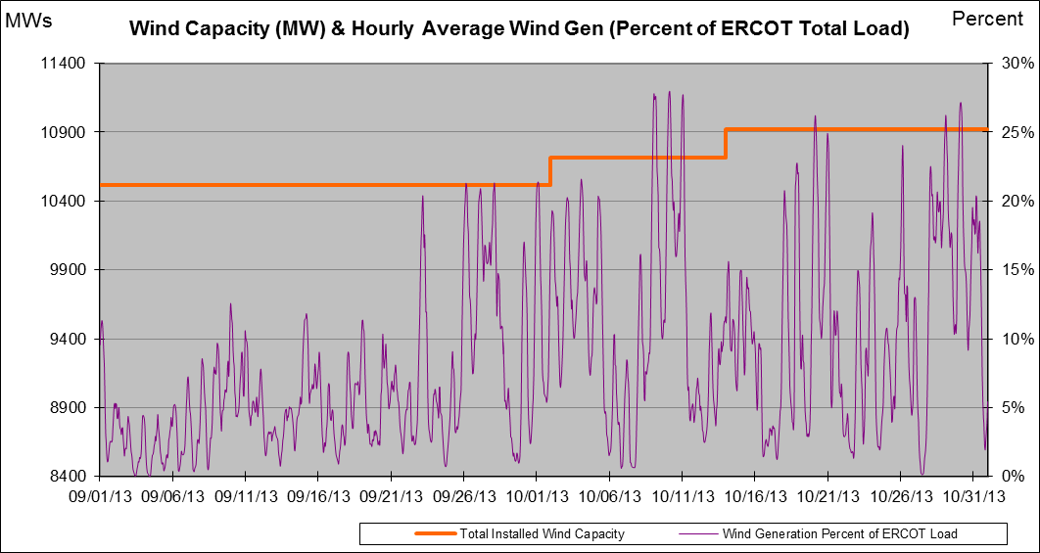

New RAP, PCAP (Date indicates last update of RAP, PCAP not implementation date.)
None

SPS (RAS) (New, Modified, Removed)
None

New Procedures/Forms/Operations Bulletins

Load Shed Incidences
None

EEA
None

System Voltage Problems
None

Application Issues
10/02 16:17 ERCOT issued an Advisory due to the State Estimator, Real Time Contingency Analysis tool (RTCA), Voltage Security Assessment Tool (VSAT), and Transient Security Assessment Tool (TSAT) not solved for 30 minutes.

Communication Issues
None

ERCOT peak (Unofficial)
10/03 17:00 54,684 MW

Yearly MTLF Error Comparison
Yearly Mid-Term (Hourly) Load Forecast Error Comparison for the ERCOT Forecast
Month | MAPE for MTLF at 16:00 Day-Ahead
Month | 2010 | 2011 | 2012 | 2013
January | 3.78 | 2.91 | 2.94 | 3.50
February | 3.79 | 3.46 | 2.51 | 2.83
March | 2.24 | 2.02 | 3.49 | 2.68
April | 2.47 | 3.55 | 2.78 | 2.81
May | 2.63 | 3.27 | 3.09 | 3.12
June | 2.84 | 2.28 | 2.85 | 2.51
July | 2.39 | 1.63 | 2.85 | 2.70
August | 2.29 | 2.28 | 2.96 | 2.07
September | 3.14 | 2.70 | 3.43 | 2.41
October | 2.37 | 3.51 | 2.99 | 2.87
November | 3.46 | 3.38 | 2.90
December | 2.60 | 2.99 | 3.47
Annual Average | 2.83 | 2.83 | 3.02 | 2.75

OCN, Advisory, Watch & Emergency Notices
Capacity

OCN
Date | Event
10/01/2013 06:20 | ERCOT issued an OCN due to projected reserve capacity shortage for HE 1500 to 1800

Advisory
Date | Event
10/02/2013 16:17 | ERCOT issued an Advisory due to the State Estimator, Real Time Contingency Analysis tool (RTCA), Voltage Security Assessment Tool (VSAT), and Transient Security Assessment Tool (TSAT) not solved in the last 30 minutes.
10/26/2013 15:40 | ERCOT issued an Advisory due to Physical Responsive Capability (PRC)
10/27/2013 12:31 | ERCOT issued an Advisory due to Physical Responsive Capability (PRC)
10/27/2013 16:00 | ERCOT issued an Advisory due to Physical Responsive Capability (PRC)

Transmission Watch
None
Watch
None

Emergency Notice
None

Texas RE Event Analysis
None

