ERCOT Operations Report
September 2013 ROS & OWG

Frequency Control
Time | Freq (Hz) | Duration (s)
9/3/2013 15:25 | 59.880 | 51 | Unit trip with approximately 614 MW net
9/20/2013 14:29 | 59.884 | 44 | Unit trip with approximately 780 MW net
9/25/2013 9:17 | 59.860 | 8 | Unit trip with approximately 716 MW net
Note: Time of frequency excursions outside the range of +/- 0.1 Hz.

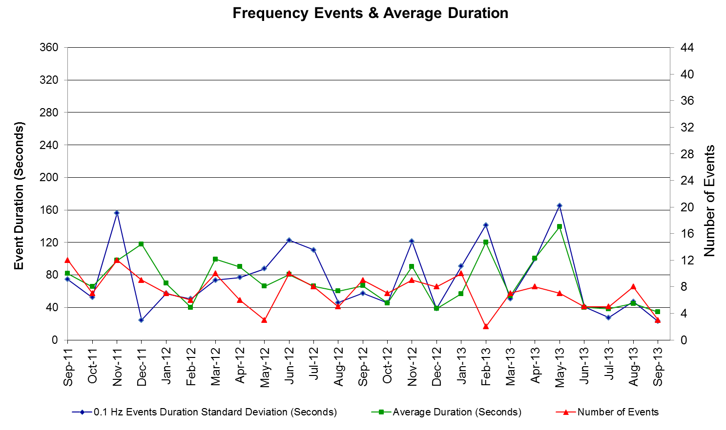

PMU Events
ERCOT evaluates PMU data according to industry standards. Industry standards specify that damping ratio for larger oscillations should be 3.0% or greater. All events listed below indicate the ERCOT system transitioned well after each disturbance.

Date | Events | Duration | Summary
9/3/2013 15:25:05 | Unit Trip | Approx. 180 sec | The event was caused by the loss of three units. The units were generating 604 MW net before the trip, the frequency dropped to 59.88 Hz. The oscillating frequency of 0.58 Hz with 9.5% damping ratio was observed.
9/20/2013 14:29:45 | Unit Trip | Approx. 140 sec | The event was caused by the loss of one unit. The unit was generating 780 MW net before the trip, the frequency dropped to 59.84 Hz. The oscillating frequency of 0.64 Hz with 7.0% damping ratio was observed.
9/25/2013 09:17:23 | Unit Trip | Approx. 136 sec | The event was caused by the loss of one unit. The unit was generating 718 MW net before the trip, the frequency dropped to 59.86 Hz. The oscillating frequency of 0.61 Hz with 8.5% damping ratio was observed.

Deployed Responsive (Reported Above)

Time deployed | Stop Time | Duration | Max | Details
9/3/13 15:25:20 | 9/3/13 15:29:16 | 0:03:56 | 168.32
9/3/13 16:23:20 | 9/12/13 16:30:31 | 0:07:11 | 456.97 | Unit trip of approximately 611 MW
9/20/13 14:29:52 | 9/20/13 14:32:44 | 0:02:52 | 419.28
9/25/13 9:17:32 | 9/25/13 9:21:24 | 0:03:52 | 313.48

RUC Commitments

SCED Congestion Management Activity
Congestion affected by outages
Contingency Description | Overloaded Element | # Days Active
Midland East - Moss Switch 345kV | Odessa - Odessa North 138kV | 15
DCKT Marion - Zorn and Clear Springs 345 KV | Seguin - Seguin West 138 kV | 13
Morgan Creek Ses Axfmr2h (3) 345/138 kV | Morgan Creek Ses Axfmr1l 345/138kV | 13
Midland East - Moss Switch 345kV | Odessa EHV Switch- Big Three Odessa Tap 138kV | 11
DCKT Skyline - Calaveras 345kV | Cagnon AXFMR4L 345/138kV | 10
DCKT Jewett - Singleton 345kV | Twin Oak Switch - Btu_Jack_Creek 345 KV | 9
DCKT Gibbons Creek - Singleton 345 kV | Jewett - Singleton 345 kV (260_A) | 7
DCKT Austrop - Sandow Switch 345 kV | Taylor - Taylor West 138 kV | 6
DCKT Roans Prairie - Kuykendahl - King and Singleton - Tomball 345 kV | Singleton - Zenith 345 kV | 5
DCKT Whitepoint - Lon Hill & South Texas Project 345kV | Sinton - Skidmore 69 kV | 5
Morgan Creek Ses Axfmr1h (3) 345/138 kV | Sterling City - Sterling County 69kV | 5
Scurry Switch - Sun Switch 138 kV | Wolfgang - Rotan 69kV | 4
Meadow - Ph Robinson 345 kV | Hastings Tnp - Friendswood 138 kV | 3
DCKT Zorn - Hays Energy 345 kV | Kendal AT4 (3) 345/138 kV | 3
Shamburger Switch - Martin Lake Ses 345 kV | Delek Poi - Tyler East 138 kV (1770_A) | 3
Salem Lcra AT3 345/138 kV | Fayetteville 26At2 345/138 kV | 3
Orange Grove Switching Station - Lon Hill 138 kV | Lon Hill - Smith 69 kV | 2
DCKT Odessa Ehv Switch - Longshore Switch & Quail Switch 345 kV | Stanton East - 1276 Triangle 138kV | 2
DCKT Odessa Ehv Switch - Longshore Switch & Quail Switch 345 kV | Morgan Creek Ses Axfmr1 (3) 345/138kV | 2
Fort Stockton Plant - Barrilla 138kV | Fort Stockton Switch - Barrilla 69 kV | 2
Cabaniss - Airline Aep 138kV | Barney Davis - Rodd Field 138 kV | 2
DCKT Garfield Lcra - Lytton Springs and Austrop - Zorn 345 kV | Garfield AT1 345/138 kV | 2
West Levee Switch AXFMR1L (3) 345/138 kV | Industrial Blvd - Compton Street 138 KV | 2
Coleto Creek - Pawnee Switching Station 345kV | Coleto Creek - Kenedy Swtich 138kV | 2
DCKT South Texas Project Units 1 and 2 | Lolita - Blessing 138kV | 2
Meadow - Ph Robinson 345 kV | Alvin Tnp - Freeway Park Tnp 138kV | 2
DCKT Roans Prairie - Kuykendahl - King and Singleton - Tomball 345 kV | Singleton - Zenith 345 kV | 2
DCKT Fayette Plant 2 - Lytton Springs & Holman Aen 345 kV | Fayetteville 26At2 345/138 kV | 2
Cheyenne - Cheyenne Tap 138kV | Holt Switch - Amoco Midland Farms Tap 138 kV | 2
Illinois #4 - Fort Lancaster 138kV | Friend Ranch - Ozona 69kV | 2
Stanton East - Big Spring Switch 138kV | Stanton East - 1276 Triangle 138kV | 2
DCKT Twin Buttes - Brown Switch & San Angelo Red Creek 345kV | Twin Buttes Xfmr T1L 345/138 kV | 2
DCKT Euless - Ligget Switch 138 kV | Dfw D-East 1 - Dfw C-East 138kV | 2
Longshore Switch - Odessa Ehv Switch 345 kV | Morgan Creek Ses Axfmr4 (3) 345/138kV | 2
Longshore Switch - Odessa Ehv Switch 345 kV | Stanton East - 1276 Triangle 138kV | 2
Mabank Tap - Malakof 138 kV | Athens - Trinidad Ses 69 kV | 2
Redwood - McCarty Lane 138 kV | McCarty Lane - Ranch Road 12 138 kV | 2
Morgan Creek Ses Axfmr1h (3) 345/138 kV | Radium - Anson 69 kV | 2
Basecase | Laquinta - Lobo 138 kV | 1
Basecase | W_TO_N | 1
DCKT Austrop - Sandow Switch 345 kV | Hutto - Round Rock Northeast 138 kV (1661_B) | 1
DCKT Morgan Creek - Longshore Switch - Quail Switch 345 kV | Holt Switch - Amoco Midland Farms Tap 138 kV | 1
DCKT Morgan Creek - Longshore Switch - Quail Switch 345 kV | Spraberry Switch AXFMR1 138/69 kV | 1
DCKT Odessa Ehv Switch - Longshore Switch & Quail Switch 345 kV | Morgan Creek Ses Axfmr4 (3) 345/138kV | 1
DCKT Odessa Ehv Switch - Longshore Switch & Quail Switch 345 kV | Morgan Creek Ses Axfmr1 (3) 345/138kV | 1
DCKT Odessa Ehv Switch - Longshore Switch & Quail Switch 345 kV | McDonald Road - Forsan Tap 138kV | 1
DCKT Odessa Ehv Switch - Longshore Switch & Quail Switch 345 kV | Morgan Creek Ses - Cosden 138 kV | 1
Falcon Seaboard - Midland East 345 kV | Stanton East - 1276 Triangle 138kV | 1
DCKT Austrop - Lost Pines 345 kV | Fayetteville 26At2 345/138 kV | 1
DCKT Austrop - Lost Pines 345 kV | Fayette Plant 2 - Holman Aen 345 kV | 1
DCKT Trinidad Ses - Watermill Switch & Tri Corner 345kV | Trinidad Ses Axfmr6 (3) 345/138kV | 1
DCKT Trinidad Ses - Watermill Switch & Tri Corner 345kV | Forest Grove Switch - Mabank Tap 138kV | 1
Coleto Creek - Pawnee Switching Station 345kV | Coleto Creek - Victoria 138kV (Coleto_Victor1) | 1
Golden Switch - Sun Switch 138 kV | China Grove Switch - Bluff Creek Switch 138 kV | 1
Sun Switch - Morgan Creek Ses 138kV | Morgan Creek Ses AXFMR3 (3) 138/69 kV | 1
DCKT Singleton - Zenith 345kV | Singleton - Tomball 345kV | 1
DCKT Royse Switch - Farmersville 345 kV | Collin Switch AXFMR1H 345/138 kV | 1
DCKT Marion - Zorn and Clear Springs 345 KV | Comfort - Cico 138kV | 1
Morgan Creek Ses Axfmr4l (3) 345/138 kV | Morgan Creek Ses Axfrm1h 345/138 kV | 1
Avery Ranch - Jollyville 138 kV | Marshall Ford - Lago Vista 138 kV | 1
DCKT Hackberry - Norwood Switch & Carrollton Northwest 345kV | Dfw D-East 1 - Dfw C-East 138kV | 1
Asherton 138_69a1 138/69kV | Uvalde Aep 138_69A1 468/69kV | 1
Moss Switch AXFMR1T (3) 345/138 kV | Odessa EHV Switch- Big Three Odessa Tap 138kV | 1
DCKT Allen Switch - Royse Switch and Monticello Ses 345 KV | Centerville Road Switch - Garland Road 138 kV (3250_A) | 1
Btu_Atkins Axfmr1 138/69 KV | Btu_Nall_Lane - Btu_Briarcrest 69KV | 1
DCKT Sherry Switch - Everman Switch and Venus Switch 345 kV | Everman Switch - Oakhill Tap 2 | 1
DCKT Zorn - Hays Energy 345 kV | Kendal AT4 (3) 345/138 kV | 1
DCKT Zorn - Hays Energy 345 kV | Comfort - Cico 138kV | 1
DCKT South Channel - Pair & Shell 138kV | Conial - Waburn 138 kV | 1
DCKT Twin Buttes - Brown Switch & San Angelo Red Creek 345kV | Twin Buttes Xfmr T1H 345/138 kV | 1
Cagnon Axfmr3l-H (3)345/138kV | Cagnon AXFMR4L-H 345/138kV | 1
Midland East Axfmr1l (3)345/138 kV | Glenhaven - Crmwd 8 Tap 138kV | 1
DCKT Whitepoint - Lon Hill & South Texas Project 345kV | Rincon - Airco Aep 138kV | 1
DCKT Kendal - Hays Energy 345 kV and Boerne - Fairra 138 kV | Kendal - Comfort 138 kV | 1
DCKT Lytton Springs - Slauger Lane & Turnersville 138kV | Lytton Springs - Pilot Knob 138kV | 1
West Columbia Main Tnp - West Columbia 138kV | West Columbia - Angleton 138kV | 1
DCKT Jefferson - Pasedena and Industrial - Phillip 138 kV | Sr Bertron - Quanab 138 kV | 1
Anna Switch - Collin Switch 345 kV 345 kV | Anna Switch AXFMR2 (3) 345/138 kV | 1
DCKT West Levee Switch - 800/900 Network 138 kV | East Levee Switch - Reagan Street 138 kV (3410_A) | 1
DCKT West Levee Switch - Sargent Road - Watermill Switch 345 kV | Industrial Blvd - Compton Street 138 KV | 1
Manual Morgan Creek Ses Axfmr1 (3) 345/138 | Morgan Creek Ses Axfmr4 (3) 345/138kV | 1
Bates - Frontera 138 kV | Frontera - Goodwin 138 kV | 1
Colorado Bend Energy Center - Dyann 138 kV | Blessing - Lane City 138kV | 1
Paint Creek - Abilene North 138 kV | Abilene Northwest - Ely Rea Tap 69kV | 1
Morgan Creek Ses Axfmr1h (3) 345/138 kV | Morgan Creek Ses Axfmr4 (3) 345/138kV | 1
DCKT Bowman Switch - Pleasant Valley Switch and Wichita Falls Cogen Switch 138 kV | Bowman Switch - Lake Wichita Switch 138 kV | 1

Generic Transmission Limits (GTL’s)
GTL | Days
West – North | 1

Congestion Cost
Binding Constraints – Year to Date
Contingency | Binding Element | Number of 5-min intervals | Shadow Price Range $/MWh | Estimated Congestion Rent $ (Shadow Price*Limit) | Transmission Project
Midland East to Odessa EHV 345 kV & Moss Switch 345/138 kV Xfmr | Odessa - Odessa North 138 kV | 8936 | 0 - 3500 | 56,980,309 | 13TPIT0136,  14TPIT0054
Roanoke Switch - West Denton 345 kV & Roanoke Switch - Lewisville Switch 345 kV; or West Denton - Roanoke Switch 345 kV; or West Denton - Rdwells 138 kV | Jim Cristal - North Denton 138kV | 1407 | 0 - 3500 | 18,679,874 | 14TPIT0047
DCKT Roansprairie - Kuykendahl - King & Singleton - Tomball 345 kV | Singleton - Zenith 345 kV | 473 | 0 - 4500 | 17,737,088
Sun Switch - Golden Switch 138 kV; Sun Switch - Morgan Creek SES 138 kV | Bluff Creek Switch - China Grove Switch 138 kV | 1042 | 0 - 3500 | 17,681,085 | 12TPIT0058, 13TPIT0098
Roanoke Switch - West Denton 345 kV & Roanoke Switch - Lewisville Switch 345 kV; or West Denton - Roanoke Switch 345 kV | Fort Worth - Teasley 138 kV | 2813 | 0 - 3500 | 16,898,845 | 14TPIT0047
Amoco South Foster to Westover 138 kV | Moss Switch - Amoco North Cowden Tap 138 kV | 1204 | 0 - 3500 | 15,801,329 | 13TPIT0098, 13TPIT0093
Morgan Creek SES 345/138 kV Autotransformer 2 | Morgan Creek SES 345/138 kV Autotransformer 4 | 394 | 0 - 4500 | 13,917,840
Morgan Creek SES AXFMR2 345/138kV | Mogan Creek SES AXFMR1 345/138kV | 4841 | 0 - 1370 | 12,209,796
Austrop 345/138 kV Xfmr & Garfield LCRA 345/138 kV Xfmr | Austrop 345/138 kV Xfmr | 1965 | 0 - 4500 | 11,898,409 | 10TPIT0031
West Denton - Rdwells 138 kV | Teasley - Pockrus Substation 138 kV | 939 | 0 - 3500 | 11,088,886 | 5YTP [2012-R46]
Midland East to Odessa EHV 345 kV & Moss Switch 345/138 kV Xfmr | Odessa EHV Switch - Big Three Odessa Tap 138kV | 1422 | 0 - 3500 | 9,655,071 | 13TPIT0153
DCKT Roansprairie - Kuykendahl - King & Singleton - Tomball 345 kV | Singleton - Zenith 345 kV | 2798 | 0 - 4500 | 8,598,427
Ajo - Rio Hondo 345 kV | North Edinburg - Lon Hill 345 kV | 39 | 2 - 4500 | 7,633,932 | 14TPIT0050
McNeil - Gilleand Creek 138 kV | Hutto - Round Rock NE 138 kV | 1671 | 0 - 3500 | 7,329,393
Garfield LCRA 345/138 kV Xfmr & Austrop - Daffin 138 kV | Austrop - Dunlap 138 kV | 740 | 0 - 3500 | 6,752,182 | 10TPIT0031
Odlaw Switchyard to Uvalde AEP 138kV | Hamilton Road - Maverick 138kV | 5676 | 0 - 2905 | 6,457,873 | 16TPIT0024
Wink 138/69 kV Autotransformer; or Wink - Wink Sub 138 kV | Wink Basin Tap - Wink Sub 69 kV | 772 | 0 - 2800 | 6,378,270 | 13TPIT0220
Calallen Sub to Lon Hill 69kV | Lon Hill - Robstown Tap 69kV | 559 | 0 - 2800 | 6,139,843 | 12TPIT0181
Meadow - PH Robinson 345 kV | Alvin - Freeway Park 138 kV | 2602 | 0 - 3500 | 4,959,533
China Grove Switch to Morgan Creek SES 138kV (6220) | China Grove Switch - Morgan Creek SES 138kV (6225) | 115 | 0 - 3500 | 4,399,879 | 12TPIT0058, 13TPIT0098

Binding Constraints – September 2013
Contingency | Binding Element | Number of 5-min intervals | Shadow Price Range $/MWh | Estimated Congestion Rent $ (Shadow Price*Limit) | Transmission Project | Comments
DCKT Roansprairie - Kuykendahl - King & Singleton - Tomball 345 kV | Singleton - Zenith 345 kV | 429 | 0 - 4500 | 17,156,056 |  | Outage of Houston generation
Midland East to Odessa EHV 345 kV & Moss Switch 345/138 kV Xfmr | Odessa EHV Switch - Big Three Odessa Tap 138kV | 1314 | 0 - 3500 | 8,991,374 | 13TPIT0153 | Outage of Odessa - Odessa North 138 kV
Midland East to Odessa EHV 345 kV & Moss Switch 345/138 kV Xfmr | Odessa - Odessa North 138 kV | 1825 | 0 - 3500 | 6,599,491 | 13TPIT0136, 14TPIT0054 | Low wind condition
Morgan Creek SES AXFMR2 345/138kV | Mogan Creek SES AXFMR1 345/138kV | 1626 | 0 - 1370 | 3,255,313 |  | Low wind condition
Cangon AXFMR3 345/138kV | Cangon AXFMR4 345/138kV | 1601 | 0 - 3500 | 2,793,059 | 14TPIT0031 | Outage of Kendal - Cagnon 345 kV and Kendal AT3 345/138 kV
Morgan Creek SES AXFMR1 345/138kV and Odessa EHV - Longshore Switch 345kV and DCKT Odessa EHV - Quail Switch 345kV | Morgan Creek SES AXFMR4 345/138kV | 263 | 0 - 4500 | 2,711,632 |  | Outage of Morgan Creek Ses AXFMR2 345/138 kV
DCKT Singleton to Jewet 345kV | Twin Oak Switch - BTU_Jack_Creek 345kV | 1241 | 0 - 4500 | 2,643,589 |  | Outage of Houston generation
DCKT Lytton Spring to Slaughter Lane & Turnersville 138kV | Lytton Spring - Pilot Knob 138kV | 140 | 0 - 3500 | 2,038,054
Shamburger Switch to Martin Lake 345kV | Tyler East - Deleck POI 138kV | 615 | 0 - 3500 | 1,805,136 | 09TPIT0122 | Outage of Elkton - Tyler West 138 kV
Marion - Zorn & Clear Spring 345kV | Seguin - Seguin West 138kV | 1931 | 0 - 3500 | 1,573,431 | 2012-R10 | Outage of Kendal - Cagnon and Holman - Hillje 345 kV
DCKT Roansprairie - Kuykendahl - King & Singleton - Tomball 345 kV | Singleton - Zenith 345 kV | 791 | 0 - 1247 | 1,571,717 |  | Outage of Houston generation
DCKT Bowman Switch - Pleasant Valley Switch & Wichita Falls Cogen Switch 138kV | Lake Wichita Switch - Bowman Switch 138kV | 71 | 0 - 3500 | 1,531,941 |  | Forced outage of Bowman Switch - Wichita Falls South Switch 138 kV
West Levee Switch AXFMR1 345/138kV | Industrial Blvd - Compton Street 138kV | 165 | 0 - 3500 | 1,273,272 | 2012-R63 | High load
DCKT Zorn - Hays Energy 345kV | Kendall AT4 345/138kV | 364 | 0 - 392 | 1,154,540 |  | Outage of Kendal - Cagnon 345 kV and Kendal AT3 345/138 kV
DCKT Fayette Plant 2 - Lytton Spring & Holman AEN 345kV | Fayetteville 26AT2 345/138kV | 589 | 0 - 1217 | 930,729 |  | Outage of Holman - Hillje 345 kV
DCKT Sherry Switch - Everman Switch 345kV | Everman Switch - Oakhill Tap 2 138kV | 20 | 0 - 3500 | 493,423 | 10TPIT0019 | High load
DCKT Odessa EHV - Quail Switch 345kV and Morgan Creek SES AXFMR4 345/138kV | Mogan Creek SES AXFMR1 345/138kV | 155 | 0 - 372 | 407,237 |  | Low wind condition
DCKT Whitepoint - Lon Hill & South Texas Project 345kV | Sinton - Skidmore 69kV | 307 | 0 - 2636 | 372,939 |  | High load
Fort Lancaster - Illinois #4 138kV | Friend Ranch - Ozona 69kV | 139 | 0 - 2307 | 335,740 |  | Outage of Midway Lane - Powerll Field Tap 69 kV
Wink Sub - No Trees Switch 138kV | Holt Switch Amoco Miland Farms Tap 138kV | 108 | 0 - 3500 | 324,158 | 15TPIT0047 | High load

Wind Generation as a Percent of Load

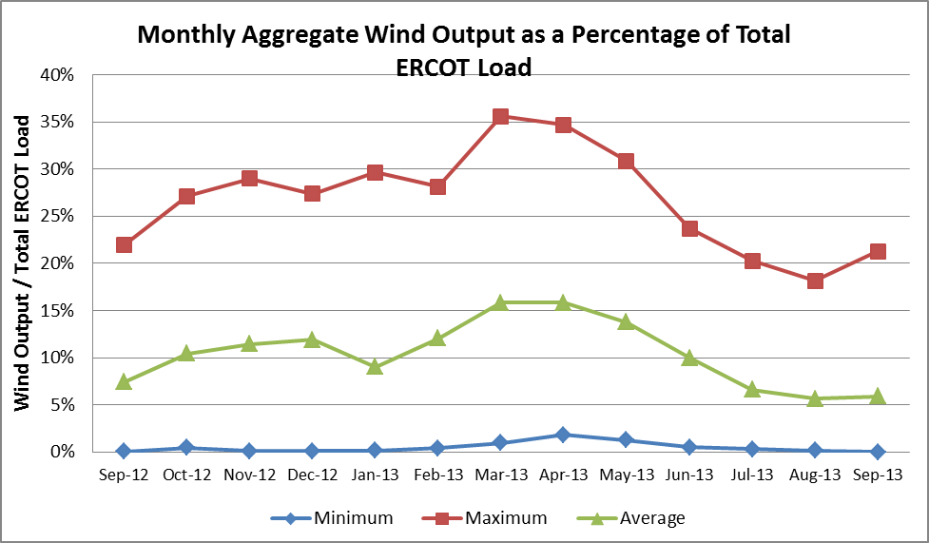

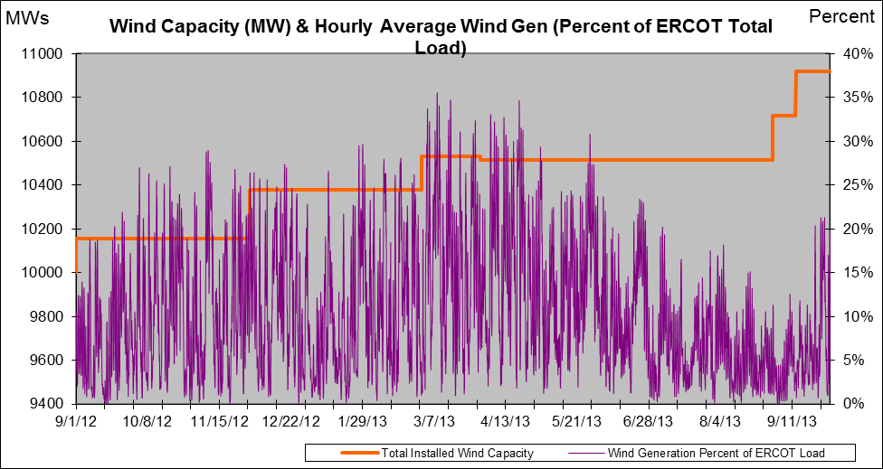

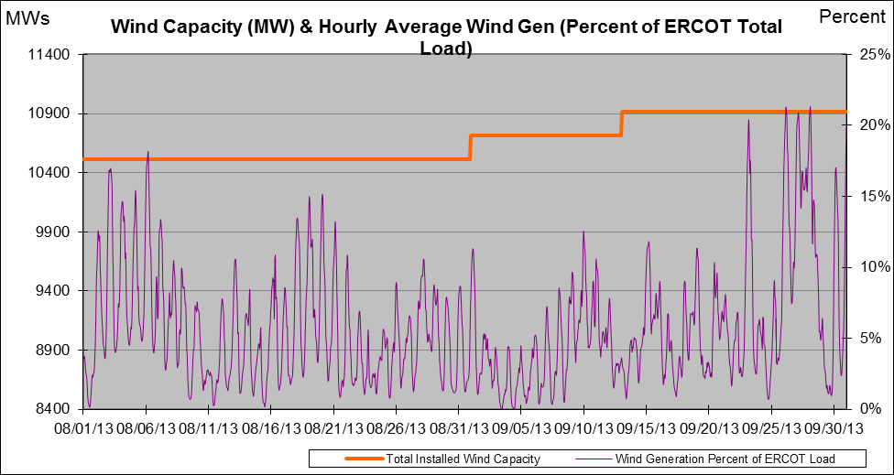

New RAP, PCAP (Date indicates last update of RAP, PCAP not implementation date.)
None

SPS (RAS) (New, Modified, Removed)
None

New Procedures/Forms/Operations Bulletins
Power Operations Bulletin 645 - Real Time Desk V1 Rev26
Power Operations Bulletin 646 - Resource Desk V1 Rev25
Power Operations Bulletin 647 - Transmission and Security Desk V1 Rev27

Load Shed Incidences
None

EEA
None

System Voltage Problems
None

Application Issues
09/19 17:42 ERCOT issued an Advisory due to the State Estimator, Real Time Contingency Analysis tool (RTCA), Voltage Security Assessment Tool (VSAT), and Transient Security Assessment Tool (TSAT) not solved for 30 minutes.

Communication Issues
None

ERCOT peak (Unofficial)
09/03 17:00 63,411 MW

Yearly MTLF Error Comparison
Yearly Mid-Term (Hourly) Load Forecast Error Comparison for the ERCOT Forecast
Month | MAPE for MTLF at 16:00 Day-Ahead
Month | 2010 | 2011 | 2012 | 2013
January | 3.78 | 2.91 | 2.94 | 3.50
February | 3.79 | 3.46 | 2.51 | 2.83
March | 2.24 | 2.02 | 3.49 | 2.68
April | 2.47 | 3.55 | 2.78 | 2.81
May | 2.63 | 3.27 | 3.09 | 3.12
June | 2.84 | 2.28 | 2.85 | 2.51
July | 2.39 | 1.63 | 2.85 | 2.70
August | 2.29 | 2.28 | 2.96 | 2.07
September | 3.14 | 2.70 | 3.43 | 2.41
October | 2.37 | 3.51 | 2.99
November | 3.46 | 3.38 | 2.90
December | 2.60 | 2.99 | 3.47
Annual Average | 2.83 | 2.83 | 3.02 | 2.74

OCN, Advisory, Watch & Emergency Notices
Capacity

OCN
None

Advisory
Date | Event
9/19/2013 17:42 | ERCOT issued Advisory due to the State Estimator, Real Time Contingency Analysis tool (RTCA), Voltage Security Assessment Tool (VSAT), and Transient Security Assessment Tool (TSAT) not solved in the last 30 minutes.

Transmission Watch
None

Watch
None

Emergency Notice
None

Texas RE Event Analysis
None

