Some data sets for consideration as options are discussed. These are starting points for some of the data analysis – to help determine at a high level if further analysis is necessary.
- Comparisons of the 15-minute telemetered generation (TWTG) to RTMG
- Comparisons of the 14-d look-back LRS to actual LRS
- What percentage of energy trades are in before/after “end of adjustment” period?
- How many Operating Days have had price corrections? What is the min/max/avg change?
- Ranking of charge types based on dollar value (e.g., identify the highest dollar value charge types)

- Comparisons of the 15-minute telemetered generation (TWTG) to RTMG
  - This does not include generators that had less than 2mwh or RTMG or TWTG for a day. Those site showed the most difference as an average of total resource generation

 | Daily % Average for all Gen |  | 1%
 | Daily % Average for worse 20 Gens |  | 11.33%
 | Daily % Average of all other Gen |  | 0.58%
Resource | DAILY AVG MW DIFFERENCE | DAILY AVG % DIFFERENCE | Notes
Generator | -4.888697886 | -21.38% | Negative Means RTMG is higher than TWTG
Generator | -2.207618592 | -18.98% | Negative Means RTMG is higher than TWTG
Generator | -1.618223707 | -18.68% | Negative Means RTMG is higher than TWTG
Generator | -4.279114124 | -17.35% | Negative Means RTMG is higher than TWTG
Generator | -1.987238873 | -16.88% | Negative Means RTMG is higher than TWTG
Generator | -2.658568481 | -16.20% | Negative Means RTMG is higher than TWTG
Generator | -0.803674587 | -15.14% | Negative Means RTMG is higher than TWTG
Generator | 1.140196803 | 14.64% | Negative Means RTMG is higher than TWTG
Generator | 4.779187682 | 12.88% | Negative Means RTMG is higher than TWTG
Generator | 2.601691883 | 12.08% | Negative Means RTMG is higher than TWTG
Generator | 21.9763821 | 7.61% | Negative Means RTMG is higher than TWTG
Generator | -0.364187162 | -7.36% | Negative Means RTMG is higher than TWTG
Generator | -0.367628608 | -7.36% | Negative Means RTMG is higher than TWTG
Generator | 0.49822937 | 7.24% | Negative Means RTMG is higher than TWTG
Generator | 26.15704502 | 5.87% | Negative Means RTMG is higher than TWTG
Generator | 20.59877655 | 5.74% | Negative Means RTMG is higher than TWTG
Generator | 0.766347822 | 5.68% | Negative Means RTMG is higher than TWTG
Generator | 8.855579053 | 5.57% | Negative Means RTMG is higher than TWTG
Generator | 0.491110331 | 5.03% | Negative Means RTMG is higher than TWTG
Generator | 84.7081038 | 4.82% | Negative Means RTMG is higher than TWTG
Generator | 44.939603 | 4.50% | Negative Means RTMG is higher than TWTG
Generator | 48.74054203 | 4.45% | Negative Means RTMG is higher than TWTG
Generator | 65.08068589 | 4.30% | Negative Means RTMG is higher than TWTG
Generator | 8.585354776 | 4.18% | Negative Means RTMG is higher than TWTG
Generator | 81.45168664 | 4.13% | Negative Means RTMG is higher than TWTG
Generator | -23.03971778 | -3.42% | Negative Means RTMG is higher than TWTG
Generator | 98.82452509 | 3.22% | Negative Means RTMG is higher than TWTG
Generator | 3.216850676 | 3.16% | Negative Means RTMG is higher than TWTG
Generator | 1.695868428 | 2.91% | Negative Means RTMG is higher than TWTG
Generator | -11.29447799 | -2.89% | Negative Means RTMG is higher than TWTG
Generator | -3.357032556 | -2.88% | Negative Means RTMG is higher than TWTG
Generator | -3.357032556 | -2.88% | Negative Means RTMG is higher than TWTG
Generator | -3.357032556 | -2.88% | Negative Means RTMG is higher than TWTG
Generator | 1.625834081 | 2.75% | Negative Means RTMG is higher than TWTG
Generator | -37.13158843 | -2.75% | Negative Means RTMG is higher than TWTG
Generator | -3.98352258 | -2.59% | Negative Means RTMG is higher than TWTG
Generator | 14.11129193 | 2.55% | Negative Means RTMG is higher than TWTG
Generator | 1.358524973 | 2.48% | Negative Means RTMG is higher than TWTG
Generator | -32.32718866 | -2.39% | Negative Means RTMG is higher than TWTG
Generator | -13.31223026 | -2.36% | Negative Means RTMG is higher than TWTG
Generator | 30.34637156 | 2.36% | Negative Means RTMG is higher than TWTG
Generator | 0.564659086 | 2.35% | Negative Means RTMG is higher than TWTG
Generator | 0.573156159 | 2.32% | Negative Means RTMG is higher than TWTG
Generator | 5.878129592 | 2.31% | Negative Means RTMG is higher than TWTG
Generator | -9.719179032 | -2.31% | Negative Means RTMG is higher than TWTG
Generator | 0.576887945 | 2.30% | Negative Means RTMG is higher than TWTG
Generator | 16.0156722 | 2.18% | Negative Means RTMG is higher than TWTG
Generator | 25.25102014 | 2.10% | Negative Means RTMG is higher than TWTG
Generator | 2.497638213 | 2.07% | Negative Means RTMG is higher than TWTG
Generator | 7.84399397 | 1.79% | Negative Means RTMG is higher than TWTG
Generator | -7.399215743 | -1.63% | Negative Means RTMG is higher than TWTG
Generator | -5.852239117 | -1.61% | Negative Means RTMG is higher than TWTG
Generator | -3.302231521 | 1.57% | Negative Means RTMG is higher than TWTG
Generator | -8.829688798 | 1.53% | Negative Means RTMG is higher than TWTG
Generator | 3.851883481 | 1.48% | Negative Means RTMG is higher than TWTG
Generator | 0.808478797 | 1.45% | Negative Means RTMG is higher than TWTG
Generator | -0.912166603 | -1.40% | Negative Means RTMG is higher than TWTG
Generator | -10.12660475 | -1.40% | Negative Means RTMG is higher than TWTG
Generator | 1.747377853 | 1.36% | Negative Means RTMG is higher than TWTG
Generator | 1.704655109 | 1.36% | Negative Means RTMG is higher than TWTG
Generator | -0.388081673 | 1.35% | Negative Means RTMG is higher than TWTG
Generator | 1.069910013 | 1.35% | Negative Means RTMG is higher than TWTG
Generator | 1.656836259 | 1.31% | Negative Means RTMG is higher than TWTG
Generator | 105.4829538 | 1.29% | Negative Means RTMG is higher than TWTG
Generator | 23.92590821 | 1.29% | Negative Means RTMG is higher than TWTG
Generator | 9.702241551 | 1.28% | Negative Means RTMG is higher than TWTG
Generator | 0.517955954 | -1.28% | Negative Means RTMG is higher than TWTG
Generator | -0.693913845 | -1.27% | Negative Means RTMG is higher than TWTG
Generator | 7.949662508 | 1.27% | Negative Means RTMG is higher than TWTG
Generator | -1.596654002 | -1.27% | Negative Means RTMG is higher than TWTG
Generator | -0.760734694 | -1.26% | Negative Means RTMG is higher than TWTG
Generator | -0.728811375 | -1.26% | Negative Means RTMG is higher than TWTG
Generator | 0.523561561 | 1.24% | Negative Means RTMG is higher than TWTG
Generator | -0.832531825 | -1.23% | Negative Means RTMG is higher than TWTG
Generator | -0.609235562 | -1.23% | Negative Means RTMG is higher than TWTG
Generator | -0.87512863 | -1.21% | Negative Means RTMG is higher than TWTG
Generator | 0.295376069 | 1.17% | Negative Means RTMG is higher than TWTG
Generator | 1.510086044 | 1.17% | Negative Means RTMG is higher than TWTG
Generator | 0.474451575 | 1.16% | Negative Means RTMG is higher than TWTG
Generator | 12.32720783 | 1.15% | Negative Means RTMG is higher than TWTG
Generator | -0.274092942 | -1.14% | Negative Means RTMG is higher than TWTG
Generator | 39.24718854 | 1.14% | Negative Means RTMG is higher than TWTG
Generator | 3.334559152 | 1.13% | Negative Means RTMG is higher than TWTG
Generator | -0.692100538 | -1.13% | Negative Means RTMG is higher than TWTG
Generator | -18.30472613 | -1.12% | Negative Means RTMG is higher than TWTG
Generator | 1.374677049 | 1.10% | Negative Means RTMG is higher than TWTG
Generator | -7.17203868 | -1.09% | Negative Means RTMG is higher than TWTG
Generator | 12.42239006 | 1.08% | Negative Means RTMG is higher than TWTG
Generator | 1.488010612 | 1.08% | Negative Means RTMG is higher than TWTG
Generator | -0.343630566 | -1.07% | Negative Means RTMG is higher than TWTG
Generator | -18.62083114 | -1.03% | Negative Means RTMG is higher than TWTG
Generator | 4.073069575 | 1.00% | Negative Means RTMG is higher than TWTG
Generator | -0.149482741 | 1.00% | Negative Means RTMG is higher than TWTG
Generator | -0.409671627 | 0.98% | Negative Means RTMG is higher than TWTG
Generator | 17.44274862 | 0.98% | Negative Means RTMG is higher than TWTG
Generator | 4.458752266 | 0.98% | Negative Means RTMG is higher than TWTG
Generator | 1.915255559 | 0.97% | Negative Means RTMG is higher than TWTG
Generator | 0.823871673 | 0.96% | Negative Means RTMG is higher than TWTG
Generator | 80.22363415 | 0.96% | Negative Means RTMG is higher than TWTG
Generator | 1.324577629 | 0.96% | Negative Means RTMG is higher than TWTG
Generator | 0.257797917 | 0.95% | Negative Means RTMG is higher than TWTG
Generator | -0.570608294 | -0.93% | Negative Means RTMG is higher than TWTG
Generator | 27.0246847 | 0.93% | Negative Means RTMG is higher than TWTG
Generator | 5.113515833 | 0.93% | Negative Means RTMG is higher than TWTG
Generator | -0.066261427 | -0.92% | Negative Means RTMG is higher than TWTG
Generator | 73.54549866 | 0.89% | Negative Means RTMG is higher than TWTG
Generator | -3.8119659 | -0.89% | Negative Means RTMG is higher than TWTG
Generator | 0.703800094 | 0.88% | Negative Means RTMG is higher than TWTG
Generator | -5.079037036 | -0.88% | Negative Means RTMG is higher than TWTG
Generator | 0.345994675 | 0.87% | Negative Means RTMG is higher than TWTG
Generator | 7.012376174 | 0.85% | Negative Means RTMG is higher than TWTG
Generator | -0.109161234 | -0.85% | Negative Means RTMG is higher than TWTG
Generator | 36.92056989 | 0.84% | Negative Means RTMG is higher than TWTG
Generator | 0.796374422 | 0.84% | Negative Means RTMG is higher than TWTG
Generator | -0.142330578 | -0.82% | Negative Means RTMG is higher than TWTG
Generator | 25.95898939 | 0.81% | Negative Means RTMG is higher than TWTG
Generator | 1.775265684 | 0.81% | Negative Means RTMG is higher than TWTG
Generator | 1.956392003 | 0.80% | Negative Means RTMG is higher than TWTG
Generator | 1.81699406 | 0.80% | Negative Means RTMG is higher than TWTG
Generator | 7.015892385 | 0.79% | Negative Means RTMG is higher than TWTG
Generator | 1.019335055 | 0.79% | Negative Means RTMG is higher than TWTG
Generator | -3.945984204 | -0.79% | Negative Means RTMG is higher than TWTG
Generator | 2.129342028 | 0.78% | Negative Means RTMG is higher than TWTG
Generator | 2.083206277 | 0.77% | Negative Means RTMG is higher than TWTG
Generator | -0.062289708 | -0.77% | Negative Means RTMG is higher than TWTG
Generator | 0.13861935 | -0.76% | Negative Means RTMG is higher than TWTG
Generator | 1.765014456 | 0.75% | Negative Means RTMG is higher than TWTG
Generator | 0.815818698 | 0.74% | Negative Means RTMG is higher than TWTG
Generator | 1.717179621 | 0.74% | Negative Means RTMG is higher than TWTG
Generator | 23.30153054 | 0.72% | Negative Means RTMG is higher than TWTG
Generator | -1.530441183 | -0.72% | Negative Means RTMG is higher than TWTG
Generator | 3.236211015 | 0.71% | Negative Means RTMG is higher than TWTG
Generator | 7.607884655 | 0.71% | Negative Means RTMG is higher than TWTG
Generator | 55.81347358 | 0.71% | Negative Means RTMG is higher than TWTG
Generator | 23.46242924 | 0.70% | Negative Means RTMG is higher than TWTG
Generator | 0.88122068 | 0.70% | Negative Means RTMG is higher than TWTG
Generator | 0.264155368 | 0.70% | Negative Means RTMG is higher than TWTG
Generator | 0.533047197 | 0.69% | Negative Means RTMG is higher than TWTG
Generator | 70.37081598 | 0.68% | Negative Means RTMG is higher than TWTG
Generator | 9.099976686 | 0.67% | Negative Means RTMG is higher than TWTG
Generator | 79.6412575 | 0.67% | Negative Means RTMG is higher than TWTG
Generator | -0.191294018 | 0.66% | Negative Means RTMG is higher than TWTG
Generator | 0.892242196 | 0.66% | Negative Means RTMG is higher than TWTG
Generator | -0.370917188 | -0.65% | Negative Means RTMG is higher than TWTG
Generator | 0.943325096 | 0.65% | Negative Means RTMG is higher than TWTG
Generator | 0.821159068 | 0.61% | Negative Means RTMG is higher than TWTG
Generator | 50.94442643 | 0.61% | Negative Means RTMG is higher than TWTG
Generator | 2.416677876 | 0.60% | Negative Means RTMG is higher than TWTG
Generator | 0.176126729 | 0.59% | Negative Means RTMG is higher than TWTG
Generator | 1.424106414 | 0.59% | Negative Means RTMG is higher than TWTG
Generator | 31.54536488 | 0.58% | Negative Means RTMG is higher than TWTG
Generator | 11.5739378 | 0.58% | Negative Means RTMG is higher than TWTG
Generator | -83.47010805 | -0.58% | Negative Means RTMG is higher than TWTG
Generator | -0.019543856 | -0.57% | Negative Means RTMG is higher than TWTG
Generator | 5.612388179 | 0.57% | Negative Means RTMG is higher than TWTG
Generator | 2.880299735 | 0.57% | Negative Means RTMG is higher than TWTG
Generator | 0.49390244 | 0.56% | Negative Means RTMG is higher than TWTG
Generator | 26.87254886 | 0.56% | Negative Means RTMG is higher than TWTG
Generator | 28.94327776 | 0.56% | Negative Means RTMG is higher than TWTG
Generator | 109.335381 | 0.55% | Negative Means RTMG is higher than TWTG
Generator | 43.30460928 | 0.54% | Negative Means RTMG is higher than TWTG
Generator | 0.102839524 | 0.54% | Negative Means RTMG is higher than TWTG
Generator | 60.42865166 | 0.54% | Negative Means RTMG is higher than TWTG
Generator | 1.251153157 | 0.54% | Negative Means RTMG is higher than TWTG
Generator | 90.7896265 | 0.54% | Negative Means RTMG is higher than TWTG
Generator | 20.29830889 | 0.51% | Negative Means RTMG is higher than TWTG
Generator | 0.313203107 | 0.50% | Negative Means RTMG is higher than TWTG
Generator | 18.25617461 | 0.49% | Negative Means RTMG is higher than TWTG
Generator | 0.535170589 | 0.49% | Negative Means RTMG is higher than TWTG
Generator | 5.096394328 | 0.48% | Negative Means RTMG is higher than TWTG
Generator | 54.48500434 | 0.48% | Negative Means RTMG is higher than TWTG
Generator | 0.164230714 | 0.46% | Negative Means RTMG is higher than TWTG
Generator | 14.39843049 | 0.46% | Negative Means RTMG is higher than TWTG
Generator | 0.837418157 | 0.46% | Negative Means RTMG is higher than TWTG
Generator | -5.032904322 | -0.46% | Negative Means RTMG is higher than TWTG
Generator | 3.151229426 | 0.46% | Negative Means RTMG is higher than TWTG
Generator | 0.029416717 | 0.46% | Negative Means RTMG is higher than TWTG
Generator | -17.25804501 | -0.46% | Negative Means RTMG is higher than TWTG
Generator | 0.915599675 | 0.45% | Negative Means RTMG is higher than TWTG
Generator | 16.06915595 | 0.45% | Negative Means RTMG is higher than TWTG
Generator | 0.335731212 | 0.44% | Negative Means RTMG is higher than TWTG
Generator | -50.09702469 | -0.44% | Negative Means RTMG is higher than TWTG
Generator | 15.74580748 | 0.44% | Negative Means RTMG is higher than TWTG
Generator | -2.907543479 | 0.43% | Negative Means RTMG is higher than TWTG
Generator | 1.181228225 | 0.43% | Negative Means RTMG is higher than TWTG
Generator | 16.42088974 | 0.42% | Negative Means RTMG is higher than TWTG
Generator | -64.72079442 | -0.42% | Negative Means RTMG is higher than TWTG
Generator | -70.25555466 | -0.42% | Negative Means RTMG is higher than TWTG
Generator | 2.987323116 | 0.42% | Negative Means RTMG is higher than TWTG
Generator | -0.008275066 | -0.41% | Negative Means RTMG is higher than TWTG
Generator | -0.015159794 | -0.41% | Negative Means RTMG is higher than TWTG
Generator | 3.95960225 | 0.41% | Negative Means RTMG is higher than TWTG
Generator | -55.29608824 | -0.41% | Negative Means RTMG is higher than TWTG
Generator | -0.346310891 | -0.40% | Negative Means RTMG is higher than TWTG
Generator | 4.469464649 | 0.40% | Negative Means RTMG is higher than TWTG
Generator | 46.5696557 | 0.40% | Negative Means RTMG is higher than TWTG
Generator | 9.015204687 | 0.39% | Negative Means RTMG is higher than TWTG
Generator | -0.152802868 | 0.38% | Negative Means RTMG is higher than TWTG
Generator | 2.087830376 | 0.38% | Negative Means RTMG is higher than TWTG
Generator | 1.378714168 | 0.37% | Negative Means RTMG is higher than TWTG
Generator | 1.171753346 | 0.37% | Negative Means RTMG is higher than TWTG
Generator | 13.91441738 | 0.37% | Negative Means RTMG is higher than TWTG
Generator | -7.513325052 | -0.37% | Negative Means RTMG is higher than TWTG
Generator | -0.007106636 | -0.37% | Negative Means RTMG is higher than TWTG
Generator | 0.714925363 | 0.36% | Negative Means RTMG is higher than TWTG
Generator | 1.247047518 | 0.36% | Negative Means RTMG is higher than TWTG
Generator | 0.072200237 | -0.35% | Negative Means RTMG is higher than TWTG
Generator | 10.43720495 | 0.35% | Negative Means RTMG is higher than TWTG
Generator | -21.13184695 | -0.34% | Negative Means RTMG is higher than TWTG
Generator | 0.441499232 | 0.34% | Negative Means RTMG is higher than TWTG
Generator | 18.93553031 | 0.34% | Negative Means RTMG is higher than TWTG
Generator | -1.956307871 | -0.33% | Negative Means RTMG is higher than TWTG
Generator | 16.50039987 | 0.33% | Negative Means RTMG is higher than TWTG
Generator | 3.920089083 | 0.33% | Negative Means RTMG is higher than TWTG
Generator | -0.002132342 | 0.33% | Negative Means RTMG is higher than TWTG
Generator | -27.87783699 | -0.33% | Negative Means RTMG is higher than TWTG
Generator | -0.193404029 | 0.33% | Negative Means RTMG is higher than TWTG
Generator | 0.153155158 | 0.33% | Negative Means RTMG is higher than TWTG
Generator | 1.920814012 | 0.33% | Negative Means RTMG is higher than TWTG
Generator | 9.267215878 | 0.32% | Negative Means RTMG is higher than TWTG
Generator | 8.669283809 | 0.32% | Negative Means RTMG is higher than TWTG
Generator | 0.289892339 | 0.32% | Negative Means RTMG is higher than TWTG
Generator | 16.24332357 | 0.31% | Negative Means RTMG is higher than TWTG
Generator | 2.792170582 | 0.31% | Negative Means RTMG is higher than TWTG
Generator | 0.078856628 | -0.31% | Negative Means RTMG is higher than TWTG
Generator | -4.77458904 | -0.31% | Negative Means RTMG is higher than TWTG
Generator | 3.305930414 | 0.31% | Negative Means RTMG is higher than TWTG
Generator | 1.50847504 | 0.30% | Negative Means RTMG is higher than TWTG
Generator | 0.653477421 | 0.30% | Negative Means RTMG is higher than TWTG
Generator | -3.168337479 | -0.30% | Negative Means RTMG is higher than TWTG
Generator | 6.28287385 | 0.30% | Negative Means RTMG is higher than TWTG
Generator | 42.40948662 | 0.30% | Negative Means RTMG is higher than TWTG
Generator | 38.55235241 | 0.30% | Negative Means RTMG is higher than TWTG
Generator | 15.41740314 | 0.30% | Negative Means RTMG is higher than TWTG
Generator | -0.197924789 | -0.29% | Negative Means RTMG is higher than TWTG
Generator | 12.99977232 | 0.29% | Negative Means RTMG is higher than TWTG
Generator | 1.208517506 | 0.29% | Negative Means RTMG is higher than TWTG
Generator | 0.697470601 | 0.29% | Negative Means RTMG is higher than TWTG
Generator | 7.609397415 | 0.28% | Negative Means RTMG is higher than TWTG
Generator | 7.479957378 | 0.28% | Negative Means RTMG is higher than TWTG
Generator | 8.816172546 | 0.28% | Negative Means RTMG is higher than TWTG
Generator | 0.285517857 | 0.28% | Negative Means RTMG is higher than TWTG
Generator | 0.25424653 | 0.28% | Negative Means RTMG is higher than TWTG
Generator | 0.478809246 | 0.28% | Negative Means RTMG is higher than TWTG
Generator | 4.236599037 | 0.28% | Negative Means RTMG is higher than TWTG
Generator | 5.764898472 | 0.28% | Negative Means RTMG is higher than TWTG
Generator | -36.56802247 | -0.28% | Negative Means RTMG is higher than TWTG
Generator | -13.35250937 | -0.27% | Negative Means RTMG is higher than TWTG
Generator | 12.97517731 | 0.27% | Negative Means RTMG is higher than TWTG
Generator | 0.356805681 | 0.27% | Negative Means RTMG is higher than TWTG
Generator | 0.208186826 | 0.26% | Negative Means RTMG is higher than TWTG
Generator | 1.293056585 | -0.26% | Negative Means RTMG is higher than TWTG
Generator | 4.641836615 | 0.25% | Negative Means RTMG is higher than TWTG
Generator | 9.528923794 | 0.25% | Negative Means RTMG is higher than TWTG
Generator | -4.395380541 | 0.24% | Negative Means RTMG is higher than TWTG
Generator | 0.752284228 | -0.24% | Negative Means RTMG is higher than TWTG
Generator | -1.531580632 | -0.24% | Negative Means RTMG is higher than TWTG
Generator | -3.722774359 | 0.24% | Negative Means RTMG is higher than TWTG
Generator | 0.03684074 | -0.24% | Negative Means RTMG is higher than TWTG
Generator | 43.46540763 | 0.23% | Negative Means RTMG is higher than TWTG
Generator | -0.117618795 | 0.23% | Negative Means RTMG is higher than TWTG
Generator | 0.29129241 | 0.23% | Negative Means RTMG is higher than TWTG
Generator | -2.215858858 | -0.23% | Negative Means RTMG is higher than TWTG
Generator | 1.676095277 | 0.23% | Negative Means RTMG is higher than TWTG
Generator | 21.79735803 | 0.23% | Negative Means RTMG is higher than TWTG
Generator | 33.81225075 | 0.22% | Negative Means RTMG is higher than TWTG
Generator | -0.285856783 | -0.22% | Negative Means RTMG is higher than TWTG
Generator | -8.24829176 | -0.21% | Negative Means RTMG is higher than TWTG
Generator | 0.469081869 | 0.21% | Negative Means RTMG is higher than TWTG
Generator | -1.13877864 | -0.21% | Negative Means RTMG is higher than TWTG
Generator | 0.10957971 | 0.21% | Negative Means RTMG is higher than TWTG
Generator | 0.070673695 | 0.21% | Negative Means RTMG is higher than TWTG
Generator | 3.225351957 | 0.20% | Negative Means RTMG is higher than TWTG
Generator | 1.448520026 | 0.20% | Negative Means RTMG is higher than TWTG
Generator | 0.052202384 | 0.19% | Negative Means RTMG is higher than TWTG
Generator | 1.733116568 | 0.19% | Negative Means RTMG is higher than TWTG
Generator | -0.386195247 | 0.19% | Negative Means RTMG is higher than TWTG
Generator | 1.2079085 | 0.19% | Negative Means RTMG is higher than TWTG
Generator | 7.076598723 | 0.19% | Negative Means RTMG is higher than TWTG
Generator | 1.706118559 | 0.18% | Negative Means RTMG is higher than TWTG
Generator | -1.340965243 | -0.18% | Negative Means RTMG is higher than TWTG
Generator | 3.914240495 | 0.17% | Negative Means RTMG is higher than TWTG
Generator | -2.394383563 | -0.17% | Negative Means RTMG is higher than TWTG
Generator | -0.153444218 | -0.16% | Negative Means RTMG is higher than TWTG
Generator | -0.914168686 | -0.16% | Negative Means RTMG is higher than TWTG
Generator | 0.099607362 | 0.16% | Negative Means RTMG is higher than TWTG
Generator | 0.936191112 | 0.16% | Negative Means RTMG is higher than TWTG
Generator | -1.437237874 | -0.15% | Negative Means RTMG is higher than TWTG
Generator | 0.142556374 | 0.15% | Negative Means RTMG is higher than TWTG
Generator | 1.236338085 | 0.15% | Negative Means RTMG is higher than TWTG
Generator | 5.097053052 | 0.15% | Negative Means RTMG is higher than TWTG
Generator | 0.203684543 | 0.15% | Negative Means RTMG is higher than TWTG
Generator | 20.69704073 | 0.14% | Negative Means RTMG is higher than TWTG
Generator | 18.70951446 | 0.14% | Negative Means RTMG is higher than TWTG
Generator | 7.537423419 | 0.14% | Negative Means RTMG is higher than TWTG
Generator | 1.593891629 | 0.14% | Negative Means RTMG is higher than TWTG
Generator | -0.075520503 | 0.14% | Negative Means RTMG is higher than TWTG
Generator | 2.203660994 | 0.13% | Negative Means RTMG is higher than TWTG
Generator | 0.905733845 | 0.13% | Negative Means RTMG is higher than TWTG
Generator | 0.164465406 | 0.13% | Negative Means RTMG is higher than TWTG
Generator | -1.387173361 | 0.13% | Negative Means RTMG is higher than TWTG
Generator | 7.84003019 | 0.13% | Negative Means RTMG is higher than TWTG
Generator | -0.467924959 | -0.12% | Negative Means RTMG is higher than TWTG
Generator | -4.731033564 | -0.12% | Negative Means RTMG is higher than TWTG
Generator | 6.856359601 | 0.12% | Negative Means RTMG is higher than TWTG
Generator | 8.245345575 | 0.12% | Negative Means RTMG is higher than TWTG
Generator | 0.26354825 | 0.12% | Negative Means RTMG is higher than TWTG
Generator | 0.004927308 | 0.12% | Negative Means RTMG is higher than TWTG
Generator | 0.004841399 | 0.12% | Negative Means RTMG is higher than TWTG
Generator | 1.043214214 | -0.12% | Negative Means RTMG is higher than TWTG
Generator | 0.21426714 | 0.12% | Negative Means RTMG is higher than TWTG
Generator | -0.080868939 | 0.12% | Negative Means RTMG is higher than TWTG
Generator | -0.471439296 | -0.11% | Negative Means RTMG is higher than TWTG
Generator | 0.033255065 | 0.11% | Negative Means RTMG is higher than TWTG
Generator | 0.493948025 | 0.11% | Negative Means RTMG is higher than TWTG
Generator | -3.751581853 | -0.11% | Negative Means RTMG is higher than TWTG
Generator | -0.031200407 | 0.11% | Negative Means RTMG is higher than TWTG
Generator | 13.74028096 | 0.10% | Negative Means RTMG is higher than TWTG
Generator | 7.475647585 | 0.10% | Negative Means RTMG is higher than TWTG
Generator | -1.668809432 | -0.10% | Negative Means RTMG is higher than TWTG
Generator | 4.548858747 | 0.10% | Negative Means RTMG is higher than TWTG
Generator | 1.635409954 | 0.10% | Negative Means RTMG is higher than TWTG
Generator | 3.092596216 | 0.10% | Negative Means RTMG is higher than TWTG
Generator | 0.35603032 | 0.10% | Negative Means RTMG is higher than TWTG
Generator | 1.038065433 | 0.09% | Negative Means RTMG is higher than TWTG
Generator | 0.272074734 | 0.09% | Negative Means RTMG is higher than TWTG
Generator | 4.105492876 | 0.09% | Negative Means RTMG is higher than TWTG
Generator | 0.075075456 | 0.09% | Negative Means RTMG is higher than TWTG
Generator | -1.188339487 | -0.09% | Negative Means RTMG is higher than TWTG
Generator | 2.966725845 | 0.09% | Negative Means RTMG is higher than TWTG
Generator | 1.593022103 | 0.08% | Negative Means RTMG is higher than TWTG
Generator | 0.182733669 | 0.08% | Negative Means RTMG is higher than TWTG
Generator | 0.209419304 | 0.08% | Negative Means RTMG is higher than TWTG
Generator | -4.874835 | -0.08% | Negative Means RTMG is higher than TWTG
Generator | 0.121886689 | 0.08% | Negative Means RTMG is higher than TWTG
Generator | 0.517926236 | 0.08% | Negative Means RTMG is higher than TWTG
Generator | 10.55873648 | 0.08% | Negative Means RTMG is higher than TWTG
Generator | -0.61493337 | -0.07% | Negative Means RTMG is higher than TWTG
Generator | 2.007371103 | 0.07% | Negative Means RTMG is higher than TWTG
Generator | 0.586523599 | 0.07% | Negative Means RTMG is higher than TWTG
Generator | 2.288864986 | 0.07% | Negative Means RTMG is higher than TWTG
Generator | 0.117543799 | 0.07% | Negative Means RTMG is higher than TWTG
Generator | 0.040916644 | 0.07% | Negative Means RTMG is higher than TWTG
Generator | 0.029484881 | 0.07% | Negative Means RTMG is higher than TWTG
Generator | 2.309131617 | 0.07% | Negative Means RTMG is higher than TWTG
Generator | -2.302590787 | -0.06% | Negative Means RTMG is higher than TWTG
Generator | 0.148053616 | 0.06% | Negative Means RTMG is higher than TWTG
Generator | 0.320038819 | 0.06% | Negative Means RTMG is higher than TWTG
Generator | 0.030703325 | 0.06% | Negative Means RTMG is higher than TWTG
Generator | -1.874356056 | 0.06% | Negative Means RTMG is higher than TWTG
Generator | -1.081617362 | -0.06% | Negative Means RTMG is higher than TWTG
Generator | -0.003108405 | 0.06% | Negative Means RTMG is higher than TWTG
Generator | 0.100001984 | 0.06% | Negative Means RTMG is higher than TWTG
Generator | -1.294969619 | 0.06% | Negative Means RTMG is higher than TWTG
Generator | -1.232782192 | -0.06% | Negative Means RTMG is higher than TWTG
Generator | -0.190064471 | 0.06% | Negative Means RTMG is higher than TWTG
Generator | -0.141800185 | 0.06% | Negative Means RTMG is higher than TWTG
Generator | -0.329356901 | -0.06% | Negative Means RTMG is higher than TWTG
Generator | 0.189615368 | 0.05% | Negative Means RTMG is higher than TWTG
Generator | 0.038130255 | 0.05% | Negative Means RTMG is higher than TWTG
Generator | -0.022663356 | 0.05% | Negative Means RTMG is higher than TWTG
Generator | -1.346633282 | -0.05% | Negative Means RTMG is higher than TWTG
Generator | -0.511345071 | -0.05% | Negative Means RTMG is higher than TWTG
Generator | 0.350648383 | 0.05% | Negative Means RTMG is higher than TWTG
Generator | -3.580443615 | 0.05% | Negative Means RTMG is higher than TWTG
Generator | -5.672469245 | -0.05% | Negative Means RTMG is higher than TWTG
Generator | 0.59441982 | 0.05% | Negative Means RTMG is higher than TWTG
Generator | 0.564178014 | 0.04% | Negative Means RTMG is higher than TWTG
Generator | -0.347074485 | -0.04% | Negative Means RTMG is higher than TWTG
Generator | 0.026179412 | 0.04% | Negative Means RTMG is higher than TWTG
Generator | 0.425177343 | 0.04% | Negative Means RTMG is higher than TWTG
Generator | -0.015198938 | -0.04% | Negative Means RTMG is higher than TWTG
Generator | -0.015674337 | -0.04% | Negative Means RTMG is higher than TWTG
Generator | 0.640627675 | -0.03% | Negative Means RTMG is higher than TWTG
Generator | -0.00725144 | -0.03% | Negative Means RTMG is higher than TWTG
Generator | -0.014012045 | -0.03% | Negative Means RTMG is higher than TWTG
Generator | -2.029829923 | -0.03% | Negative Means RTMG is higher than TWTG
Generator | -0.008816906 | -0.03% | Negative Means RTMG is higher than TWTG
Generator | -0.007247034 | -0.03% | Negative Means RTMG is higher than TWTG
Generator | -4.226927167 | 0.03% | Negative Means RTMG is higher than TWTG
Generator | -9.006529562 | -0.03% | Negative Means RTMG is higher than TWTG
Generator | 0.027205575 | 0.03% | Negative Means RTMG is higher than TWTG
Generator | -4.81900293 | -0.03% | Negative Means RTMG is higher than TWTG
Generator | -8.452227991 | -0.03% | Negative Means RTMG is higher than TWTG
Generator | 0.852705406 | -0.03% | Negative Means RTMG is higher than TWTG
Generator | 2.387476813 | 0.03% | Negative Means RTMG is higher than TWTG
Generator | 0.01819023 | 0.03% | Negative Means RTMG is higher than TWTG
Generator | 0.052284767 | 0.03% | Negative Means RTMG is higher than TWTG
Generator | 0.65975385 | 0.03% | Negative Means RTMG is higher than TWTG
Generator | -2.120875561 | -0.02% | Negative Means RTMG is higher than TWTG
Generator | 1.630580477 | 0.02% | Negative Means RTMG is higher than TWTG
Generator | -0.011430609 | -0.02% | Negative Means RTMG is higher than TWTG
Generator | -0.162133851 | -0.02% | Negative Means RTMG is higher than TWTG
Generator | -0.004463005 | -0.02% | Negative Means RTMG is higher than TWTG
Generator | 0.002847073 | 0.02% | Negative Means RTMG is higher than TWTG
Generator | -0.071058093 | -0.02% | Negative Means RTMG is higher than TWTG
Generator | -0.84817047 | -0.02% | Negative Means RTMG is higher than TWTG
Generator | -0.162010129 | 0.02% | Negative Means RTMG is higher than TWTG
Generator | 0.013721412 | -0.02% | Negative Means RTMG is higher than TWTG
Generator | 0.006019004 | 0.02% | Negative Means RTMG is higher than TWTG
Generator | 0.232176069 | 0.01% | Negative Means RTMG is higher than TWTG
Generator | -0.009294688 | -0.01% | Negative Means RTMG is higher than TWTG
Generator | -0.013963011 | -0.01% | Negative Means RTMG is higher than TWTG
Generator | -0.05443654 | -0.01% | Negative Means RTMG is higher than TWTG
Generator | -0.514325647 | 0.01% | Negative Means RTMG is higher than TWTG
Generator | -1.837778756 | 0.01% | Negative Means RTMG is higher than TWTG
Generator | -2.580740334 | -0.01% | Negative Means RTMG is higher than TWTG
Generator | 0.005758326 | 0.01% | Negative Means RTMG is higher than TWTG
Generator | 0.001493952 | 0.01% | Negative Means RTMG is higher than TWTG
Generator | -0.02883909 | -0.01% | Negative Means RTMG is higher than TWTG
Generator | -1.269783922 | -0.01% | Negative Means RTMG is higher than TWTG
Generator | -1.154129689 | -0.01% | Negative Means RTMG is higher than TWTG
Generator | -2.86280263 | 0.01% | Negative Means RTMG is higher than TWTG
Generator | -1.930584272 | 0.01% | Negative Means RTMG is higher than TWTG
Generator | -0.486664118 | 0.01% | Negative Means RTMG is higher than TWTG
Generator | 0.464423846 | -0.01% | Negative Means RTMG is higher than TWTG
Generator | -0.251289848 | -0.01% | Negative Means RTMG is higher than TWTG
Generator | 0.009632128 | 0.01% | Negative Means RTMG is higher than TWTG
Generator | -0.006929417 | -0.01% | Negative Means RTMG is higher than TWTG
Generator | -0.000264644 | -0.01% | Negative Means RTMG is higher than TWTG
Generator | 0.004251521 | 0.01% | Negative Means RTMG is higher than TWTG
Generator | -0.549553937 | 0.00% | Negative Means RTMG is higher than TWTG
Generator | 0.305633788 | 0.00% | Negative Means RTMG is higher than TWTG
Generator | -0.008708379 | 0.00% | Negative Means RTMG is higher than TWTG
Generator | -1.856831555 | 0.00% | Negative Means RTMG is higher than TWTG
Generator | -0.005749261 | 0.00% | Negative Means RTMG is higher than TWTG
Generator | -0.662313669 | 0.00% | Negative Means RTMG is higher than TWTG
Generator | -0.357111095 | 0.00% | Negative Means RTMG is higher than TWTG
Generator | -0.617236432 | 0.00% | Negative Means RTMG is higher than TWTG
Generator | -0.003301347 | 0.00% | Negative Means RTMG is higher than TWTG
Generator | -0.026045278 | 0.00% | Negative Means RTMG is higher than TWTG
Generator | -0.000169791 | 0.00% | Negative Means RTMG is higher than TWTG
Generator | 0.125619269 | 0.00% | Negative Means RTMG is higher than TWTG
Generator | 0 | 0.00% | Negative Means RTMG is higher than TWTG
Generator | 0 | 0.00% | Negative Means RTMG is higher than TWTG
Generator | 0 | 0.00% | Negative Means RTMG is higher than TWTG
Generator | 0 | 0.00% | Negative Means RTMG is higher than TWTG
Generator | 0 | 0.00% | Negative Means RTMG is higher than TWTG
Generator | 0 | 0.00% | Negative Means RTMG is higher than TWTG
Generator | 0 | 0.00% | Negative Means RTMG is higher than TWTG
Generator | 0 | 0.00% | Negative Means RTMG is higher than TWTG
Generator | 0 | 0.00% | Negative Means RTMG is higher than TWTG
Generator | 0 | 0.00% | Negative Means RTMG is higher than TWTG
Generator | 0.008937776 | 0.00% | Negative Means RTMG is higher than TWTG
Generator | 0.008304151 | 0.00% | Negative Means RTMG is higher than TWTG
Generator | 0 | 0.00% | Negative Means RTMG is higher than TWTG
Generator | 0 | 0.00% | Negative Means RTMG is higher than TWTG
Generator | 0 | 0.00% | Negative Means RTMG is higher than TWTG
Generator | 0 | 0.00% | Negative Means RTMG is higher than TWTG
Generator | 0 | 0.00% | Negative Means RTMG is higher than TWTG
Generator | 0 | 0.00% | Negative Means RTMG is higher than TWTG
Generator | 0 | 0.00% | Negative Means RTMG is higher than TWTG
Generator | 0 | 0.00% | Negative Means RTMG is higher than TWTG
Generator | 0 | 0.00% | Negative Means RTMG is higher than TWTG
Generator | -0.107156588 | 0.00% | Negative Means RTMG is higher than TWTG

- Load data comparisons – for purpose of understanding options around using a proxy for load.

Could the estimated load, used for credit estimates, be used for an early settlement?

Analysis below compares the QSE level load used for credit estimates vs. the QSE level actual load as calculated by data aggregation (NOT at the settlement point or interval level)

General Notes
Data Range: 12/1/2010 – current
Calculated % DIFF of Daily Total Actual Load (LTOTQSE) vs Daily Total Credit Estimated Load
If estimated load = 0 and actual load <> 0, % diff=-100.00%
Minimum % Diff cannot be less than -100.00%
Excluded where actual load=0 (divide by zero error)
Excluded 1 QSE from all graphs because it was a QSE with 1 ESI ID and that ESI ID is a gensite ESI ID (avg. 1481.66%; max. 169,100.00%; min. -100.00%)
Excluded 1st 14 days for all QSEs due to estimated load = 0 for 1st 14 days
Need to investigate/review where estimated load <>0 and actual load=0
Need to investigate/review where estimated load <>0 and actual load is missing
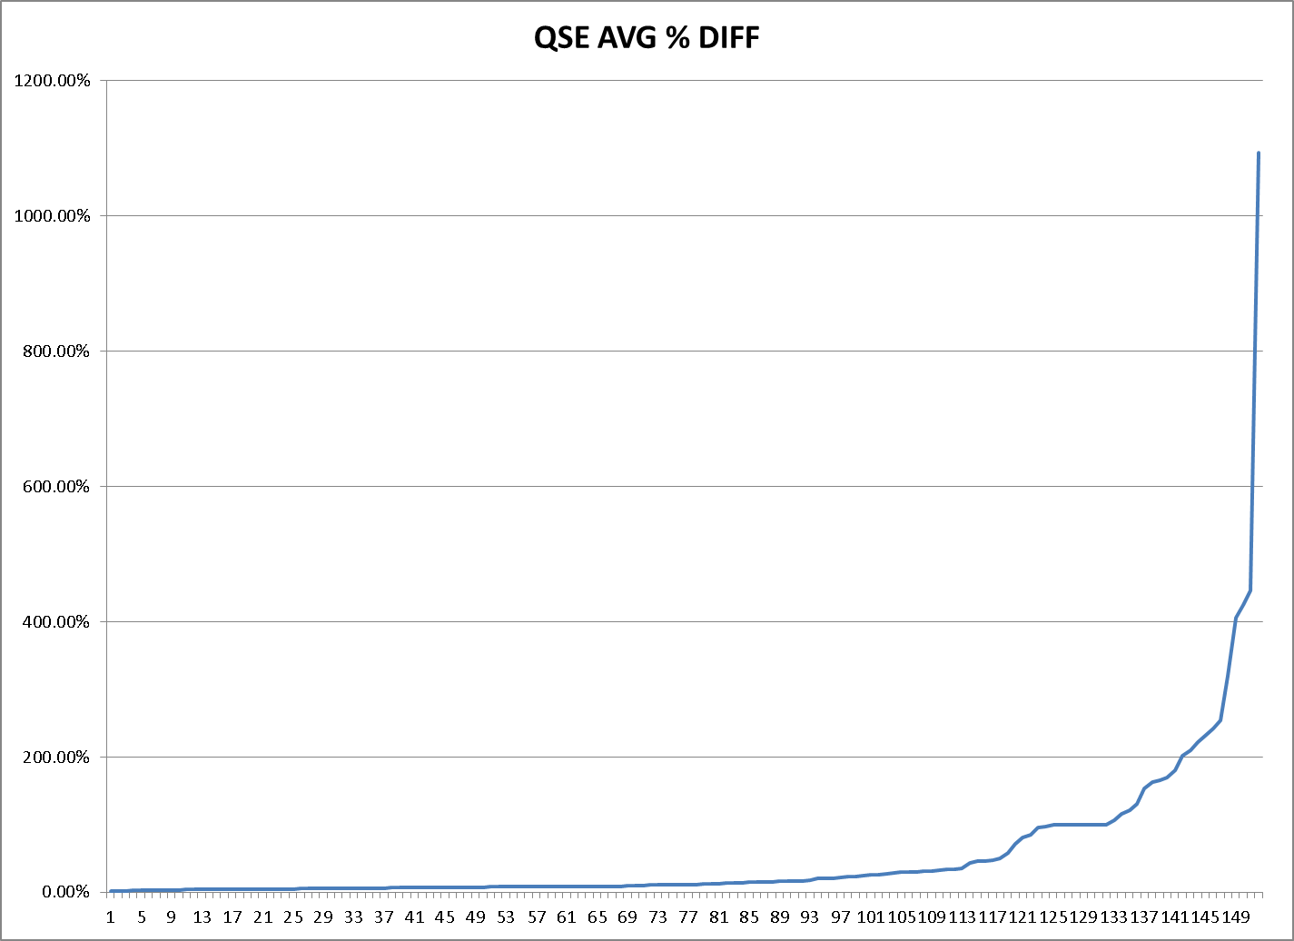
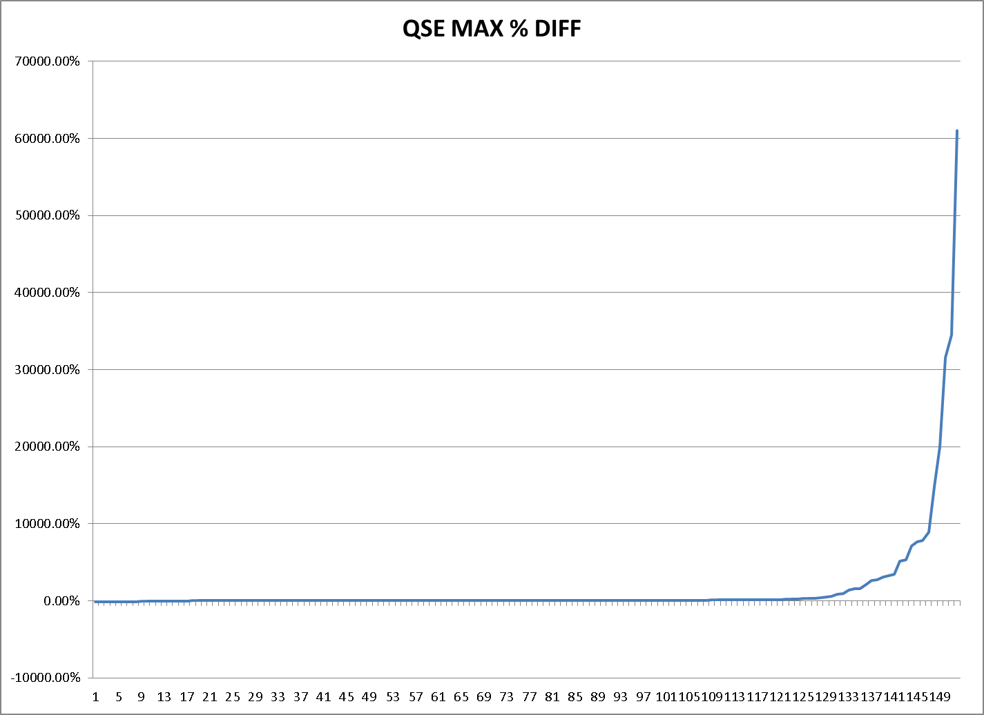
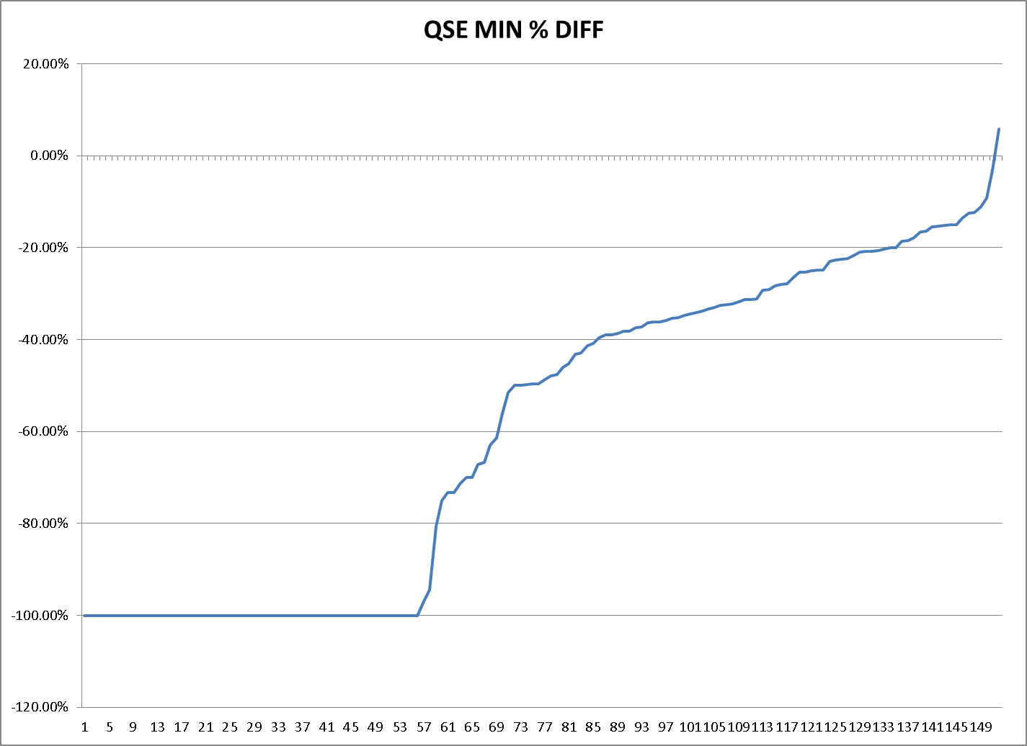
Data:  QSEAVG | QSEMAX | QSEMIN
1.52% | -100.00% | -100.00%
1.79% | -100.00% | -100.00%
2.29% | -100.00% | -100.00%
2.46% | -100.00% | -100.00%
2.77% | -100.00% | -100.00%
2.87% | -100.00% | -100.00%
3.08% | -100.00% | -100.00%
3.69% | -100.00% | -100.00%
3.77% | -1.39% | -100.00%
3.77% | 0.00% | -100.00%
3.84% | 0.00% | -100.00%
4.04% | 5.00% | -100.00%
4.09% | 5.11% | -100.00%
4.17% | 5.91% | -100.00%
4.17% | 6.26% | -100.00%
4.42% | 8.50% | -100.00%
4.47% | 9.77% | -100.00%
4.54% | 11.55% | -100.00%
4.62% | 12.59% | -100.00%
4.74% | 12.86% | -100.00%
4.98% | 13.02% | -100.00%
5.08% | 14.75% | -100.00%
5.08% | 14.96% | -100.00%
5.10% | 15.57% | -100.00%
5.12% | 18.18% | -100.00%
5.15% | 18.87% | -100.00%
5.22% | 19.36% | -100.00%
5.28% | 19.76% | -100.00%
5.38% | 21.74% | -100.00%
5.51% | 22.73% | -100.00%
5.63% | 24.29% | -100.00%
5.67% | 24.55% | -100.00%
5.68% | 25.42% | -100.00%
5.79% | 26.07% | -100.00%
5.91% | 26.32% | -100.00%
6.13% | 26.45% | -100.00%
6.33% | 26.97% | -100.00%
6.48% | 27.47% | -100.00%
6.49% | 27.64% | -100.00%
6.50% | 28.09% | -100.00%
6.54% | 28.40% | -100.00%
6.77% | 28.57% | -100.00%
7.00% | 28.97% | -100.00%
7.03% | 29.85% | -100.00%
7.09% | 30.43% | -100.00%
7.11% | 30.64% | -100.00%
7.19% | 30.94% | -100.00%
7.26% | 31.00% | -100.00%
7.29% | 31.19% | -100.00%
7.75% | 31.41% | -100.00%
7.82% | 31.60% | -100.00%
7.82% | 32.37% | -100.00%
7.85% | 33.13% | -100.00%
7.88% | 33.33% | -100.00%
8.04% | 33.61% | -100.00%
8.28% | 34.24% | -100.00%
8.39% | 35.11% | -96.92%
8.44% | 35.71% | -94.38%
8.45% | 35.78% | -80.70%
8.49% | 37.92% | -75.04%
8.57% | 38.10% | -73.33%
8.58% | 39.58% | -73.23%
8.58% | 39.58% | -71.39%
8.63% | 41.38% | -70.03%
8.72% | 43.17% | -69.91%
8.72% | 43.68% | -67.18%
9.05% | 43.85% | -66.69%
9.11% | 44.84% | -62.94%
9.45% | 44.97% | -61.38%
9.68% | 45.45% | -55.97%
10.12% | 46.09% | -51.44%
10.89% | 46.15% | -50.00%
11.02% | 46.27% | -50.00%
11.04% | 47.37% | -49.77%
11.12% | 48.03% | -49.68%
11.21% | 49.24% | -49.61%
11.22% | 49.91% | -48.68%
11.23% | 50.42% | -47.91%
12.83% | 50.77% | -47.50%
12.96% | 52.50% | -45.95%
13.11% | 53.43% | -45.19%
13.58% | 54.17% | -43.13%
13.76% | 57.14% | -42.93%
13.77% | 58.62% | -41.32%
14.89% | 59.06% | -40.79%
15.42% | 62.83% | -39.63%
15.47% | 65.49% | -38.94%
15.78% | 67.30% | -38.89%
16.23% | 67.90% | -38.58%
16.57% | 68.75% | -38.23%
16.58% | 69.57% | -38.13%
16.63% | 72.23% | -37.46%
18.42% | 72.55% | -37.25%
20.31% | 74.36% | -36.36%
20.32% | 75.68% | -36.20%
20.37% | 76.61% | -36.07%
21.48% | 80.00% | -35.90%
23.51% | 80.06% | -35.41%
23.55% | 82.37% | -35.25%
25.21% | 82.95% | -34.66%
25.59% | 84.31% | -34.39%
25.66% | 85.85% | -34.07%
27.85% | 86.45% | -33.83%
28.12% | 88.46% | -33.27%
29.38% | 90.87% | -32.93%
29.90% | 90.91% | -32.56%
30.03% | 98.16% | -32.42%
30.98% | 98.88% | -32.22%
31.92% | 100.00% | -31.82%
33.06% | 100.00% | -31.31%
34.14% | 100.00% | -31.27%
34.45% | 105.10% | -31.08%
35.05% | 111.11% | -29.20%
43.09% | 119.35% | -29.02%
45.98% | 120.17% | -28.27%
46.10% | 125.71% | -28.06%
46.80% | 128.06% | -27.77%
49.97% | 142.37% | -26.61%
58.52% | 142.86% | -25.37%
71.26% | 164.29% | -25.30%
80.50% | 164.46% | -25.06%
85.24% | 189.32% | -24.86%
96.16% | 217.65% | -24.85%
97.64% | 250.00% | -23.03%
100.00% | 287.29% | -22.72%
100.00% | 300.00% | -22.52%
100.00% | 314.29% | -22.28%
100.00% | 416.90% | -21.79%
100.00% | 500.00% | -20.97%
100.00% | 604.82% | -20.86%
100.00% | 900.00% | -20.84%
100.00% | 950.65% | -20.60%
106.84% | 1411.76% | -20.36%
116.14% | 1545.45% | -19.95%
120.72% | 1580.00% | -19.93%
130.58% | 2133.33% | -18.52%
153.94% | 2654.55% | -18.45%
162.82% | 2714.81% | -17.85%
166.26% | 3107.69% | -16.53%
169.86% | 3244.57% | -16.37%
180.87% | 3470.78% | -15.39%
201.90% | 5200.00% | -15.32%
210.09% | 5352.94% | -15.20%
222.01% | 7151.06% | -14.96%
231.62% | 7700.00% | -14.92%
241.54% | 7800.00% | -13.65%
254.60% | 8892.31% | -12.52%
320.52% | 14800.00% | -12.27%
405.54% | 20000.00% | -11.13%
425.37% | 31600.00% | -9.19%
446.29% | 34500.00% | -3.13%
1093.56% | 61000.00% | 5.91%

- What percentage of energy trades are in before/after “end of adjustment” period?

This data is for the Month of May 2013
End of Adjustment Period |  |  | After End of Operating Day
Percentage of Trades | Percentage of Trade MW |  | Percentage of Trades | Percentage of Trade MW
57% | 65% |  | 43% | 35%

- How many Operating Days have had price corrections? What is the min/max/avg change?
  - 45 Total Operating Days with Real Time Price Corrections

Average Daily Change Per Interval
MIN | MAX | AVERAGE
0.01 | 2011.34 | 139.51

Operating Days | Price | Number of Intervals | Total Change | Avg Change Per Interval
12/15/2010 | RTRMPR | 485 | 41513.89 | 85.60
12/15/2010 | RTSPP | 581 | 49970.79 | 86.00
2/8/2011 | RTRMPR | 1390 | 496968.43 | 357.53
2/8/2011 | RTSPP | 1677 | 608090.37 | 362.60
3/13/2011 | RTRMPR | 5 | 1.24 | 0.25
3/13/2011 | RTSPP | - | - | -
3/25/2011 | RTRMPR | 464 | 472127.44 | 1017.52
3/25/2011 | RTSPP | 570 | 578581.48 | 1015.05
4/1/2011 | RTRMPR | 466 | 159787.88 | 342.89
4/1/2011 | RTSPP | 572 | 228361.80 | 399.23
4/5/2011 | RTRMPR | 1355 | 1076.05 | 0.79
4/5/2011 | RTSPP | 1659 | 1198.50 | 0.72
4/11/2011 | RTRMPR | - | - | -
4/11/2011 | RTSPP | 1 | 38.93 | 38.93
4/12/2011 | RTRMPR | 1 | 9.27 | 9.27
4/12/2011 | RTSPP | - | - | -
5/10/2011 | RTRMPR | 919 | 821.30 | 0.89
5/10/2011 | RTSPP | 1130 | 1058.58 | 0.93
5/11/2011 | RTRMPR | 147 | 101.26 | 0.69
5/11/2011 | RTSPP | 164 | 98.08 | 0.60
5/12/2011 | RTRMPR | 1418 | 200.14 | 0.14
5/12/2011 | RTSPP | 1766 | 246.92 | 0.14
5/22/2011 | RTRMPR | 926 | 2104.85 | 2.27
5/22/2011 | RTSPP | 1130 | 2610.37 | 2.31
5/25/2011 | RTRMPR | 917 | 4346.28 | 4.74
5/25/2011 | RTSPP | 1122 | 4786.41 | 4.27
6/7/2011 | RTRMPR | 65 | 2.89 | 0.04
6/7/2011 | RTSPP | 65 | 3.53 | 0.05
6/13/2011 | RTRMPR | 2758 | 60676.83 | 22.00
6/13/2011 | RTSPP | 3364 | 56941.66 | 16.93
7/15/2011 | RTRMPR | 466 | 46322.22 | 99.40
7/15/2011 | RTSPP | 541 | 52909.85 | 97.80
7/21/2011 | RTRMPR | 156 | 11.81 | 0.08
7/21/2011 | RTSPP | 128 | 10.20 | 0.08
7/23/2011 | RTRMPR | 83 | 8.21 | 0.10
7/23/2011 | RTSPP | 72 | 7.90 | 0.11
7/24/2011 | RTRMPR | 142 | 43.32 | 0.31
7/24/2011 | RTSPP | 129 | 68.03 | 0.53
7/25/2011 | RTRMPR | 931 | 52766.95 | 56.68
7/25/2011 | RTSPP | 1080 | 55183.00 | 51.10
8/12/2011 | RTRMPR | 463 | 132.32 | 0.29
8/12/2011 | RTSPP | 539 | 153.47 | 0.28
8/13/2011 | RTRMPR | 198 | 26.17 | 0.13
8/13/2011 | RTSPP | 170 | 29.79 | 0.18
10/4/2011 | RTRMPR | 433 | 6.63 | 0.02
10/4/2011 | RTSPP | 505 | 8.04 | 0.02
10/26/2011 | RTRMPR | 439 | 1415.84 | 3.23
10/26/2011 | RTSPP | 60 | 1389.48 | 23.16
10/27/2011 | RTRMPR | 5 | 0.25 | 0.05
10/27/2011 | RTSPP | 5 | 0.25 | 0.05
11/6/2011 | RTRMPR | 32 | 55.26 | 1.73
11/6/2011 | RTSPP | 35 | 74.71 | 2.13
11/7/2011 | RTRMPR | 464 | 226090.18 | 487.26
11/7/2011 | RTSPP | 230 | 108910.40 | 473.52
11/8/2011 | RTRMPR | 45 | 116.96 | 2.60
11/8/2011 | RTSPP | 45 | 116.96 | 2.60
11/9/2011 | RTRMPR | 18 | 16.68 | 0.93
11/9/2011 | RTSPP | 18 | 16.68 | 0.93
11/11/2011 | RTRMPR | 2 | 0.40 | 0.20
11/11/2011 | RTSPP | 2 | 0.40 | 0.20
11/17/2011 | RTRMPR | 34 | 46603.44 | 1370.69
11/17/2011 | RTSPP | 34 | 46603.44 | 1370.69
11/18/2011 | RTRMPR | 42 | 49.62 | 1.18
11/18/2011 | RTSPP | 27 | 101.37 | 3.75
11/29/2011 | RTRMPR | 147 | 865.26 | 5.89
11/29/2011 | RTSPP | 140 | 11040.76 | 78.86
1/7/2012 | RTRMPR | 4 | 0.20 | 0.05
1/7/2012 | RTSPP | 4 | 0.20 | 0.05
2/2/2012 | RTRMPR | 448 | 14.70 | 0.03
2/2/2012 | RTSPP | 525 | 15.86 | 0.03
3/8/2012 | RTRMPR | 6054 | 274795.81 | 45.39
3/8/2012 | RTSPP | 7203 | 322923.99 | 44.84
4/11/2012 | RTRMPR | 9011 | 10586.72 | 1.17
4/11/2012 | RTSPP | 9617 | 10091.33 | 1.05
4/26/2012 | RTRMPR | 141 | 18.55 | 0.13
4/26/2012 | RTSPP | - | - | -
6/13/2012 | RTRMPR | 534 | 724323.83 | 1356.41
6/13/2012 | RTSPP | 557 | 1120314.86 | 2011.34
9/12/2012 | RTRMPR | 11 | 0.31 | 0.03
9/12/2012 | RTSPP | 1 | 0.01 | 0.01
4/28/2013 | RTRMPR | 933 | 643.13 | 0.69
4/28/2013 | RTSPP | 1126 | 776.94 | 0.69
5/4/2013 | RTRMPR | 465 | 81966.51 | 176.34
5/4/2013 | RTSPP | 564 | 94560.93 | 167.66
5/8/2013 | RTRMPR | 46 | 1.23 | 0.03
5/8/2013 | RTSPP | - | - | -
6/12/2013 | RTRMPR | 1394 | 2916.32 | 2.09
6/12/2013 | RTSPP | 1688 | 2734.35 | 1.62
8/16/2013 | RTRMPR | 59 | 1.22 | 0.02
8/16/2013 | RTSPP | - | - | -

- Ranking of charge types based on dollar value (e.g., identify the highest dollar value charge types)

 | Charge Type | Total Settlements for YTD 2013 | % of Total Real Time Settlements
Energy & PTP | RTEIAMTTOT | 280,909,698.83 | 40%
Energy & PTP | RTOBLAMTTOT & RTOBLLOAMTTOT | (252,174,812.91) | 35%
DC Tie Imports | RTDCIMPAMTTOT | (63,767,348.33) | 9%
Admin Fee | ESACAMT | 93,011,692.44 | 13%
Other Charge Types - 1% or less of Market Total | RTCCAMTTOT | 5,217,067.00 | 1%
Other Charge Types - 1% or less of Market Total | RTDCEXPAMTTOT | 4,551,123.98 | 1%
Other Charge Types - 1% or less of Market Total | BSSAMTTOT | (4,388,671.81) | 1%
Other Charge Types - 1% or less of Market Total | BPDAMTTOT | 2,637,387.99 | 0%
Other Charge Types - 1% or less of Market Total | EMREAMTTOT | (2,374,680.42) | 0%
Other Charge Types - 1% or less of Market Total | RTRUAMT | 706,388.60 | 0%
Other Charge Types - 1% or less of Market Total | RUCMWAMTTOT | (681,685.38) | 0%
Other Charge Types - 1% or less of Market Total | RUCCBAMTTOT | 111,341.29 | 0%
Other Charge Types - 1% or less of Market Total | RTRRAMT | (103,792.94) | 0%
Other Charge Types - 1% or less of Market Total | RTRDAMT | 52,055.68 | 0%
Other Charge Types - 1% or less of Market Total | RTNSAMT | (2,696.92) | 0%
Other Charge Types - 1% or less of Market Total | BLTRAMTTOT | -

