 |  |  |  | System Planning
Monthly Status Report
August 2013

 |  | Report Highlights
 | - ERCOT is currently tracking 162 active generation interconnection requests totaling over 41,400 MW. This includes over 20,900 MW of wind generation.
- ERCOT is currently reviewing proposed transmission improvements with a total cost of $750 Million
- Transmission Projects endorsed in 2013 total $349.8 Million
- All projects (in engineering, routing, licensing and construction) total approximately $8.82 Billion.
- Transmission Projects energized in 2013 total about $1.29 Billion.

Table of Contents

1. Generation Interconnection 1
1.1 Signed Generation Interconnection Agreements 1
1.2 New Generation Approved for Commercial Operations 1
1.3 Summary of Generation Interconnection Requests 1
1.4 Projects with Interconnection Agreements 4
1.5 Projects Undergoing Full Interconnection Studies with Confidentiality Waived 5
1.6 Generation Projects Undergoing Full Interconnection Studies 6
1.7 Wind Generation Capacity Installed by Year 9
2. Regional Planning Group Project Reviews 11
3. Asynchronous Tie Interconnection 12
4. Congestion Costs 13
5. Planning Model Activities 14
6. Other Notable Activities 14

1. Generation Interconnection
Additional information regarding detailed generation interconnection and impact studies is contained in the “Generation Project Interconnection Information” folder in the “Operations and System Planning” area on the ERCOT website: http://planning.ercot.com/login/login.

Signed Generation Interconnection Agreements
13INR0057 – Windhorst 2 – 65 MW located in Archer County
14INR0012a – Miami Wind 1 Project – 231 MW located in Gray County
14INR0012b - Miami Wind 1 Project – 170 MW located in Gray County
11INR0057 – Cameron County Wind – 165 MW located in Cameron County

New Generation Approved for Commercial Operations
11INR0033 – Los Vientos (LV1A) – 200 MW Wind in Cameron County

The total installed wind capacity is now reported as 10,570 MW by the resource owners through the registration process. Capacity by North, South and West is 832 MW, 2,375 MW, and 7,363 MW respectively. Eight-hundred fifty MW is able to switch between the West and South zones and is currently shown in the South zone.

Summary of Generation Interconnection Requests
GENERATION INTERCONNECTION REQUESTS CURRENTLY UNDER REVIEW
Currently tracking 161 generation interconnection or change requests
As of August 31, 2013 | Total
Security Screening Study | 4
SSS Completed | 13
Full Interconnect Study | 97
FIS Completed | 7
Suspended Studies | 0
Capacity of Suspended Study Projects | 0
Interconnect Agreement Completed | 41
Capacity under Interconnection Agreements | 13,485
Capacity for Grid, MW | 41,403
Wind Capacity, MW | 20,932
Cancelled Projects | 5

Fuel Type | Confidential Projects (MW) | Projects Under Full Study (MW) | Public Projects (MW) | Suspended Studies (MW) | Grand Total (MW)
Gas-AllOther |  |  | 374 | - | 4,428
Gas-CombinedCycle |  |  | 6,522 | - | 13,568
Total Gas | 320 | 10,780 | 6,896 | - | 17,996
Nuclear | - | - | - | - | -
Coal | - | - | 240 | - | 240
Wind | 2,111 | 13,859 | 5,959 | - | 20,931
Solar | 271 | 809 | 150 | - | 1,322
Biomass | - | - | - | - | -
Storage | - | 874 | 40 | - | 914
Petroleum Coke | - | - | - | - | -
Grand Total | 2,702 | 25,416 | 13,285 | - | 41,403

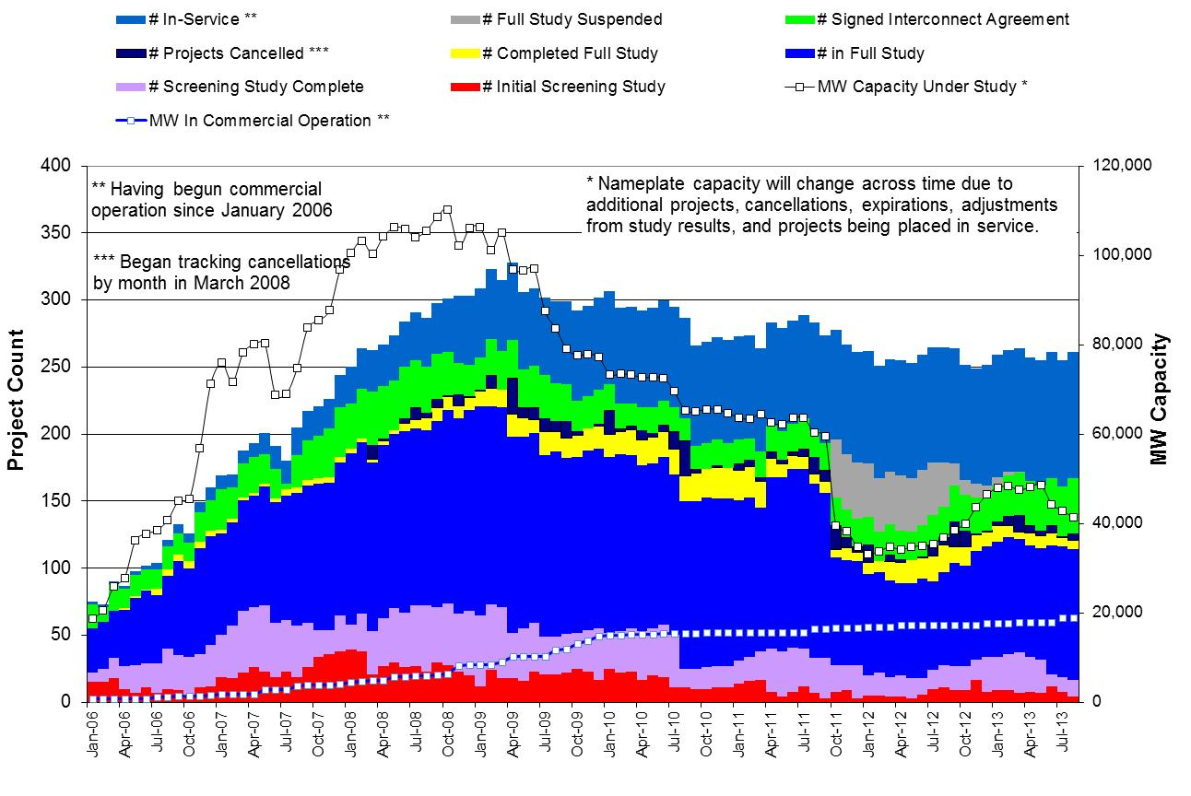

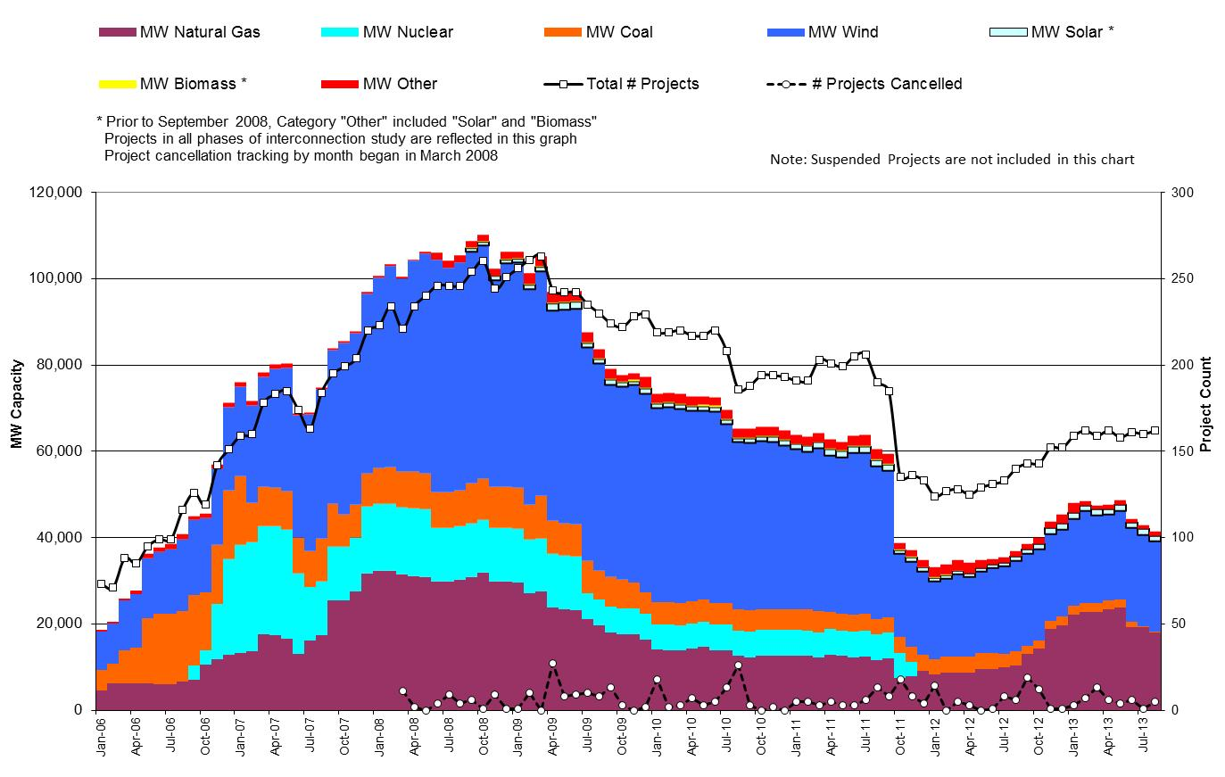

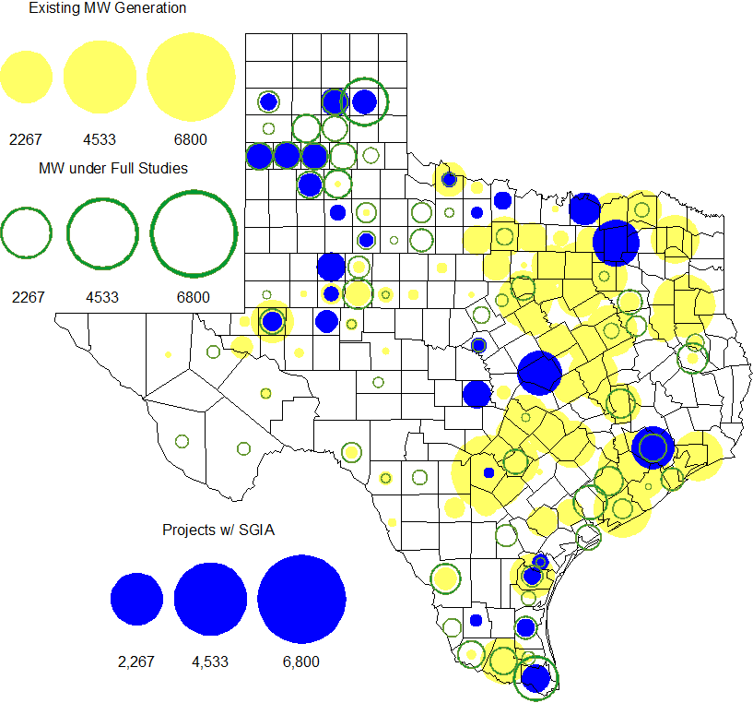

County Location of Installed Generation and Interconnection Requests (all fuels)

Projects with Interconnection Agreements

Generation Interconnection Agreements as of August 31, 2013
INR | Site Name | County | COD | Fuel | MW For Grid | Change from Last Report
12INR0075 | Blue Summit Windfarm | Wilbarger | Oct-13 | Wind | 135
11INR0033 | Los Vientos | Cameron | Oct-13 | Wind | 200 | MW for Grid
13INR0058 | OCI Alamo 1 | Bexar | Oct-13 | Solar | 50
11INR0094 | White Camp Solar | Kent | Nov-13 | Solar | 100
11INR0013 | Goldthwaite Wind Energy | Mills | Dec-13 | Wind | 150
12INR0068 | Sendero Wind Energy Project | Jim Hogg | Feb-14 | Wind | 78
10INR0089 | Deepwater Energy Storage | Harris | Mar-14 | Storage | 40
12INR0034 | Stephens Ranch Wind Energy | Borden | Apr-14 | Wind | 378
13INR0059 | Hereford Wind | Castro | Apr-14 | Wind | 499
13INR0057 | Windthorst 2 | Archer | Jun-14 | Wind | 65 | New
13INR0048 | Spinning Spur Wind Two | Oldham | Jun-14 | Wind | 161
14INR0015 | Deer Park Energy Center | Harris | Jun-14 | Gas | 192
14INR0016 | Channel Energy Center 138/345kV CT | Harris | Jun-14 | Gas | 190
11INR0062 | Patriot (Petronilla) Wind | Nueces | Jun-14 | Wind | 178
14INR0012a | Miami Wind 1 Project | Gray | Jul-14 | Wind | 231 | New
13INR0021 | Ferguson Replacement Project | Llano | Jul-14 | Gas | 570
14INR0030a_2 | Panhandle Wind | Carson | Aug-14 | Wind | 218
10INR0021 | Panda Sherman Power | Grayson | Jun-14 | Gas | 720
13INR0040 | Rentech Project | Harris | Aug-14 | Gas | 15 | Name change
10INR0020a | Panda Temple Power | Bell | Jun-14 | Gas | 717
11INR0050 | Moore Wind 1 | Crosby | Jun-14 | Wind | 149
13INR0010a | Mariah Wind | Parmer | Oct-14 | Wind | 200
13INR0020a | CPV Rattlesnake Den Ph 1 | Glasscock | Oct-14 | Wind | 200
13INR0020b | CPV Rattlesnake Den Ph 2 | Glasscock | Oct-14 | Wind | 150
11INR0054 | Midway Farms Wind | San Patricio | Oct-14 | Wind | 161
14INR0023 | Longhorn Energy Center | Briscoe | Dec-14 | Wind | 200
13INR0005 | Conway Windfarm | Carson | Dec-14 | Wind | 600
11INR0057 | Cameron County Wind | Cameron | Dec-14 | Wind | 165 | New
11INR0079a | South Clay Windfarm | Clay | Dec-14 | Wind | 200
06INR0022c | Penascal Wind Farm 3 | Kenedy | Dec-14 | Wind | 202
09INR0051 | Mesquite Creek | Borden | Jan-15 | Wind | 249
08INR0018 | Gunsight Mountain | Howard | Aug-15 | Wind | 120
14INR0012b | Miami Wind 1 Project | Gray | Aug-15 | Wind | 170 | New
10INR0020b | Panda Temple Power | Bell | Aug-15 | Gas | 780
13INR0010b | Mariah Wind | Parmer | Dec-15 | Wind | 200
12INR0029 | Comanche Run Wind | Swisher | Dec-15 | Wind | 500
13INR0023 | Texas Clean Energy Project | Ector | Jan-16 | Coal | 240
13INR0028 | Antelope Station | Hale | Jun-16 | Gas | 359
10INR0022 | Pondera King Power Project | Harris | Jun-16 | Gas | 1,380
06INR0006 | Cobisa-Greenville | Hunt | Dec-16 | Gas | 1,792
13INR0010c | Mariah Wind | Parmer | Dec-16 | Wind | 200

Projects Undergoing Full Interconnection Studies with Confidentiality Waived
INR | Site Name | County | COD | Fuel | MW for Grid | Change from Last Report

Generation Projects Undergoing Full Interconnection Studies

Interconnection Database Reference Number | County | Fuel | Capacity to Grid (MW) | Commercial Operation Data (as specified by the resource developer)
12INR0055 | Baylor | Wind | 40 | Jan-14
13INR0006 | Gray | Wind | 750 | Jan-14
14INR0014 | Val Verde | Solar | 100 | Jan-14
14INR0039 | Ector | Gas | 450 | Mar-14
12INR0060 | Schleicher | Wind | 58 | Apr-14
14INR0013 | Cameron | Wind | 103 | Apr-14
14INR0024 | Kinney | Solar | 42 | Apr-14
08INR0019a | Gray | Wind | 250 | Jun-14
08INR0019b | Gray | Wind | 250 | Jun-14
08INR0019c | Gray | Wind | 250 | Jun-14
13INR0026 | Oldham | Wind | 201 | Jun-14
14INR0031 | Harris | Gas | 270 | Jun-14
14INR0038 | Galveston | Gas | 390 | Jun-14
14INR0048 | Wilbarger | Wind | 114 | Jun-14
14INR0040 | Hidalgo | Gas | 225 | Jun-14
12INR0059 | Pecos | Solar | 50 | Jun-14
11INR0093 | San Patricio | Wind | 41 | Jul-14
12INR0085 | Stonewall | Wind | 24 | Jul-14
14INR0029 | Uvalde | Solar | 42 | Jul-14
14INR0059 | Kaufman | Gas | 52 | Aug-14
13INR0055 | Zapata | Wind | 250 | Sep-14
13INR0038 | Swisher | Wind | 300 | Sep-14
14INR0042 | Deaf Smith | Solar | 80 | Sep-14
14INR0062 | Hall/Motley | Wind | 161 | Sep-14
14INR0047 | Dickens | Wind | 301 | Oct-14
12INR0070 | Knox | Wind | 300 | Oct-14
12INR0045 | Kleberg | Wind | 135 | Oct-14
13INR0036 | Hidalgo | Wind | 200 | Oct-14
13INR0031 | Travis | Solar | 30 | Oct-14
11INR0065 | Nueces | Wind | 350 | Oct-14
13INR0025 | Randall | Wind | 150 | Nov-14
14INR0060 | Haskell | Wind | 400 | Nov-14
14INR0030b | Carson | Wind | 198 | Nov-14
13INR0056 | Scurry | Wind | 366 | Nov-14

Interconnection Database Reference Number | County | Fuel | Capacity to Grid (MW) | Commercial Operation Data (as specified by the resource developer)
14INR0066 | Lamar | Gas | 130 | Nov-14
13INR0050 | Comanche | Wind | 200 | Dec-14
14INR0025a | Floyd | Wind | 200 | Dec-14
14INR0032a | Randall | Wind | 200 | Dec-14
10INR0085 | Ector | Solar | 57 | Dec-14
11INR0081 | Live Oak | Wind | 72 | Dec-14
11INR0082a | Val Verde | Wind | 50 | Dec-14
11INR0082b | Val Verde | Wind | 150 | Dec-14
13INR0054 | Bee | Gas | 0 | Dec-14
14INR0009 | Kent | Wind | 248 | Dec-14
14INR0028 | Live Oak | Wind | 300 | Dec-14
14INR0033 | Armstrong | Wind | 500 | Dec-14
14INR0041 | Willacy | Wind | 114 | Dec-14
14INR0043 | Sterling | Solar | 40 | Dec-14
14INR0044 | Reeves | Solar | 100 | Dec-14
14INR0058 | Brewster | Solar | 100 | Dec-14
12INR0079 | Kenedy | Wind | 200 | Dec-14
13INR0045 | Castro | Wind | 288 | Dec-14
13INR0010d | Parmer | Wind | 200 | Dec-14
13INR0052 | Starr | Wind | 200 | Dec-14
14INR0053 | Oldham | Wind | 161 | Dec-14
14INR0020 | Floyd | Wind | 150 | Dec-14
14INR0045a | Webb | Wind | 502 | Dec-14
14INR0049_1 | Jack | Wind | 102 | Dec-14
14INR0049_2 | Jack | Wind | 102 | Dec-14
14INR0056 | Mills | Wind | 101 | Dec-14
14INR0057a | Erath | Wind | 48 | Dec-14
14INR0057b | Erath | Wind | 48 | Dec-14
14INR0067 | Briscoe and Floyd | Wind | 161 | Dec-14
15INR0036 | Uvalde | Solar | 105 | Mar-15
10INR0009 | Castro | Wind | 300 | Mar-15
15INR0021 | Starr | Wind | 200 | May-15
14INR0027 | Guadalupe | Gas | 471 | Jun-15
15INR0022 | Presidio | Solar | 75 | Jun-15
15INR0027 | Hidalgo | Gas | 79 | Jun-15

Interconnection Database Reference Number | County | Fuel | Capacity to Grid (MW) | Commercial Operation Data (as specified by the resource developer)
15INR0028 | Freestone | Gas | 160 | Jun-15
15INR0042 | Hood | Gas | 460 | Jun-15
15INR0023 | Wharton | Gas | 700 | Jun-15
14INR0026 | Presidio | Solar | 30 | Sep-15
15INR0013 | Anderson | Storage/Gas | 324 | Oct-15
15INR0014 | Matagorda | Storage/Gas | 280 | Oct-15
14INR0030a_1 | Carson | Wind | 322 | Nov-15
14INR0025b | Floyd | Wind | 300 | Dec-15
14INR0032b | Randall | Wind | 300 | Dec-15
15INR0035 | Kenedy | Wind | 200 | Dec-15
13INR0010e | Parmer | Wind | 200 | Dec-15
12INR0002a | Briscoe | Wind | 200 | Dec-15
14INR0018 | Nolan | Solar | 20 | Dec-15
13INR0032 | Andrews | Solar | 30 | Dec-15
14INR0045b | Webb | Wind | 251 | Dec-15
15INR0037 | Starr | Wind | 200 | Dec-15
16INR0010 | Mitchell | Gas | 799 | Feb-16
16INR0005 | Cameron | Gas | 871 | Apr-16
16INR0009 | Calhoun | Gas | 510 | Apr-16
15INR0032 | Hale | Gas | 197 | May-16
15INR0033 | Hale | Gas | 197 | May-16
16INR0008 | Grimes | Gas | 687 | May-16
16INR0003 | Brazoria | Gas | 11 | Jun-16
16INR0004 | Cameron | Gas | 730 | Jun-16
16INR0006 | Angelina | Gas | 785 | Jun-16
16INR0007 | Hidalgo | Gas | 95 | Jun-16
17INR0004 | Hale | Gas | 202 | Jun-16
14INR0011 | Swisher | Storage/Gas | 270 | Jul-16
16INR0013 | Nacogdoches | Gas | 215 | Jul-16
13INR0010f | Parmer | Wind | 200 | Dec-16
12INR0002b | Briscoe | Wind | 200 | Dec-16
12INR0018 | Gray | Wind | 500 | Mar-17
17INR0002 | Henderson | Gas | 489 | Jun-17
17INR0003 | Jackson | Gas | 965 | Jun-17
11INR0040 | Freestone | Gas | 640 | Mar-18

Wind Generation Capacity Installed by Year
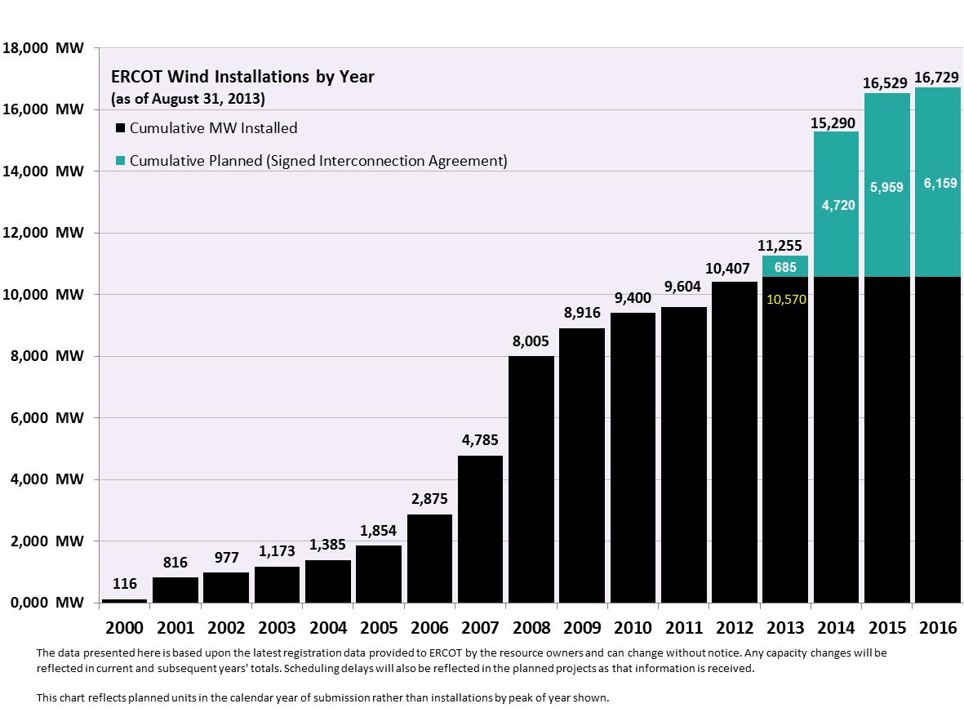

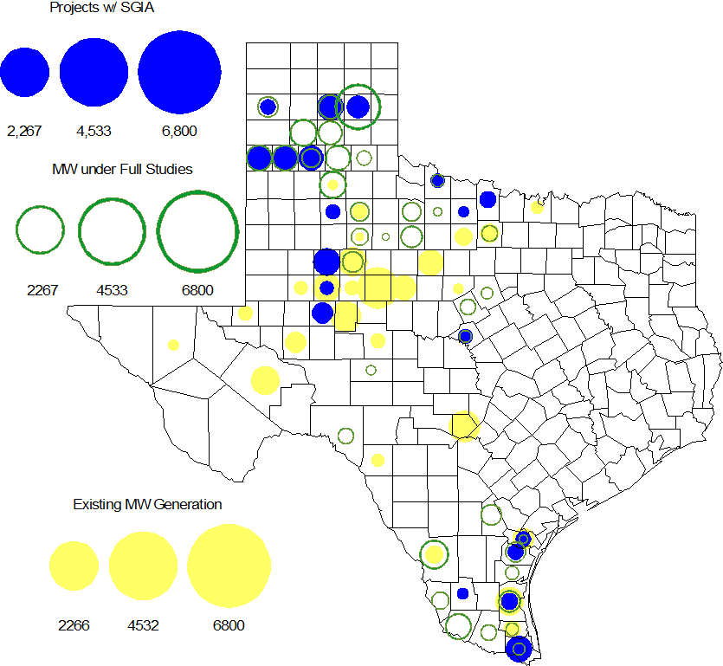

Regional Planning Group Project Reviews

- Oncor submitted the Permian Basin to Moss to Odessa EHV 345 kV project. This is a Tier 1 project that is estimated to cost approximately $75 million. This project is currently under ERCOT independent review.

- CenterPoint Energy submitted the Houston Region Import Capacity project. This is a Tier 1 project that is estimated to cost between $297 to $532 million. This project has received several RPG comments and it is under study mode.

- Garland Power & Light (GP&L) and Cross Texas Transmission (CTT) have jointly submitted the Houston Import project. This is a Tier 1 project that is estimated to cost between $195 to $317 million. This project has received several RPG comments and it is under study mode.

- Denton Municipal Electric has submitted the Spencer-Pockrus 138 kV project. The project is estimated to cost approximately $5.5 million. The project is under study mode. The Spencer-Pockrus 138 kV project is initially classified as a Tier 3 project and once the RPG comments are resolved it will be reclassified as a Tier 4 Neutral project.

- Lone Star Transmission has submitted the Houston Import project. This is a Tier 1 project that is estimated to cost between $417 to $675 million. This project has been submitted for RPG comments.

Asynchronous Tie Interconnection

Project | Notification to ERCOT | Reliability Study | RPG Review | Interconnection Agreement | In-service Year
Railroad DC tie expansion (150 MW - CFE) |  |  |  |  | 2014
Southern Cross HVDC (3000 MW - SERC)
Tres Amigas (1500 MW - SPP)

Color Legend
In progress
Complete

Congestion Costs
Dollars shown in RUC Make Whole payment graph are of settlement quality.

RUC net Make Whole payment in $mm
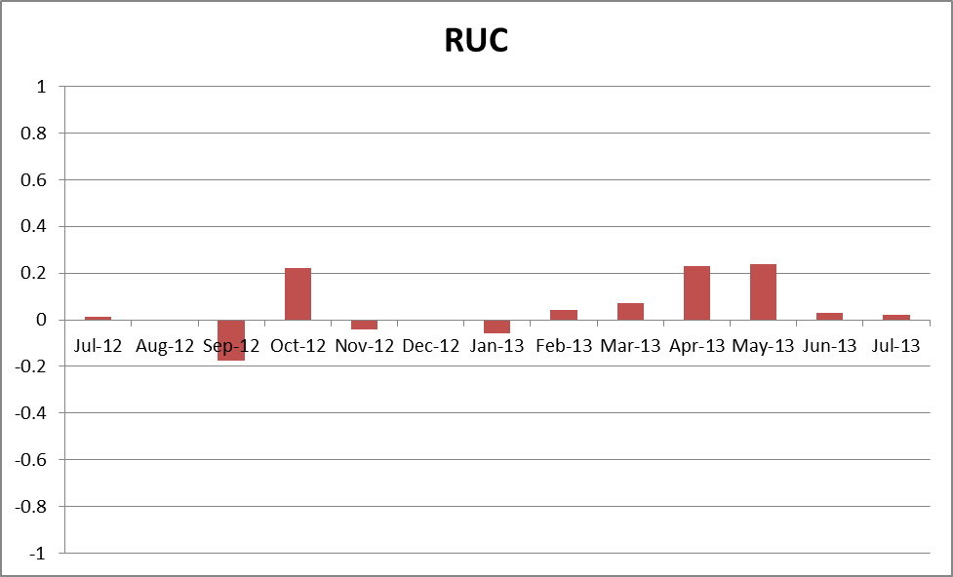

Monthly Average LMP
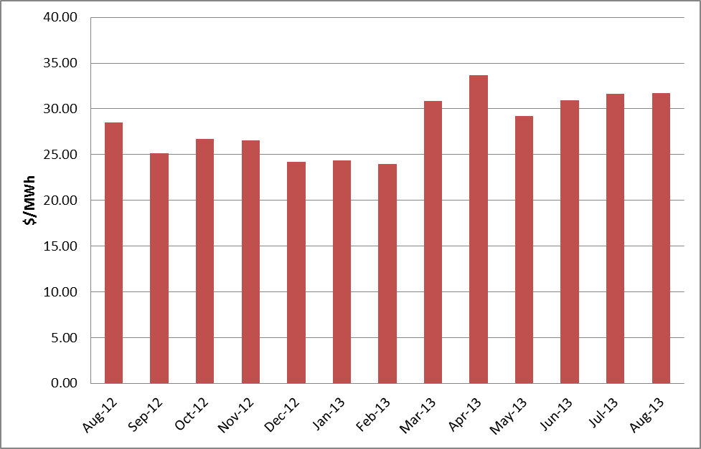

Planning Model Activities
- The short term calendar of major planning model events follows:
  - Aug 1, 2013 Start of 14 Data Set B case build
  - Aug 7, 2013 SSWG Meeting to discuss HWLL case
  - Sept 30 – Oct 2, 2013 SSWG Data Set B Meeting
  - Oct 15, 2013 SSWG Data Set B posted
  - Oct 31, 2013 Contingency files posted

Other Notable Activities
- The project to complete the missing and questionable data for the remaining Resource Asset Registration Forms (RARF) that are still incomplete is underway. ERCOT and Siemens created a list of 3387 individual data items that are missing or suspect.
- ERCOT is working on the 2013 Regional Transmission Plan (RTP). The Reliability start cases including initial projects (previous 5YTP projects) was posted at the ERCOT POI on Aug. 19, 2013. ERCOT is currently working on reliability analysis to resolve the thermal and voltage issues.
- ERCOT has performed the study to analyze the system needs in the West Texas area due to oil and gas load growth. The final reliability and economic study results were presented at the August RPG meeting. ERCOT is currently working on the West Texas Sensitivity study report and anticipates to complete the report in Sept. 2013.
- ERCOT is preparing the report on the results of the Long-Term System Assessment and the improvements to the long-term study process as a result of the grant received from the Department of Energy.
- ERCOT has issued a Request For Proposal (RFP) in order to hire a consultant to perform a small signal stability study.

