 |  |  |  | System Planning
Monthly Status Report
July 2013

 |  | Report Highlights
 | - ERCOT is currently tracking 163 active generation interconnection requests totaling over 42,800 MW. This includes over 21,000 MW of wind generation.
- ERCOT is currently reviewing proposed transmission improvements with a total cost of $607 Million
- Transmission Projects endorsed in 2013 total $349.8 Million
- All projects (in engineering, routing, licensing and construction) total approximately $8.82 Billion.
- Transmission Projects energized in 2013 total about $1.29 Billion.
- SCR 760 Changes Needed for Information Model Manager and Topology Processor for Planning Models completed with migration of final items to ERCOT production systems on 7/31/2013.

Table of Contents

1. Generation Interconnection 1
1.1 Signed Generation Interconnection Agreements 1
1.2 New Generation Registering for Commercial Operations 1
1.3 Summary of Generation Interconnection Requests 1
1.4 Projects with Interconnection Agreements 5
1.5 Projects Undergoing Full Interconnection Studies with Confidentiality Waived 6
1.6 Generation Projects Undergoing Full Interconnection Studies 6
1.7 Wind Generation Capacity Installed by Year 9
2. Regional Planning Group Project Reviews 10
3. Asynchronous Tie Interconnection 11
4. Congestion Costs 12
5. Wind Generation as a Percent of Load 13
6. Planning Model Activities 14
7. Other Notable Activities 15

1. Generation Interconnection
Additional information regarding detailed generation interconnection and impact studies is contained in the “Generation Project Interconnection Information” folder in the “Operations and System Planning” area on the ERCOT website: http://planning.ercot.com/login/login.

Signed Generation Interconnection Agreements
11INR0062 – Patriot (Petronilla) Wind – 178 MW wind in Nueces County
12INR0029 – Comanche Run Wind – 500 MW wind in Swisher County
12INR0068 – Sendero Wind Energy Project – 78 MW wind in Jim Hogg County
13INR0020a – CPV Rattlesnake Den Ph 1 – 200 MW wind in Glasscock County
13INR0020b - CPV Rattlesnake Den Ph 2 – 150 MW wind in Glasscock County

New Generation Registering for Commercial Operations
09INR0001 – Sandy Creek 1 – 970 MW Coal in Mclennan County

The total installed wind capacity is now reported as 10,570 MW by the resource owners through the registration process. Capacity by North, South and West is 832 MW, 2,375 MW, and 7,363 MW respectively. Eight-hundred fifty MW is able to switch between the West and South zones and is currently shown in the South zone.

Summary of Generation Interconnection Requests
GENERATION INTERCONNECTION REQUESTS CURRENTLY UNDER REVIEW
Currently tracking 161 generation interconnection or change requests
As of July 31, 2013 | Total
Security Screening Study | 8
SSS Completed | 14
Full Interconnect Study | 104
FIS Completed | 7
Suspended Studies | 0
Capacity of Suspended Study Projects | 0
Interconnect Agreement Completed | 37
Capacity under Interconnection Agreements | 12,840
Capacity for Grid, MW | 42,872
Wind Capacity, MW | 21,160

Fuel Type | Confidential Projects (MW) | Projects Under Full Study (MW) | Public Projects (MW) | Suspended Studies (MW) | Grand Total (MW)
Gas-AllOther |  |  | 359 | - | 7,542
Gas-CombinedCycle |  |  | 6,522 | - | 11,729
Total Gas | 2,420 | 9,952 | 6,881 | - | 19,253
Nuclear | - | - | - | - | -
Coal | - | - | 240 | - | 240
Wind | 2,627 | 13,859 | 5,062 | - | 21,160
Solar | 346 | 809 | 150 | - | 1,305
Biomass | - | - | - | - | -
Storage | - | 874 | 40 | - | 914
Petroleum Coke | - | - | - | - | -
Grand Total | 5,393 | 24,639 | 12,840 | - | 42,872

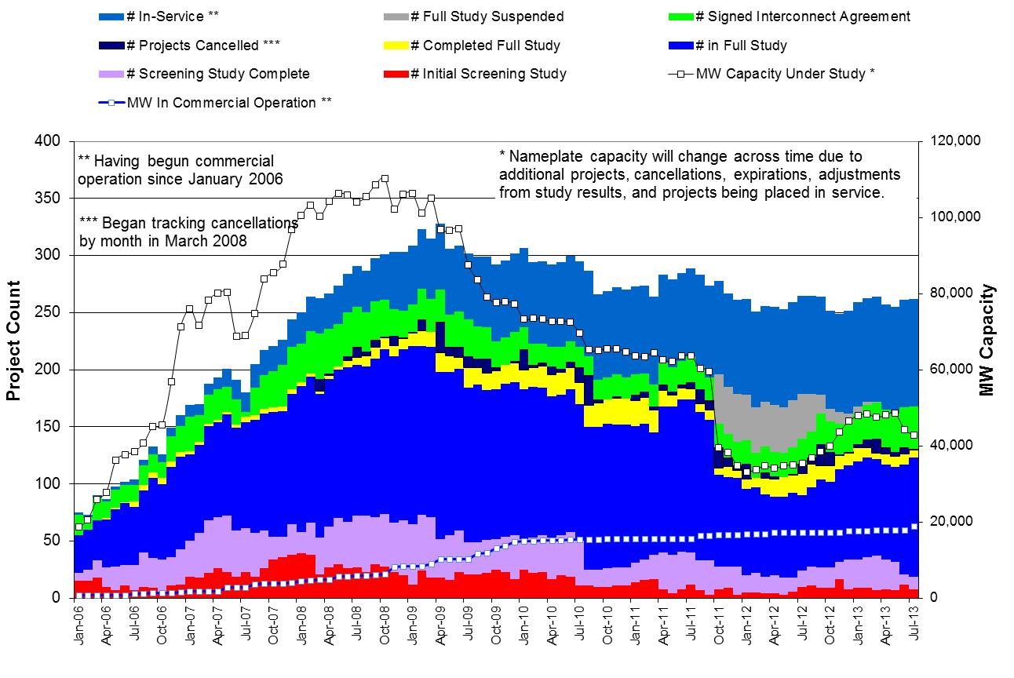

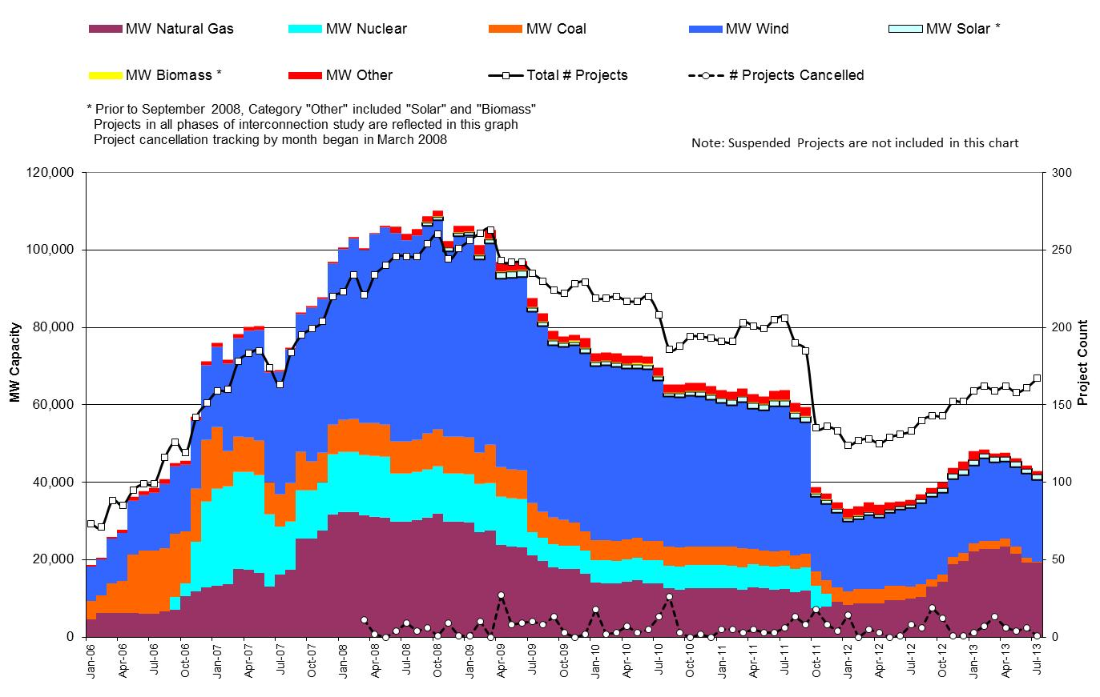

County Location of Installed Generation and Interconnection Requests (all fuels)

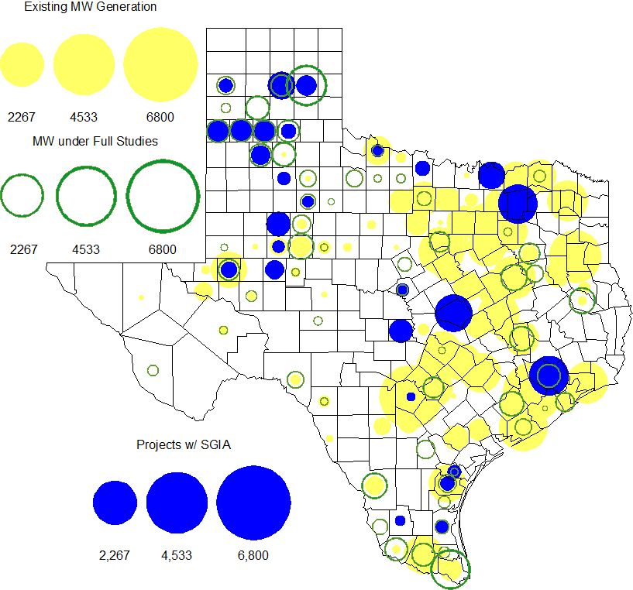

Projects with Interconnection Agreements

Generation Interconnection Agreements as of July 31, 2013
INR | Site Name | County | COD | Fuel | MW For Grid | Change from Last Report
13INR0059 | Hereford Wind | Castro | Oct-13 | Wind | 499
13INR0058 | OCI Alamo 1 | Bexar | Oct-13 | Solar | 50
11INR0094 | White Camp Solar | Kent | Nov-13 | Solar | 100
11INR0013 | Goldthwaite Wind Energy | Mills | Dec-13 | Wind | 150
12INR0068 | Sendero Wind Energy Project | Jim Hogg | Feb-14 | Wind | 78 | New
10INR0089 | Deepwater Energy Storage | Harris | Mar-14 | Storage | 40 | Date
12INR0034 | Stephens Ranch Wind Energy | Borden | Apr-14 | Wind | 378 | Date
11INR0062 | Patriot (Petronilla) Wind | Nueces | Apr-14 | Wind | 178 | New
14INR0012 | Miami Wind 1 Project | Gray | May-14 | Wind | 401
13INR0048 | Spinning Spur Wind Two | Oldham | Jun-14 | Wind | 161
14INR0015 | Deer Park Energy Center | Harris | Jun-14 | Gas | 192
14INR0016 | Channel Energy Center 138/345kV CT | Harris | Jun-14 | Gas | 190
10INR0020a | Panda Temple Power | Bell | Jun-14 | Gas | 809
10INR0021 | Panda Sherman Power | Grayson | Jun-14 | Gas | 809
13INR0021 | Ferguson Replacement Project | Llano | Jul-14 | Gas | 570
14INR0030a2 | Panhandle Wind | Carson | Aug-14 | Wind | 218
11INR0050 | Moore Wind 1 | Crosby | Aug-14 | Wind | 149
13INR0010a | Mariah Wind | Parmer | Oct-14 | Wind | 200
11INR0054 | Midway Farms Wind | San Patricio | Oct-14 | Wind | 161
13INR0020a | CPV Rattlesnake Den Ph 1 | Glasscock | Oct-14 | Wind | 200 | New
13INR0020b | CPV Rattlesnake Den Ph 2 | Glasscock | Oct-14 | Wind | 150 | New
14INR0023 | Longhorn Energy Center | Briscoe | Dec-14 | Wind | 200 | MW for Grid
13INR0005 | Conway Windfarm | Carson | Dec-14 | Wind | 600
06INR0022c | Penascal Wind Farm 3 | Kenedy | Dec-14 | Wind | 202
11INR0079a | South Clay Windfarm | Clay | Dec-14 | Wind | 200
09INR0051 | Mesquite Creek | Borden | Mar-15 | Wind | 249
08INR0018 | Gunsight Mountain | Howard | Aug-15 | Wind | 120
10INR0020b | Panda Temple Power | Bell | Aug-15 | Gas | 780
12INR0029 | Comanche Run Wind | Swisher | Dec-15 | Wind | 500 | New
13INR0010b | Mariah Wind | Parmer | Dec-15 | Wind | 200
13INR0023 | Texas Clean Energy Project | Ector | Jan-16 | Coal | 240
13INR0028 | Antelope Station | Hale | Jun-16 | Gas | 359
10INR0022 | Pondera King Power Project | Harris | Jun-16 | Gas | 1,380
06INR0006 | Cobisa-Greenville | Hunt | Dec-16 | Gas | 1,792
13INR0010c | Mariah Wind | Parmer | Dec-16 | Wind | 200

Projects Undergoing Full Interconnection Studies with Confidentiality Waived
INR | Site Name | County | COD | Fuel | MW for Grid | Change from Last Report

Generation Projects Undergoing Full Interconnection Studies

Interconnection Database Reference Number | County | Fuel | Capacity to Grid (MW) | Commercial Operation Date (as specified by the resource developer)
13INR0026 | Oldham | Wind | 201 | 12/1/2013
13INR0052 | Starr | Wind | 200 | 12/1/2013
13INR0055 | Zapata | Wind | 250 | 12/1/2013
13INR0056 | Scurry | Wind | 366 | 12/1/2013
12INR0081a | Upton | Wind | 112 | 12/31/2013
14INR0024 | Kinney | Solar | 42 | 12/31/2013
15INR0021 | Starr | Wind | 200 | 12/31/2013
12INR0055 | Baylor | Wind | 40 | 1/1/2014
13INR0006 | Gray | Wind | 750 | 1/1/2014
14INR0013 | Cameron | Wind | 103 | 1/1/2014
14INR0014 | Val Verde | Solar | 100 | 1/1/2014
14INR0059 | Kaufman | Gas | 52 | 2/1/2014
14INR0039 | Ector | Gas | 450 | 3/1/2014
12INR0060 | Schleicher | Wind | 58 | 4/1/2014
08INR0019a | Gray | Wind | 250 | 6/1/2014
08INR0019b | Gray | Wind | 250 | 6/1/2014
08INR0019c | Gray | Wind | 250 | 6/1/2014
11INR0057 | Cameron | Wind | 165 | 6/1/2014
13INR0049 | Harris | Gas | 352 | 6/1/2014
13INR0057 | Archer | Wind | 65 | 6/1/2014
14INR0031 | Harris | Gas | 270 | 6/1/2014
14INR0038 | Galveston | Gas | 390 | 6/1/2014
14INR0048 | Wilbarger | Wind | 114 | 6/1/2014
14INR0040 | Hidalgo | Gas | 225 | 6/7/2014
12INR0059 | Pecos | Solar | 50 | 6/30/2014
11INR0093 | San Patricio | Wind | 41 | 7/1/2014
12INR0085 | Stonewall | Wind | 24 | 7/1/2014
14INR0029 | Uvalde | Solar | 42 | 7/1/2014
13INR0038 | Swisher | Wind | 300 | 9/15/2014
14INR0042 | Deaf Smith | Solar | 80 | 9/30/2014
Interconnection Database Reference Number | County | Fuel | Capacity to Grid (MW) | Commercial Operation Date (as specified by the resource developer)
14INR0062 | Hall/Motley | Wind | 161 | 9/30/2014
14INR0047 | Dickens | Wind | 301 | 10/1/2014
12INR0070 | Knox | Wind | 300 | 10/15/2014
12INR0045 | Kleberg | Wind | 135 | 10/31/2014
13INR0031 | Travis | Solar | 30 | 10/31/2014
13INR0036 | Hidalgo | Wind | 200 | 10/31/2014
13INR0025 | Randall | Wind | 150 | 11/1/2014
14INR0030b | Carson | Wind | 198 | 11/1/2014
14INR0060 | Haskell | Wind | 400 | 11/1/2014
14INR0066 | Lamar | Gas | 130 | 11/30/2014
10INR0085 | Ector | Solar | 57 | 12/1/2014
11INR0081 | Live Oak | Wind | 72 | 12/1/2014
11INR0082A | Val Verde | Wind | 50 | 12/1/2014
11INR0082B | Val Verde | Wind | 150 | 12/1/2014
13INR0050 | Comanche | Wind | 200 | 12/1/2014
13INR0054 | Bee | Gas | 0 | 12/1/2014
14INR0009 | Kent | Wind | 248 | 12/1/2014
14INR0025a | Floyd | Wind | 200 | 12/1/2014
14INR0028 | Live Oak | Wind | 300 | 12/1/2014
14INR0032a | Randall | Wind | 200 | 12/1/2014
14INR0033 | Armstrong | Wind | 500 | 12/1/2014
14INR0041 | Willacy | Wind | 114 | 12/1/2014
14INR0043 | Sterling | Solar | 40 | 12/1/2014
14INR0044 | Reeves | Solar | 100 | 12/1/2014
14INR0053 | Oldham | Wind | 161 | 12/1/2014
14INR0058 | Brewster | Solar | 100 | 12/1/2014
12INR0079 | Kenedy | Wind | 200 | 12/15/2014
13INR0045 | Castro | Wind | 288 | 12/30/2014
13INR0010d | Parmer | Wind | 200 | 12/31/2014
14INR0020 | Floyd | Wind | 150 | 12/31/2014
14INR0057b | Erath | Wind | 48 | 12/31/2014
14INR0067 | Briscoe and Floyd | Wind | 161 | 12/31/2014
14INR0049_1 | Jack | Wind | 102 | 12/31/2014
14INR0056 | Mills | Wind | 101 | 12/31/2014
14INR0057 | Erath | Wind | 48 | 12/31/2014
14INR0045a | Webb | Wind | 502 | 12/31/2014
10INR0009 | Castro | Wind | 300 | 3/31/2015
14INR0027 | Guadalupe | Gas | 471 | 6/1/2015
15INR0022 | Presidio | Solar | 75 | 6/1/2015
15INR0028 | Freestone | Gas | 160 | 6/1/2015
15INR0042 | Hood | Gas | 460 | 6/1/2015
15INR0027 | Hidalgo | Gas | 79 | 6/1/2015
Interconnection Database Reference Number | County | Fuel | Capacity to Grid (MW) | Commercial Operation Date (as specified by the resource developer)
15INR0023 | Wharton | Gas | 700 | 6/15/2015
14INR0026 | Presidio | Solar | 28 | 9/1/2015
15INR0013 | Anderson | Storage/Gas | 324 | 10/1/2015
15INR0014 | Matagorda | Storage/Gas | 280 | 10/1/2015
11INR0065 | Nueces | Wind | 350 | 10/31/2015
14INR0025b | Floyd | Wind | 300 | 12/1/2015
14INR0032b | Randall | Wind | 300 | 12/1/2015
12INR0002a | Briscoe | Wind | 200 | 12/31/2015
13INR0010e | Parmer | Wind | 200 | 12/31/2015
14INR0018 | Nolan | Solar | 35 | 12/31/2015
13INR0032 | Andrews | Solar | 30 | 12/31/2015
15INR0037 | Starr | Wind | 200 | 12/31/2015
14INR0045b | Webb | Wind | 251 | 12/31/2015
16INR0010 | Mitchell | Gas | 799 | 2/1/2016
16INR0005 | Cameron | Gas | 871 | 4/1/2016
16INR0009 | Calhoun | Gas | 510 | 4/14/2016
15INR0032 | Hale | Gas | 197 | 5/1/2016
15INR0033 | Hale | Gas | 197 | 5/1/2016
16INR0008 | Grimes | Gas | 687 | 5/1/2016
16INR0004 | Cameron | Gas | 730 | 6/1/2016
16INR0006 | Angelina | Gas | 785 | 6/1/2016
16INR0007 | Hidalgo | Gas | 95 | 6/1/2016
16INR0003 | Brazoria | Gas | 11 | 6/1/2016
14INR0011 | Swisher | Storage/Gas | 270 | 7/1/2016
12INR0002b | Briscoe | Wind | 200 | 12/31/2016
13INR0010f | Parmer | Wind | 200 | 12/31/2016
12INR0018 | Gray | Wind | 500 | 3/31/2017
17INR0004 | Hale | Gas | 202 | 5/1/2017
17INR0002 | Henderson | Gas | 489 | 6/1/2017
11INR0040 | freestone | Gas | 640 | 3/1/2018

Wind Generation Capacity Installed by Year
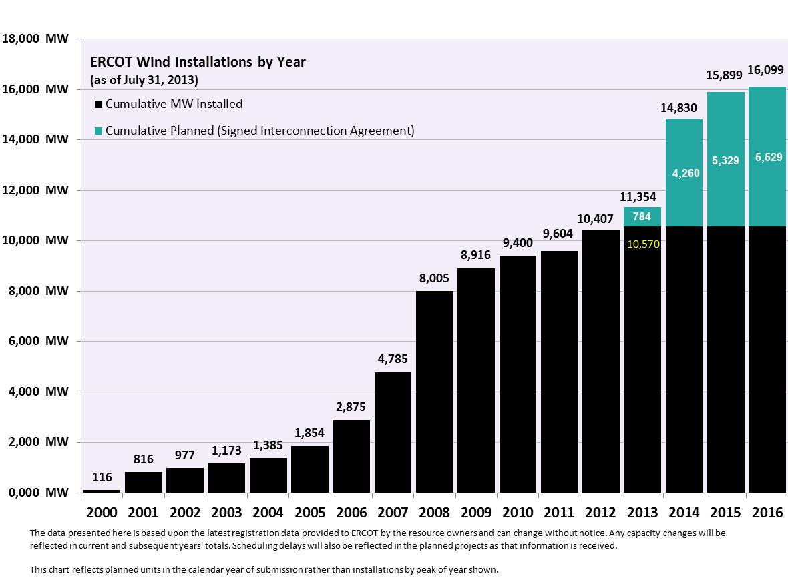

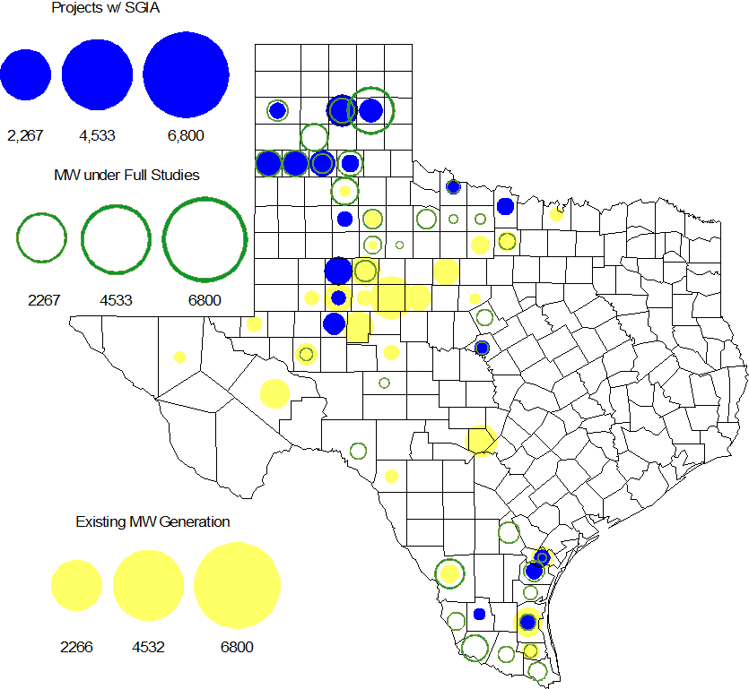

Regional Planning Group Project Reviews

- Oncor submitted the Permian Basin to Moss to Odessa EHV 345 kV project. This is a Tier 1 project that is estimated to cost approximately $75 million. This project is currently under ERCOT independent review.

- Sharyland Utilities submitted the Stanton/Midland Northern loop project. This project was initially classified as a Tier 3 and and the project has statisfied all the RPG comments. In accordance with Protocol Section 3.11.4.5, the Stanton/Midland Northern loop project has been reclassified as a “Tier 4 Neutral Project.”

- CenterPoint Energy submitted the Houston Region Import Capacity project. This is a Tier 1 project that is estimated to cost between $297 to $532 million. This project has been submitted for RPG comments.

- Garland Power & Light (GP&L) and Cross Texas Transmission (CTT) have jointly submitted the Houston Import project. This is a Tier 1 project that is estimated to cost between $ 195 to $ 317 million. This project has been submitted for RPG comments.

- Denton Municipal Electric has submitted the Spencer-Pockrus 138 kV project. The project is estimated to cost approximately $5.5 million. The project been submitted for RPG comments. The Spencer-Pockrus 138 kV project is initially classified as a Tier 3 project and once the RPG comments are resolved it will be reclassified as a Tier 4 Neutral project..

Asynchronous Tie Interconnection

Project | Notification to ERCOT | Reliability Study | RPG Review | Interconnection Agreement | In-service Year
Railroad DC tie expansion (150 MW - CFE) |  |  |  |  | 2014
Southern Cross HVDC (3000 MW - SERC)
Tres Amigas (1500 MW - SPP)

Color Legend
In progress
Complete

Congestion Costs
Dollars shown in RUC Make Whole payment graph are of settlement quality.

RUC net Make Whole payment in $mm
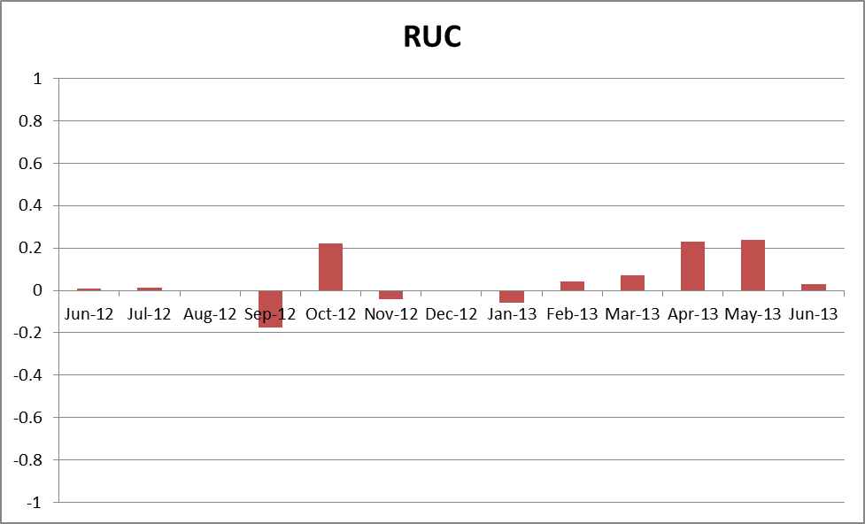

Monthly Average LMP
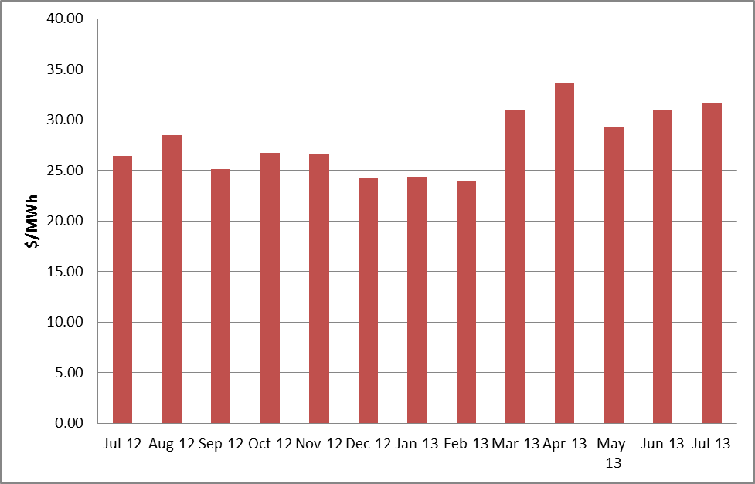

Wind Generation as a Percent of Load
One-hour average of total wind power output as a percentage of ERCOT load.

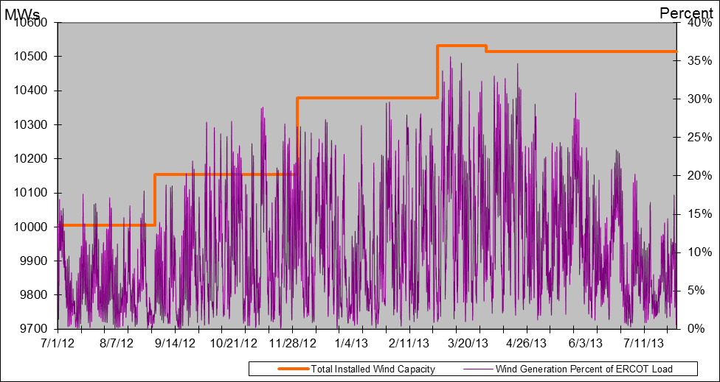

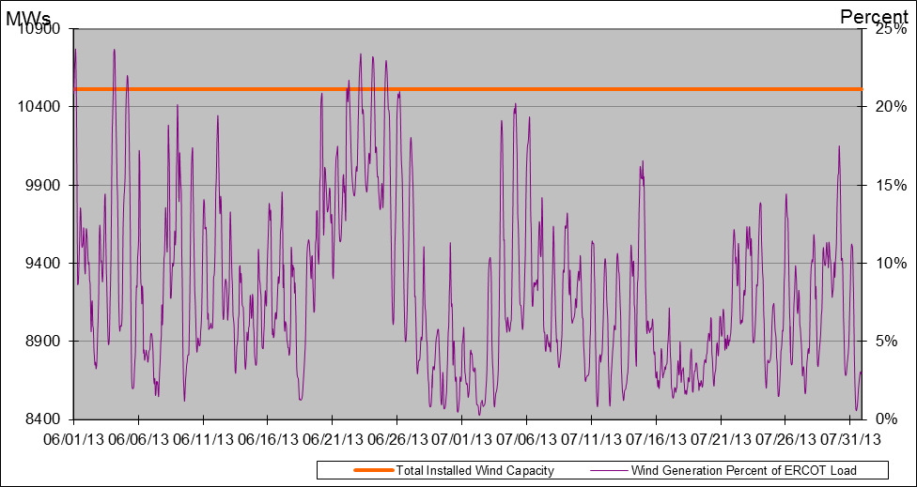

The hourly wind generation and load data used to develop these charts are available in the Nodal Monthly Aggregate WPF Report provided by ERCOT Operations to the QMWG.

Planning Model Activities
- The short term calendar of major planning model events follows:
  - Jun 14, 2013 13DSA/DSB TPIT updates posted
  - Jul 15, 2013 14 Data Set A posted
  - Aug 1, 2013 Project start of 14 Data Set B case build
  - Aug 7, 2013 SSWG Meeting to discuss HWLL case
- Status update on SCR760, Changes Needed for Information Model Manager and Topology Processor for Planning Models, which was approved by the ERCOT Board in March 2011.
- Final bundle migrated to ERCOT Production system on 7/31/2013. SCR760 is COMPLETE.
  - Bundle 1 (Items 3, 7 and 8): In Production.
  - Bundle 2 (Items 2a, 4, 9): In Production.
  - Bundle 3 (Item 5, 2b, 2c): In Production
  - Bundle 4 (Items 1, 6): In Production.
SCR Sub Part | SCR Description | Status
SCR760-1 | Upgrade to PSS/E v32 | Production
SCR760-2 | Distribution Capacitor banks | Production
SCR760-3 | Zero Impedance Line Ratings | Production
SCR760-4 | Associate Loads and Capacitor banks with the correct CNG | Production
SCR760-5 | Additional Transformer Data for Planning | Production
SCR760-6 | FACTS Devices | Production
SCR760-7 | Assign valid PSSE IDs to Breakers/  Switches/ Series Devices | Production
SCR760-8 | Phase shift of Autos for short circuit studies | Production
SCR760-9 | Multisection Line Grouping | Production
Table 1: In the following table:
- Red will be used to show status of Not Submitted, meaning that the SCR sub part has not been submitted to Siemens as a Service Request.
- Yellow will indicate that the SCR sub part has been submitted. The color will remain yellow and the status will change in order to Submitted, Planning (Requirements, SOW, Code Writing), Release (Siemens produces first code to test), and Testing (code has completed internal test and is moving through release management).
- Green will indicate that the code has been tested and installed on the machines that ERCOT uses to produce Topology Processor output for Planning and CRR.

Other Notable Activities
- The project to complete the missing and questionable data for the remaining Resource Asset Registration Forms (RARF) that are still incomplete is underway. ERCOT and Siemens created a list of 3387 individual data items that are missing or suspect. To date, 33 calls to Resource Entities regarding 51 different sites and 482 items within the list have been completed.
- ERCOT is working on the 2013 Regional Transmission Plan (RTP). The Reliability start cases including initial projects (previous 5YTP projects) was posted at the ERCOT POI on July 27, 2013. ERCOT is currently working on Reliability analysis to resolve the thermal and voltage issues.
- ERCOT is performing the study to analyze the system needs in the West Texas area due to oil and gas load growth. The preliminary reliability analysis results were presented at the June RPG meeting. The steady-state base cases used for this study are posted at the ERCOT POI. ERCOT is currently working on preparing the West Texas Sensitivity study report.
- ERCOT is preparing the report on the results of the Long-Term System Assessment and the improvements to the long-term study process as a result of the grant received from the Department of Energy.
- ERCOT is preparing a Request For Proposal (RFP) in order to hire a consultant to perform a small signal stability study. A draft study scope was presented to the PDCWG in July in order to obtain comments.

