ERCOT Operations Report
July 2013 ROS & OWG

Frequency Control
Time | Freq (Hz) | Duration (s)
7/8/2013 14:50 | 59.879 | 28 | Unit trip with approximately 610 MW net.
7/14/2013 0:05 | 59.881 | 78 | Gen deviation of approximately -395.3MW during frequency event.
7/18/2013 3:55 | 59.896 | 4 | Unit trip with approximately 436 MW net
7/21/2013 18:00 | 59.878 | 32 | Unit trip with approximately 600 MW net.
7/25/2013 1:15 | 59.824 | 49 | Unit trip with approximately 838 MW net.
Note: Time of frequency excursions outside the range of +/- 0.1 Hz.

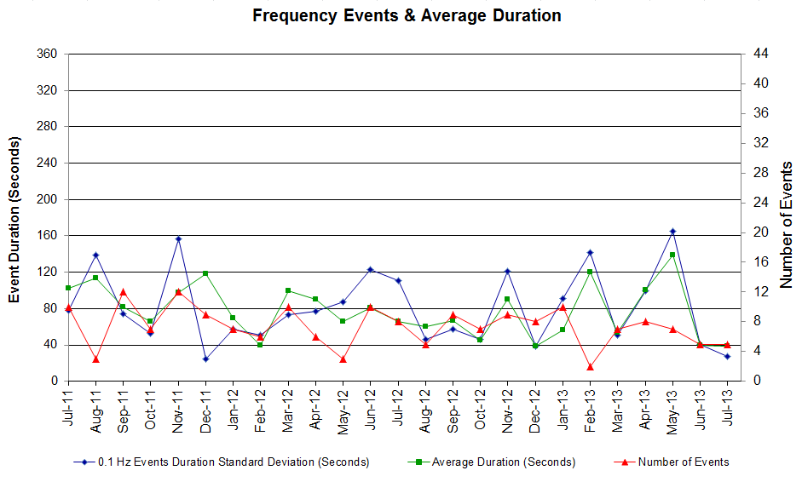

PMU Events

Date | Events | Duration | Summary
7/18/2013 03:55:13 | Unit Trip | Approx. 57 sec | The event was caused by the loss of one unit. The unit was generating 438 MW net before the trip, the frequency dropped to 59.89 Hz. The two oscillating frequencies of 0.51 Hz with 5.61% damping ratio and 0.3 Hz with 18.63% damping ratio were observed.
7/21/2013 18:00:44 | Unit Trip | Approx. 118 sec | The event was caused by the loss of one unit. The unit was generating 600 MW net before the trip, the frequency dropped to 59.877 Hz. The oscillating frequency of 0.56 Hz with 3.9% damping ratio was observed.
7/25/2013 01:15:45 | Unit Trip | Approx. 225 sec | The event was caused by the loss of one unit. The unit was generating 830 MW net before the trip, the frequency dropped to 59.822 Hz. The oscillating frequency of 0.53 Hz with 4.27% damping ratio was observed.

Deployed Responsive (Reported Above)

Time deployed | Stop Time | Duration | Max | Details
7/8/13 14:50:36 | 7/8/13 14:55:16 | 0:04:40 | 527.6
7/14/13 00:04:50 | 7/14/13 00:10:06 | 0:05:16 | 598.1
7/18/13 3:55:22 | 7/18/13 3:59:33 | 0:04:11 | 302.1
7/21/13 6:00:54 | 7/21/13 6:03:45 | 0:02:51 | 336.1
7/25/13 1:15:54 | 7/25/13 1:20:33 | 0:04:39 | 598.9

RUC Commitments
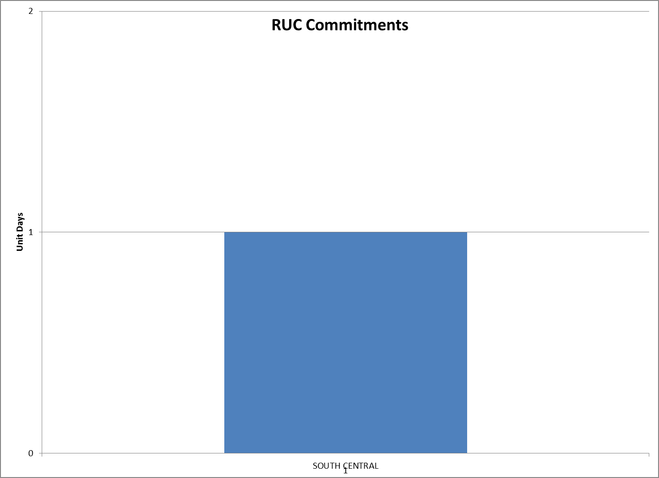

SCED Congestion Management Activity
Congestion affected by outages (*)
Contingency Description | Overloaded Element | Total
Midland East - Moss Switch 345kV | Odessa - Odessa North 138kV | 26
Austrop AU_AT2l (3) 345/138 kV | Austrop AU_AT1H 345/138 kV | 18
DCKT Roans Prairie - Kuykendahl - King and Singleton - Tomball 345 kV | Singleton - Zenith 345kV (SNGZEN99) | 15
Morgan Creek Ses Axfmr2h (3) 345/138 kV | Morgan Creek Ses Axfmr1l 345/138kV | 13
Lobo - San Miguel 345_138 KV Switchyards 345 KV | Laquinta - Lobo 138 kV | 12
Cagnon Axfmr3l-H (3)345/138kV | Cagnon AXFMR4H 345/138kV | 11
Orange Grove Switching Station - Lon Hill 138 kV | Lon Hill - Smith 69 kV | 9
Daffin Gin - Austrop 138 kV | Austrop - Dunlap 138 kV | 8
DCKT Jewett - Singleton 345kV | Twin Oak Switch - Btu_Jack_Creek 345 KV | 7
DCKT Whitepoint - Lon Hill & South Texas Project 345kV | Sinton - Skidmore 69 kV | 7
Laquinta - Lobo 138 kV | Falfur 138_69A1 138/69kV | 6
DCKT Marion - Zorn and Clear Springs 345 KV | Seguin - Seguin West 138 kV | 4
Fort Stockton Plant - Barrilla 138kV | Fort Stockton Switch - Barrilla 69 kV | 3
Kiamichi Energy Facility - Kiowa Switch 345kV (Kmchi_Kwass1) | Kiamichi Energy Facility - Kiowa Switch 345kV (Kmchi_Kwass2) | 3
Lobo 2_345_138_H 345/138 KV | Laquinta - Lobo 138 kV | 3
Victoria - Coleto Creek 138kV (Coleto_Victor1) | Coleto Creek - Victoria 138kV (Coleto_Victor2) | 3
DCKT Whitepoint - Lon Hill & South Texas Project 345kV | Rincon - Bonnieview 69kV | 3
DCKT Austrop -Sandow Switch 345 kV | Hutto - Round Rock Northeast 138 kV (1661_B) | 2
DCKT Odessa Ehv Switch - Longshore Switch & Quail Switch 345 kV | Stanton East - 1276 Triangle 138kV | 2
DCKT Garfield Lcra - Lytton Springs and Austrop - Zorn 345 kV | Garfield AT1 345/138 kV | 2
West Levee Switch AXFMR1L (3) 345/138 kV | Industrial Blvd - Compton Street 138 KV | 2
Bosque Switch - Elm Mott 345kV | Bosque Switch - Rogers Hill Bepc 138kV | 2
Bosque Switch - Elm Mott 345kV | Rogers Hill Bepc - Elm Mott 138kV | 2
DCKT Roans Prairie - Kuykendahl - King and Singleton - Tomball 345 kV | Singleton - Zenith 345kV (SNGZEN98) | 2
Morgan Creek Ses Axfmr2h (3) 345/138 kV | Morgan Creek Ses Axfmr1h 345/138kV | 2
DCKT Jefferson - Pasedena 138 kV and Deepwater - South Houston 69 kV | Conial - Waburn 138 kV | 2
Basecase | Laquinta - Lobo 138 kV | 1
DCKT Odessa Ehv Switch - Longshore Switch & Quail Switch 345 kV | Morgan Creek Ses - Cosden 138 kV | 1
DCKT Wa Parish - O'Brien 345 kV | Wa Parish - Jeanetta 245 kV (Jn_Wap72) | 1
Westside Aep - Cabaniss - Airline Aep 138 kV | Barney Davis - Rodd Field 138 kV | 1
China Grove Switch - Morgan Creek Ses 138 kV (6220) | China Grove Switch - Morgan Creek Ses 138 KV (6225) | 1
DCKT Watermill Switch - TriCorner & Trinidad Ses 345 kV | Seagoville - Kleberg Tap 138 kV | 1
Lobo - San Miguel 345_138 KV Switchyards 345 KV | Catarina - North Laredo Switch 138 kV | 1
Lobo - San Miguel 345_138 KV Switchyards 345 KV | Asherton - Catarina 138kV (Ashert_Catari1) | 1
Lobo 2_345_138_H 345/138 KV | Asherton - Catarina 138kV (Ashert_Catari1) | 1
Golden Switch - Sun Switch 138 kV | China Grove Switch - Bluff Creek Switch 138 kV | 1
Lon Hill 138_69A1 138/69 kV | Lon Hill 138_69A2 138/69 kV | 1
Morgan Creek - Sun Switch 138 kV | China Grove Switch - Bull Creek Switch 138 kV | 1
Ajo - Rio Hondo 345 KV | Yturria Sub - Raymondville 2 138 kV | 1
Laquinta - Lobo 138 kV | Falfurrias - Premont 69 kV | 1
DCKT Jewett - Singleton 345kV | Gibbons Creek - Singleton (SNGXGC99) | 1
DCKT Carrollton - Hackberry - Norwood Switch 345 kV | Dfw D-East 1 - Dfw C-East 138kV | 1
DCKT Austrop - Dunlap & Daffin Gin 138 kV | Garfield AT1 345/138 kV | 1
DCKT Austrop - Dunlap & Daffin Gin 138 kV | Hutto - Round Rock Northeast 138 kV (1661_B) | 1
Moss Switch AXFMR1T (3) 345/138 kV | Odessa - Odessa North 138kV | 1
DCKT Enterprise - Trinidad Ses & Stryker Creek Ses - Martin Lake Ses 345 kV | Nacogdoches SE - Herty North Switch 138 kV | 1
DCKT Martin Lake Ses - Elkton and Tyler Grande 345 kV and Stryker Creek Ses Unit 2 | Shamburger Switch - Tyler Northwest 138 kV | 1
Calallen Sub to Lon_hill 69kV | Lon_hill - Robstown_Tap 69kV | 1
Asphalt Mines - Uvalde Aep & Odlaw Switchyard 138kV | Hamilton Road - Maverick 138kV | 1
China Grove Switch - Morgan Creek Ses 138 kV (6225) | China Grove Switch - Morgan Creek Ses 138 kV (6220) | 1
No Trees Switch - Cheyenne Tap - Wink Sub 138 kV | Holt Switch - Amoco Midland Farms Tap 138 kV | 1
DCKT Gibbons Creek - Singleton 345 kV | Jewett - Singleton 345 kV (240) | 1
DCKT Gibbons Creek - Singleton 345 kV | Jewett - Singleton 345 kV (260_A) | 1
DCKT Gabriel - Bell County & Round Rock 138 kV | Hutto - Round Rock Northeast 138 kV (1661_B) | 1
Garfield GF_AT_1 345/138 kV | Austrop - Dunlap 138 kV | 1
Garfield GF_AT_1 345/138 kV | Austrop AU_AT1H 345/138 kV | 1
Salem Lcra AT3 345/138 kV | Fayetteville 26At2 345/138 kV | 1
Ph Robinson At3_H (3)345/138kV | Ph Robinson At1 (3) 345/138kV | 1
DCKT Skyline - Calaveras 345kV | Cagnon AXFMR4H 345/138kV | 1
DCKT Euless - Ligget Switch 138 kV | Dfw D-East 1 - Dfw C-East 138kV | 1
Cagnon Axfmr3l-H (3)345/138kV | Cagnon AXFMR4L-H 345/138kV | 1
Midland East Axfmr1l (3)345/138 kV | Stanton East - 1276 Triangle 138kV | 1
Euless - Dfw D-West - Dfw Southwest - Dfw E-East - Ligget Switch 138 kV | Dfw D-East 1 - Dfw C-East 138kV | 1
Utopia - Bandera Lcra 69 kV | Uvalde Aep 138_69A1 468/69kV | 1
DCKT Watermill Switch - Navarro 345 kV | Navarro - Venus Switch 345 kV (35040) | 1
Daffin Gin - Austrop 138 kV | Dunlap - Decker 138 kV | 1
Techridge - Decker Power Plant & Aep Dunlap 138 kV | Dunlap - Decker 138 kV | 1
DCKT Jefferson - Pasedena and Industrial - Phillip 138 kV | South Channel AT1_H (3) 138/69 kV | 1
DCKT Sr Bertron - Esfork - Rollen 138 kV | Sr Bertron - Miller 138 kV | 1

Generic Transmission Limits (GTL’s)
GTL | Days
West – North | 0

Congestion Cost
Binding Constraints – Year to Date
Contingency | Binding Element | Number of 5-min intervals | Shadow Price Range $/MWh | Estimated Congestion Rent $ (Shadow Price*Limit) | Transmission Project
Midland East to Moss Switch 138 kV & Moss Switch 345/138 kV Xfmr | Odessa - Odessa North 138 kV | 4391 | 0 - 3500 | 28,990,158 | 13TPIT0136,  14TPIT0054
Roanoke Switch - West Denton 345 kV & Roanoke Switch - Lewisville Switch 345 kV; or West Denton - Roanoke Switch 345 kV; or West Denton - Rdwells 138 kV | Jim Cristal - North Denton 138kV | 1407 | 0 - 3500 | 18,679,874 | 14TPIT0047
Roanoke Switch - West Denton 345 kV & Roanoke Switch - Lewisville Switch 345 kV; or West Denton - Roanoke Switch 345 kV | Fort Worth - Teasley 138 kV | 2813 | 0 - 3500 | 16,898,845 | 14TPIT0047
Amoco South Foster to Westover 138 kV | Moss Switch - Amoco North Cowden Tap 138 kV | 1204 | 0 - 3500 | 15,801,329 | 13TPIT0098, 13TPIT0093
Sun Switch - Golden Switch 138 kV; Sun Switch - Morgan Creek SES 138 kV | Bluff Creek Switch - China Grove Switch 138 kV | 809 | 0 - 3500 | 13,280,708 | 12TPIT0058, 13TPIT0098
Austrop 345/138 kV Xfmr & Garfield LCRA 345/138 kV Xfmr | Austrop 345/138 kV Xfmr | 1965 | 0 - 4500 | 11,898,409 | 10TPIT0031
Morgan Creek SES 345/138 kV Autotransformer 2 | Morgan Creek SES 345/138 kV Autotransformer 4 | 131 | 29 - 4500 | 11,206,208
West Denton - Rdwells 138 kV | Teasley - Pockrus Substation 138 kV | 939 | 0 - 3500 | 11,088,886
Ajo - Rio Hondo 345 kV | North Edinburg - Lon Hill 345 kV | 39 | 2 - 4500 | 7,633,932 | 14TPIT0050
McNeil - Gilleland Creek 138 kV;Gabriel To Bell County & Round Rock | Hutto - Round Rock NE 138 Kv | 1644 | 0 - 3500 | 7,305,704

Binding Constraints – July 2013
Contingency | Binding Element | Number of 5-min intervals | Shadow Price Range $/MWh | Estimated Congestion Rent $ (Shadow Price*Limit) | Transmission Project | Comments
Midland East to Moss Switch 138 kV & Moss Switch 345/138 kV Xfmr | Odessa - Odessa North 138 kV | 3006 | 0 - 3500 | 14,923,031 | 13TPIT0136,  14TPIT0054 | High load and low wind conditions
Austrop 345/138 kV Xfmr & Garfield LCRA 345/138 kV Xfmr | Austrop 345/138 kV Xfmr | 1965 | 0 - 4500 | 11,898,409 | 10TPIT0031 | Due to outage in Central Texas
Garfield LCRA 345/138 kV Xfmr & Austrop - Daffin 138 kV | Austrop - Dunlap 138 kV | 740 | 0 - 3500 | 6,752,182 | 10TPIT0031 | Due to outage in Central Texas
DCKT Roansprairie - Kuykendahl - King & Singleton - Tomball 345 kV | Singleton - Zenith 345 kV | 932 | 0 - 4500 | 1,823,097 |  | High load
Morgan Creek SES 345/138 kV AXFMR 2 | Morgan Creek SES 345/138 kV AXFMR 1 | 1012 | 0 - 478 | 1,654,067 |  | Low wind and high load condition
Orange Grove Switch - Lon Hill 138 kV | Lon Hill - Smith 69 kV | 690 | 0 - 2800 | 964,484 | 16TPIT0026 | High load
Cagnon 345/138 kV XFMR 3; DCKT Skyline - Calaveras 345 kV | Cagnon345/138kV XFMR 4 | 595 | 0 - 4500 | 939,327 | 14TPIT0031 | High load
DCKT Martin Lake SES - Elkton & Tyler Grande 345 kV | Tyler Northwest - Shamburger Switch 138 kV | 140 | 0 - 1498 | 766,890 | 09TPIT0122 | Planned outage in East Texas
DCKT Roansprairie - Kuykendahl - King & Singleton - Tomball 345 kV | Singleton - Zenith 345 kV | 44 | 0 - 4500 | 581,032 |  | High load
DCKT Whitepoint - Lon Hill & STP 345 kV | Sinton - Skidmore 69 kV | 379 | 0 - 2800 | 579,422 | 16TPIT0027 | High load

Wind Generation as a Percent of Load
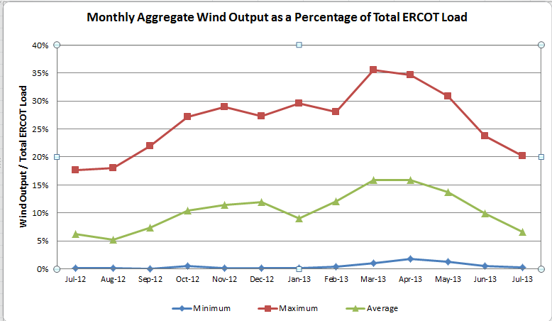

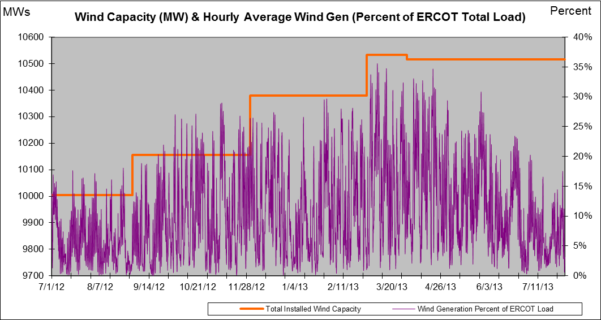

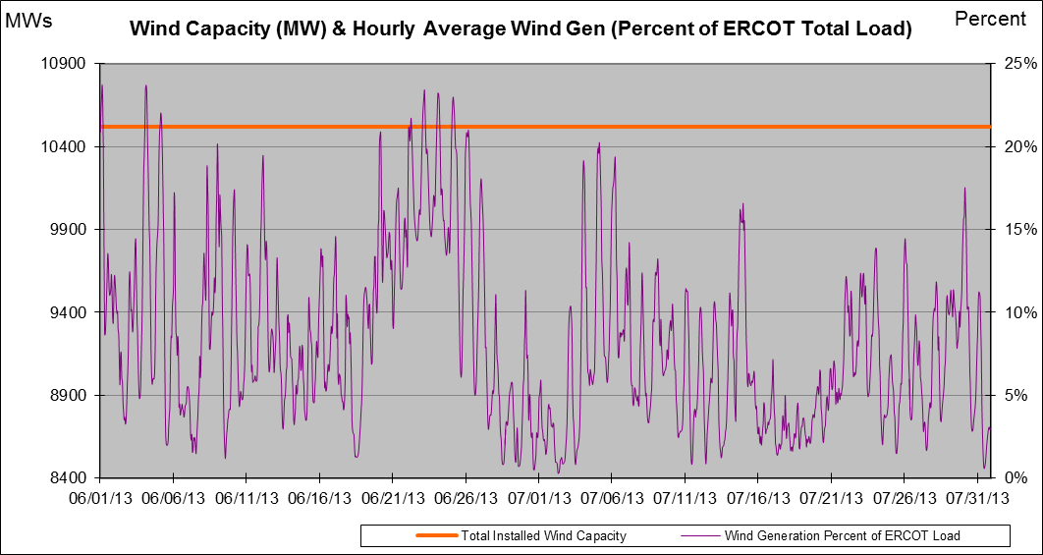

New RAP, PCAP (Date indicates last update of RAP, PCAP not implementation date.)
1 new RAP: Watermill – Tricorner/Trinidad 345 kV Double Circuit Line

SPS (RAS) (New, Modified, Removed)
1 SPS Removed: Austrop 345/138kV Auto Transformer
1 SPS Modified: Barney Davis Generation

New Procedures/Forms/Operations Bulletins
Power Operations Bulletin 636 - Transmission and Security Desk V1 Rev24
Power Operations Bulletin 635 - Shift Supervisor Desk V1 Rev21
Power Operations Bulletin 634 - Resource Desk V1 Rev23
Power Operations Bulletin 633 - Reliability Unit Commitment Desk V1 Rev20
Power Operations Bulletin 632 - Real Time Desk V1 Rev24
Power Operations Bulletin 631 - DC Tie Desk V1 Rev21
Power Operations Bulletin 630 - DC Tie Desk V1 Rev20

Load Shed Incidences
None

EEA
None

System Voltage Problems
None

Application Issues
07/29 10:54 ERCOT issued Advisory due to Voltage Security Assessment Tool (VSAT) has not solved in the last 30 minutes.

Communication Issues
None

ERCOT peak (Unofficial)
07/31 17:00 64,773 MW

Yearly MTLF Error Comparison
Yearly Mid-Term (Hourly) Load Forecast Error Comparison for the ERCOT Forecast
Month | MAPE for MTLF at 16:00 Day-Ahead
Month | 2010 | 2011 | 2012 | 2013
January | 3.78 | 2.91 | 2.94 | 3.50
February | 3.79 | 3.46 | 2.51 | 2.83
March | 2.24 | 2.02 | 3.49 | 2.68
April | 2.47 | 3.55 | 2.78 | 2.81
May | 2.63 | 3.27 | 3.09 | 3.12
June | 2.84 | 2.28 | 2.85 | 2.51
July | 2.39 | 1.63 | 2.85 | 2.70
August | 2.29 | 2.28 | 2.96
September | 3.14 | 2.70 | 3.43
October | 2.37 | 3.51 | 2.99
November | 3.46 | 3.38 | 2.90
December | 2.60 | 2.99 | 3.47
Annual Average | 2.83 | 2.83 | 3.02 | 2.91

OCN, Advisory, Watch & Emergency Notices
Capacity

OCN
None

Advisory
Date | Event
7/24/2013 15:49 | ERCOT issued Advisory due to Voltage Security Assessment Tool (VSAT) has not solved in the last 30 minutes.
7/29/2013 10:54 | ERCOT issued Advisory due to Voltage Security Assessment Tool (VSAT) has not solved in the last 30 minutes.

Transmission Watch
None

Watch
None

Emergency Notice
None

Texas RE Event Analysis
None

