 |  |  |  | System Planning
Monthly Status Report
June 2013

 |  | Report Highlights
 | - ERCOT is currently tracking 161 active generation interconnection requests totaling over 41,000 MW. This includes over 21,000 MW of wind generation.
- ERCOT is currently reviewing proposed transmission improvements with a total cost of $75 Million
- Transmission Projects endorsed in 2013 total $349.8 Million
- All projects (in engineering, routing, licensing and construction) total approximately $8.82 Billion.
- Transmission Projects energized in 2013 total about $1.29 Billion.

Table of Contents

1. Generation Interconnection 1
1.1 Signed Generation Interconnection Agreements 1
1.2 New Generation Registering for Commercial Operations 1
1.3 Summary of Generation Interconnection Requests 1
1.4 Projects with Interconnection Agreements 4
1.5 Projects Undergoing Full Interconnection Studies with Confidentiality Waived 5
1.6 Generation Projects Undergoing Full Interconnection Studies 5
1.7 Wind Generation Capacity Installed by Year 8
2. Regional Planning Group Project Reviews 9
3. Asynchronous Tie Interconnection 10
4. Congestion Costs 11
5. Wind Generation as a Percent of Load 14
6. Planning Model Activities 15
7. Other Notable Activities 16

1. Generation Interconnection
Additional information regarding detailed generation interconnection and impact studies is contained in the “Generation Project Interconnection Information” folder in the “Operations and System Planning” area on the ERCOT website: http://planning.ercot.com/login/login.

Signed Generation Interconnection Agreements
13INR0059 – Hereford Wind – 499 MW of Wind in Castro County

New Generation Registering for Commercial Operations
13DGR0001 – Bryan Solar – 10 MW of Solar in Presidio County
12INR0086 – WA Parish Addition – 75 MW of Gas in Fort Bend County

The total installed wind capacity is now reported as 10,570 MW by the resource owners through the registration process. Capacity by North, South and West is 832 MW, 2,375 MW, and 7,363 MW respectively. Eight-hundred fifty MW is able to switch between the West and South zones and is currently shown in the South zone.

Summary of Generation Interconnection Requests
GENERATION INTERCONNECTION REQUESTS CURRENTLY UNDER REVIEW
Currently tracking 161 generation interconnection or change requests
As of June 30, 2013 | Total
Security Screening Study | 12
SSS Completed | 12
Full Interconnect Study | 96
FIS Completed | 9
Suspended Studies | 0
Capacity of Suspended Study Projects | 0
Interconnect Agreement Completed | 35
Capacity under Interconnection Agreements | 13,295
Capacity for Grid, MW | 44,372
Wind Capacity, MW | 21,669

Fuel Type | Confidential Projects (MW) | Projects Under Full Study (MW) | Public Projects (MW) | Suspended Studies (MW) | Grand Total (MW)
Gas-AllOther |  |  | 449 | - | 6,903
Gas-CombinedCycle |  |  | 6,506 | - | 12,457
Total Gas | 2,615 | 9,790 | 6,955 | - | 19,360
Nuclear | - | - | - | - | -
Coal | - | - | 1,165 | - | 1,165
Wind | 2,748 | 13,859 | 5,062 | - | 21,669
Solar | 395 | 719 | 150 | - | 1,264
Biomass | - | - | - | - | -
Storage | - | 874 | 40 | - | 914
Petroleum Coke | - | - | - | - | -
Grand Total | 5,758 | 25,242 | 13,372 | - | 44,372

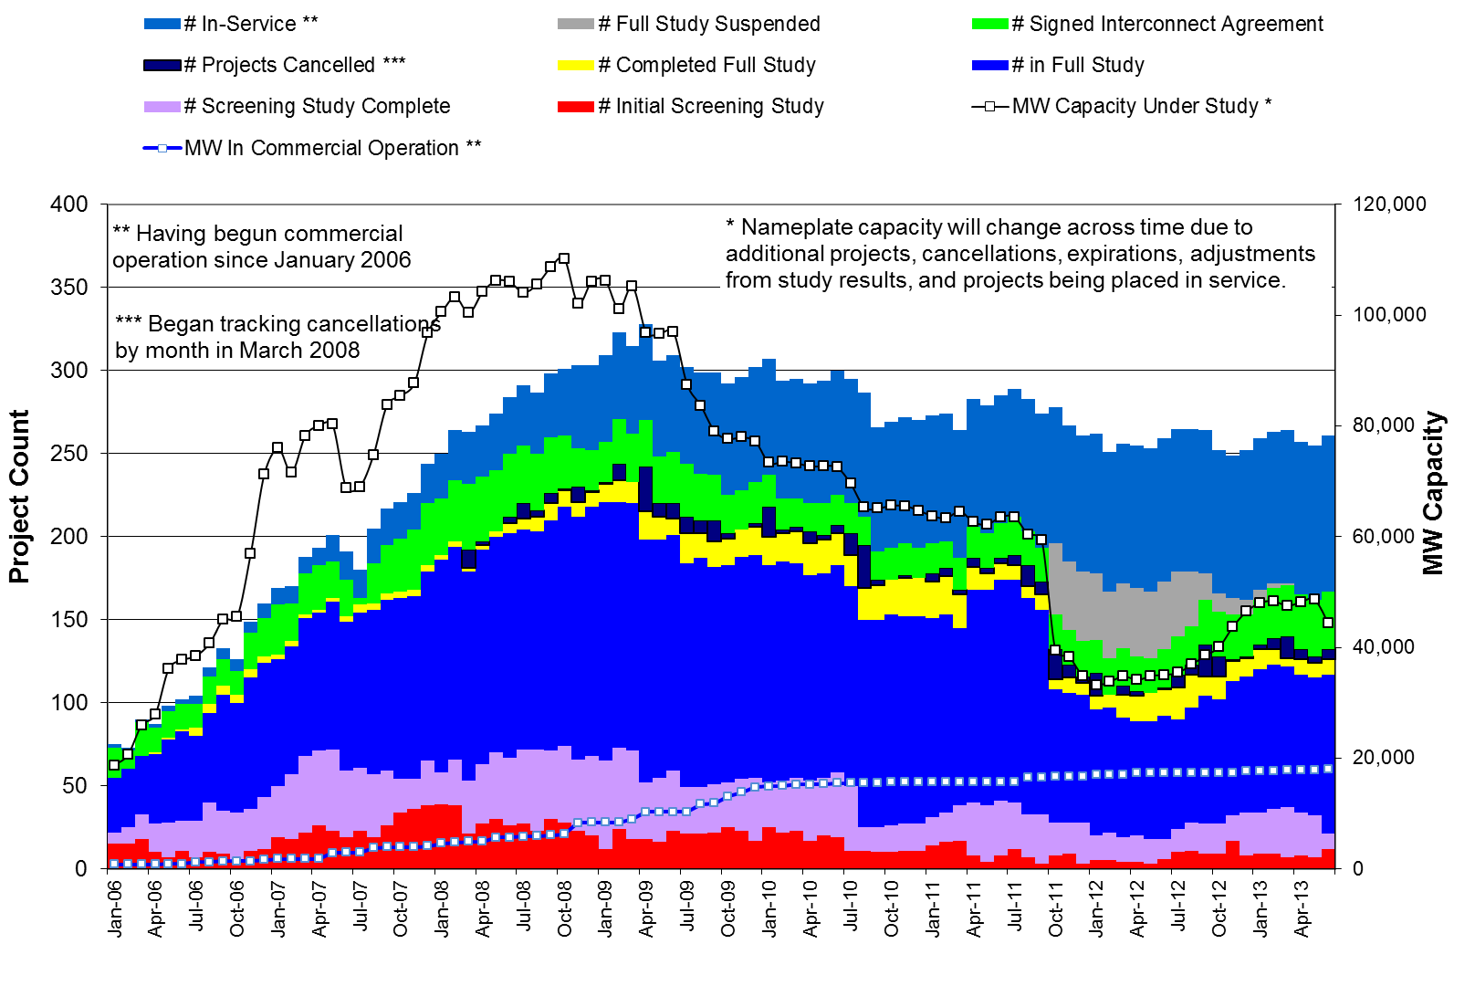
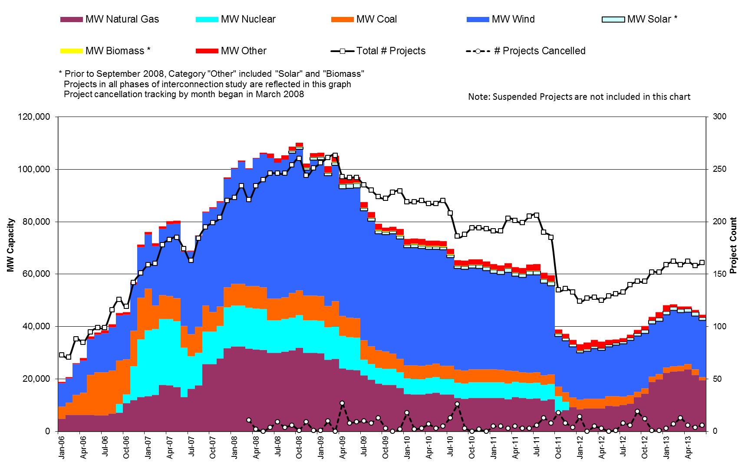

County Location of Installed Generation and Interconnection Requests (all fuels)

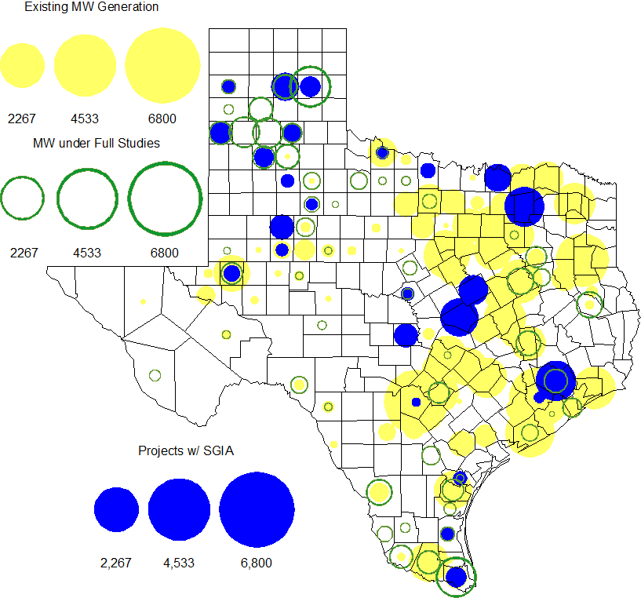

Projects with Interconnection Agreements

Generation Interconnections as of June 30, 2013
INR | Site Name | County | COD | Fuel | MW For Grid | Change from Last Report
10INR0089 | Deepwater Energy Storage | Harris | Jul-13 | Storage | 40
11INR0033 | Los Vientos | Cameron | Jul-13 | Wind | 400 | Date
12INR0075 | Blue Summit Windfarm | Wilbarger | Jul-13 | Wind | 135 | Date
09INR0001 | Sandy Creek 1 | McLennan | Jul-13 | Coal | 925 | Date
13INR0059 | Hereford Wind | Castro | Oct-13 | Wind | 499 | New
13INR0058 | OCI Alamo 1 | Bexar | Oct-13 | Solar | 50
11INR0094 | White Camp Solar | Kent | Nov-13 | Solar | 100
11INR0013 | Goldthwaite Wind Energy | Mills | Dec-13 | Wind | 150
12INR0034 | Stephens Ranch Wind Energy | Borden | Dec-13 | Wind | 378
14INR0012 | Miami Wind 1 Project | Gray | May-14 | Wind | 401
13INR0048 | Spinning Spur Wind Two | Oldham | Jun-14 | Wind | 161
14INR0015 | Deer Park Energy Center | Harris | Jun-14 | Gas | 192
14INR0016 | Channel Energy Center 138/345kV CT | Harris | Jun-14 | Gas | 190
10INR0021 | Panda Sherman Power | Grayson | Jun-14 | Gas | 809
10INR0020a | Panda Temple Power | Bell | Jun-14 | Gas | 809
13INR0021 | Ferguson Replacement Project | Llano | Jul-14 | Gas | 570
13INR0040 | Agrifos Steam Unit | Harris | Aug-14 | Gas | -
14INR0030a2 | Panhandle Wind | Carson | Aug-14 | Wind | 218
11INR0050 | Moore Wind 1 | Crosby | Aug-14 | Wind | 149
13INR0010a | Mariah Wind | Parmer | Oct-14 | Wind | 200
11INR0054 | Midway Farms Wind | San Patricio | Oct-14 | Wind | 161 | Date
14INR0023 | Longhorn Energy Center | Briscoe | Dec-14 | Wind | 361
13INR0005 | Conway Windfarm | Carson | Dec-14 | Wind | 600
06INR0022c | Penascal Wind Farm 3 | Kenedy | Dec-14 | Wind | 202
11INR0079a | South Clay Windfarm | Clay | Dec-14 | Wind | 200
09INR0051 | Mesquite Creek | Borden | Mar-15 | Wind | 249
08INR0018 | Gunsight Mountain | Howard | Aug-15 | Wind | 120
10INR0020b | Panda Temple Power | Bell | Aug-15 | Gas | 780
13INR0010b | Mariah Wind | Parmer | Dec-15 | Wind | 200
13INR0023 | Texas Clean Energy Project | Ector | Jan-16 | Coal | 240
13INR0028 | Antelope Station | Hale | Jun-16 | Gas | 359
10INR0022 | Pondera King Power Project | Harris | Jun-16 | Gas | 1,380
06INR0006 | Cobisa-Greenville | Hunt | Dec-16 | Gas | 1,792 | Date
13INR0010c | Mariah Wind | Parmer | Dec-16 | Wind | 200 | Date

Projects Undergoing Full Interconnection Studies with Confidentiality Waived
INR | Site Name | County | COD | Fuel | MW for Grid | Change from Last Report

Generation Projects Undergoing Full Interconnection Studies

Interconnection Database Reference Number | County | Fuel | Capacity to Grid (MW) | Commercial Operation Date (as specified by the resource developer)
13INR0026 | Oldham | Wind | 201 | 12/1/2013
13INR0056 | Scurry | Wind | 366 | 12/1/2013
13INR0055 | Zapata | Wind | 250 | 12/1/2013
13INR0052 | Starr | Wind | 200 | 12/1/2013
13INR0038 | Swisher | Wind | 300 | 12/1/2013
15INR0021 | Starr | Wind | 200 | 12/31/2013
14INR0024 | Kinney | Solar | 42 | 12/31/2013
12INR0068 | Jim Hogg | Wind | 78 | 12/31/2013
14INR0014 | Val Verde | Solar | 100 | 1/1/2014
12INR0055 | Baylor | Wind | 40 | 1/1/2014
13INR0006 | Gray | Wind | 750 | 1/1/2014
14INR0013 | Cameron | Wind | 103 | 1/1/2014
14INR0059 | Kaufman | Gas | 52 | 2/1/2014
14INR0039 | Ector | Gas | 450 | 3/1/2014
13INR0059 | Castro | Wind | 499 | 3/1/2014
12INR0060 | Schleicher | Wind | 58 | 4/1/2014
14INR0027 | Guadalupe | Gas | 471 | 5/1/2014
11INR0057 | Cameron | Wind | 165 | 6/1/2014
08INR0019a | Gray | Wind | 250 | 6/1/2014
08INR0019b | Gray | Wind | 250 | 6/1/2014
08INR0019c | Gray | Wind | 250 | 6/1/2014
14INR0048 | Wilbarger | Wind | 114 | 6/1/2014
14INR0038 | Galveston | Gas | 390 | 6/1/2014
13INR0057 | Archer | Wind | 65 | 6/1/2014
14INR0040 | Hidalgo | Gas | 225 | 6/7/2014
12INR0059 | Pecos | Solar | 50 | 6/30/2014
12INR0085 | Stonewall | Wind | 24 | 7/1/2014
11INR0093 | San Patricio | Wind | 41 | 7/1/2014
14INR0029 | Uvalde | Solar | 42 | 7/1/2014
14INR0047 | Dickens | Wind | 301 | 10/1/2014
Interconnection Database Reference Number | County | Fuel | Capacity to Grid (MW) | Commercial Operation Date (as specified by the resource developer)
12INR0070 | Knox | Wind | 300 | 10/15/2014
13INR0036 | Hidalgo | Wind | 200 | 10/31/2014
12INR0045 | Kleberg | Wind | 135 | 10/31/2014
14INR0060 | Haskell | Wind | 400 | 11/1/2014
13INR0025 | Randall | Wind | 150 | 11/1/2014
14INR0030b | Carson | Wind | 322 | 11/1/2014
14INR0033 | Armstrong | Wind | 500 | 12/1/2014
13INR0050 | Comanche | Wind | 200 | 12/1/2014
14INR0032a | Randall | Wind | 200 | 12/1/2014
13INR0054 | Bee | Gas | 0 | 12/1/2014
14INR0025a | Floyd | Wind | 200 | 12/1/2014
14INR0041 | Willacy | Wind | 300 | 12/1/2014
14INR0043 | Sterling | Solar | 40 | 12/1/2014
11INR0082A | Val Verde | Wind | 50 | 12/1/2014
11INR0082B | Val Verde | Wind | 150 | 12/1/2014
14INR0044 | Reeves | Solar | 100 | 12/1/2014
10INR0085 | Ector | Solar | 56.5 | 12/1/2014
14INR0028 | Live Oak | Wind | 300 | 12/1/2014
14INR0009 | Kent | Wind | 248 | 12/1/2014
12INR0079 | Kenedy | Wind | 200 | 12/15/2014
13INR0045 | Castro | Wind | 288 | 12/30/2014
14INR0057b | Erath | Wind | 48 | 12/31/2014
14INR0020 | Floyd | Wind | 150 | 12/31/2014
14INR0049_2 | Jack | Wind | 102 | 12/31/2014
14INR0057 | Erath | Wind | 48 | 12/31/2014
14INR0049_1 | Jack | Wind | 102 | 12/31/2014
13INR0010d | Parmer | Wind | 200 | 12/31/2014
14INR0056 | Mills | Wind | 101 | 12/31/2014
14INR0045a | Webb | Wind | 502 | 12/31/2014
10INR0009 | Castro | Wind | 300 | 3/31/2015
15INR0028 | Freestone | Gas | 160 | 6/1/2015
15INR0042 | Hood | Gas | 460 | 6/1/2015
15INR0027 | Hidalgo | Gas | 79 | 6/1/2015
15INR0022 | Presidio | Solar | 75 | 6/1/2015
15INR0023 | Wharton | Gas | 700 | 6/15/2015
14INR0026 | Presidio | Solar | 28 | 9/1/2015
15INR0013 | Anderson | Gas | 324 | 10/1/2015
15INR0014 | Matagorda | Gas | 280 | 10/1/2015
11INR0065 | Nueces | Wind | 350 | 10/31/2015
14INR0030a1 | Carson | Wind | 322 | 11/1/2015
14INR0032b | Randall | Wind | 300 | 12/1/2015
14INR0018 | Nolan | Solar | 35 | 12/31/2015
Interconnection Database Reference Number | County | Fuel | Capacity to Grid (MW) | Commercial Operation Date (as specified by the resource developer)
13INR0010e | Parmer | Wind | 200 | 12/31/2015
12INR0002a | Briscoe | Wind | 200 | 12/31/2015
15INR0037 | Starr | Wind | 200 | 12/31/2015
13INR0032 | Andrews | Solar | 30 | 12/31/2015
14INR0045b | Webb | Wind | 251 | 12/31/2015
16INR0010 | Mitchell | Gas | 799 | 2/1/2016
16INR0005 | Cameron | Gas | 871 | 4/1/2016
16INR0009 | Calhoun | Gas | 510 | 4/14/2016
15INR0032 | Hale | Gas | 197 | 5/1/2016
15INR0033 | Hale | Gas | 197 | 5/1/2016
16INR0008 | Grimes | Gas | 687 | 5/1/2016
16INR0004 | Cameron | Gas | 730 | 6/1/2016
16INR0007 | Hidalgo | Gas | 95 | 6/1/2016
16INR0003 | Brazoria | Gas | 11 | 6/1/2016
16INR0006 | Angelina | Gas | 785 | 6/1/2016
14INR0011 | Swisher | Gas | 270 | 7/1/2016
13INR0010f | Parmer | Wind | 200 | 12/31/2016
12INR0002b | Briscoe | Wind | 200 | 12/31/2016
12INR0018 | Gray | Wind | 500 | 3/31/2017
17INR0004 | Hale | Gas | 170 | 5/1/2017
17INR0002 | Henderson | Gas | 489 | 6/1/2017
11INR0040 | Freestone | Gas | 640 | 3/1/2018

Wind Generation Capacity Installed by Year
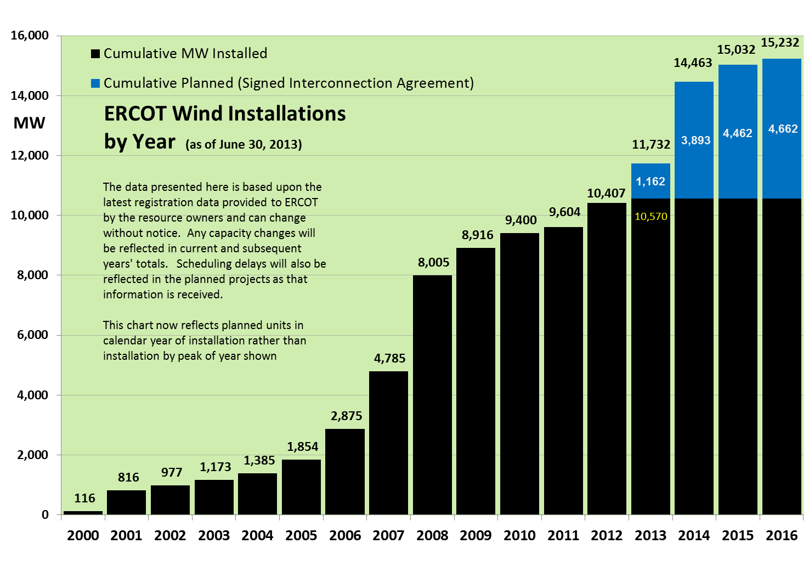
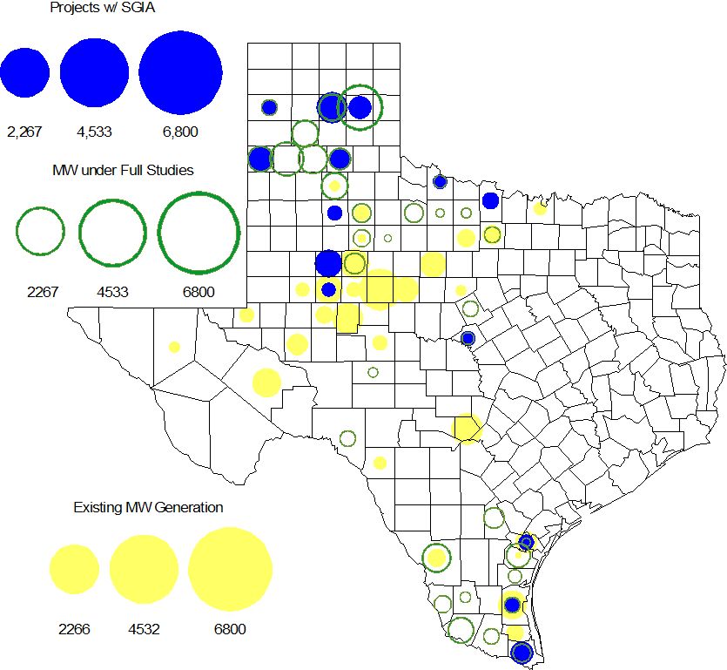

Regional Planning Group Project Reviews

- Oncor submitted the Permian Basin to Moss to Odessa EHV 345 kV project. This is a Tier 1 project that is estimated to cost approximately $75 million. This project is currently under ERCOT independent review.

- Bryan Texas Utilities (BTU) submitted the Southwest Brazos County 138 kV loop project. This project is estimated to cost approximately $6.2 million. This project was initially classified as a Tier 3 and and the project has statisfied all the RPG comments. In accordance with Protocol Section 3.11.4.5, the Southwest Brazos County 138 kV loop project has been reclassified as a “Tier 4 Neutral Project.”

- Sharyland Utilities submitted the Stanton/Midland Northern loop project. This project is classified as a Tier 3 and has been submitted for RPG comments. In accordance with Protocol Section 3.11.4.5(c), once the RPG comments are resolved this project will be reclassified as a Tier 4 Neutral project.

Asynchronous Tie Interconnection

Project | Notification to ERCOT | Reliability Study | RPG Review | Interconnection Agreement | In-service Year
Railroad DC tie expansion (150 MW - CFE) |  |  |  |  | 2014
Southern Cross HVDC (3000 MW - SERC)
Tres Amigas (1500 MW - SPP)

Color Legend
In progress
Complete

Congestion Costs
Dollars shown in RUC Make Whole payment graph are of settlement quality.

RUC net Make Whole payment in $mm
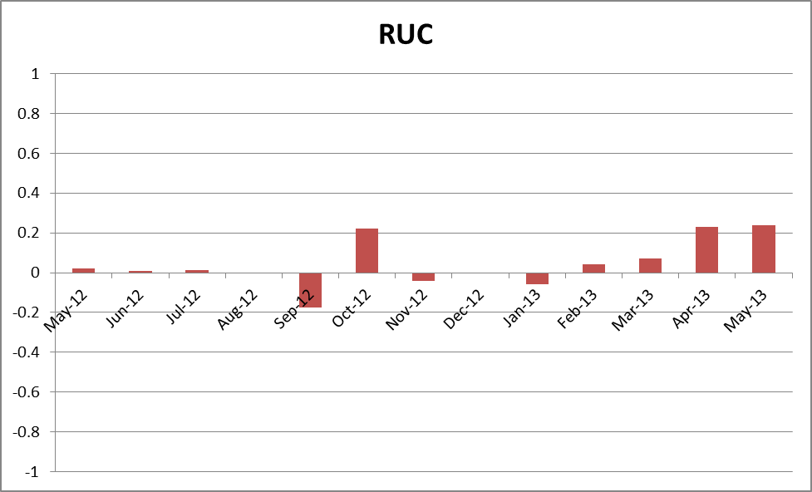

Monthly Average LMP
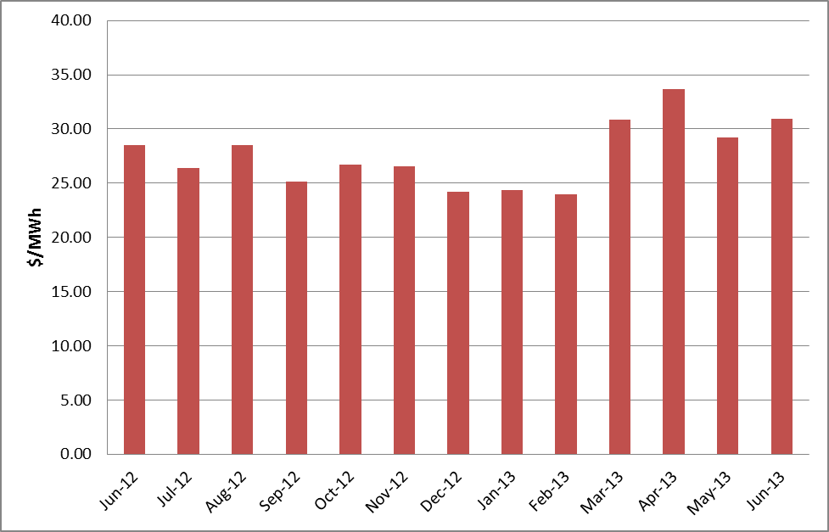

Binding Constraints – Year to Date
Contingency | Binding Element | Number of 5-min intervals | Shadow Price Range $/MWh | Estimated Congestion Rent $ (Shadow Price*Limit) | Transmission Project
Roanoke Switch - West Denton and - Lewisville Switch 345 kV; or West Denton - Roanoke Switch 345 kV; or West Denton - Rdwells 138 kV | Jim Cristal - North Denton 138kV | 1407 | 0 - 3500 | 18,679,874 | 14TPIT0047
Roanoke Switch - West Denton 345 kV & Roanoke Switch - Lewisville Switch 345 kV | Fort Worth - Teasley 138 kV | 2813 | 0 - 3500 | 16,898,845 | 14TPIT0047
Odessa North 138/69 kV Autotransformer; or West Over - Odessa 138 kV | Moss Switch - Amoco North Cowden Tap 138 kV | 1204 | 0 - 3500 | 15,801,329 | 13TPIT0098, 13TPIT0093
Midland East to Moss Switch 138 kV | Odessa - Odessa North 138 kV | 1385 | 0 - 3500 | 14,067,127 | 13TPIT0136,14TPIT0054
Golden Switch - Sun Switch 138 kV; or Sacroc - Sun Switch 138 kV; or Snyder - China Grove 138 kV | China Grove - Bluff Creek 138 kV | 755 | 0 - 3500 | 12,781,489 | 12TPIT0058, 13TPIT0098
Morgan Creek SES 345/138 kV Autotransformer 2 | Morgan Creek SES 345/138 kV Autotransformer 4 | 131 | 29 - 4500 | 11,206,208
West Denton - Rdwells 138 kV | Teasley - Pockrus Substation 138 kV | 939 | 0 - 3500 | 11,088,886
Ajo - Rio Hondo 345 kV | North Edinburg - Lon Hill 345 kV | 39 | 2 - 4500 | 7,633,932 | 14TPIT0050
McNeil - Gilleand Creek 138 kV | Hutto - Round Rock NE 138 Kv | 1446 | 0 - 3500 | 7,205,932
Asphalt Mines - Odlaw Switch 138 kV | Hamilton Road - Marverick 138 kV | 5604 | 0 - 2905 | 6,451,792 | 16TPIT0024
Binding Constraints – June 2013
Contingency | Binding Element | Number of 5-min intervals | Shadow Price Range $/MWh | Estimated Congestion Rent $ (Shadow Price*Limit) | Transmission Project | Comments
Midland East to Moss Switch 138 kV | Odessa - Odessa North 138 kV | 1122 | 0 - 3500 | 12,833,493 | 13TPIT0136,14TPIT0054 | High load and low wind conditions.
McNeil - Gilleland Creek 138 kV;Gabriel To Bell County & Round Rock | Hutto - Round Rock NE 138 Kv | 1012 | 0 - 3500 | 4,190,809 |  | Outage on Austrop – Decker 138 kV line and Decker to Webber Tap 138 kV line.
DCKT Singleton - Tomball 345 kV | Singleton - Zenith 345 kV | 816 | 0 - 4500 | 4,168,352
Amoco South Foster to Westover 138 kV | Moss Switch - Amoco North Cowden Tap 138 kV | 268 | 0 - 3500 | 3,342,420 | 13TPIT0098, 13TPIT0093 | High load and low wind conditions.
Sun Switch - Morgan Creek 138 kV | Chinagrove Switch - Snyder 138 kV | 45 | 3500 - 3500 | 2,596,242 | 12TPIT0058, 13TPIT0098 | Forced outage on Bluff Creek Switch – China Grove Switch 138 kV line.
Atkins - Dansby 138 kV | BTU Industrial Park - BTU North 69 kV | 127 | 9 - 2800 | 2,232,480
DCKT Garfield - Hicross 138 kV; DCKT Austrop - Garfield 345 kV; DCKT Garfield - Lytton Springs 345 kV; DCKT Garfield - Stoney Ridge 138 kV | Austrop - Daffin 138 kV | 585 | 0 - 3500 | 2,190,356 | 10TPIT0031 | Outage on Austrop – Decker 138 kV line and Decker to Webber Tap 138 kV line.
Cagnon 345/138 kV XFMR 3; DCKT Skyline - Calaveras 345 kV | Cagnon345/138kV XFMR 4 | 594 | 0 - 979 | 2,094,881 | 14TPIT0031
Morgan Creek SES 345/138 kV AXFMR 2 | Morgan Creek SES 345/138 kV AXFMR 1 | 497 | 0 - 462 | 2,000,902
Ajo - Rio Hondo 345 kV | North Edinburg - Lon Hill 345 kV | 5 | 4500 - 4500 | 1,774,388 | 14TPIT0050 | Generation outages in the area.

Wind Generation as a Percent of Load
One-hour average of total wind power output as a percentage of ERCOT load.

The hourly wind generation and load data used to develop these charts are available in the Nodal Monthly Aggregate WPF Report provided by ERCOT Operations to the QMWG.

Planning Model Activities
- The short term calendar of major planning model events follows:
  - Jun 14, 2013 13DSA/DSB TPIT updates posted
  - Jul 12, 2013 Projected posting 14 Data Set A
  - Aug 1, 2013 Project start of 14 Data Set B case build
- Status update on SCR760, Changes Needed for Information Model Manager and Topology Processor for Planning Models, which was approved by the ERCOT Board in March 2011.
  - Bundle 1 (Items 3, 7 and 8): In Production.
  - Bundle 2 (Items 2a, 4, 9): In Production.
  - Bundle 3 (Item 5, 2b, 2c): In Production
  - Bundle 4 (Items 1, 6): Development testing completed, moved to ITEST for more testing. Expected off-cycle release to the environments used to create the products used for production planned for end of July 2013.
SCR Sub Part | SCR Description | Status
SCR760-1 | Upgrade to PSS/E v32 | Production
SCR760-2 | Distribution Capacitor banks | Production
SCR760-3 | Zero Impedance Line Ratings | Production
SCR760-4 | Associate Loads and Capacitor banks with the correct CNG | Production
SCR760-5 | Additional Transformer Data for Planning | Production
SCR760-6 | FACTS Devices | Testing
SCR760-7 | Assign valid PSSE IDs to Breakers/  Switches/ Series Devices | Production
SCR760-8 | Phase shift of Autos for short circuit studies | Production
SCR760-9 | Multisection Line Grouping | Production
Table 1: In the following table:
- Red will be used to show status of Not Submitted, meaning that the SCR sub part has not been submitted to Siemens as a Service Request.
- Yellow will indicate that the SCR sub part has been submitted. The color will remain yellow and the status will change in order to Submitted, Planning (Requirements, SOW, Code Writing), Release (Siemens produces first code to test), and Testing (code has completed internal test and is moving through release management).
- Green will indicate that the code has been tested and installed on the machines that ERCOT uses to produce Topology Processor output for Planning and CRR.

Other Notable Activities
- The project to complete the missing and questionable data for the remaining Resource Asset Registration Forms (RARF) that are still incomplete is underway. ERCOT and Siemens created a list of 3339 individual data items that are missing or suspect. To date, 24 calls to Resource Entities regarding 40 different sites and 199 items within the list have been completed.
- ERCOT is working on the 2013 Regional Transmission Plan (RTP). The study base case modeling assumptions (load, generation, DC ties etc.) were presented at the June RPG meeting. ERCOT is currently working on preparing the Reliability start cases for the 2013 RTP.
- ERCOT is currently performing the study to analyze the system needs in the West Texas area due to oil and gas load growth. The preliminary reliability analysis results were presented at the June RPG meeting. The steady-state base cases used for this study are posted at the ERCOT POI. ERCOT is currently performing the economic analysis for the West Texas Sensitivity study.
- ERCOT is preparing the report on the results of the Long-Term System Assessment and the improvements to the long-term study process as a result of the grant received from the Department of Energy. The report is expected to be published in July.

