 |  |  |  | System Planning
Monthly Status Report
May 2013

 |  | Report Highlights
 | - ERCOT is currently tracking 158 active generation interconnection requests totaling over 48,000 MW. This includes over 20,000 MW of wind generation.
- ERCOT is currently reviewing proposed transmission improvements with a total cost of $81.2 Million
- Transmission Projects endorsed in 2013 total $349.8 Million
- All projects (in engineering, routing, licensing and construction) total approximately $9.68 Billion.
- Transmission Projects energized in 2013 total about $38.6 million.

Table of Contents
1. Generation Interconnection 1
1.1 Signed Generation Interconnection Agreements 1
1.2 New Generation Registering for Commercial Operations 1
1.3 Summary of Generation Interconnection Requests 1
1.4 Projects with Interconnection Agreements 4
1.5 Generation Projects Undergoing Full Interconnection Studies with Confidentiality Waived by Developer 4
1.6 Generation Projects Undergoing Full Interconnection Studies 5
1.7 Wind Generation Capacity Installed by Year 6
2. Regional Planning Group Project Reviews 7
3. Asynchronous Tie Interconnection 8
4. Congestion Costs 9
5. Wind Generation as a Percent of Load 12
6. Planning Model Activities 13
7. Other Notable Activities 14

1. Generation Interconnection
Additional information regarding detailed generation interconnection and impact studies is contained in the “Generation Project Interconnection Information” folder in the “Operations and System Planning” area on the ERCOT website: http://planning.ercot.com/login/login.

Signed Generation Interconnection Agreements
11INR0094 – White Camp Solar – 100 MW of Solar in Kent County

New Generation Registering for Commercial Operations
None

The total installed wind capacity is now reported as 10,570 MW by the resource owners through the registration process. Capacity by North, South and West is 832 MW, 2,375 MW, and 7,363 MW respectively. Eight-hundred fifty MW is able to switch between the West and South zones and is currently shown in the South zone.

Summary of Generation Interconnection Requests
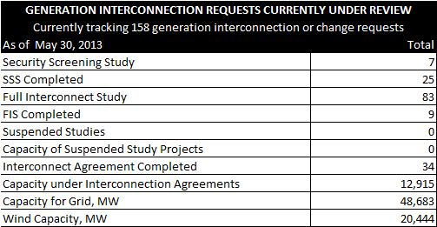

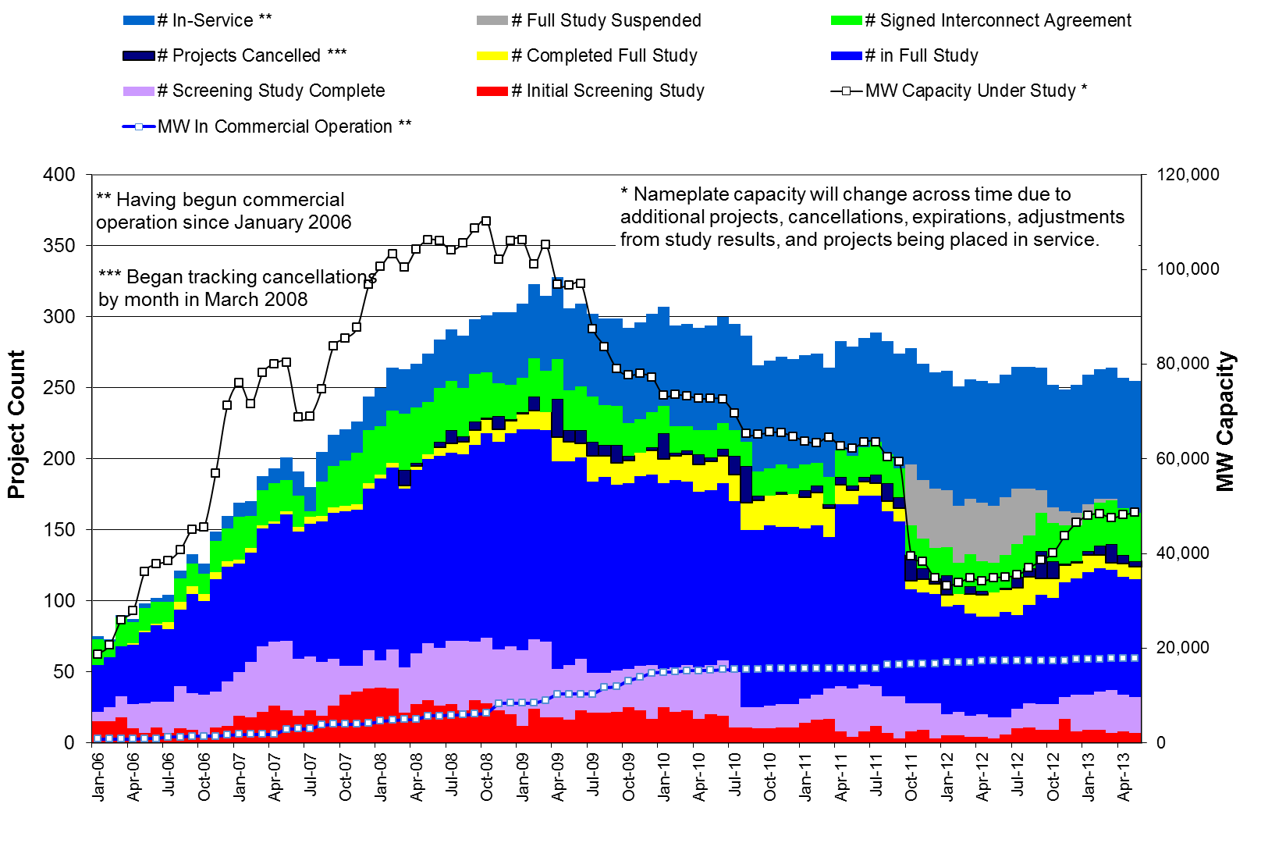

County Location of Installed Generation and Interconnection Requests (all fuels)

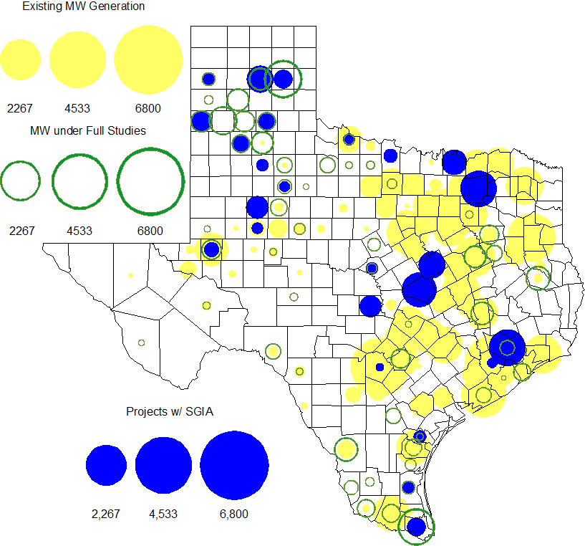

Projects with Interconnection Agreements

Generation Interconnections as of May 30, 2013
INR | Site Name | County | COD | Fuel | MW For Grid | Change from Last Report
09INR0001 | Sandy Creek 1 | McLennan | Jun-13 | Coal | 925 | date
12INR0075 | Blue Summit Windfarm | Wilbarger | Jun-13 | Wind | 135 | date
11INR0033 | Los Vientos | Cameron | Jun-13 | Wind | 400 | date
12INR0086 | WA Parish Addition | Fort Bend | Jun-13 | Gas | 90
10INR0089 | Deepwater Energy Storage | Harris | Jul-13 | Storage | 40
13INR0058 | OCI Alamo 1 | Bexar | Oct-13 | Solar | 50 | date
11INR0094 | White Camp Solar | Kent | Nov-13 | Solar | 100 | New
11INR0013 | Goldthwaite Wind Energy | Mills | Dec-13 | Wind | 150
11INR0054 | Midway Farms Wind | San Patricio | Dec-13 | Wind | 161 | date
12INR0034 | Stephens Ranch Wind Energy | Borden | Dec-13 | Wind | 378
14INR0012 | Miami Wind 1 Project | Gray | May-14 | Wind | 401 | date
13INR0048 | Spinning Spur Wind Two | Oldham | Jun-14 | Wind | 161
14INR0015 | Deer Park Energy Center | Harris | Jun-14 | Gas | 192
14INR0016 | Channel Energy Center 138/345kV CT | Harris | Jun-14 | Gas | 190
13INR0021 | Ferguson Replacement Project | Llano | Jul-14 | Gas | 570 | date
14INR0030a2 | Panhandle Wind | Carson | Aug-14 | Wind | 322 | date
10INR0021 | Panda Sherman Power | Grayson | Jun-14 | Gas | 809 | date
13INR0040 | Agrifos Steam Unit | Harris | Aug-14 | Gas | 0
11INR0050 | Moore Wind 1 | Crosby | Aug-14 | Wind | 149
13INR0010a | Mariah Wind | Parmer | Oct-14 | Wind | 200
14INR0023 | Longhorn Energy Center | Briscoe | Dec-14 | Wind | 361
13INR0005 | Conway Windfarm | Carson | Dec-14 | Wind | 600
11INR0079a | South Clay Windfarm | Clay | Dec-14 | Wind | 200
06INR0022c | Penascal Wind Farm 3 | Kenedy | Dec-14 | Wind | 202
13INR0010c | Mariah Wind | Parmer | Jan-15 | Wind | 200 | date
09INR0051 | Mesquite Creek | Borden | Mar-15 | Wind | 249
10INR0020a | Panda Temple Power | Bell | Jun-14 | Gas | 809 | date
08INR0018 | Gunsight Mountain | Howard | Aug-15 | Wind | 120
13INR0010b | Mariah Wind | Parmer | Dec-15 | Wind | 200
13INR0023 | Texas Clean Energy Project | Ector | Jan-16 | Coal | 240
06INR0006 | Cobisa-Greenville | Hunt | May-16 | Gas | 1,792
10INR0020b | Panda Temple Power | Bell | Aug-15 | Gas | 780
13INR0028 | Antelope Station | Hale | Jun-16 | Gas | 359
10INR0022 | Pondera King Power Project | Harris | Dec-16 | Gas | 1,380

Generation Projects Undergoing Full Interconnection Studies with Confidentiality Waived by Developer
INR | Site Name | County | COD | Fuel | MW for Grid | Change from Last Report
14INR0040 | Redgate Power Plant | Hidalgo | Jun-14 | Gas | 225

Generation Projects Undergoing Full Interconnection Studies
INR | County | Fuel | MW | COD |  | INR | County | Fuel | MW | COD
14INR0059 | Kaufman | Gas | 52 | 2/1/2014 |  | 14INR0060 | Haskell | Wind | 400 | 8/1/2014
14INR0048 | Wilbarger | Wind | 114 | 6/1/2014 |  | 13INR0020b | Glasscock | Wind | 150 | 9/1/2014
13INR0010f | Parmer | Wind | 200 | 1/31/2013 |  | 14INR0032 | Randall | Wind | 501 | 9/1/2014
14INR0011 | Swisher | Storage | 270 | 6/1/2014 |  | 14INR0042 | Deaf Smith | Solar | 80 | 9/30/2014
13INR0010e | Parmer | Wind | 200 | 1/31/2013 |  | 14INR0047 | Dickens | Wind | 301 | 10/1/2014
12INR0002a | Briscoe | Wind | 200 | 12/1/2013 |  | 12INR0070 | Knox | Wind | 300 | 10/15/2014
14INR0026 | Presidio | Solar | 28 | 7/1/2014 |  | 13INR0031 | Travis | Solar | 30 | 10/31/2014
13INR0010d | Parmer | Wind | 200 | 1/31/2013 |  | 14INR0030b | Carson | Wind | 322 | 11/1/2014
13INR0045 | Castro | Wind | 288 | 1/1/2014 |  | 10INR0085 | Ector | Solar | 56.5 | 12/1/2014
13INR0050 | Comanche | Wind | 200 | 12/1/2013 |  | 11INR0081 | Live Oak | Wind | 72 | 12/1/2014
13INR0025 | Randall | Wind | 150 | 9/1/2013 |  | 11INR0082A | Val Verde | Wind | 50 | 12/1/2014
12INR0045 | Kleberg | Wind | 135 | 3/31/2012 |  | 11INR0082B | Val Verde | Wind | 150 | 12/1/2014
13INR0020a | Glasscock | Wind | 200 | 5/1/2013 |  | 11INR0085 | Nolan | Wind | 106 | 12/1/2014
13INR0036 | Hidalgo | Wind | 200 | 12/1/2013 |  | 12INR0002b | Briscoe | Wind | 200 | 12/1/2014
11INR0093 | San Patricio | Wind | 41 | 12/31/2013 |  | 13INR0054 | Bee | Gas | 0 | 12/1/2014
12INR0085 | Stonewall | Wind | 24 | 7/1/2014 |  | 14INR0009 | Kent | Wind | 248 | 12/1/2014
14INR0025 | Floyd | Wind | 500 | 7/1/2014 |  | 14INR0028 | Live Oak | Wind | 300 | 12/1/2014
14INR0029 | Uvalde | Solar | 42 | 7/1/2014 |  | 14INR0033 | Armstrong | Wind | 500 | 12/1/2014
12INR0059 | Pecos | Solar | 50 | 12/1/2012 |  | 14INR0043 | Sterling | Solar | 40 | 12/1/2014
14INR0040 | Hidalgo | Gas | 225 | 6/7/2014 |  | 12INR0079 | Kenedy | Wind | 200 | 12/15/2014
13INR0057 | Archer | Wind | 65 | 6/1/2013 |  | 12INR0029 | Swisher | Wind | 500 | 12/31/2014
11INR0057 | Cameron | Wind | 165 | 12/31/2013 |  | 14INR0020 | Floyd | Wind | 150 | 12/31/2014
08INR0019a | Gray | Wind | 250 | 6/1/2014 |  | 14INR0045a | Webb | Wind | 502 | 12/31/2014
08INR0019b | Gray | Wind | 250 | 6/1/2014 |  | 14INR0049 | Jack | Wind | 102 | 12/31/2014
08INR0019c | Gray | Wind | 250 | 6/1/2014 |  | 14INR0056 | Mills | Wind | 101 | 12/31/2014
13INR0049 | Harris | Gas | 352 | 6/1/2014 |  | 14INR0057 | Erath | Wind | 48 | 12/31/2014
14INR0031 | Harris | Gas | 270 | 6/1/2014 |  | 15INR0021 | Starr | Wind | 200 | 12/31/2014
14INR0038 | Galveston | Gas | 390 | 6/1/2014 |  | 10INR0009 | Castro | Wind | 300 | 3/31/2015
14INR0027 | Guadalupe | Gas | 471 | 5/1/2014 |  | 15INR0032 | Hale | Gas | 197 | 6/1/2015
11INR0062 | Nueces | Wind | 178 | 12/1/2013 |  | 15INR0033 | Hale | Gas | 197 | 6/1/2015
12INR0060 | Schleicher | Wind | 58 | 4/1/2014 |  | 15INR0013 | Anderson | Storage | 324 | 10/1/2015
14INR0039 | Ector | Gas | 450 | 3/1/2014 |  | 15INR0014 | Matagorda | Storage | 280 | 10/1/2015
12INR0055 | Baylor | Wind | 40 | 1/1/2014 |  | 11INR0065 | Nueces | Wind | 350 | 10/31/2015
13INR0006 | Gray | Wind | 750 | 1/1/2014 |  | 14INR0030a1 | Carson | Wind | 322 | 11/1/2015
14INR0014 | Val Verde | Solar | 100 | 1/1/2014 |  | 14INR0018 | Nolan | Solar | 35 | 12/1/2015
14INR0013 | Cameron | Wind | 103 | 4/1/2014 |  | 12INR0018 | Gray | Wind | 500 | 12/31/2015
12INR0068 | Jim Hogg | Wind | 80 | 12/31/2013 |  | 13INR0032 | Andrews | Solar | 30 | 12/31/2015
12INR0081a | Upton | Wind | 112 | 12/31/2013 |  | 14INR0045b | Webb | Wind | 251 | 12/31/2015
14INR0024 | Kinney | Solar | 42 | 4/1/2014 |  | 16INR0005 | Cameron | Gas | 871 | 4/1/2016
13INR0038 | Swisher | Wind | 300 | 12/1/2013 |  | 16INR0008 | Grimes | Gas | 687 | 5/1/2016
13INR0052 | Starr | Wind | 200 | 12/1/2013 |  | 16INR0003 | Brazoria | Gas | 11 | 6/1/2016
13INR0056 | Scurry | Wind | 366 | 12/1/2013 |  | 16INR0004 | Cameron | Gas | 730 | 6/1/2016
13INR0055 | Zapata | Wind | 250 | 12/31/2013 |  | 16INR0006 | Angelina | Gas | 785 | 6/1/2016
13INR0026 | Oldham | Wind | 201 | 6/1/2014 |  | 17INR0002 | Henderson | Gas | 489 | 6/1/2017
13INR0059 | Castro | Wind | 499 | 3/1/2014 |  | 11INR0040 | freestone | Gas | 640 | 3/1/2018
14INR0003 | Nolan | Coal | 850 | 6/1/2019

Wind Generation Capacity Installed by Year
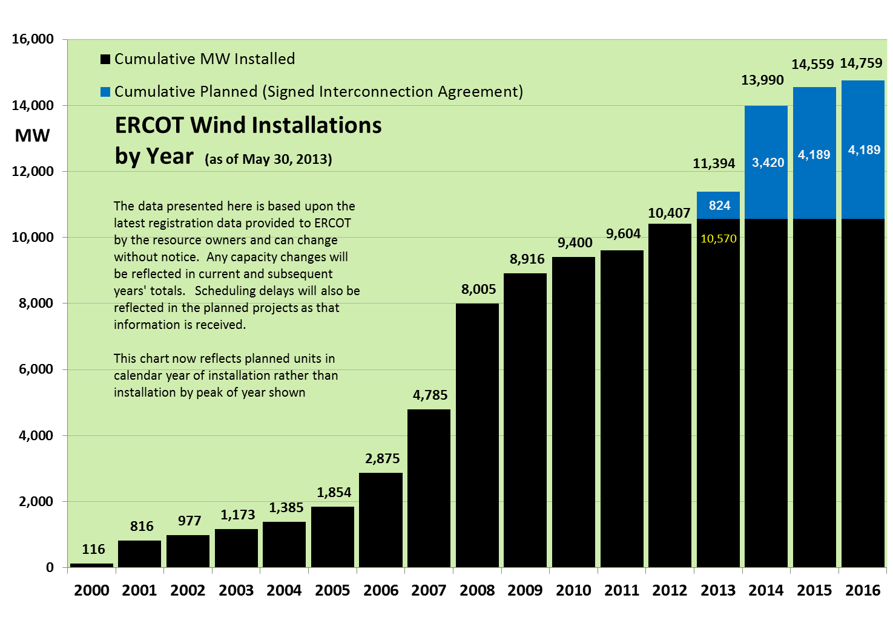
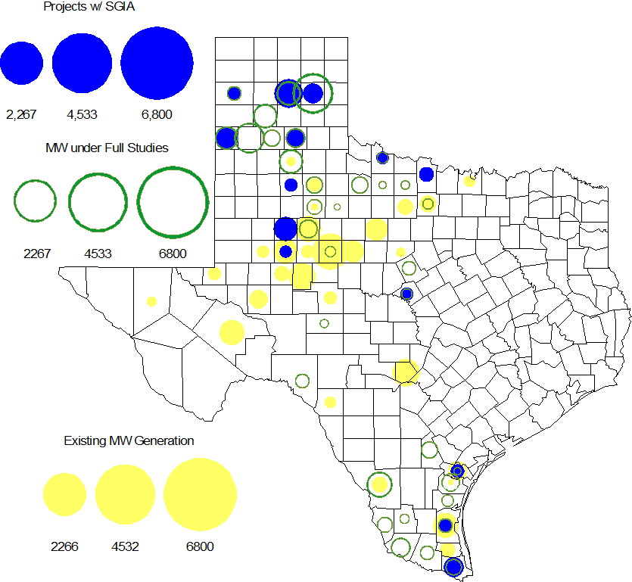

Regional Planning Group Project Reviews

- Sharyland submitted the Atlas-Driver Load Integration project, a Tier 2 project that is estimated to cost approximately $18.6 million. This project has completed the RPG review and ERCOT has sent the RPG acceptance letter.

- Oncor submitted the Collin-Payne 138 kV rebuild project. This is a Tier 3 project that is estimated to cost approximately $20.6 million. This project has completed the RPG review and ERCOT has sent the RPG acceptance letter.

- Oncor submitted the Permian Basin to Moss to Odessa EHV 345 kV project. This is a Tier 1 project that is estimated to cost approximately $75 million. This project is currently under ERCOT independent review.

- Bryan Texas Utilities (BTU) submitted the Southwest Brazos County 138 kV loop project. This project is estimated to cost approximately $6.2 million. This project is classified as a Tier 3 and has been submitted for RPG comments. In accordance with Protocol Section 3.11.4.5(c), once the RPG comments are resolved this project will be reclassified as a Tier 4 Neutral project.

Asynchronous Tie Interconnection

Project | Notification to ERCOT | Reliability Study | RPG Review | Interconnection Agreement | In-service Year
Railroad DC tie expansion (150 MW - CFE) |  |  |  |  | 2014
Southern Cross HVDC (3000 MW - SERC)
Tres Amigas (1500 MW - SPP)

Color Legend
In progress
Complete

Congestion Costs
Dollars shown in RUC Make Whole payment graph are of settlement quality.

RUC net Make Whole payment in $mm
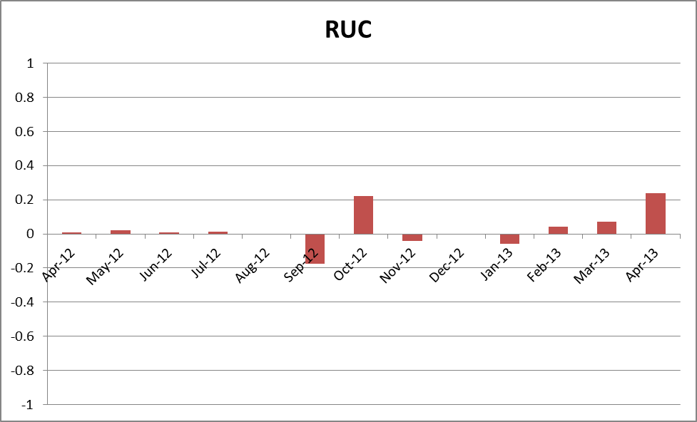

Monthly Average LMP
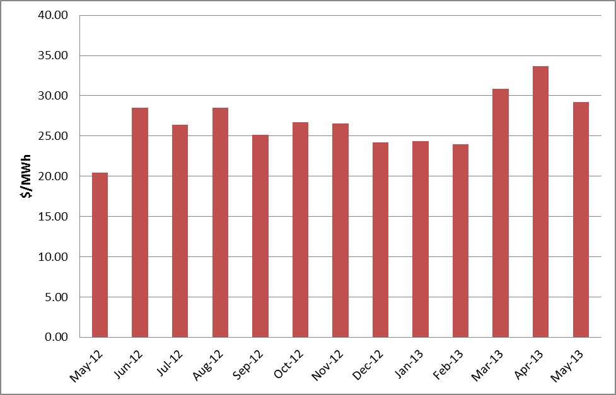

Binding Constraints – Year to Date
Contingency | Binding Element | Number of 5-min intervals | Shadow Price Range $/MWh | Estimated Congestion Rent $ (Shadow Price*Limit) | Transmission Project
Roanoke Switch - West Denton and - Lewisville Switch 345 kV; or West Denton - Roanoke Switch 345 kV; or West Denton - Rdwells 138 kV | Jim Cristal - North Denton 138kV | 1407 | 0 - 3500 | 18,679,874 | 14TPIT0047
Roanoke Switch - West Denton 345 kV & Roanoke Switch - Lewisville Switch 345 kV | Fort Worth - Teasley 138 kV | 2813 | 0 - 3500 | 16,898,845 | 14TPIT0047
Morgan Creek SES 345/138 kV Autotransformer 2 | Morgan Creek SES 345/138 kV Autotransformer 4 | 150 | 29 - 4500 | 12,952,199
Golden Switch - Sun Switch 138 kV; or Sacroc - Sun Switch 138 kV; or Snyder - China Grove 138 kV | China Grove - Bluff Creek 138 kV | 742 | 0 - 3500 | 12,659,248 | 12TPIT0058, 13TPIT0098
Odessa North 138/69 kV Autotransformer; or West Over - Odessa 138 kV | Moss Switch - Amoco North Cowden Tap 138 kV | 936 | 0 - 3500 | 12,458,908 | 13TPIT0098, 13TPIT0093
West Denton - Rdwells 138 kV | Teasley - Pockrus Substation 138 kV | 939 | 0 - 3500 | 11,088,886 | 14TPIT0047
Wink 138/69 kV Autotransformer; or Wink - Wink Sub 138 kV | Wink Basin Tap - Wink Sub 69 kV | 772 | 0 - 2800 | 6,378,270 | 13TPIT0204, 14TPIT0105
Ajo - Rio Hondo 345 kV | North Edinburg - Lon Hill 345 kV | 34 | 2 - 4500 | 5,859,545 | 14TPIT0050
Asphalt Mines - Odlaw Switch 138 kV | Hamilton Road - Marverick 138 kV | 5071 | 0 - 2905 | 5,788,616 | 16TPIT0024
Meadow - PH Robinson 345 kV | Alvin - Freeway Park 138 kV | 1869 | 0 - 3500 | 3,712,885 | 15TPIT0030
Binding Constraints – May 2013
Contingency | Binding Element | Number of 5-min intervals | Shadow Price Range $/MWh | Estimated Congestion Rent $ (Shadow Price*Limit) | Transmission Project | Comments
Wink 138/69 kV Autotransformer; or Wink - Wink Sub 138 kV | Wink Basin Tap - Wink Sub 69 kV | 753 | 0 - 2800 | 6,261,858 | 13TPIT0204, 14TPIT0105 | High load and low wind conditions
Odessa North 138/69 kV Autotransformer; or West Over - Odessa 138 kV | Moss Switch - Amoco North Cowden Tap 138 kV | 475 | 0 - 3500 | 5,945,661 | 13TPIT0098, 13TPIT0093 | Outage on Moss Switch 138 kV breaker
Golden Switch - Sun Switch 138 kV; or Sacroc - Sun Switch 138 kV; or Snyder - China Grove 138 kV | China Grove - Bluff Creek 138 kV | 330 | 2 - 3500 | 5,650,503 | 12TPIT0058, 13TPIT0098 | High load and low wind conditions
Ajo - Rio Hondo 345 kV | North Edinburg - Lon Hill 345 kV | 23 | 2 - 4500 | 4,244,993 | 14TPIT0050 | Generation outages in the area
Meadow - PH Robinson 345 kV | Alvin - Freeway Park 138 kV | 1714 | 0 - 3500 | 2,917,651 | 15TPIT0030 | High load and outage on Hastings - Friendswoord 138 kV line
McNeil - Gilleand Creek 138 kV | Hutto - Round Rock NE 138 kV | 366 | 1 - 3500 | 2,731,644 |  | Outage on Hutto Switch 138 kV circuit breaker
Fayette - Holman & Fayette - Lytton Springs 345 kV | Austrop - Lost Pines 345 kV | 1200 | 0 - 4500 | 2,341,544 | 10TPIT0031 | Outage on Lost Pines - Austrop 345 kV line
Singleton - Zenith 345 kV | Singleton - Tomball 345 kV | 867 | 0 - 153 | 1,999,546 |  | Outage on Roans Prairie - Kuykendahl and Kuykendahl - King 345 kV line
Lobo 345/138 kV Autotransformer; or Lobo - San Miguel 345 kV | San Diego - Freer 69 kV | 374 | 0 - 2800 | 1,877,406 | 13TPIT0132 | Outage on Cotulla - Dilley Switch 138 kV line
Garfield - Hicross & Garfield - Onion Creek 138 kV | Austrop - Daffin 138 kV | 448 | 0 - 3500 | 1,861,853 | 10TPIT0031 | Outage on Austrop - Decker 138 kV and Decker - Webber Tap 138 kV line

Wind Generation as a Percent of Load
One-hour average of total wind power output as a percentage of ERCOT load.
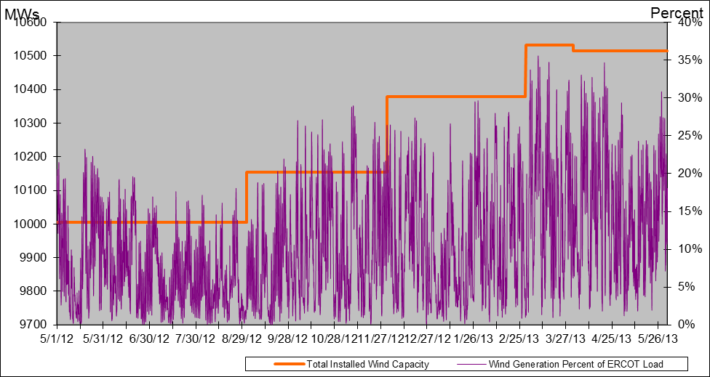
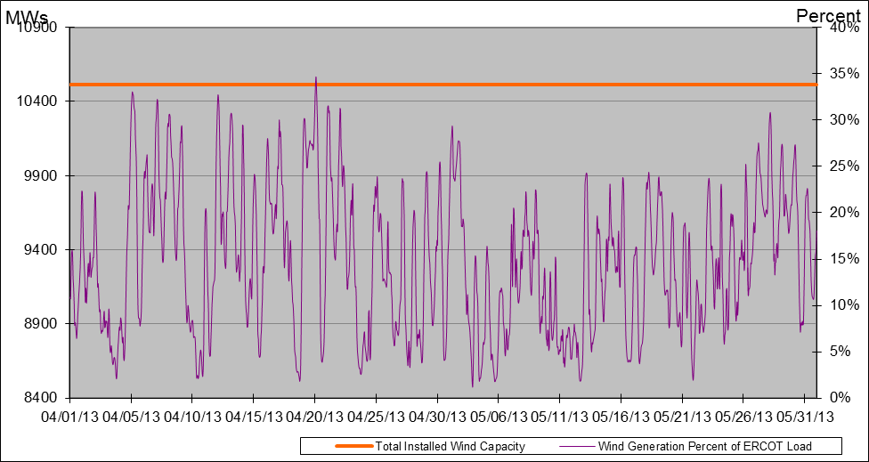
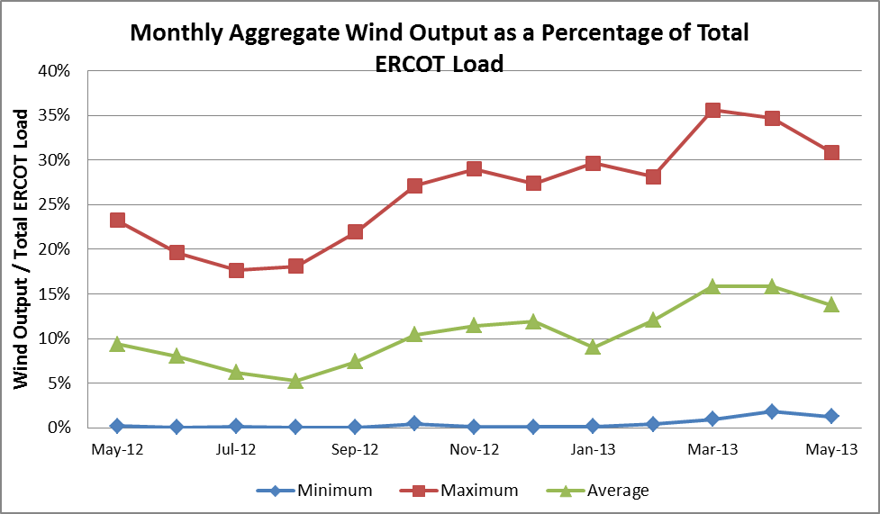

Planning Model Activities
- The short term calendar of major planning model events follows:
  - Jun 11-13, 2013 SSWG Data Set A meeting in Taylor
  - Jun 14, 2013 Projected posting of 13DSA/DSB TPIT updates
  - Jul 5, 2013 Projected posting 14 Data Set A
- Status update on SCR760, Changes Needed for Information Model Manager and Topology Processor for Planning Models, which was approved by the ERCOT Board in March 2011.
  - Bundle 1 (Items 3, 7 and 8): In Production.
  - Bundle 2 (Items 2a, 4, 9): In Production.
  - Bundle 3 (Item 5, 2b, 2c): In Production
  - Bundle 4 (Items 1, 6): First vendor release arrived at ERCOT on April 19, 2013. ERCOT is testing the release for both Planning and CRR environments. Expected off-cycle release to the environments used to create the products used for production planned for July 2013.
SCR Sub Part | SCR Description | Status
SCR760-1 | Upgrade to PSS/E v32 | Production
SCR760-2 | Distribution Capacitor banks | Production
SCR760-3 | Zero Impedance Line Ratings | Production
SCR760-4 | Associate Loads and Capacitor banks with the correct CNG | Production
SCR760-5 | Additional Transformer Data for Planning | Production
SCR760-6 | FACTS Devices | Release
SCR760-7 | Assign valid PSSE IDs to Breakers/  Switches/ Series Devices | Production
SCR760-8 | Phase shift of Autos for short circuit studies | Production
SCR760-9 | Multisection Line Grouping | Production
Table 1: In the following table:
- Red will be used to show status of Not Submitted, meaning that the SCR sub part has not been submitted to Siemens as a Service Request.
- Yellow will indicate that the SCR sub part has been submitted. The color will remain yellow and the status will change in order to Submitted, Planning (Requirements, SOW, Code Writing), Release (Siemens produces first code to test), and Testing (code has completed internal test and is moving through release management).
- Green will indicate that the code has been tested and installed on the machines that ERCOT uses to produce Topology Processor output for Planning and CRR.

Other Notable Activities
- The project to complete the missing and questionable data for the remaining Resource Asset Registration Forms (RARF) that are still incomplete is underway. ERCOT and Siemens created a list of 3339 individual data items that are missing or suspect. To date, 11 calls to Resource Entities regarding 19 different sites and 324 items within the list have been completed.
- Work on the 2013 Regional Transmission Plan (formerly the Five-Year Transmission Plan) has begun.
- ERCOT is currently performing the study to analyze the system needs in the West Texas area due to oil and gas load growth. The initial reliability analysis results were presented at the May RPG meeting. The steady-state base cases used for this study are posted at the ERCOT POI.
- ERCOT is preparing the report on the results of the Long-Term System Assessment and the improvements to the long-term study process as a result of the grant received from the Department of Energy. The report is expected to be published in July.
- ERCOT has begun a study to plan the long-term transmission roadmap for the Panhandle Region. With CREZ lines now extending the ERCOT transmission system into the area, ERCOT has received a significant amount of wind generation interconnection study activity in the Panhandle. Currently, there are almost 2,600 MW of wind generation with signed generation interconnection agreeements in the region with another approximately 2,500 MW that have completed the full interconnection study phase of the process. An additional approximately 5,400 MW is in the advanced stages of the interconnection study process.

