
Whitepaper for Congestion Revenue Rights Model Build Processes

Version 0.2

Revision History
Date | Version | Description | Author
02/7/2012 | 0.1 | Summarize internal CRR procedures into market-facing CRR Model Build Process | ERCOT
March 2012 | 0.15 | Incorporated feedback from Market/CMWG | ERCOT
June 2013 | 0.2 | Version to include Long-Term Auction Sequence and more details | ERCOT

Contents
1 Create Common Information Model (CIM) File from Network Model Management System (NMMS) 3
2 Topology Processor (TP) 5
2.1 Topology Processor Inputs 6
2.2 Topology Processor Outputs 6
3 CRR Auction Engine 6
4 Output of CRR Model Build 8
5 Multi-Month Auctions 8
6 CRR Model Posting 8
7 Other Specific Modeling Details 9
7.1 Special Protection Schemes (SPS) 9
7.2 Remedial Action Plans (RAP) 9
7.3 Contingencies 9

This document is intended for use by ERCOT Market Participants to better understand the sequence and processes followed in the creation of Congestion Revenue Rights (CRR) Auction Model files.

Create Common Information Model (CIM) File from Network Model Management System (NMMS)

Approximately two weeks before the posting of the CRR Auction Model per the CRR Auction Calendar:

  - CRR Engineer contacts ERCOT Network Modeling department to snapshot and copy the current CIM model used for Real Time Operations and all Network Operations Model Change Request (NOMCRs) for eventual use in the development of the CRR auction model.

  - CRR Engineer selects the NOMCRs to be applied to the current version of the CIM file; selecting only NOMCRs with status of “Approved for Production” and “Approved for Testing” up to the model build date.

  - An ERCOT contingency tool is applied to the CRR network Model to create a contingency file and CIM model inclusive of all Transmission Element contingencies expected to be used by ERCOT in Real-Time operations.

  - Outage Evaluation

In parallel to the CIM file creation steps in 1.1-1.3, the CRR engineer will interface with and pull all approved and accepted transmission outages from the Outage Scheduler for the auction month. Once the outages have been acquired, the CRR team will filter the outages for those deemed as “acceptable” per the criteria described in section 5.1(f) of the Nodal Operating Guides. The CRR modeling team will then determine the day that the outages, in aggregate, create the most congestion on the system and apply those outages to the model for that month. Nodal Operating Guides 5.1(f): System Modeling Information

(6) Congestion Revenue Right (CRR) Network Model Outage determination uses network topology of the CRR Network Model identified by ERCOT. This must include Planned Outages of Transmission Elements approved by ERCOT at the time the CRR Network Model is being built and that demonstrate significant impact to the transfer capability during the effective period. ERCOT will consider including Outages in the CRR Network Model that are scheduled to occur in the relevant time period and meet one or more of the following criteria:

(a) Consecutive or continuous approved Outages greater than or equal to five days;

(b) Approved Outages which include Transmission Elements included in the definition of a Hub;

(c) Approved Outages which include Transmission Elements in a 345 kV Transmission Facility;

(d) Approved Outages that require the use of a Block Load Transfer (BLT); and

(e) Any other approved Outage that has been determined by ERCOT to carry a substantial risk of causing significant congestion.

Outages utilized by CRR Team also include Accepted Outages to capture Forced Outages and Unavoidable Extensions of Outages.

    - CRR Engineer analyzes the list of Outages that meet the criteria in Step 1.4.1 using some or all of the methods described below to determine the date to be used for applying the final set of corresponding outages and NOMCRs to create the final CRR model:

      - Gantt chart to highlight groupings of potential worst-case days, considering kV levels. Gantt chart example seen below.

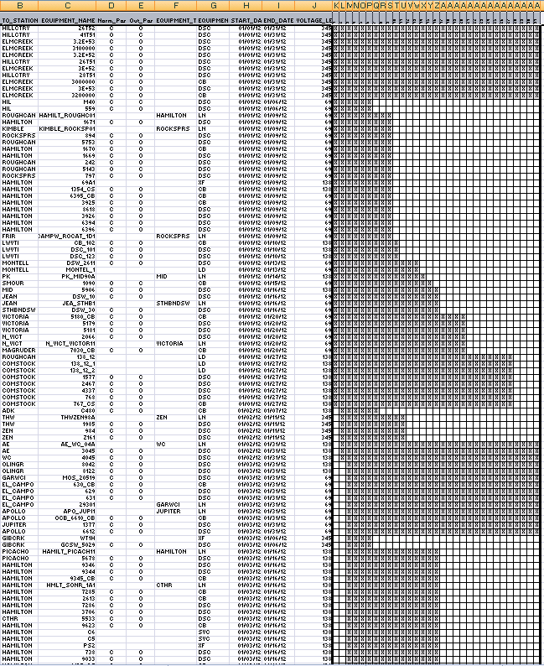

      - Verify with Outage Coordination department of any major outages for the month.

      - Special consideration for impacts to interfaces (Generic Transmission Limits), impacts to historically significant constraints in DAM and RTM, and consider SPS or RAP equipment outages

      - If an outage is known to affect the operation of an SPS or RAP, the CRR engineer will consider that in the flow analysis and potentially disable that SPS or RAP in the CRR model.

      - MW flow impact analysis performed on subset of Outage combinations.

Topology Processor (TP)

CRR Engineer utilizes software developed by Siemens that is designed to accept an ERCOT CIM model and output a bus branch model. TP is used by the CRR engineer to convert the CIM file(s) and create files needed by the CRR Auction Engine.

Topology Processor Inputs

    - CIM model with NOMCRs and contingencies (performed in Step 1)
    - Dynamic Ratings, per ERCOT Nodal Protocols 7.3 (f) using the monthly forecasted temperatures provided by the Planning Department’s Load Forecasting and Analysis group. The dynamic ratings tables are in the NMMS and combined with the forecasted temperature to create the model ratings, so there is no inconsistency in CRR model and Real-Time.)
7.3 (f) Thermal operating limits (including estimates for Dynamic Ratings) for transmission lines; (ii) for the monthly auction ERCOT shall use Dynamic Ratings for the maximum peak-hour temperature forecast for the month;
    - Outages (performed in Step 1.4.1)

Topology Processor Outputs

    - System Topology with Outages
    - Transmission Element Ratings
    - Resource Node Location
    - Settlement Point Location
    - Contingency Definitions

CRR Auction Engine

CRR Engineer prepares TP output data and other supporting files for the CRR Auction Engine developed by Nexant.

  - CRR Engineer develops files that list every settlement point found in the CRR Model and assigns participation factors to each PSSE bus containing a settlement point. Participation factors are assigned separately for Load Zones (LDF), Hub Buses (Protocols 3.5), DC Ties and Resource Nodes. The Load Distribution Factor (LDF) values are created in accordance with Protocols Section 4.5.1(5) and come from the Advanced Network Application group to appropriately apply hot, mild, or cold LDFs.
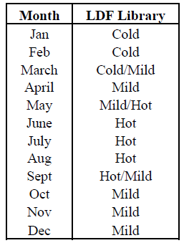

  - CRR Engineer will create Non-Thermal files that identify the transmission elements included in each of the current three interfaces and assign a MW limit for each interface. The three interfaces that are currently in use in 2013 are West – North, Valley Import and North – Houston (these are Generic Transmission Limits).

  - CRR Engineer will develop Contingency files that list all the contingencies in the monthly model and will have a brief description of each contingency. The file will also identify each element defined in the contingency.

  - CRR Engineer will build a list of Electrically Similar Settlement Points (ESSPs), which are defined in Section 2 of the ERCOT Protocols. These ESSPs are posted to the market and enforced in the auction. The list is made using the monthly model’s topology andreactance.

  - CRR Engineer will create a Models file that lists all the lines and transformers in the CRR model and associates ratings to each element. The posted models all reflect 100% system capability (after outages and NOMCRs applied), and the scaling down of the system is performed within the auction clearing engine and enforced at the appropriate lower level (90% for monthly, and 60%, 45%, 30%, 15% as appropriate for Long Term-Auction Sequence models).

  - Each CRR Model is considered for testing by running a mock CRR Auction to ensure there are no significant issues with the CRR model that yield unexpected results.

Output of CRR Model Build

  - ESSP file
  - PSSe file
  - Outage list included in model build
  - Contingency files
  - Non Thermal/Flow Gate Files
  - Source Sink files
  - Mapping file CRR to Operations names
  - Monitored Elements File

Multi-Month Auctions

For the multi-month Auctions, the CRR Engineer repeats steps 1-4, where the model-build activity is initiated weeks in advance of the multi-month auction sequence to accommodate multiple-month models and satisfy the longer 20-day posting requirement prior to auction. Specific timing of model builds are not available as the dates are subject to change as automation decreases the model build time.

Other key assumption for the multi-month model are:
- RAP expiration dates are utilized in multi-month models. In the example of the Spring 2013 auction for Fall2014 the CRR engineer does not include any RAPs as they are all expired in May/June timeframe.
- ERCOT utilizes Dynamic Ratings based on a historical analysis of the maximum peak-hour temperatures for the previous ten years.
- Due to the historical uncertainty of energization dates more than 12-months in advance, the CRR Engineer only utilizes the approved NOMCRs up to twelve months in advance.

CRR Model Posting

All outputs from the CRR Model Build process are delivered to the ERCOT MIS Secure site and available in a zipped file format and posted in accordance with the dates reflected in the CRR Activity Calendar.
Location of posted CRR model files: https://mis.ercot.com/pps/tibco/mis/Pages/Market+Information/CRR
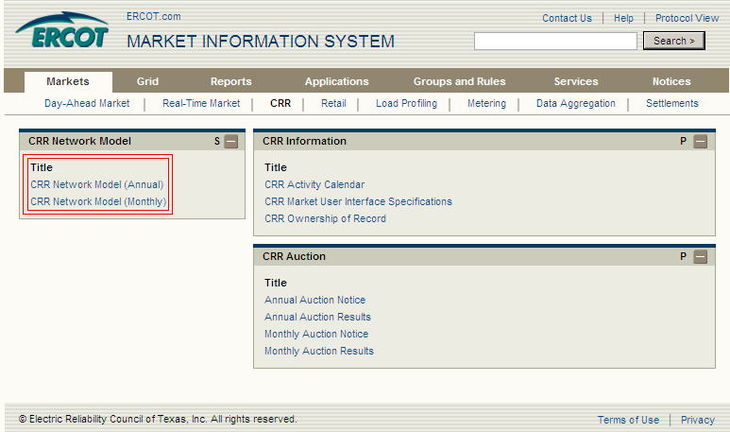

Other Specific Modeling Details

Engineering judgment and analysis is used in building the most accurate models within the limitations of the different software vendors and technologies. Below is a subset of special modeling that is used for CRR models.

Special Protection Schemes (SPS)
SPSs are modeled in such a manner as similar as possible in real-time operations. In real-time where an SPS protects a piece of equipment, in CRR the equipment is provided with an emergency rating of 9,999 (effectively monitor-only) so that in post-contingency flow the element will not bind (since emergency rating is used). Potential discussion of expanding this to also include the base-case flow rating to also be 9,999. The ratings are applied not only on the protected equipment, but to the first fork in the topology (ie serial lines also receive same rating).

Remedial Action Plans (RAP)
RAPs are included in the model build process, whereby any element protected by a RAP is set-to 9,999MVA rating for emergency ratings.

Contingencies
ERCOT contingency tool is applied to the CRR network Model to create a contingency file and CIM model inclusive of contingencies. Contingencies for the CRR model utilize the same tool as the production real-time model build for DAM and SCED. More specifically, the contingency creation tool creates single circuit contingencies by looking at every branch in the network and searches outward until it a finds breaker on either end of the starting point. The single circuit contingency will contain all branches found before a breaker has been reached. The double circuit contingencies are found in the same manner, except double circuit contingencies have two predefined starting points for each contingency. The program will start at each point and branch outward until it finds breakers on either end of the starting points. The double circuit contingency will contain all branches found before the breakers were reached. The transformer contingencies start at the transformer and branch outward until it finds breakers. This branching will contain any tertiary components of the transformer.

