 |  |  |  | System Planning
Monthly Status Report
April 2013

 |  | Report Highlights
 | - ERCOT is currently tracking 159 active generation interconnection requests totaling over 48,000 MW. This includes almost 20,000 MW of wind generation.
- ERCOT is currently reviewing proposed transmission improvements with a total cost of $75 Million
- Transmission Projects endorsed in 2013 total $349.8 Million
- All projects (in engineering, routing, licensing and construction) total approximately $9.68 Billion.
- Transmission Projects energized in 2013 total about $38.6 million.

Table of Contents
1. Generation Interconnection 1
1.1 Signed Generation Interconnection Agreements 1
1.2 New Generation Registering for Commercial Operations 1
1.3 Summary of Generation Interconnection Requests 1
1.4 Projects with Interconnection Agreements 4
1.5 Generation Projects Undergoing Full Interconnection Studies with Confidentiality Waived by Developer 4
1.6 Generation Projects Undergoing Full Interconnection Studies 5
1.7 Wind Generation Capacity Installed by Year 6
2. Regional Planning Group Project Reviews 7
3. Asynchronous Tie Interconnection 8
4. Congestion Costs 9
5. Wind Generation as a Percent of Load 12
6. Planning Model Activities 13
7. Other Notable Activities 14

1. Generation Interconnection
Additional information regarding detailed generation interconnection and impact studies is contained in the “Generation Project Interconnection Information” folder in the “Operations and System Planning” area on the ERCOT website: http://planning.ercot.com/login/login.

Signed Generation Interconnection Agreements
13INR0028 – Antelope Station – 364 MW of Gas in Hale County
11INR0079a – South Clay Wind Farm – 200 MW of Wind in Clay County

New Generation Registering for Commercial Operations
None

The total installed wind capacity is now reported as 10,570 MW by the resource owners through the registration process. Capacity by North, South and West is 832 MW, 2,375 MW, and 7,363 MW respectively. Eight-hundred fifty MW is able to switch between the West and South zones and is currently shown in the South zone.

Summary of Generation Interconnection Requests
GENERATION INTERCONNECTION REQUESTS CURRENTLY UNDER REVIEW
Currently tracking 159 generation interconnection or change requests
As of April 30, 2013 |  |  |  | Total
Security Screening Study | 8
SSS Completed | 26
Full Interconnect Study | 83
FIS Completed | 9
Suspended Studies | 0
Capacity of Suspended Study Projects | 0
Interconnect Agreement Completed | 33
Capacity under Interconnection Agreements | 12,815
Capacity for Grid, MW | 48,148
Wind Capacity, MW | 19,964

Fuel Type | Confidential Projects (MW) | Projects Under Full Study (MW) | Public Projects (MW) | Suspended Studies (MW) | Grand Total (MW)
Gas-AllOther |  |  | 449 |  | 8,053
Gas-CombinedCycle |  |  | 6,522 |  | 15,918
Total Gas | 10,622 | 6,378 | 6,971 |  | 23,971
Nuclear
Coal |  | 850 | 1,165 |  | 2,015
Wind | 2,111 | 13,264 | 4,589 |  | 19,964
Solar | 710 | 524 | 50 |  | 1,284
Biomass
Storage |  | 874 | 40 |  | 914
Petroleum Coke
Grand Total | 13,443 | 21,890 | 12,815 |  | 48,148

County Location of Installed Generation and Interconnection Requests (all fuels)

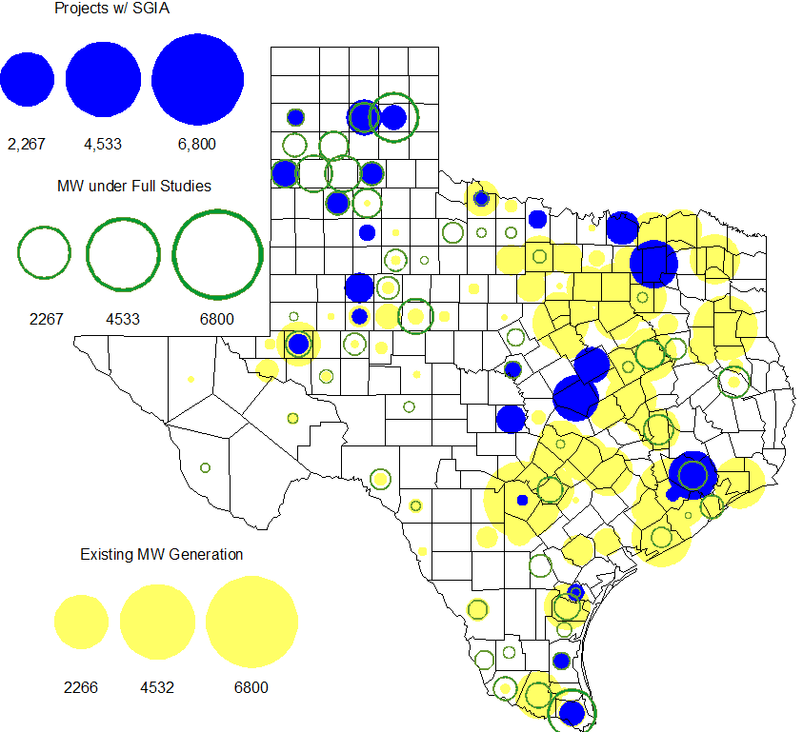

Projects with Interconnection Agreements

Generation Interconnections as of April 30, 2013
INR | Site Name |  | County |  | COD |  | Fuel | MW For Grid | Change from Last Report
12INR0075 |  | Blue Summit Windfarm |  | Wilbarger |  | May-13 | Wind | 135 | date
11INR0033 |  | Los Vientos |  | Cameron |  | May-13 | Wind | 400 | date
09INR0001 |  | Sandy Creek 1 |  | McLennan |  | May-13 | Coal | 925 | date
12INR0086 |  | WA Parish Addition |  | Fort Bend |  | Jun-13 | Gas | 90
10INR0089 |  | Deepwater Energy Storage |  | Harris |  | Jul-13 | Storage | 40
13INR0058 |  | OCI Alamo 1 |  | Bexar |  | Nov-13 | Solar | 50
11INR0013 |  | Goldthwaite Wind Energy |  | Mills |  | Dec-13 | Wind | 150
12INR0034 |  | Stephens Ranch Wind Energy |  | Borden |  | Dec-13 | Wind | 378
14INR0030a2 |  | Panhandle Wind |  | Carson |  | Feb-14 | Wind | 322
13INR0048 |  | Spinning Spur Wind Two |  | Oldham |  | Jun-14 | Wind | 161
14INR0015 |  | Deer Park Energy Center |  | Harris |  | Jun-14 | Gas-CC | 192
14INR0016 |  | Channel Energy Center 138/345kV CT |  | Harris |  | Jun-14 | Gas-CC | 190
14INR0012 |  | Miami Wind 1 Project |  | Gray |  | Jun-14 | Wind | 401
10INR0021 |  | Panda Sherman Power |  | Grayson |  | Jun-14 | Gas-CC | 809 | date
10INR0020a |  | Panda Temple Power |  | Bell |  | Jun-14 | Gas-CC | 809 | date
13INR0021 |  | Ferguson Replacement Project |  | Llano |  | Jul-14 | Gas-CC | 570
13INR0040 |  | Agrifos Steam Unit |  | Harris |  | Aug-14 | Gas | 0
11INR0050 |  | Moore Wind 1 |  | Crosby |  | Aug-14 | Wind | 149
13INR0010a |  | Mariah Wind |  | Parmer |  | Oct-14 | Wind | 200
14INR0023 |  | Longhorn Energy Center |  | Briscoe |  | Dec-14 | Wind | 361
13INR0005 |  | Conway Windfarm |  | Carson |  | Dec-14 | Wind | 600
11INR0079a |  | South Clay Windfarm |  | Clay |  | Dec-14 | Wind | 200 | New
06INR0022c |  | Penascal Wind Farm 3 |  | Kenedy |  | Dec-14 | Wind | 202
09INR0051 |  | Mesquite Creek |  | Borden |  | Mar-15 | Wind | 249
08INR0018 |  | Gunsight Mountain |  | Howard |  | Aug-15 | Wind | 120
13INR0010b |  | Mariah Wind |  | Parmer |  | Dec-15 | Wind | 200 | date
13INR0023 |  | Texas Clean Energy Project |  | Ector |  | Jan-16 | Coal | 240
06INR0006 |  | Cobisa-Greenville |  | Hunt |  | May-16 | Gas-CC | 1,792
10INR0020b |  | Panda Temple Power |  | Bell |  | May-16 | Gas-CC | 780
13INR0028 |  | Antelope Station |  | Hale |  | Jun-16 | Gas | 359 | New
10INR0022 |  | Pondera King Power Project |  | Harris |  | Jun-16 | Gas-CC | 1,380
13INR0010c |  | Mariah Wind |  | Parmer |  | Dec-16 | Wind | 200 | date
11INR0054 |  | Midway Farms Wind |  | San Patricio |  | Oct-14 | Wind | 161 | date

Generation Projects Undergoing Full Interconnection Studies with Confidentiality Waived by Developer
14INR0040 | Redgate Power Plant | Hidalgo | Jun-14 | Gas | 225 | New

Generation Projects Undergoing Full Interconnection Studies
INR | County | Fuel | MW | COD |  | INR | County | Fuel | MW | COD
13DGR0001 | Presidio | Solar | 10 | Apr-13 |  | 13INR0060 | Hidalgo | Gas | 50 | Jun-13
13INR0046 | Limestone | Wind | 71 | Sep-13 |  | 11INR0094 | Kent | Solar | 100 | Oct-13
13INR0038 | Swisher | Wind | 300 | Dec-13 |  | 13INR0052 | Starr | Wind | 200 | Dec-13
13INR0055 | Zapata | Wind | 250 | Dec-13 |  | 13INR0056 | Scurry | Wind | 366 | Dec-13
12INR0068 | Jim Hogg | Wind | 80 | Dec-13 |  | 12INR0081a | Upton | Wind | 112 | Dec-13
14INR0014 | Val Verde | Solar | 100 | Jan-14 |  | 13INR0006 | Gray | Wind | 750 | Jan-14
12INR0055 | Baylor | Wind | 40 | Jan-14 |  | 14INR0059 | Kaufman | Gas | 52 | Feb-14
14INR0039 | Ector | Gas | 450 | Mar-14 |  | 13INR0059 | Castro | Wind | 499 | Mar-14
14INR0024 | Kinney | Solar | 42 | Apr-14 |  | 12INR0060 | Schleicher | Wind | 58 | Apr-14
14INR0013 | Cameron | Wind | 103 | Apr-14 |  | 11INR0062 | Nueces | Wind | 178 | Apr-14
14INR0027 | Guadalupe | Gas | 471 | May-14 |  | 14INR0031 | Harris | Gas | 270 | Jun-14
14INR0038 | Galveston | Gas | 390 | Jun-14 |  | 08INR0019a | Gray | Wind | 250 | Jun-14
08INR0019b | Gray | Wind | 250 | Jun-14 |  | 08INR0019c | Gray | Wind | 250 | Jun-14
11INR0057 | Cameron | Wind | 165 | Jun-14 |  | 13INR0026 | Oldham | Wind | 201 | Jun-14
13INR0057 | Archer | Wind | 65 | Jun-14 |  | 14INR0048 | Wilbarger | Wind | 114 | Jun-14
13INR0049 | Harris | Gas | 352 | Jun-14 |  | 14INR0040 | Hidalgo | Gas | 225 | Jun-14
12INR0059 | Pecos | Solar | 50 | Jun-14 |  | 14INR0029 | Uvalde | Solar | 42 | Jul-14
11INR0093 | San Patricio | Wind | 41 | Jul-14 |  | 12INR0085 | Stonewall | Wind | 24 | Jul-14
14INR0025 | Floyd | Wind | 500 | Jul-14 |  | 12INR0042a | Deaf Smith | Wind | 265 | Sep-14
12INR0042b | Deaf Smith | Wind | 135 | Sep-14 |  | 14INR0032 | Randall | Wind | 501 | Sep-14
12INR0070 | Knox | Wind | 300 | Oct-14 |  | 13INR0031 | Travis | Solar | 30 | Oct-14
12INR0045 | Kleberg | Wind | 135 | Oct-14 |  | 13INR0036 | Hidalgo | Wind | 200 | Oct-14
13INR0020a | Glasscock | Wind | 200 | Oct-14 |  | 13INR0020b | Glasscock | Wind | 150 | Oct-14
13INR0025 | Randall | Wind | 150 | Nov-14 |  | 14INR0030b | Carson | Wind | 322 | Nov-14
13INR0054 | Bee | Gas | 0 | Dec-14 |  | 10INR0085 | Ector | Solar | 57 | Dec-14
11INR0082A | Val Verde | Wind | 50 | Dec-14 |  | 11INR0082B | Val Verde | Wind | 150 | Dec-14
11INR0085 | Nolan | Wind | 106 | Dec-14 |  | 14INR0009 | Kent | Wind | 248 | Dec-14
13INR0050 | Comanche | Wind | 200 | Dec-14 |  | 14INR0028 | Live Oak | Wind | 300 | Dec-14
14INR0033 | Armstrong | Wind | 500 | Dec-14 |  | 11INR0081 | Live Oak | Wind | 72 | Dec-14
12INR0079 | Kenedy | Wind | 200 | Dec-14 |  | 13INR0045 | Castro | Wind | 288 | Dec-14
14INR0020 | Floyd | Wind | 150 | Dec-14 |  | 15INR0021 | Starr | Wind | 200 | Dec-14
13INR0010d | Parmer | Wind | 200 | Dec-14 |  | 14INR0045 | Webb | Wind | 251 | Dec-14
14INR0049 | Jack | Wind | 102 | Dec-14 |  | 14INR0055 | Mills | Wind | 101 | Dec-14
14INR0056 | Mills | Wind | 101 | Dec-14 |  | 14INR0057 | Erath | Wind | 48 | Dec-14
10INR0009 | Castro | Wind | 300 | Mar-15 |  | 15INR0032 | Hale | Gas | 197 | Jun-15
15INR0033 | Hale | Gas | 197 | Jun-15 |  | 14INR0026 | Presidio | Solar | 28 | Sep-15
15INR0013 | Anderson | Storage | 324 | Oct-15 |  | 15INR0014 | Matagorda | Storage | 280 | Oct-15
11INR0065 | Nueces | Wind | 350 | Oct-15 |  | 14INR0030a1 | Carson | Wind | 322 | Nov-15
14INR0018 | Nolan | Solar | 35 | Dec-15 |  | 13INR0032 | Andrews | Solar | 30 | Dec-15
13INR0010e | Parmer | Wind | 200 | Dec-15 |  | 12INR0002a | Briscoe | Wind | 200 | Dec-15
16INR0005 | Cameron | Gas | 871 | Apr-16 |  | 12INR0029 | Swisher | Wind | 500 | Dec-15
16INR0006 | Angelina | Gas | 785 | Jun-16 |  | 16INR0008 | Grimes | Gas | 687 | May-16
16INR0003 | Brazoria | Gas | 11 | Jun-16 |  | 16INR0004 | Cameron | Gas | 730 | Jun-16
12INR0002b | Briscoe | Wind | 200 | Dec-16 |  | 14INR0011 | Swisher | Storage | 270 | Jul-16
12INR0018 | Gray | Wind | 500 | Mar-17 |  | 13INR0010f | Parmer | Wind | 200 | Dec-16
14INR0003 | Nolan | Coal | 850 | Jun-19 |  | 11INR0040 | Freestone | Gas | 640 | Mar-18

Wind Generation Capacity Installed by Year
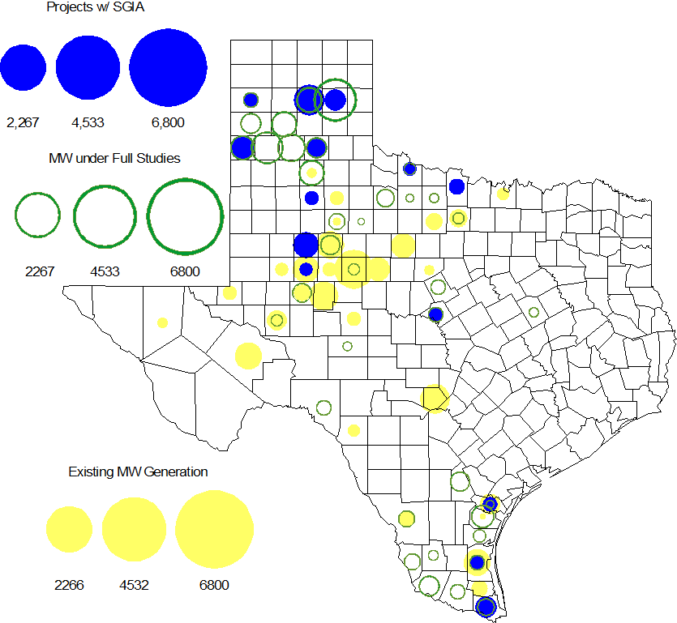

Regional Planning Group Project Reviews

- Sharyland submitted the Atlas-Driver Load Integration project, this is a Tier 2 project that is estimated to cost approximately $18.6 million. This project has completed the RPG review and ERCOT will now prepare the RPG acceptance letter.

- Guadalupe Valley Electric Cooperative (GVEC) submitted the McQueeney-SMI-Geronimo 69 kV to 138 kV rebuild project. This is a Tier 2 project that is estimated to cost approximately $8.1 million. This project has completed the RPG review and ERCOT has sent the RPG acceptance letter.

- LCRA TSC submitted the McNeil-Marshall Ford line upgrade (69 kV to 138 kV conversion) project. This is a Tier 3 project that is estimated to cost approximately $20 million. This project has completed the RPG review and ERCOT has sent the RPG acceptance letter.

- Oncor submitted the Permian Basin to Moss to Odessa EHV 345 kV project. This is a Tier 1 project that is estimated to cost approximately $75 million. This project is currently under ERCOT independent review.

- Oncor submitted the Collin-Payne 138 kV rebuild project. This is a Tier 3 project that is estimated to cost approximately $20.6 million. This project has completed the RPG review and ERCOT will now prepare the RPG acceptance letter.

Asynchronous Tie Interconnection
Project | Notification to ERCOT | Reliability Study | RPG Review | Interconnection Agreement | In-service Year
Railroad DC tie expansion (150 MW - CFE) |  |  |  |  | 2014
Southern Cross HVDC (3000 MW - SERC)
Tres Amigas (1500 MW - SPP)

Color Legend
In progress
Complete

Congestion Costs
Dollars shown in RUC Make Whole payment graph are of settlement quality.

RUC net Make Whole payment in $mm
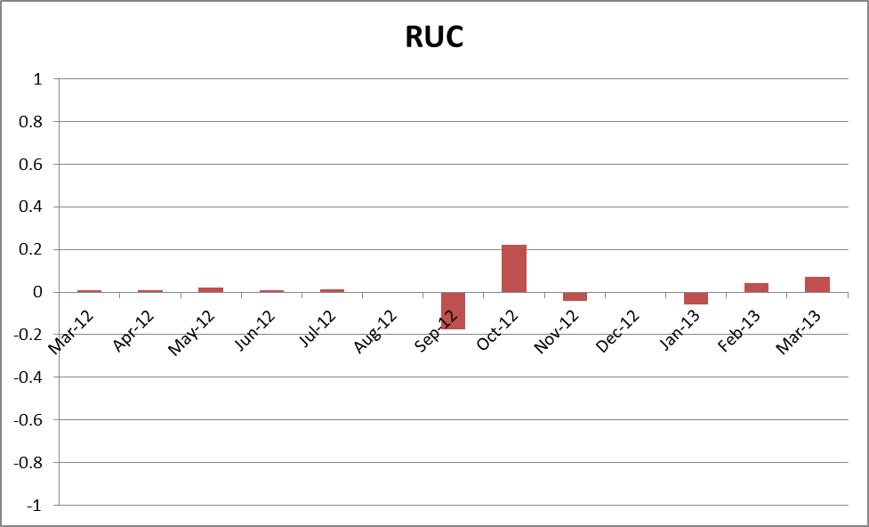

Monthly Average LMP
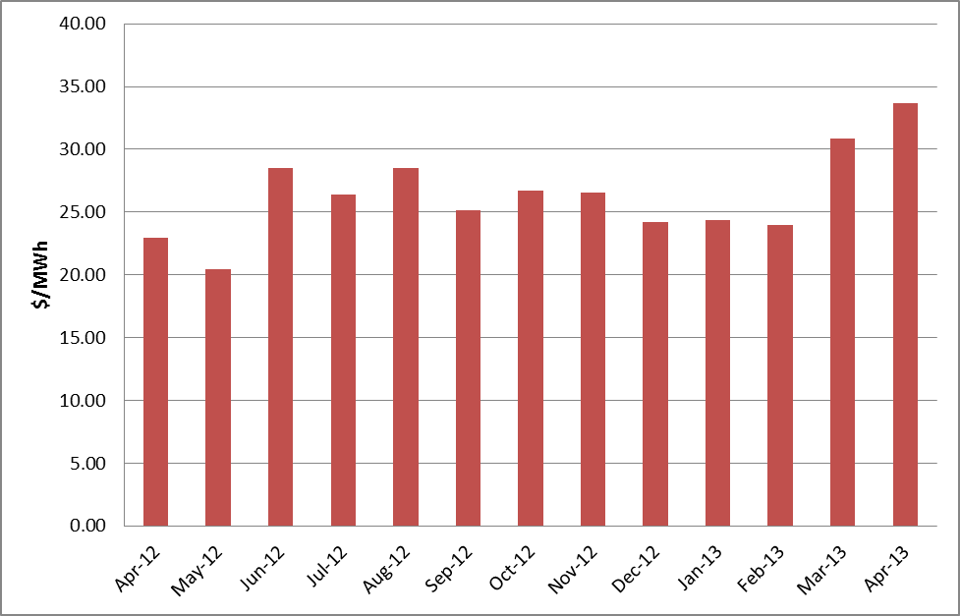

Binding Constraints – Year to Date
Contingency | Binding Element | Number of 5-min intervals | Shadow Price Range $/MWh | Estimated Congestion Rent $ (Shadow Price*Limit) | Transmission Project
Roanoke Switch - West Denton 345 kV & Roanoke Switch - Lewisville Switch 345 kV; or West Denton - Roanoke Switch 345 kV; or West Denton - Rdwells 138 kV | Jim Cristal - North Denton 138kV | 1407 | 0 - 3500 | 18,679,874 | 14TPIT0047
Roanoke Switch - West Denton 345 kV & Roanoke Switch - Lewisville Switch 345 kV | Fort Worth - Teasley 138 kV | 2813 | 0 - 3500 | 16,898,845 | 14TPIT0047
Morgan Creek SES 345/138 kV Autotransformer 2 | Morgan Creek SES 345/138 kV Autotransformer 4 | 150 | 29 - 4500 | 12,952,199
West Denton - Rdwells 138 kV | Teasley - Pockrus Substation 138 kV | 728 | 0 - 3500 | 10,220,099 | 14TPIT0047
Golden Switch - Sun Switch 138 kV; or Sacroc - Sun Switch 138 kV; or Snyder - China Grove 138 kV | China Grove - Bluff Creek 138 kV | 412 | 0 - 3500 | 7,008,745 | 12TPIT0058, 13TPIT0098
Odessa North 138/69 kV Autotransformer; or West Over - Odessa 138 kV | Moss Switch - Amoco North Cowden Tap 138 kV | 461 | 0 - 3500 | 6,513,247 | 13TPIT0098, 13TPIT0093
Asphalt Mines - Odlaw Switch 138 kV | Hamilton Road - Marverick 138 kV | 4176 | 0 - 2905 | 4,447,166 | 16TPIT0024
Graham SES - Long Creek 345 kV; or Temple Pecan Creek - Tradinghouse SES 345 kV & Temple Switch - Lake Creek SES 345 kV; or Comanche Switch - Brown Switch 345 kV | Brown Switch - Killen Switch 345 kV | 1035 | 0 - 393 | 3,759,548
Morgan Creek SES - China Grove 138 kV double-circuit | Morgan Creek SES 138/69 kV Autotransformer 3 | 158 | 0 - 2800 | 2,677,907
Base Case | West to North Stability | 481 | 0 - 60 | 2,624,519 | CREZ
Binding Constraints – Apr 2013
Contingency | Binding Element | Number of 5-min intervals | Shadow Price Range $/MWh | Estimated Congestion Rent $ (Shadow Price*Limit) | Transmission Project | Comments
Roanoke Switch - West Denton 345 kV & Roanoke Switch - Lewisville Switch 345 kV ; or West Denton - Roanoke Switch 345 kV; or West Denton - Rdwells 138 kV | Jim Cristal - North Denton 138kV | 1046 | 0 - 3500 | 17,473,024 | 14TPIT0047 | Outage on Teasley Substation to Fort Worth Substation 138kV
West Denton - Rdwells 138 kV | Teasley - Pockrus Substation 138 kV | 728 | 0 - 3500 | 10,220,099 | 14TPIT0047 | Outage on Jim Crystal to West Denton 138kV
Morgan Creek SES 345/138 kV Autotransformer 2 | Morgan Creek SES 345/138 kV Autotransformer 4 | 95 high-side; and 19 low side | 29 - 4500 high side; and 186 - 3500 low side | 9,646,738 |  | Outage on Morgan Creek SES 345/138kV Autotransformer
Odessa North 138/69 kV Autotransformer; or West Over - Odessa 138 kV | Moss Switch - Amoco North Cowden Tap 138 kV | 323 | 0 - 3500 | 4,771,142 | 13TPIT0098, 13TPIT0093 | Outage on Odessa EHV Switch to Big Three Odessa Tap (BTHOT), BTHOT to Odessa Southwest and BTHOT to Nylon Switch 138 kV
Asphalt Mines - Odlaw Switch 138 kV | Hamilton Road - Marverick 138 kV | 1420 | 0 - 2905 | 2,260,171 | 16TPIT0024 | High wind leading to west – south transfers
Ajo - Rio Hondo 345 kV | North Edinburg - Lon Hill 345 kV | 8 | 4 - 4500 | 1,500,659 | 14TPIT0050 | Planned unit outages in the valley
California Creek - Paint Creek 138 kV; or Vernon 138/69 kV Autotransformer | Lake Pauline 138/69 kV Autotransformer | 2943 | 1 - 2800 | 1,115,603 |  | Outage on Salt Creek BEPC to Scurry Switch 138kV
Base Case | West to North Stability | 167 | 0 - 28 | 1,109,581 | CREZ | High wind
La Palma - Los Fresnos 138 kV | La Palma - Villa Cavazos 138 kV | 16 | 3500 - 3500 | 983,471 | 16TPIT0029, 16TPIT0030 | Outage on East Riohondo to Central Avenue Sub 138 kV
Singleton - Zenith 345 kV | Singleton - Tomball 345 kV | 199 | 0 - 2167 | 869,416 |  | Outage on Kuykendahl to King REIT 345 kV and Kuykendahl to Roans Prairie 345 kV

Wind Generation as a Percent of Load
One-hour average of total wind power output as a percentage of ERCOT load.
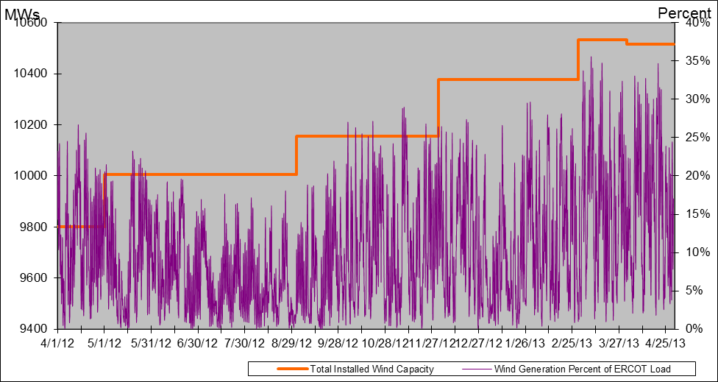

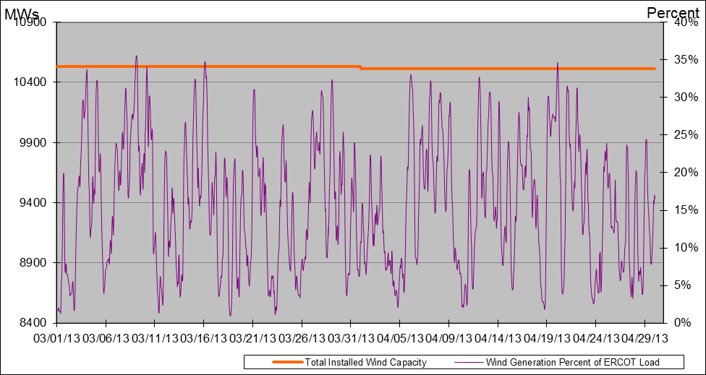

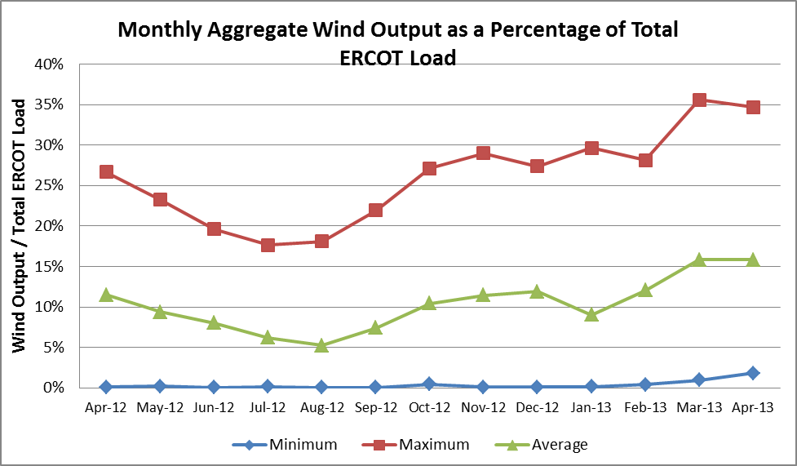

Planning Model Activities
- The short term calendar of major planning model events follows:
  - Apr 2, 2013 Begin 14 Data Set A case build
  - Apr 12, 2013 Begin 13DSA/DSB March TPIT updates
  - May 24, 2013 Post 13DSA/DSB March TPIT cases
  - Jun 11-13, 2013 SSWG Data Set A meeting in Taylor
  - Jul 5, 2013 Projected posting 14 Data Set A
- Status update on SCR760, Changes Needed for Information Model Manager and Topology Processor for Planning Models, which was approved by the ERCOT Board in March 2011.
  - Bundle 1 (Items 3, 7 and 8): In Production.
  - Bundle 2 (Items 2a, 4, 9): In Production.
  - Bundle 3 (Item 5, 2b, 2c): In Production
  - Bundle 4 (Items 1, 6): First vendor release arrived at ERCOT on April 19, 2013. ERCOT is testing the release for both Planning and CRR environments. Expected off-cycle release to the environments used to create the products used for production planned for July 2013.
SCR Sub Part | SCR Description | Status
SCR760-1 | Upgrade to PSS/E v32 | Production
SCR760-2 | Distribution Capacitor banks | Production
SCR760-3 | Zero Impedance Line Ratings | Production
SCR760-4 | Associate Loads and Capacitor banks with the correct CNG | Production
SCR760-5 | Additional Transformer Data for Planning | Production
SCR760-6 | FACTS Devices | Release
SCR760-7 | Assign valid PSSE IDs to Breakers/  Switches/ Series Devices | Production
SCR760-8 | Phase shift of Autos for short circuit studies | Production
SCR760-9 | Multisection Line Grouping | Production
Table 1: In the following table:
- Red will be used to show status of Not Submitted, meaning that the SCR sub part has not been submitted to Siemens as a Service Request.
- Yellow will indicate that the SCR sub part has been submitted. The color will remain yellow and the status will change in order to Submitted, Planning (Requirements, SOW, Code Writing), Release (Siemens produces first code to test), and Testing (code has completed internal test and is moving through release management).
- Green will indicate that the code has been tested and installed on the machines that ERCOT uses to produce Topology Processor output for Planning and CRR.

Other Notable Activities
- ERCOT has contracted with Siemens PTI to complete the missing and questionable data for the remaining Resource Asset Registration Forms (RARF) that are still incomplete. ERCOT and Siemens are working together to gather a list of all missing and suspect data that will be used to create metrics and track progress on this project. So far, this list contains 3,000 individual data elements that are missing or suspect from 84 individual RE having between 1 and 389 missing or suspect values of required data elements. Four-hundred thirty units are included in the count.
- The Transmission Project and Information Tracking (TPIT) process is being modified to use the Model On-Demand (MOD) database as the source for future TPIT workbook postings starting with the July TPIT posting, which will be produced using the current process and the new process. Starting with the November 1 TPIT posting, the new process will be used. New fields have been added to the MOD user interface to hold the additional TPIT information not currely in MOD.
- Work on the 2013 Regional Transmission Plan (formerly the Five-Year Transmission Plan) has begun.
- ERCOT is currently performing the study to analyze the system needs in the West Texas area due to oil and gas load growth. The steady-state base cases used for this study are posted at the ERCOT POI.
- ERCOT is preparing the report on the results of the Long-Term System Assessment and the improvements to the long-term study process as a result of the grant received from the Department of Energy. The report is expected to be published in July.
- ERCOT has begun a study to plan the long-term transmission roadmap for the Panhandle Region. With CREZ lines now extending the ERCOT transmission system into the area, ERCOT has received a significant amount of wind generation interconnection study activity in the Panhandle. Currently, there are almost 2,600 MW of wind generation with signed generation interconnection agreeements in the region with another approximately 2,500 MW that have completed the full interconnection study phase of the process. An additional approximately 5,400 MW is in the advanced stages of the interconnection study process.

