AMWG Issue Tracking Request Form

AMWG Issue Tracking Number: | 2013-002
Issue Status: | New
Last Modification Date: | (AMWG Use)

ISSUE SUBMITTER SECTION:
Submitter Name: | Submitting Company Name: | Date of Submission:
Steve Brightman | Southwest Energy Smarts | 4-19-13
Submitter’s E-Mail Address: | Phone Number: | Affected Business Process:
steve@swesmarts.com | 214-680-6088 | SMT Usability enhancement
Issue Statement: (Short description of issue)
Redundant screen for Users with only one meter when accessing HAN device information: 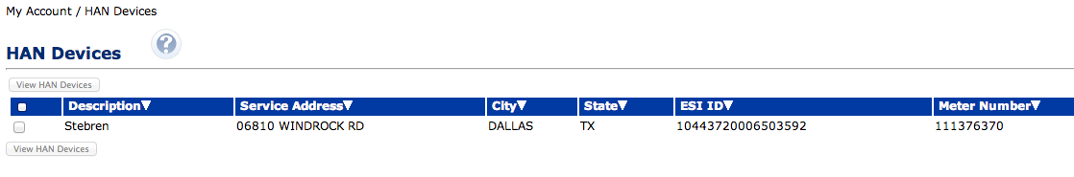
Operational/System Impact: (What is the issue doing to your system and/or operations)
none
Market Impact: (What is the issue doing to others)
Creates unnecessary confusion for users
Desired Outcome: (What do you expect to change)
For users with only one ESIID bypass this screen and go directly to the view HAN devices screen.

Once Completed:
Please submit this completed form via e-mail to current AMWG Leadership

AMWG DISCUSSION SECTION: (AMWG Use)
Date of AMWG Discussion: | Change Request Created (Y/N): |  | Change or Revision Request Tracking Number:
Discussion/Revision History: |  | Referred to AMWG Subteam (Y/N):
Recommended Resolution:

