Smart Meter Texas
Service Level Objectives
________________________________________________________________

Summary:

Availability targets and related service information for the core services provided by the Smart Meter Texas Portal.

Effective: 10/17/12

Document Revisions
Date | Version | Description | Author(s)
October 7, 2011 | .9 | First draft | Karen Farley
Feb 29, 2012 | 1.0 | Second draft | Ronnie Puckett
March 23, 2012 | 1.1 | Draft - TEAM Comments | Miles Higgins
April 11, 2012 | 1.2 | Draft – OW comments – sending to market for additional feedback | Karen Farley
June 5, 2012 | 1.3 | JDOA SMT Review | Andrea O’Flaherty
Sept 12, 2012 | 1.4 | Adding section 8 for unplanned outages | OWG
October 09, 2012 | 1.5 | Draft – incorporated feedback from market | OWG
October 17, 2012 | 1.6 | Approved with minor changes at AMIT Steering | AMIT Steering

1. Introduction

This document describes the service objective targets and reporting mechanisms for the core services, browser compatibility, renegotiation, change control, and review processes provided by the Smart Meter Texas Solution (SMT) to the Texas competitive retail electric market.

2. SMT Core Services

SMT core services include:

- SMT Graphic User Interface (GUI) for access to energy data, premise, and meter data
- SMT Application Programming Interface (API) for access to energy data, premise, meter data
- SMT File Transfer Protocol (FTPS) for file delivery of 15 minute interval energy data, usage and ad hoc report delivery
- SMT Call Center for customer/market support
- SMT HAN functionality including GUI and API for provisioning, de-provisioning, messaging and status

3. SMT Graphical User Interface (GUI) Service Level Objectives, Notifications, and Reporting

3.1 Service Scope

Included in the scope of the SMT GUI service is the user interface for viewing or downloading advanced meter energy data, premise data, and meter data .

3.2 Service Level Objectives

SMT is designed to be a 24x7 application and service, subject to scheduled maintenance windows and in case of any issues the SLAs and support teams hours vary based on severity levels.

The advanced meter energy data files delivered from the TDSPs will be posted to the SMT data base and available via the SMT GUI by no later than 6:00 am the following day (2 days after actual energy usage).

SMT GUI availability is targeted to be over 99 percent as defined by the SMT JDOA contracts. As the SMT Solution matures it will move into enhanced contractual agreements and the SLOs will be modified accordingly.

SMT GUI availability will be measured as a percentage of minutes that the service is available compared to the total number of minutes, excluding planned maintenance outage window time.

3.3 Market Outage Notification

SMT reserves the following times as scheduled maintenance outage windows for the SMT GUI. Notifications for planned maintenance during this window will be sent to the market at least 3 business days prior to the planned outage.

- Maintenance is conducted after hours and on weekends during low usage and the typical maintenance window is Saturday 2 AM until noon

Planned SMT GUI outages greater than 15 minutes in length will be reported to the market as follows:

- Market Notices will be sent RMS Listserv and AMIT Listserv

Elements included in the market notification are:
- Notice Date:
- Notice Type: (Identification Code)
- Day Affected: Incident start and end times and duration
- Short Description: Impact to affected service
- Long Description: Application(s) affected
- Additional Information: Actions Taken to Resolve
- Additional comments or notes
- Contact Information

Screen shot of Smart Meter Texas during outage

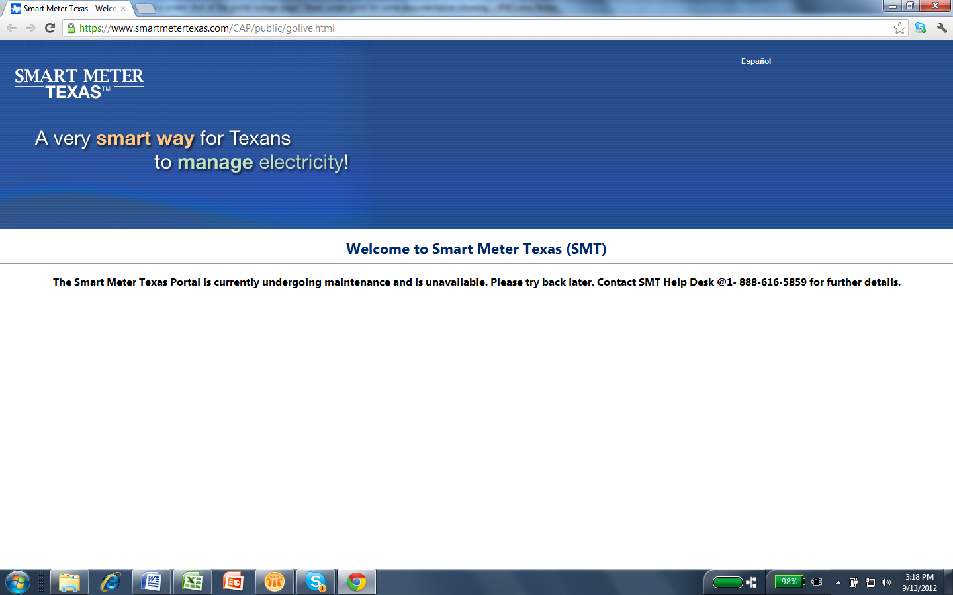

3.4 Reporting

SMT JDOA Committee will review both monthly and annual GUI reporting statistics as appropriate.

As an end to end solution the TDSPs and SMT report to the AMIT Operations Working Group and the AMIT Steering Committee on a monthly basis the following:

- Time to Market for energy data accessible through the SMT GUI
- Data quality for energy data accessible through the SMT GUI
- GUI Monthly Availability

Also, the JDOA will review issues and change requests concerning the GUI brought forth by Market participants through the SMT call center or through the AMIT Steering Committee review process.

4. SMT Application Programming Interface (API) Service Level Objectives, Notifications, and Reporting

4.1 Service Scope

Included in the scope of the SMT API service are the APIs for energy data requests from RORs and TDSPs. APIs for HAN functionality provisioning, de-provisioning, and messaging are covered below in section 7 HAN functionality.

4.2 Service Level Objectives

SMT is designed to be a 24x7 application and service, subject to scheduled maintenance windows and in case of any issues the SLAs and support teams hours vary based on severity levels.

SMT API availability is targeted to be over 99 percent as defined by the JDOA contracts. As the SMT Solution matures it will move into enhanced contractual agreements and the SLOs will be modified accordingly.

SMT API availability will be measured as a percentage of minutes that the service is available compared to the total number of minutes, excluding planned maintenance outage window time.

4.3 Market Outage Notification

SMT reserves the following times as scheduled maintenance outage windows for the SMT API. Notifications for planned maintenance during this window will be sent to the market at least 3 business days prior to the planned outage.

- Maintenance is conducted after hours and on weekends during low usage and the typical maintenance window is Saturday 2 AM until noon

Planned SMT API outages greater than 15 minutes in length will be reported to the market as follows:

Market Notices will be sent to RMS Listserv and AMIT Listserv

Elements included in the market notification are:
- Notice Date:
- Notice Type: (Identification Code)
- Day Affected: Incident start and end times and duration
- Short Description: Impact to affected service
- Long Description: Application(s) affected
- Additional Information: Actions Taken to Resolve
- Additional comments or notes
- Contact Information

4.4 Reporting

SMT JDOA Committee will review both monthly and annual reporting statistics as appropriate.

As an end to end solution the TDSPs and SMT report to the AMIT Operations Working Group and the AMIT Steering Committee on a monthly basis the following:

- Time to Market for energy data accessible through the SMT Energy Data API
- Data quality for energy data accessible through the SMT Energy Data API
- API Monthly Availability

Also, the JDOA will review issues and change requests concerning the API brought forth by Market participants through the SMT call center or through the AMIT Steering Committee review process.

5. SMT File Transfer Protocol (FTPS) Service Level Objectives, Notifications, and Reporting

5.1 Service Scope

Included in the scope of the SMT FTPS service is the Rep of Record interface for access to advanced meter 15 minute interval energy usage data.

5.2 Service Level Objectives

The advanced meter energy data files delivered from the TDSPs on the day following the actual day energy usage occurred will be made available on the SMT FTPS by no later than 11:00 pm that same day. If files are not available by that time, follow the process for submitting a help desk ticket.

SMT is designed to be a 24x7 application and service, subject to scheduled maintenance windows and in case of any issues the SLAs and support teams hours vary based on severity levels.

SMT FTPS availability is targeted to be over 99 percent as defined by the JDOA contracts. As the SMT Solution matures it will move into enhanced contractual agreements and the SLOs will be modified accordingly:

SMT FTP availability will be measured as a percentage of minutes that the service is available compared to the total number of minutes, excluding planned maintenance outage window time.

5.3 Market Outage Notification

SMT reserves the following times as scheduled maintenance outage windows for the SMT FTPS. Notifications for planned maintenance during this window will be sent to the market at least 3 business days prior to the planned outage.

- Maintenance is conducted after hours and on weekends during low usage and the typical maintenance window is Saturday 2 AM until noon

Planned SMT FTPS outages greater than 15 minutes in length will be reported to the market as follows:

- Market Notices will be sent to RMS Listserv and AMIT Listserv

Elements included in the market notification are:

- Notice Date:
- Notice Type: (Identification Code)
- Day Affected: Incident start and end times and duration
- Short Description: Impact to affected service
- Long Description: Application(s) affected
- Additional Information: Actions Taken to Resolve
- Additional comments or notes
- Contact Information

5.4 Reporting

SMT JDOA Committee will review both monthly and annual reporting statistics as appropriate.

As an end to end solution the TDSPs and SMT report to the AMIT Operations Working Group and the AMIT Steering Committee on a monthly basis the following:

- Time to Market for energy data accessible through the SMT FTPS site
- Data quality for energy data accessible through the SMT FTPS Site
- Monthly FTPS Availability

Also, the JDOA will review issues and change requests concerning the FTPS brought forth by Market participants through the SMT call center or through the AMIT Steering Committee review process.

6. SMT Call Center Service Level Objectives, Notifications, and Reporting

6.1 Service Scope

Included in the scope of the SMT Call Center service is consumer, Rep, and TDSP, support for SMT issue resolution and assistance.

This service includes support via phone for consumers, Reps, and TDSPs and an email help desk ticket submission for Reps and TDSPs.

6.2 Service Level Objectives

SMT Call Center availability is targeted to be: 24x 7.

6.3 Market Outage Notification

SMT Call Center outages greater than 15 minutes in length will be reported to the market as follows:

Market Notices will be sent to RMS Listserv and AMIT Listserv

Elements included in the market notification are:

- Notice Date:
- Notice Type: (Identification Code)
- Day Affected: Incident start and end times and duration
- Short Description: Impact to affected service
- Long Description: Application(s) affected
- Additional Information: Actions Taken to Resolve
- Additional comments or notes
- Contact Information

6.4 Reporting

SMT JDOA Committee will review both monthly and annual reporting statistics as appropriate.

On request, as an end to end solution the TDSPs and SMT report to the AMIT Operations Working Group and the AMIT Steering Committee on a monthly basis the following:

1. Number of call center tickets by month
2. Number of call center tickets by type

Also, the JDOA will review issues and change requests concerning the Call Center brought forth by Market participants through the AMIT Steering Committee review process.

7. SMT HAN Functionality Service Level Objectives

7.1 Service Scope

The scope of the SMT HAN service is the use of GUI and API home area network functionality for provisioning, de-provisioning, and messaging HAN devices.

7.2 Service Level Objectives

SMT is designed to be a 24x7 application and service, subject to scheduled maintenance windows and in case of any issues the SLAs and support teams hours vary based on severity levels.

SMT HAN availability is targeted to be over 99 percent as defined by the JDOA contracts. As the SMT Solution matures it will move into enhanced contractual agreements and the SLOs will be modified accordingly.

SMT HAN Services availability will be measured as a percentage of minutes that the service is available compared to the total number of minutes, excluding planned maintenance outage window time.

7.3 Market Outage Notification

SMT reserves the following times as scheduled maintenance outage windows for the SMT HAN. Notifications for planned maintenance during this window will be sent to the market at least 3 business days prior to the planned outage.

Maintenance is conducted after hours and on weekends during low usage and the typical maintenance window is Saturday 2 AM until noon
Planned SMT HAN Services outages greater than 15 minutes in length will be reported to the market as follows:

- Market Notices will be sent to RMS Listserv and AMIT Listserv

Elements included in the market notification are:

- Notice Date:
- Notice Type: (Identification Code)
- Day Affected: Incident start and end times and duration
- Short Description: Impact to affected service
- Long Description: Application(s) affected
- Additional Information: Actions Taken to Resolve
- Additional comments or notes
- Contact Information

7.4 Reporting

SMT JDOA Committee will review both monthly and annual reporting statistics as appropriate.

As an end to end solution the TDSPs and SMT report to the AMIT Operations Working Group and the AMIT Steering Committee on a monthly basis the following:

- Number of HAN devices provisioned by status type
- Number of HAN devices provisioned by TDSP territory
- Monthly HAN Availability

Also, the JDOA will review issues and change requests concerning the HAN functionality brought forth by Market participants through the SMT call center or through the AMIT Steering Committee review process.

8.0 Unplanned Outages Market Notifications

Unplanned outages or business process failures of SMT will be noticed to the market following the table below (excerpt from the Market Notice Communication Process).

Notices are sent to RMS listserv and/or other distribution lists as appropriate. The notices are sent when the issue is detected and follow up notices are sent each business day until issue is resolved. A notice outlining lessons learned and mitigation action is provided when information is available on the issue.

Table 5: SMT Unplanned System Outages or Business Processing Failures Notifications
Timing of Market Notification | Phases of Notice | Escalation | Notice Content | Listserv
Issue Detected (Business Day 1); ASAP | I – Initial General Market Notification | None | Minimal | RMS Listserv and/or other distribution lists as appropriate
At least by close of business (COB) Day 1 | II –Follow-Up | None | Standard content | Same as previous
By COB Day 2 | II –Follow-Up | None | Standard content | Same as previous
** Exception: For HAN, LSE and GUI functionality, the market expects frequent status notifications within the business day, in addition to the timelines outlined here

By COB Day 3 and beyond | II – Follow-Up | None | Same as previous + updates | Same as previous
End of Event ASAP | IV – Final | None | Normal Processing /Problem Explanation | Same as previous
End of Event + Reasonable Time to develop an explanation of the problem, not to exceed 45 calendar days without at least an interim report. | V – Lessons Learned & Mitigation Action | Optional – AMIT Update | Same as previous + lessons learned and mitigation actions; additional follow-up communications | Same as previous

9. Browser Compatibility

SMT maintains its services to support most commonly-used web browsers.

Supported browsers currently include IE6, IE7, IE8, FireFox 3.5, FireFox 3.6 and FireFox 4

10. Service Availability Renegotiations and Change Control Process

Renegotiation of SMT core services and the availability, operating hours, and reporting mechanisms of such core services will be reviewed as the solution matures and new contractual agreements are developed in the future.

The JDOA will review issues brought forth through the SMT call center and change requests concerning the SMT Solution brought forth by Market participants in the AMIT Steering Committee review process.

Version control in the form of document version numbering will be maintained in this document as a means of providing a change control process.

11. Annual SLO Review Process

The SMT core services availability targets defined in this document will be reviewed at least annually by the JDOA Committee

12. Approvals

Area of Responsibility | Name | Reviewed / Approved | Date

