 |  |  |  | System Planning
Monthly Status Report
February 2013

 |  | Report Highlights
 | - ERCOT is currently tracking 162 active generation interconnection requests totaling over 48,000 MW. This includes over 21,000 MW of wind generation.
- ERCOT is currently reviewing proposed transmission improvements with a total cost of $261 Million
- Transmission Projects endorsed in 2013 total $138 Million
- All projects (in engineering, routing, licensing and construction) total approximately $9.97 Billion.
- Transmission Projects energized in 2012 total about $854.2 million.

Table of Contents
1. Generation Interconnection 1
1.1 Signed Generation Interconnection Agreements 1
1.2 New Generation Registering for Commercial Operations - none 1
1.3 Summary of Generation Interconnection Requests 1
1.4 Projects with Interconnection Agreements 4
1.5 Generation Projects Undergoing Full Interconnection Studies with Confidentiality Waived by Developer 4
1.6 Generation Projects Undergoing Full Interconnection Studies 5
1.7 Wind Generation Capacity Installed by Year 6
2. Regional Planning Group Project Reviews 7
3. Congestion Costs 8
4. Wind Generation as a Percent of Load 11
5. Planning Model Activities 12
6. Other Notable Activities 13

1. Generation Interconnection
Additional information regarding detailed generation interconnection and impact studies is contained in the “Generation Project Interconnection Information” folder in the “Operations and System Planning” area on the ERCOT website: http://planning.ercot.com/login/login.

Signed Generation Interconnection Agreements

14INR0016 – Channel Energy Center – 190 MW of Combined Cycle Gas in Harris County
13INR0010 – Mariah Wind – 600 MW of Wind in Parmer County

New Generation Registering for Commercial Operations

None

Summary of Generation Interconnection Requests
GENERATION INTERCONNECTION REQUESTS CURRENTLY UNDER REVIEW
Currently tracking 165 generation interconnection or change requests
As of February 28, 2013 |  |  |  | Total
Security Screening Study | 9
SSS Completed | 27
Full Interconnect Study | 87
FIS Completed | 9
Suspended Studies | 3
Capacity of Suspended Study Projects | 350
Interconnect Agreement Completed | 30
Capacity under Interconnection Agreements | 11,402
Capacity for Grid, MW | 48,372
Wind Capacity, MW | 21,311

Fuel Type | Confidential Projects (MW) | Projects Under Full Study (MW) | Public Projects (MW) | Suspended Studies (MW) | Grand Total (MW)
Gas-AllOther |  |  | 89 |  | 8,442
Gas-CombinedCycle |  |  | 6,068 |  | 14,343
Total Gas | 10,603 | 6,025 | 6,157 |  | 22,785
Nuclear
Coal |  | 850 | 1,165 |  | 2,015
Wind | 2,804 | 14,517 | 3,990 | 312 | 21,623
Solar | 760 | 537 | 50 | 38 | 1,385
Biomass
Storage |  | 874 | 40 |  | 914
Petroleum Coke
Grand Total | 14,167 | 22,803 | 11,402 | 350 | 48,722

County Location of Installed Generation and Interconnection Requests (all fuels)

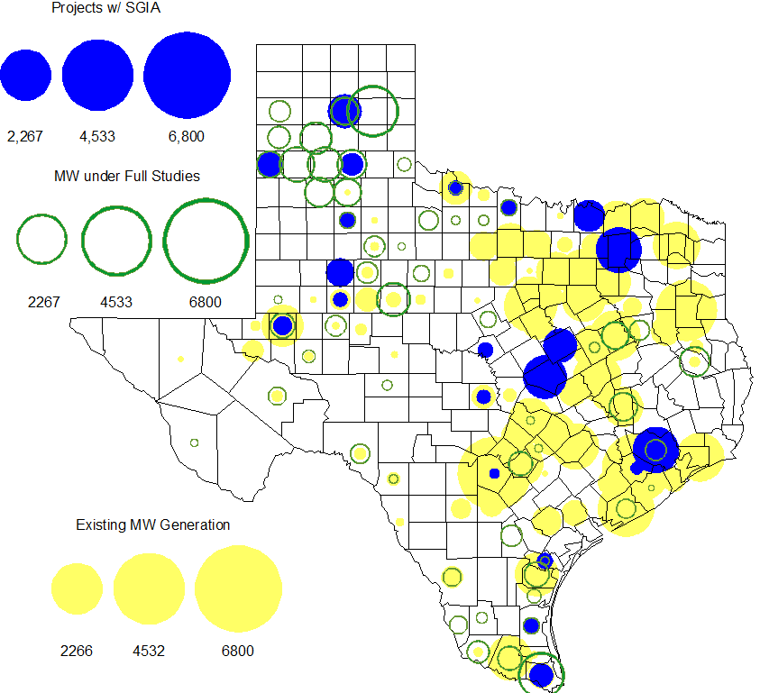

Projects with Interconnection Agreements

Generation Interconnections as of February 28, 2013
INR | Site Name | County | COD | Fuel | MW For Grid | Change from Last Report
08INR0049 | Bobcat Bluff | Clay | Mar-13 | Wind | 163 | Date
11INR0033 | Los Vientos | Cameron | Mar-13 | Wind | 400 | Date
12INR0075 | Blue Summit Windfarm | Wilbarger | Apr-13 | Wind | 135 | Date
09INR0001 | Sandy Creek 1 | McLennan | Apr-13 | Coal | 925
06INR0006 | Cobisa-Greenville | Hunt | May-13 | Gas | 1,792
12INR0086 | WA Parish Addition | Fort Bend | May-13 | Gas | 89
12INR0016a | Las Brisas Energy Center | Nueces | May-13 | PetCoke | 660 | Cancelled
12INR0016b | Las Brisas Energy Center | Nueces | May-13 | PetCoke | 660 | Cancelled
10INR0089 | Deepwater Energy Storage | Harris | Jul-13 | Storage | 40 | Date
13INR0058 | OCI Alamo 1 | Bexar | Oct-13 | Solar | 50 | Date
14INR0030a2 | Panhandle Wind | Carson | Nov-13 | Wind | 322
11INR0013 | Goldthwaite Wind Energy | Mills | Dec-13 | Wind | 150 | Date
11INR0054 | Midway Farms Wind | San Patricio | Dec-13 | Wind | 161
12INR0034 | Stephens Ranch Wind Energy | Borden | Dec-13 | Wind | 378
14INR0015 | Deer Park Energy Center | Harris | Jun-14 | Gas | 192
14INR0016 | Channel Energy Center 138/345kV CT | Harris | Jun-14 | Gas | 190 | New
13INR0021 | Ferguson Replacement Project | Llano | Jun-14 | Gas | 116 | Date
10INR0020a | Panda Temple Power | Bell | Aug-14 | Gas | 809
10INR0021 | Panda Sherman Power | Grayson | Aug-14 | Gas | 809
13INR0040 | Agrifos Steam Unit (PUN) | Harris | Aug-14 | Gas | 0 | New
11INR0050 | Moore Wind 1 | Crosby | Aug-14 | Wind | 149
13INR0010a | Mariah Wind | Parmer | Oct-14 | Wind | 200 | New
14INR0023 | Longhorn Energy Center | Briscoe | Dec-14 | Wind | 361
13INR0005 | Conway Windfarm | Carson | Dec-14 | Wind | 600
06INR0022c | Penascal Wind Farm 3 | Kenedy | Dec-14 | Wind | 202
09INR0051 | Mesquite Creek | Borden | Mar-15 | Wind | 249
08INR0018 | Gunsight Mountain | Howard | Aug-15 | Wind | 120
13INR0010b | Mariah Wind | Parmer | Oct-15 | Wind | 200 | New
13INR0023 | Texas Clean Energy Project | Ector | Jan-16 | Coal | 240
10INR0020b | Panda Temple Power | Bell | May-16 | Gas | 780
10INR0022 | Pondera King Power Project | Harris | Jun-16 | Gas | 1,380
13INR0010c | Mariah Wind | Parmer | Oct-16 | Wind | 200 | New

Generation Projects Undergoing Full Interconnection Studies with Confidentiality Waived by Developer

None

Generation Projects Undergoing Full Interconnection Studies
INR | County | Fuel | MW | COD |  | INR | County | Fuel | MW | COD
13INR0045 | Castro | Wind | 288 | Apr-13 |  | 11INR0094 | Kent | Solar | 100 | Apr-13
13INR0020a | Glasscock | Wind | 200 | May-13 |  | 13INR0060 | Hidalgo | Gas | 50 | Jun-13
12INR0045 | Kleberg | Wind | 135 | Jun-13 |  | 13INR0057 | Archer | Wind | 65 | Jun-13
12INR0081a | Upton | Wind | 112 | Jun-13 |  | 13INR0049 | Harris | Gas | 352 | Jul-13
13INR0025 | Randall | Wind | 150 | Sep-13 |  | 13INR0046 | Limestone | Wind | 71 | Sep-13
13INR0059 | Castro | Wind | 499 | Oct-13 |  | 13INR0028 | Hale | Gas | 359 | Nov-13
14INR0030a1 | Carson | Wind | 322 | Nov-13 |  | 12INR0059 | Pecos | Solar | 50 | Dec-13
11INR0062 | Nueces | Wind | 178 | Dec-13 |  | 11INR0085 | Nolan | Wind | 106 | Dec-13
12INR0002a | Briscoe | Wind | 200 | Dec-13 |  | 12INR0054 | Jones | Wind | 200 | Dec-13
13INR0026 | Oldham | Wind | 201 | Dec-13 |  | 13INR0036 | Hidalgo | Wind | 200 | Dec-13
13INR0038 | Swisher | Wind | 300 | Dec-13 |  | 13INR0052 | Starr | Wind | 200 | Dec-13
13INR0055 | Zapata | Wind | 250 | Dec-13 |  | 13INR0056 | Scurry | Wind | 366 | Dec-13
14INR0024 | Kinney | Solar | 42 | Dec-13 |  | 11INR0057 | Cameron | Wind | 165 | Dec-13
11INR0093 | San Patricio | Wind | 41 | Dec-13 |  | 12INR0068 | Jim Hogg | Wind | 80 | Dec-13
12INR0088 | Crosby | Wind | 201 | Dec-13 |  | 13INR0048 | Oldham | Wind | 161 | Dec-13
14INR0012 | Gray | Wind | 401 | Dec-13 |  | 15INR0021 | Starr | Wind | 200 | Dec-13
14INR0014 | Val Verde | Solar | 100 | Jan-14 |  | 12INR0055 | Baylor | Wind | 40 | Jan-14
12INR0084 | Randall | Wind | 242 | Jan-14 |  | 13INR0006 | Gray | Wind | 750 | Jan-14
14INR0013 | Cameron | Wind | 103 | Jan-14 |  | 14INR0039 | Ector | Gas | 450 | Mar-14
12INR0060 | Schleicher | Wind | 58 | Apr-14 |  | 14INR0027 | Guadalupe | Gas | 471 | May-14
13INR0020b | Glasscock | Wind | 150 | May-14 |  | 14INR0031 | Harris | Gas | 0 | Jun-14
14INR0011 | Swisher | Gas | 270 | Jun-14 |  | 08INR0019a | Gray | Wind | 250 | Jun-14
08INR0019b | Gray | Wind | 250 | Jun-14 |  | 08INR0019c | Gray | Wind | 250 | Jun-14
14INR0048 | Wilbarger | Wind | 114 | Jun-14 |  | 14INR0040 | Hidalgo | Gas | 225 | Jun-14
14INR0029 | Uvalde | Solar | 42 | Jul-14 |  | 12INR0085 | Stonewall | Wind | 24 | Jul-14
14INR0025 | Floyd | Wind | 500 | Jul-14 |  | 12INR0042a | Deaf Smith | Wind | 265 | Sep-14
12INR0042b | Deaf Smith | Wind | 135 | Sep-14 |  | 14INR0032 | Randall | Wind | 501 | Sep-14
12INR0070 | Knox | Wind | 300 | Oct-14 |  | 13INR0031 | Travis | Solar | 30 | Oct-14
14INR0030b | Carson | Wind | 322 | Nov-14 |  | 13INR0054 | Bee | Gas | 0 | Dec-14
10INR0085 | Ector | Solar | 40 | Dec-14 |  | 11INR0081 | Live Oak | Wind | 72 | Dec-14
11INR0082A | Val Verde | Wind | 50 | Dec-14 |  | 11INR0082B | Val Verde | Wind | 150 | Dec-14
12INR0002b | Briscoe | Wind | 200 | Dec-14 |  | 12INR0071 | Caldwell | Wind | 30 | Dec-14
13INR0007 | Pecos | Wind | 200 | Dec-14 |  | 13INR0050 | Comanche | Wind | 200 | Dec-14
14INR0009 | Kent | Wind | 248 | Dec-14 |  | 14INR0020 | Floyd | Wind | 150 | Dec-14
14INR0028 | Live Oak | Wind | 300 | Dec-14 |  | 12INR0079 | Kenedy | Wind | 200 | Dec-14
11INR0079a | Clay | Wind | 200 | Dec-14 |  | 08INR0031 | Childress | Wind | 120 | Dec-14
12INR0029 | Swisher | Wind | 500 | Dec-14 |  | 14INR0045 | Webb | Wind | 251 | Dec-14
10INR0009 | Castro | Wind | 300 | Mar-15 |  | 12INR0057 | Ector | Solar | 40 | Apr-15
15INR0032 | Hale | Gas | 197 | Jun-15 |  | 15INR0033 | Hale | Gas | 197 | Jun-15
16INR0008 | Grimes | Gas | 687 | Jun-15 |  | 14INR0026 | Presidio | Solar | 28 | Sep-15
15INR0013 | Anderson | Gas | 324 | Oct-15 |  | 15INR0014 | Matagorda | Gas | 280 | Oct-15
11INR0065 | Nueces | Wind | 350 | Oct-15 |  | 12INR0002c | Briscoe | Wind | 350 | Dec-15
14INR0018 | Nolan | Solar | 35 | Dec-15 |  | 13INR0032 | Andrews | Solar | 30 | Dec-15
16INR0005 | Cameron | Gas | 871 | Apr-16 |  | 16INR0004 | Cameron | Gas | 730 | Jun-16
16INR0006 | Angelina | Gas | 785 | Jun-16 |  | 16INR0003 | Brazoria | Gas | 11 | Jun-16
12INR0018 | Gray | Wind | 500 | Mar-17 |  | 11INR0040 | Freestone | Gas | 640 | Mar-18
14INR0003 | Nolan | Coal | 850 | Jun-19 |  | 13INR0010d | Parmer | Wind | 200 | TBD
13INR0010e | Parmer | Wind | 200 | TBD |  | 13INR0010f | Parmer | Wind | 200 | TBD
Note: Projects that are classified as “Cancelled” or “Suspended” are excluded from this table.

Wind Generation Capacity Installed by Year
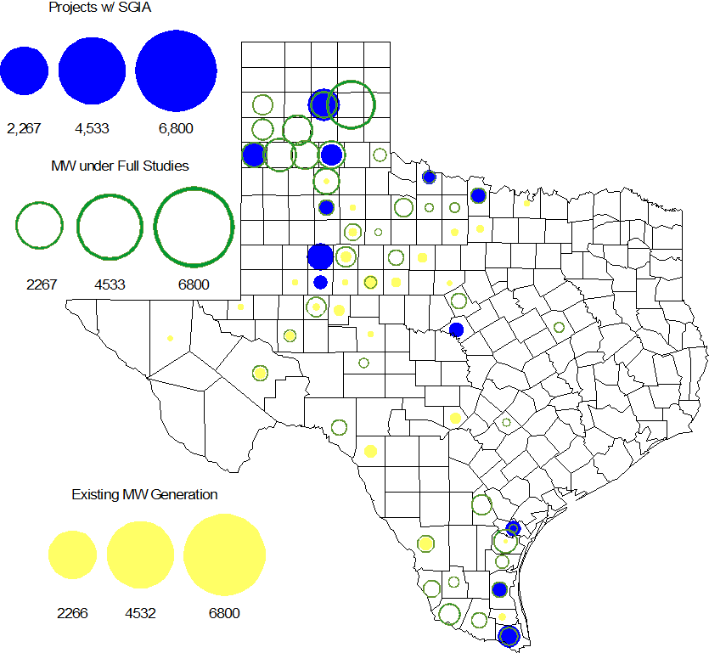

The total installed wind capacity is now reported as 10,407 MW by the resource owners through the registration process. Capacity by North, South and West is 669 MW, 2,375 MW, and 7,363 MW respectively. 850 MW is able to switch between the West and South zones and is currently shown in the South zone.

Regional Planning Group Project Reviews

- Sharyland has submitted the Atlas-Driver Load Integration project, this is a Tier 2 project that is estimated to cost approximately $15.4 million. This project is currently under ERCOT independent review.

- American Electric Power Service Corporation (AEPSC) has submitted the Sinton-Beeville-Kenedy Area Improvements project to accommodate load additions due to Eagle Ford Shale development in South Texas. This is a Tier 1 project that is estimated to cost $89.2 million. ERCOT has completed the independent review. This project was approved by TAC on Feb. 07, 2013 and will be presented to the Board of Directors on March 19, 2013 for their endorsement.

- LCRA TSC, Guadalupe Valley Electric Cooperative (GVEC), American Electric Power (AEP), and South Texas Electric Cooperative (STEC) have jointly submitted the Kenedy Switch to Nixon to Seguin Line Upgrade project. This is a Tier 1 project that is estimated to cost approximately $55.3 million. ERCOT has completed the independent review. This project was approved by TAC on Feb. 07, 2013 and will be presented to the Board of Directors on March 19, 2013 for their endorsement.

- Guadalupe Valley Electric Cooperative (GVEC) has submitted the McQueeney-SMI-Geronimo 69 kV to 138 kV rebuild project. This is a Tier 2 project that is estimated to cost approximately $8.1 million. This project is currently under ERCOT independent review.

- Oncor has submitted the Permian Basin to Culberson 138 kV line project. The project is estimated to cost approximately $73 million. The Permian Basin to Culberson 138 kV line project is classified as a Tier 3 project and once the RPG comments are resolved it will be reclassified as a Tier 4 Neutral project. This project is currently in study mode.

- LCRA TSC, Guadalupe Valley Electric Cooperative (GVEC) and American Electric Power (AEP) jointly submitted the Kenedy Switch to Guadalupe line upgrade project. This is a Tier 3 project that is estimated to cost approximately $37.9 million. This project has completed the RPG review and ERCOT will now prepare the RPG acceptance letter.

- Oncor submitted the Hicks to Elizabeth Creek 138 kV line project. This is a Tier 2 project that is estimated to cost approximately $42 million. The proposed Hicks to Elizabeth Creek 138 kV line project was identified as a reliability project (needed in 2016) in the 2011 Five-Year Transmission Plan (5YTP). The 2011 5YTP will serve as an ERCOT independent review for this project. This project has completed the RPG review and ERCOT will now prepare the RPG acceptance letter.

- LCRA TSC has submitted the McNeil-Marshall Ford line upgrade (69 kV to 138 kV conversion) project. This is a Tier 3 project that is estimated to cost approximately $20 million. This project has been submitted for RPG comments.

Congestion Costs
Dollars shown in RUC Make Whole payment graph are of settlement quality.

RUC net Make Whole payment in $mm

Monthly Average LMP

Binding Constraints – Year to Date
Contingency | Binding Element | Number of 5-min intervals | Shadow Price Range $/MWh | Estimated Congestion Rent $ (Shadow Price*Limit) | Transmission Project
Roanoke Switch - West Denton 345 kV & Roanoke Switch - Lewisville Switch 345 kV; West Denton - Roanoke Switch 345 kV; or RD Wells Interchange - West Denton 138 kV | Fort Worth - Teasley 138 kV | 1102 | 0 - 3500 | 6,144,747 | 14TPIT0047
Morgan Creek SES - China Grove 138 kV double-circuit | Morgan Creek SES 138/69 kV Autotransformer 3 | 158 | 0 - 2800 | 2,677,907
Asphalt Mines - Odlaw Switch 138 kV | Hamilton Road - Marverick 138 kV | 1837 | 0 - 458 | 1,342,192 | 16TPIT0024
Los Fresnos - La Palma 138 kV | La Palma - Villa Cavazos 138 kV | 38 | 13 - 3500 | 1,234,584 | 16TPIT0029
Golden Switch - Sun Switch 138 kV | China Grove - Bluff Creek 138 kV | 178 | 0 - 3500 | 1,208,909 | 12TPIT0058, 13TPIT0098
Roanoke Switch - West Denton 345 kV & Roanoke Switch - Lewisville Switch 345 kV; or West Denton - Roanoke Switch 345 kV | North Denton - Jim Christal 138 kV | 361 | 0 - 704 | 1,206,850 | 14TPIT0047
Fort Stockton Switch -Barrilla 138 kV | Fort Stockton Switch -Barrilla 69 kV | 755 | 0 - 1819 | 1,192,325
Temple Elm Creek - Belton 138 kV double-circuit | Temple Switch - Temple Southeast 138 kV | 104 | 0 - 2204 | 1,136,295 | 06TPIT0143
Carrollton Northwest - Lewisville Switch 345 kV double-circuit; or Carrollton Northwest - Lewisville Switch (to Roanoke Switch) 345 kV | Highlands TNP - West TNP 138 kV | 277 | 0 - 398 | 940,665
Base Case; Lobo - San Miguel 345 kV; Pawnee - Lon Hill 345 kV; Lobo 345/138 kV Autotransformer; or Comanche Peak Units 1 & 2 | LaQuinta - Lobo 138 kV | 704 | 0 - 109 | 799,068
Binding Constraints – Feb 2013
Contingency | Binding Element | Number of 5-min intervals | Shadow Price Range $/MWh | Estimated Congestion Rent $ (Shadow Price*Limit) | Transmission Project | Comments
Roanoke Switch - West Denton 345 kV & Roanoke Switch - Lewisville Switch 345 kV; or West Denton - Roanoke Switch 345 kV | Fort Worth - Teasley 138 kV | 459 | 0 - 1008 | 2,555,275 | 14TPIT0047 | High west to north transfer; Jim Christal - West Denton 138 kV line outage; and Jim Christal - North Denton 138 kV line outage
Golden Switch - Sun Switch 138 kV | China Grove - Bluff Creek 138 kV | 178 | 0 - 3500 | 1,208,909 | 12TPIT0058, 13TPIT0098 | High wind and low loads; or low wind and high loads
Fort Stockton Switch -Barrilla 138 kV | Fort Stockton Switch -Barrilla 69 kV | 703 | 0 - 1819 | 1,153,141 |  | High McCamey wind
Temple Elm Creek - Belton 138 kV double-circuit | Temple Switch - Temple Southeast 138 kV | 104 | 0 - 2204 | 1,136,295 | 06TPIT0143
Carrollton Northwest - Lewisville Switch 345 kV double-circuit; or Carrollton Northwest - Lewisville Switch (to Roanoke Switch) 345 kV | Highlands TNP - West TNP 138 kV | 277 | 0 - 398 | 940,665 |  | Low load in DFW Area and high wind
Roanoke Switch - West Denton 345 kV & Roanoke Switch - Lewisville Switch 345 kV; or West Denton - Roanoke Switch 345 kV | North Denton - Jim Christal 138 kV | 204 | 0 - 704 | 839,711 | 14TPIT0047 | High west to north transfer; and West Denton - Fort Worth 138 kV line outage
Asphalt Mines - Odlaw Switch 138 kV | Hamilton Road - Marverick 138 kV | 1019 | 0 - 458 | 757,135 | 16TPIT0024 | High McCamey wind
Killeen Switch 345/138 Autotransformer 2 | Killeen Switch 345/138 kV Autotransformer 1 | 263 | 0 - 146 | 691,350 | 10TPIT0125 | Killeen Switch - Salado Switch 345 kV double-circuit line outage
Scurry Switch - Spur 138 kV; or Scurry Switch - Sun Switch 138 kV | Aspermont AEP 138/69 kV Autotransformer | 2321 | 0 - 104 | 528,270 |  | High wind in the area
Rodd Field - Holly 138 kV | Airline - Cabaniss 138 kV | 31 | 0 - 3500 | 468,550 | 12TPIT0185

Wind Generation as a Percent of Load
One-hour average of total wind power output as a percentage of ERCOT load.

Planning Model Activities
- Data Set B work began on August 1, 2012 with a Topology Processor case extracted from NMMS with a build date of January 1, 2013. Process is underway with creation of Pass 1 cases on Aug 31, 2012.
- The short term calendar of major planning model events follows:
  - Feb 18,2013 December TPIT updates complete
  - Mar 7, 2013 Contingency update complete
  - Apr 2, 2013 Begin 14 Data Set A case build
  - Jun 11-13, 2013 SSWG Data Set A meeting in Taylor
  - Jul 5, 2013 Projected posting 14 Data Set A
- Status update on SCR760, Changes Needed for Information Model Manager and Topology Processor for Planning Models, which was approved by the ERCOT Board in March 2011.
  - Bundle 1 (Items 3, 7 and 8): In Production.
  - Bundle 2 (Items 2a, 4, 9): In Production.
  - Bundle 3 (Item 5, 2b, 2c): In Production
  - Bundle 4 (Items 1, 6): Requirements agreed to by ERCOT and Vendor. Vendor proposal approved by ERCOT. SOW amendment underway. Vendor has begun work. Expect to receive first release in April 2013.
SCR Sub Part | SCR Description | Status
SCR760-1 | Upgrade to PSS/E v32 | Production
SCR760-2 | Distribution Capacitor banks | Production
SCR760-3 | Zero Impedance Line Ratings | Production
SCR760-4 | Associate Loads and Capacitor banks with the correct CNG | Production
SCR760-5 | Additional Transformer Data for Planning | Production
SCR760-6 | FACTS Devices | Planning
SCR760-7 | Assign valid PSSE IDs to Breakers/  Switches/ Series Devices | Production
SCR760-8 | Phase shift of Autos for short circuit studies | Production
SCR760-9 | Multisection Line Grouping | Production
Table 1: In the following table:
- Red will be used to show status of Not Submitted, meaning that the SCR sub part has not been submitted to Siemens as a Service Request.
- Yellow will indicate that the SCR sub part has been submitted. The color will remain yellow and the status will change in order to Submitted, Planning (Requirements, SOW, Code Writing), Release (Siemens produces first code to test), and Testing (code has completed internal test and is moving through release management).
- Green will indicate that the code has been tested and installed on the machines that ERCOT uses to produce Topology Processor output for Planning and CRR.

Other Notable Activities
- ERCOT has completed sensitivity analysis for the 2012 Five-Year Transmission Plan and the draft report was sent to the TO’s for review/comments. The 2012 5YTP sensitivity analysis is anticipated to be posted at the ERCOT POI by March. 25, 2013. ERCOT 5YTPer’s are currently working on the start cases for the 2013 Five-Year Transmission Plan.

