ERCOT Operations Report
February 2013 ROS & OWG

Frequency Control

Time | Freq (Hz) | Duration (s)
2/16/2013 17:57 | 59.850 | 220 | Unit runback and trip over a 6 minute period with approximately 1150 MW net.
2/16/2013 20:03 | 59.897 | 20 | Gen Deviation of 455 MW
Note: Time of frequency excursions outside the range of +/- 0.1 Hz.

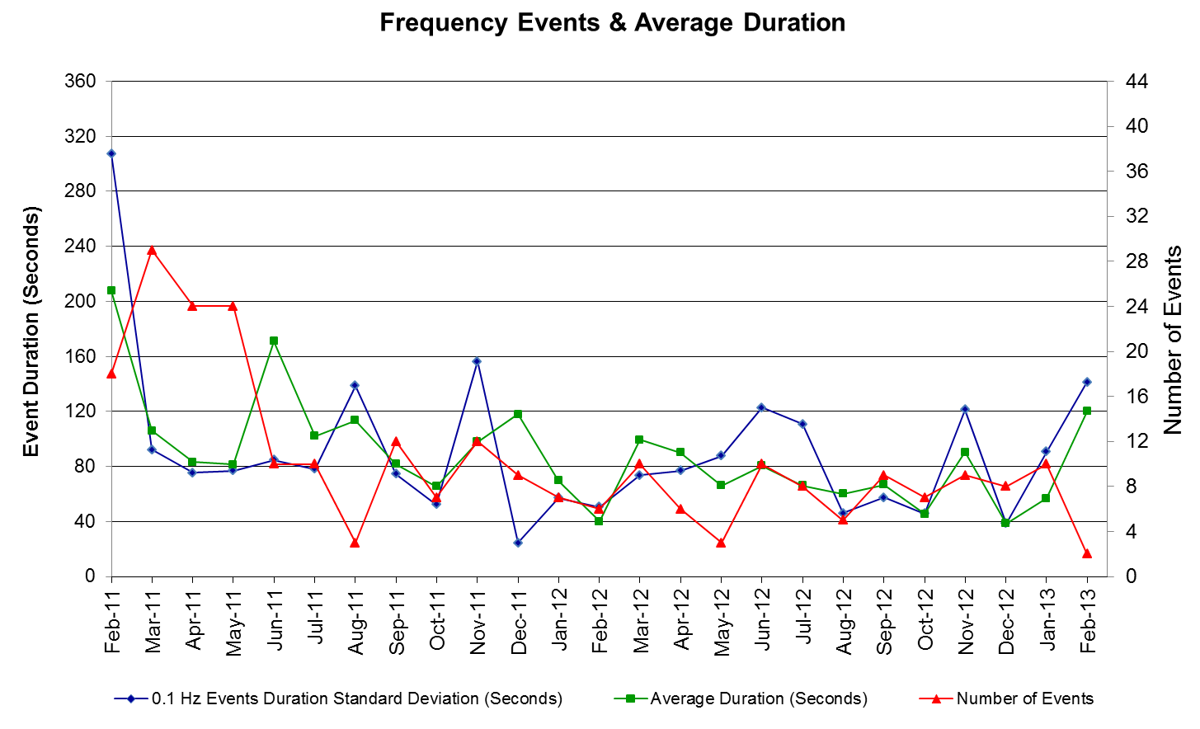

PMU Events

Date | Events | Duration | Summary
2/16/2013 17:57 | Unit trip | Approx. 5 min | The event was caused by the loss of two combined cycles. Units ranback and tripped over a 6 minute period with approximately 1150 MW net. The frequency dropped to 59.85 Hz due to the event. No significant oscillation was observed in this event.

Deployed Responsive (Reported Above)

Time deployed | Stop Time | Duration | Max | Details
2/16/13 17:59:01 | 2/16/13 18:02:56 | 0:03:55 | 229.02
2/16/13 20:02:32 | 2/16/13 20:06:28 | 0:03:57 | 469.76

RUC Commitments

SCED Congestion Management Activity
Congestion affected by outages (*) Remedial action plan has been developed for the element
Contingency | Overloaded Element | Days | MP
Asphalt Mines - Uvalde Aep & Odlaw Switchyard 138kV | Hamilton Road - Maverick 138kV | 21 | N
Scurry Switch - Sun Switch 138 kV | Aspermont Aep 138_69T1 138/69kV | 13 | N
Salt Creek Bepc - Spur And Scurry Switch 138kV | Aspermont Aep 138_69T1 138/69kV | 12 | N
Fort Stockton Plant - Barrilla 138kV | Fort Stockton Switch - Barrilla 69 kV | 12 | N
Salt Creek Bepc - Spur And Scurry Switch 138kV | Aspermont AEP - Aspermont Continental 69kV | 9 | N
Basecase | Laquinta - Lobo 138 kV | 9 | N
Scurry Switch - Sun Switch 138 kV | Aspermont AEP - Aspermont Continental 69kV | 8 | N
Pawnee Switching Station - Lon Hill 345 kV | Rincon - Airco Aep 138kV | 8 | N
Golden Switch - Sun Switch 138 kV | China Grove Switch - Bluff Creek Switch 138 kV | 7 | N
DCKT Roanoke Switch - West Denton and Lewisville Switch 345kV | Fort Worth Substation - Teasley Substation 138kV | 6 | N
Coleto Creek - Pawnee Switching Station 345kV | Coleto Creek - Kenedy Swtich 138kV | 6 | N
Basecase | W_TO_N | 5 | N
Pawnee Switching Station - Lon Hill 345 kV | Laquinta - Lobo 138 kV | 5 | N
DCKT Roanoke Switch - West Denton and Lewisville Switch 345kV | Jim Christal Substation - North Denton Interchange 138 kV | 5 | N
Killeen Switch Axfmr2h (3) 345/138kV | Killeen Switch Axfmr1h (3) 345/138kV | 5 | N
Bosque Switch - Whitney 138 kV | Lake Whitney Tnp - Whitney 138kV | 4 | N
Bosque Switch - Whitney 138 kV | Bosque Switch - Lake Whitney Tnp 138 kV | 4 | N
Aspermont Aep - Spur 138KV | Wolfgang - Rotan 69kV | 4 | N
Laquinta - Lobo 138 kV | Laquinta - Bruni Tap 138kV | 4 | N
Aspermont Aep - Spur 138KV | Spur 138_69_1 138/69kV | 3 | N
Comanche Switch (Oncor) - Brown Switch 345kV | Brown Switch - Killeen Switch 345kV (35095) | 3 | N
DCKT Lewisville Switch - Carrollton Northwest 345 kV | Highlands Tnp - West Tnp 138kV | 3 | N
DCKT Sweetwater East Switch - Abilene Mulberry Creek & Long Creek 345kV | Radium - Anson 69kV | 3 | N
Basecase | Langford Wind Power Llc - Santiago 138kV | 2
Pawnee Switching Station - Lon Hill 345 kV | Rincon - Bonnieview 69kV | 2
Comanche Switch (Oncor) - Brown Switch 345kV | Brown Switch - Killeen Switch 345kV (35090) | 2
DCKT Whitepoint - Lon Hill & South Texas Project 345kV | Rincon - Airco Aep 138kV | 2
DCKT Whitepoint - Lon Hill & South Texas Project 345kV | Sinton - Skidmore 69 kV | 2
Nelson Sharpe - Lon Hill 345kV | Kingsville - Kleberg Aep 138kV | 2
Nelson Sharpe - Lon Hill 345kV | Celanese Bishop - Kleberg Aep 138kv | 2
Lobo 2_345_138_H 345/138 kV | Laquinta - Lobo 138 kV | 2
DCKT Morgan Creek Ses - China Grove Switch 138kV | Radium - Anson 69kV | 2
West Denton - Roanoke Switch 345kV | Fort Worth Substation - Teasley Substation 138kV | 2
DCKT Temple Northwest - Belton & Temple North 138kV | Temple Switch - Temple Southeast 138 kV | 2
Orange Grove Switching Station - Lon Hill 138 kV | Smith - Edroy 69kV | 2
Vernon 138_69t1 138/69 kV | Aspermont AEP - Aspermont Continental 69kV | 2
DCKT North Edinburg - Rio Hondo - South Santa Rosa - Harlingen Switch 345kV | Rio Hondo - Burns Sub 138kV | 2
Moss Switch - Holt Switch & Amoco North Cowden 138kV | Odessa North - Odessa Basin Switch 69 kV | 2
Victoria - Coleto Creek 138kV (Coleto_Victor1) | Victoria - Coleto Creek 138kV (Coleto_Victor2) | 2
Scurry Switch - Sun Switch 138 kV | Hamlin Shell - Aspermont Continental 69kV | 1
Salt Creek Bepc - Spur And Scurry Switch 138kV | Wolfgang - Rotan 69kV | 1
Basecase | Post Oak Wind (Potomes) 138kV | 1
Coleto Creek - Pawnee Switching Station 345kV | Fallscty - Kenedy Switch 138kV | 1
DCKT Lewisville Switch - Carrollton Northwest 345 kV | Lewisville Switch - Jones Street Tnp 138kV | 1
DCKT Graham Ses - Long Creek & Cook Field Road Switch 345kV | Orlando - Vernon 138kV | 1
DCKT Graham Ses - Long Creek & Cook Field Road Switch 345kV | Leon Switch - Eastland Tap 69kV | 1
DCKT Graham Ses - Long Creek & Cook Field Road Switch 345kV | Brown Switch - Killeen Switch 345kV (35095) | 1
Lobo 2_345_138_H 345/138 kV | Asherton - Catarina 138kV (Ashert_Catari0) | 1
DCKT Morgan Creek Ses - China Grove Switch 138kV | Morgan Creek Ses Axfmr3h 138/69 kV | 1
West Denton - Roanoke Switch 345kV | Jim Christal Substation - North Denton Interchange 138 kV | 1
Ajo - Rio Hondo 345 KV | North Edinburg Nedin_XC2 345kV | 1
Ajo - Rio Hondo 345 KV | Rio Hondo Riohondo_345L 345kV | 1
Ajo - Rio Hondo 345 KV | Las Pulgas - Rio Hondo 138kV | 1
Lobo - San Miguel 345_138 KV Switchyards 345 KV | Asherton - Catarina 138kV (Ashert_Catari0) | 1
Lobo - San Miguel 345_138 KV Switchyards 345 KV | Laquinta - Lobo 138 kV | 1
DCKT Fayette Plant 2 - Lytton Springs & Holman Aen 345 kV | Austrop - Garfield Lcra 345kV | 1
Belton Southwest - Killeen Switch & Belton 138kV | Killeen Elm - Killeen Taft Street 138kV (641_B) | 1
Horse Hollow Generation Tie T1h (3) 345/138kV | Horse Hollow Generation Tie T2h (3) 345/138kV | 1
Falcon Seaboard - Morgan Creek Ses 345kV | McDonald Road - Forsan Tap 138kV | 1
DCKT Temple Switch - Lake Creek Ses & Temple Pecan Creek 345kV | Temple Switch Axfmr1h 345/138kV | 1
Lewisville Switch - Carrollton Northwest 345kV (105_A) | Highlands Tnp - West Tnp 138kV | 1
DCKT Big Brown SES - Richland Chambers 345 kV | Trinidad Ses Axfmr6 (3) 345/138kV | 1
DCKT Austrop - Garfield Lcra & Zorn 345 kV | Garfield Aen Gf_At_2 345/138 kV | 1
Weil Tract - Lon Hill 138kV | Weil Tract - Citgo West 138kV | 1
DCKT Gibbons Creek - Singleton 345 kV | Jewett - Singleton 345kV (240) | 1
Falcon Seaboard - Midland East 345kV | McDonald Road - Forsan Tap 138kV | 1
Illinois #4 - Fort Lancaster 138kV | Sonora - Friess Ranch 69kV | 1
Paloduro Sub - Dilley Switch Aep 138kV | Dilley Switch Aep 138_69A1 138/69kV | 1
DCKT Salado Switch - Hutto Switch 345kV | Sandow Switch - Austrop 345kV (450) | 1
North Edinburg - Rio Hondo 345 kV | Aderhold - Elsa 138kV | 1
Cisco - Putnam 138kV & Leon Switch 138kV | Abilene South - Potosi Tap 138kV | 1
Lake Pauline - Munday East 138kV | Lake Pauline 138_69_1 138/69 kV | 1
Bosque Switch - Elm Mott 345 kV | Elm Mott - Rogers Hill Bepc 138kV | 1
DCKT Grandvew - Highland & Braunig 138kV | Kirby - Holbrook 138kV | 1
Odessa North Axfmr1 138/69 kV | Moss Switch - Amoco North Cowden Tap 138 kV | 1
Kenedy Switch - Coleto Creek 138kV | Beeville - Normanna 69kV | 1
DCKT Comanche Peak Ses Units 1 & 2 | Laquinta - Lobo 138 kV | 1
Salado Switch - Temple Switch 345kV | Sandow Switch - Austrop 345kV (450) | 1
DCKT South Channel-Pair & Shell 138kV | Conial - Waburn 138kV | 1
DCKT Sonora - Friend Ranch 138kV and 69kV | Sonora - Friess Ranch 69kV | 1
Haskell - Weinert - Munday Aep 69kV | Munday Aep - Bkem Munday 69kV | 1
DCKT Brown Switch - Killeen Switch 345kV | Sonora - Friess Ranch 69kV | 1
Bosque Switch - Whitney 345 kV | Elm Mott - Rogers Hill Bepc 138kV | 1
North Edinburg - Lon Hill 345kV | Las Pulgas - Rio Hondo 138kV | 1
Rodd Field - Holly 138kV | Airline Aep - Cabaniss 138 kV | 1

Note: MP column refers to Mitigation plans involving load shed and were only listed which met our recurring congestion criteria.

Generic Transmission Limits (GTL’s)
GTL | Days
West – North | 5

New RAP, PCAP (Date indicates last update of RAP, PCAP not implementation date.)

None

SPS (RAS) (New, Modified, Removed)
None
New Procedures/Forms/Operations Bulletins
None

Load Shed Incidences
None

EEA
None

System Voltage Problems
None

Application Issues
02/19 SCED failed but was restored and ran successfully within the same SCED interval.

Communication Issues
None

ERCOT peak (Unofficial)
02/28 08:00 40,752 MW

Yearly MTLF Error Comparison
Yearly Mid-Term (Hourly) Load Forecast Error Comparison for the ERCOT Forecast
Month | MAPE for MTLF at 16:00 Day-Ahead
Month | 2010 | 2011 | 2012 | 2013
January | 3.78 | 2.91 | 2.94 | 3.50
February | 3.79 | 3.46 | 2.51 | 2.83
March | 2.24 | 2.02 | 3.49
April | 2.47 | 3.55 | 2.78
May | 2.63 | 3.27 | 3.09
June | 2.84 | 2.28 | 2.85
July | 2.39 | 1.63 | 2.85
August | 2.29 | 2.28 | 2.96
September | 3.14 | 2.70 | 3.43
October | 2.37 | 3.51 | 2.99
November | 3.46 | 3.38 | 2.90
December | 2.60 | 2.99 | 3.47
Annual Average | 2.83 | 2.83 | 3.02 | 3.17

OCN, Advisory, Watch & Emergency Notices
Capacity
Date | Start | Event
2/10/2013 | 20:08 | ERCOT issued an Advisory due to Physical Responsive Capability (PRC) below 3000 MW.
Transmission Watch
None

Watch
None

Emergency Notice
None

Texas RE Event Analysis
None

