2012 CRR Auction Revenue Distribution by Month
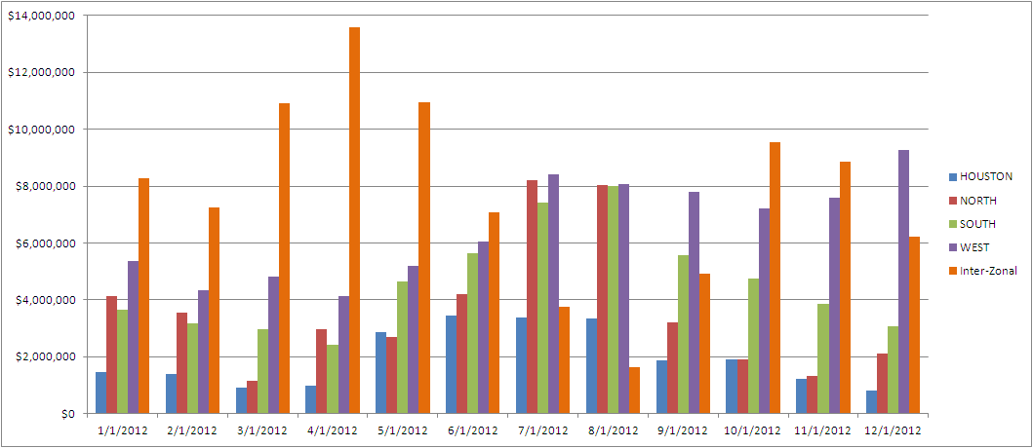
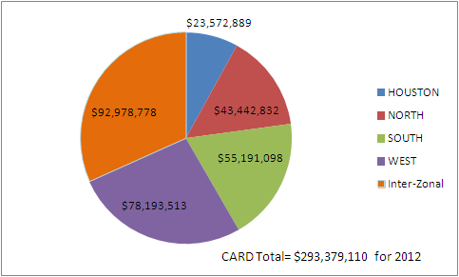

CRR Auction Revenue Distribution per MWh by Month and Zone
