COPMGRR Number | 035 | COPMGRR Title | Synchronization of NPRR347 and NPRR509
Date Posted |  | March 1, 2013
Requested Resolution |  | Normal
Commercial Operations Market Guide (COPMG) Section(s) Requiring Revision |  | 8.2, Settlement Statements and Invoices  8.2.1.1, CRR Auction Award Invoices  8.2.2, Day-Ahead Market Statements and Invoices  8.2.2.1, DAM Statement  8.2.3.1, Real-Time Market Statements  8.2.3.2, Real-Time Market Invoice  8.2.3.3, Default Uplift Invoice  8.2.3.4, RTM Late Fee Invoice  8.2.3.5, Miscellaneous Invoice
Protocol Section(s) Requiring Revision |  | None.
Revision Description |  | This Commercial Operations Market Guide Revision Request (COPMGRR) aligns the Commercial Operations Market Guide (COPMG) with revisions made to the Protocols pursuant to Nodal Protocol Revision Request (NPRR) 347, Single Daily Settlement Invoice and Updates to Credit Calculations, including addition of a Minimum Collateral Exposure Component, approved by the ERCOT Board on 8/16/11; and aligns the COPMG with the changes proposed in NPRR509, Shortened RTM Settlement Timelines.
Reason for Revision |  | To synchronize the COPMG with NPRR347 and NPRR509.

Business Case
Business Case | 1 | - Alignment with the Protocols.

Sponsor
Name | Jim Galvin on behalf of the Communications and Settlements Working Group (CSWG)
E-mail Address | james.galvin@luminant.com
Company | Luminant
Phone Number | 214-875-8086
Cell Number | 214-406-2155
Market Segment | Not applicable.

Market Rules Staff Contact
Name | Sandra Tindall
E-Mail Address | stindall@ercot.com
Phone Number | 512-248-3867

Proposed Guide Language Revision
8.2 Settlement Statements and Invoices
(1) The Real-Time Market (RTM), the Day-Ahead Market (DAM), and the Congestion Revenue Right (CRR) Auction are settled separately. Each type of Settlement has a unique set of statements and/or Invoices and settles according to a different timeline. Settlement Statements and Invoices can apply to a registered CRR Account Holder (CRRAH), a registered Qualified Scheduling Entity (QSE), or both. The table below provides details regarding the various statements and Invoices.
Type | Invoice or Statement | Recipient | Frequency | Post Timing | Payment Due
CRR | CRR Auction Invoice | - CRRAHs | Monthly | 1st Business Day after completion of a CRR Auction (Monthly and Annual CRR Auctions will be invoiced separately) | 3rd Bank Business Day after Invoice posts (or next day that is both Business Day and Bank Business Day)
CRR | CRR Auction Revenue Distribution Invoice | - QSEs (with Load) | Monthly | 1st Business Day after RTM Initial Statement posts for the last day of the relevant month  and  1st Business Day after RTM Final Statement posts for the last day of the relevant month | 5th Bank Business Day after Invoice posts (or next day that is both Business Day and Bank Business Day)
CRR | CRR Balancing Account Invoice | - CRRAH (due a shortfall refund)  - QSEs (with load) | Monthly | 1st Business Day after RTM Initial Statement posts for the last day of the relevant month | 1st Bank Business Day after the due date of the RTM Invoice that includes the RTM Initial Settlement statement for the last day of the month (or next day that is both Business Day and Bank Business Day)  *Note: Payout to market only
DAM | DAM Statement | - QSEs  - CRRAHs | Daily | 2nd Business after the Operating Day | n/a
DAM | DAM Resettlement Statement | - QSEs  - CRRAHs | Ad hoc | Ad hoc (on Business Day)  *Note: Notice posted on Market Information System (MIS) Public Area | n/a
RTM | RTM Initial Settlement Statement | - QSEs  - CRRAHs | Daily | Operating Day + 8 (or next Business Day) | n/a
RTM | RTM Final Settlement Statement | - QSEs  - CRRAHs | Daily | Operating Day + 59 (or next Business Day) | n/a
RTM | RTM True-Up Settlement Statement | - QSEs  CRRAHs | Daily | Operating Day + 180 (or next Business Day) | n/a
RTM | RTM Resettlement Settlement Statement | - QSEs  CRRAHs | Ad hoc | Ad hoc (on Business Day)  *Note: Notice posted on MIS Public Area | n/a
RTM | Default Uplift Invoice | - QSEs  - CRRAHs | Ad hoc | Ad hoc (on Business Day)  *Market Notice required | 5th Bank Business Day after the Invoice posts, (or next day that is both Business Day and Bank Business Day)
 | Miscellaneous Invoice | - QSEs  - CRRAHs | Ad hoc | Ad hoc (on Business Day)  *Market Notice required | Specified in the Market Notice
STL | Settlement Invoice | - QSE  - CRRAHs | Daily | Every Business Day – Rolls up all statements posted that day | 2nd Bank Business Day after the Invoice posts, (or next day that is both Business Day and Bank Business Day)
 | Late Fee Invoice | - QSE  - CRRAHs | Monthly | 10th calendar day after the end of the relevant month (or next Business Day) | 4th Business Day after Invoice posts (or next day that is both Business Day and Bank Business Day)

[COPMGRRXXX: Replace paragraph (1) above with the following on [insert implementation date of NPRR509] .]
(1) The Real-Time Market (RTM), the Day-Ahead Market (DAM), and the Congestion Revenue Right (CRR) Auction are settled separately. Each type of Settlement has a unique set of statements and/or Invoices and settles according to a different timeline. Settlement Statements and Invoices can apply to a registered CRR Account Holder (CRRAH), a registered Qualified Scheduling Entity (QSE), or both. The table below provides details regarding the various statements and Invoices.
Type | Invoice or Statement | Recipient | Frequency | Post Timing | Payment Due
CRR | CRR Auction Invoice | - CRRAHs | Monthly | 1st Business Day after completion of a CRR Auction (Monthly and Annual CRR Auctions will be invoiced separately) | 3rd Bank Business Day after Invoice posts (or next day that is both Business Day and Bank Business Day)
CRR | CRR Auction Revenue Distribution Invoice | - QSEs (with Load) | Monthly | 1st Business Day after RTM Initial Statement posts for the last day of the relevant month  and  1st Business Day after RTM Final Statement posts for the last day of the relevant month | 5th Bank Business Day after Invoice posts (or next day that is both Business Day and Bank Business Day)
CRR | CRR Balancing Account Invoice | - CRRAH (due a shortfall refund)  - QSEs (with load) | Monthly | 1st Business Day after RTM Initial Statement posts for the last day of the relevant month | 1st Bank Business Day after the due date of the RTM Invoice that includes the RTM Initial Settlement statement for the last day of the month (or next day that is both Business Day and Bank Business Day)  *Note: Payout to market only
DAM | DAM Statement | - QSEs  - CRRAHs | Daily | 2nd Business after the Operating Day | n/a
DAM | DAM Resettlement Statement | - QSEs  - CRRAHs | Ad hoc | Ad hoc (on Business Day)  *Note: Notice posted on Market Information System (MIS) Public Area | n/a
RTM | RTM Initial Settlement Statement | - QSEs  - CRRAHs | Daily | Operating Day + 7 (or next Business Day) | n/a
RTM | RTM Final Settlement Statement | - QSEs  - CRRAHs | Daily | Operating Day + 57 (or next Business Day) | n/a
RTM | RTM True-Up Settlement Statement | - QSEs  CRRAHs | Daily | Operating Day + 180 (or next Business Day) | n/a
RTM | RTM Resettlement Settlement Statement | - QSEs  CRRAHs | Ad hoc | Ad hoc (on Business Day)  *Note: Notice posted on MIS Public Area | n/a
RTM | Default Uplift Invoice | - QSEs  - CRRAHs | Ad hoc | Ad hoc (on Business Day)  *Market Notice required | 5th Bank Business Day after the Invoice posts, (or next day that is both Business Day and Bank Business Day)
 | Miscellaneous Invoice | - QSEs  - CRRAHs | Ad hoc | Ad hoc (on Business Day)  *Market Notice required | Specified in the Market Notice
STL | Settlement Invoice | - QSE  - CRRAHs | Daily | Every Business Day – Rolls up all statements posted that day | 2nd Bank Business Day after the Invoice posts, (or next day that is both Business Day and Bank Business Day)
 | Late Fee Invoice | - QSE  - CRRAHs | Monthly | 10th calendar day after the end of the relevant month (or next Business Day) | 4th Business Day after Invoice posts (or next day that is both Business Day and Bank Business Day)

(2) Upon approval and posting of Settlement Statements and Invoices, the associated data is sent to the Credit Monitoring & Management (CMM) system for use in credit calculations. Similarly, when payment is made to or from the QSE/CRRAH, the payment data is subsequently sent to the CMM system.
(3) The QSE Settlement Statements and Invoices and the CRR Account Holder Statements and Invoices are available on the MIS Certified Area. Statements and Invoices are ‘MIS Certified’ meaning they are Market Participant specific and have data proprietary to individual Entities. Therefore, these files are only available to those Entities owning the data and having a matching Data Universal Numbering System (DUNS) Number.
(4) Market Participants must have access to the ERCOT MIS and a Digital Certificate with appropriate roles in order to retrieve data via the MIS and/or Application Programmatic Interface (API). This Digital Certificate must be obtained from your Entity’s User Security Administrator (USA) and must contain the role of QSE Extracts (for QSEs) or CRR_Extracts (for CRRs) in order to view and download statements, Invoices and/or related Settlement extracts.
(5) Invoices, statements and extracts are also available via the API. To download the information from the API, utilize the report type IDs as described in the Nodal Settlement and extract user guides, along with the GetReport functionality on the API. For details regarding this option, refer to the External Web Services information posted to the ERCOT website.
(6) In addition to statements and Invoices, the Settlements Calendar which provides statement, Invoice and dispute posting information details, is provided as an extract and can be found on both the MIS Public Area and on the ERCOT website. Supporting information for the Settlements Calendar can be found in the Settlements Calendar User Guide and in the Data Definition Language (DDL) and XML Schema Definition (XSD).
(7) Settlement details, including the supporting input, intermediate, and output Settlement billing determinants and other data associated with Settlement Statements and Invoices are found in the appropriate Settlements extracts and reports. When viewing QSE/CRRAH Settlement Statements, a negative amount represents a payment due to the QSE/CRRAH and a positive amount represents a payment due to ERCOT. More information about the available extracts and reports, as well as example statements and Invoices, are available on the MIS Public Area and on the ERCOT website. Descriptions and definitions for the billing determinants can be found on the ERCOT website in the Settlement Charge Matrix and in the relevant Protocol sections. (Also see Section 10, Extracts and Reports).
(8) Information about the Settlements Calendar, statements, and Invoices may be found in Protocol Section 9, Settlement and Billing.
8.2.1.1 CRR Auction Award Invoices
Refer to Protocol Sections 9.8, CRR Auction Award Invoices, and 9.9, Payment Process for CRR Auction Invoices, for details regarding CRR Auction invoicing. Monthly and Annual CRR Auctions are invoiced separately. Additionally, each year of the two year annual auction will be invoiced separately.
CRR Auction Invoice Timeline

Payment
Due to
ERCOT
CRR
Auction
Results
Posted
CRR
Auction
Day +1*
Invoice
Issued
Payment
Due to
MPs
CRR
Auction
Day +4*
CRR
Auction
Day +3*
Payment
Due to
ERCOT
CRR
Auction
Results
Posted
CRR
Auction
Results
Day +1*
Invoice
Issued
Payment
Due to
MPs
CRR
Auction Invoice Date

Day +4*
CRR
Auction Invoice Date

Day +3*
*Must be a Business Day or move to next Business Day.

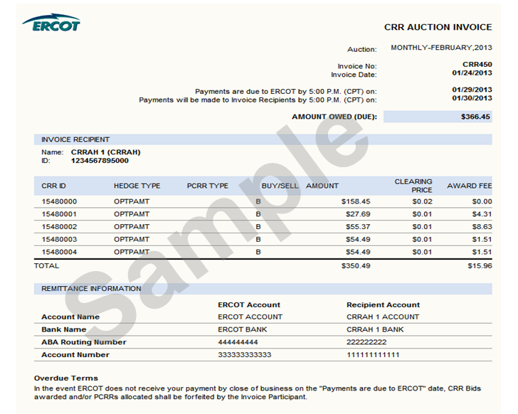
8.2.2 Day-Ahead Market Statements
The DAM statements for CCRAHs and QSEs are issued two days after the Operating Day.
Refer to Protocol Section 9.2, Settlement Statements for the Day-Ahead Market, for details regarding DAM Settlement Statements.

DAM Statement Timeline
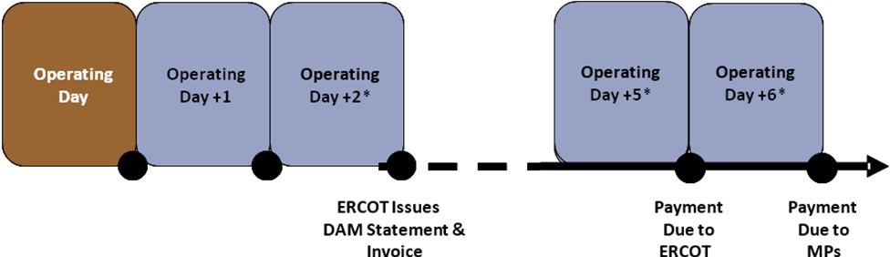
*Must be a Business Day or move to next Business Day.
8.2.2.1 DAM Statement
Refer to Protocol Section 9.2, Settlement Statements for the Day-Ahead Market, for details regarding DAM Settlement Statements. In the case of a “No DAM” scenario, where DAM is not successfully executed for an Operating Day, DAM statements will not be generated or posted for that Operating Day.
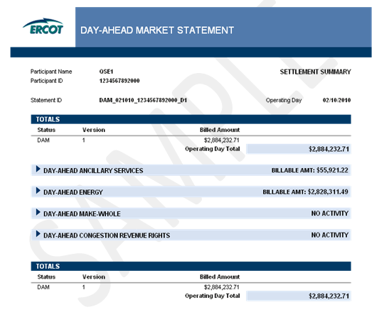
8.2.3.1 Real-Time Market Statements
(1) Refer to Protocol Section 9.5, Settlement Statements for Real-Time Market, for details regarding RTM Settlement Statements.
(2) There are four types of RTM Settlement Statements: Initial, Final, True-Up and Resettlement.
(3) The figure below illustrates the timing of each statement. Resettlements can occur at any point in accordance with Protocol Section 9.5.6, RTM Resettlement Statement.
RTM Statement Timeline

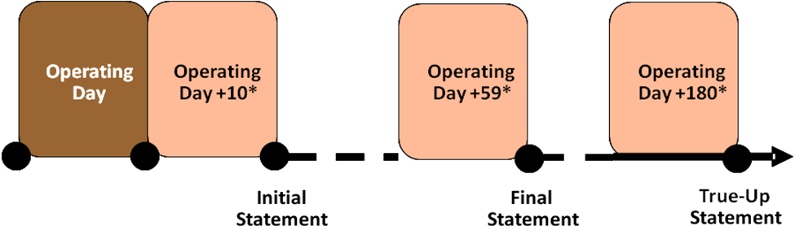
*Must be a Business Day or move to next Business Day.
[COPMGRRXXX: Replace RTM Statement Timeline above with the following on [insert implementation date of NPRR509] .]
RTM Statement Timeline

Operating Day

Operating Day + 10*

Operating Day + 180*

Operating Day + 57*

Initial Statement
Final Statement
True-Up Statement

*Must be a Business Day or move to next Business Day.
8.2.3.2 Settlement Invoice
Refer to Protocol Section 9.6, Settlement Invoices for the Day-Ahead Market and Real-Time Market, for details regarding the invoicing process. The weekly daily Settlement invoicing process finds and includes the DAM, RTM Initial, Final, True-Up and/or Resettlement Statements that are posting on the same day.

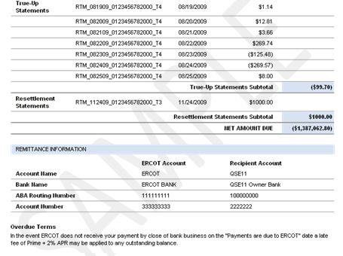
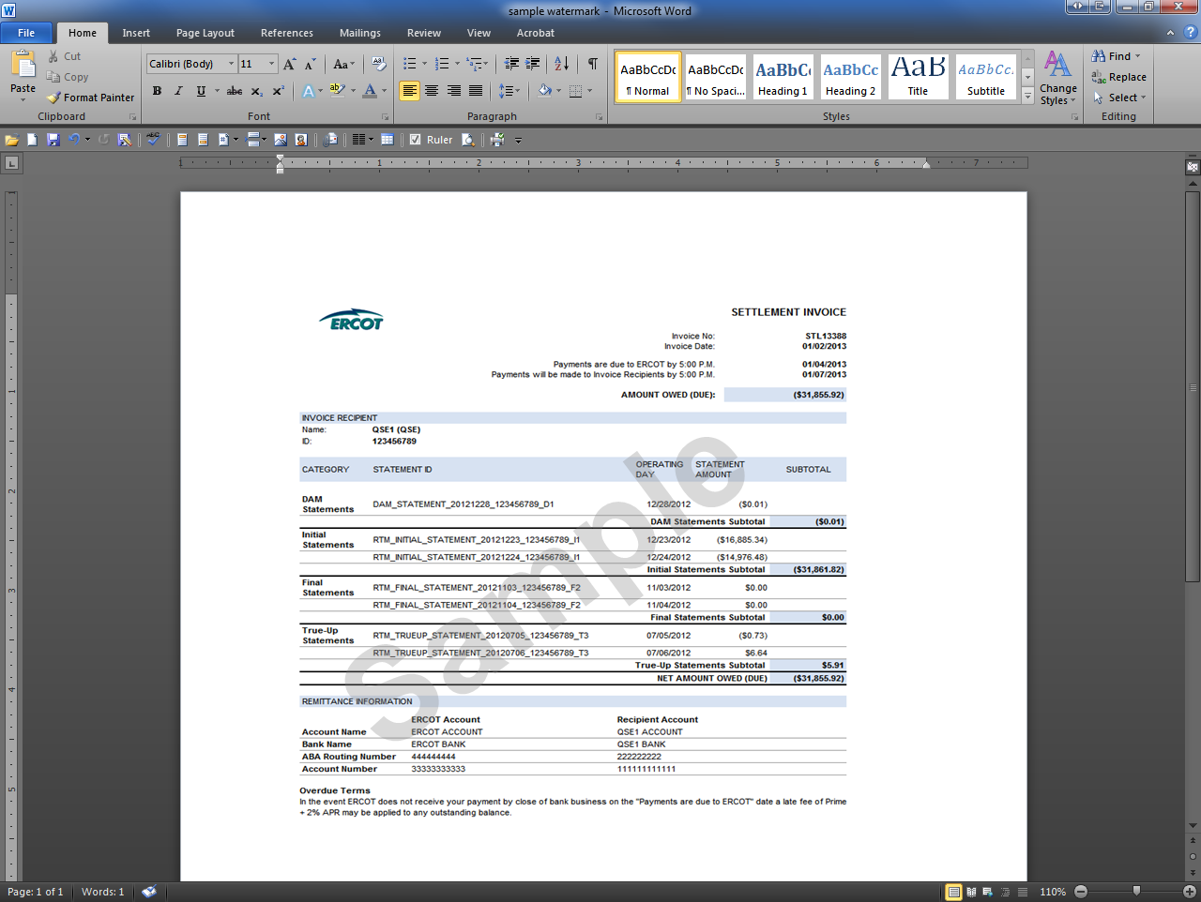
8.2.3.3 Default Uplift Invoice
Refer to Protocol Sections 9.19.1, Default Uplift Invoices, and 9.19.2, Payment Process for Default Uplift Invoices, for details regarding the Default Uplift Invoicing process. The Default Uplift Invoicing process allocates DAM and/or RTM losses to QSEs and CRRAHs.

8.2.3.4 Late Fee Invoice
Refer to Protocol Section 9.7.4, Late Fees and Late Fee Invoices for the Settlement Invoices, for details regarding the Late Fee Invoicing process. To better facilitate verification of relatively small late fee charges and credits, the late fee charge line items have greater precision than the total amount on the Late Fee Invoice.

8.2.3.5 Miscellaneous Invoice
In the event that ERCOT cannot reasonably Invoice Market Participants via one of the other Protocol-defined Invoices, ERCOT may utilize the Miscellaneous Invoice. Use of the Miscellaneous Invoice would be noticed to the market and could be in support of any invoicing activity described as “ad hoc” in Section 8.1, Invoice Process, of this document. The Miscellaneous Invoice posts to the same location on MIS as other QSE/CRRAH Invoices. This Invoice is generated out of the Settlements and Billing System using data which is derived and input by analysts. The Invoice format allows for flexibility to communicate descriptive information which varies depending on the nature of the ad hoc Invoice.
INCLUDEPICTURE "cid:image001.png@01CAC515.8A601C20" \* MERGEFORMATINET INCLUDEPICTURE "cid:image001.png@01CAC515.8A601C20" \* MERGEFORMATINET INCLUDEPICTURE "cid:image001.png@01CAC515.8A601C20" \* MERGEFORMATINET INCLUDEPICTURE "cid:image001.png@01CAC515.8A601C20" \* MERGEFORMATINET 