 |  |  |  | System Planning
Monthly Status Report
January 2013

 |  | Report Highlights
 | - ERCOT is currently tracking 159 active generation interconnection requests totaling over 48,000 MW. This includes over 20,000 MW of wind generation.
- ERCOT is currently reviewing proposed transmission improvements with a total cost of $278.9 Million
- Transmission Projects endorsed in 2013 total $58.1 Million
- All projects (in engineering, routing, licensing and construction) total approximately $9.97 Billion.
- Transmission Projects energized in 2012 total about $854.2 million.

Table of Contents
1. Generation Interconnection 1
1.1 Signed Generation Interconnection Agreements 1
1.2 New Generation Registering for Commercial Operations 1
1.3 Summary of Generation Interconnection Requests 1
1.4 Projects with Interconnection Agreements 4
1.5 Generation Projects Undergoing Full Interconnection Studies with Confidentiality Waived by Developer 4
1.6 Generation Projects Undergoing Full Interconnection Studies 5
1.7 Wind Generation Capacity Installed by Year 6
2. Regional Planning Group Project Reviews 7
3. Congestion Costs 8
4. Wind Generation as a Percent of Load 11
5. Planning Model Activities 12
6. Other Notable Activities 13

1. Generation Interconnection
Additional information regarding detailed generation interconnection and impact studies is contained in the “Generation Project Interconnection Information” folder in the “Operations and System Planning” area on the ERCOT website: http://planning.ercot.com/login/login.

Signed Generation Interconnection Agreements
13INR0058 – OCI Alamo 1 – 50 MW of Solar in Bexar County
10INR0089 – Deepwater Energy Storage – 40 MW of Batteries in Harris County
14INR0015 – Deer Park Energy Center – 192 MW of Combined Cycle Gas in Harris County

New Generation Registering for Commercial Operations
12INR0076 – NoTrees Battery Storage – 36 MW of Batteries in Winkler County

The total installed wind capacity is now reported as 10,407 MW by the resource owners through the registration process. Capacity by North, South and West is 669 MW, 2,375 MW, and 7,363 MW respectively. 850 MW is able to switch between the West and South zones and is currently shown in the South zone.

Summary of Generation Interconnection Requests
GENERATION INTERCONNECTION REQUESTS CURRENTLY UNDER REVIEW
Currently tracking 165 generation interconnection or change requests
As of January 31, 2013 |  |  |  | Total
Security Screening Study | 9
SSS Completed | 25
Full Interconnect Study | 86
FIS Completed | 12
Suspended Studies | 6
Capacity of Suspended Study Projects | 951
Interconnect Agreement Completed | 27
Capacity under Interconnection Agreements | 11,932
Capacity for Grid, MW | 48,025
Wind Capacity, MW | 20,147

Fuel Type | Confidential Projects (MW) | Projects Under Full Study (MW) | Public Projects (MW) | Suspended Studies (MW) | Grand Total (MW)
Gas-AllOther |  |  | 89 |  | 8,439
Gas-CombinedCycle |  |  | 5,878 |  | 13,833
Total Gas | 11,227 | 5,078 | 5,967 |  | 22,272
Nuclear
Coal |  | 850 | 1,165 |  | 2,015
Wind | 2,076 | 14,681 | 3,390 | 913 | 21,060
Solar | 770 | 537 | 50 | 38 | 1,395
Biomass
Storage |  | 874 | 40 |  | 914
Petroleum Coke |  |  | 1,320 |  | 1,320
Grand Total | 14,073 | 22,020 | 11,932 | 951 | 48,976

County Location of Installed Generation and Interconnection Requests (all fuels)

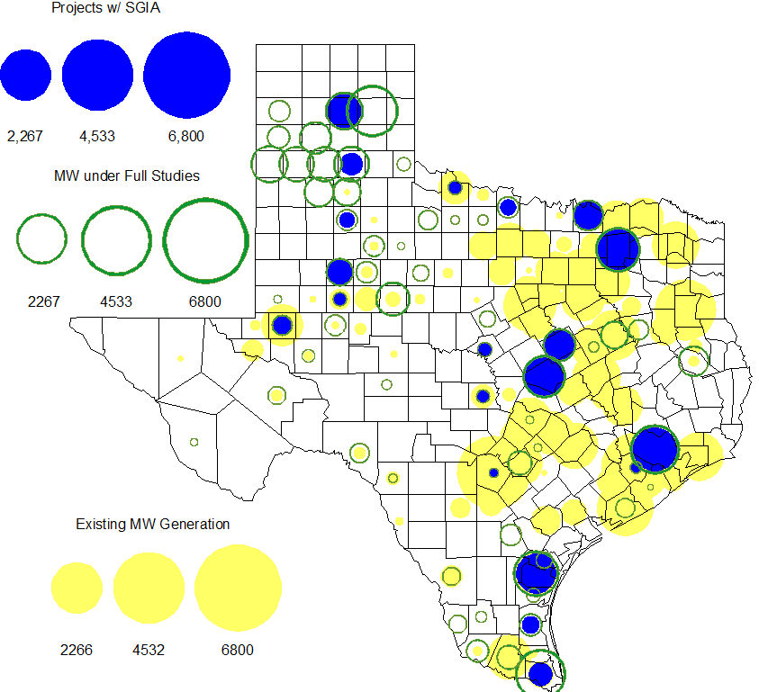

Projects with Interconnection Agreements

Generation Interconnections as of January 31, 2013
INR | Site Name | County | COD | Fuel | MW For Grid | Change from Last Report
12INR0075 | Blue Summit Windfarm | Wilbarger | Feb-13 | Wind | 135 | Date
08INR0049 | Bobcat Bluff | Clay | Feb-13 | Wind | 163 | Date
11INR0033 | Los Vientos | Cameron | Feb-13 | Wind | 400 | Date
09INR0001 | Sandy Creek 1 | McLennan | Apr-13 | Coal | 925
13INR0058 | OCI Alamo 1 | Bexar | May-13 | Solar | 50 | NEW
10INR0089 | Deepwater Energy Storage | Harris | May-13 | Storage | 40 | NEW
12INR0086 | WA Parish Addition | Fort Bend | May-13 | Gas | 89
11INR0013 | Goldthwaite Wind Energy | Mills | Sep-13 | Wind | 150
14INR0030a2 | Panhandle Wind | Carson | Nov-13 | Wind | 322
11INR0054 | Midway Farms Wind | San Patricio | Dec-13 | Wind | 161
12INR0034 | Stephens-Borlynn Wind Project | Borden | Dec-13 | Wind | 378
14INR0015 | Deer Park Energy Center | Harris | Jun-14 | Gas-CC | 192 | NEW
13INR0021 | Ferguson Replacement Project | Llano | Jul-14 | Gas-CC | 116
10INR0020a | Panda Temple Power | Bell | Aug-14 | Gas-CC | 809
10INR0021 | Panda Sherman Power | Grayson | Aug-14 | Gas-CC | 809
11INR0050 | Moore Wind 1 | Crosby | Aug-14 | Wind | 149
14INR0023 | Longhorn Energy Center | Briscoe | Dec-14 | Wind | 361
13INR0005 | Conway Windfarm | Carson | Dec-14 | Wind | 600
06INR0022c | Penascal Wind Farm 3 | Kenedy | Dec-14 | Wind | 202
09INR0051 | Mesquite Creek | Borden | Mar-15 | Wind | 249
08INR0018 | Gunsight Mountain | Howard | Aug-15 | Wind | 120
13INR0023 | Texas Clean Energy Project | Ector | Jan-16 | Coal | 240
06INR0006 | Cobisa-Greenville | Hunt | May-16 | Gas-CC | 1,792
10INR0020b | Panda Temple Power | Bell | May-16 | Gas-CC | 780
10INR0022 | Pondera King Power Project | Harris | Jun-16 | Gas-CC | 1,380
12INR0016a | Las Brisas Energy Center | Nueces | May-18 | PetCoke | 660
12INR0016b | Las Brisas Energy Center | Nueces | May-18 | PetCoke | 660

Generation Projects Undergoing Full Interconnection Studies with Confidentiality Waived by Developer

None

Generation Projects Undergoing Full Interconnection Studies
INR | County | Fuel | MW | COD |  | INR | County | Fuel | MW | COD
11INR0094 | Kent | Solar | 100 | Apr-13 |  | 12INR0045 | Kleberg | Wind | 135 | Jun-13
13INR0057 | Archer | Wind | 65 | Jun-13 |  | 13INR0060 | Hidalgo | Gas | 50 | Jun-13
13INR0025 | Randall | Wind | 150 | Sep-13 |  | 13INR0046 | Limestone | Wind | 71 | Sep-13
13INR0059 | Castro | Wind | 499 | Oct-13 |  | 13INR0028 | Hale | Gas | 359 | Nov-13
14INR0030a1 | Carson | Wind | 322 | Nov-13 |  | 11INR0062 | Nueces | Wind | 178 | Dec-13
11INR0085 | Nolan | Wind | 106 | Dec-13 |  | 12INR0002a | Briscoe | Wind | 200 | Dec-13
12INR0054 | Jones | Wind | 200 | Dec-13 |  | 12INR0059 | Pecos | Solar | 50 | Dec-13
13INR0007 | Pecos | Wind | 200 | Dec-13 |  | 13INR0036 | Hidalgo | Wind | 200 | Dec-13
13INR0038 | Swisher | Wind | 300 | Dec-13 |  | 13INR0050 | Comanche | Wind | 200 | Dec-13
13INR0052 | Starr | Wind | 200 | Dec-13 |  | 13INR0055 | Zapata | Wind | 250 | Dec-13
13INR0056 | Scurry | Wind | 366 | Dec-13 |  | 12INR0079 | Kenedy | Wind | 200 | Dec-13
11INR0057 | Cameron | Wind | 165 | Dec-13 |  | 11INR0093 | San Patricio | Wind | 41 | Dec-13
12INR0068 | Jim Hogg | Wind | 80 | Dec-13 |  | 12INR0088 | Crosby | Wind | 201 | Dec-13
13INR0048 | Oldham | Wind | 161 | Dec-13 |  | 14INR0024 | Kinney | Solar | 42 | Dec-13
12INR0055 | Baylor | Wind | 40 | Jan-14 |  | 12INR0084 | Randall | Wind | 242 | Jan-14
13INR0006 | Gray | Wind | 750 | Jan-14 |  | 13INR0045 | Castro | Wind | 288 | Jan-14
14INR0013 | Cameron | Wind | 103 | Jan-14 |  | 14INR0014 | Val Verde | Solar | 100 | Jan-14
13INR0010b | Parmer | Wind | 200 | Jan-14 |  | 12INR0060 | Schleicher | Wind | 58 | Apr-14
13INR0020b | Glasscock | Wind | 150 | May-14 |  | 14INR0027 | Guadalupe | Gas | 471 | May-14
08INR0019a | Gray | Wind | 250 | Jun-14 |  | 08INR0019b | Gray | Wind | 250 | Jun-14
08INR0019c | Gray | Wind | 250 | Jun-14 |  | 13INR0026 | Oldham | Wind | 201 | Jun-14
13INR0049 | Harris | Gas | 352 | Jun-14 |  | 14INR0011 | Swisher | Gas | 270 | Jun-14
14INR0012 | Gray | Wind | 401 | Jun-14 |  | 14INR0016 | Harris | Gas | 190 | Jun-14
14INR0031 | Harris | Gas | 0 | Jun-14 |  | 14INR0040 | Hidalgo | Gas | 225 | Jun-14
12INR0085 | Stonewall | Wind | 24 | Jul-14 |  | 14INR0025 | Floyd | Wind | 500 | Jul-14
14INR0026 | Presidio | Solar | 28 | Jul-14 |  | 14INR0029 | Uvalde | Solar | 42 | Jul-14
13INR0040 | Harris | Gas | 0 | Aug-14 |  | 12INR0042a | Deaf Smith | Wind | 265 | Sep-14
12INR0042b | Deaf Smith | Wind | 135 | Sep-14 |  | 14INR0032 | Randall | Wind | 501 | Sep-14
12INR0070 | Knox | Wind | 300 | Oct-14 |  | 13INR0031 | Travis | Solar | 30 | Oct-14
10INR0085 | Ector | Solar | 40 | Dec-14 |  | 11INR0081 | Live Oak | Wind | 72 | Dec-14
11INR0082A | Val Verde | Wind | 50 | Dec-14 |  | 11INR0082B | Val Verde | Wind | 150 | Dec-14
12INR0002b | Briscoe | Wind | 200 | Dec-14 |  | 12INR0071 | Caldwell | Wind | 30 | Dec-14
13INR0054 | Bee | Gas | 0 | Dec-14 |  | 14INR0009 | Kent | Wind | 248 | Dec-14
14INR0020 | Floyd | Wind | 150 | Dec-14 |  | 14INR0028 | Live Oak | Wind | 300 | Dec-14
11INR0079a | Clay | Wind | 200 | Dec-14 |  | 08INR0031 | Childress | Wind | 120 | Dec-14
12INR0029 | Swisher | Wind | 500 | Dec-14 |  | 13INR0020a | Glasscock | Wind | 200 | Dec-14
14INR0045 | Webb | Wind | 251 | Dec-14 |  | 15INR0021 | Starr | Wind | 200 | Dec-14
13INR0010c | Parmer | Wind | 200 | Jan-15 |  | 10INR0009 | Castro | Wind | 300 | Mar-15
12INR0057 | Ector | Solar | 40 | Apr-15 |  | 15INR0032 | Hale | Gas | 197 | Jun-15
15INR0033 | Hale | Gas | 197 | Jun-15 |  | 15INR0013 | Anderson | Gas | 324 | Oct-15
15INR0014 | Matagorda | Gas | 280 | Oct-15 |  | 11INR0065 | Nueces | Wind | 350 | Oct-15
12INR0002c | Briscoe | Wind | 350 | Dec-15 |  | 14INR0018 | Nolan | Solar | 35 | Dec-15
12INR0018 | Gray | Wind | 500 | Dec-15 |  | 13INR0032 | Andrews | Solar | 30 | Dec-15
16INR0005 | Cameron | Gas | 871 | Apr-16 |  | 16INR0003 | Brazoria | Gas | 11 | Jun-16
16INR0004 | Cameron | Gas | 730 | Jun-16 |  | 16INR0006 | Angelina | Gas | 785 | Jun-16
11INR0040 | Freestone | Gas | 640 | Mar-18 |  | 14INR0003 | Nolan | Coal | 850 | Jun-19
13INR0010a | Parmer | Wind | 200 | TBD |  | 13INR0010d | Parmer | Wind | 200 | TBD
13INR0010e | Parmer | Wind | 200 | TBD |  | 13INR0010f | Parmer | Wind | 200 | TBD
12INR0081a | Upton | Wind | 112 | TBD

Note: Projects that are classified as “Cancelled” or “Suspended” are excluded from this table.

Wind Generation Capacity Installed by Year
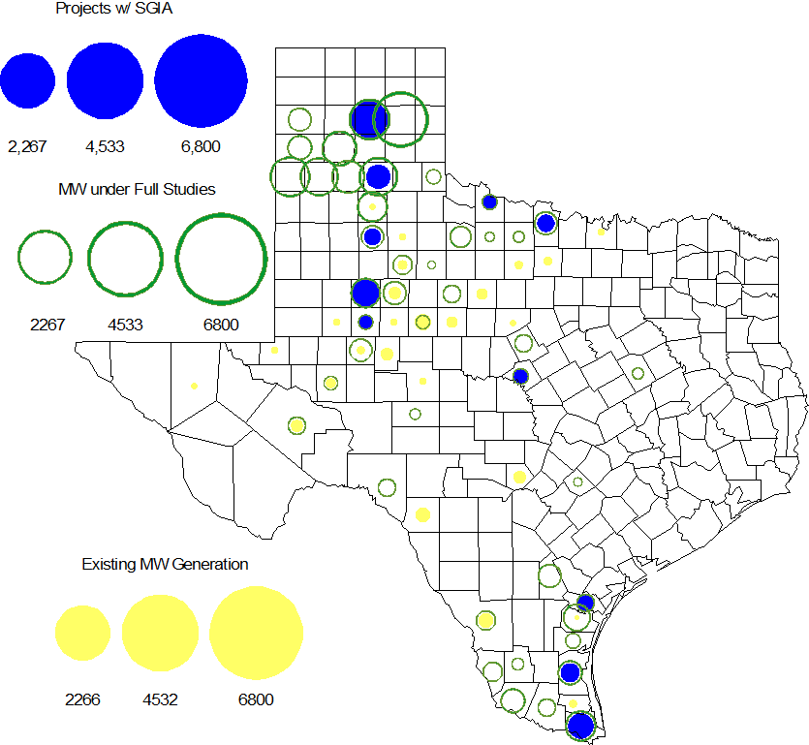

Regional Planning Group Project Reviews

- AEPSC has submitted the Airline/North Padre Island Area Improvements project. This project was submitted as a revision to the Barney Davis to Laguna 138 kV line (AEPSC Corpus Christi Improvements Project ) that was endorsed by ERCOT in December 2009. This is a Tier 1 project that is estimated to cost approximately $58.1 million. ERCOT has completed the independent review and the project was endorsed by the ERCOT Board of Directors on January 15, 2013.

- Sharyland has submitted the Atlas-Driver Load Integration project, this is a Tier 2 project that is estimated to cost approximately $15.4 million. This project is currently under ERCOT independent review.

- American Electric Power Service Corporation (AEPSC) has submitted the Sinton-Beeville-Kenedy Area Improvements project to accommodate load additions due to Eagle Ford Shale development in South Texas. This is a Tier 1 project that is estimated to cost $89.2 million. ERCOT has completed the independent review. ERCOT will present the project to TAC on February 7, 2013 and at the Board of Directors in March 2013 for their endorsement.

- LCRA TSC, Guadalupe Valley Electric Cooperative (GVEC), American Electric Power (AEP), and South Texas Electric Cooperative (STEC) have jointly submitted the Kenedy Switch to Nixon to Seguin Line Upgrade project. This is a Tier 1 project that is estimated to cost approximately $55.3 million. ERCOT has completed the independent review. ERCOT will present the project to TAC on February 7, 2013 and at the Board of Directors in March 2013 for their endorsement.

- Guadalupe Valley Electric Cooperative (GVEC) has submitted the McQueeney-SMI-Geronimo 69 kV to 138 kV rebuild project. This is a Tier 2 project that is estimated to cost approximately $8.1 million. This project is currently under ERCOT independent review.

- Oncor has submitted the Permian Basin to Culberson 138 kV line project. The project is estimated to cost approximately $73 million. The Permian Basin to Culberson 138 kV line project is classified as a Tier 3 project and once the RPG comments are resolved it will be reclassified as a Tier 4 Neutral project. This project has been submitted for RPG comments.

- LCRA TSC, Guadalupe Valley Electric Cooperative (GVEC) and American Electric Power (AEP) have jointly submitted the Kenedy Switch to Guadalupe line upgrade project. This is a Tier 3 project that is estimated to cost approximately $37.9 million. This project has been submitted for RPG comments.

Congestion Costs
Dollars shown in RUC Make Whole payment graph are of settlement quality.

RUC Net Make Whole Payment in $mm

Monthly Average LMP of “ERCOT 345”

Binding Constraints – January 2013
Contingency | Binding Element | Number of 5-min intervals | Shadow Price Range $/MWh | Estimated Congestion Rent $ (Shadow Price*Limit) | Transmission Project | Comments
Roanoke Switch - West Denton 345 kV & Roanoke Switch - Lewisville Switch 345 kV; West Denton - Roanoke Switch 345 kV; or RD Wells Interchange - West Denton 138 kV | Fort Worth - Teasley 138 kV | 643 | 0 - 3500 | 3,589,473 | 14TPIT0047 | Outage of the Jim Christal - North Denton 138 kV line
Morgan Creek SES - China Grove 138 kV double-circuit | Morgan Creek SES 138/69 kV Autotransformer 3 | 155 | 0 - 2800 | 2,650,503 |  | Invalid contingency
Los Fresnos - La Palma 138 kV | La Palma - Villa Cavazos 138 kV | 38 | 13 - 3500 | 1,234,584 | 16TPIT0029 | Forced Outage of 138 kV lines in the Valley area
Hamilton Road - Bracketville 138 kV | Hamilton Road - Maverick 138 kV | 818 | 0 - 384 | 585,057 | 16TPIT0024
Base Case | West to North Stability | 135 | 0 - 60 | 561,348 | CREZ
Orange Grove Switching Station - Lon Hill 138 kV; or Whitepoint - Lon Hill 345 kV & Whitepoint - STP 345 kV | Sinton - Skidmore 69 kV | 595 | 0 - 2800 | 554,413 | 16TPIT0027
Hiway 9 138/69 kV Autotransformer | Koch Up River 138/69 kV Autotransformer | 32 | 0 - 2800 | 528,694
Skyline - Calaveras 345 kV double-circuit | Braunig - Cagnon 345 kV | 18 | 11 - 4500 | 508,147 |  | Outage of one Calaveras - Cagnon 345 kV circuit
Base Case | Bastrop Energy Center - Garfield AEN 345 kV | 2 | 5000 - 5000 | 495,542 |  | Lower line rating; corrected
Willow Creek Switch - Parker Switch 345 kV double-circuit | Graham SES - Parker Switch 345 kV | 73 | 20 - 656 | 490,136 |  | Bus outage at Willow Creek Switch and line outage of a Willow Creek Switch - Parker Switch 345 kV circuit

Wind Generation as a Percent of Load
One-hour average of total wind power output as a percentage of ERCOT load.

Planning Model Activities
- The December TPIT updates are underway to the 13DSA and 13DSB cases. Projected completion and posting is February 15, 2013.
- The first spreadsheet example for creating TPIT from Model On Demand (MOD) was populated and sent to SSWG for review. This project will add additional fields to MOD for TSPs to populate during SSWG case building. The TPIT spreadsheet will be created from the MOD database. Projected completion July 2013. The March TPIT spreadsheet will include additional data validation drop-down menus to make certain fields more consistent.
- The short term calendar of major planning model events follows:
  - Jan 16, 2013 Planning Data Dictionary Posted to POI.
  - Jan 17, 2013 Begin December TPIT update to 13 DSA and 13 DSB cases
  - Feb 15, 2013 Complete and Post December TPIT update to 13 DSA and 13 DSB cases.
- Status update on SCR760, Changes Needed for Information Model Manager and Topology Processor for Planning Models, which was approved by the ERCOT Board in March 2011.
  - Bundle 1 (Items 3, 7 and 8): In Production.
  - Bundle 2 (Items 2a, 4, 9): In Production.
  - Bundle 3 (Item 5, 2b, 2c): In Production
  - Bundle 4 (Items 1, 6): Requirements agreed to by ERCOT and Vendor. Vendor proposal approved by ERCOT. SOW amendment underway. Vendor has begun work. Expect to receive first release in April 2013.
SCR Sub Part | SCR Description | Status
SCR760-1 | Upgrade to PSS/E v32 | Production
SCR760-2 | Distribution Capacitor banks | Production
SCR760-3 | Zero Impedance Line Ratings | Production
SCR760-4 | Associate Loads and Capacitor banks with the correct CNG | Production
SCR760-5 | Additional Transformer Data for Planning | Production
SCR760-6 | FACTS Devices | Planning
SCR760-7 | Assign valid PSSE IDs to Breakers/  Switches/ Series Devices | Production
SCR760-8 | Phase shift of Autos for short circuit studies | Production
SCR760-9 | Multisection Line Grouping | Production
Table 1: In the following table:
- Red will be used to show status of Not Submitted, meaning that the SCR sub part has not been submitted to Siemens as a Service Request.
- Yellow will indicate that the SCR sub part has been submitted. The color will remain yellow and the status will change in order to Submitted, Planning (Requirements, SOW, Code Writing), Release (Siemens produces first code to test), and Testing (code has completed internal test and is moving through release management).
- Green will indicate that the code has been tested and installed on the machines that ERCOT uses to produce Topology Processor output for Planning and CRR.

Other Notable Activities
- ERCOT has completed the 2012 Five-Year Transmission Plan and the final report was posted at the ERCOT Planning and Operations Information (POI) website on December 27, 2012. The 5YTP team is currently working on the sensitivity analysis for the 2012 5YTP which is anticipated to be completed by February 28, 2013.
- The Long-Term Study team is wrapping up the scenario analysis for the Department of Energy project.

