 |  |  |  | System Planning
Monthly Status Report
December 2012

 |  | Report Highlights
 | - ERCOT is currently tracking 152 active generation interconnection requests totaling over 46,000 MW. This includes over 20,000 MW of wind generation.
- ERCOT is currently reviewing proposed transmission improvements with a total cost of $226.1 Million
- Transmission Projects endorsed in 2012 total $596.8 Million
- All projects (in engineering, routing, licensing and construction) total approximately $9.68 Billion.
- Transmission Projects energized in 2012 total about $732.2 million.

Table of Contents
1. Generation Interconnection 1
1.1 Signed Generation Interconnection Agreements 1
1.2 New Generation Registering for Commercial Operations - none 1
1.3 Summary of Generation Interconnection Requests 1
1.4 Projects with Interconnection Agreements 4
1.5 Generation Projects Undergoing Full Interconnection Studies with Confidentiality Waived by Developer 4
1.6 Generation Projects Undergoing Full Interconnection Studies 5
1.7 Wind Generation Capacity Installed by Year 6
2. Regional Planning Group Project Reviews 7
3. Congestion Costs 8
4. Wind Generation as a Percent of Load 11
5. Planning Model Activities 12
6. Other Notable Activities 13

1. Generation Interconnection
Additional information regarding detailed generation interconnection and impact studies is contained in the “Generation Project Interconnection Information” folder in the “Operations and System Planning” area on the ERCOT website: http://planning.ercot.com/login/login.

Signed Generation Interconnection Agreements
14INR0023 – Longhorn Energy Center – 361 MW of Wind in Briscoe County
12INR0086 – W A Parish Addition – 89 MW of Gas in Fort Bend County
14INR0030a2 – Pattern Panhandle Wind – 322 MW of Wind in Carson County

New Generation Registering for Commercial Operations
08INR0011 – Senate Wind – 150 MW of Wind in Jack County
12INR0072 – Anacacho Windfarm – 100 MW of Wind in Kinney County
09INR0061 – WKN Mozart Wind – 30 MW of Wind in Kent County
11INR0091 – Whitetail Wind Energy Project – 92 MW of Wind in Webb County

The total installed wind capacity is now reported as 10,407 MW by the resource owners through the registration process. Capacity by North, South and West is 669 MW, 2,375 MW, and 7,363 MW respectively. 850 MW is able to switch between the West and South zones and is currently shown in the South zone.

Summary of Generation Interconnection Requests
GENERATION INTERCONNECTION REQUESTS CURRENTLY UNDER REVIEW
Currently tracking 161 generation interconnection or change requests
As of December 31, 2012 |  |  |  | Total
Security Screening Study | 8
SSS Completed | 26
Full Interconnect Study | 82
FIS Completed | 11
Suspended Studies | 9
Capacity of Suspended Study Projects | 4,571
Interconnect Agreement Completed | 25
Capacity under Interconnection Agreements | 12,300
Capacity for Grid, MW | 46,465
Wind Capacity, MW | 20,097

Fuel Type | Confidential Projects (MW) | Projects Under Full Study (MW) | Public Projects (MW) | Suspended Studies (MW) | Grand Total (MW)
Gas-AllOther |  |  | 89 |  | 5,978
Gas-CombinedCycle |  |  | 5,686 |  | 13,828
Total Gas | 10,687 | 3,344 | 5,775 |  | 19,806
Nuclear |  |  |  | 3,200 | 3,200
Coal |  | 850 | 1,165 |  | 2,015
Wind | 2,489 | 14,218 | 3,390 | 1,333 | 21,430
Solar | 592 | 685 |  | 38 | 1,315
Biomass
Storage |  | 914 | 36 |  | 950
Petroleum Coke |  |  | 1,320 |  | 1,320
Grand Total | 12,276 | 20,029 | 11,346 | 4,571 | 50,036

County Location of Installed Generation and Interconnection Requests (all fuels)

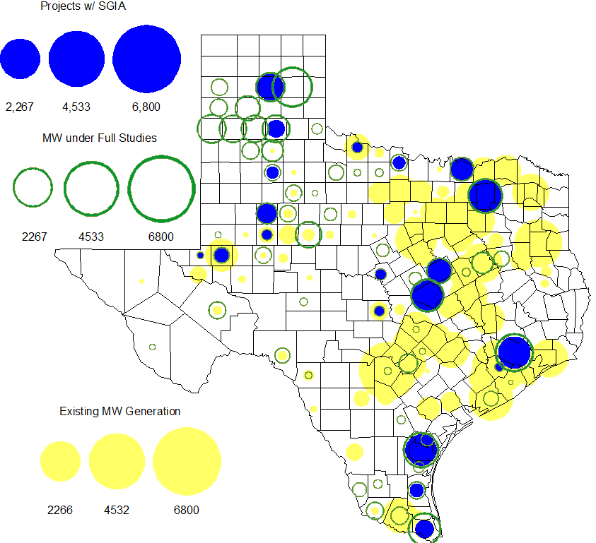

Projects with Interconnection Agreements

Generation Interconnections as of December 31, 2012
INR | Site Name | County | COD | Fuel | MW For Grid | Change from Last Report
12INR0076 | Notrees Battery Storage | Winkler | Jan-13 | Storage | 36.00 | DATE
12INR0075 | Blue Summit Windfarm | Wilbarger | Jan-13 | Wind | 135.00 | DATE
11INR0033 | Los Vientos | Cameron | Jan-13 | Wind | 400.00 | DATE
08INR0049 | Bobcat Bluff | Clay | Jan-13 | Wind | 163.00 | DATE
09INR0001 | Sandy Creek 1 | McLennan | Apr-13 | Coal | 925.00
12INR0086 | WA Parish Addition | Fort Bend | May-13 | Gas | 89.00 | NEW
11INR0013 | Goldthwaite Wind Energy | Mills | Sep-13 | Wind | 150.00
14INR0030a2 | Panhandle Wind | Carson | Nov-13 | Wind | 322.00 | NEW
06INR0022c | Penascal Wind Farm 3 | Kenedy | Dec-13 | Wind | 202.00
12INR0034 | Stephens-Borlynn Wind Project | Borden | Dec-13 | Wind | 378.00
11INR0054 | Midway Farms Wind | San Patricio | Dec-13 | Wind | 161.00
13INR0021 | Ferguson Replacement Project | Llano | Jul-14 | Gas-CC | 116.00
10INR0021 | Panda Sherman Power | Grayson | Aug-14 | Gas-CC | 809.00
10INR0020a | Panda Temple Power | Bell | Aug-14 | Gas-CC | 809.00
11INR0050 | Moore Wind 1 | Crosby | Aug-14 | Wind | 148.50
14INR0023 | Longhorn Energy Center | Briscoe | Dec-14 | Wind | 361.00 | NEW
13INR0005 | Conway Windfarm | Carson | Dec-14 | Wind | 600.00
09INR0051 | Mesquite Creek | Borden | Mar-15 | Wind | 249.00
08INR0018 | Gunsight Mountain | Howard | Aug-15 | Wind | 120.00
13INR0023 | Texas Clean Energy Project | Ector | Jan-16 | Coal | 240.00
06INR0006 | Cobisa-Greenville | Hunt | May-16 | Gas-CC | 1,792.00
10INR0020b | Panda Temple Power | Bell | May-16 | Gas-CC | 780.00
10INR0022 | Pondera King Power Project | Harris | Jun-16 | Gas-CC | 1,380.00
12INR0016a | Las Brisas Energy Center | Nueces | May-18 | PetCoke | 660.00
12INR0016b | Las Brisas Energy Center | Nueces | May-18 | PetCoke | 660.00
11INR0086 | RRE Austin Solar | Travis | Oct-13 | Solar | 60 | CANCELLED

Generation Projects Undergoing Full Interconnection Studies with Confidentiality Waived by Developer

None

Generation Projects Undergoing Full Interconnection Studies
INR | County | Fuel | MW | COD |  | INR | County | Fuel | MW | COD
13INR0040 | Harris | Gas | 0 | Jan-13 |  | 13INR0010a | Parmer | Wind | 200 | Jan-13
13INR0010d | Parmer | Wind | 200 | Jan-13 |  | 13INR0010e | Parmer | Wind | 200 | Jan-13
13INR0010f | Parmer | Wind | 200 | Jan-13 |  | 13INR0045 | Castro | Wind | 288 | Apr-13
11INR0094 | Kent | Solar | 100 | Apr-13 |  | 13INR0058 | Bexar | Solar | 50 | May-13
10INR0089 | Harris | Storage | 40 | May-13 |  | 13INR0020a | Glasscock | Wind | 200 | May-13
12INR0045 | Kleberg | Wind | 135 | Jun-13 |  | 13INR0057 | Archer | Wind | 65 | Jun-13
13INR0049 | Harris | Gas | 352 | Jul-13 |  | 13INR0025 | Randall | Wind | 150 | Sep-13
13INR0046 | Limestone | Wind | 71 | Sep-13 |  | 13INR0059 | Castro | Wind | 499 | Oct-13
13INR0028 | Hale | Gas | 392 | Nov-13 |  | 14INR0030a1 | Carson | Wind | 322 | Nov-13
12INR0059 | Pecos | Solar | 50 | Dec-13 |  | 12INR0002a | Briscoe | Wind | 200 | Dec-13
11INR0062 | Nueces | Wind | 178 | Dec-13 |  | 13INR0007 | Pecos | Wind | 200 | Dec-13
11INR0085 | Nolan | Wind | 106 | Dec-13 |  | 13INR0036 | Hidalgo | Wind | 200 | Dec-13
12INR0054 | Jones | Wind | 200 | Dec-13 |  | 13INR0038 | Swisher | Wind | 300 | Dec-13
13INR0050 | Comanche | Wind | 200 | Dec-13 |  | 13INR0052 | Starr | Wind | 200 | Dec-13
13INR0055 | Zapata | Wind | 250 | Dec-13 |  | 13INR0056 | Scurry | Wind | 366 | Dec-13
12INR0079 | Kenedy | Wind | 200 | Dec-13 |  | 14INR0024 | Kinney | Solar | 42 | Dec-13
11INR0057 | Cameron | Wind | 165 | Dec-13 |  | 12INR0068 | Jim Hogg | Wind | 80 | Dec-13
11INR0093 | San Patricio | Wind | 41 | Dec-13 |  | 12INR0088 | Crosby | Wind | 201 | Dec-13
13INR0048 | Oldham | Wind | 161 | Dec-13 |  | 14INR0014 | Val Verde | Solar | 100 | Jan-14
13INR0006 | Gray | Wind | 750 | Jan-14 |  | 12INR0055 | Baylor | Wind | 40 | Jan-14
14INR0013 | Cameron | Wind | 103 | Jan-14 |  | 12INR0084 | Randall | Wind | 242 | Jan-14
13INR0010b | Parmer | Wind | 200 | Jan-14 |  | 12INR0060 | Schleicher | Wind | 58 | Apr-14
14INR0027 | Guadalupe | Gas | 471 | May-14 |  | 13INR0020b | Glasscock | Wind | 150 | May-14
14INR0015 | Harris | Gas | 192 | Jun-14 |  | 14INR0016 | Harris | Gas | 190 | Jun-14
14INR0031 | Harris | Gas | 0 | Jun-14 |  | 14INR0011 | Swisher | Storage | 270 | Jun-14
08INR0019a | Gray | Wind | 250 | Jun-14 |  | 08INR0019b | Gray | Wind | 250 | Jun-14
08INR0019c | Gray | Wind | 250 | Jun-14 |  | 13INR0026 | Oldham | Wind | 201 | Jun-14
14INR0012 | Gray | Wind | 401 | Jun-14 |  | 14INR0040 | Hidalgo | Gas | 225 | Jun-14
14INR0026 | Presidio | Solar | 28 | Jul-14 |  | 12INR0085 | Stonewall | Wind | 24 | Jul-14
14INR0025 | Floyd | Wind | 500 | Jul-14 |  | 12INR0042a | Deaf Smith | Wind | 265 | Sep-14
12INR0042b | Deaf Smith | Wind | 135 | Sep-14 |  | 14INR0032 | Randall | Wind | 501 | Sep-14
12INR0070 | Knox | Wind | 300 | Oct-14 |  | 13INR0031 | Travis | Solar | 30 | Oct-14
09INR0034 | Coryell | Wind | 200 | Oct-14 |  | 13INR0054 | Bexar | Gas | 0 | Dec-14
10INR0085 | Ector | Solar | 40 | Dec-14 |  | 12INR0002b | Briscoe | Wind | 200 | Dec-14
11INR0081 | Live Oak | Wind | 72 | Dec-14 |  | 11INR0082A | Val Verde | Wind | 50 | Dec-14
11INR0082B | Val Verde | Wind | 150 | Dec-14 |  | 14INR0009 | Kent | Wind | 248 | Dec-14
12INR0071 | Caldwell | Wind | 30 | Dec-14 |  | 14INR0020 | Floyd | Wind | 150 | Dec-14
11INR0079a | Clay | Wind | 200 | Dec-14 |  | 08INR0031 | Childress | Wind | 120 | Dec-14
12INR0029 | Swisher | Wind | 500 | Dec-14 |  | 15INR0021 | Starr | Wind | 200 | Dec-14
13INR0010c | Parmer | Wind | 200 | Jan-15 |  | 10INR0009 | Castro | Wind | 300 | Mar-15
12INR0057 | Ector | Solar | 40 | Apr-15 |  | 15INR0013 | Anderson | Storage | 324 | Oct-15
15INR0014 | Matagorda | Storage | 280 | Oct-15 |  | 11INR0065 | Nueces | Wind | 350 | Oct-15
14INR0018 | Nolan | Solar | 35 | Dec-15 |  | 15INR0015 | Pecos | Solar | 140 | Dec-15
12INR0002c | Briscoe | Wind | 350 | Dec-15 |  | 13INR0032 | Andrews | Solar | 30 | Dec-15
12INR0018 | Gray | Wind | 500 | Dec-15 |  | 16INR0005 | Cameron | Gas | 871 | Apr-16
16INR0003 | Brazoria | Gas | 11 | Jun-16 |  | 11INR0040 | Freestone | Gas | 640 | Mar-18
14INR0003 | Nolan | Coal | 850 | Jun-19

Note: Projects that are classified as “Cancelled” or “Suspended” are excluded from this table.

Wind Generation Capacity Installed by Year
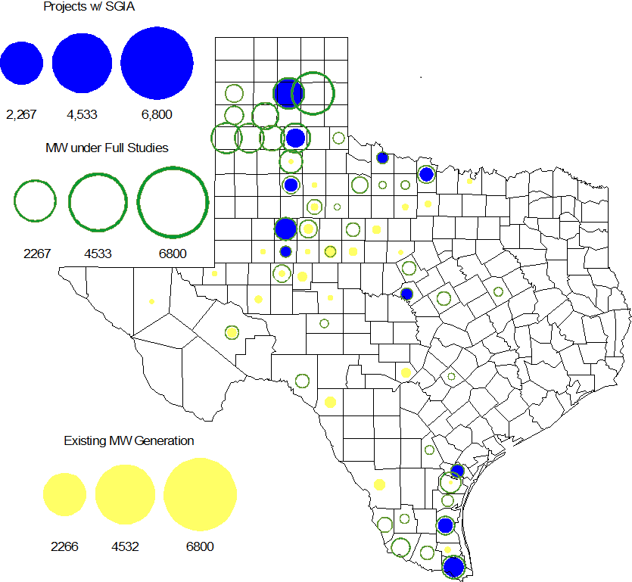

Regional Planning Group Project Reviews

- AEPSC has submitted the Airline/North Padre Island Area Improvements project. This project is submitted as a revision to the Barney Davis to Laguna 138 kV line (AEPSC Corpus Christi Improvements Project ) that was endorsed by ERCOT in December 2009. This is a Tier 1 project that is estimated to cost approximately $58.1 million. ERCOT has completed the independent review. ERCOT will present the project to TAC and at the Board of Directors in January 2013 for their endorsement.

- CPS Energy has submitted the TCC Transmission project to support load growth on the west side of San Antonio. The project is Tier 2 project estimated to cost $10.9 million. Based on the EROCT independent review, this project was reclassified as a Tier 4 project (as per ERCOT Protocols 3.11.4.5(c)) since there are no NERC Reliability Standard or ERCOT Planning Criteria violations identified in the ERCOT review.

- Sharyland has submitted the Atlas-Driver Load Integration project, this is a Tier 2 project that is estimated to cost approximately $15.4 million. This project is currently under ERCOT independent review.

- American Electric Power Service Corporation (AEPSC) has submitted the Sinton-Beeville-Kenedy Area Improvements project to accommodate load additions due to Eagle Ford Shale development in South Texas. This is a Tier 1 project that is estimated to cost $89.2 million. This project is currently under ERCOT independent review.

- LCRA TSC, Guadalupe Valley Electric Cooperative (GVEC), American Electric Power (AEP), and South Texas Electric Cooperative (STEC) have jointly submitted the Kenedy Switch to Nixon to Seguin Line Upgrade. This is a Tier 1 project that is estimated to cost approximately $55.3 million. This project is currently under ERCOT independent review.

- Guadalupe Valley Electric Cooperative (GVEC) has submitted the McQueeney-SMI-Geronimo 69 kV to 138 kV rebuild project. This is a Tier 2 project that is estimated to cost approximately $8.1 million. This project has been submitted for RPG comments.

Congestion Costs
Dollars shown in RUC Make Whole payment graph are of settlement quality.

RUC net Make Whole payment in $mm

Monthly Average LMP

Binding Constraints – Year to Date
Contingency | Binding Element | Number of 5-min intervals | Shadow Price Range $/MWh | Estimated Congestion Rent $ (Shadow Price*Limit) | Transmission Project
Amoco North Cowden Tap - Moss 138kV | Odessa North 138/69 kV Autotransformer | 16957 | 0 - 2800 | 134,188,994 | 5YTP [2010-R7, R8]  12TPIT0214, 13TPIT0136
Quail Switch - Odessa EHV 345 kV & Longshore Switch - Odessa EHV 345 kV; Golden Switch - Sun Switch 138 kV; Falcon Seaboard - Midland East 345 kV; etc. | China Grove - Bluff Creek 138 kV | 2777 | 0 - 3500 | 63,879,472 | 13TPIT0098, 13TPIT0093
Base Case | West to North Stability Limit | 9259 | 0 - 436 | 31,958,328 | CREZ
Batesville Switching Station - Paloduro Substation 138 kV; Batesville 138/69 kV Autotransformer; West Batesville - Uvalde 138 kV; etc | Moore Switching Station - Downie Switching Station 138 kV | 1971 | 0 - 3500 | 20,422,574 | 08TPIT0018
Midland East - Odessa EHV 345 kV; or Moss Switch 345/138 kV Autotransformer | Odessa - Odessa North 138 kV | 609 | 0 - 3500 | 18,830,852 | 14TPIT0054
Twin Buttes 345/138 kV Autotransformer | San Angelo Red Creek 345/138 kV Autotransformer 2 | 113 low-side; and 262 high-side | 19 - 3500 low-side; and 2 - 4500 high-side | 18,360,051 | 14TPIT0067
Kyle - San Marcos 138 kV; or Lytton Spring - Zorn 345 kV & Austrop - Zorn 345 kV | Turnersville - Buda 138 kV | 568 | 0 - 3500 | 17,352,442 | 09TPIT0060
Lewisville Switch - Carrollton Northwest 345 kV; or Lewisville Switch - Carrollton Northwest 345 kV double-circuit | Lewisville Switch - Jones Street TNP 138 kV | 4776 | 0 - 3500 | 17,273,208 | CREZ, 07TPIT0042
Salado - Killeen 345 kV double-circuit | Belton - Belton Southwest 138 kV | 272 | 0 - 3500 | 15,598,608 | 12TPIT0036, 12TPIT0037
Morgan Creek SES 345/138 kV Autotransformer 1 | Morgan Creek SES 345/138 kV Autotransformer 4 high-side | 150 | 3 - 4500 | 14,673,592
Binding Constraints – Dec 2012
Contingency | Binding Element | Number of 5-min intervals | Shadow Price Range $/MWh | Estimated Congestion Rent $ (Shadow Price*Limit) | Transmission Project | Comments
Valley South - Valley SES 345 kV & Valley South - Paris Switch 345 kV; or Paris Switch - Valley SES 345 kV & Paris Switch - Valley South 345 kV | Paris Switch 345/138 kV Autotransformer | 18 | 4 - 4500 | 2,771,837 |  | Paris Switch - Monticello 345 kV line switched out due to high voltage and switched back after the TO being contacted
Base Case | West to North Stability Limit | 612 | 0 - 153 | 2,756,558 | CREZ | High west wind
North Edinburg - Lon Hill 345 kV | Yturria Sub - Raymondville 2 138 kV | 55 | 0 - 3500 | 1,881,392 | 5YTP [2012-R22] | Ajo - Rio Hondo 345 kV line outage and generation outage
Nelson Sharpe - Lon Hill 345 kV | Celanese Bishop - Kleberg AEP 138 kV | 1023 | 0 - 1799 | 1,176,799 | 5YTP [2012-R22] | Ajo - Rio Hondo 345 kV line outage and generation outage
Salado - Killeen 345 kV double-circuit | Belton - Belton Southwest 138 kV | 14 | 250 - 3500 | 1,108,458 | 12TPIT0036, 12TPIT0037 | Multiple line outages
Comanche Peak SES - Comanche Switch 345 kV | Comanche Switch - Comanche Tap 138 kV | 164 | 0 - 474 | 825,327 | CREZ | High west wind
Orange Grove Switching Station - Lon Hill 138 k;, Pawnee - Lon Hill 345 kV; or Whitepoint 345/138 kV Autotransformer | Sinton - Skidmore 69 kV | 415 | 0 - 2800 | 756,823 | 5YTP [2012-R16]
North Edinburg - Lon Hill 345 kV | Las Pulgas - Rio Hondo 138 kV | 416 | 0 - 1880 | 688,015 | 5YTP [2012-R22] | Ajo - Rio Hondo 345 kV line outage and generation outage
Base Case | ENA Snyder Wind - Snyder Wind Farm WKN Breaker 69 kV | 35 | 19 - 5000 | 668,531 |  | High west wind
Sam Switch - Venus Switch 345 kV double-circuit | Whitney 138/69 kV Autotransformer 2 | 207 | 0 - 2800 | 626,964 | 12TPIT0090

Wind Generation as a Percent of Load
One-hour average of total wind power output as a percentage of ERCOT load.

Planning Model Activities
- The short term calendar of major planning model events follows:
  - Jan 11, 2013 Complete Planning Data Dictionary Update
- Status update on SCR760, Changes Needed for Information Model Manager and Topology Processor for Planning Models, which was approved by the ERCOT Board in March 2011.
  - Bundle 1 (Items 3, 7 and 8): In Production.
  - Bundle 2 (Items 2a, 4, 9): In Production.
  - Bundle 3 (Item 5, 2b, 2c): In Production
  - Bundle 4 (Items 1, 6): Requirements agreed to by ERCOT and Vendor. Vendor proposal approved by ERCOT. SOW amendment underway. Vendor has begun work. Expect to receive first release in April 2013.
SCR Sub Part | SCR Description | Status
SCR760-1 | Upgrade to PSS/E v32 | Production
SCR760-2 | Distribution Capacitor banks | Production
SCR760-3 | Zero Impedance Line Ratings | Production
SCR760-4 | Associate Loads and Capacitor banks with the correct CNG | Production
SCR760-5 | Additional Transformer Data for Planning | Production
SCR760-6 | FACTS Devices | Planning
SCR760-7 | Assign valid PSSE IDs to Breakers/  Switches/ Series Devices | Production
SCR760-8 | Phase shift of Autos for short circuit studies | Production
SCR760-9 | Multisection Line Grouping | Production
Table 1: In the following table:
- Red will be used to show status of Not Submitted, meaning that the SCR sub part has not been submitted to Siemens as a Service Request.
- Yellow will indicate that the SCR sub part has been submitted. The color will remain yellow and the status will change in order to Submitted, Planning (Requirements, SOW, Code Writing), Release (Siemens produces first code to test), and Testing (code has completed internal test and is moving through release management).
- Green will indicate that the code has been tested and installed on the machines that ERCOT uses to produce Topology Processor output for Planning and CRR.

Other Notable Activities
- ERCOT has completed the 2012 Five-Year Transmission Plan and the final report was posted at the ERCOT Planning and Operations Information (POI) website on Dec. 27, 2012.
- ERCOT has completed the 2012 Constraints and Needs Report.
- ERCOT has completed the 2012 Long-Term System Assessment and the final report was posted on ercot.com.

