 |  |  |  | System Planning
Monthly Status Report
November 2012

 |  | Report Highlights
 | - ERCOT is currently tracking 152 active generation interconnection requests totaling over 43,000 MW. This includes over 20,000 MW of wind generation.
- ERCOT is currently reviewing proposed transmission improvements with a total cost of $228.9 Million
- Transmission Projects endorsed in 2012 total $596.8 Million
- All projects (in engineering, routing, licensing and construction) total approximately $9.68 Billion.
- Transmission Projects energized in 2012 total about $732.2 million.

Table of Contents
1. Generation Interconnection 1
1.1 Signed Generation Interconnection Agreements 1
1.2 New Generation Registering for Commercial Operations - none 1
1.3 Summary of Generation Interconnection Requests 1
1.4 Projects with Interconnection Agreements 4
1.5 Generation Projects Undergoing Full Interconnection Studies with Confidentiality Waived by Developer 4
1.6 Generation Projects Undergoing Full Interconnection Studies 5
1.7 Wind Generation Capacity Installed by Year 6
2. Regional Planning Group Project Reviews 7
3. Congestion Costs 8
4. Wind Generation as a Percent of Load 11
5. Planning Model Activities 12
6. Other Notable Activities 13

1. Generation Interconnection
Additional information regarding detailed generation interconnection and impact studies is contained in the “Generation Project Interconnection Information” folder in the “Operations and System Planning” area on the ERCOT website: http://planning.ercot.com/login/login.

Signed Generation Interconnection Agreements
13INR0005 – Conway Windfarm – 600 MW of Wind in Carson County

New Generation Registering for Commercial Operations - none

The total installed wind capacity is now reported as 10,035 MW by the resource owners through the registration process. Capacity by North, South and West is 519 MW, 2,283 MW, and 7,233 MW respectively. 850 MW is able to switch between the West and South zones and is currently shown in the South zone.

Summary of Generation Interconnection Requests
GENERATION INTERCONNECTION REQUESTS CURRENTLY UNDER REVIEW
Currently tracking 162 generation interconnection or change requests
As of November 28, 2012 |  |  |  | Total
Security Screening Study | 17
SSS Completed | 15
Full Interconnect Study | 81
FIS Completed | 12
Suspended Studies | 10
Capacity of Suspended Study Projects | 7,512
Interconnect Agreement Completed | 27
Capacity under Interconnection Agreements | 11,345
Capacity for Grid, MW | 43,650
Wind Capacity, MW | 20,056

Fuel Type | Confidential Projects (MW) | Projects Under Full Study (MW) | Public Projects (MW) | Suspended Studies (MW) | Grand Total (MW)
Gas-AllOther |  |  |  |  | 5,940
Gas-CombinedCycle |  |  | 5,686 |  | 12,863
Total Gas | 9,035 | 4,082 | 5,686 |  | 18,803
Nuclear |  |  |  | 3,200 | 3,200
Coal |  | 850 | 1,165 |  | 2,015
Wind | 2,577 | 14,400 | 3,078 | 4,273 | 24,329
Solar | 664 | 657 | 60 | 38 | 1,419
Biomass
Storage |  | 40 | 36 |  | 76
Petroleum Coke |  |  | 1,320 |  | 1,320
Grand Total | 12,276 | 20,029 | 11,346 | 7,512 | 51,162

County Location of Installed Generation and Interconnection Requests (all fuels)

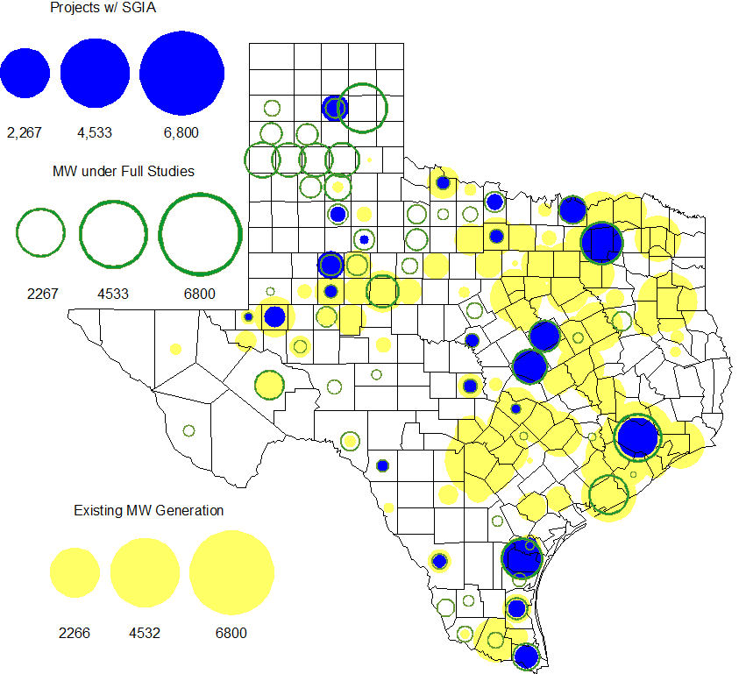

Projects with Interconnection Agreements

Generation Interconnections as of November 28, 2012
INR | Site Name | County | COD | Fuel | MW For Grid | Change from Last Report
12INR0076 | Notrees Battery Storage | Winkler | Nov-12 | Storage | 36 | Date
12INR0075 | Blue Summit Windfarm | Wilbarger | Nov-12 | Wind | 135
08INR0011 | Senate Wind Project | Jack | Dec-12 | Wind | 150
11INR0091 | Whitetail Wind Energy Project | Webb | Dec-12 | Wind | 92
12INR0072 | Anacacho Windfarm | Kinney | Dec-12 | Wind | 100
09INR0061 | WKN Mozart | Kent | Dec-12 | Wind | 30
11INR0033 | Los Vientos | Cameron | Dec-12 | Wind | 400
08INR0049 | Bobcat Bluff (Briar Creek) | Clay | Dec-12 | Wind | 163
09INR0001 | Sandy Creek 1 | McLennan | Apr-13 | Coal | 925
11INR0086 | RRE Austin Solar | Travis | Oct-13 | Solar | 60
06INR0022c | Penascal Wind Farm 3 | Kenedy | Dec-13 | Wind | 202
11INR0013 | Goldthwaite Wind Energy | Mills | Dec-13 | Wind | 150
11INR0054 | Midway Farms Wind | San Patricio | Dec-13 | Wind | 161
12INR0034 | Stephens-Borlynn Wind Project | Borden | Dec-13 | Wind | 378
13INR0021 | Ferguson Replacement Project | Llano | Jul-14 | Gas-CC | 116
10INR0021 | Panda Sherman Power | Grayson | Aug-14 | Gas-CC | 809
10INR0020a | Panda Temple Power | Bell | Aug-14 | Gas-CC | 809
11INR0050 | Moore Wind 1 | Crosby | Aug-14 | Wind | 149
10INR0023 | Baker Ranch | Haskell | Sep-14 | Wind | 400
13INR0005 | Conway Windfarm | Carson | Dec-14 | Wind | 600 | new
09INR0051 | Mesquite Creek | Borden | Mar-15 | Wind | 249
06INR0006 | Cobisa-Greenville | Hunt | May-16 | Gas-CC | 1,792 | Date
08INR0018 | Gunsight Mountain | Howard | Aug-15 | Wind | 120
13INR0023 | Texas Clean Energy Project | Ector | Jan-16 | Coal | 240
10INR0020b | Panda Temple Power | Bell | May-16 | Gas-CC | 780
10INR0022 | Pondera King Power Project | Harris | Jun-16 | Gas-CC | 1,380
12INR0016a | Las Brisas Energy Center | Nueces | May-18 | PetCoke | 660
12INR0016b | Las Brisas Energy Center | Nueces | May-18 | PetCoke | 660

Generation Projects Undergoing Full Interconnection Studies with Confidentiality Waived by Developer

None

Generation Projects Undergoing Full Interconnection Studies
INR | County | Grid | COD | Fuel |  | INR | County | Grid | COD | Fuel
13INR0040 | Harris | 0 | Jan-13 | Gas |  | 13INR0010a | Parmer | 200 | Jan-13 | Wind
13INR0010d | Parmer | 200 | Jan-13 | Wind |  | 13INR0010e | Parmer | 200 | Jan-13 | Wind
13INR0010f | Parmer | 200 | Jan-13 | Wind |  | 13INR0045 | Castro | 288 | Apr-13 | Wind
11INR0094 | Kent | 100 | Apr-13 | Solar |  | 13INR0020a | Glasscock | 200 | May-13 | Wind
13INR0058 | Bexar | 50 | May-13 | Solar |  | 10INR0089 | Harris | 40 | May-13 | Storage
12INR0086 | Fort Bend | 89 | May-13 | Gas |  | 12INR0045 | Kleberg | 135 | Jun-13 | Wind
13INR0057 | Archer | 65 | Jun-13 | Wind |  | 13INR0049 | Harris | 352 | Jul-13 | Gas
13INR0025 | Randall | 150 | Sep-13 | Wind |  | 13INR0046 | Limestone | 71 | Sep-13 | Wind
13INR0059 | Castro | 499 | Oct-13 | Wind |  | 13INR0028 | Hale | 392 | Nov-13 | Gas
14INR0030a1 | Carson | 322 | Nov-13 | Wind |  | 14INR0030a2 | Carson | 322 | Nov-13 | Wind
12INR0002a | Briscoe | 200 | Dec-13 | Wind |  | 11INR0062 | Nueces | 178 | Dec-13 | Wind
11INR0085 | Nolan | 106 | Dec-13 | Wind |  | 13INR0026 | Oldham | 201 | Dec-13 | Wind
12INR0054 | Jones | 200 | Dec-13 | Wind |  | 12INR0059 | Pecos | 50 | Dec-13 | Solar
13INR0007 | Pecos | 200 | Dec-13 | Wind |  | 13INR0036 | Hidalgo | 200 | Dec-13 | Wind
13INR0038 | Swisher | 300 | Dec-13 | Wind |  | 13INR0050 | Comanche | 200 | Dec-13 | Wind
13INR0052 | Starr | 200 | Dec-13 | Wind |  | 13INR0055 | Zapata | 250 | Dec-13 | Wind
13INR0056 | Scurry | 366 | Dec-13 | Wind |  | 12INR0079 | Kenedy | 200 | Dec-13 | Wind
11INR0057 | Cameron | 165 | Dec-13 | Wind |  | 11INR0093 | San Patricio | 41 | Dec-13 | Wind
12INR0068 | Jim Hogg | 80 | Dec-13 | Wind |  | 13INR0048 | Oldham | 161 | Dec-13 | Wind
12INR0088 | Crosby | 201 | Dec-13 | Wind |  | 14INR0024 | Kinney | 42 | Dec-13 | Solar
13INR0006 | Gray | 750 | Jan-14 | Wind |  | 12INR0055 | Baylor | 40 | Jan-14 | Wind
14INR0013 | Cameron | 103 | Jan-14 | Wind |  | 14INR0014 | Val Verde | 100 | Jan-14 | Solar
12INR0084 | Randall | 242 | Jan-14 | Wind |  | 13INR0010b | Parmer | 200 | Jan-14 | Wind
12INR0060 | Schleicher | 58 | Apr-14 | Wind |  | 13INR0020b | Glasscock | 150 | May-14 | Wind
14INR0027 | Guadalupe | 471 | May-14 | Gas |  | 08INR0019a | Gray | 250 | Jun-14 | Wind
08INR0019b | Gray | 250 | Jun-14 | Wind |  | 08INR0019c | Gray | 250 | Jun-14 | Wind
14INR0011 | Swisher | 270 | Jun-14 | Gas |  | 14INR0012 | Gray | 401 | Jun-14 | Wind
14INR0015 | Harris | 192 | Jun-14 | Gas |  | 14INR0016 | Harris | 190 | Jun-14 | Gas
14INR0031 | Harris |  | Jun-14 | Gas |  | 12INR0085 | Stonewall | 24 | Jul-14 | Wind
14INR0025 | Floyd | 500 | Jul-14 | Wind |  | 12INR0042a | Deaf Smith | 265 | Sep-14 | Wind
12INR0042b | Deaf Smith | 135 | Sep-14 | Wind |  | 12INR0070 | Knox | 300 | Oct-14 | Wind
13INR0031 | Travis | 30 | Oct-14 | Solar |  | 09INR0034 | Coryell | 200 | Oct-14 | Wind
12INR0002b | Briscoe | 200 | Dec-14 | Wind |  | 11INR0081 | Live Oak | 72 | Dec-14 | Wind
11INR0082A | Val Verde | 50 | Dec-14 | Wind |  | 11INR0082B | Val Verde | 150 | Dec-14 | Wind
14INR0009 | Kent | 248 | Dec-14 | Wind |  | 12INR0071 | Caldwell | 30 | Dec-14 | Wind
10INR0085 | Ector | 40 | Dec-14 | Solar |  | 14INR0020 | Floyd | 150 | Dec-14 | Wind
14INR0023 | Briscoe | 361 | Dec-14 | Wind |  | 13INR0054 | Bexar |  | Dec-14 | Gas
11INR0079a | Clay | 200 | Dec-14 | Wind |  | 08INR0031 | Childress | 120 | Dec-14 | Wind
12INR0029 | Swisher | 500 | Dec-14 | Wind |  | 15INR0021 | Starr | 200 | Dec-14 | Wind
13INR0010c | Parmer | 200 | Jan-15 | Wind |  | 10INR0009 | Castro | 300 | Mar-15 | Wind
12INR0057 | Ector | 40 | Apr-15 | Solar |  | 15INR0013 | Anderson | 324 | Oct-15 | Gas
15INR0014 | Matagorda | 280 | Oct-15 | Gas |  | 11INR0065 | Nueces | 350 | Oct-15 | Wind
12INR0002c | Briscoe | 350 | Dec-15 | Wind |  | 14INR0018 | Nolan | 35 | Dec-15 | Solar
15INR0015 | Pecos | 140 | Dec-15 | Solar |  | 13INR0032 | Andrews | 30 | Dec-15 | Solar
12INR0018 | Gray | 500 | Dec-15 | Wind |  | 16INR0005 | Cameron | 871 | Apr-16 | Gas
16INR0003 | Brazoria | 11 | Jun-16 | Gas |  | 11INR0040 | freestone | 640 | Mar-18 | Gas
14INR0003 | Nolan | 850 | Jun-19 | Coal
Note: Projects that are classified as “Cancelled” or “Suspended” are excluded from this table.

Wind Generation Capacity Installed by Year
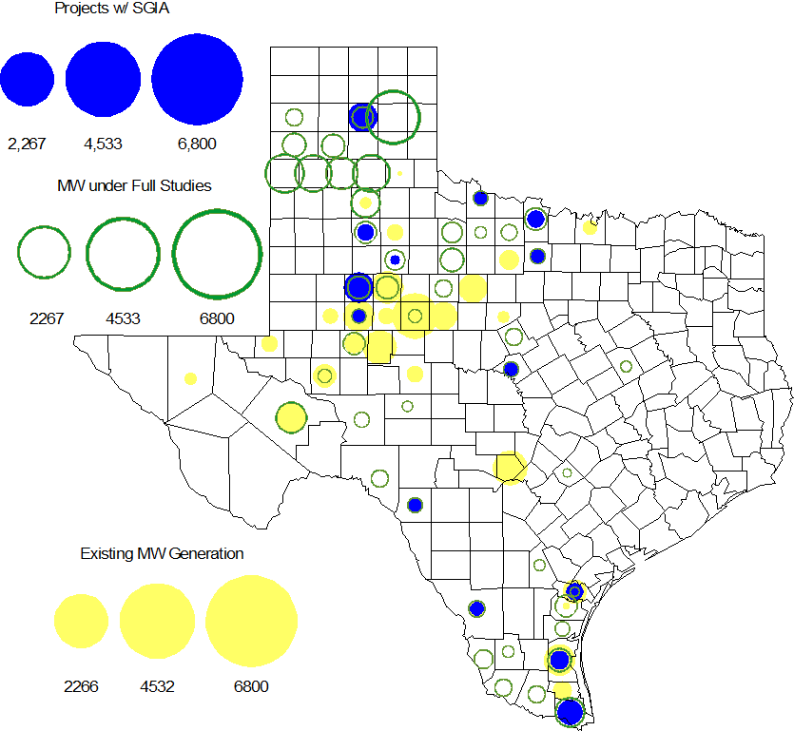

Regional Planning Group Project Reviews

- AEPSC has submitted the Airline/North Padre Island Area Improvements project. This project is submitted as a revision to the Barney Davis to Laguna 138 kV line (AEPSC Corpus Christi Improvements Project ) that was endorsed by ERCOT in November 2009. This is a Tier 1 project that is estimated to cost approximately $58.1 million. This project is currently under ERCOT independent review.

- CPS Energy has submitted the TCC Transmission project to support load growth on the west side of San Antonio. The project is Tier 2 project estimated to cost $10.9 million. This project is currently under ERCOT independent review.

- Sharyland has submitted the Atlas-Driver Load Integration project, this is a Tier 2 project that is estimated to cost approximately $15.4 million. This project is currently under ERCOT independent review.

- American Electric Power Service Corporation (AEPSC) has submitted the Sinton-Beeville-Kenedy Area Improvements project to accommodate load additions due to Eagle Ford Shale development in South Texas. This is a Tier 1 project that is estimated to cost $89.2 million. This project is currently under ERCOT independent review.

- LCRA TSC, Guadalupe Valley Electric Cooperative (GVEC), American Electric Power (AEP), and South Texas Electric Cooperative (STEC) have jointly submitted the Kenedy Switch to Nixon to Seguin Line Upgrade. This is a Tier 1 project that is estimated to cost approximately $55.3 million. This project is currently under ERCOT independent review.

Congestion Costs
Dollars shown in RUC Make Whole payment graph are of settlement quality.

RUC net Make Whole payment in $mm

Monthly Average LMP

Binding Constraints – Year to Date
Contingency | Binding Element | Number of 5-min intervals | Shadow Price Range $/MWh | Estimated Congestion Rent $ (Shadow Price*Limit) | Transmission Project
Amoco North Cowden Tap - Moss 138kV | Odessa North 138/69 kV Autotransformer | 16957 | 0 - 2800 | 134,188,994 | 5YTP [2010-R7, R8]  12TPIT0214, 13TPIT0136
Quail Switch - Odessa EHV 345 kV & Longshore Switch - Odessa EHV 345 kV; Golden Switch - Sun Switch 138 kV; Falcon Seaboard - Midland East 345 kV; etc. | China Grove - Bluff Creek 138 kV | 2777 | 0 - 3500 | 63,879,472 | 13TPIT0098, 13TPIT0093
BASE CASE | West to North Stability Limit | 8647 | 0 - 436 | 29,201,770 | CREZ
Batesville Switching Station - Paloduro Substation 138 kV; Batesville 138/69 kV Autotransformer; West Batesville - Uvalde 138 kV; etc | Moore Switching Station - Downie Switching Station 138 kV | 1971 | 0 - 3500 | 20,422,574 | 08TPIT0018
Midland East - Odessa EHV 345 kV; or Moss Switch 345/138 kV Autotransformer | Odessa - Odessa North 138 kV | 609 | 0 - 3500 | 18,830,852 | 14TPIT0054
Twin Buttes 345/138 kV Autotransformer | San Angelo Red Creek 345/138 kV Autotransformer 2 | 113 low-side; and 262 high-side | 19 - 3500 low-side; and 2 - 4500 high-side | 18,360,051 | 14TPIT0067
Kyle - San Marcos 138 kV; or Lytton Spring - Zorn 345 kV & Austrop - Zorn 345 kV | Turnersville - Buda 138 kV | 568 | 0 - 3500 | 17,352,442 | 09TPIT0060
Lewisville Switch - Carrollton Northwest 345 kV; or Lewisville Switch - Carrollton Northwest 345 kV double-circuit | Lewisville Switch - Jones Street TNP 138 kV | 4666 | 0 - 3500 | 17,099,428 | CREZ, 07TPIT0042
Morgan Creek SES 345/138 kV Autotransformer 1 | Morgan Creek SES 345/138 kV Autotransformer 4 high-side | 150 | 3 - 4500 | 14,673,592
Salado - Killeen 345 kV double-circuit | Belton - Belton Southwest 138 kV | 258 | 0 - 3500 | 14,490,150
Binding Constraints – Nov 2012
Contingency | Binding Element | Number of 5-min intervals | Shadow Price Range $/MWh | Estimated Congestion Rent $ (Shadow Price*Limit) | Transmission Project | Comments
Leon Switch - Cisco - Putnam 138 kV | Leon Switch - Putnam 138 kV | 1498 | 0 - 3500 | 7,213,417 |  | Maintenance outage and high wind
Greens Bayou - King 345 kV double-circuit | Greens Bayou 345/138 kV Autotransformer A2 low-side | 42 | 26 - 3500 | 5,069,923 | 13TPIT0102 | Maintenance at Greens Bayou
Ajo - Rio Hondo 345 kV | North Edinburg - Lon Hill 345 kV | 12 | 4500 - 4500 | 4,366,163 | 14TPIT0050 | Outage of Falfurrias to Rachal 138 kV line
Skyline - Calaveras 345 kV double-circuit | Pawnee - Spruce 345 kV | 2285 | 0 - 4500 | 3,078,583 |  | Outages of Calaveras to Braunig and Calaveras to Cagnon 345 kV lines
Andrews North - Holt Switch 138 kV & Andrews North - No Tree 138 kV; Golden Switch - Sun Switch 138 kV; Falcon Seaboard - Midland East 345 kV; or Falcon Seaboard - Morgan Creek SES 345 kV | China Grove - Bluff Creek 138 kV | 127 | 0 - 3500 | 1,980,625 | 13TPIT0098, 13TPIT0093 | Outage of Odessa EHV 345 kV bus and connected 345/138 kV autotransformer #1 and 345 kV lines
Watermill - Limestone 345 kV double-circuit | Jewett - Big Brown SES 345 kV | 60 | 0 - 4500 | 1,824,357 |  | 345 kV bus outage at Big Brown SES
Morgan Creek SES - China Grove 138 kV double-circuit | Morgan Creek SES 345/138 kV Autotransformer 3 low-side | 103 | 2800 - 2800 | 1,779,190 |  | Outage of Odessa EHV 345 kV bus and connected 345/138 kV autotransformer #1 and 345 kV lines
BASE CASE | West to North Stability Limit | 239 | 0 - 64 | 1,377,443 |  | High west wind
Permian Basin SES - Wink 138 kV & Permian Basin SES - Wickett 138 kV | Northward - Wink 69 kV | 138 | 0 - 2800 | 1,285,671
Odessa EHV 345/138 kV Autotransformer 2 | Odessa EHV 345/138 kV Autotransformer 3 high-side | 222 | 1 - 3748 | 1,188,991 |  | Outage of Odessa EHV 345 kV bus and connected 345/138 kV autotransformer #1 and 345 kV lines

Wind Generation as a Percent of Load
One-hour average of total wind power output as a percentage of ERCOT load.

Planning Model Activities
- Data Set B work began on August 1, 2012 with a Topology Processor case extracted from NMMS with a build date of January 1, 2013. Process is underway with creation of Pass 1 cases on Aug 31, 2012.
- The short term calendar of major planning model events follows:
  - Nov 16, 2012 Posted Sept TPIT update to 12 DSA and 13 DSA cases.
  - Nov 14, 2012 Begin Contingency database update for 13 DSA and DSB cases.
  - Nov 19, 2012 Begin Transmission Loss Factor Calculations
  - Dec 12, 2012 Begin Planning Data Dictionary Update
  - Dec 19, 2012 Post Contingency database update for 13 DSA and DSB cases
  - Dec 21, 2012 Complete Transmission Loss Factor Calculations
  - Jan 11, 2013 Complete Planning Data Dictionary Update
- Status update on SCR760, Changes Needed for Information Model Manager and Topology Processor for Planning Models, which was approved by the ERCOT Board in March 2011.
  - Bundle 1 (Items 3, 7 and 8): In Production.
  - Bundle 2 (Items 2a, 4, 9): In Production.
  - Bundle 3 (Item 5, 2b, 2c): In Production
  - Bundle 4 (Items 1, 6): Requirements agreed to by ERCOT and Vendor. Vendor proposal approved by ERCOT. SOW amendment underway. Vendor has begun work. Expect to receive first release in April 2013.
SCR Sub Part | SCR Description | Status
SCR760-1 | Upgrade to PSS/E v32 | Production
SCR760-2 | Distribution Capacitor banks | Production
SCR760-3 | Zero Impedance Line Ratings | Production
SCR760-4 | Associate Loads and Capacitor banks with the correct CNG | Production
SCR760-5 | Additional Transformer Data for Planning | Production
SCR760-6 | FACTS Devices | Planning
SCR760-7 | Assign valid PSSE IDs to Breakers/  Switches/ Series Devices | Production
SCR760-8 | Phase shift of Autos for short circuit studies | Production
SCR760-9 | Multisection Line Grouping | Production
Table 1: In the following table:
- Red will be used to show status of Not Submitted, meaning that the SCR sub part has not been submitted to Siemens as a Service Request.
- Yellow will indicate that the SCR sub part has been submitted. The color will remain yellow and the status will change in order to Submitted, Planning (Requirements, SOW, Code Writing), Release (Siemens produces first code to test), and Testing (code has completed internal test and is moving through release management).
- Green will indicate that the code has been tested and installed on the machines that ERCOT uses to produce Topology Processor output for Planning and CRR.

Other Notable Activities
- All of the reliability projects for the 2012 Five-Year Transmission Plan have been identified and the results posted at the ERCOT POI. The ERCOT 5YTP team is current working on the draft 5YTP report for reliability analysis section and concurrently working on the economic analysis.

